HSS 2381: Quantitative Methods in Health Sciences – Midterm 1

Lecture 1: Intro

What is research?
Research is what we do when we have a question or a problem we want to resolve.
- It is more than just data collection, we have to be able to analyse it and have a reason for collection
- Until the problem is subjected to rigorous scientific scrutiny, our knowledge remains little more than guesswork or at best, intuition.
- This is why we have the scientific method; the basis for statistics
- Research questions are about what you want to know, not about what you want to do

Classical scientific method
Observation of some phenomenon – may be systematic, occasional or accidental
Some idea of an explanation (hypothesis) - guesswork, usually informed by related work
Testing of the hypothesis – test and revision cycle

Qualitative research: may be more concerned with the individual’s personal experiences of the problem under study

Quantitative research: systematically observe changes in the phenomena of interest while manipulating what are believed to be casual influences
- Scientific investigation of data and their relationships
- The data collected is in terms of numbers, since any variable can be coded
- The objective is to develop and employ mathematical models, theories, and hypotheses pertaining to natural phenomena
- Measuring is key in quantitative research because it shows the relationship between data and observation

Hypothesis: an educated guess, its role is to reflect the general problem statement or question that is driving the research.
- Translates the problem/research question into a form that can be tested

****Research hypotheses: an educated guess or presumption based on literature, states the nature of the relationship between two or more variables. It predicts the research outcome using a research study designed to test the relationship described.
- Directional hypothesis: precise statement indicating the nature and direction of the relationship/difference between variables
- Nondirectional hypothesis: states only that relationship/difference will occur (we don’t know the direction for the correlation between the variables, only that there is one)

A good hypothesis;
- Simply stated in a single sentence
- At least two variables which are clearly stated
- The relationship/difference is precisely stated and testable

**Null hypotheses
Implicit complementary statement to the research hypothesis, states no relationship/difference exists between the variables. The statistical test is performed on the null and is assumed to be true until support for the research hypothesis is demonstrated.
- There is no relationship between the variables, representing the opposite of a research statement

Types of variables
A variable can be anything; it is an element that is identified in the hypothesis or research question.
- The property or characteristic of people or things that varies in quality or magnitude.

- Independent variables
  - Manipulation or variation of this variable is the cause of change in other variables
  - Technically, the independent variable is the term reserved for experimental studies. It is sometimes called the antecedent variable, experimental variable, treatment variable, predictor variable, etc.
- Dependent variables
  - The variable of primary interest - it is influenced or changed by the independent variable.
  - Research question or hypothesis describes, explains or predicts changes in it
  - In non-experimental research, it is also called the criterion variable or the outcome variable.
Measurement hierarchy

Ratio

Interval
Ordinal
Nominal
The relationship between independent and dependent variables
- Cannot specify independent variables without specifying dependent variables
- The number of independent and dependent variables depends on the nature
and complexity of the study; and will determine which statistical test will be used
strongest
- A simple hypothesis includes one of each variable; a complex hypothesis
has one or more of each

Levels of measurement
- Nominal
  - The values name the attribute uniquely
  - There is no meaningful difference in how the numbers are coded
  - These variables consist of categories that are non-ordered. For example, race or ethnicity is a variable
  - A simple categorical variable is binary or dichotomous (1/0 for yes/no)

- Ordinal
  - These variables are also categorical, but we can say that some categories are higher than others
  - For example, income tax brackets, social class, levels of education, etc.
  - However, we cannot measure the distance between categories, only which is higher or lower.
  - When attributes can be rank-ordered, distances between attributes do not have any meaning, for example, educational attainment:
0 – less than high school
1- Some high school
2 – high school degree
3 – some college
4 – college degree

    - We cannot say for example that the distance from 0 to 1 is the same as from 3 to 4

- Interval
  - Variables of this type are called scalar or index variables in the sense that they provide a scale or index that allows us to measure between levels. We can not only measure which is higher or lower, but by how much so.
  - Distance is measured between points on a scale with even units
  - Example: temperature based on Fahrenheit or Celsius (distance from 30 to 40 is the same as 70 to 80)
  - However, ratios do not make sense
  - There is NEVER a meaningful zero, since zero of something does not exist

- Ratio
  - Similar to interval level variables in that it can measure the distance between two points, but it can do so in absolute terms
  - Ratio measures have a true zero, unlike interval measures
  - Example: someone can be twice as rich as someone else based on the value of their assets since to have no money is based on a starting point of zero
  - Can construct a meaningful ratio (fraction), example number of clients in the past six months
Lecture 2: Descriptive Statistics

Evidence-based practice (EBP): use of best clinical evidence in making patient care decisions. The best source of evidence is systematic research
- Reliability: statistics can be manipulated
- Magnitude: how big or small the effect is
- Precision: the margin of error

Data and Data Analysis
The information gathered to address research questions is data. In quantitative research, data are usually numbers which are then subjected to statistical analysis.

Descriptive statistics – describe and summarize data about the sample
Researchers collect their data from a sample of study participants – a subset of the population of interest.
Example: percent which are female in the sample, the average weight of participants

Inferential statistics
Researchers obtain data from a sample but often want to draw conclusions about a population
- Parameter: a descriptive index for a population (ex. Average daily caloric intake of all 10-year-old children in Ottawa)
- Statistic: a descriptive index for a sample (ex. Average daily caloric intake of 300 10-year-old children from three particular Ottawa area schools)

Variables – have different qualities with regard to the measurement potential
- Discrete variables
  - Categories are indivisible, with a finite number of values between two points
  - Example: number of siblings (1.2 siblings is not possible, must be whole numbers)
- Continuous variables
  - Can assume an infinite number of values between two points
  - Example: time elapsed since birth

Frequency Distributions
A method of tallying and representing how often certain scores occur (can be portrayed as a table or graph).
- List each data value in a sequence in ascending order
- Tally the occurrence of the value
- Total the frequencies for each value
- The sum of all frequencies for all data values must equal the sample size; Σf=N

**A typical frequency distribution typically involves absolute frequencies (the tallies), relative frequencies (in percentages), and cumulative relative frequencies (the percentage for a given score value, combined with percentages for all preceding values)

Class intervals: select a class interval that has 2,5, 10, or 20 data points, and they will cover the entire range of data.

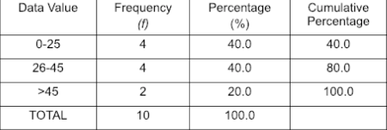
Example: 17, 26, 33, 35, 13, 55, 67, 35, 21, 19

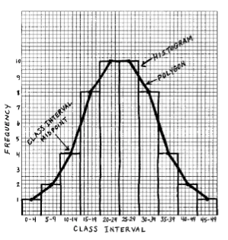
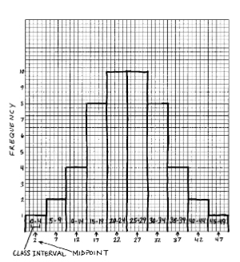
Ten tips for creating a figure;
Frequency Polygon
A histogram
- Minimize the junk
- Plan before you start creating
- Say what you mean
- Label everything
- Communicate one idea
- Keep things balances
- Maintain the scale in the graph
- Simple is best, and less is more
- Limit the number of words
- The chart alone should convey what you want to say
A continuous line that represents the frequencies of scores within a class interval

Can also chart data using a line chart or a pie chart.

**Frequency distributions and measurement levels
Can be constructed for variables measured at any level of measurement, but for categorical (nominal level) variables, cumulative frequencies do not make sense.
Also, when a variable has many possible values, a regular frequency distribution may be long and extensive. This is the theory behind why we describe age using an “age group”. This technique is sometimes described as a “grouped frequency distribution”. Continuous values are grouped into sets, or class intervals.

Bar graphs – used for nominal and ordinal level variables
X axis specifies categories (data values), Y axis specifies either frequencies or percentages. Bars do not touch each other.

Pie charts – also for nominal and ordinal level variables
The circle is divided into pie shaped wedges corresponding to percentages for a given category or data value. The biggest wedge should start at 12 o’clock.

Histograms – used for interval and ratio level data
Similar to a bar graph, but adjacent values are on a continuum, so the bars touch one another. The data values on the X axis are arranged from lowest to highest.

Frequency polygons – also used for interval and ratio level data
Similar to histograms, but instead of bars, a dot is used above score values to designate frequency or percentage. These are better for showing the shape of the distribution and is usually preferred for continuous variables.

***Central Tendency
A characteristic of a distribution that describes how data is clustered around some value. It is a way of summarizing data by identifying one value in the set that is the most important. There are 3 important indices;

- Mean: the most common measure of central tendency; the sum of all the values in a group, divided by the number of values in that group
_
X is the mean value of the group of scores
Σ is the summation sign, add whatever follows
X is each individual score in a group
n is sample size, N is population size
  - To compute the mean;
    - List the entire set of values
    - Compute the sum or total of all the values
    - Divide the total or sum by the number of values
  - Use the mean when the data does not include extreme scores and are not qualitative, categorical, or nominal

- Median
  - The midpoint of a set of scores - where half fall above, and the other half fall below this value
  - If there are two middle scores, the median is the mean of the two middle values
  - Percentile ranks are used to define the percentage of cases equal to and below a certain point on a distribution (ex. The 75th percentile means that the score received is at or above 75% of all other scores in the distribution). The median is the 50th percentile
  - Outliers do not impact the median; so use the median when there are extreme scores.

- Mode
  - The mode is the most frequently occurring value
  - The least precise measure of central tendency
  - When two values occur the same number of times, there is bimodal distribution (can also be trimodal)
  - Use the mode when the data is qualitative, categorical, or nominal, and the values can only fit into one category.

Variability
Reflects how scores differ from one another, also called spread or dispersion.
A heterogeneous sample has a lot of variation, whereas a homogenous sample has little variation
There are 3 measures of variability;

- Range
  - The most general estimate of variability – it gives an idea of how far apart scores are from one another
  - Exclusive range = h-l; where h is the highest score, and l is the lowest score
  - Inclusive range adds 1 to this number

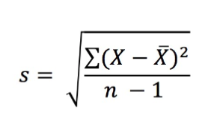
- Standard Deviation (most frequently used)
  - Represents the average amount of variability in a set of scores
  - Standard deviation is the average distance from the mean
  - s= standard deviation
  - To make an unbiased estimate, must subtract 1 from n, which artificially makes the standard deviation bigger
  - The larger the SD, the more variability in the values – sensitive to extreme scores
  - If s=0, there is no variability among scores

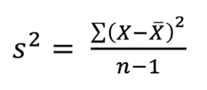
- Variance
  - Standard deviation squared

Lecture 3: Correlation

Bivariate Data - more than one variable is collected on each individual.

Bivariate analysis
One of the simplest forms of quantitative statistical analysis. It involves the analysis of two variables (often denoted as X, Y), for the purpose of determining the empirical relationship between them.

Bivariate descriptive statistics are used to describe relationships between two variables.
- Example: height and weight; smoking status and lung cancer incidence
- The appropriate statistic depends on the variables’ level of measurement

Crosstabulation
Researchers cross-tabulate the frequencies of all categories of two variables in a frequency distribution. The results are then displayed in a contingency table (crosstab table). Cross-tabulated variables should be nominal level (or ordinal with a small number of categories).

Relationships between variables
Positive association: one variable increases with the second variable
Negative association: decrease with the second variable

Correlations
The casual model: evaluation with data that describes an association or a correlation between variables.
- Although a casual relationship between 2 sets of data leads to an association between them, an association may occur even when there is no causation

A correlation is a bond or connection between two variables; variation in one variable is systematically related to variation in another.

Scatterplot
Graphs the values of one variable on the X axis, and the others of a second variable on the Y axis. Serves as an indication for whether the variables have a linear relationship with each other (which occurs when there is a constant rate of change between the two variables). Scatterplots indicate direction and magnitude of the relationship.
- Lines sloping from lower left to upper right have positive relationships
- Lines sloping from upper left to lower right are negative relationships
- If data points are tightly packed or clustered, it indicates a strong relationship
- If data points are loosely spaced, but suggest a diagonal, it indicates a weak relationship
- If data points are seemingly random, there is no relationship

A correlation coefficient is a statistic that summarizes the magnitude and direction of relationships between two variables. The most widely used is Pearson’s product moment correlation coefficient, often called Pearson’s r (can also be computed with variables that are interval or ratio level measures).
- Correlation coefficients range from -1.00 to 1.00
- The sign of the coefficient indicates direction (- = negative correlation, + = positive correlation)
- The value of the coefficient indicates strength

- A correlation between two variables never implies that one variable caused the other. They indicate a link
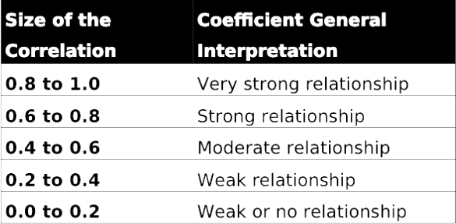
- CORRELATION DOES NOT EQUAL CAUSATION

The square of r indicates the proportion of variability in one variable accounted for or explained by the second variable. If the r between height and weight.
- Example: If the r between height and weight is .60, then 36% of the variation in weight is accounted for by height

Correlation Matrix
A way to display several correlation coefficients. It lists all variables in the top row and first column, then information about the correlation between variables is entered in the appropriate cells.

Reliability
A test of whether a test or measurement tool describes something consistently.
For test scores;
- Observed score: what you got on the test
- True score: the accurate reflection of what you really know
- Observed score = true score + error score; the error score is the difference between the observed score and the true score. Sources of error include testing situations or conditions that impact the obtained score.

Types of reliability;
- Test-retest reliability: whether a test is reliable over time
- Parallel-forms reliability; if several different forms of a test are reliable or equivalent
- Internal-consistency reliability: when you want to know if the items on a test assess one and only one dimension
- Interrater reliability: whether there is consistency in the rating of some outcome (how much raters agree on their judgements of some outcome)

Reliability coefficients have to be positive and not negative, and the goal is that they should be as large as possible (between 0.00 and +1.00).

To establish reliability;
- Standardize instructions
- Increase the number of items
- Delete unclear items
- Make the test neither too easy nor too hard
- Reduce the effects of external distractions

Validity
The test, scale, or instrument measures what it is supposed to.
- Content validity
  - Whether a sample of items truly reflects an entire universe of items on a certain topic
  - Can establish by contacting an expert; how well does the number of items reflect what was taught?
- Criterion validity
  - If test scores are systematically related to other criteria that indicate the test taker is competent in a certain area
  - Concurrent criterion validity: how well a test outcome is consistent with a criterion that exists in the present
  - Predictive criterion validity: how consistent a test outcome is with a criterion that occurs in the future
- Construct validity
  - How well a test reflects an underlying psychological idea, such as intelligence or aggression
  - Most difficult source of validity to establish

A test can overall be reliable but not valid. A test however cannot be valid unless it is reliable because if a test does what it is supposed to, then it has to do it consistently to work.

January 28: Hypothesis Testing and Probability

A sampling error is a measure of how well a sample represents the population. This is measured by the margin of error; the difference between the values – error is a component of every statistical test.

The two types of hypotheses;

Research hypotheses | Null hypotheses
Nondirectional  Reflect a relationship, but the direction is not specified  Use of a two-tailed test (takes into account variables on both ends of the normal curve) | Statements that contain two or more things that are unrelated to one another  H0 : m1 = m2  Used as a benchmark to compare actual outcomes
Directional
Reflects a specified direction in a relationship
Use of a one-tailed test

Two tailed test One tailed test
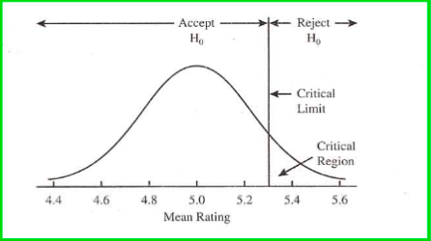
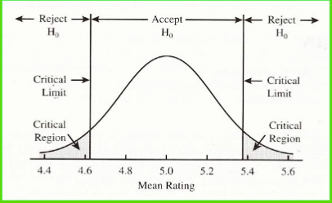

Characteristics of the normal curve
The mean, median and mode are all equal to one another, and the curve is perfectly symmetrical about the mean. The tails are asymptotic (get closer to the horizontal axis but never touch it)
- Sometimes sets of scores represent a distribution that is not normal
- Sets of data larger than 30 often approximate the shape of a normal curve

The z score (standard score)
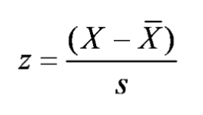
A standard score that is the result of dividing the amount that a raw score differs from the mean of the distribution by the standard deviation;

- Scores below the mean are negative (left of the mean), and those above are positive (right of the mean)
- A z score is the number of standard deviations from the mean
- Z scores across different distributions are comparable

The areas of the curve that are covered by different z scores also represent the probability of a certain score occurring. Knowing the probability that a z score will occur can help you determine how extreme a z score you can expect before determining that a factor other than chance produced the outcome.

Frequency distributions on a curve

Variability Skewness
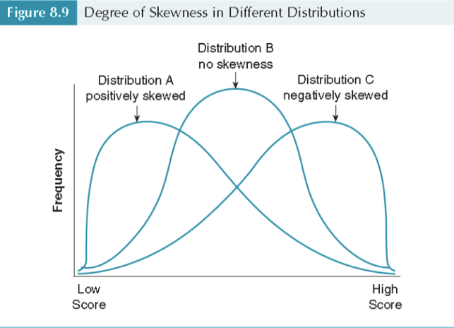
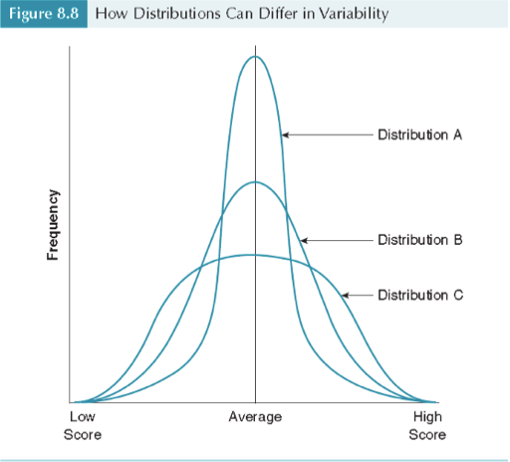

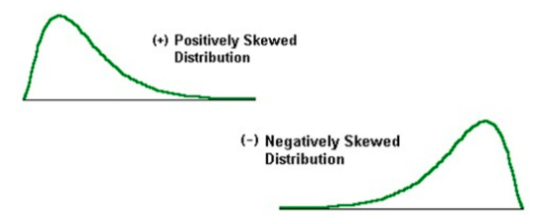
Skewness
In a skewed distribution, the mean is pulled off center in the direction of the skew. A skewness index has:
- Negative values for a negative skew
- 0 for no skew
- Positive values for a positive skew

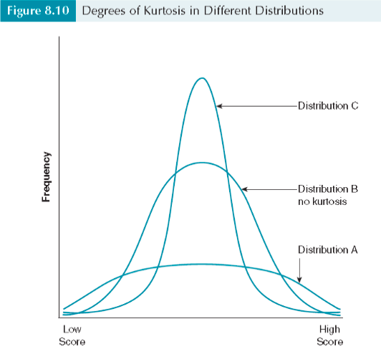
Kurtosis
The degree of pointedness or flatness of the distribution’s peak
- Leptokurtic: very thin, sharp peak
- Platykurtic: flat peak
- Mesokurtic: neither pointy nor flat
  - Positive values have a greater peakedness
  - Negative values have a greater flatness

Modality
Concerns how many peaks there are in a distribution;
- Unimodal: 1 peak
- Bimodal: 2 peaks
- Multimodal: multiple peaks

The normal distribution is unimodal, symmetric, and neither peaked nor flat.

February 4: Statistical Inference

The concept of significance
Any difference between groups that is due to a systematic influence rather than chance.

Significance versus meaningfulness – a study can be statistically significant but not meaningful (results have no importance depending on the context).
- Therefore, statistical significance should not be the only goal of scientific research
- Significance is influenced by sample size, a greater sample reflates to the population more accurately

Statistical significance: the degree of risk you are willing to take that you will reject a null hypothesis when it is actually true.

Statistical significance is a property associated with inferential statistics, where a conclusion from a sample is reached that applies to the whole population. This concept uses the laws of probability to provide guidance on what is probably true. There are two basic approaches;
- Parameter estimation
  - Used to estimate a population value
  - Example: heart rate; expect results between 60 and 100
- Hypothesis testing
  - What you guess to be true about the results
  - Involves the calculation of a single value as the estimate of the parameter

Interval estimates: provides a range of values within which the population value has a specified probability of lying (for example; heart rate). Interval estimation involves constructing confidence intervals around the point estimate.
- A 95% confidence interval designates the range of values within which the parameter has a 95% probability of lying
- 95% confidence represents a score of +/- 1.96 (standard deviation)
- 99% confidence represents a score of +/- 2.56
The formula for confidence limits around a mean involves three components;
- The sample mean
- The estimated SEM
- The value corresponding to the area from a theoretical distribution for the desired confidence interval

t distribution – similar to a normal distribution (bell shaped and symmetric), but different in the way that its flatness varies with n and not standard deviation. As the sample size increases, the t distribution becomes closer to the appearance of the normal distribution.

Hypothesis testing – uses laws of probability to help researchers make objective decisions about accepting or rejecting a null hypothesis
- A null hypothesis states a prediction that variables in the study are not related (example: cigarette smoking is unrelated to lung cancer)
- The null hypothesis contrasts with the research hypothesis – which states a prediction that variables in the study are related (example: cigarette smoking is related to cancer)
- In statistics, hypothesis testing works similar to the criminal justice system, where variables are assumed to be innocent of any relationship until evidence from sample data indicate a high probability that the null is not true

Hypothesis testing works on the basis that the research hypotheses are correct or incorrect, they use laws of probability to make decisions about whether the null hypothesis is probably incorrect. Rejection of the null hypothesis relates to the support of the alternative hypothesis.

Error risk in hypothesis tests
Without data from the population, researchers make decisions about accepting or rejecting the null hypothesis based on incomplete information. There is always a risk of error associated with any statistical test.

Correct outcomes in statistical decision making
- The null is really true in the population and the researcher accepts it as true (true negative)
- The null is really false in the population and the researcher rejects it (true positive)

Type I error
The probability of rejecting a null hypothesis when it is true
- Conventional levels are set between .01 and .05
- Usually represented in a report as p < .05
- Known as a false positive error (alpha error)
Type I errors are controlled through the level of significance, the probability accepted as the risk of a false positive.
- The level of significance or alpha is the area in the theoretical probability distribution corresponding to a rejection of the null hypothesis
- In most cases, alpha=.05, which is a 5% risk of a type I error, this is analogous to a 95% confidence interval
Type II error
The probability of accepting a null hypothesis when it is actually false.
- False negative error (beta error)
The power of a statistical test to correctly reject a false null is 1 – beta
- Researchers cannot control beta like they can control alpha, but they can take steps to reduce the risk of beta
- The most straightforward way to increase power is to increase sample size

Reasons for error;
- Measurement error (reliability and validity) in tools such as surveys, interviews, lab results, physical measurement, and data recorded in a data base
- Misclassification (information bias): wrongly classifying a person/subject to a category that they should not be assigned to
- Error can also be due to both of these factors
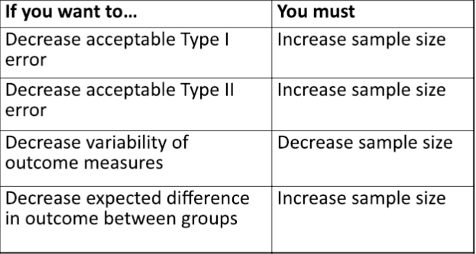

Researchers calculate a test statistic using their sample data. They reject the null hypothesis if the test statistic falls at or beyond a critical region; they accept the null hypothesis otherwise.

- When the null hypothesis is rejected, the results are statistically significant.
- If the null hypothesis is retained (whenever p > .05), the results are statistically nonsignificant. A nonsignificant result reflects an outcome that could have been obtained as a result of chance more than five out of 100 times

MIDTERM #1 REVIEW:
Normal/Negative/Positive distribution Skews
- Larger the sample the more normal it is
- Normal distribution
  - SD (standard deviation)
  - X bar at bottom
  - Outliers on either end
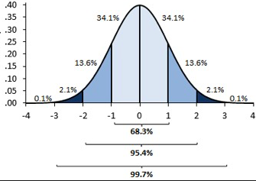

Example of a confidence interval (a determined before for how precise you want to be and p determined from your data… must be less than or equal to have statistical significance)

- Negative skew = majority of people are above the mean (ex. Kariannes exam results)
  - Important example is age of death… most likely to die when older
- Positive skew = tails down to the right of the diagram
  - Important example is income

4 Levels of Measurements:
- Nominal = categorical … no meaningful difference between variables
  - Ex. yes/no, colours
  - Discrete variables… graphed with bar graphs
- Ordinal = ranks … somewhat meaningful difference between variables… think scales
  - Ex. 1-10 pain scales, abcd grades
  - Discrete variables
- Ratio = meaningful zero
  - Ex. income, temp in kalvin, exam marks
  - “I am 4 x __ as __”
  - Continuous variables… graphed with a histogram
- Interval =
  - Continuous variables

- If you prove the null is wrong than you have statistical significance
- Simple= one independent and one dependent variable
- Complex = multiple independent and one or more dependent variable
Type 1 = alpha error and worst one to make
- Type 2 is beta (20% chance of making this error)

