Lab BCH2333

Section: 9 (Wednesday morning)

Lab 2: Proteins and Amino Acids

Demonstrator: Puneet

January 29, 2020

Team 1

Morgan Payne
300008594

University of Ottawa

Purpose:
The purpose of this experiment is to demonstrate the principle of ion exchange chromatography to separate the amino acid mix of aspartic acid, glycine and lysine. Protein analysis by SDS polyacrylamide gel electrophoresis. Using these principles, we will separate a mixture of amino acids and analyze proteins.

Results
R1.

Aspartic acid (C₄H₇NO₄)
pI = 0.5 (pKa1+pKa2)
= 0.5 (1.88+3.65)
= 2.77
pKa
COO⁻= 1.88 NH₃⁼=9.68 β-COOH⁻=3.65

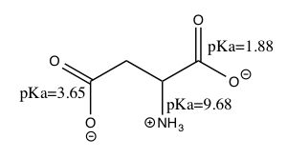

Lysine (C₆H₁₄N₂O₂)
pKa
COO⁻ = 2.16 NH₃⁺=9.18 NH₃⁺=10.79
pI = 0.5 (pKa1+pKa2)
= 0.5 (9.18+ 10.79)
= 9.99

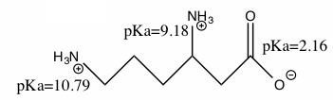

Glycine (C₂H₅NO₂)
pI = 0.5 (pKa1+pKa2)
= 0.5 (2.34+ 9.60)
= 5.95
pKa
COO⁻ = 2.34 NH₃⁺=9.60

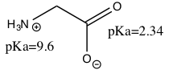

R2.

Table 1: Column elution results from ion exchange chromatography of the amino acids aspartic acid, glycine, and lysine on Dowex-50W-X. NaH₂PO₄, pH 4.0 was first added to the column followed by 4 mL of the amino acid mixture of 2.5mM glycine, 2.5mM lysine and 2.5mM aspartic acid, in water. The exit compartment of the gradient maker was filled with 35 mL of 0.1M NaH2PO4, pH 4.0, and the second compartment with 35 mL of 0.1M Na2HPO4, pH 12.5. The column was eluted with a 0.1M NaH₂PO₄ pH gradient from pH 4.06 to 11.50 resulting in 14 fractions of 4.96mL including a blank tube with NaH₂PO₄, pH 4.0 (fraction 1). 100µL Ninhydrin reagent (20mg/mL ninhydrin, 3mg/mL hydrindantin, 75% DMSO and 1M lithium acetate) were added to each of the fractions, followed by heating at 100 degrees Celsius for 15 minutes and addition of ethanol-water (1:1). The absorbance at 570nm of the 14 fractions were observed from ion exchange-chromatography of the three eluted amino acids. Corrected absorbance was calculated by subtracting the blank (fraction 1) reading (0.033) from the initial readings. The concentrations (mM) were calculated using Beer-Lambert law using 1.0mM aspartic acid (corrected absorbance of 1.288) for fractions 1-7, 1.0mM glycine (corrected absorbance of 1.163) for fractions 8-12, and 1.0mM lysine (corrected absorbance of 1.28) for fractions 13-14. The average volume of each fraction was calculated to be 4.96mL.

Fraction # | Elution volume (mL) | pH | A₅₇₀ | A₅₇₀ corrected | Concentration (mM) | μmole
1 | 4.96 | 4.06 | 0.048 | 0.015 | 0.012 | 0.057
2 | 9.92 | 4.04 | 0.015 | 0.00 | 0.00 | 0.00
3 | 14.88 | 4.17 | 0.523 | 0.49 | 0.038 | 0.188
4 | 19.84 | 4.23 | 0.620 | 0.587 | 0.456 | 2.26
5 | 24.8 | 4.03 | 0.204 | 0.171 | 0.133 | 0.66
6 | 29.76 | 4.20 | 0.270 | 0.237 | 0.184 | 0.913
7 | 34.72 | 6.20 | 0.440 | 0.407 | 0.350 | 1.736
8 | 39.68 | 6.71 | 0.221 | 0.188 | 0.162 | 0.80
9 | 44.64 | 7.05 | 0.258 | 0.225 | 0.193 | 0.96
10 | 49.6 | 7.36 | 0.145 | 0.112 | 0.096 | 0.478
11 | 54.56 | 7.71 | 0.132 | 0.099 | 0.085 | 0.422
12 | 59.52 | 8.45 | 0.141 | 0.108 | 0.015 | 0.076
13 | 64.48 | 10.46 | 0.478 | 0.445 | 0.348 | 1.73
14 | 69.44 | 11.50 | 0.381 | 0.348 | 0.270 | 1.35
Variables
Fraction Number= 2
Average Volume = 4.96mL
Elution volume = ?

Sample Calculations
Elution Volume = (Fraction Number) (Average Volume)
= (2) (4.96)
= 9.92 mL
Therefore, the elution volume for fraction 2 is 9.92mL.
Variables
Fraction 1 A₅₇₀ uncorrected = 0.048
A₅₇₀ Blank NaH₂PO₄ (4.0M) = 0.033

A₅₇₀corrected
Fraction 1 A₅₇₀corrected = A₅₇₀ uncorrected – A₅₇₀ Blank NaH₂PO₄ (4.0M)
= 0.048 – 0.033
= 0.015
Therefore, the corrected absorbance of fraction 1 is 0.015.

Concentration and moles
Variables for fraction 3
A(corrected, fraction 3)= 0.49
A(corrected, aspartic acid) = 1.288
C(asp) = 1.0mM
C3= ?
Vav= 4.96mL
n3=?

Aspartic Acid (Fractions 1-6)

C3= (A(corr,3) x C(asp))/A(corr,asp)
C3=(0.49 x 1.0mM)/1.288
C3= 0.38mM

n3= Vav x C3
n3=4.96mL x 0.38mM
n3=0.188μM

The concentration of aspartic acid in fraction 3 is 0.38mM and the number of moles in it is 1.88uM.
Variables for fraction 3
A(corrected, fraction 8)= 0.188
A(corrected, glycine) = 1.163
C(gly) = 1.0mM
C8= ?
Vav= 4.96mL
n8=?

Glycine (Fractions 7-12)

C8 = (A(corr,8) x C(gly))/A(corr,gly)
C8 = (0.188 x 1.0mM)/1.163
C8 = 0.162mM

n8= Vav x C8
n8 = 4.96mL x 0.1617mM
n8 = 0.80μM

The concentration of glycine in fraction 8 is 0.162mM and the number of moles in it is 0.8uM.

Lysine (Fractions 13-14)

C13 = (A(corr,13) x C(lys))/A(corr,lys)
Variables for fraction 3
A(corrected, fraction 13)= 0.445
A(corrected, lysine) = 1.28
C(lys) = 1.0mM
C13= ?
Vav= 4.96mL
n8=?

C13 = (0.445 x 1.0uM)/1.28
C13 = 0.348mM

n 13 = Vav x C13
n 13 = 4.96mL x 0.348mM
n 13 = 1.73μM
The concentration of lysine in fraction 13 is 0.348mM and the number of moles in it is 1.73uM.

R3.

Figure 1. pH values and concentration (mM) plotted against the corresponding elution volume (mL) of the amino acids separated by ion-exchange chromatography into 1.0M glycine, aspartic acid, and lysine. The column was packed with DOWEX-50W-X with 0.5mL 0.1M NaH₂PO₄, pH 4.0. 15 fractions of 120 drops at an average of 4.96mL were collected giving a pH gradient from pH 4.06 to 11.50. The pH of each fraction was measured and assayed for aspartic acid, glycine, and lysine. The concentrations (mM) were calculated using Beer-Lambert law using 1.0mM aspartic acid (corrected absorbance of 1.288) for fractions 1-7, 1.0mM glycine (corrected absorbance of 1.163) for fractions 8-12, and 1.0mM lysine (corrected absorbance of 1.28) for fractions 13-14. The average volume of each fraction was calculated to be 4.96mL.

Figure 1 allows us to see a visual representation of the separation of the molecules. We can see a change in the amino acids, 1.0M aspartic acid, 1.0M glycine, and 1.0M lysine, when a large peak is seen in the concentration or large increase in the pH. There are three distinct peaks observed, showing the amino acids are separated well and can be observed in Figure 1 fairly easily. Though lysine’s peak cannot be observed descending, it still makes an obvious slope showing separation from the other two amino acids. Lysine, being the most basic due to its increased alkalinity, corresponds to the third peak with the highest pH value. The first peak is aspartic acid, and the second peak glycine. There is a small peak observed in pH observed between glycine and lysine’s peaks which could be due to experimental errors. This could be improved upon by increasing the accuracy by eluting the amino acids slower and having smaller fraction volumes, therefore decreasing the rate pH increases, allowing the data to be more precise. This could also be done by increasing the amount of the buffer NaH₂PO₄ in the mixture, allowing the amino acids to separate slower, giving the graphs more accuracy.

R4.
Recovery yield (%) = (nActual /nTheoretical) x 100%
Final moles aspartic acid
nActual = Σn fraction 1-6 from Table 1= 0.057 +0.00 + 0.188 + 2.26 +0.66 + 0.913
Variables
ni from Table 1
nActual= ?
= 4.08 μmol

The experimental yield for aspartic acid is 4.08 μmol.
Variables
Camino=1.0mM
Vav= 4.96mL
nTheoretical= ?
Theoretical value: all amino acids
nTheoretical = Camino x Vav
= 1.0mM x 4.96mL = 4.96μmol

Variables
nTheoretical= 4.96 μmol
nActual = 4.08 μmol
Aspartic acid recovery yield (%)= (nActual /nTheoretical) x 100%
= (4.08 μmol /4.96)x100%
= 82.26%

The recovery yield of aspartic acid is 82.26%.

The recovery yields for aspartic acid, glycine, and lysine are 82.26%, 90.12%, and 62.1% respectively. These values are fairly expected as their values are high enough to expect only some slight experimental error, though lysine is slightly lower. Glycine’s value is reasonable considering the apparatus is not completely effective. For aspartic acid and lysine, it is possible some of their contents were left within the apparatus and stayed behind. Other Sources of error could have been pipetting errors and absorbance measurements.

R5.
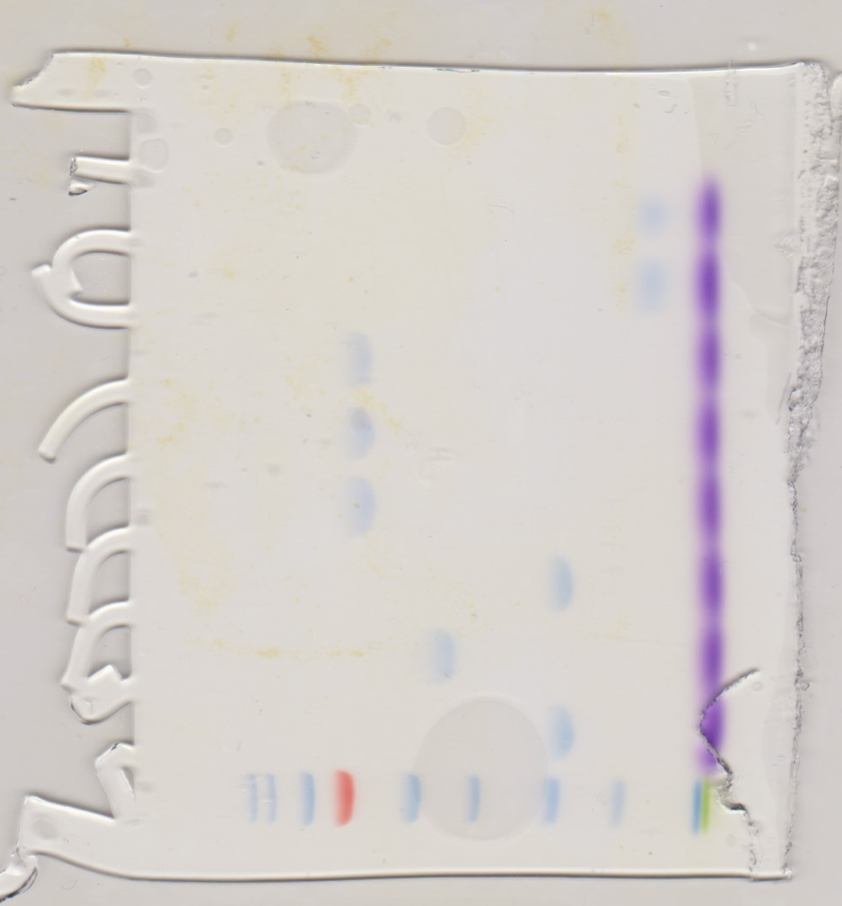
170 kDa

Well 7

Sample #22

130 kDa

72 kDa

95 kDa

55 kDa

43 kDa

34 kDa

26 kDa

17 kDa

10 kDa

Well 3

Well 1

Well 9

Well 8

Well 2

Well 4

Well 5

Well 6

Figure 2. Gel 2 image of a gel electrophoresis for unknown sample number 22 in well 4 Slab gel was assembled into a clamped gel sandwich to form the upper buffer chamber and molecular weight (MW) marker mixture was pipetted into well #1. The molecular weights are marked to the left for their particular protein markers. The pre-stained unknowns were dissolved in buffer 62.5mM Tris-Ci (pH6.8), 2% SDS, 5% 2-mercaptoethanol, 10% glycerol and 0.002% bromophenol blue then heated at 100ºC for 3 minutes. Sample 22 (with a travel distance of 5.0cm) was inserted into well 4 next to other pre-stained unknowns and compared to the protein markers. The cathode and anode were then connected, and the power turned on at 200V. Once the dye reached the end of the gel the power was turned off, and the gel was observed. The migration distance of the sample depends on its size (the larger the sample the less it travels).

Table 2. The standard molecular weight markers and measured migration distance (cm).
The migration distance of the protein markers shown in figure 2 were measured from the bottom of the well to the center of the band, those with larger weight travelling less of a distance (cm).

MW (kDa) | Log (MW) | Distance (cm)
170 | 2.230448921 | 1.3
130 | 2.113943352 | 1.6
95 | 1.977723605 | 2.0
72 | 1.857332496 | 2.6
55 | 1.740362689 | 3.2
43 | 1.633468455 | 3.9
34 | 1.531478917 | 4.8
26 | 1.141497334 | 5.6
17 | 1.230448921 | 6.5
10 | 1.0 | 6.7

Figure 3. Log (MW) of the protein markers versus the measured migration distance (cm).
Shown in figure 2, pre-stained protein markers were pipetted into lane 1 of a clamped gel sandwich. Once the migration was complete, the distance each band travelled was measured from the bottom of the well to the middle of the band. This measurement is plotted against the log(MW) of the standard proteins. The regression line is y= -0.2049x + 2.4305. From this we can estimate the MW of the unknown sample number 22 to be 25.47kDa.

Sample Calculations
Variables
y= -0.2049x + 2.4305
log MW = y
x = d = distance travelled (sample 22)= 5.0cm

log(MW)= -0.2049x + 2.4305
log(MW)= (-0.2049(5.0cm)) + 2.4305
log(MW)= 1.406
MW= 10^{1.406}
MW= 25.47 kDa

Therefore, the predicted molecular weight of our unknown sample number 22 is 25.47 kDa.

