Heart: Histology and Physiology

Cardiac Muscle
Cardiac muscle cells are very similar to skeletal muscle cells. However, there are a few differences;
- A skeletal muscle fiber or cell is a long cylinder that runs the length of the entire muscle, whereas cardiac muscle cells;
- are elongated and branching
- Do not run the entire length of the cell
- Instead, they are quite a bit shorter and connect together in series
- In skeletal muscle, the nuclei are found just underneath the sarcolemma and their multinuclear cells, so one fiber has many nuclei
- Nuclei are centrally located
- Part of the reason for this is that there are not as many myofibrils within a cardiac muscle cell as there are in a skeletal muscle cell
- In a skeletal muscle cells, the myofibrils were the reason the nucleus were pushed towards the sides – We did not want them to interfere with the myofibrils in the sarcomeres, and the ability for those to shorten
- Because there are few myofibrils within each cardiac muscle cell, the nucleus being central is not a big issue
- The myofibril are not as highly organized as in skeletal muscle either
- Because of all the branching and organization, we have in cardiac muscle cells, the striations/bands created by the sarcomeres within myofibrils are not as clear as what is seen in skeletal muscle
- Review: Because we have myofibrils, the main contractile proteins are the same as in skeletal muscle
- Actin and myosin – Form sarcomeres
- Have cross bridge cycling
- Have sliding filament theory
- Plasma membrane = sarcolemma (plasma membrane of a muscle cell)
- Within the sarcolemma, there are openings for the transverse tubules
- Transverse tubules ~ evaginations of the sarcolemma that allow for action potentials to move down within or into the cell
- The transverse tubules are not organized quite as regularly as they are in skeletal muscle - A little bit more random and fewer in number
- Very few nuclei per cell compared to skeletal muscle
- Typically, 1-2 nuclei
- The number of mitochondria is different in cardiac muscle compared to skeletal muscle
- Cardiac muscle has a large number of mitochondria
- This is because our heart constantly needs to work over our entire lifespan
- We need to consistently produce ATP in order to keep this muscle constantly going
- One thing that's unique to the cardiac muscle = An intercalated disc
- Intercalated disc ~ Regions of the plasma membrane where we have specialized cell to cell contacts
- They are folds in the sarcolemma – Actually holds the cells together
- In the image (the wave line) – Little bumps and grooves, on the edge of the cell, are in the sarcolemma and they match with the bumps and groves of the neighboring cardiac muscle cell = Fit together like a lock and key/two puzzle pieces fitting together
- Allows the cells to be closely held together
- Desmosomes ~ Within the intercalated disk region, and they are specialized plasma membrane structures that are what hold the cells nicely together (act like staples when the muscle fibers are contracting).
- They are important to the functioning of the cardiac muscle cells
- Unlike our skeletal muscle fibers, which run the entire length of the muscle, when the sarcomeres contract, they pull on each other in series
- When the cardiac muscle gets smaller it's pulling within its own cell, but its sarcomeres are not connected to the neighboring sarcomeres in the next cell
- Therefore, when it pulls it actually pulls away from the cells beside it
- Therefore, we need to have these really strong staples or connections in this region of the intercalated disk, so that when we are pulling or shortening the cardiac muscle, it will also pull along with it all of the neighboring cells that it's attached to
- In addition to the desmosomes, we also have gap junctions which are also found within the intercalated discs
- Gap junctions ~ Where we have electrical synapses, or where we have direct movement of ions from one cell to another cell
- This allows us to have a direct change in membrane potential from one cell affecting a neighboring cell that it was connected to
- The purpose of the gap junctions is to make sure that electrically, the cardiac muscle of the atria and the ventricles wind up behaving like a single unit
- The actual muscle fibers between the atria and the ventricles are separated, however there is one connection between the atria and the ventricles that does contain gap junctions
- This allows the signal to move from the atria into the ventricles
- Within the atria, all these fibers are connected to each other
- Therefore, if we have an action potential moving though this cell, once it hits the gap junctions, it's going to move to the next cell and so on and so forth as it spreads through the entire cardiac muscle
- So this would happen within the atria, and then once it moves through that one specialized region where the atria and the ventricles are connected, it would spread through the ventricles as well

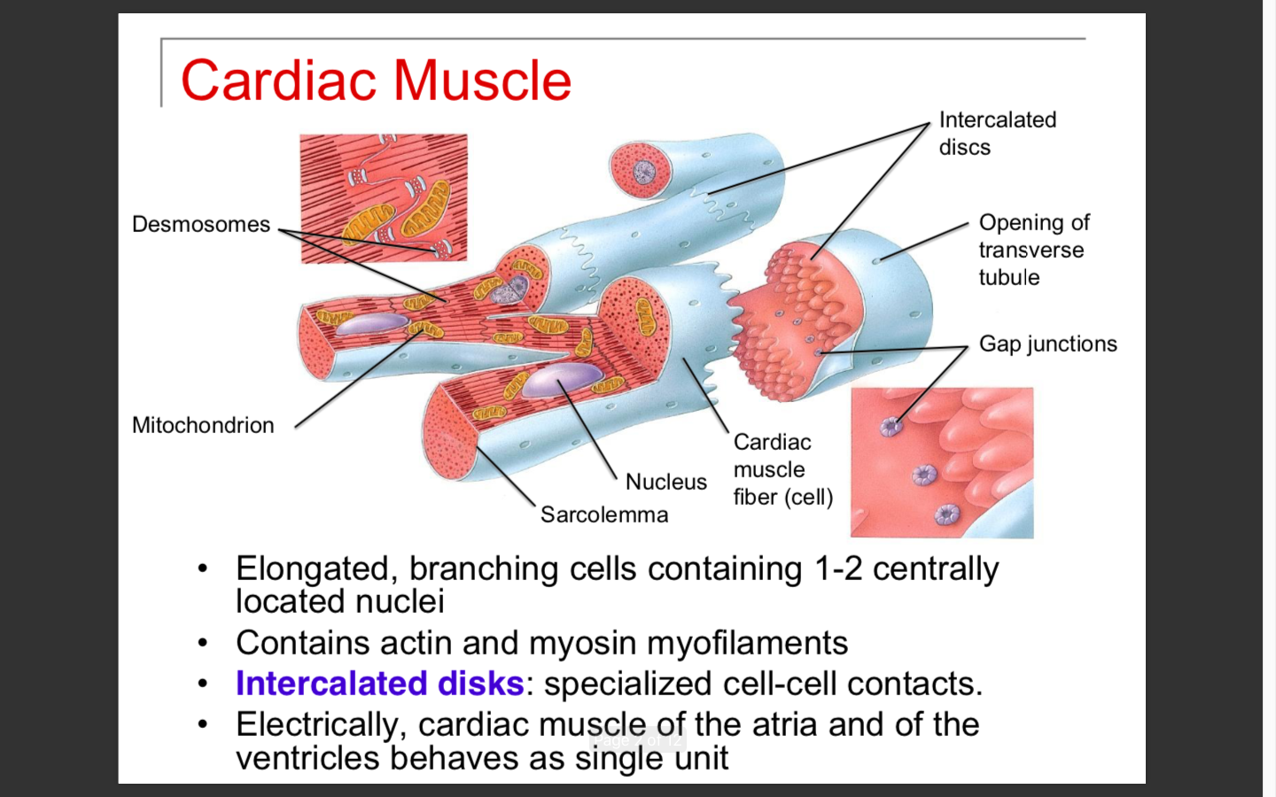
Edge of one cardiac muscle cell

Cardiac muscle fiber or cell

More on Gap Junctions
- Image is what they look like
- Gap junction ~ A physical connection, or pore, between one cell and the neighboring cell
- When the action potential moves along the sarcolemma of one cell, it reaches the pore and the ions can travel directly into the neighboring cell
- This will cause the depolarization of the neighboring cell
- This is how we are enabling our heart tissue to have an action potential that can travel through each and every single cardiac muscle cell that's connected
- And all of the atria and all of the ventricles are connected to each other in some way or another

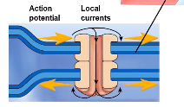

Components of Cardiac Muscle Fibers
Cardiac muscle fibers are very similar to skeletal muscle fibers. They both have very similar organization of the sarcomeres and the banding that’s created by those sarcomeres. But there are a few differences:
- Transverse tubules are larger
- Usually had two transverse tubules running around each sarcomere in skeletal muscle, and they usually overlapped where the actin and myosin overlapped
- In cardiac muscle, we have larger transverse tubules, but they are less frequent along the length of the fiber
- Present where the Z disc is located
- Location of the transverse tubules (or T-tubules)
- Review: Function – the action potential is moving along the sarcolemma and drops down into the T-tubules
- This signals the sarcoplasmic reticulum, which is right beside it, to release calcium
- The calcium binds onto the troponin, which is found over top of the actin, and moves the tropomyosin off the binding sites
- This allows for cross-bridge cycling to occur
- The way these are organized actually makes this whole process less efficient
- This is because it is not located where all of the actin and the myosin is, it is in between at the Z disk
- Makes this type of contraction a little bit slower
- Not a bad thing because with our heart we have a very regulated pattern, and it does not need to be a fast type of contraction
- Another difference is because of the location of the T-tubules again
- In skeletal muscle when the transverse tubules were in contact with the sarcoplasmic reticulum, it was a very organized region = Formed a triad
- Triad ~ Enlarged region of the sarcoplasmic reticulum, next to the transverse tubules = Terminal cisternae
- In cardiac muscle we do not have those enlarged regions anymore
- Instead, the sarcoplasmic reticulum is not as highly organized, it doesn't come in contact with the transverse tubules to as great an extent
- This is another reason why contraction is a little less efficient in cardiac muscle than it is in skeletal muscle, to slow down what's happening with contraction

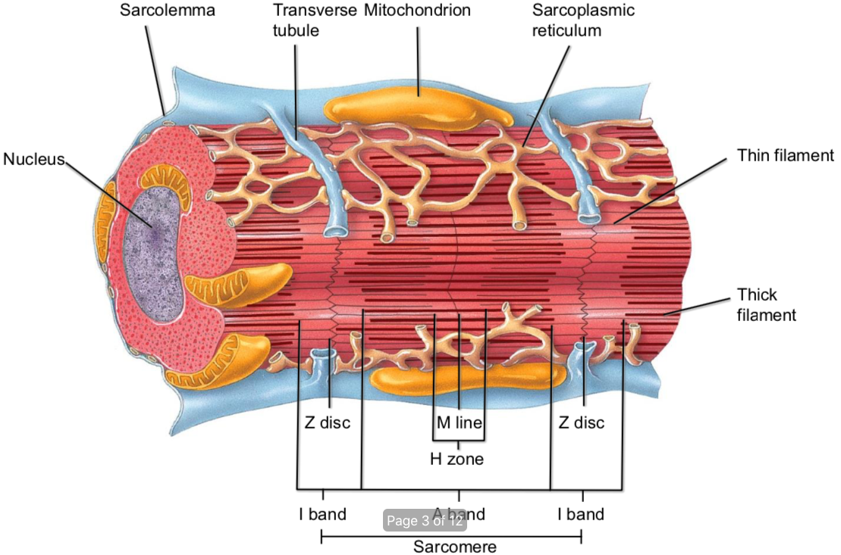

Conducting Systems of the Heart
Conducting system of the heart ~ How action potentials move through the heart
We know that we need an action potential to move along that sarcolemma of each of our cardiac muscle cells in order to stimulate the calcium to bind onto the troponin to cause the muscle contraction. Therefore, if we know how the electrical signals are moving through the heart, we can then use that information to see how that will connect to the contraction of the actual muscle fibers themselves.
Differences:
- The conducting system of the heart contains specialized cardiac muscle fiber cells
- Specialized cardiac muscle cells ~ Control the transmission of the signal through the heart
- Therefore, these cells are slightly different than the cells that we just looked at (they have some special features about them
- One special feature is that they are autorhythmic
- Autorhythmic ~ The cells can spontaneously depolarize themselves, or spontaneously generate an action potential
- Usually with neurons you have to reach threshold. You need a large enough grade potential to reach that threshold in order to get maximum potential
- The specialized cells with the conducting system have some very specific alterations to their plasma membrane, that allow them to spontaneously create an action potential
- Another difference in the cells is that they differ in the number of gap junctions that they have between the cells
- This is because in certain regions of the conducting system, you may want to slow or speed up the signal
- Fewer gap junctions = slower movement of signal
- More gap junctions = Faster movement of signal
- The cells have slightly different ion channels present on their sarcolemma
- This will change which ions are moving in and out during action potentials
- Also differ in diameter
- Small diameter = Signal moves slower
- Larger diameter = Signal moves quicker
In conclusion: Based on some of these characteristics, the conducting system cells are altered different regions throughout this pathway, so that we can highly control the movement of the action potential.

Action Potentials
- First action potential ~ Happens at a region known as the sinoatrial node (SA node)
- Sinoatrial node ~ A lump or mass of specialized cardiac cells
- Found near the opening of the superior vena cava in the right atrium
- Able to depolarize itself
- Depolarizes itself more quickly than the rest of the conducting system
- As long as everything in your heart is working correctly, the SA node is dictating the pace of the firing of the action potentials for the whole rest of the system
- Because of this, it is known as the pacemaker of the heart
- Technically all of the cells within the connecting system of the heart can act as pacemaker cells, but because the SA node fires the most rapidly, it tends to override the pace of all of the downstream conducting system cells
- Once the SA node fires, it will then send an action potential through all of the cardiac muscle cells in series connected to that SA node
- That is going to send signals through the interatrial septum to the left atrium, as well as through the right atrium itself
- Once the signals reached the next node, the atrial ventricular (AV node), the signal slows down
- Second ~ Atrial ventricular (AV node)
- Found in the interatrial septum near the coronary sinus, and also near the AV valve
- In the AV valve, we have smaller diameter fibers and a decreased number of gap junctions
- The reason for this is we want to slow the signal down after the action potentials have moved through the right and left atrial walls
- This allows the atria to fully contract and squeeze the last little bit of blood into the ventricle, before the action potentials enter into the ventricle and cause contraction of the ventricles
- We need the atria to be fully contracted to squeeze that blood in before the ventricles or valves close off
- Once the ventricle starts to contract, the valves close, and we can no longer add any more blood into the ventricles before they can contract
- The AV node is connected to the next portion of the conducting system
- Third ~ Atrioventricular bundle (AV bundle or bundle of HIS)
- Is where the signal is able to move through a small hole in the fibrous skeleton, to move from the atria region into the ventricle region
- This is how we tightly control the electrical conductivity through the heart
- In the fibrous skeleton in this region, we have a small hole where the bundle of HIS moves through
- That is the only place the electrical signal can go from the atria into the ventricle
- It had to be slowed down through the AV node first
- This is what is giving us that nice coordinated contraction that we need in order to fully pump the blood out of the heart
- Conclusion: The AV bundle is the gateway from the atria into the ventricles
- Once the signal reaches the AV bundle and it moves into the ventricular region, it will then split into the right and left bundle branches
- Fourth ~ Right and left bundle branches
- In the ventricles;
- The number of gap junctions rises
- The diameter of the cardiac cells and the conducting system also rises
- Therefore, we now have very fast conduction of our action potentials through the right and left bundle branches
- The bundle branches extend beneath the endocardium
- Endocardium ~ The layer covering the inner walls of the heart
- It also extends through the interventricular septum down to the apices or the apex of the heart
- Once it reaches the apex, it folds back up along the outside regions of the ventricles and forms fibers known as the purkinje fibers
- Fifth ~ Purkinje fibers
- Purkinje fibers ~ Very large diameter cardiac muscle cells, with very few myofibrils
- Therefore, their job isn't contraction
- Their job is to send the signal and send it fast
- They have many gap junctions, so they can send the action potential very quickly to the rest of the ventricular muscle cells

Summary: What is happening is
- The signal slowed = Contraction in the atria The signal enters into the ventricles The signal moves very quickly through the interventricular septum, and then up the purkinje fibers
- During this time, we are now triggering contraction
- The interventricular septum begins to contract first
- Next the apex of the heart will contract as the signal moves through
- What this does is it takes the apex of the heart, contracts towards the fibrous skeleton, and it pulls the apex towards the base of the heart
- It is pushing the blood upwards and outwards into the semi lunar valve and into the aorta.
The movement through this conducting system allows for this nice coordinated contraction

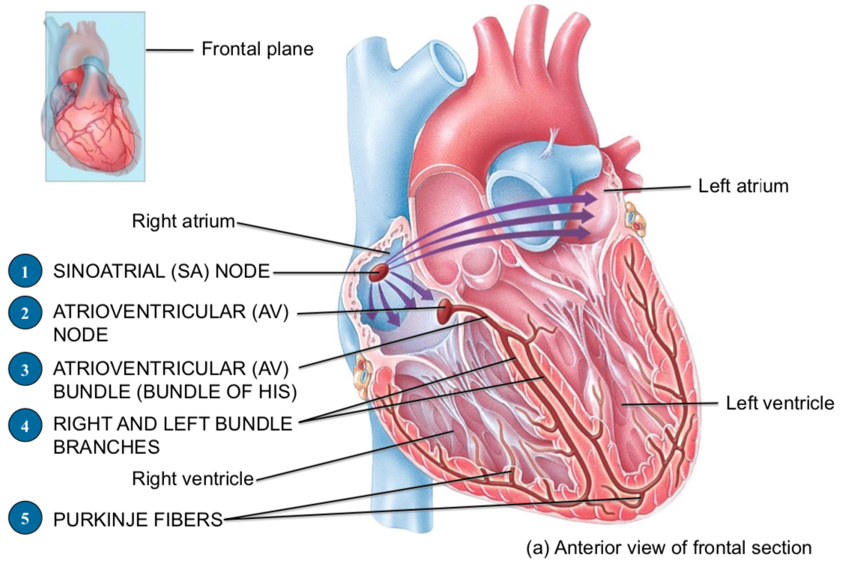

Cardiac Muscle Action Potential
- The image is the type of action potential you would see in a typical cardiac muscle fiber
- Not in the type where we have the autorhythmic cells, or those that are found in the conducting system of the heart = Both have slightly different action potentials
Once we get the connecting system sending the action potentials, it's moving through the gap junctions. Now this is what's happening in the rest of the cardiac muscle fibers in order to generate that action potential, which will then stimulate the calcium to be released to cause the contraction to occur.
- We have a resting membrane potential in the cell if we want to create an action potential
- In a cardiac muscle cell, the typical resting membrane potential is around negative 90 millivolts (-90mV)
- Also have conditions that are quite similar to what we've seen with our neurons
- The extracellular fluid is high in concentration of sodium and calcium
- The intracellular fluid is high in concentration of potassium
- When we get an action potential that reaches a cardiac muscle cell from the conducting system, we get a rapid depolarization
- What's happened is a signal or a local current has move through a gap junction of a connecting cell that is triggered a regular cardiac muscle cell to get closer to threshold
- Once it reaches threshold, what happens is we get sodium channels rapidly opening
- This causes rapid depolarization
- They call them fast sodium channels because they open quickly
- We are moving from about -90mV up to about +20mV
- After we get this rapid depolarization the sodium channels close
- When those sodium channels close, we also have opening of some potassium channels
- When those potassium channels open, we get a slight repolarization… but it doesn't move very far
- It gets to about 0mV zero membrane potential
- The reason for that is that as our potassium channels are opening, we also get an opening of calcium voltage gated channels
- So when we talked about neurons, the calcium voltage gated channels were only found in the presynaptic terminals at the end, where we wanted to have the chemical synapse being activated
- But in cardiac muscle fibers, the calcium voltage gated channels are found all over the Sarcolemma
- Therefore, it is different than it is in skeletal muscle and neurons
- Now what happens is we reach a phase known as the plateau phase
- That's because the calcium that's entering into the cell with its concentration gradient, via those voltage gated calcium channels, is balancing the potassium that's leaving the cell
- So, we wind up getting very little change in the membrane potential (because the balance of ions in is equaling the balance of ions out) = A sustained depolarization created
- This very long sustained depolarization is really important for cardiac muscle fibers to allow contraction to occur
- Thinking about what's happening, the sodium is depolarizing, that is triggering our muscle fibers to begin contraction. So shortly after the depolarization occurs, we're going to trigger those SR cells to release calcium
- Once the calcium gets released, it has to sort of maneuver its way over to the troponin, move the tropomyosin out of the way, and allow for cross bridge cycling to occur
- So, contraction starts to happen slightly after depolarization
- In addition to the fact that the calcium that's being released by the SR is initiating contraction, the calcium that's also entering into the cell can also contribute to contraction. It does this by;
- Those calcium ions themselves can float over to troponin and do the same job, they don't need to be released from the SR
- In other words, the calcium coming in through those voltage gated channels is contributing to the cross-bridge cycling action
- There are also specialized receptors on the SR that respond to calcium
- Known as calcium induced calcium release
- So, the calcium itself binds on to the SR and opens more calcium channels allowing even more calcium to be released
- This is allowing for contraction to occur for a sustained amount of time
- At the end of this period the calcium channels will close, but there will be a greater opening up of the potassium channels – This is where repolarization occurs
- Very similar to what we saw in our neuron
- Potassium channels stay open, all of our other channels are closed = Going to reestablish resting membrane potential
- Calcium channels close, potassium channel opens
- Potassium continues to leave the cell, and that brings us back down to a negative membrane potential
- Therefore, we can now generate another action potential
- At the same time, just like we had in neurons and skeletal muscle, the sodium potassium pumps are reestablishing the concentration gradient so that we can establish another action potential in a few moments
- Refractory period ~ Time in which you cannot generate another action potential
- When the cardiac muscle fiber is depolarizing and even into repolarization, we cannot stimulate another action potential = Refractory period
- It is not until very late repolarization, that we can actually stimulate that cardiac muscle cell to have another action potential
- The refractory period is longer than the contraction period
- The reason for this is that it allows the heart to fully contract, squeeze out all of the blood and begin to relax before we initiate the next contraction
- Otherwise, if this refractory period was shorter or the same length as the contraction, then the heart could potentially stay fully contracted all the time
- We do not want the heart to maintain a contraction because we needed to relax in order to refill
- Therefore, the refractory period being longer than the contraction period, actually forces the heart to relax before the next action potential can occur
- This is really important for stopping tetanus
- Tetanus ~ A sustained contraction of the heart

Differences Between Skeletal and Cardiac Muscle Physiology
- Cardiac - Action potentials conducted from cell to cell, via gap junctions or electric synapses
Skeletal - Action potential conducted/moves along the entire length of a single fiber, because the fiber itself is the length of the muscle
- Cardiac - Rate of action potential propagation is slow because it has to move from cell to cell in series through gap junctions. The fibers themselves are also smaller in diameter, which slows the movement of the action potentials
Skeletal - It is faster because it is all one cell. It does not need to travel from cell to cell, and the diameter of the fibers is larger
- Cardiac - Calcium induced calcium release (CICR). Movement of calcium though plasma membrane and T-tubules into sarcoplasm, stimulates the release of calcium from the SR (just need the movement of calcium into the cell to trigger the release). Then this calcium from the voltage gated calcium channels can also move to the sarcomere and initiate cross-bridge cycling
Skeletal – Needs to have a muscle action potential triggering the SR to release calcium in order for cross-bridge cycling to occur

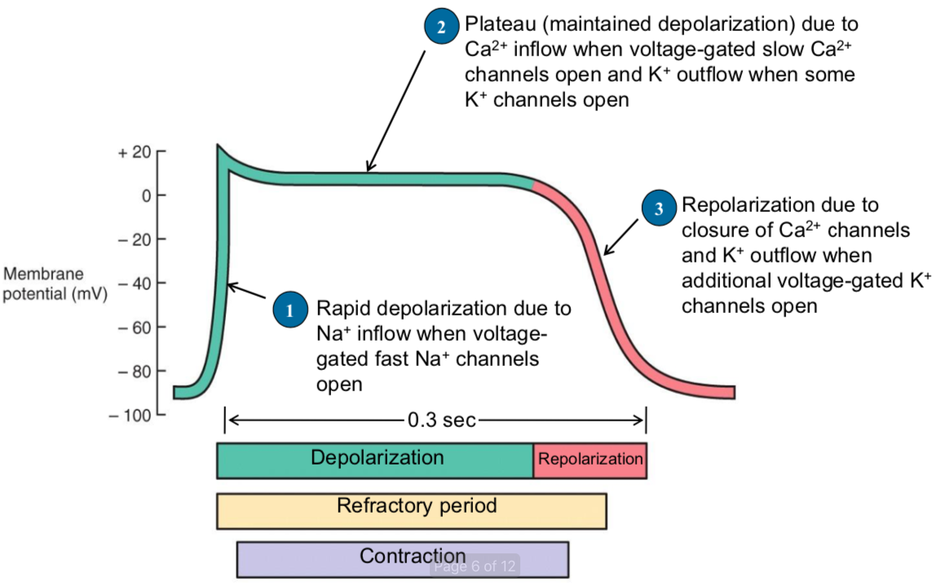

Autorhythmicity: SA Node Action Potential
- Specialized cells that are part of the conducting system
- Have an autorhythmicity property, meaning they can self-depolarize (or self-generate action potentials) at regular time intervals
- These types of cells are also known as the pacemaker cells, because they dictate the pace or the frequency of depolarization of the rest of the cardiac muscle fiber cells
- Because they are different, they also have a different actual potential curve
- There is not really a stable resting membrane potential of these type of cells
- The low end is typically around -60mV
- This is much closer to threshold than what we see with a regular cardiac muscle cells, so it actually makes it easier to reach threshold
- One thing that makes the cells different is that they contain sodium leak channels
- Review: Resting membrane potential is typically set up by potassium leak channels, as well as their sodium potassium pump = Neurons
- In the case of these autorhythmic cells, they contain sodium leak channels.
- These leak channels are going to allow sodium to constantly move into the cell
- And we still have the sodium potassium ATPase pumping sodium out of the cell
- But what happens is as sodium leaks into the cell, we get closer and closer to threshold = Pacemaker potential
- By the sodium leaking into the cell causing the resting potential to move towards threshold, it makes the inside of the cell ore electrically positive or closer and closer to threshold
- The reason that this leaking is slowly reaching threshold is that during this phase, our potassium channels that we typically have during repolarization that are open, are closing
- As they are closing, sodium takes over the changes in membrane potential
- Once we reach threshold, we get the depolarization phase
- In the autorhythmic cells, the channels that open to cause depolarization are not sodium, but their calcium channels
- So, in this case, a calcium channel opens at threshold and this is what causes depolarization
- Calcium rushes into the cell and it makes the inside of the cell more positive than it was before
- This is unlike what we typically see with a neuron, skeletal muscle, and even in the cardiac muscle cells
- The potassium channels are continuing to close during this time, allowing for this depolarization
- Repolarization phase
- After depolarization has occurred, the calcium channels now close, much like our sodium channels closed in the neuron
- This is when our potassium channels reopen, and it's the potassium channels reopening that allow for repolarization to occur
- Eventually those potassium channels will close again, and we'll start with the next pacemaker potential
- This is continually happening over and over again, in each and every one of those conducting system cells
- Here it has listed the SA node as this action potential that's been highlighted. But technically, all of the conducting system fibers are autorhythmic. They all have the same characteristics.
- The only difference between the SA node and the other fibers is that the length of time it takes to reach threshold gets longer and longer as you move through the conducting system, away from the SA node
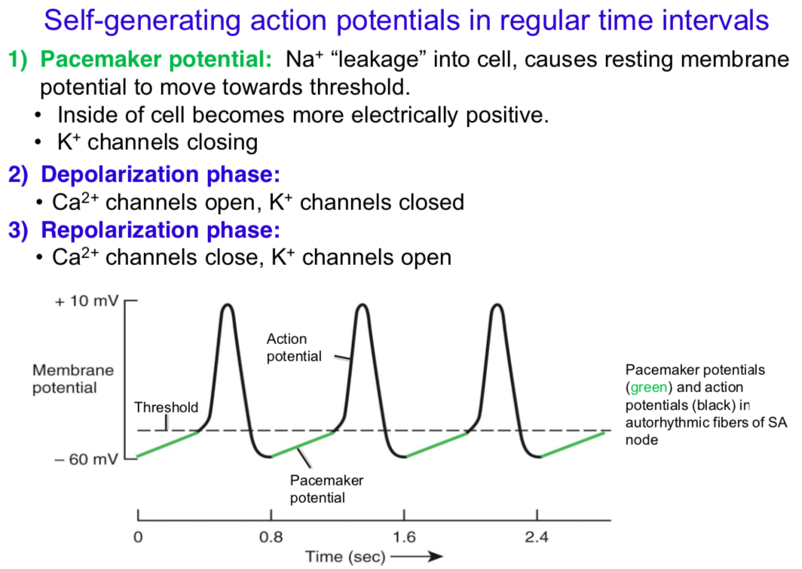

Action Potentials in Pacemaker Cells
- Here is what our SA node pacemaker potential looks like
- Once we reach threshold, we get our action potential
- If you were to take your heart out and put it on a table, as long as you provided it with the nutrients and oxygen it needs to keep going, the heart would fire/beat all by itself
- Based on the SA nodes rate of firing, this rate of firing is around 100 beats per minute
- AV node
- Takes a little bit longer to reach threshold
- Because it takes a little bit longer to reach threshold, it is not going to fire at a fast rate
- If we only had our AV node working, and our SA node was not working, our heartbeat would be closer to about 60 or 70 beats per minute
- Looking at the action potential, it is exactly the same curve, it's just taken longer to reach threshold
- Now, if you think about how this is working, the SA node has already fired, it's already sending ions moving through all of those gap junctions before the AV node has even had a chance to reach threshold
- This is why the SA know dictates what happens in the rest of the conducting system
- Because the SA node is firing so quickly, the other regions of the conducting system haven't reached their threshold yet, so they wind up depolarizing because of the signal from the SA node instead of depolarizing all on their own
- Purkinje fibers
- Even slower, so they take a much longer time to reach threshold
- Purkinje fibers fire at about 25 to 30 times per minute, where your heart rate would be around 20 to 30 beats per minute.
- If we only have the purkinje fibers and all of the other connecting system was not working, we would be a little bit in trouble
- This is because our heartrate being around 20 to 30 beats per minute is not really enough to sustain our body – It is too slow to meet the oxygen and fuel demands of our body
- This is why if people have something wrong with their SA node or their AV node, they would usually get an artificial pacemaker
- Therefore, if you've had a heart attack for some reason and it's damaged your atria and the specialized cardiac cells are no longer functioning, then the pacemaker stimulates the depolarization at a regular interval
- If we were without our SA node but had our AV node, we would pretty well be okay because our heart would still be firing at 60 to 70 beats per minute
- But as you move through the conducting system, it gets slower and slower. Therefore, once the AV node is no longer functioning, that's when you would need to rely on a pacemaker to trigger depolarization instead of waiting for it to happen on its own

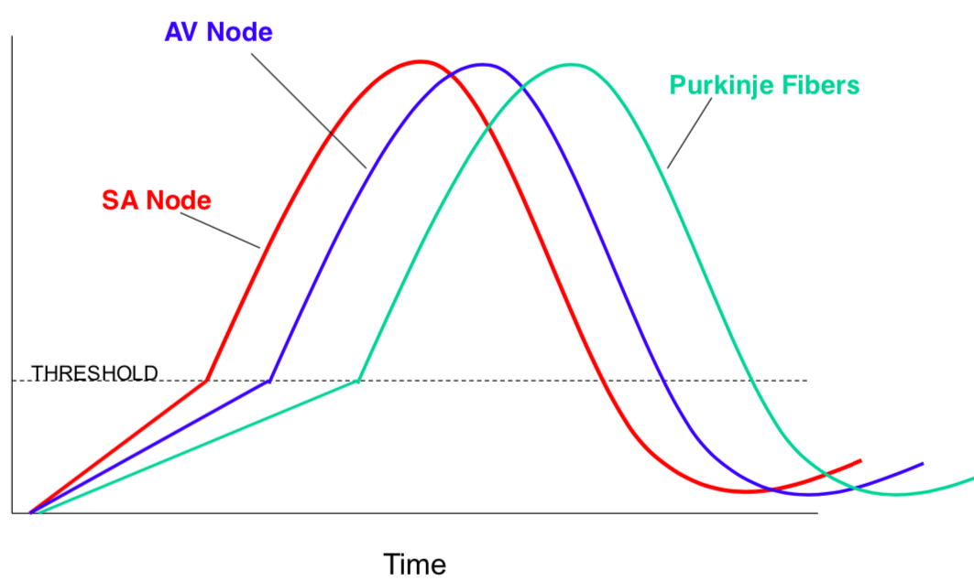

Echocardiogram (ECG)
- ECG ~ How we can measure or examine these electrical events that are happening inside the heart
- It is a record of electrical event in the myocardium that can be correlated with mechanical events
- Uses a series of leads or electrodes that are placed on the surface of the skin
- These can detect the electrical signals that are being sent through the heart.
- They create a very specific wave pattern
- This particular device wave pattern is known as an electrocardiogram, or an ECG, also sometimes called an EKG
- The pattern that is created doesn't look like the same action potential pattern, because it isn't measuring a single action potential
- It is measuring the spread or movement of the action potentials through the heart, or the electrical signal through the heart.
- Give a very characteristic pattern (in a series of waves and spikes)
- The characteristic pattern can also be coordinated to mechanical events that are happening inside the heart
- When you think about mechanical events, we're talking about the actual contraction phases of the heart, or even the valves moving in and out
- But what we get from an ECG are when atria is contracting and when the ventricles contracting
- First wave ~ P wave
- Represents depolarization of the atria
- Signals the onset of atrial contraction
- P represents the very first firing of that SA node in the atria
- The electrical signal precedes what we see with the contraction
- The P wave represents the electrical change or current that's moving through the atria
- QRS complex
- As the current slows and then enters into the ventricles, we get this next phase
- Represents ventricular depolarization = The movement of the signal through the ventricles
- It also is the signal for the start of ventricular contraction
- Ventricular contraction is happening just after the start of the QRS complex
- During the time when the ventricle is depolarizing, the atrium is actually repolarizing
- But because the ventricular depolarization is so large in electrical signal, the repolarization of the atria is masked during this time, so you can't really see it in the ECG
- T wave
- The T way represents repolarization of the ventricles
- So we've had the electrical membrane potential move closer to a positive side, and now we haven't moving back down to resting membrane conditions
- It will also be the period when ventricular relaxation begins = Partway into the T wave when it starts to repolarize, contraction ends, and we will start to get relaxation
- We can see not just the waves, but also the time between the waves = intervals or segment
- We can use these intervals to measure the length of things like a contraction phase of the heart
- P-Q interval is running from the start of P to the start of Q
- Represents the start of atrial excitation to the start of ventricular excitation
- So, the amount of time it takes to go from the SA node and then enter into the AV bundle
- The S-T segment represents that time between the beginning of depolarization and repolarization or when we have that plateau phase
- The QT interval represents the start of ventricular depolarization, to the end of ventricular repolarization
- So, the entire phase of the ventricles through contraction and relaxation
- There are many different changes that can occur in these waves and the length of these intervals
- Clinicians can use this information as a diagnostic tool to determine the overall functioning of the heart
- Examples: Whether or not someone is in heart failure, whether they've had a heart attack, etc
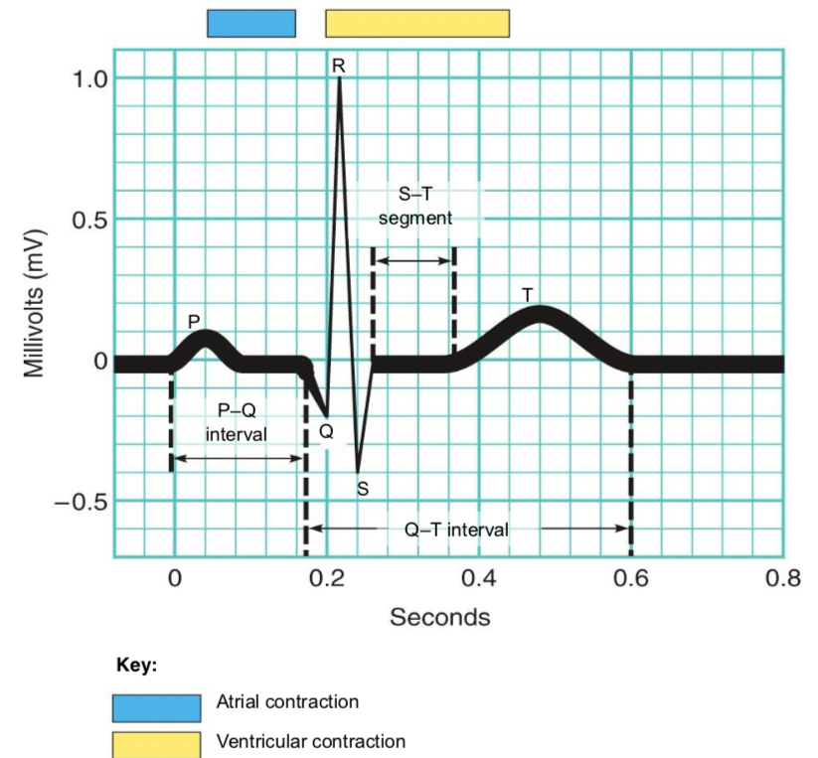

Summary
- P wave: Depolarization of atrial myocardium. Signals onset of atrial contraction
- QRS complex: Ventricular depolarization and signals onset of ventricular contraction. Repolarization of atria simultaneously
- T wave: Repolarization of ventricles; Ventricle relaxation
- PQ interval: 0.16 seconds; Start of atrial excitation to start of ventricular excitation
- Also known as PR interval
- This is because they Q portion of the QR complex is quite small
- and originally when they did these types of ECG's, they were doing it on paper and they physically had to measure the distance between one segment and another with a ruler
- So, the QR region was quite small, so they just measured from P to R instead
- QT interval: 0.36 seconds; Start of ventricular depolarization to end of ventricular repolarization

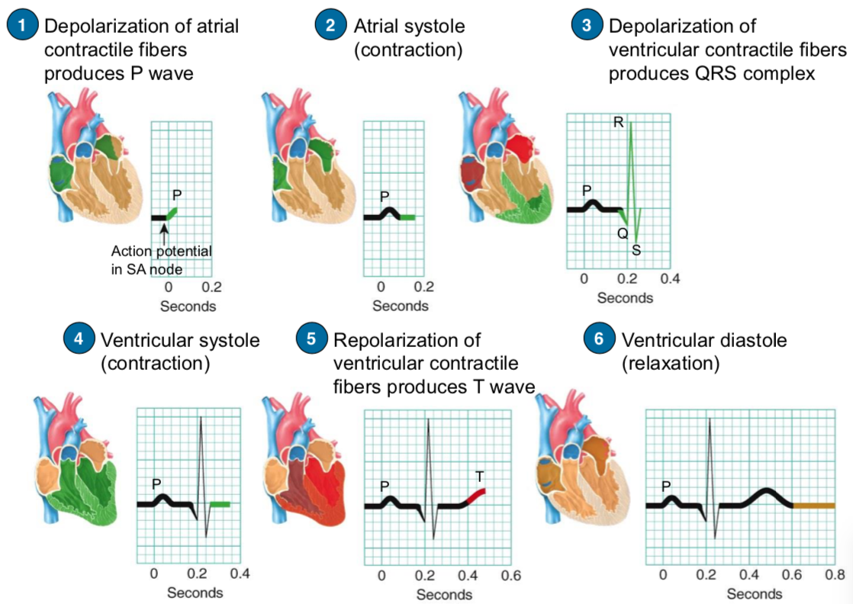
Extra Image: Not Needed

