ADM 1370 Exam Notes
Module 1
  - An Information System consists of FIVE PARTS, including:
    - People,
    - Procedures,
    - Software,
    - Hardware, and
    - Data
IT = hardware + software + data
- Digitization - Basically, the replacement of physical tasks by digital means – Facebook is social digitization
Five factors to consider when assessing impact of IT on Business:
- Internet growth and technology convergence
- Transformation of the business enterprise
- Growth of a globally connected economy
- Growth of knowledge and information-based economies
- Emergence of the digital firm

- Digital firms use information systems to enable the seamless flow of information between different parts of the organization as well as between the organization and its suppliers and customers
- Conducting business electronically enables new levels of efficiency, competitiveness, and profitability (i.e strategy)
Four activities produce information that organizations need:
  - Input: Captures raw data from organization or external environment
  - Processing: Converts raw data into meaningful form
  - Output: Transfers processed information to people or activities that use it
  - Feedback: output that allows evaluation and correction
Iivari, Hirschheim and Klein (2004) classify IS body of knowledge as needing:
- technology knowledge
- application domain knowledge
- systems development knowledge
- organizational knowledge
- IS application knowledge

Business processes:
- Manner in which work is organized, coordinated, and focused to produce a valuable product or service
- Concrete work flows of material, information, and knowledge – sets of activities
- Unique ways to coordinate work, information, and knowledge
- Ways in which management coordinates work
Cross-Functional Business Processes:
Transcend boundary between sales, marketing, manufacturing, and research and development
- Group employees from different functional specialties to a complete piece of work
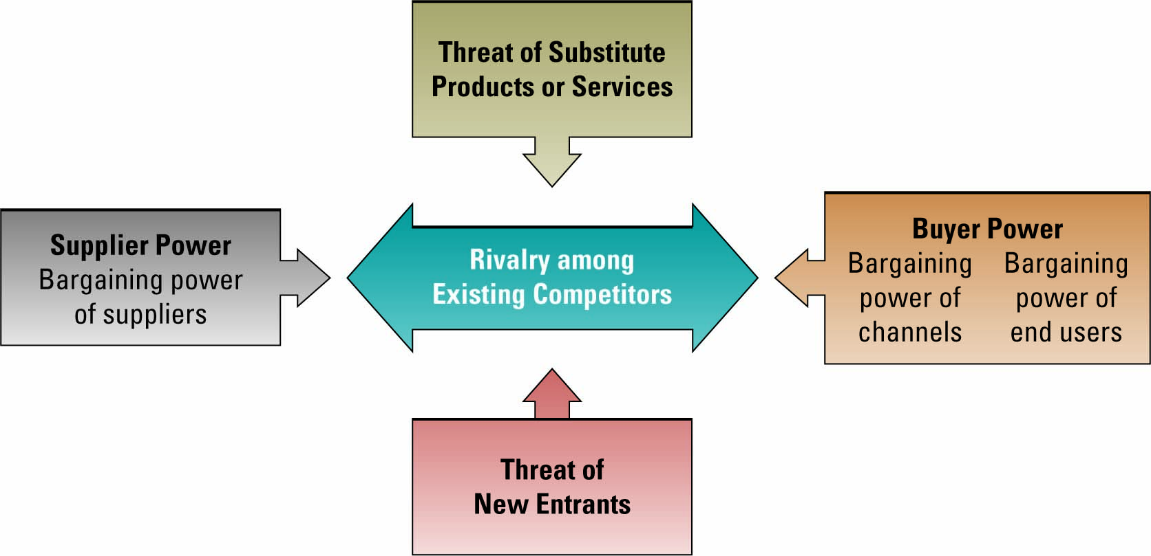
^^ Negative impacts of the internet expressed through Porter’s model
  - Investing in complementary assets (organizational and management capital):
    - Assets required to derive value from a primary investment
    - Complementary assets include:
      - Organizational assets, e.g. Appropriate business model ; Efficient business processes
      - Managerial assets, e.g. Incentives for management innovation ; Teamwork and collaborative work environments
      - Social assets, e.g. Internet and telecommunications infrastructure ; Technology standards
- In-forming is the ability to build and deploy your own supply chain of information, knowledge and entertainment. Largely attributed to search engines.
- Steroids: The new technologies that are amplifying and turbo-charging all other flatteners.
  - Computing speed and capacity
  - Instant messaging
  - Videoconferencing
  - Computer graphics
  - Wireless technologies and devices

  - Triple Convergence - We are in a convergence of three powerful, technological forces:
    - Cheap and ubiquitous computing devices
    - Low-cost, high bandwidth
    - Open standards
- All of the ten flatteners coming together around the year 2000 creating a platform that is global, Web-enabled allowing for multiple forms of collaboration
- Business and individuals adopting new habits, skills and processes to maximize the benefits of a flat world.
- When all of this flattening was occurring, a whole new group of people in the billions from China, India and the former Soviet Union have entered the market and are leveraging the flat world

Globalization also created a set of unprecedented challenges:
    - Governmental challenges
    - Geoeconomical challenges
    - Demographic challenges
    - Cultural challenges
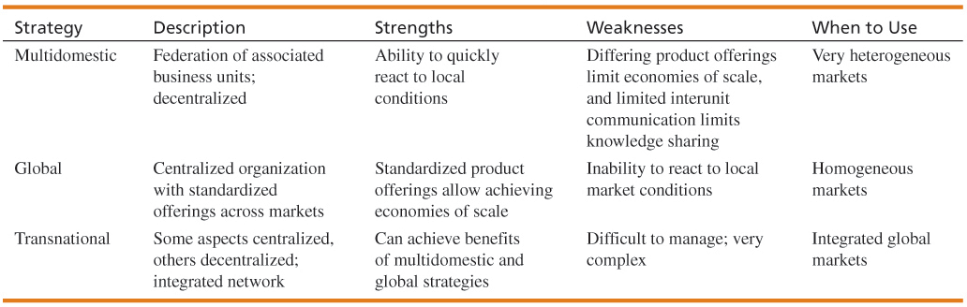
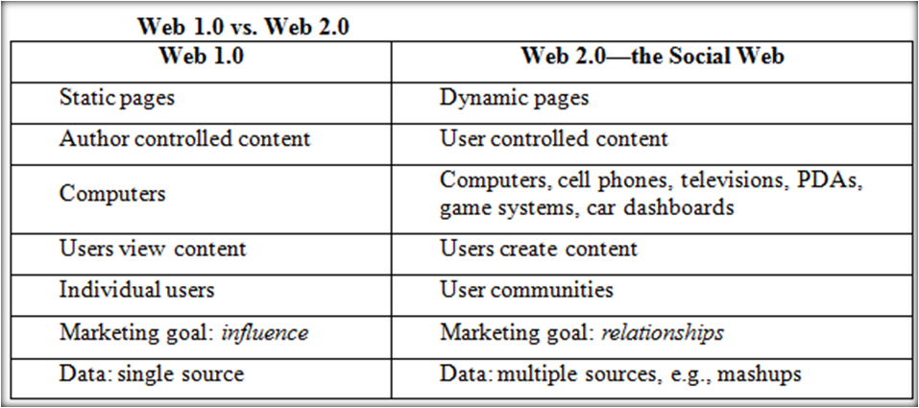
- How is Social Media different from Web 2.0?
  - Social media is a subset of Web 2.0
  - Web 2.0 provides the technical and philosophical foundation for creating, implementing, and using social media applications and tools.
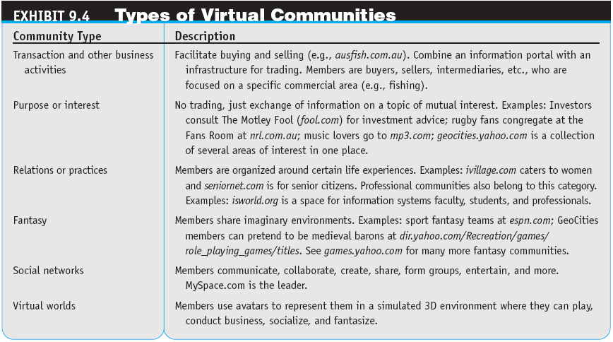

- Relationship between Mashups & APIs:
  - Mashups:
    - Applications that may combine functionality from multiple sources
  - APIs:
    - The mechanism to get the applications to talk to each other
    - The mechanism to send messages back and forth between applications
- Presentation mashups:
  - A presentation layer mashup deals mainly with user interface artifacts
- Process mashups:
  - These are more of an IT operation, with inter-process communication and message queues. It's more of a traditional source code integration.
- Data mashups:
  - Mashups that are integrated at the data level, whether it's integrating files, databases, external Web service APIs.
0

