ORGANIC CHEMISTRY MIDTERM 1 REVIEW
TERMS
- VSPER: Valence Shell Electron Pair Repulsion Theory
- Orbital: region where the probability of finding an electron is high.
- Conformers (or rotamers): identical molecular formulas, identical connectivity, but different 3D conformations due to bond rotation.
- Staggered Rotamer: most stable low energy rotamer – all substituents spread out evenly.
  - Gauche-Staggered Rotamer: A form of staggered where the two largest substituents are next to each other.
  - Anti-Staggered Rotamer: A from of staggered where the two largest substituents are as far apart as possible.
- Eclipsed Rotamer: Rare high energy rotamer – maximum overlap between substituents.
- Torsion Angle (or dihedral angle): is the angle between two bonds originating from different atoms in a Newman projection.
- Torsional Strain: is the repulsion caused from electrons getting close to each other when rotating about a bond. This strain can be alleviated by further rotation.
- Steric Strain: is the repulsion caused by two atoms or groups being close to each other in space. Steric strain cannot be alleviated by rotation.
- Ring Strain: the energetic penalty paid by a cyclic molecule for existing with non-ideal angles and conformations.
- Geometric Isomers: same connectivity, different 3D geometry of atoms
- Stereochemistry: study of the three-dimensional arrangement of atoms

ANATOMY OF AN ORGANIC MOLECULE
Basic Bonding
- Hydrogen bonding – Strongest
  - Look for O-H bonds
- Dipole- Dipole – Middle
  - Occurs in polar molecules
- Dispersion – Weakest
  - Occurs in almost all molecules

Electronegativity
- As measure of an atom’s ability to attract electrons to itself
- Indicated by arrow, where the less electronegative species is one the plus end.
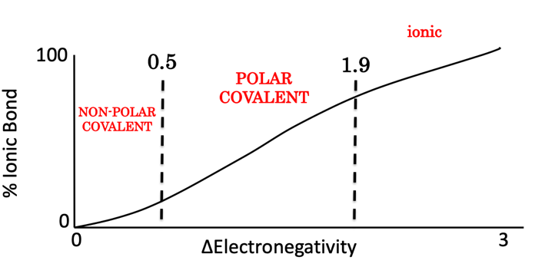

CARBON AND ITS COMPOUNDS
Valence Electrons
- All atoms want to achieve a full octet, except for a few atoms with access to d orbitals that can have more than 8 valence electrons.
  - Examples: phosphorous, sulfur, iodine

Converting from “Condensed Formula” to Lewis Structure
- Count the total number of valence electrons
  - Add one electron for each negative charge
  - Subtract one electron for each positive charge
- Draw the molecule using single bonds
- Count electrons used in each bond -> subtract from total
- Add leftover electrons to the structure.
  - Most electronegative atoms first. Stops when octets are full
- Make double and triple bonds to complete octets
  - Minimize formal charges

Formal Charges
- Present when an atom has “too many” or “too few” electrons
  - When the molecules is not in its “native state”
Formal charge = #valence electrons - # lone pair electrons - # of bonds

Resonance Theory
- Multiple structures of the same molecule
*note that π bonds and location of lone pairs change – NEVER σ bonds

VSEPR
- Valence Shell Electron Pair Repulsion theory
- A simple guide to predicting the 3D shape of a molecule
- In general, pair of electrons (bonds and lone pairs) try to avoid each other.

Hybridization
- Overlap of orbitals, creating various hybrid orbitals

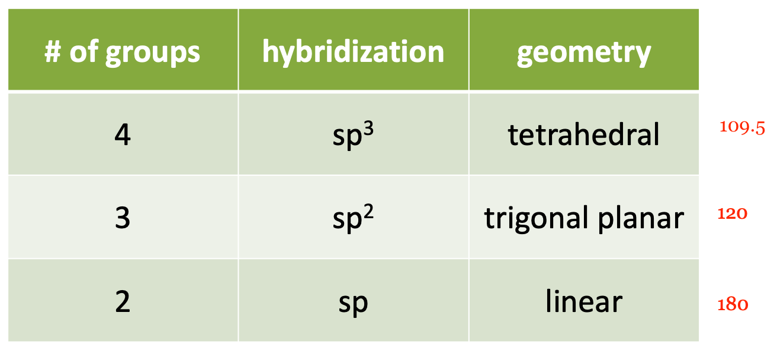
*count number of bonds (including lone pairs)

SINGLE BOND – 1 σ
DOUBLE BOND – 1 σ and 1π
TRIPLE BOND – 1 σ and 1π

Drawing Organic Molecules
Condensed Structure
*note that the species in brackets indicate a branch
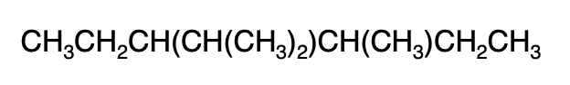
Lewis structure
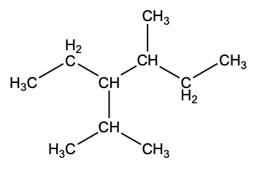

Line Structure

MOLECULES IN MOTION
- Structural Isomers: identical formulas, different connectivity

Bond Rotation
- Rotating around a sigma bond creates multiple conformations
  - Distinct shapes/orientations of that molecule
- These conformational isomers are called conformers or rotamers.
- Conformers (or rotamers): identical molecular formula, identical connectivity but different 3D conformations due to rotation.

Newman Projections
- Method of depicting conformers, view down the axis of one bond
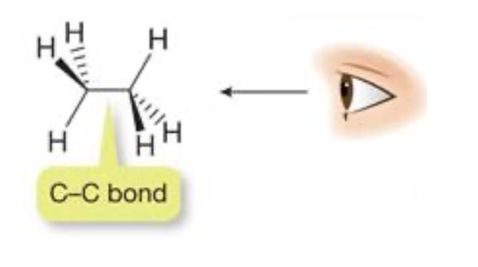
Notes When Drawing:
- Front wheel: carbon closest to the eye view
- Back wheel: other carbon

Staggered vs. Eclipsed
- Eclipsed rotamers are much rarer because they are high energy molecules.
- Gauche Staggered – when large groups are next to each other in a staggered rotamer.
- Most unfavourable configurations are ones that force large groups to molecules.

Staggered | Eclipsed
- Minimal electron repulsion  - Lower energy  - More stable  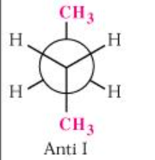 | - Significant electron repulsion  - Higher energy  - Less stable  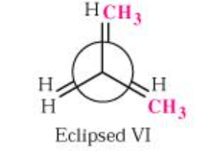

IMPORTANT: lowest energy conformation is achieved when the largest groups are as far away from each other as possible -> anti-staggered.
  - Lower on the periodic table = bigger
Cycloalkanes
- Rings can exist as conformers, but rotation is restricted
- Any ring size is possible, but C5 and C6 are the most common.
- Ring Strain: the energetic penalty paid by a cyclic molecule for existing with non-ideal angles and conformations.
  - Causes weird angles in order to be a ring, must give up energy in order to sustain this.
    - Payment for not being in ideal state.

Cyclohexane
- Cyclohexane can twist into a strain-free “chair”
- Ideal bond angles, and no eclipsing interactions
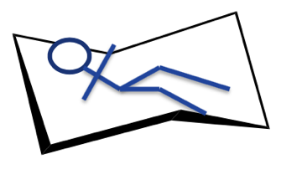

Chairs
- Substituents can be axial or equatorial
  - Axial: straight up and down
  - Equatorial: parallel to other line, angled

Chair Flips
- Cyclohexane rings are flexible and can “flip”
- When a chair flips:
  - Axial bonds become equatorial (and vice-versa)
  - Substituents points “up” stay up (and vice-versa)

Conformers of Cyclohexane
- Cyclohexane prefers conformations that put large groups in equatorial positions.
- Note that:
  - Axial positions: HIGH ENERGY
  - Equatorial positions: LOW ENERGY
    - Biggest groups are farthest away – minimizes steric strain

Disubstituted Cycloalkanes
- If a cycloalkane has two substituents on different carbon atoms, we encounter a new type of isomer
- Geometric Isomers: same connectivity, different 3D geometry of atoms
  - Cyclic double bonded molecules – CIS AND TRANS ISOMERS

CHIRALITY AND STEREOCHEMISTRY
Classifying Isomers
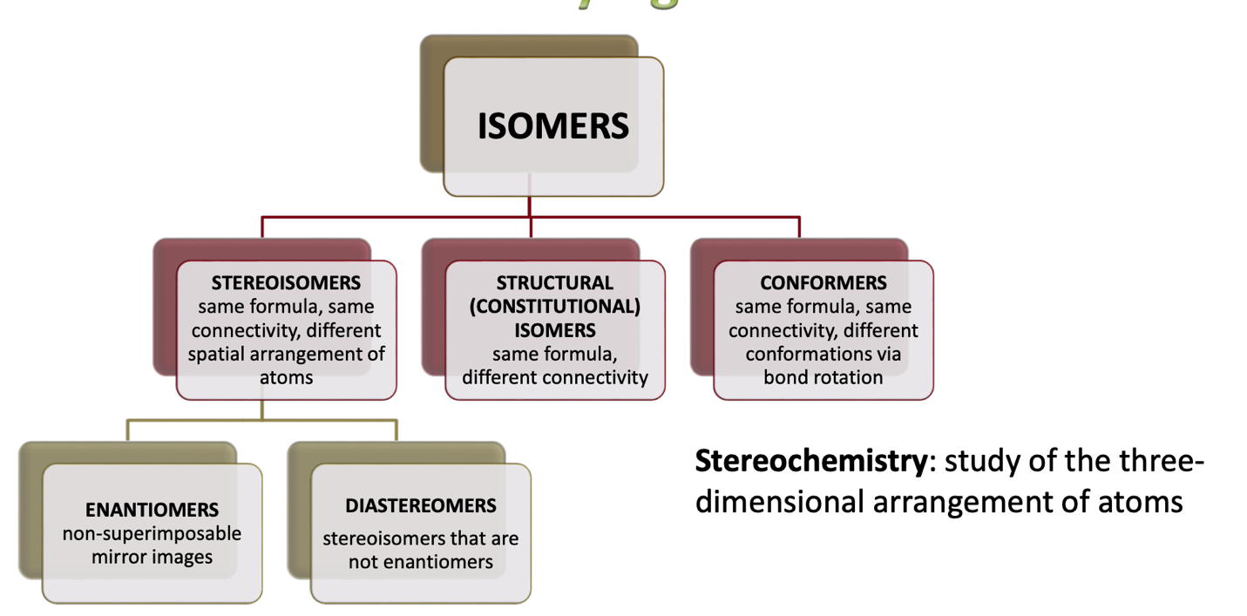

Chirality
CHIRAL – if it is not superimposable on its mirror image
ACHIRAL - if it is superimposable on its mirror image

Example:

- Life is full of examples of chirality:
  - Screwdrivers, golf clubs, shoes, ears, hands, cars

Stereogenic Centres
- A tetrahedral atom with 4 distinct groups is said to be a stereogenic centre of a stereocenter.
- If the stereogenic centre renders the molecule non-superimposable with its mirror image, it is a chiral centre.

Naming Enantiomers
- Enantiomers: non-superimposable mirror images
- We use “R” and “S” to describe chirality centres

STEPS
Step 1: Assign a priority to each substituent
- Look at the first atom bonded to the stereocenter
- Highest atomic number = highest priority

Step 2: Rotate the molecule to place the lowest priority substituent in the back
- Number 4 should always be dashed

Step 3: Name according to the direction of substituents 1, 2 and 3
- CLOCKWISE = R centre
- COUNTERCLOCKWISE = S centre

What if there is a tie?
- Look at the next atoms in the chain
- Highest atomic # first
- One atom at a time
- Stop as soon as the tie is broken
  - C-H bonds do not have priority over C-O bonds

What about double bonds?
- Create “phantom atoms” by breaking π bonds into 2

To Draw an Enantiomer (converting R to S or vice versa)
- Draw the mirror image
- Exchange two groups on the chiral centre

Diastereoisomers
- Stereoisomers that aren’t enantiomers
- Often times, they contain more than 1 sterocentre.
For a molecule of n sterocentres, the maximum number of stereoisomers is = 2^{n}

Symmetry Elements – Meso Compounds
- If a molecule has a plane of symmetry, it will be superimposable with its mirror image (and thus be achiral).
  - Plane of Symmetry: an imaginary plane that bisects a molecule into two identical halves
- A molecule with multiple stereocenters can still have a mirror plane and can thus be achiral
  - These are call meso compounds.

Physical Properties of Stereoisomers
- Diastereoisomers
  - Have different chemical and physical properties
    - Eg. Melting and boiling point, solubility, reactivity
- Enantiomers
  - Have identical chemical and physical properties EXCEPT for 2 things:
- Interaction with plane-polarized light
- Interaction with other chiral molecules

