“OH HOW BITTER A THING IT IS…”
ACID BASE TITRATIONS
Written By: Katherine Birkby
300057255

TA: Patrick Berro
Tuesday, October 30, 2018
Introduction: In this lab, 2 different experiments will be preformed both dealing with the use of acids and bases. In the first part we will be diluting a sample of NaOH through the addition of water and then standardizing this sample of diluted NaOH by adding acid. After, the concentration of an unknown acid will be calculated by using the standardized NaOH that was created in the previous part.
Acids and bases both contain several different properties that makes them unique and different from one another. Acids are identified to be sour in taste and are seen to be very corrosive whereas bases are very bitter and taste and are also seen to be very corrosive. In a reaction involving acid and bases, water is always on of the products as well as a salt. During these reactions if an acid ionizes completely in water then it is considered to be a strong acid that has a weak attraction for its H+ proton. A weak acid is one that does not ionize completely in water and has an intermediate attraction for their proton. This is relatively the same for bases. Strong bases are ionic hydroxides that dissociate completely in water, whereas weak bases do not ionize completely and form a hydroxide by taking a proton from water. Concentration also affects acids and bases. If a solution such as water contains more acid/base known as solute then the solution is more concentrated. If it contains less solute and more solvent then the solution is less concentrated, this can be determined by the following equation:
Concentration = n (mols) / V (volume in liters)
These observations have led to a couple different definitions of acids and bases. The earliest one of the Arrhenius acid-base definition which considered an acid to be a substance that contains an H+ and releases it in water to create H3O+. A base is considered to be a substance that contains an OH- and dissociates in water to form an OH-. However, this definition wasn’t completely accurate because many substances that release OH- do not have OH- in the equation. The Bronsted-Lowry acid-base definition stated that an acid is a proton donor or an H+ donor and a base is a proton acceptor or an H+ acceptor.
Whenever acid an bases react with one another to form salt and water we call this a neutralization reaction, and this neutralization can be determined by using titration. The amount of acid required to neutralize a base and vice versa depends on several different stoichiometric calculations which can be determined when given the volumes and concentrations. When an acid and base has been completely consumed in a reaction then the equivalence point has been reached. We can determine when the equivalence point is reached by using indicators. Since acids and bases are usually colorless, it is hard to tell when the amounts of acid and base are equal due to the little change that occurs. These indicators are weak acids that dissociate slightly in acid solutions resulting in a colour change, and if the right indicator is chosen the endpoint and colour change should be almost the exact same as the equivalence point.

Procedure: As described in lab manual for “Oh How Bitter a Thing It Is…Acid Base Titrations”, Exp. 4 page 79-83.
Data/Observations:
Calibrating the Count dropper;
Concentration of NaOH = 6 M initial volume of NaOH in cylinder = 2.7 mL
Volume of NaOH in diluted solution = 4.9 mL final volume of NaOH in cylinder = 5.1 mL
Volume of water in diluted solution = 250 mL # of drops added = 53 drops
Total volume of diluted solution = 254.9 mL Volume added = 2.4 mL
Standardizing Diluted NaOH
Trial # | Amount of acid transferred (mL) | Drops of phenolphthalein added | Volume of NaOH added resulting in colour change (mL)
1 | 10.20 | 3 drops | 8.832
2 | 10.05 | 3 drops | 8.514
3 | 10.12 | 3 drops | 8.696

Change in volume and concentration as NaOH is added to standard acid
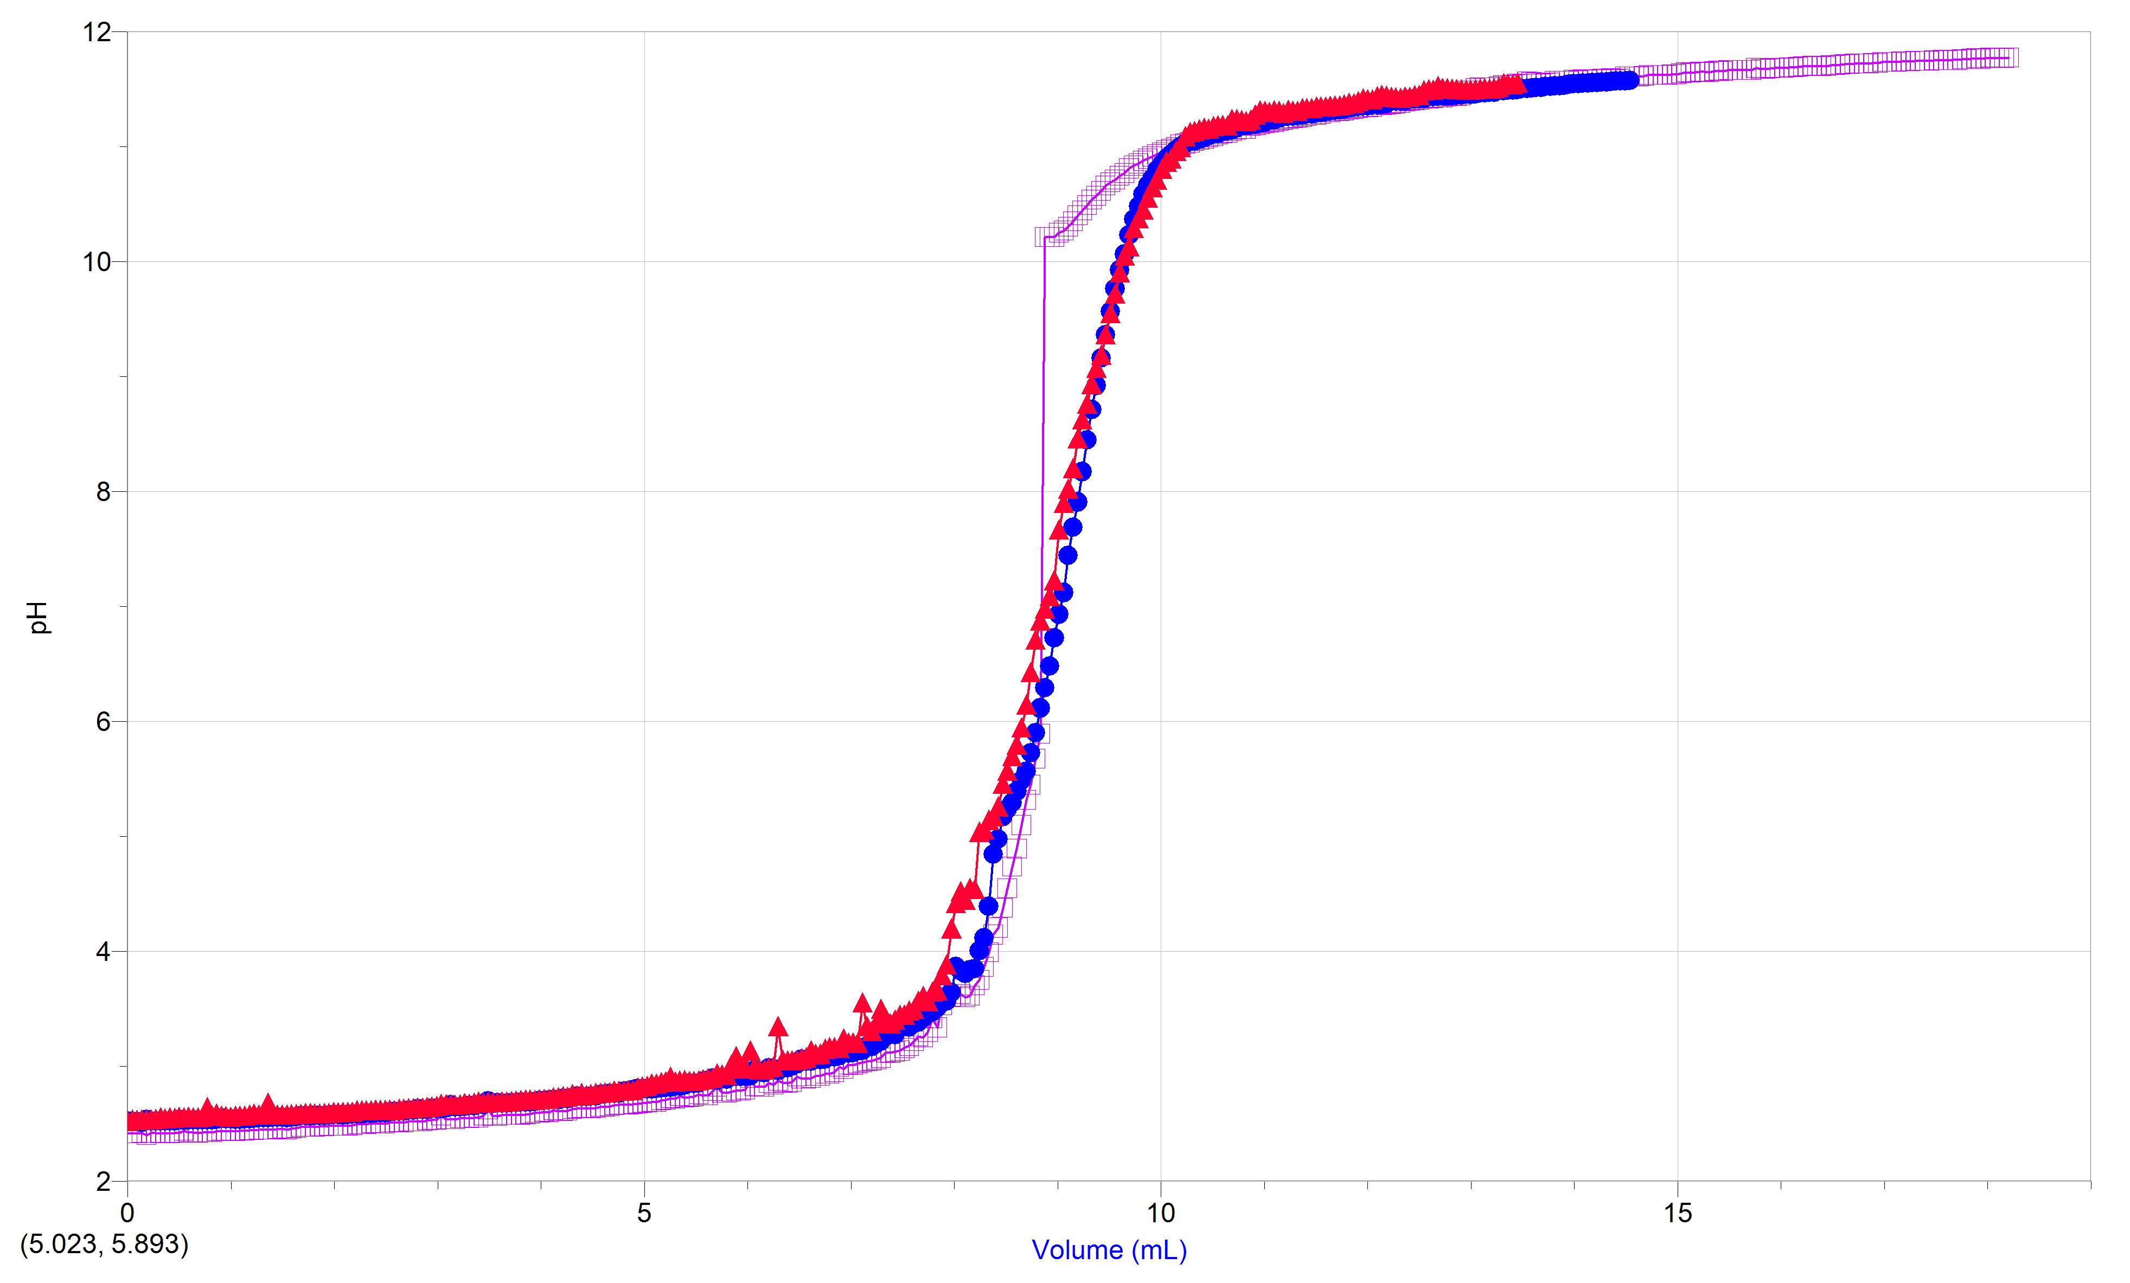
Trial 1 = light purple
Trial 2 = blue
Trial 3 = pink
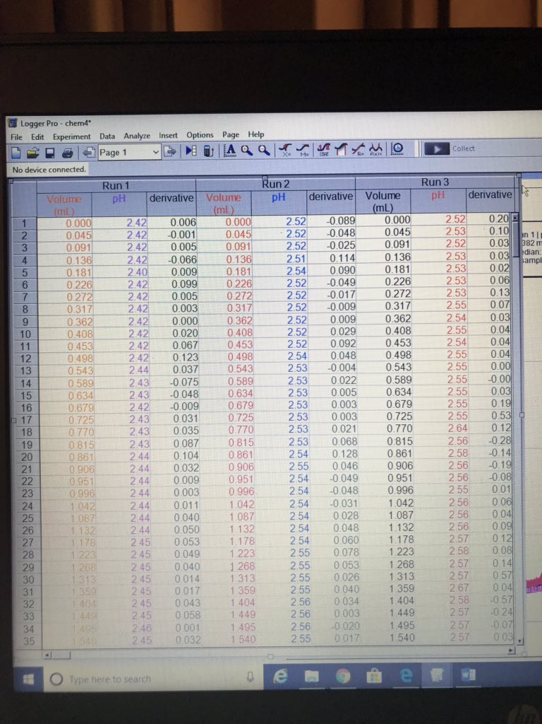
Values for the standardization of diluted NaOH
Part 2: Unknown Acid #3
Trial # | Amount of acid transferred (mL) | Volume of NaOH added resulting in a colour change (mL)
1 | 10.08 | 13.496
2 | 9.8 | 13.315
3 | 9.93 | 14.131
4 | 10.09 | 13.043

Change in volume and pH as NaOH is added to an unknown acid
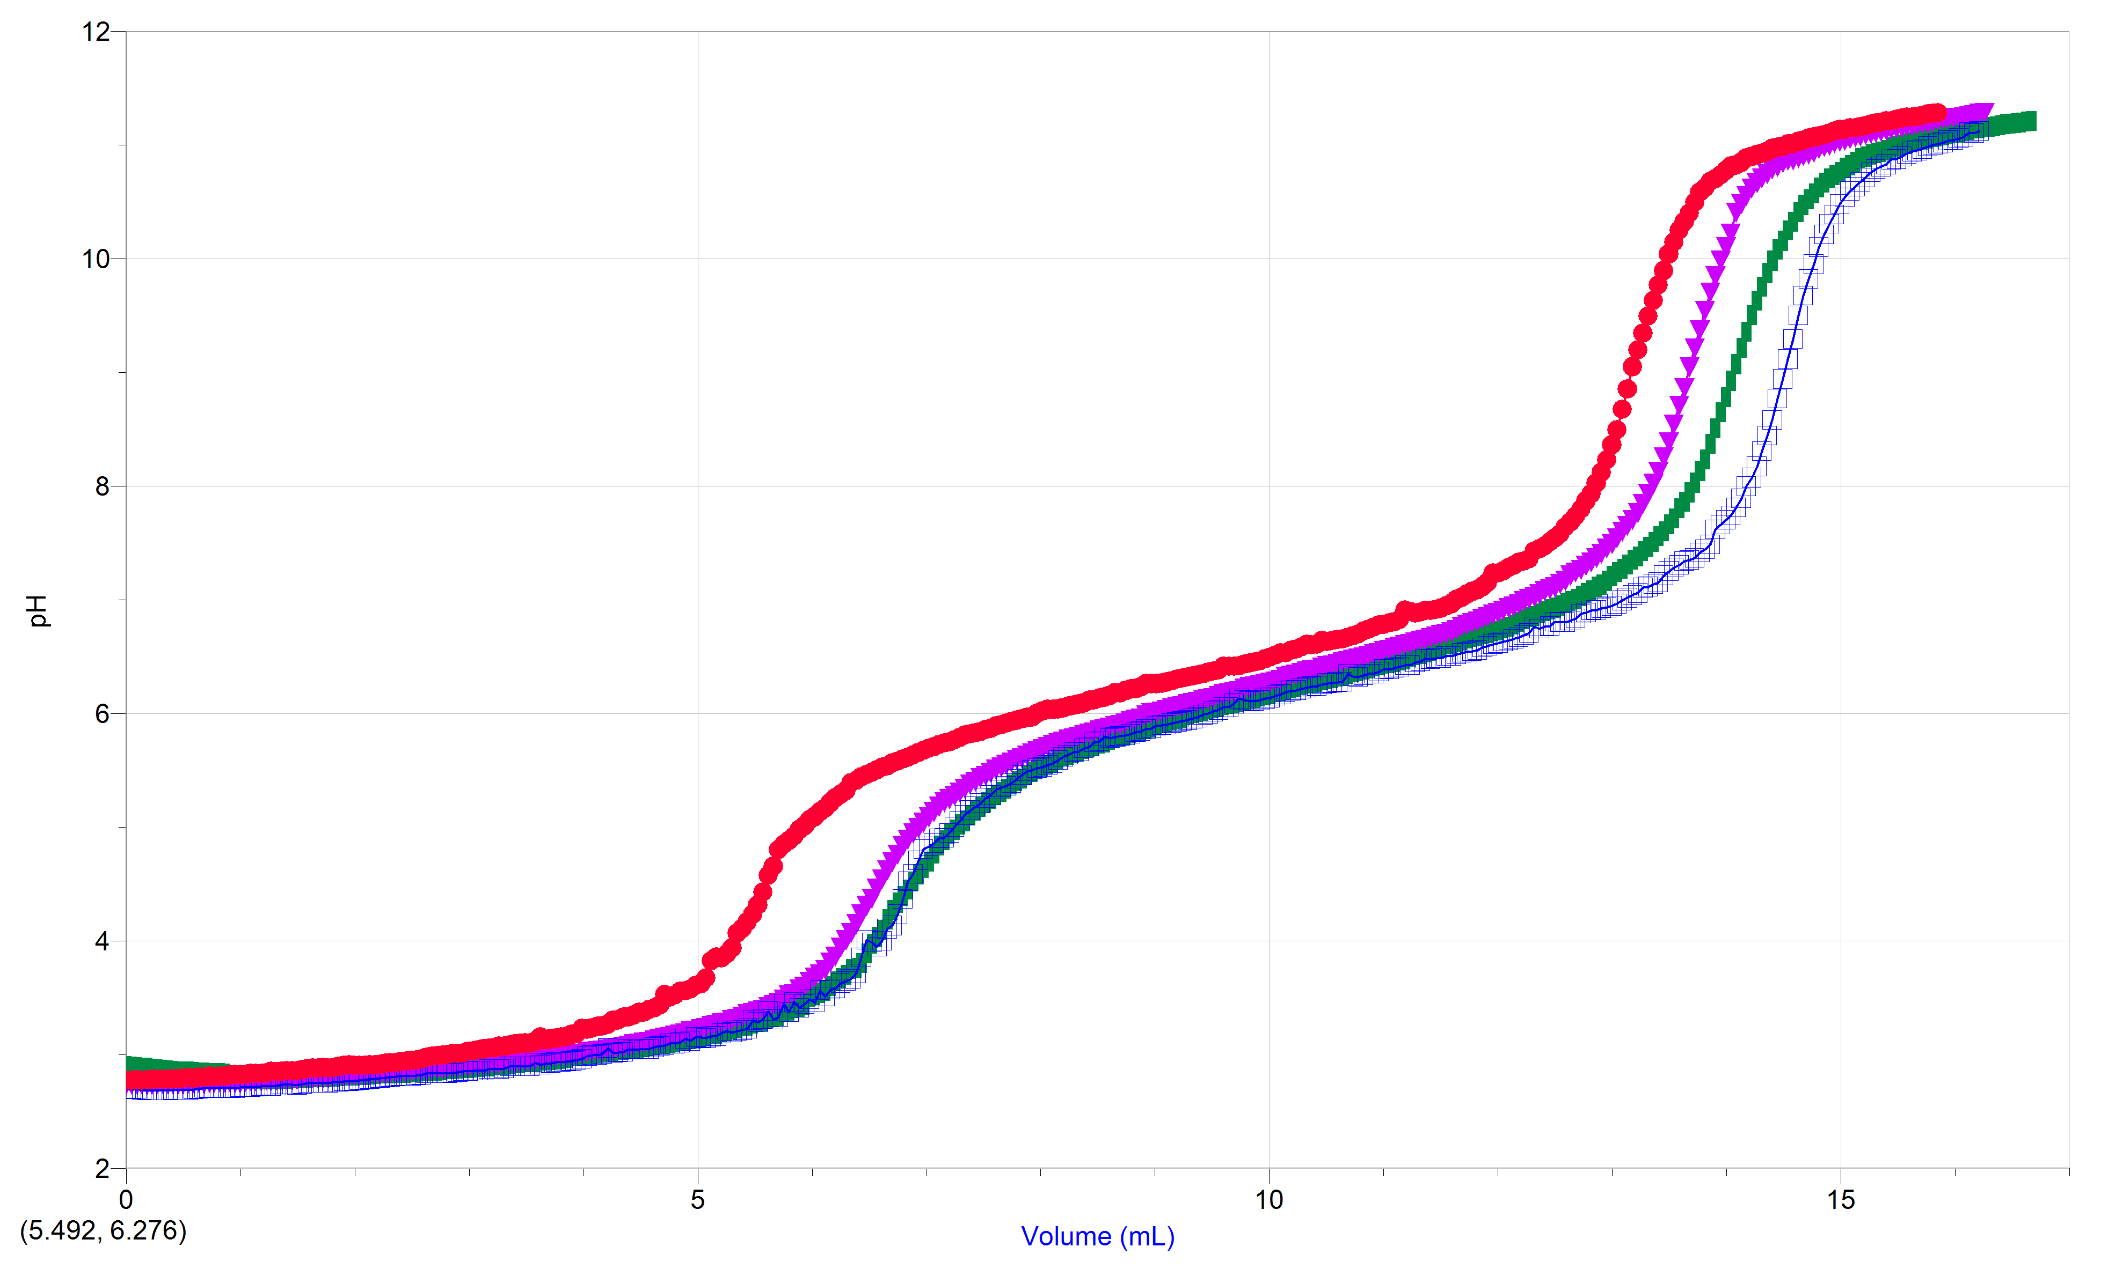
Trial 1 = green
Trial 2 = purple
Trial 3 = blue
Trial 4 = pink/red
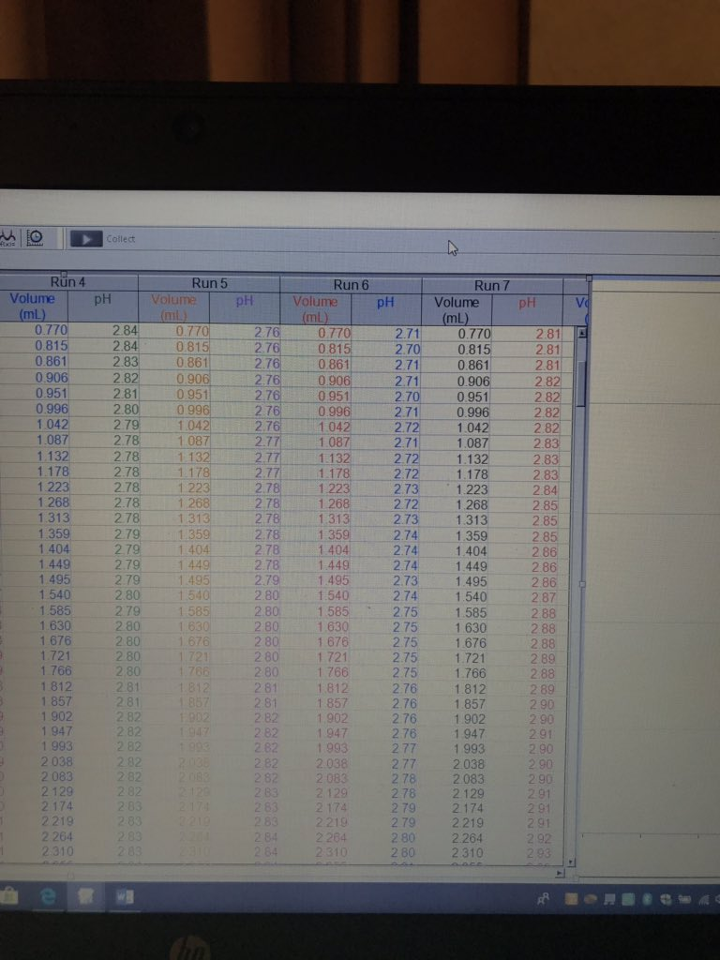
Values of the titration of the unknown acid #3
Calculations:
- Use the initial volume of NaOH, its initial concentration, and the total volume to determine the approximate concentration of your NaOH solution, in mol/L, using c1V1 = c2V2 (Remember: The total amount (mol) is the same!) This is ONLY an approximate value as c1 is ONLY given to 1 decimal!
Initial volume of NaOH = 4.9 mL (.0049 L) c1v1 = c2v2
Initial concentration = 6.00 M (6.00 mol/L)(.0049 L) = c2(.2549 L)
Volume of water = 250 mL 0.0294 mol = .2549 L(c2)
Total Volume = 250 mL + 4.9 mL c2 = 0.115 mol/L
= 254.9 mL (.2549 L) c2 = 0.12 mol/L

- Use Logger Pro to determine the equivalence point of your titration. To do this, you will need to create a “New Calculated Column”. Select “Data”, “New Calculated Column”, label the Short Name “Derivative”, click “Functions”, “Calculus”, then “Derivative”, select “Variables (Columns)”, “pH”, then “Done”. Using the first derivative function, select the range of data that includes the point from which the curve begins to rise until the point just before the curve plateaus. Select “Analyze”, then “Statistics”. (The equivalence point is the volume at which the first derivative of the pH has its maximum value). Use the exact volume of the standard acid, the exact concentration of the standard acid, and the volume of your base determined from Logger Pro to determine the EXACT concentration of your NaOH, using Equation 7. (Please attend the lab tutorial!)
Trial #1
At 8.832 mL of NaOH added you have the equivalence point
volume of standard acid = 10.20 mL
concentration of standard acid = 0.100 M
c1v1 = c2v2
c1(8.832mL) = (0.100M)(10.20mL)
c1(8.832mL) = (0.100M)(10.20mL/8.832mL)
c1 = 0.1308 M

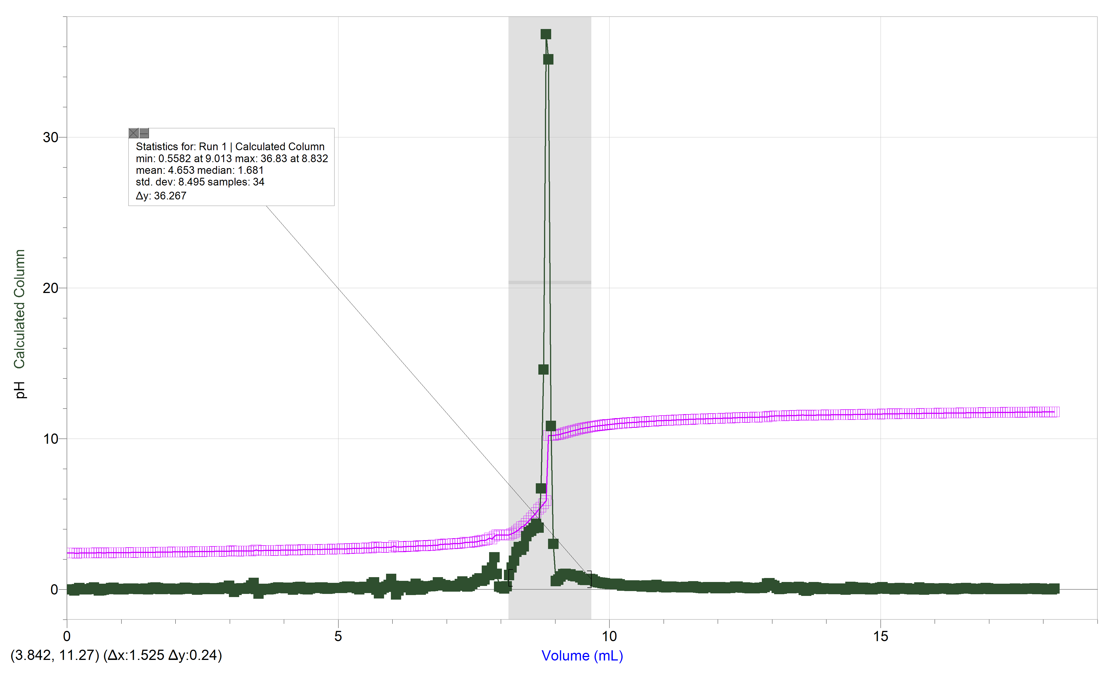
Trial 1

Trial #2
Equivalence point = 8.333mL
Volume of standard acid = 10.05 mL
Concentration of standard acid = 0.100M
c1v1=c2v2
c1(8.333mL)=(0.100M)(10.05mL)
c1 = 0.100M(10.05mL/8.333mL)
c1 = 0.1206 M
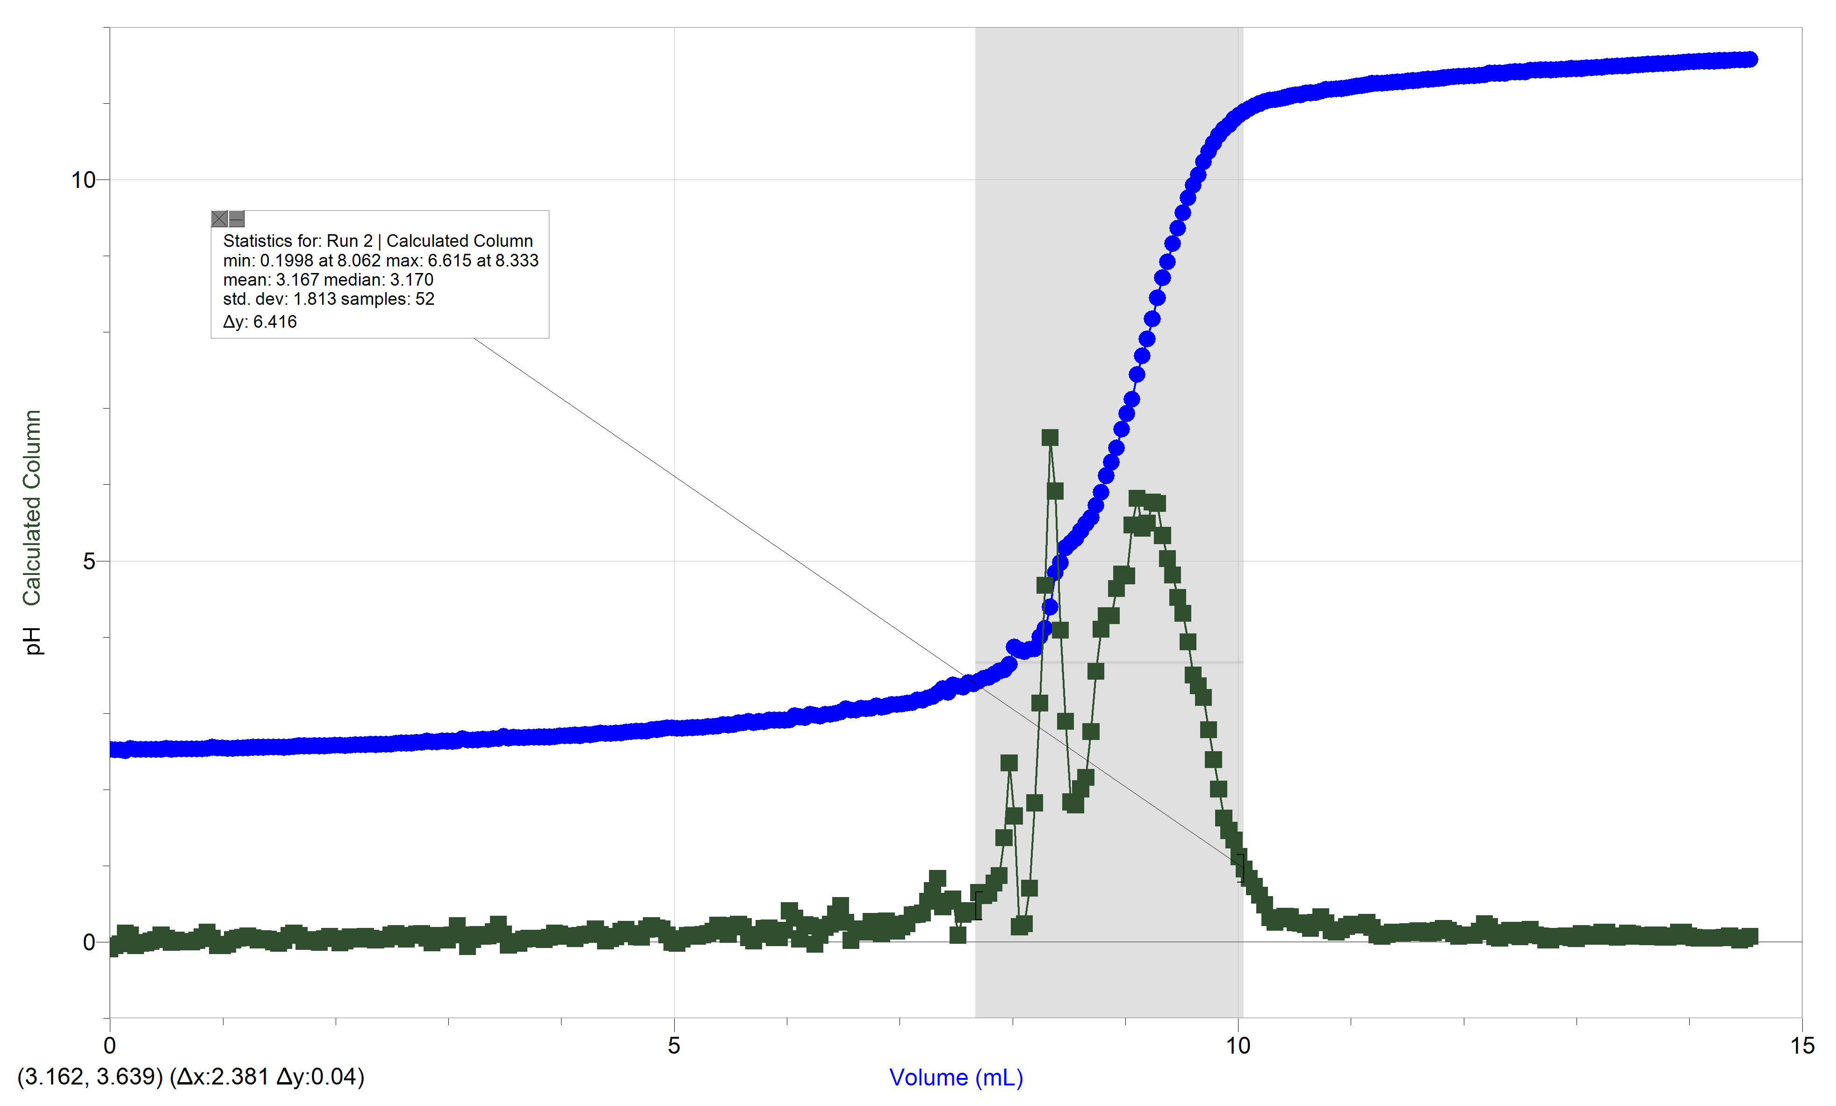
Trial 2

Trial #3
Equivalence point = 9.013 mL
Volume of standard acid = 10.12 mL
Concentration of standard acid = 0.100M
c1v1=c2v2
c1(9.013mL) = (0.100M)(10.12mL)
c1 = 0.100M(10.12mL/9.013mL)
c1 = 0.1123 M

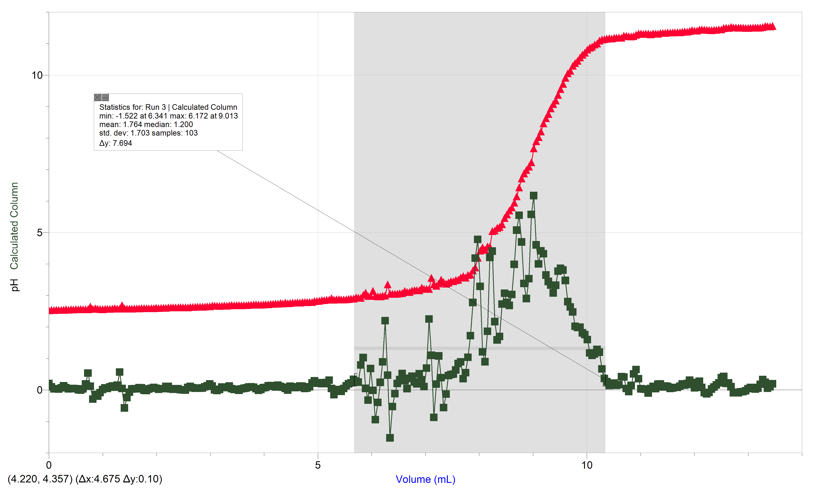
Trial #3

average concentration of NaOH = (0.1308 M + 0.1206 M + 0.1123 M) / 3
= 0.3637 /3
= 0.1212 M

Therefore, the exact concentration of NaOH is 0.1212 M

- Repeat the procedure outlined in Step 2 of the Calculations to find the exact volume of base used to titrate the unknown acid. Use this volume and the concentration you calculated in the previous step, as well as the volume of your unknown acid to determine the concentration of your unknown acid using Equation 7. Remember: the unknown acid is Diprotic!

H2A + 2NaOH Na2A + 2H2O

Trial #1
Concentration of NaOH = 0.1212 M
Equivalence point reached when 14.09 mL of NaOH was added
Volume of unknown acid = 10.08 mL
nbase =nacid
cbase ⋅ Vbase = b/a cacid ⋅ Vacid
(0.1212M)(14.09mL) = 2/1(cacid)(10.08mL)
0.1212 M (14.09mL/10.08mL) =2cacid
Cacid = 0.0847 M

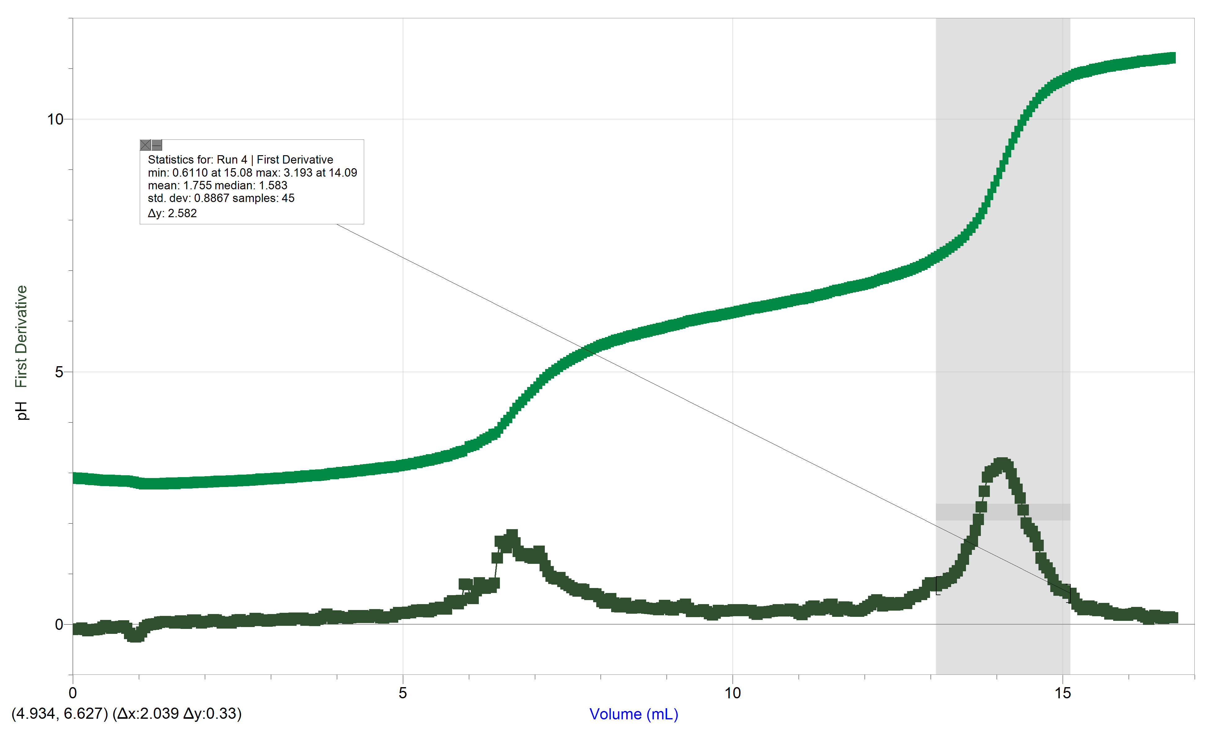
Trial #2
Concentration of NaOH = 0.1212 M
equivalence point = 13.68 mL
Volume of unknown acid = 9.8 mL
nbase =nacid
cbase ⋅ Vbase = b/a cacid ⋅ Vacid
(0.1212 M)(13.68 mL) = 2/1 (cacid)(9.8 mL)
cacid = 0.0846 M
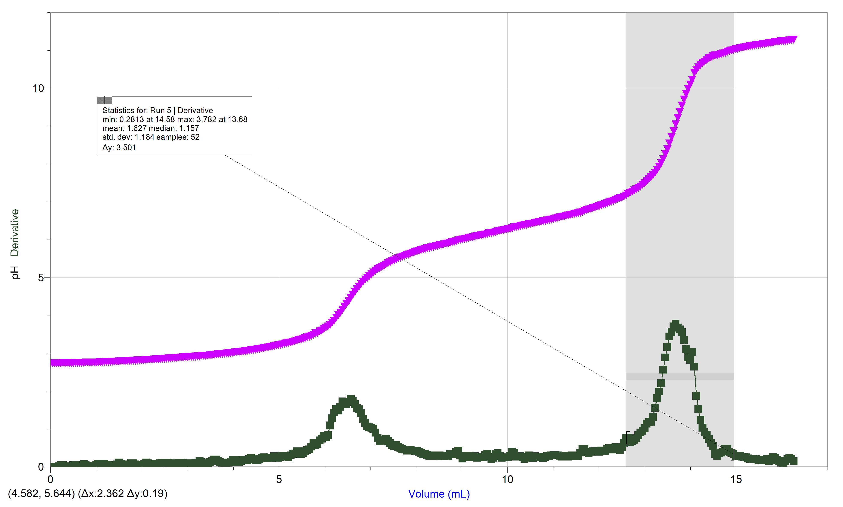
Trial #3
Concentration of NaOH = 0.1212 M
Equivalence point = 14.58 mL
Volume of unknown acid = 9.93 mL
nbase =nacid
cbase ⋅ Vbase = b/a cacid ⋅ Vacid
(0.1212M)(14.58mL) = 2/1 (cacid)(9.93mL)
Cacid = 0.0890 M
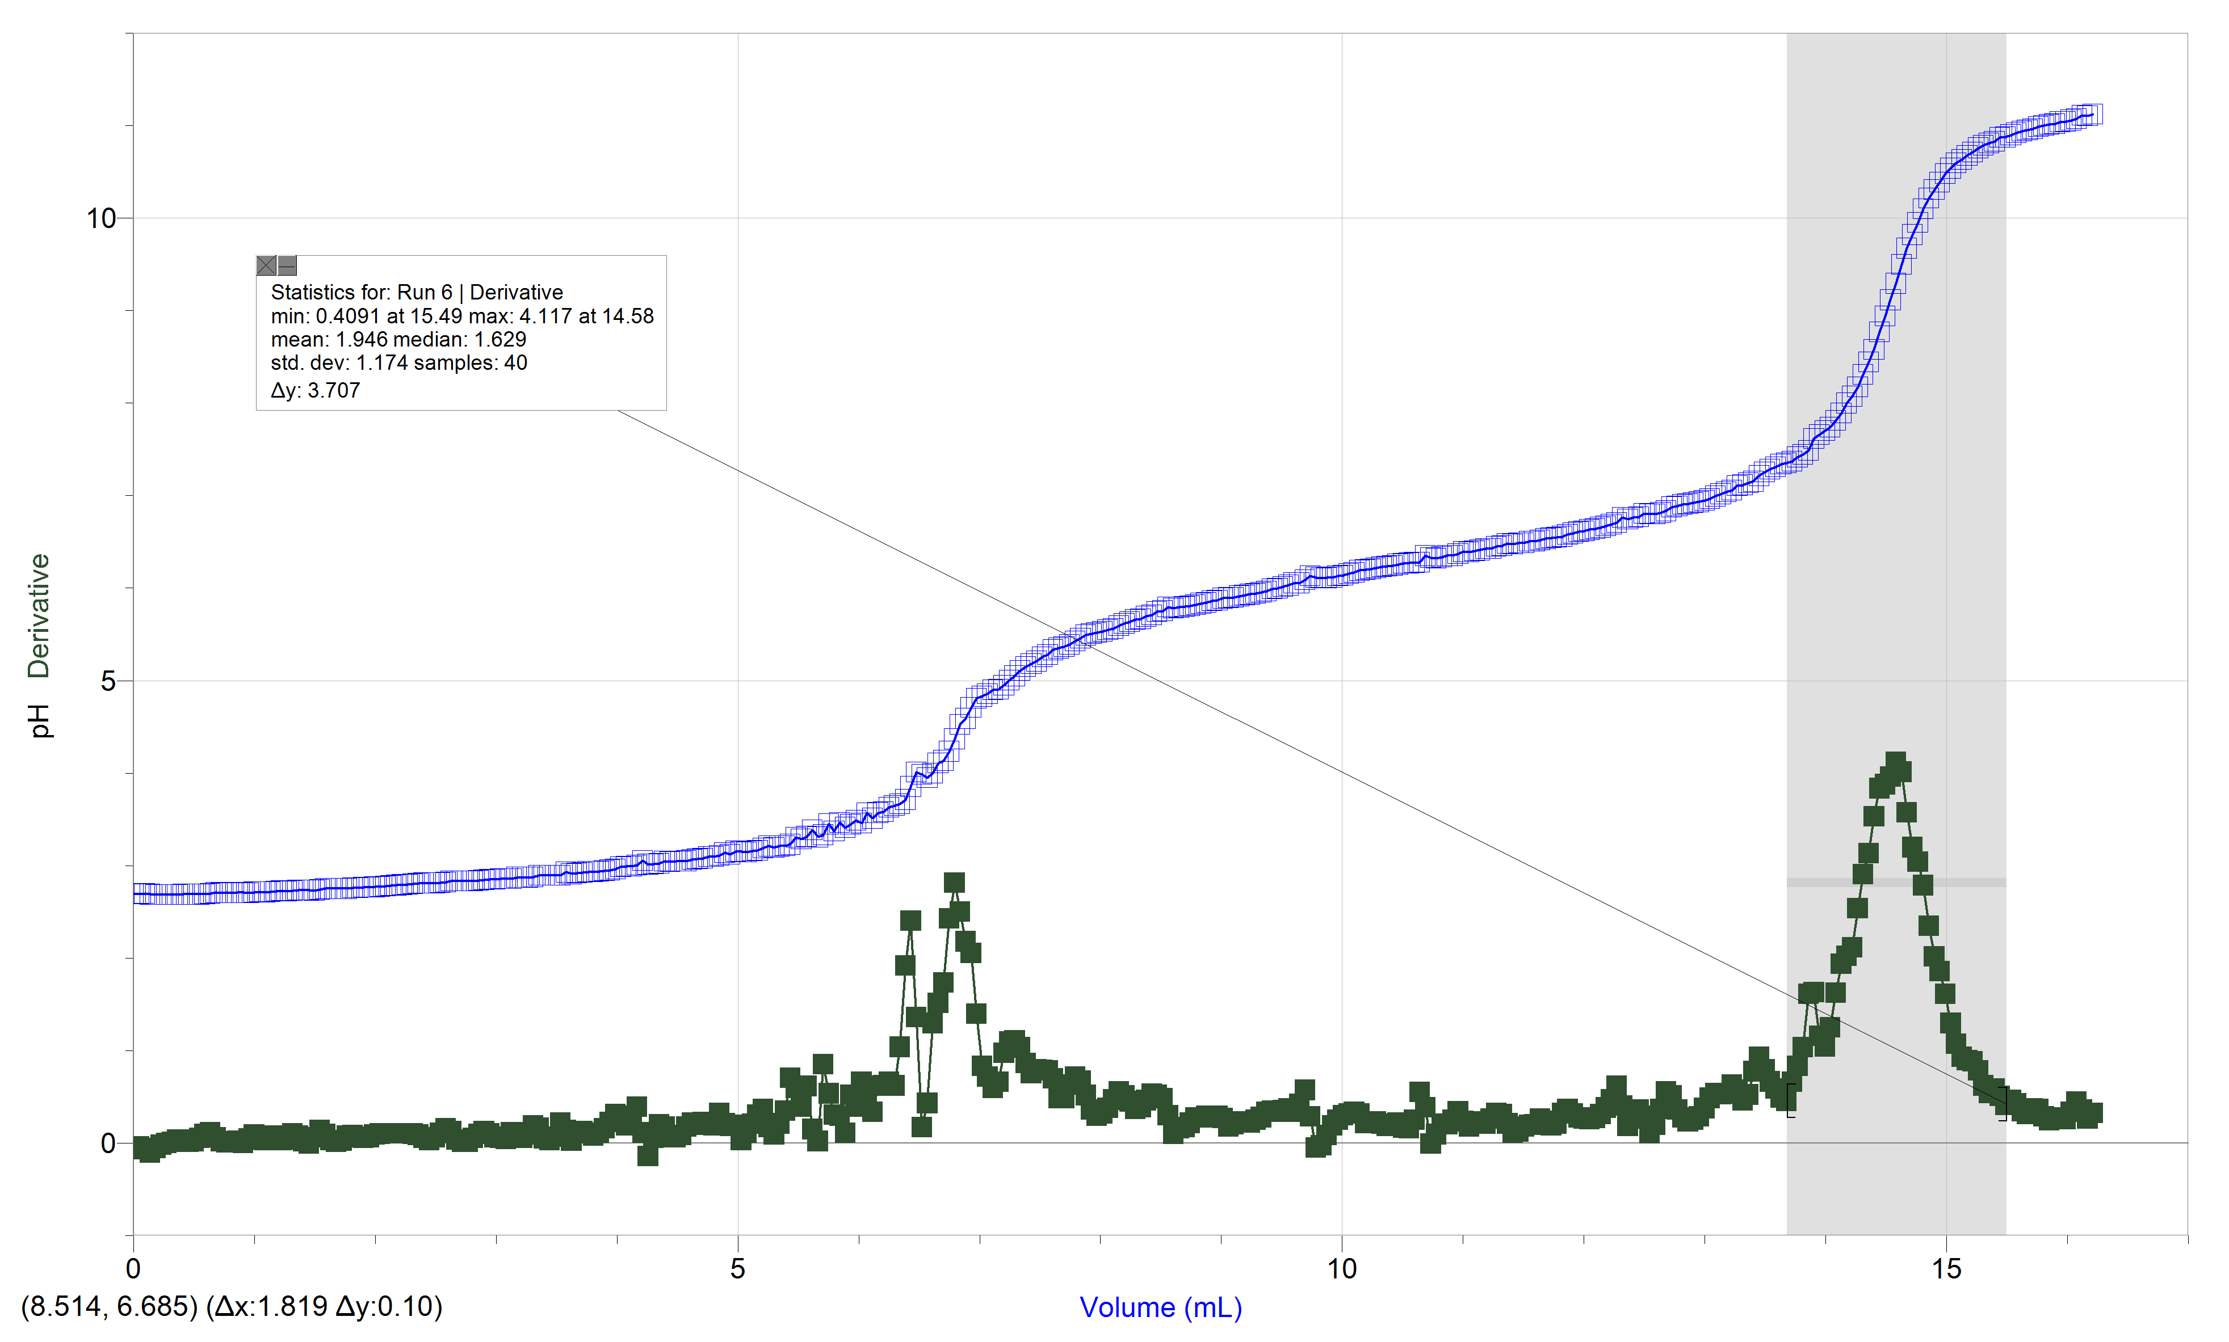
Trial #4
Concentration of NaOH = 0.1212 M
Equivalence point = 13.13 mL
Volume of unknown acid = 10.09 mL
nbase =nacid
cbase ⋅ Vbase = b/a cacid ⋅ Vacid
(0.1212M)(13.13mL) = 2/1(cacid)(10.09mL)
Cacid = 0.0789 M
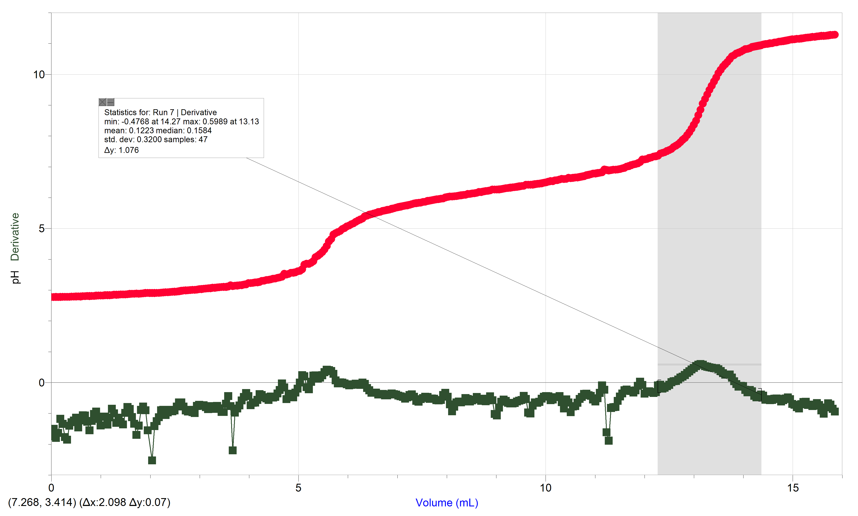
Average concentration of unknown acid = (0.0847 M + 0.0846 M + 0.0890 M + 0.0789 M) / 4
= 0.0843 mol/L
Therefore, the concentration of the unknown diprotic acid is 0.0843 mol/L

Discussion: After completing both parts of this experiment and analyzing all our data and graphs it is clear that our trials were very similar and consistent throughout the course of this lab. During the first part of the lab, standardizing the diluted NaOH, when comparing the pH value to the volume of base that was being added to the acid, the graph had a very consistent and steady pH value to begin with and it then started to increase rapidly and then eventually plateaued. The pH value started off low due to the high concentration of the acid, or H+ ions that was within the beaker. As we gradually added the NaOH to the acid, the pH stayed very low due to the solutions ability to act as a buffer, allowing the pH of the system to be relatively maintained. However, once the buffer systems capacity is reached it can not longer maintain that pH value causing it to eventually increase once a sufficient amount of NaOH has been added. As more and more base is added, the system becomes more neutral due to the fact that the H+ ions within the acid combine with the OH- ions in the base to produce water. Approximately halfway up the steep curve, the equivalence point is reached where the amount of mols of acid equals the amount of mols of base. Meaning that the solution is completely neutralized containing salt (which is produced by the spectator ions) and water due to the combination of the acid and base ions. As more base continues to be added this point is passed and the solution becomes more basic due to the higher concentration of NaOH compared to the concentration of the acid. Eventually it plateaus at the very end due to the excess NaOH being added doesn’t have as great of an effect since the H+ has been successfully neutralized. During the second part of the experiment, where an unknown diprotic acid was used in the titration, it caused our graph to have a wavy mirrored shape. This is a result of there being two equivalence points rather than one which was observed during the first part. Since the acid is diprotic meaning there’s two H+ ions per molecule, the first equivalence point is reached through the dissociation of the first H+ ions neutralizing it. The second point is reached when all the H+ has dissociated and reacted with the NaOH. There are several errors that could have occurred during this experiment, one of these errors could have the improper use of the count dropper. There were several times where we had to restart our trial due to the burette not being directly aligned above the sensor on the drop counter. This would have resulted in drops being miscounted which would have affected our lab quest data. Another error could have been accessing our end point although this would not have affected our data as much since the equivalence point was used for the calculations.

Conclusion: In conclusion after conducting this experiment we were able to approximately determine the concentration of our diluted NaOH solution to be 0.12 mol/L. The exact concentration was then calculated using the c1v1 = c2v2 formula as well as the equivalence point volume, the volume of the acid used and the concentration of the acid. We calculated this to be 0.1212 mol/L, which is the exact same as our approximate calculation. This concentration was then used to determine the concentration of an unknown diprotic acid which was titrated using the diluted NaOH. The concentration of this acid ended up being 0.0843 mol/L.

Raw Data:

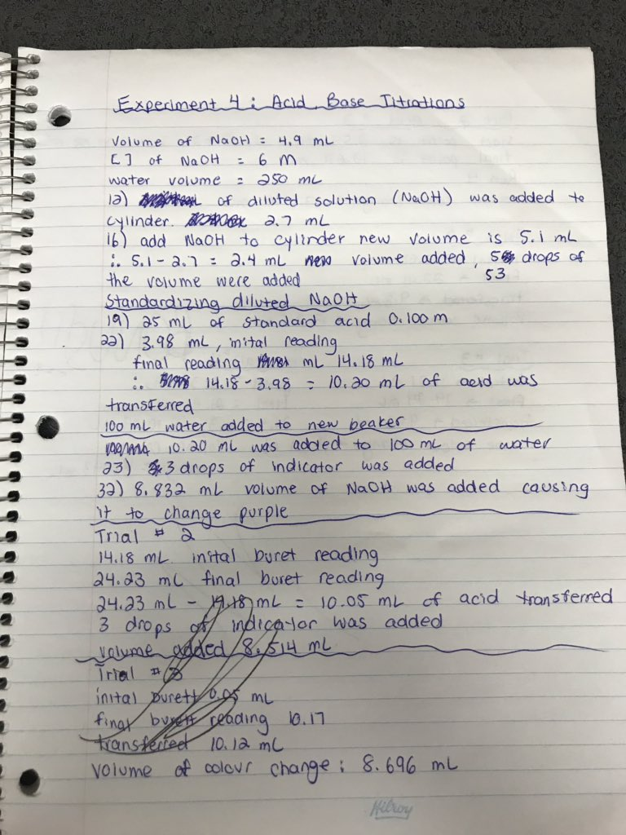

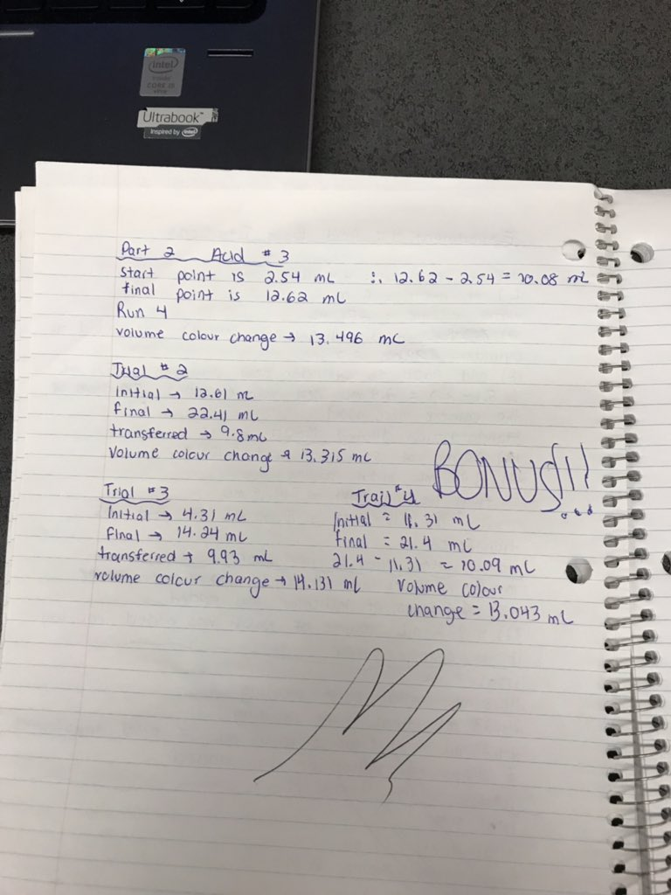

Bibliography
“Acid-Base Titration Curves.” Khan Academy, Khan Academy, “Acid-Base Titration Curves.” Khan Academy, Khan Academy, www.khanacademy.org/test-prep/mcat/chemical-processes/titrations-and-solubility-equilibria/a/acid-base-titration-curves.
Libretexts. “Titration Fundamentals.” Chemistry LibreTexts, Libretexts, 21 July 2016, chem.libretexts.org/Demos%2C_Techniques%2C_and_Experiments/General_Lab_Techniques/Titration/Titration_Fundamentals.
“PH Curves Titrations and Indicators.” Secondary Science 4 All, 11 June 2015, secondaryscience4all.wordpress.com/2014/08/10/ph-curves-titrations-and-indicators/.
Venkateswaran, Rashmi, “Chemistry, The Molecular Nature of Matter and Change”, 4.3,
McGraw-Hill Ryerson Limited, Pg , 2016.

