BPS 2110
Lectures 1 and 2: DISCOVERY OF DRUGS
September 6 and 10, 2018

  - DRUGS: chemical substances that are used in the treatment, prevention, or diagnosis of disease; to enhance or improve quality of life
  - Types:
    - BIOLOGIC: large molecules, manufactured by living things; vaccine, protein, antibody, nucleic acid
    - SMALL MOLECULE: lower molecular weight; traditional; can be used with living things (penicillin); chemical synthesis (petrochemicals)

THE PHARMACEUTICAL INDUSTRY:
- Multi-billion dollar industry
- Highly regulated by FDA (Health Canada and other organizations copy the FDA)
- Research intensive
- High risk meaning that we pay more (high profit)

4 Types of Companies:
- Ethical Pharmaceutical Companies
  - Heavily invested in research
  - Discover and develop NEW MOLECULAR ENTITIES (make up drugs)
  - Very large companies (100,000’s of employees); big names
  - Ex. Johnson and Johnson, Pfizer

- Generic Pharmaceutical Companies
  - Research is very limited; not a lot of scientific research; mostly lawyers
  - Focus on breaking/adapting patents
  - Manufacture products that are not protected by patent
  - Sell procures at lower prices because they make what someone has already made
  - Majority of generic companies are owned by a big name ethical company; made in the same factory, just a different label on the bottle
  - Apotex (Canadian), Pfizer

- Biotech Companies
  - Created to exploit academic discoveries; spinoff academic research labs
    - Build the idea from the academic lab and then into a profitable product
  - Heavily research intensive
  - Tend to be smaller companies
  - Usually sell only a few specialty products; create potential products
  - Often bought out by larger companies, if not then they will disappear; 5-6 years existence

- Contract Research Organizations (CRO’s)
  - Provide specialty services for the pharmaceutical industry like biological testing, specialty chemical synthesis, specialty manufacturing, special research ares (animal, purification, one chemical reaction)
  - Provide service to other companies that do not take a risk
  - If the drug doesn’t make it out on the market, they are still paid for the service
  - CRO’s in other countries due to the high risk of experiments (different laws)
  - Tends to be small to medium sized

Drugs Sold in Canada
- Thousands of products are licensed; most are versions of other products (same drug, different company; same drug, different doses; same drug, different formulation aka pill or liquid; combinations of other drugs)
- Drug Product Database (Health Canada):
  - Data on over 47,000 products
- Compendium of Pharmaceuticals and Specialities:
  - Data on over 2000 molecular entities
- World-wide, only about 30 new molecular entities (innovator drugs) are approved each year
- Cost to develop a new drug (US millions)
  - 1975: $138
  - 1987: $318
  - 2001: $803
  - 2005: $1300

PRODUCTION OF A NEW DRUG
Vocabulary:
      - Drug Candidate: intensified after 1-3 years of research; no approval needed for future tests
        - heavily driven by chemistry and biochemistry;
        - synthesis and testing of up to 5000 new compounds;
        - structure is kept secret;

      - Investigational New Drug (IND): Application made to the FDA to enter development; is a public document, permission to test on humans
        - contains:
        - Animal Pharmacology and Toxicity Data—ensures safety and used to validate clinical procedures
          - Manufacturing Information—method, purity profile, ensures company can produce and supply consistent batches of the drug
          - Clinical Protocols and Investigator Information—prevent unnecessary risks

        - New Drug Application (NDA): Application made to the FDA to enter market
          - Benefits of the drug and all the labels; safety of drug
          - Efficacy of drug—benefits outweigh risks
          - Appropriate labelling—what it should contain
          - Manufacturing methods are sound
          - Controls in place to maintain quality—identity, dose, purity
5 Stages:
  - DISCOVERY:
    - 1-3 years
    - Starting with an idea, a drug candidate is identified
        - Project Initiation:
        - Drug companies target market, not disease; to make money, instead of medical reasons
          - Each new drug costs more than $1 billion to develop, and the company must recover

          - Market Analysis
          - Ensure research and discovery costs can be recovered;
          - Ensure someone will buy the product; survive the demands
          - Number of potential customers
          - Type of potential customers—can they pay for the drugs?
          - Nature of disease:
            - Life threatening, quality of life, lifestyle
              - Cancer drugs (20-30% get approved), FDA is more lenient due to the rest of the life that can be lived
              - Acute v Chronic (Short: headache v Long: diabetes, blood pressure)
              - Current treatment:
                - Cost
                - Effectiveness
                - Safety
                - Convenience: the way the drug is presented
                - Antibiotics don’t make a lot of money; much better to sell cancer drugs even though it won’t work as well

- Feasibility Study (Biochemistry)
- Looks at the disease itself
  - Focus on a solvable problem
  - Is the disease well understood?
    - Diagnosis—Cold and flu drugs and antivirals: exhibit the same symptoms
    - Fixable using drugs?
    - Mechanism of disease understood?
    - Hard to solve “black box” problems
    - Biochemical tools available?
    - Assays to rest drugs
    - Animal models
    - Ex. Humans are the only ones to get AIDS after HIV, there was no animal model before humans
    - Are there existing drugs?
    - Serve as a starting point
    - Proof of principle that the idea can work

- Competitive Assessment
- What are other companies doing?
- Timing onto the market
- 1st drug: makes most money
- 2nd drug: makes less overall money, but spends less on development so high profit
- 3rd drug: makes least amount of profit
- A fourth company will not make it to the market
- What are the advantages/disadvantages?
- Safety/efficacy of existing therapies and their costs

- Biochemical Studies
- Proof of Principle
- Does it have a chance to work?
- Experimental evidence showing the drug could work in its intended way
- Drug testing methods
- Need a way to test candidate drugs
- Usually several methods will be developed (enzyme, cell, tissue)
- Development of animal models

- Lead Identification
- Medicinal chemistry requires a staring point: lead compound
  - LEAD COMPOUNDS:
  - proven biological activity; some specificity;
  - pattern of “drug-like” properties: facilitate entry into body; can be made into a product
  - patent opportunity
  - chemistry is possible; med chemistry starts with a lead

- Several methods used to identify leads:

- HIGH THROUGHPUT SCREENING (HTS)
- First method, widely used
    - Thousands of compounds are tested for activity
    - Randomly test as many compounds as you can and see what works
    - Tested at the same dose—30 µM
    - Companies maintain large compound collections:
      - Some compounds over 100 years old
      - Solid samples; frozen solutions in DMSO—solvent, melting point is 18ºC; preserves it, mixes with water
      - Requires biological assay (test) that is easily automated
      - Modern robots screen >200,000 compounds per week
      - Compounds showing activity tested more carefully
      - Most of these are false positive (>99%)
      - Counter screen used to sort false positives: assay using related biological function; want compounds that are specific (only active in one assay)
      - Good HTS generates approximately 500 hits
      - HIT: compound that tests positive in an HTS; doesn’t have to be real

      - Hit to Lead Removes the False Positives
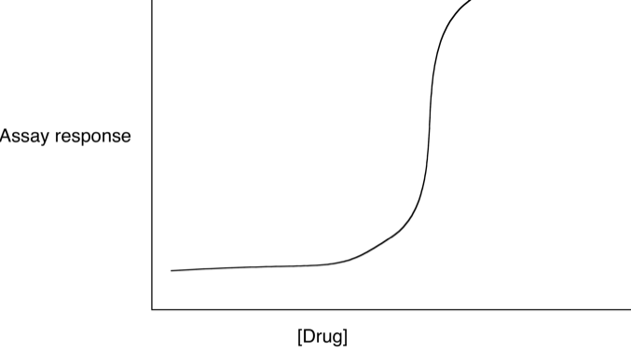
      - Most hits are false
      - Impurity
      - Decomposition
      - Compound reactivity (detergent, redox reaction, strong electrophile or nucleophile)
      - Interference with Assay (hydrophobic: sticks to protein or plastic; assay measurement: colour; solubility)
- Want to eliminate false hits quickly; usually interferes with the acid

- Pan-Assay Interference Compounds (PAINS)
- Promiscuous bioactive compounds
  - Show activity in virtually any biological test
  - Certain chemical structures act nonspecifically with biological targets (some interfere with test methods)
  - Redox activity
  - Detergents
  - Strong acid/base
  - Strong nucleophile/electrophile
  - Photoreactive
  - Chelator
  - Highly lipophilic
  - Always gives you a positive result; likes to use light/UV/fluorescence

  - Re-testing Hits
  - Re-test using purified samples
  - Test at multiple concentrations
  - Compounds interact in concentration-dependent manner
  - Dose response high
  - Should fit this shape of graph:

- Test in Other Assays
- Past data collected for the compound is examined
- Reject promiscuous compounds (PAINS)

- Confirmation of Structure
- Spectroscopy and Independent synthesis
- Many compounds in collections are very old
- Decomposition (storage)
- Incorrectly identified
- Synthesize, purify, confirm structure and test
- Test a series of compounds with related structures
- Compounds in the series should all be active, but show differences that can be related to structural patterns
- Try and recreate the compound all over again
- Slight variation in structure, slight variation in function

- Drugs Developed by HTS
- Aromatic
- Many nitrogens present
- Few or no stereocentres
- Small Molecules
- Molecular weight <500
- Patterns in HTS-discovered drugs
- Heterocyclic
- Lots of rings and nitrogens
- Amide groups
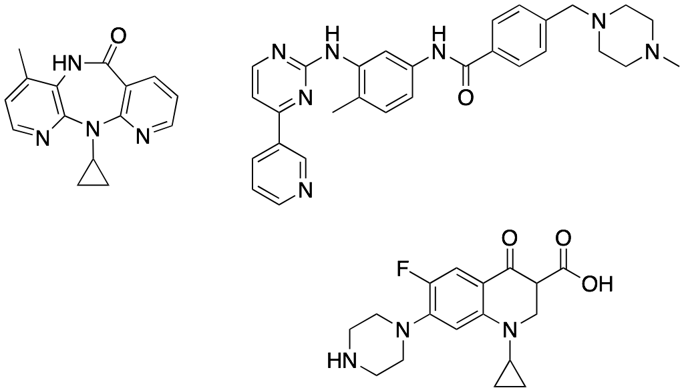
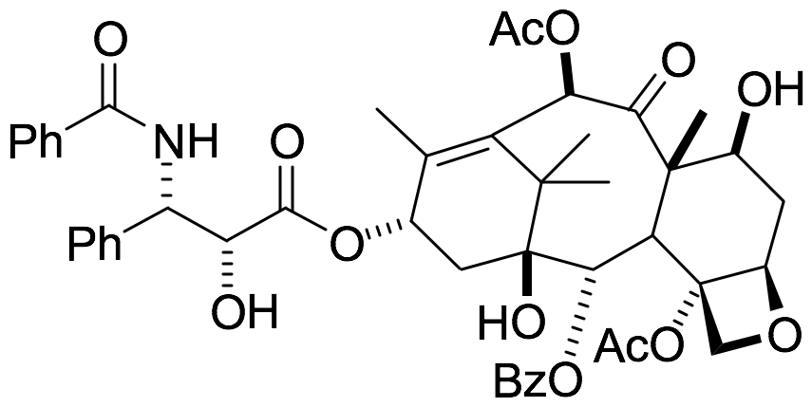
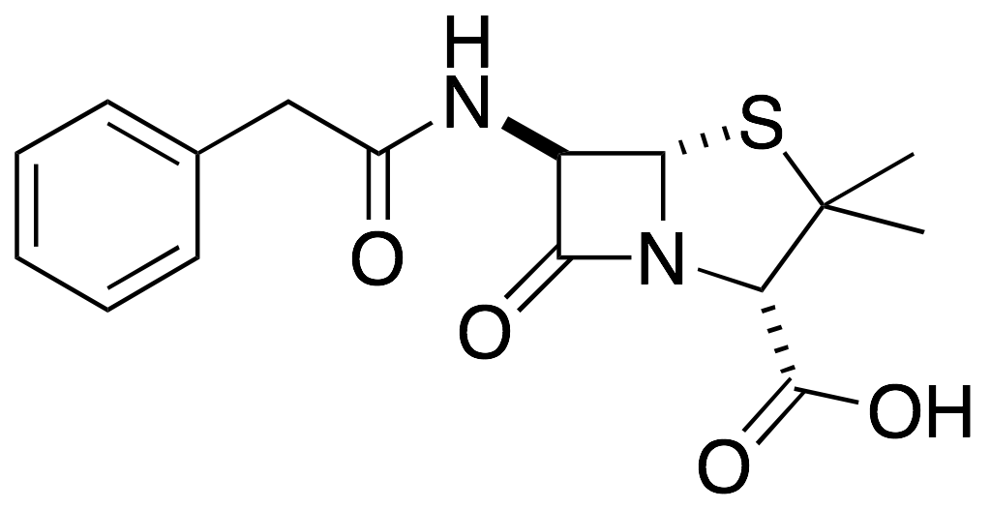
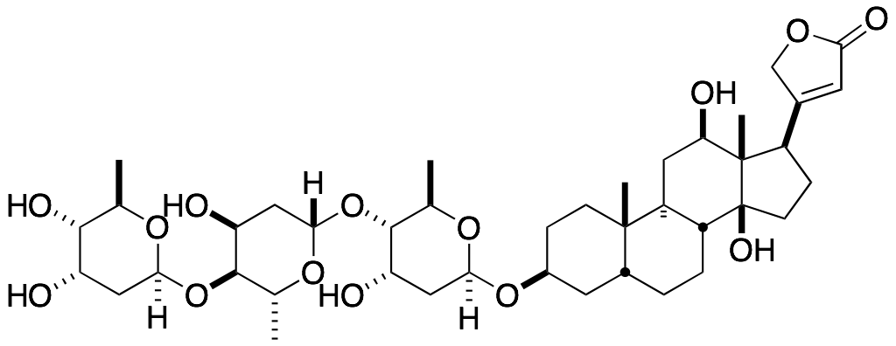
- Aromaticity (easier to operate in a lab than any other structure)
- Drug companies try and get rid of stereocentres

- NATURAL PRODUCTS
- Chemicals isolated from plants, animals, microbes
- Natural products are usually secondary metabolites
- Chemicals not directly required for life
- Produced by the organism for secondary purpose
- Poisons for defence or predation
- Colours, fragrances
- Hormones, pheromones
- Modify organism’s environment

- Natural Product Leads
- Isolated from living things: plants, bacteria, marine organisms, animals or humans
- Often difficult to perform Hit-to-Lead
  - Chemical synthesis of related compounds difficult
  - Limited to chemical modification of the natural product
  - Academic labs only
  - Companies stopped doing this in 1980’s
- Combinatorial chemistry

- Natural Product Structures
- Penicillin
- Taxol
- Digoxin

- Patterns in Natural Product Leads
- Lots of alcohols and oxygen
- More complex structure; larger molecules
- Stereochemistry (difficult, naturally occurring); lots of stereocentres
- Rings and instability
- Aliphatic (not aromatic)
- Lots of heteroatoms

- Supply is an Issue for Natural Products
- Difficult to create synthetically
- Structure is so complex that you can’t recreate it
- The only way is to go to the original and then regrow them in multitudes

- Drugs Produced in Industrial Quantities
- More than 20,000 tonnes of penicillin per year
- Must be farmable or produced by industrially compatible method
- Must be in large scale production which is a challenge
- Example: Spongistatin:
    - 400 kg of marine sponge provided only 13.8 mg of spongisatin
    - Found to be one of most potent tumour-growth inhibitors ever discovered, but grew only in one particular space
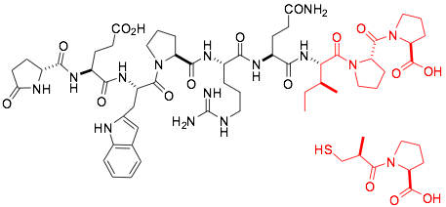
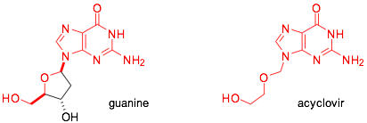
    - Attempt to re-isolate the compound unsuccessful (probably due to different growth seasons)
    - 13 tons of wet sponge gave 35 mg
    - Sponge was extinct on the third extraction; 13 tons represented the total population

- RATIONAL DRUG DESIGN
- Design a bad using a known chemical structure:
- Enzyme substrate
- Natural inhibitor
- Ligand for a biological receptor
- Existing drug
- Knowledge of structure, mechanism of action
- Design for improved properties
- Design for patent advantage

- Captopril Resembles Snake Venom
- Lowers blood pressure
- H-S replaces N=O, methyl replaces N-cyclopentance
- Black structure is snake venom, bottom red is the drug;
- Both red structures mimic each other

- Acyclovir Resembles Guanine
- Mimics guanine to attack viruses while keeping the rest of the body unharmed
- Simply strips out the black part

- Patterns in Rationally Designed Drugs
- Aromatic
- Little stereocentres
- Aliphatic (sigma connected carbon groups)

- COMBINATORIAL CHEMISTRY
- Semi-random synthesis of large library of related compounds
  - Robotic synthesis
  - Test all compounds for biological activity
  - Randomly make a bunch of molecules, test them, and then find the survivors
  - Make a large collection of molecules
  - Structures have common “core” and random “appendages”
  - Made using similar chemical reaction
  - Test the compounds as a mixture or using HTS methods
  - “Select” those molecules that shoe desired properties
  - Based on the idea of Darwinian selection
  - Newer method ~25 years
  - Has not been very successful; only one drug has ever been discovered this way:
  - Sorafenib: used for kidney and liver cancer (rare)

- DE-NOVO DESIGN
- Use computers to design lead from scratch
- Requires 3-D structure of biological target
- X-ray crystal structure; NMR structure
- Start with a protein structure
- Build computer model of binding site
- Design a molecule that fits this active pocket (ball and stick)
- Not very successful
- Using the map of electrostatics and then connect them together to find the structure of the drug

- Lead Optimization
- Once a lead is available, optimization work begins (medicinal chemistry)
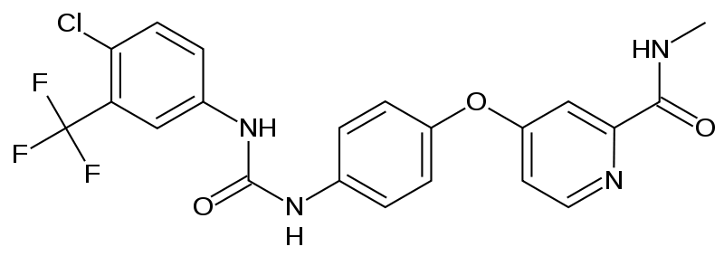
- Structure Activity and Property Relationships (SAR and SPR)
- Make small changes in a drug and look for changes in activity
- Emphasis on speed
- Try to optimize as many properties as possible

- Structure Property Relationships (SPR)
- Challenge: As you optimize one propter, you make one worse
- Properties of each compound synthesized:
- Potency (smallest dose possible for desired target activity)
- Selectivity (largest dose possible for minimum off-target activity)
- Solubility (water)
- Lipophilicity (solubility in non-polar solvents
- Chemical Stability
- Metabolism
- Toxicity
- Ease of Synthesis (drug companies will avoid the perfect molecule because it is harder or longer to make

- Focus on Molecules That Can Enter The Body
- Hardest problem in medicinal chemistry is getting drugs into the body
- Don’t waste effort on compounds the can never become drugs (“drug-like”)
- Certain properties correlate well with drug performance, try to optimize these at the same time as potency is optimized
- Requires extensive computer support

- Drug Candidate
- End result of the discovery phase
- Chemical properties and basic biological profile are known
- Process requires 1-3 years
- Approximately 2000-5000 chemical compounds have been made and tested to find each candidate
- Companies often identify 3-4 backup compounds
- If primary compound fails, minimize recovery time
- At this point you have a picture of what the molecule looks like

- DEVELOPMENT:
- Turn the drug candidate into a product (Investigational New Drug—IND)
- 1-2 years

- Major Goals:
- DOCUMENTATION AND PATENTS
- All research subject to regulatory scrutiny
  - Experiments are tightly regulated
  - Mistakes will haunt you
  - Once the drug reaches the market, you will get sued

  - All data will be sent to the FDA
  - Proper record keeping and lab book discipline

  - Patent coverage
  - Make sure the candidate and all possible future drugs in the class are protected

  - Patent is intellectual property
  - Gives you the right to prevent others from using your idea
  - Process, machine, manufactured product, composition of matter can be patented
  - As well as chemicals (compound, process of its making, and method of using it)
  - Cannot patent laws of nature, physical phenomenon, abstract ideas, algorithms

  - Patent Requirements:
  - Novelty
  - Something made or discovered for the first time
  - Utility
  - Must be able to be used for some purpose (should be “real”)
  - Non-obvious
  - Person “skilled in the art” would not immediately recognize

  - LARGE SCALE MANUFACTURE (PROCESS)
  - Process Chemistry
  - Large-Scale Synthesis
  - Reactions do not work the same way on large scale as on small scale
  - Heat transfer in the major problem
  - FDA Requirements:
  - Reliable: consistent yield, purity, purity profile (same impurities in same proportions every time)
  - During development hundreds of kg are prepared

  - Purification Methods Limited
  - Crystallization
  - Distillation

  - Regulated by Good Laboratory Practice (GLP)
  - Lab book regulations

  - Goals of Process Chemistry:
  - Optimize the synthesis for LOWEST COST
  - of goods
  - energy
  - equipment
  - labour
  - of waste disposal
  - safety: pay other countries to do dangerous reactions that they are unable to authorize
  - transportation
  - Often market their goals as environmentally friendly

  - SAFETY
  - Safety Testing I
  - Initial testing using in-vitro methods (in glass)
  - Uses biochemical assays developed over time
    - Contract companies do these assays; thousands of tests are run
    - Look for a “clean” profile
    - Minimum number of positive results
    - Look for “deal-breakers” (like carcinogen, serious interference with organ function)
    - In-vitro is cheaper than animals, but not as accurate

    - Safety Testing II
    - Animal testing
    - Smallest and fewest animals as possible
    - Two species, at least one primate
    - Rats: low cost, small size, good reproducibility (genetic uniformity)
    - Dogs: low cost, small size (other animals may be chosen if special circumstance)
    - Primate: as small as possible, human similarity
    - Animal testing probably will not end because it is very hard to stimulate a living organism artificially

- FORMULATION
- Form of the final product (pill, liquid, etc)
- Active pharmaceutical ingredient (API)
- Excipients:
- Non-medicinal ingredients
- Taken from food industry
- Added to create a product
- Common Excipients:
- Stabilizers: usually an acid or base; protect from chemical degradation due to oxygen
- Preservatives: Prevent mold or bacterial growth; made from cellulose
- Fillers: ensure consistent dosing; dilute drug; made from cellulose, MgSO
- Disintegrates: “blows” the pill apart in the stomach; made from starch
- Binders: holds ingredients together
- Flavours: taste
- Colours: safety
- Lubricants: ease of manufacture; the mixing of solids will not stick to the fabrication machines

- Types of Formulation (Most convenient—>Least convenient)
- Pills or caplets
- Capsules
- Liquids
- Topical cream
- Patch
- Injectable liquid
- Nasal spray
- Eye drops
- Suppositories
- First three: go through the liver
- After liquids: by-pass the liver and are susceptible to metabolism

- INVESTIGATIONAL NEW DRUG (IND)
- Compounds that survive development become IND
- Report submitted to FDA asking permission to enter clinical trials; 1-2 stacks of paper

- CLINICAL:
- 1-5 years; NDA (New Drug Application) is filed
- Drugs tested in humans
  - Safety
  - Efficacy: it works
  - Dose range finding
  - Requires thousands of kg; 60-70% of the cost of new drug
  - Drug made according to Good Manufacturing Practice (GMP)

  - Double Blind Studies are Used
  - Compare 2 groups of patients
  - One group gets the drug, the other the placebo
  - Note: many people will improve just by getting treatment
  - Placebos are not used or serious illness
  - Compare to existing therapy
  - Cancer
  - AIDS
  - Patient does not which group they are in;
  - Doctor does not know which patients are getting placebos (Difficult to enforce)

    - Nuremberg Code for Research on Humans
    - Participation is voluntary
    - Informed consent
    - Prior animal studies: controversial
    - Benefits outweigh risk
    - Qualified scientists
    - No suffering
    - Experiments stopped if dangerous
    - Prior WWII (1947), there were no regulations on human testing; unnecessary and immoral experiments on prisoners by the Nazi’s
    - Nuremberg code seeks to improve the quality of experimental results (prevents WWII)
    - Government Regulation and Oversight
    - Important that health care (drugs, surgery, equipment, experiments) is regulated
    - FDA (U.S.A.) and Health Canada
    - 3 Phases of Clinical Trials:
    - PHASE I:
    - Small number of healthy people (<100)
    - Safety only
    - Range finding
      - Try to find maximum safe dose
      - Start near estimated minimum effective dose
      - 30% of IND’s fail at this stage
      - Requires < 1 year
      - Phase I not always done
        - Cancer trial: chemotherapy is very reactive, harmful to people without cancer; no Phase I

        - PHASE II:
        - Small number of patients (200-300)
        - Safety and efficacy: works or not
        - Establish effective dose
        - 70% of IND’s entering this stage fail
        - Ex. circulates the body, but doesn’t actually do anything
        - Requires < 1 year
        - Before continuing, must communicate with the FDA that phase is completed

- PHASE III
- Similar to Phase II with a larger amount of patients (thousands)
- Safety and Efficacy
- Look for rare side effects
- 70% of IND’s entering this stage fail

- FDA APPROVAL:
- 6 months-1.5 years
- New Drug Application is filed to the FDA for approval

- MARKET:
- Produce hundred of tonnes each year
- Continue safety testing (Phase IV) for the very rare side effects or any new side effects
- Find new indications to increase potential markets
- Worldwide: ~30 new drugs/year enter the market
- Small % of drugs drop out
- Orphan Drugs:
- Pharmaceutical agent for rare condition: fewer than 200,000 US patients
- Promotes research for small, rare diseases
- Currently >400 drugs
- Small clinical trials (fewer patients available)
- Lower the bar on safety
- Some companies manipulate this law
- Find a rare condition and piggyback into it for related diseases
- 7 Year market exclusivity
- Tax credits up to 50% of research costs
- High cost

- Government Regulation
- Prior to 1097, drugs were completely unregulated
- Board of Food and Drug Inspection created in 1907
- First attempt and only required labelling (list of ingredients)
- No regulation of therapeutic claims—could sell anything
- No safety testing
- No monitoring or oversight
- Food and Drug Administration created in 1938
- Ensure the safety of new drugs

- Medication in the 1800’s
- Patent medication
- No regulation—anyone could make and sell anything
- No instructions provided
- No testing required
- Most products contained “feel good” ingredients
- Alcohol and Narcotics
- Ex. Kickapoo Indian Oil contained alcohol

- Massengil Sells Sulfanilamide Elixir
- During the time of the Board of Food and Drug Inspection
- This drug was a powder and tasted bad to children
- The company then used ethylene glycol (automotive ant-freeze) as a solvent
- Children who took this drug were highly affected
- Labelling forced drug off the market since the legal definition of elixir is a substance dissolved in ethanol
- Recovered 234-240 gallons that were sold
- 107 dead; 260 permanently disabled

- FDA
- Ensure the safety of drugs
- Animal testing now required (safety only)
- Clinical murals required for safety in humans
- Directions for proper use are required on the label
- All testing done by companies according to government regulation
- FDA employs inspectors for manufacturing
- How the FDA Functions:
- All testing done by companies: provide data to FDA, inspectors check the data to ensure it meets guidelines, base on this info, approves marketing for drugs
- FDA requires companies to monitor their products—report any problems (adverse events)
- If a patient places a complaint on a drug, the doctor contacts the drug company, and the company will contact the FDA
- FDA provides inspections for manufacturing
- Onsite inspections
- Shortage of inspectors

- Modern Safety Standards:
- Thalidomide started the different use of animals for testing
- Must show that drug is bioavailable (get into the body)
- Must use relevant doses (some companies would use low dosages)

- Thalidomide:
- Used as a sedative (1957), due to its success, doctors prescribed it to pregnant women, but then they gave birth to babies with phocomelia—without limbs
- By 1962, it was recognized as a teratogen (causes birth defects)
- Never marketed in U.S. as teratogenicity was discovered prior FDA approval
- Thalidomide was tested in rats
- Even with rat testing, humans have different effects
- Rates do not give birth to deformed pups as they will be absorbed in utero
- Theory of Teratogenicity:
- Based on animal experiments in 1970’s
- Drug was sold as a racimate—S enantiomer was toxic, R was not
- S—vasoconstrictor, used for leprosy today
- Difficult to reproduce the experiment
- Enantiomer effect requires i.p. dosing (injection)
- Can undergo racimization (chiral centres appear on flat molecule) if pH level is off

- INDUSTRY NEEDS REGULATION
- Ensures safe products
- Ensures products work
- Provides consumer protection
- Increases costs
- Increases taxes
- Important to balance the amount of regulations
- Enough to protect consumer
- Avoid overkill
- NDA 1990 : stack of paper 6 feet high
- NDA 2010: 1 or 2 semi-trailers full of paper

