BIOC*2580 Lecture 4: Protein Separation/Protein Hierarchy & Chemical Reactivity

- Centrifugation: a sample is spun in an ultracentrifuge at speeds from 10000 to 75000 rpm producing a force from 10,000 to 500,000 x gravity. Individual proteins are large enough to sediment at a rate determined by their size.
  - By measuring sedimentation velocity, its possible to derive the molecular mass.
- Electrophoresis: is separation based on movement of charged particles in an electric field. Mixture of proteins is place between a pair of electrodes immersed in a conductive buffer solution, and a voltage of 100-1000 V is applied. Positive molecules move towards the negative electrode and negative molecules towards the positive one. Rate of movement is a function of size, shape, and charge.
  - Since free solution is subject to disturbances by convection (local fluid motion caused by temperature differences), the buffer is immobilized in a gel. Gel is sufficiently porous enough to allow protein-sized molecules to pass through. Agarose gels are best for very high mass, especially when DNA where molecular masses may be >10 MDa.
    - Polyacrylamide gels are easily formed and are often used for proteins where molecular mass is in the range 10-1000 kDa. Typically, 5-10% polymer, 90-95% buffer.
- SDS-PolyAcrylamide Gel Electrophoresis (SDS-PAGE) is a modified form of electrophoresis in which protein is treated with the ionic detergent sodium dodecyl sulfate SDS.
  - SDS ions coat the protein molecule, which adopt rod like shapes, so that with SDS bound, all proteins have the same rod like shape.
  - Strong negative charge of the bound SDS ions override the variable charge of the polypeptide itself.
  - Charge of molecule now depends on the number of SDS molecules bound, which in turn depends on the size of the polypeptide. Now all peptides behave as they had similar charge per unit length.
- Proteins in the presence of SDS have increased frictional resistance for larger proteins.
  - Smaller proteins are most mobile
  - Large proteins are retarded (opposite to gel filtration)
  - Can use SDS to get information about the size or molecular mass of a polypeptide.
  - Unknown protein samples are compares to known proteins to create a calibration plot to match distance migrated to molecular mass.
- Isoelectric focussing: electrophoresis in a pH gradient and separated the proteins on the basis of their isoelectric point.
  - Every protein has an isoelectric point, the specific pH where the sum of negative charges is exactly equal to the sum of positive charges and its net charge is ZERO.
  - Positive protein starts at high pH it will have a negative charge. If the electrode is placed at the low pH end of the gradient the protein migrates towards the positive electrode and passes through the buffer of gradually decreasing pH.
    - As pH decreases side chains become protonated, cause the net negative charge to decrease.
    - At some point the protein reaches the pH equal to its isoelectric point, where it has no charge and stop migrating since there is no attraction to either electrode.
    - Separation occurs because each protein in a mixture has a different isoelectric point.
- Two-Dimensional Electrophoresis: involves separation of a protein first by isoelectric focussing in a thin capillary tube.
  - Spaghetti like gel contains the partly separated proteins and is then laid on the top edge of a conventional SDS-PAGE gel.
  - A secondary separation is done by electrophoresis at 90 degrees to the original isoelectric focussing.
- Mass Spectrometry: is a technique often used in conjunction to identify proteins
  - Pure protein sample is obtained as a band cut out from the gel electrophoresis.
  - Sample is either introduced into a high vacuum chamber as a super spray or vaporized by laser bombardment on a positively charge electrode.
  - Yields charged protein ionic particles which are accelerated by attraction towards a negative electrode. A small hole in the negative electrode allows some of the ions to pass through, forming a beam of positively charged proteins ions.
  - Velocity depends on m/z, the ratio of mass to charge.
  - Since the unit charge on an electron or proton is known, exact mass of the protein can be calculated by measuring time of flight.
- Level of Protein Structure Hierarchy
  - Primary structure: The specific sequence of amino acids in the polypeptide chain
    - Linear sequence of amino acids in a polypeptide chain.
    - Start at N-terminal amino acid and are numbered counting from the N-terminal end
  - Secondary structure: The occurrence of regular repetitive patterns over short regions of the polypeptide
    - Represented as a single ribbon. The ribbon forms regular helical or spiral patterns in some parts, and irregular loops elsewhere.
    - Regular repetitive folding patterns over short sections of the peptide chain (5-20 amino acids long) such as the helix.
  - Tertiary structure: the overall folding of the complete polypeptide chain
    - Myoglobin 8 helical secondary structure segments fold together to enclose a central cavity.
  - Quaternary structure: the assembly of several protein molecules to form a larger complex with distinct properties.
    - Several individual polypeptide chains into a larger structure that has special properties.
    - Hemoglobin- 4 independent molecules of globin, each similar in size and structure to myoglobin.
- Practical Aspects of Peptide Hydrolysis (attack by water)
  - Hydrolysis of peptides and proteins is usually done with a catalyst, because neutral O: is a poor nucleophile. Although it has 2 lone pairs, electronegative O: is less willing to share them than N: or S:
  - Acid hydrolysis is done in 6M HCL at 110C, it takes 24-72 hours to get complete breakdown of a peptide chain, Trp is destroyed in this process
  - Base hydrolysis is done in 4M NaOH at 110C and takes 16 hours to complete, but some amino acids are destroyed in the strong base.
- Enzymes are proteins that have a catalytic function in this case to hydrolyse peptide bonds.
  - After hydrolysis, amino acids present in a protein sample can be detected by chromatography.
- Hydrolysis is a chemical process called nucleophilic displacement.
  - Chemical reactivity of a molecule is a consequence of imbalances in the distribution of valence electrons of atoms.
  - C-C and C-H bonds are well balanced, non-polar and chemically inert.
  - Atoms that have valence electrons to spare or are electron deficient or draw electrons towards them, these create imbalances where a reaction may occur as the atoms seek a better arrangement.
- A nucleophile is simply an atom with a lone pair of electrons that is available to share with another nucleus.
  - A nucleophile is “nucleus loving” and seeks out other atoms (nuclei) that are electron deficient: this may a fully or partially positively charged atom.

- A Nucleophilic displacement: is a reaction in which an incoming nucleophile X: attacks a target atom C to displace another attached group. The group Y that detaches is called the leaving group
  - X: C---Y -------> X----C :Y
  - Atoms with lone pairs:
  - The atom acts as a hydrogen bond acceptor if it simply attracts an -OH or -NH dipole.
    - R-O: ----- H-N
  - The atom acts as a base if it uses the lone pair to capture H+
    - H+ + :NH2-R ---> +NH3-R
  - The atom acts as a nucleophile when it shares the lone pair bond to another nucleus
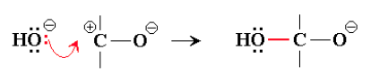

- In the example above, O is acting as a nucleophile because it has shared one of its lone pairs to bond C, which is electron-deficient.
- The curly arrow notation is commonly used to indicate movement of a pair of electrons, in this case from a non-bonded or lone pair position to form a new bond.
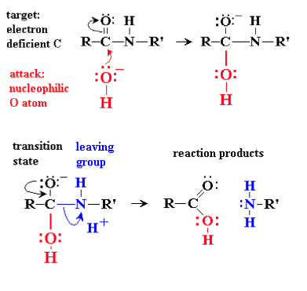
  - Hydrolysis is an attack by H20, using O as a nucleophile, on a susceptible bond such as a peptide bond.
  - Bond is susceptible because the C atom of the C=O is electron deficient, as electrons are drawn towards the electronegative O atom of C=O. Because the C is electron deficient, it can accommodate the incoming electron pair.
  - This sequence then produces a transition state
    - A halfway semi-stable stage of the reaction
    - This state gives rise to stable end products by breaking the C-N bond
    - N Atom can serve as a good leaving group meaning it can hold the electrons from the breaking bond as a lone pair.

LECTURE 5: Determing the Amino Acid Sequence of a protein

- Determining Amino Acid Sequence
  - Fred Sanger was the first person to devise a method to determine the amino acid sequence of a polypeptide/protein
  - Over 1947-1953 he worked out methods to find the amino acid sequence of the protein hormone insulin
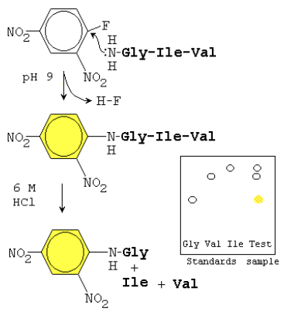
  - Introduced 2 important techniques
    - N-terminal tagging identifies the first amino acid in the chain
    - Limited hydrolysis breaks the chain into smaller, more manageable pieces
  - N-tagging works because the N-terminal amino group becomes a nucleophile under mildly basic conditions
    - At pH 7 NH³₊ is not a nucleophile, but at 8 or 9 is becomes deprotonated NH₂
    - Should not be greater than 9 as could yield unwanted reaction with Lysine (pKa 10.2)
  - Nucleophilic N-terminal :NH₂ will react by displacing HF from the reagent fluorodinitrobenzene
    - The bright yellow dinitrophenyl group becomes bonded to the N-terminal amino acid
    - Tagged protein is hydrolyzed to its constituent amino acids and labeled (yellow) N-terminal amino acid can easily be separated and identified by chromatography
  - Sangers method required complete hydrolysis of the peptide chain to recover the tagged amino acid and this destroys the rest of the peptide chain so that amino acids #2, #3, etc. are not identified.
    - Figured out to use limited hydrolysis by either lowering the temperature or for shorter time so that not all the peptide bonds broke
    - Creates a random mixture of dipeptides and tripeptides.
    - By analyzing the fragments, he was able to reconstruct the whole sequence
    - Took 7 years

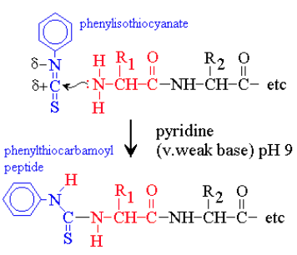
- Per Edman solved the problem of hydrolyzing the complete peptide to recover the tagged amino acid in 1956.
  - Used reagent phenylisothiocyanate to label the N-terminal end of the polypeptide
  - This reagent reacts with the deprotonated N-terminal amino group
  - Deprotonation exposes the lone pair of N allowing it to react as a Nucleophile which can then attack an electron deficient nucleus, the C atom of isothiocyanate.
  - Requires mildly basic condition (pH 9) use a weak base such as pyridine
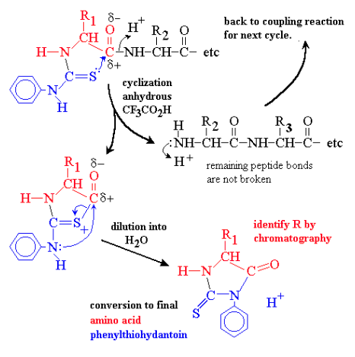
  - Coupled product is called phenylthiocarbamoyl peptide
  - Phenylthiocarbamoyl peptide is transferred into weak anhydrous (no H₂O) acid which causes C=S to attack the nearest peptide bond, the one linking the N-terminal amino acid to the rest of the chain
    - Result is a cyclization reaction that splits off the first amino acid, leaving the rest of the chain intact.
    - No hydrolysis
    - Cyclized form of the first amino acid rearranges to the final product or amino acid Phenylthiohydantoin or PTH amino acid
- Released amino acid Phenylthiohydantoin is then identified by chromatography or mass spectrometry
  - Since the chain is intact, the cycle of reactions can be repeated many times, each cycle removing the current exposed N-terminal amino acid allowing each to be identified
  - PTH-Gly + Ile-Val-Glu-Gln-Cys-Cys-Ala-Ser-Val
  - 2 steps require contrasting conditions
    - Coupling with phenylisothiocyanate occurs in weak base
    - Cyclization to phenylthiohydantoin occurs in anhydrous acid
  - Because two distinct phases to reaction, the reaction cycle remains strictly in phase.
    - Step 1 can complete without risk of molecules of Glycine cyclizing early and exposing Ile prematurely because cyclization requires acid
    - Step 2, the cyclization of Gly can proceed without risk of Ile coupling early since conditions are acidic not basic.
  - Cycle reactions are very easy to automate, can be carried out by machine
    - Producing one PTH amino acid every hour
  - Although the Edmans reaction can be repeated many times and yield highly, there are practical limits. 20-30 sequences can be done, but over 50 or 60 amino acids are very hard to handle in a single run
  - To overcome this proteins are hydrolyzed into peptides that can be sequenced

- Selective Hydrolysis
  - Selective hydrolysis of polypeptides allows a long polypeptide to be cut at specific locations to give shorter oligopeptides
    - If the oligopeptides are no longer than 20-30 amino acids, their sequences can be determined by Edmans method or mass spectrometry
- Proteases
  - Proteases are digestive enzymes and can achieve selective hydrolysis.
  - Enzymes are proteins that catalyze a specific reaction
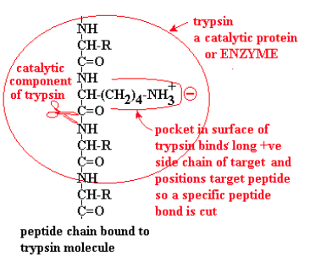
    - Trypsin is an enzyme that binds a polypeptide and cuts the peptide bond on the carboxylate side of the targets Arg or Lys
    - Chymotrypsin cuts polypeptides on the carboxylate side of Phe, Tyr or Trp
    - In both cases, if the next amino acid after the target is proline, the polypeptide fails to bind to the enzyme and can’t be cut at that point.
      - This is due to prolines unusual conformation due to the side chain bonding to the a(alpha) amino N
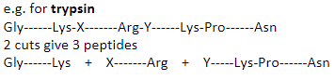
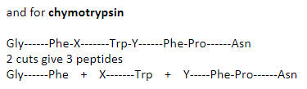

- Selective Chemical Hydrolysis
  - Chemical reagents cyanogen bromide, CNBr may also be used
    - Cyanogen bromide attacks on the carboxylate side of methionine, converting it to homoserine, Hse.
    - Being a chemical reagent, not a catalyst, cyanogen bromide is consumed in the reaction
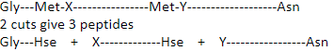

- Overlap method
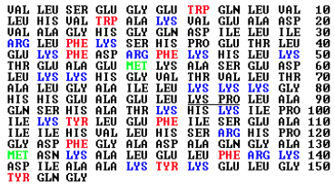
  - Sequence of myoglobin showing sites where the polypeptide chain can be cut: red for sites where chymotrypsin attacks; blue where trypsin attacks (Lys-Pro not cut); and green where cyanogen bromide attacks Met.

- If myoglobin is digested in chymotrypsin, all the red labelled sites will be hydrolysed at the peptide bonds immediately following the target amino acid, since it is impossible to attack at only one location at a time.
  - Similarly, all sites in blue will be cut off by trypsin
  - This creates a series of oligopeptides with a characteristic pattern of molar masses that is unique to a give polypeptide
  - To sequence a complete amino acid
    - Selective hydrolysis is first carried out
    - Resulting oligopeptides are separated by chromatography.
      - Usually ion exchange, reverse phase or gel filtration techniques are used
      - Individual peptides can then be sequenced by Edmans method.
      - Alternatively, the oligopeptide masses are easily measured by mass spectrometry to identify the particular proteins
      - After all oligopeptide sequences have been determined, the complete polypeptide sequence is deduced by the overlap method
- Proteins can be sequenced directly using tandem mass spectrometry (tandem MS or MS/MS)
  - Modern technique that is commonly used in the analysis of the entire protein complement of an organism or cell (proteomics).
  - Very small amounts of proteins are required, individual bands on 2D gels can be cut out and sequenced without the need for complicated protein purification techniques
  - Protein samples are hydrolysed into a mixture of shorter peptides using a protease or through chemical means.
    - Mixture is then injected into a tandem MS (essentially 2 mass spectrometers in series)
    - In the first MS chamber, peptides of different masses are separated. Each of these peptides is then introduded into a collision cell where each peptide molecule fragments only once
      - Usually at the peptide bond
    - In the second MS chamber, masses of peptide fragments are measured
  - Commonly used method
    - Peptides are generated from the full-length protein with trypsin; each resulting peptide must therefore have a Lys or Arg at its C-terminus
    - Peptide is then moved into a low pH buffer.
      - Under these conditions, acidic residues have no charge on the sidechain
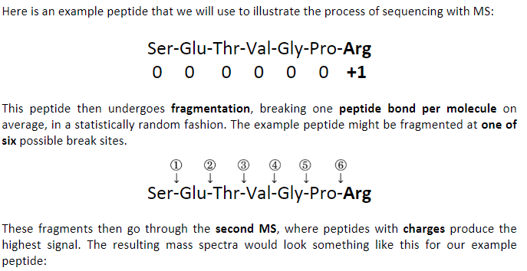
      - Basic residues have +1 charge on their side chains.

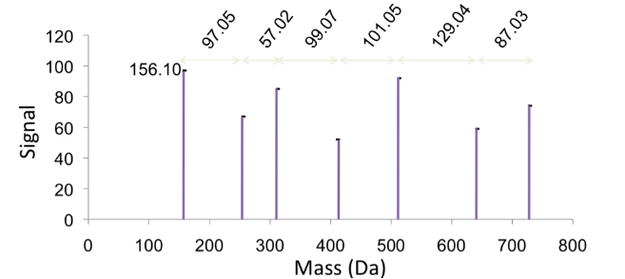

- Mass peaks represent the mass of one charged fragment type
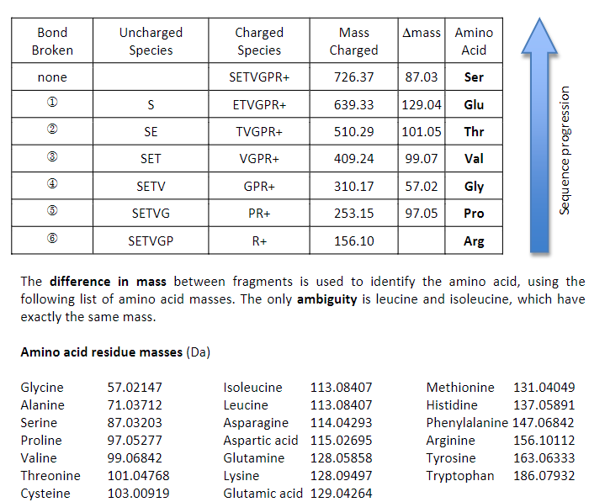
  - Difference in mass between the peaks presents the mass of one amino acid as you go from one fragment to the next
- Using the progression of masses that then identify the amino acids involved, the original sequence of the peptide can be assembled
  - In the example, charged amino acid (Arg) was at the C-Terminus.
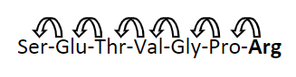
  - Because this amino acid served as the “anchor” for the MS due to its charge under the low pH conditions of the fragmentation, we must begin assembling the sequence from the C-terminus and progress towards the N-terminus
LECTURE 6: Protein Secondary Structure

- Secondary structure is the occurrence of regular repetitive patterns, such as alpha helix, over short sections of the polypeptide chain
- Why is there a pattern?
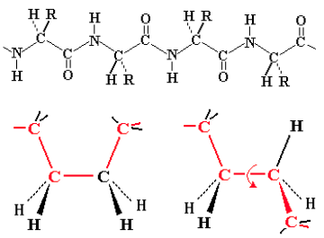
  - Polypeptide chain forms a backbone structure in proteins.
  - Structure appears connected entirely by single C-C or C-N bonds.
  - Therefore, should be flexible.
    - Flexing in a covalent chain structure does not occur by bending bonds
    - Can be achieved while the normal tetrahedral or trigonal planar bond angles are maintained.
    - Instead different shapes are obtained by rotation about the axis of single bonds.
  - A chain of only single bonds is highly flexible.
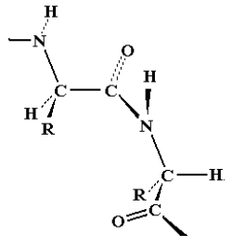
  - All polypeptides can adopt a form which is flexible BUT is random and disordered in bond orientation.
    - This is called the denatured state of a proteins.
    - Denaturation occurs at elevated temps or in the presence of a disruptive solvent.
  - Due to no orderly arrangement, denatured proteins are non-functional
- Most proteins have an ordered arrangement called the native state.
  - Organization of amino acids in 3-dimensional space required for proper function
  - Poses question why any special pattern should exist at all.
- Fibrous proteins called Keratins
  - Alpha keratin – protein of hair, skin and wool;
  - Beta keratin or fibroin – spider and silk moth silk
  - First studied by X-Ray diffraction
    - X-Rays reflected off a regular repetitive structure such as a crystal or fibre of protein.
    - Reflected X-rays form a characteristic pattern if the repetitive spacing in the sample is comparable to X-ray wavelengths.
    - Since X-rays have the same dimensions as atoms and bonds, repetitive features in molecular structure can be detected.
    - If the X-ray wavelength is known, the size of the repeating pattern in the protein can be calculated.
- X-ray diffraction gave the following measurements for repeating patterns
  - Alpha Keratin -------- Major pattern: 5.4 A -------- Minor pattern: 1.5 A
  - Beta Keratin -------- Major Pattern 7.0 A --------- Minor pattern: 3.5 A
  - A (angstrom unit) = 1.0 X 10⁻¹⁰ meter is a measurement used for atomic structures.
    - Hydrogen atom and the C-H bond is 1 A in size

- Linus Pauling worked out these repeated bond distances.
  - Precise atomic radii
  - Bond lengths
  - Bond Angles
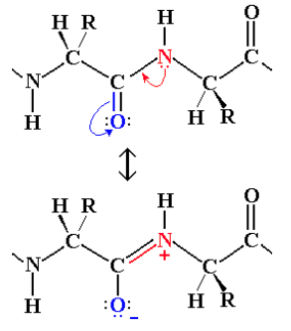
- Peptide bond behaves more like a double bond due to contribution of the second resonance form of an amide.
  - This would make the peptide bond rigid and unable to rotate freely
  - Can only form cis and trans geometric isomers
  - In proteins, peptide bond are almost always trans
  - Bond rotation is only allowed at the alpha carbon’s atoms in the chain
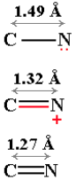
  - Paulings evidence was a comparison of C-N and double C=N bonds with the peptide bond length of 1.32 A
    - Since bond length correlates with bond order, this suggests that the peptide bond behaves more like a double bond

- Using peptide bonds as flexible single bonds, the peptide chain was free to adopt such a variety of structures that no single consistent pattern would emerge
  - When including rigid peptide bonds, the number of possible arrangements became limited, allowing only certain stable well-defined patterns would be present.
- Paulings models were based on >C=N< state of the peptide bond
  - This state maintains a flat trigonal planar structure and is quite rigid.
  - In the peptide backbone, rigid peptide bonds are linked through the alpha carbon atoms, which have a tetrahedral shape.
  - At the backbone there is a 109-degree bend.
  - Model can adopt two basic patterns
    - A helical state in which bond rotation at the alpha carbon bonds was repeatedly in the same direction
    - An extended state in which the bond rotation at the alpha carbon bonds alternated in direction, resulting in a zig-zag structure for the peptide chain
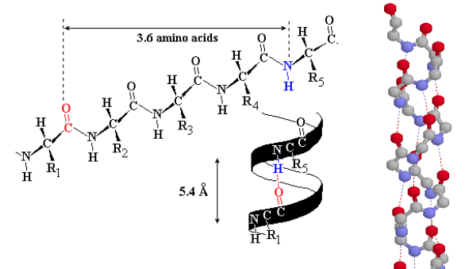
    - Even possible to set the peptide chain in a non-repetitive arrangement called a random coil

- Alpha Helix
  - An alpha-helix has 3.6 amino acids per turn of the helix. This places the C=O group of amino acids #1 (bolded O and Grey C) exactly in line with with H-N (bolded N) and amino acid #5 (and C=O #2 with H-N #6)
  - The alignment and spacing is ideal for a hydrogen bond C=O: ----H-N
    - This hydrogen bond makes this structure especially stable
    - Distance separating each turn of the helix was 5.4 A
    - Since 5.4 A / 3.6 A = 1.5 A, the alpha helix has an amino acid every 1.5 A
  - Right handed version of the helix places side chain R next to a much smaller N-H, for a better fit, as opposed to the left-hand arrangement which places the R chain too close to the C=O group making the structure overcrowded.
  - Myoglobin was the first globular proteins to have its full 3-dimensional structure worked out
- Beta Sheet
  - Paulings extended state model matched the spacing of fibroin or beta keratin exactly (3.5 A and 7.0 A)
  - In the extended state, H bonding NH and CO groups point out to each side
  - Lining up extended strands side by side, H-bonds bridge from strand to strand
  - H-bonds may link extended strands in parallel (same direction) or antiparallel (opposite direction orientations)
  - Arrangements with multiple strands forma 2-dimensional structure called a Beta-sheet.
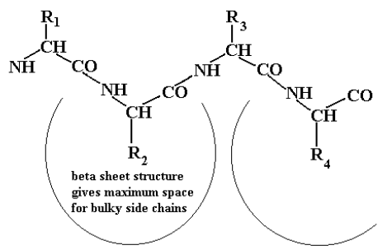
  - Alignment of H-bonds is much better in the anti-parallel arrangement
  - When beta sheet viewed from edge, zig-zag patter is seen
    - The beta-sheet structure gives bulky amino acid side chains the maximum space and freedom of movement
    - Odd numbered-amino acids appear on one side of the sheet and even numbered on the opposite side.

- Different amino acids prefer particular secondary structure:
  - Extended structure leaves maximum space for free amino acid side chains: as a result those amino acids with large bulky side chains prefer to form Beta-sheet structure
    - Tyr, Trp (sometimes Phe) are just plain large
    - Ile, Val, Thr are bulky and awkward due to branched Beta-carbon
    - Cys has a large S atom on beta-carbon
  - Beta-carbon atom is the first atom on the side-chain, so bulky groups are crowded close up to the backbone. Presence of bulky groups on the second carbon of the side chain (gamma-carbon) in Leu is less of a crowding problem.

- Main criterion for an alpha-helix preference is that the amino acid side chain should cover and protect the backbone H-bonds in the core of the helix from disruption by the surrounding H₂O
  - Alpha-helix preference: Ala, Leu, Met, Phe, Glu, Gln, His, Lys, Arg
  - Remaining amino acids are known as secondary structure breakers: Gly, Pro, Asn, Asp, Ser
    - Gly side chain is a single H atom, which is too small to shield backbone H-bonds from disruption by surrounding H₂O
    - Pro is unique because its sidechain is directly linked to the backbone N, and obstructs the space where the H-bond would otherwise form
    - Asp, Asn and Ser the side chain is at an ideal length to form H-bonds with adjacent backbone N-H or C=0 groups, as a result these amino acids actually disrupt adjacent H-bonds instead of protecting them
    - Cluster of breakers give rise to regions known as loops or turns which mark boundaries of regular secondary structures and server to link up secondary structure segments.
- Amino acids select a secondary structure by consensus, not individually.
  - Section of a polypeptide is likely to form an alpha-helix if it contains 60% helix formers in runs of 6 amino acids or more and no more than 20% breakers.
  - A section of a polypeptide is likely to form beta-sheet if it contains 60% beta-sheet formers in runs of 5+ amino acids, and no more than 20% breakers.
  - 2 or more breakers in a run of 4 amino acids are usually necessary to initiate a turn or loop

LECTURE 7: Tertiary Structure & Protein Stability
- Fibrous Proteins and Globular Proteins
  - Simplest tertiary structure for a protein to adopt is a single uniform secondary structure
  - Alpha keratin is Alpha-helix
  - Fibroin is antiparallel Beta sheet
  - Collagen forms a unique triple helical structure, the collagen helix
    - Not considered a generic secondary structure since collagen helix depends on a specific repeating sequence (Gly-Pro-Gly)
    - Secondary structures by themselves are rigid, and give the protein an overall fibrous shape whereas most proteins are globular
  - A globular shape is the result of folding the polypeptide onto itself and depends on the following
    - Clearly defined interruptions in the secondary structure
      - Clusters of secondary structure breakers
        - Gly, Pro, Ser, Asn and Asp interrupt rigid segments of secondary structures, creating more flexible turns or loops regions where the polypeptide can fold back on itself
        - Clusters may be pairs of strong breakers or runs with ¾ breakers
      - A turn is a break of 2-3 residues
      - A loop is a longer section of amino acids with less regular arrangements
    - Folded protein brings together almost all the non-polar amino acids in the core of the globular shape.
      - Non polar amino acids are thus grouped away from direct contact with H₂O
      - Outer shell of folded protein is largely made up of polar amino acids that interact with H₂O
      - Grouping of non-polar amino acids together by hydrophobic interactions accounts for 50% of the energy responsible for stabilizing the folded form.
    - Ideal folded state interlocks like a jigsaw puzzle
      - Arrangement maximizes the number of close atom to atom contacts
      - Atoms in perfect contact bind via van der Waals interactions
        - Force becomes strongly repulsive if atoms are too close together and fades to zero if atoms are spaced apart by more than two atom diameters
    - Van dar Waal interactions may be weak, overall effect is significant only if many van der Waals contacts exist
      - Atom to atom contact at the ideal distance of separation
      - True for a protein --- 1000’s of atoms in contact
      - When atoms are too far apart, no interaction
      - Too close together, there is strong repulsion
  - Other stabilizing factors include
    - Ion pairs - -ve charged side chains paired up with a +ve charged neighbor
    - H-bonds between donor groups such as Arg, Lys, His, Asn, Gln, Ser, Thr Tyr and acceptor groups such as Asp, Glu, Asn, Gln, His, Ser, Thr and Tyr
    - Disulfide bonds, which form between pairs of Cys side chains which are align side by side the folder protein
- Most Proteins fold in a Limited Number of Patterns
  - Supersecondary structures – simple combinations of secondary structures
    - Helix-turn-Helix, Beta hairpins, Beta Alpha Beta units

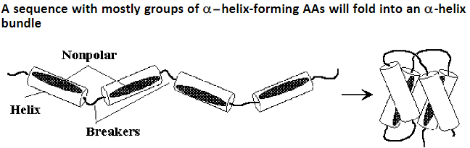
- Alpha helical bundles are interrupted at intervals by breaker amino acids forming the connecting loops
  - Often Pro is found near the N-Terminal of a helix while Gly often marks the C-terminal of each helix
  - Inward facing amino acids are mostly non-polar, interlock to hold the bundle together
  - Some ion pairs and H-bonds may link adjacent helices along the outer shell
- Since a helix has 3.6 amino acids per turn, or about 7 amino acids per 2 turns, the arrangement of P(polar) and N(non-polar) in sequence pattern similar to -PNNPPNP- will place all the nonpolar side chains on one face of the helix, leading to the folding similar to the image above.
  - Bundles of 6-10 helices appear more complex because the helices tend to splay apart.
  - Beta-sheet preferring amino acids are not absent, distribution is scattered so their “vote” is not effective
  - Alpha-helical amino acids are more clustered, more dominant presence, determine the secondary structure.
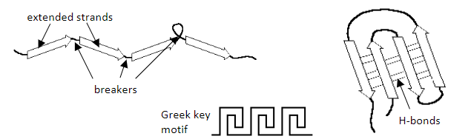
- A sequence with mostly groups of Beta-Sheet forming AAs folds into antiparallel Beta-Sheets
- Beta strands (extended strands)
  - Two strands connected by a turn naturally tend to form a hairpin structure
  - Hairpin that flops over gives rise to four-stranded unit called the Greek key
  - Since strands run in opposite directions, they line up into an Anti-parallel beta-sheet
  - Antiparallel is more stable due to the good alignment of H-bonds between strand
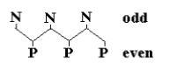
- Amino acids frequently arrange to alternate polar and non-polar side chains
  - Strand has a zig-zag backbone, this places all non-polar amino acids on one side of the sheet, and all polar on the opposite side
  - Sheet is sufficiently flexible that it can wrap around itself so that the nonpolar side chains face each other on the inside, leaving polar amino acids on the outside
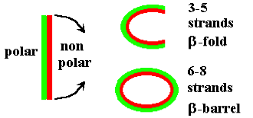
    - Open fold produced from a sheet of 3-5 strands
    - 6 strands or more, opposite edges can connect via H-bonds to produce a closed antiparallel Beta-barrel

- Proteins with Alternating B-strand and A-helix segments (ALPHA BETA BARRELS)
  - A parallel B-sheet (extended strains all running in the same direction) can’t form from one continuous polypeptide chain.
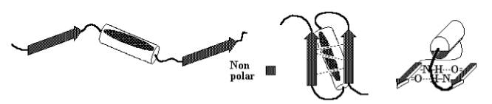
    - When a polypeptide consists of alternating B-strands and A-helix, this allows the polypeptide to run in one direction up the B-strains, and the back down through the connecting A-helix.
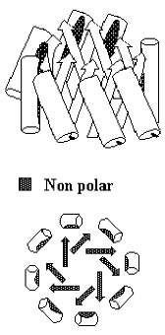
  - Proteins that alternate B-strands and A-helix can form multistranded parallel B-sheets
    - Parallel sheet is less stable, due to the angled H-Bonds, and is usually totally non-polar so the sheet is buried protected from contact with H₂O
    - If the helices all lie on one side of the sheet, the sheet folds on itself to form a barrel (shown on the right)
    - If helices lie on both sides of the sheet, this results in a sandwich structure
  - Parallel A/B sandwiches from when the connecting A-helices are arranged on both sides of a central parallel B-sheet
    - B-sheet is not flat, and is usually twisted, but does not wrap around to form a cylinder like a barrel.
    - Helices cover the central non-polar sheet and protect it from contact with H₂O
- Domains
  - Complex proteins are large enough to have several folding units or domains
  - Each domains of about 10-20 kDa folds up as an independent entity, so a large polypeptide of 50 kDa may be made up of 3 or 4 domains, each with its own folding pattern
- Protein Stability
  - Normal folded state or tertiary structure of a protein is called it native state
  - Exact spatial relationship of the amino acids in the native state give the protein a specific function
  - When the polypeptide is unfolded from its tertiary structure, the protein is said to be denatured
    - Spatial relationship of amino acids is disorganized, so a denatured protein loses all function
    - Protein in denatured state may exist as a long-extended polypeptide chain (by action of Sodium Dodecyl Sulfate in SDS electrophoresis)
    - Any other shape other than the native state, and the protein is rendered inactive and denatured.
- Covalent Bonding Determines the First Level of Protein Structure
  - Polypeptide backbone consists of a chain of covalently bonded amino acids linked in a specific sequence ---- Primary structure
  - Non covalent interactions give rise to secondary and tertiary structures and dictate the precise pattern of folding and stability of the folded form
    - Effects are hydrophobic interactions, van der Waal forces, hydrogen bonding and ionic
- Hydrophobic Effect
  - Describes tendency of non-polar amino acids to cluster in the core of a protein, to not contact water
    - Provides about 50% total energy that stabilizes the folded state of the protein.
    - Energy arises from the strong interactions between polar amino acids and the surrounding H₂O.
      - When non-polar amino acids concentrate in the interior, this maximizes the number of polar amino acids on the exterior, where they interact strongly with the surround H₂O.
      - Direct contact with non-polar amino acids has energetically unfavorable effects on the H₂O organization
- Van der Waals effect
  - Van der Waals forces are weak electrostatic attractions between atoms which are non-covalently bonded, but which are in close physical contact
  - Interactions arise because of random fluctuations in distribution of electrons around a nucleus creates a transient dipole
    - Can induce a neighbor to become polarised also, so they attract each other
    - Net effect is weak because the polarisation is temporary
    - Weak attractive force is called a London dispersion force
- Plot of Energy of Van der Waal interactions as a function of distance
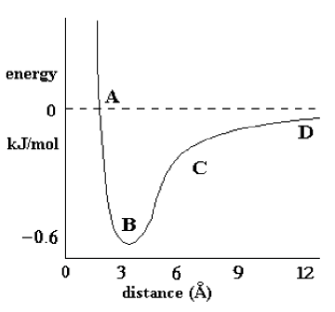
  - When non-bonded atoms are too close (A) there is a strong repulsion indicated by the steep negative slope and positive free energy
  - (B) represent optimum separation distance, about 3.4 A for a pair of C atoms
  - (C), a moderate attractive force (negative energy) exists provided the distance is no more than 2-3 atom diameters, otherwise the attractive force fades rapidly to zero
  - (D), small negative energy
  - Van der Waal forces are significant in proteins because thousands of atoms may be in close contact if sidechains in one region are correctly interlocked with a neighboring region.
  - If the two regions don’t fit, only a few atoms come into direct contact, and some atoms may be forced so close they end up repelling each other.
- Polar interaction also stabilize the folder structure of a protein
- Hydrogen bonds in the polypeptide backbone are important for secondary structures alpha-helix and beta-sheet. Some hydrogen bonds may form between adjacent side chains in the tertiary structure
- Ion pairs (salt bridges) are electrostatic interactions that result when a positive group, e.g. Lys or Arg, comes near a negative group, eg. Asp or Glu
- Ion pairs and H-bonds make less contributions than hydrophobic or van der Waals interactions, because most polar groups face the surrounding aqueous medium.
  - Majority of charged side chains simply pair up with solution ions e.g. K+ or Cl- or with dipolar water molecules rather than linking with other side chains
  - Same applies to H-bonding side chains since H₂O is an excellent H-Bonding Agent
  - Peptide backbone H-bonds involved in secondary structure generally need to be protected from the surrounding H₂O by the side chains of their constituent amino acids
- In the denatures state (unfolded) charged groups stabilize by hydration
- In the correctly folded state: charged groups stabilize by forming opposite pairs or remain hydrated
- In any wrongly folded state: charged groups that become unpaired, dehydrated or wrongly paired (+ve with +ve) will decrease stability of the misfolded form
- Disulfide bonds: covalent contribution to the tertiary structure of some proteins
  - Form between pairs of cysteines (-SH side chains) which are physically close to the folded protein
  - Hydrogen is removed from paired -SH groups by reactions with O₂
  - Disulfides require oxidising conditions, whereas conditions inside normal cells are often reducing, indicating that disulfides are not common
  - Limited to proteins outside of the cell
- The primary structure of a protein contains all the information needed to specify the normal secondary and tertiary structure
  - Demonstrated by Christian Anfinsen did an experiment in the early 1960’s
  - Answered the question how proteins fold
  - Started with the enzyme ribonuclease, a small protein of 124 amino acids, the enzyme is first treated with urea, NH₂CONH₂
  - Concentrated urea solutions weaken the hydrophobic interactions causing the protein to unfold or denature and lose ability to act as an enzyme
  - In addition, ribonuclease contains four disulfide bonds between cysteine side chains in specific pairs which are close together in the native state of ribonuclease
  - Reducing agent 2-mercaptoethanol HS-CH₂-CH₂-OH is added to reduce -S-S- bonds to individual -SH groups
  - Anfinsen demonstrated that unfolded ribonuclease can refold if urea was first removed to allow refolding, and then the sample was exposed to air to allow disulfides to reform.
    - Enzyme regains activity
    - Refolds to the original structure, indicating that the correct tertiary structure formed itself simply from the positions of specific amino acids in the primary structure or sequence
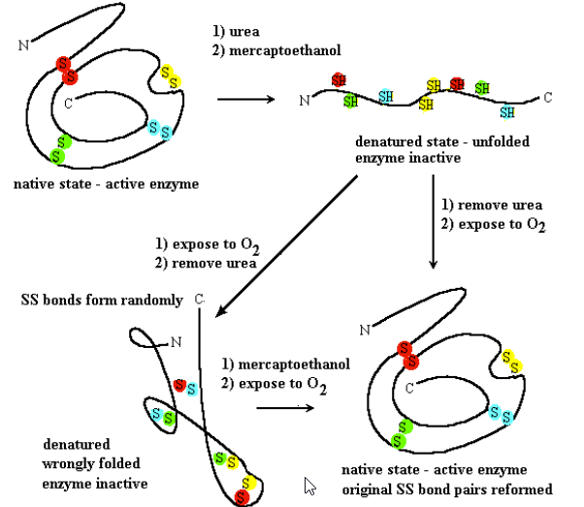
    - If unfolded ribonuclease is exposed to air before removal of urea, disulfides come together before the correct tertiary structure forms, but pair at random

LECTURE 8: Protein Binding & Recognition Chemical Basis of Enzyme Catalysis

- Enzymes catalyze a reaction on their bound target, speeding up reactions by a variety of catalytic effects, including proximity effect, orientation effect and chemical catalysis.
- Chemical catalysis lowers the activation energy E_{a} required for reaction by finding a better chemical pathway for the reaction
  - Achieved by nucleophilic catalysis, electrophilic catalysis, general acid or general base catalysis or by transition state stabilization
- Protein binding and recognition of other molecules
  - Proteins fold because one part of the polypeptide chain binds and recognizes other specific part of the same polypeptide
  - The same types of non-covalent interactions that cause a protein to fold can also be used to allow a protein molecule to bind any other kind of molecules.
    - Strong binding interactions require a complementary match between protein and bound molecule
    - Binding is highly specific and serves as a molecular recognition mechanism
  - Non-polar patches on the protein surface bind by hydrophobic effect
  - Complementary shapes maximize close contact – Van der Waal effect
  - Charged or H-bonding groups line up with complementary partners, e.g. Donor with acceptor, +ve with -ve
- Each protein has a unique shape and can bind specific target molecules
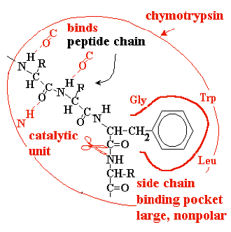
  - If a protein binds another molecule, the interaction is non-covalent and reversible
  - Bonding refers to the covalent links between two parts of a molecule
  - Example – binding and recognition of target peptides by peptidases of the chymotrypsin family
    - Peptidase = generic name for enzymes that catalyze hydrolysis of peptide bonds
    - Chymotrypsin and other enzymes have a groove in their molecule that accommodates a target peptide chain, and forms hydrogen bonds to its backbone CO and NH groups.
    - Hydrophobic pocket in the chymotrypsin fits a side chain with an aromatic ring, e.g. Phe, Tyr or Trp
    - Binding of the target peptide is much tighter if this pocket is occupied by an appropriate amino acid, and in this position peptide bond on the carboxylate side of the aromatic amino acid next to the catalytic component of chymotrypsin, which proceeds to hydrolyze that bond.
    - Binding pocket is formed by amino acids Gly, Trp and Leu of the chymotrypsin molecule

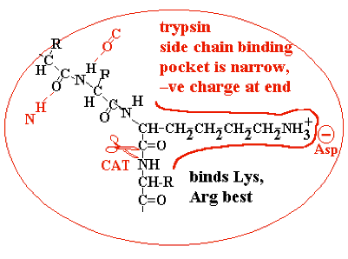
- Trypsin is similar but the pocket is narrower, and the trypsin has a negatively charged aspartate in the back of the pocket
  - Target peptide now fits best in the binding pocket with an amino acid having a long side chain with a positive charge at the end
  - Lysine or Arginine are bound and recognized
  - Hydrolysis occurs on the next peptide bond

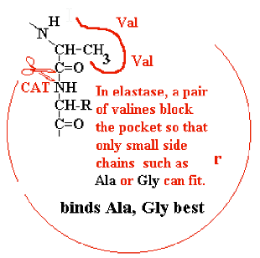
- Elastase is similar to chymotrypsin, but part of the pocket is blocked off by a pair of bulky valines
  - Best fit for the target peptide occurs if it places alanine or glycine in the binding

- Enzyme catalysis
  - Enzymes are proteins that bind target molecules and catalyze a specific reaction
  - Suffix -ase at the end of a protein indicates an enzyme
    - Ribonuclease breaks down RNA by hydrolysis
    - Peptidase breaks peptide bonds by hydrolysis
  - A target molecule bound to and reacting on the surface of the enzyme is called the substrate of the enzyme
  - Enzyme catalyze reactions that might otherwise occur spontaneously, but at a very slow rate
    - Enzymes may speed up reactions anywhere from 10⁶ to 10¹⁷ fold
  - Uncatalyzed reactions are slow because of the random nature of the process
  - Molecules must first collide, and they must also be in the right orientation and possess a critical threshold energy, in order to react
    - Energy is exchanged through collisions
  - Rate = (p)(z)(e)^{-(ea/rt)}
    - Z is the collision frequency
    - P is the probability factor, relates to the relative orientation of reacting molecules
    - E_{a} is the activation energy. Minimum energy a molecule must possess to initiate the reaction
    - E^{-(Ea/RT)} is the fraction of molecules at temperature T (Kelvin) which possess energy E_{a}; value tends to zero as E_{a} increases (E_{a} is always postivie), so E_{a} should be as low as possible
  - Can speed up a reaction if we can increase p or Z, or decrease E_{a}
  - Proximity effect: enzymes bind their substrates so their reactive groups are brought close together and stay together long enough for the reaction to proceed. This eliminates randomness of collision in free solution (increases Z)
  - Orientation effect: even if two molecules manage to meet by random collision, their reactive groups are not necessarily pointed in the right direction to proceed with the reaction
  - Binding of substrates by enzymes involves very specific interaction, substrates of enzymes are precisely positioned, and reactive groups are well aligned. This eliminates randomness of substrate orientation (increases p)
    - Randomness can be represented by entropy; so the proximity effect and orientation effect both reduce the activation entropy of the reaction
  - Proximity effect is the elimination of translational entropy
  - Orientation effect is the elimination of rotational entropy
  - These entropies can be calculated at any given temperature and this allows us to estimate that a theoretically perfect enzyme could speed up a reaction 10⁵ fold by the proximity effect and by 10⁵ fold by the orientation effect.
  - Overall causing a 10¹⁰ fold speed up for the combination of both those effects.
- How enzymes decrease E_{a}
  - Chemical catalysis – the enzyme provides a reaction pathway that is better than the uncatalyzed reaction. At 298K E_{a} is reduced by 5.7kJ increasing the rate 10-fold
  - H₂O alone, the reaction is incredibly slow
  - :O is a poor nucleophile and an excessively weak acid
  - :O is very electronegative and reluctant to share its electrons
    - Reaction is radically speeded up by using -OH, a much better nucleophile due to the excess negative charge, or H₃O+, an excellent proton donor
    - Most biochemical reactions happen close to pH 7, so strong acid/base are ruled out
    - Nor can the temperature be raised, which is a common trick used to speed up reactions in chemistry, but in biochemical processes this is not possible
- Enzymes speed up reactions at normal pH and temperature
  - Nucleophilic catalysis
    - Reaction is initiated by a nucleophile on the enzyme, e.g. CysSH, His, or Asp/Glu-, more rarely TyrOH, SerOH or LysNH₂
    - Nucleophules act by donating a lone pair to an electron deficient C atom in the substrate (e.g. C=O groups)
  - Electrophilic catalysis
    - Electrophile is a species, which react by attracting electrons from a reactant
    - No excellent electrophiles among amino acids, but enzymes recruit a non-amino acid helper molecule called a prosthetic group
    - Prosthetic group is bound into enzymes active site like the substrate
    - Zn²⁺sometimes functions this way, and is found in the active site of carboxypeptidase A, an enzyme that hydrolyzes a single amino acid from the C-terminus of a peptide chain
- General Acid and General Base Catalysis
  - Catalysis by weak acid or weak base functional groups that donate a proton to or steal a proton from the substrate
  - Enzyme can position an acidic or basic group in a confined space in close proximity to the substrate
  - If a single H+ donor is localized in a small volume, it behaves as if the concentration of the reactive group is very high, without altering the pH of the general environment
    - Each of these effects can contribute a factor of about 10² fold to speed up the overall enzyme catalyzed reaction
- Transition State Stabilization
  - Reactions pass through a transition state which represents an energy maximum
  - E_{a} is the energy needed to get up to the transition state
  - By shaping the active site of the enzyme so it fits the transition state even better than the substrate, E_{a} can be significantly lowered
  - When the substrate binds, the enzyme may stretch or distort a key bond and weaken it so that less activation energy is needed to break that bond at the start of the reaction.
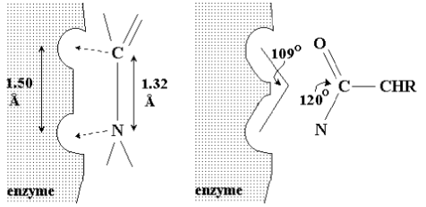
  - The transition state of a reaction has a different geometry at the key atom (e.g. tetrahedral instead of trigonal planar). By optimizing binding of a tetrahedral atom, the substrate is helped on its way to reaction

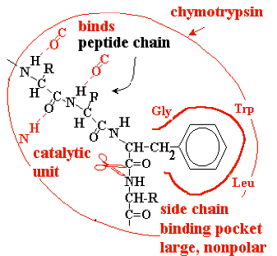
LECTURE 9: The Catalytic Mechanism of Chymotrypsin & Measuring Activity
- Chymotrpypsin binds the substrate peptide into a groove on the surface of the enzyme
  - Weak binding occurs via hydrogen bonds to the NH group of the target amino acid and to several backbone CO or NH groups preceding, so the enzyme selects a peptide chain as its substrate
  - Strong binding of target amino acid occurs when its benzene ring side chain fits in a hydrophobic pocket on the surface of chymotrypsin
  - If the substrate peptide chain contains one of the target amino acids, the peptide bond immediately following the target is positioned precisely next to the catalytic components
- Peptide hydrolysis by H₂O without the help of a catalyst
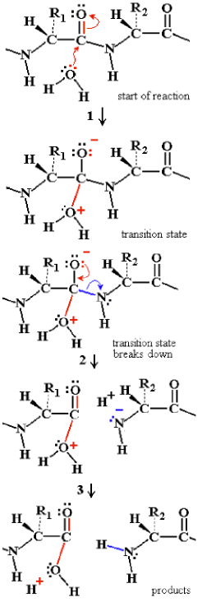
  - H₂O acts as a nucleophile:
    - (1) a lone pair from the water is donated to C of C=O due to C with a partial positive charge (bonded to electronegative O)
      - C cannot accommodate more than 8 valence electrons, so the electronegative O atom withdraws a bonding electron pair to itself
      - Transition state forms a semistable oxyanion -O⁻ and the attacked C atom goes from initial sp² state (trigonal planar) to sp³ (tetrahedral) in the transition state
    - (2) if the transition state breaks up allowing N to withdraw its bonding electrons, the peptide bond is broken
    - The products stabilize by exchanging protons
    - (3) to become neutral; additional proton exchanges with the surrounding H₂O may then lead to -COO⁻ and NH₃⁺ groups, and the reaction is complete
    - (2B) if the unstable transition state breaks up by withdrawing electrons back to the original H₂O, the reactants are restored without any chemical change having taken place and the reaction has no outcome

- Problem With Hydrolysis By Neutral H₂O
  - H₂O is not a very good nucleophile because O is too electronegative to share its lone pair of electrons
  - OH would be much better, but not enough is available at normal pH.
  - H₂O is also a good leaving group, so the transition state may go back to starting materials and thus not lead to a net reaction.
  - As a result the uncatalyzed reaction is extremely slow, about one reaction every 10 years
  - At high pH, OH⁻ will be a better nucleophile, and at low pH, H⁺ stabilizes the transition state and makes the N into a better leaving group by adding H⁺. However a biological catalyst must be able to function close to pH 7
- Chymotrypsin makes a multi-pronged attack to give about 40 reactions per second (4x10⁹ fold increase in reaction rate
  - Chymotrypsin uses a better nucleophile in the form of the catalytic triad – Asp 102, His 57, Ser 195 side chains
  - Transition state is stabilized by the oxyanion hole -Gly 193 and Ser 195 peptide backbone -NH- groups
  - Reaction take in 2 easy steps rather than 1 difficult step
- Step 1:
  - Nucleophile in the enzyme attacks the target peptide bond, splitting the C-terminal half of the substrate peptide
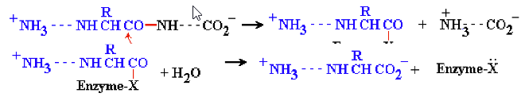
  - N terminal half remains covalently bonded to the enzyme to form a reaction intermediate
- Step 2:
  - Enzyme recruits H₂O splitting off the N-terminal half of the substrate, restoring the enzyme to its original state
- Catalytic Triad:
  - 3 amino acid side chains, far apart in the polypeptide, but brought physically close together by the folding of chymotrypsin
    - 1) Aspartate 102 is a negative carboxylate, isolated inside the protein away from external aqueous solution at chymotrypsin surface; it would like to have a +ve charged partner
    - 2) Histidine 57, a weak base, could be positive but is only weakly protonated since its side chain has a pKa = 6.5
    - 3) Serine 195, side chain CH₂-OH is not a good nucleophile unless it can get rid of the proton, but by itself this does not happen

- Step 1 of the Catalytic Reaction
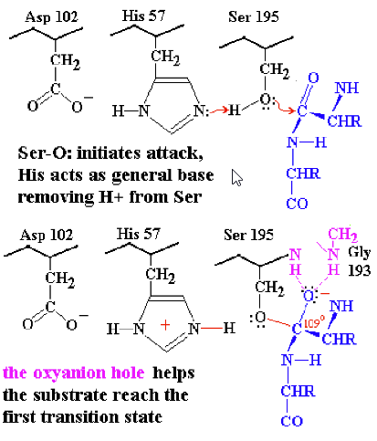
  - Substrate binds to the enzyme with its target C=O group next to Ser 195 (substrate is shown in blue) the catalytic triad (shown in black) and electron exchanges (shown in red)
  - Cooperative action among the catalytic triad helps form the first transition state
  - His 57 acts as a general base by removing a proton from Ser-OH, and this helps the Ser O: make its nucleophilic attack on the substrate C=O, while negative Asp 102 promotes formation of HisH+
  - Oxyanion hole is also part of chymotrypsin and consists of the peptide backbone -NH- groups of Gly 193 and Ser 195 (shown in pink)
  - N-H groups are positioned in such a way that they can donate strong H-bonds to the substrate C=O, but only if the C atom is tetrahedral as found in the transition state.
  - This strains the bonds of the trigonal planar C=O of the original substrate, helping the reaction to proceed to the transition state
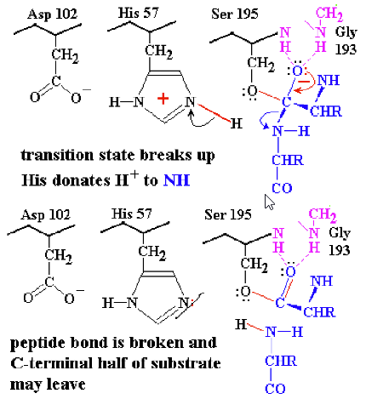
- Breakdown of the first transition state and formation of the intermediate
  - Transition state is broken up by cleavage of the peptide bond following the target amino acid
  - Histidine now acts as a general acid, donating its proton to the N atom so that it is a better leaving group
  - After gaining a proton from His 57, a neutral NH₂ group is formed, so the C-terminal half of the substrate is no longer bonded to the enzyme and is free to leave
  - Remainder of the substrate remains bonded via its carboxylate group in an ester bond to Ser 195
    - This is called the acyl-enzyme intermediate
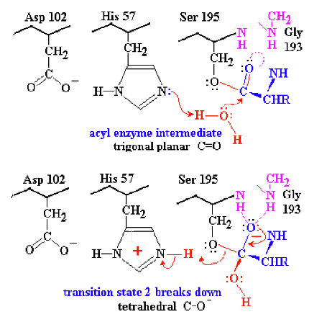
- Step 2:
  - With half of the substrate out of the way, there is not room for an H₂O to get into range of the catalytic triad
  - His 57 acts as a general base to remove a proton from H₂O, enhancing the nucleophilic power of the O in H₂O (much like the earlier step with Ser 195)
  - H₂O can now attack the substrate
  - Transition state 2 breaks up by HisH+ 57 acting as a general acid to donate the proton back to Ser 195, in turn breaking the Ser-O to substrate C-O ester bond

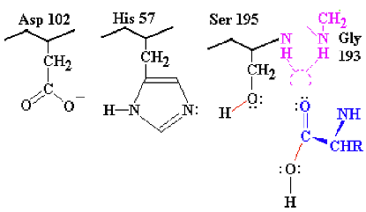
- Final Result:
  - N-terminal half of the original peptide substrate now carries the target amino acid at its newly formed C-terminus. This is now free to leave in the form of a carboxylic acid, since the C=O is trigonal planar and pops out of the oxyanion hole

- Some Points to Note
  - At the end of the reaction, the catalytic triad is back to the original state
  - A single enzyme molecule can go through this cycle of reactions with other substrate molecules millions of times over
  - Ambivalent behaviour of His 57 is critical to this process. Because the pka of His is about 6.5, His is able to protonate and deprotonate almost equally well and won’t commit to staying protonated
  - Deprotonated His 57 acts as a general base, removing the proton from Ser 19 to form transition state 1, and again removing the proton from H₂O to form transition state 2
  - Protonated HisH+ 57 acts as a general acid donating a proton back to the departing amino group, and then finally to replace the proton on Ser 195

- Enzyme assay is the process or measuring enzyme catalyzed reaction rate
- Enzyme Kinetics: Mathematical analysis of how the observed reaction rate varies with substrate concentrations; kinetic behavior can be used to test models of reaction mechanism (rules out wrong models)
- Measuring of enzyme rate:
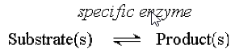
  - Enzyme is placed above the reaction arrow because it’s a catalyst, not consumed in the reaction
  - Complete reaction cycle restores the enzyme to its initial state
  - To measure reaction rate, some property difference between reactant and product must be identified. Rate can be measured as disappearance of reactant or accumulation of product
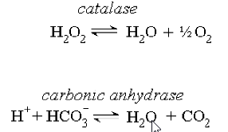
  - Examples:
  - Measure volume of O₂ gas produced

  - Measure pH increase as [H+] is consumed
  - It is more difficult when the reactants and products are chemically similar
  - Can separate the products and analyze each one, but this would be a lot of work
- More efficient method for trypsin and other hydrolytic enzymes:
  - Artificial Substrate: A compound with a structure similar to the real substrate that the enzyme is fooled and binds and reacts with the artificial substrate, but is designed so that one of the products has a distinguishing property
    - Trypsin, a short peptide ends in lysine, however the lysine is amide-bonded to p-nitroalanine
    - Trypsin binds and recognises the peptide sequence ahead of the lysine, so the nitroanilide bond is accepted as if it was a peptide bond, and is a target for hydrolysis
    - Trypsin proceeds to hydrolyze the amide bond between lysine carboxylate and the aniline NH₂
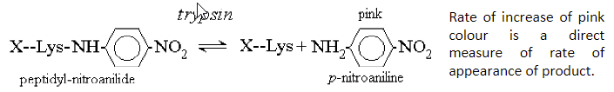
    - Free p-nitroaniline has a distinctive colour, which is easily measured
- Some natural substrates show absorbance change on conversion to product:
  - Lactate dehydrogenase oxidizes the secondary alcohol in lactate to a carbonyl in pyruvate
  - LH removes 2 H atoms (not H+) from the substrate hence the enzyme named dehydrogenase
  - 2 H atoms are donated to a common biological oxidizing agent, NAD+, nicotinamide adenine dinucleotide, which is reduced to NADH + H⁺
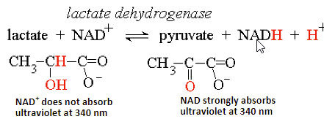
    - Many metabolic enzymes follow this naming pattern: name of substrate + type of process
    - This reaction progress can be monitored by measuring the ultraviolet absorbance increase at 340 nm due to the formation of NADH
- Coloured or Ultraviolet absorbing molecules possess Chromophores
  - A chromophore is part of a molecule that contains conjugated double bonds, a series of at least two double bonds that alternate with single bonds, e.g. N-C=C-C=O
  - Chromophore absorbs visible (400-700 nm wavelength) or ultraviolet light (200-400 nm)
  - Compounds that absorb visible light appear with a colour opposite to what is absorbed, so a compound that absorbs blue light appears yellow
  - Large chromophores with many conjugated double bonds tend to absorb at longer wavelengths e.g. heme, the red pigment in blood
  - NADH has a relatively small chromophore, so absorbs ultraviolet at 340 nm
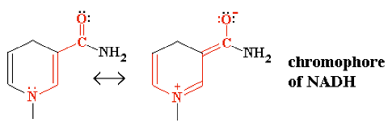
  - Alternative resonance form extends the chromophore through the N atom to the third double bond
  - Absorbance measurement for ultraviolet or visible light
    - Absorbance is measured in a spectrophotometer, which provides a light source with selectable wavelength in the range 200-700 nm (ultraviolet and visible light)
    - Sample is contained in a square chamber or cuvet of exactly 1.00 cm thickness
    - Light passing through the sample is then measured and recorded by a detector
    - If light is absorbed by the sample, the measured intensity I passing through the sample is less than the original intensity of the beam Io
    - Absorbance A of the sample is defined as A = log10 ( ^{I}O/I), so if 90% is absorbed, I = 0.1 and A = log10 = 1.000
    - Most spectrophotometers read out directly in absorbance units in ranges 0-3.0000, so the user never had to deal directly with intensity ratios
- Absorbance sample is directly proportional to concentration (Beer’s Law) and to Sample thickness (Lambert’s Law)
- When these two relationships are combined, we get the Beer-Lambert equation
- Absorbance A=ϵlc
- Where ϵ = extinction coefficient, a characteristic constant for a given absorbing substance
- C = concentration of sample
- l = thickness of sample in cm

LECTURE 9: Enzyme Kinetics & The Michaelis-Menten Equation
- Quantitative description of enzyme catalysis
  - Rate of reaction: Concentration of substrate disappearing per unit time (mol/L/S)
  - Or: concentration of product produced per unit time (mol/L/s)
  - Enzyme activity: moles converted per unit time = rate x reaction volume
    - Measure of quantity of enzyme present. SI unit is the katal, 1 katal = 1 mol/s but this is excessively large
    - More practical value is 1 enzyme unit (EU) = 1 micro mol / min (micro = 10⁻⁶)
  - Specific activity:
    - Moles converted per unit time per unit mass of enzyme
    - Enzyme activity / actual mass of enzyme present
    - SI units = katal / kg ------ more practical units = micro mol / mg / min or micro mol / micro gram / min
    - The measure of enzyme efficiency, usually constant for a pure enzyme
    - If the specific activity of 100% pure enzyme is known, then an impure sample will have a lower specific activity, allowing purity to be calculated
    - Purity = (100) x (specific activity of enzyme sample) / (specific activity of pure enzyme sample)
    - Impure sample has a lower specific activity because some of the mass is not actually enzyme
    - Turnover number = (moles of substrate converted per unit time) / (moles of substrate)
      - = specific activity x molar mass of enzyme (some unit conversion is necessary)
    - Multiplying mass by molar mass converts specific activity (per unit mass) into activity per mole
    - If n moles of substrate are catalyzed by one mole of enzyme per second, then n molecules of substrate are catalyzed by each molecule of enzyme per second
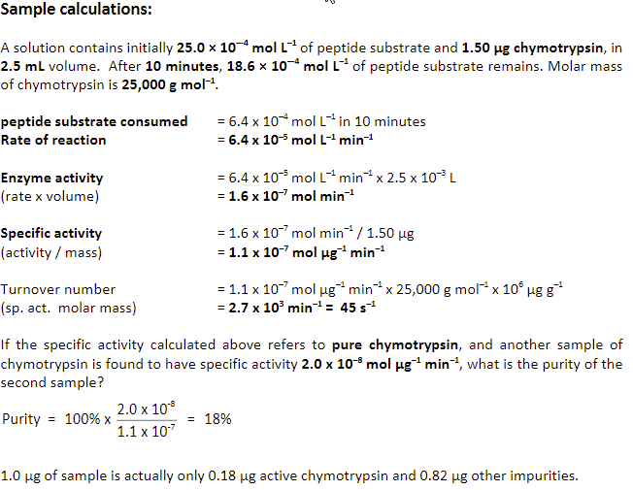
    - Hence turnover number represent the number of times per second that the enzyme completes a reaction cycle
- Enzyme Kinetics
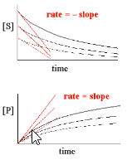
  - Reaction rate and chemical kinetics
  - If decrease in substrate or increase in product concentration is measured over a period of time for an enzyme catalyzed reaction, the data can be plotted as a curve called the progress curve
  - Reaction rate is the slope of the curve. The initial reaction rate is given the symbol v_{o} and is the tangent to the progress curve at time 0 (negative tangent if disappearance of reactant is measured) Some enzyme reactions remain linear for a significant time, making slop measurements easier; some reaction follow curves as in the example
  - If several experiments are run, each with a different initial concentration of substrate, each experiment produces a different progress curve with one value of initial rate v_{o} for each curve measured
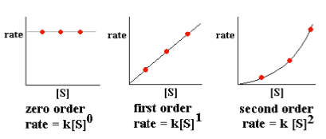
  - The initial rates are then plotted as a function of initial substrate concentration (S). Normal chemical reactions follow simple rate laws, which describe how rate varies as a function of reactant or substrate concentration
- Enzyme catalyzed reaction does not follow a simple rate law
  - Although v_{o} is directly proportional to [E], concentration of enzyme, initial rate v_{o} is a complex function of [S], substrate concentration
- Interpretation of Initial Velocity Dependance on [S]
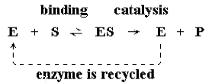
  - First worked out by Henry and subsequent verified experiments by Michaelis and Menten
  - Although the overall reaction appears to be S P the underlying process is more complex and can be interpreted as a two-step reaction
  - (1) the enzyme is a catalyst and is recycled in an unchanged state by the end of the reaction process, so the total quantity of enzyme [E] does not change as the reaction proceeds
  - (2) if we deal only with initial reaction rate v_{o}, when the product P is not yet present, there will be no reverse reaction ES E + P at the catalytic step to complicate matters. Omitting this reverse reaction will make the algebra more manageable
  - (3) Each stage in the reaction has an associated rate constant, K₁, K₂, plus K₋₁ for the reverse step of step 1. K₂ is sometimes described as K_{cat}, the rate constant for catalysis
  - Rate of appearance of product P describes overall rate of the complete enzyme reaction, and can be determined by taking the rate of step 2, which is a fundamental chemical process, for which we can write the first order equation
    - V_{o} = K₂ [ES]
    - Where [ES] is the concentration of enzyme actually occupied by substrate
    - Although we know [E]total because that is how much enzyme we put into the reaction, we do not explicitly know what fraction of enzyme is empty E and what fraction is occupied ES so [E] and [ES] are unknown values, but related by the equation =
      - [E]total = [E] + [ES]
    - We can determine [ES] algebraically
      - Breakdown of ES
        - Rate of formation of ES = K₁ [E][S]
        - Rate of breakdown of ES = K₂[ES] + K₋₁ [ES] (forwards + reverse)
      - Steady state conditions of Briggs and Haldane States that
        - Rate of breakdown = rate of formation
      - If the rate of breakdown happens to be greater than the rate of formation, [ES] will decrease causing the rate of breakdown to slow down
      - If the rate of breakdown happens to be less than the rate of formation [ES] will increase, causing the rate of breakdown to speed up.
      - Hence the two rates rapidly tend to match each other
      - Thus we can write (K₂ + K₋₁) [ES] = K₁ [E][S]
      - Divide by K₁ to put all the constant on the left, and let K_{m} = K₂ + K₋₁ / K₁
      - K_{m}[ES] = [E][S] but both [ES] and [E] are unknown
      - Now use the relationship [E] = [E]total – [ES] to eliminate the second unknown value [E] K_{m} = ([E]total – [ES]) [S]
      - Then take the term [ES][S] over to the left side
        - (K_{m} + [S]) [ES] = [E]total [S]
        - And divide by (K_{m} + [S])
        - [ES] = [E]total [S] / K_{m} + [S] where [E] Total and [S] are known values and K_{m} is a constant
      - This is used to replace the [ES] in the rate equation V_{o} = K₂[ES]
        - V_{o} = K₂ [E]total [S] / K_{m} + [S]
      - The maximum observable rate V_{max} occurs when 100% of the enzyme is occupied by substrate, so [ES]_{max} = [E]_{total} where [E]_{total} is a measurable quantity
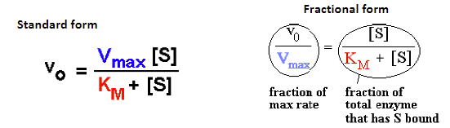
      - Thus we can write V_{max} = K₂[E]_{total} and replace K₂[E]_{total} in the equation above with V_{max} to get the Michaelis-Menten Equation

- The Michaelis-Menten equation shows how V_{o} varies as a function of substrate concentration [S] in terms of two constants V_{max} and K_{m}

- Every enzyme has characteristic values of K_{m} and V_{max} that describe its catalytic behaviour
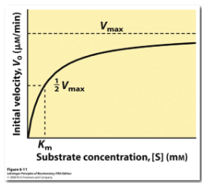
  - V_{max} is the theoretical upper limit for the observed rate, where the kinetic curve levels off at high [S]:
  - When V_{o} approaches V_{max} almost all of the enzyme is in the occupied ES state, and the enzyme is said to be saturated with substrate
  - The Michaelis constant K_{m} is the concentration of substrate needed to give a rate of exactly 0.5 V_{max} [S] = K_{m} when V_{o} = 0.5 V_{max}
  - K_{m} has units of concentration, and typical K_{m} values are between 10⁻⁶ M and 10⁻² M
  - Low K_{M} indicates that the enzyme binds and utilizes the substrate well; a lower [S] is sufficient to occupy the enzyme
  - A high K_{m} indicates that the enzyme binds and utilizes the substrate poorly; a higher [S] is need to get S to occupy the enzyme

