Experiment Title:
A Kinetic Study: Catalase

Author(s) Name(s):
Mustafa Warsame (0300116411)
&
Youssef Yacout (0300106440)

TA (Demonstrator)’s Name:
Mr. Ali Mansour

Date Experiment Performed:
Thursday, Nov 28th, 2019

Date Experiment Submitted:
Friday, Dec 6th, 2019

Introduction:

Often present within the human body as a metabolic material is the toxic substance called hydrogen peroxide (H2O2) used as a mild household cleaning agent, which can be extremely dangerous (Schwarcz, 2017). H2O2 is implicated in "degenerative diseases such as diabetes, cataract, leukaemia and Lou Gehrig's disease, developmental degenerative mechanisms such as ageing and apoptosis, macrophage-mediated pathogens death and stress response activation" (Willekens et al., 1997). The way the human body gets rid of hydrogen peroxide is by creating a catalase enzyme. Catalase is used to break down H2O2 into the innocuous H2O and O2 compounds. Catalase is developed not only in human bodies, but also in vegetables such as onions, celery and lettuce (Cheung, 2007). Catalase is also known as a catalyst as it accelerates H202's decomposition. The reaction speed can therefore be calculated using the following equation:
Rate = k[H2O2]^{x} [catalyst]^{y}
In this formula, the k value is the constant frequency, the x exponent is the partial order of the H2O2 reaction, and the y exponent is the partial order of the catalyst reaction.
The exponent to which a molecular species concentration is elevated is assumed to be the order of reaction, it determines what effect a species concentration has on the rate of reaction and which species has the most significant effect. It is obvious that by summing the exponents of the reactants present in the rate law equation, the reaction order can be calculated from the rate law.
The initial value can be defined as the instantaneous rate at the beginning of the reaction when t=0 when calculating the frequency of a reaction using graphical methods. As far as the diagram is concerned, it is equal to the negative of the reactant concentration curve gradient versus time at t=0. The following formula can best describe the kinetics of the reactions in decomposition:
K = A e^{-Ea/RT}

This formula is commonly referred to as the equation Arrhenius. The activation energy(EA) is the minimal amount of energy required for the reaction to occur and is calculated in units kJ mol-1, R is assigned the value 8.314 J K-1mol-1, T is the temperature in Kelvin, e is the basis of natural logarithms, and A is the pre-exponential component (Vyazovkin, 2001). Arrhenius equation is used to calculate the constant rate and can be used to determine the energy of activation.
Through doing the following experiment, one can evaluate the exponent(x), which is the partial order of the H2O2 reaction. This was achieved by adjusting each trial's concentration of H2O2. The activation energy was also calculated for each given temperature by performing the experiment at different temperatures and by calculating the resulting frequency constant. Through holding those parameters unchanged, the optimal experimental variable can be calculated. During the test, temperature remained constant as [ H2O2], T varied, and [ catalase] remained constant as well. Nevertheless, [ H2O2] and [ catalase] remained constant while T changed.
The selected test values were determined by the amount of resources available. It was also clear that catalase was extracted from the lettuce by combining the lettuce with water and pressing the catalase into a bowl using a rag. In order to prevent oxidation, the catalase was then covered.

After considering the different resources present and acknowledging that the rate law for the decomposition of H2O2 catalysed by the catalase, extracted from the lettuce and KI (potassium iodide) had to be determined, it was established that the experiment would be conducted using the Vernier gas-pressure sensor connected to LabQuest 2. The reaction rate was calculated by measuring the frequency at which the material was produced by oxygen gas, O2.

Materials:
- Gas pressure sensor
- LabQuest 2
- Thermometer
- Romaine Lettuce
- Blender
- Hydrogen Peroxide
- Distilled Water
- Pressure-probe sensors
- Erlenmeyer flask
- Ice water bath
- Hot Plate

Procedure:

Part A:
To create catalase:
- Tear leaf into smaller pieces and place in blender.
- Add 40 mL of distilled water to the blender and blend until thoroughly blended.
- Place cloth in a beaker and pour the substance in the cloth.
- Squeeze the liquid through the cloth into the beaker until no more can come out.
- Place the beaker with the catalase in an ice bath and cover to keep the catalase from getting oxidized.

Part B:
- Wear safety goggles.
- Place 3 mL of H₂O₂ and 2 mL of distilled water in a vile.
- Place 10mL of catalase in a flask.
- Use tweezers to place the vile into the flask in a way where the vile will not tilt and the H₂O₂ will not mix with the catalase
- Connect the pressure tube onto the flask and to LabQuest (While doing so, use two fingers to secure the tube and keep a tight cover while swirling).
- Tip the vile to mix the H₂O₂ with the catalase and swirl gently and start recording on LabQuest.
- Stop recording once the pressure starts to plateau.
- Repeat steps 1-7 using 2 mL of H₂O₂ with 3 mL of distilled water.

Part C:
- Wear safety goggles.
- Place 5 mL of H₂O₂ in a vile
- Place 10mL of catalase in a flask.
- Place the flask onto a hot plate.
- Place a thermometer into the flask, increase the temperature of the catalase to 30 degrees and keep it at that temperature.
- Use tweezers to place the vile into the flask in a way where the vile will not tilt and the H₂O₂ will not mix with the catalase
- Connect the pressure tube onto the flask and to LabQuest.
- Tip the vile to mix the H₂O₂ with the catalase and swirl gently and start recording on LabQuest (While doing so, use two fingers to secure the tube and keep a tight cover while swirling).
- Stop recording once the pressure starts to plateau.
- Repeat steps 1-9 with 32 degrees.

Part D:
- Wear safety goggles.
- Place 5 mL of H₂O₂ in a vile.
- Place 10 mL of KI in a flask.
- Place the flask onto a hot plate.
- Place a thermometer into the flask, increase the temperature of KI to 50 degrees and keep it at that temperature.
- Use tweezers to place the vile into the flask in a way where the vile will not tilt and the H₂O₂ will not mix with the solution of KI
- Connect the pressure tube onto the flask and to LabQuest.
- Tip the vile to mix the H₂O₂ with the KI and swirl gently and start recording on LabQuest. (While doing so, use two fingers to secure the tube and keep a tight cover while swirling)
- Stop recording once the pressure starts to plateau.
- Repeat steps 1-7 with 55 degrees.

Graphs:

Figure 1.1: 3 mL water and 2 mL H₂O₂ Trial 2
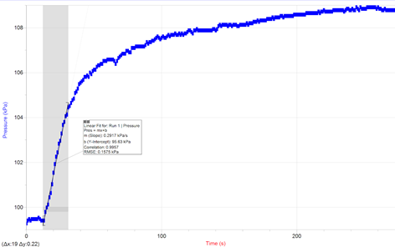

Figure 1.2: 3 mL water and 2 mL H₂O₂ Trial 3
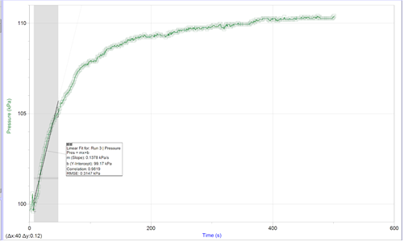

Figure 2.1: 2 mL water and 3 mL H₂O₂ Trial 2
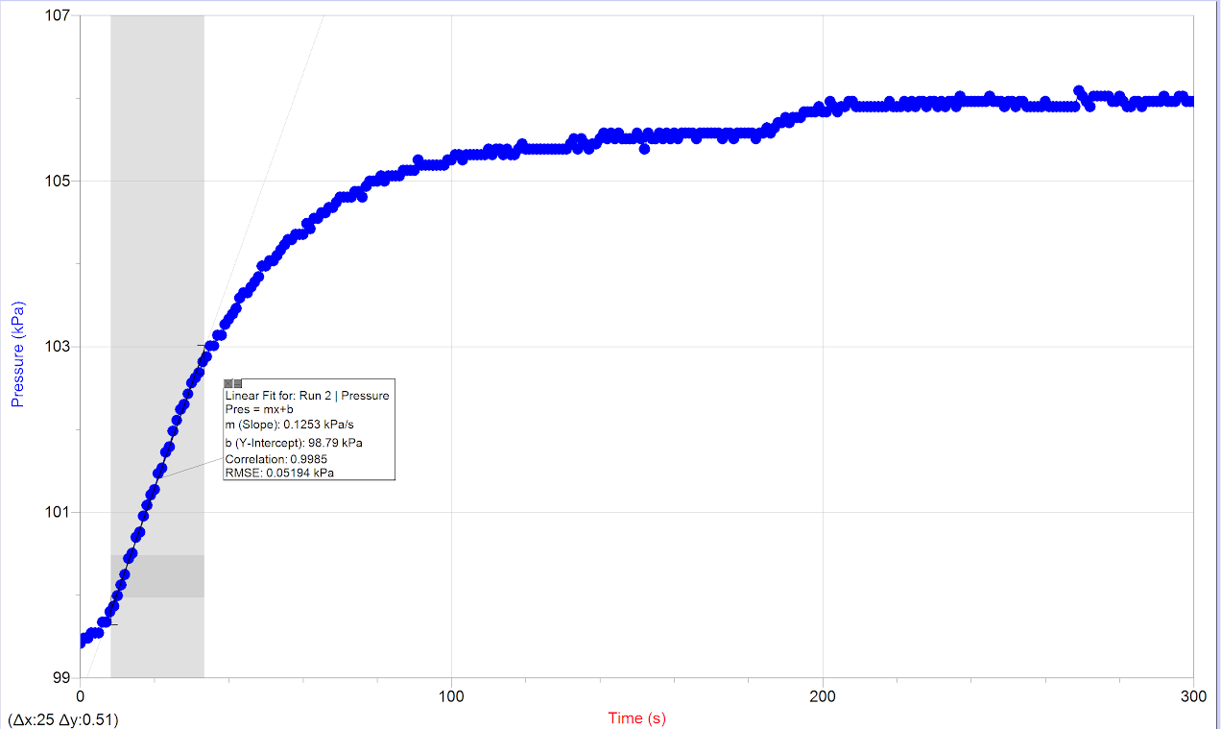

Figure 2.2: 2 mL water and 3 mL H₂O₂ Trial 3
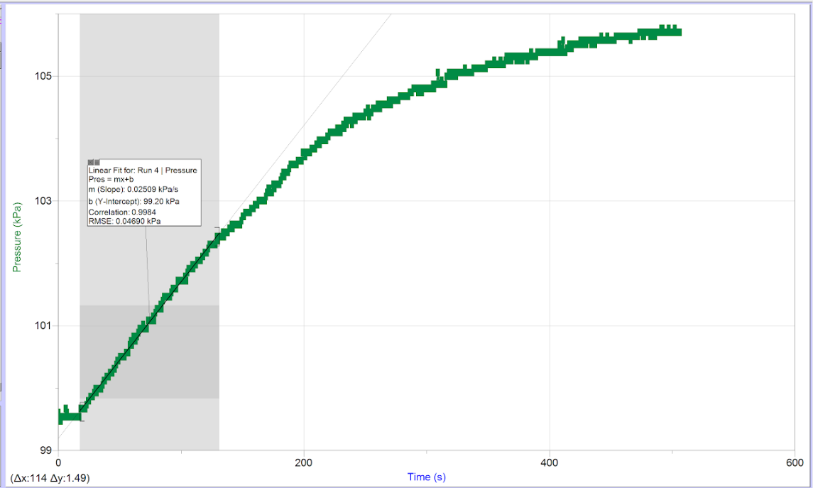
Figure 3.1: 2.5 mL water and 2.5 mL H₂O₂ Trial 1
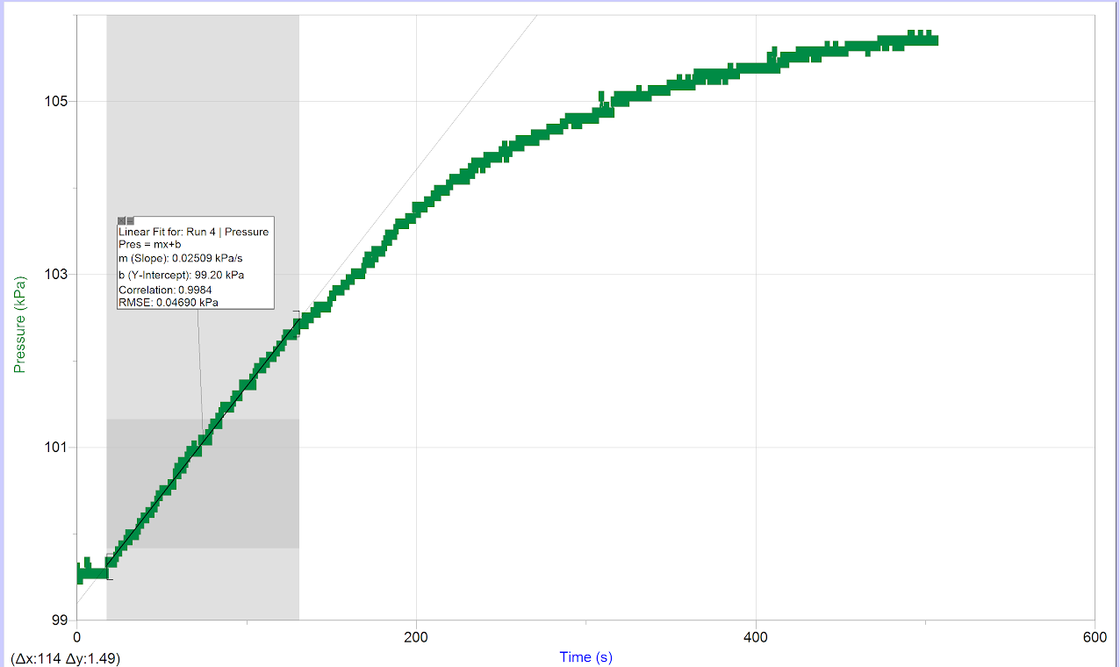

Figure 4.1: Part A, graph of ln (Rate) over ln[H₂O₂] with respect to overall class trials

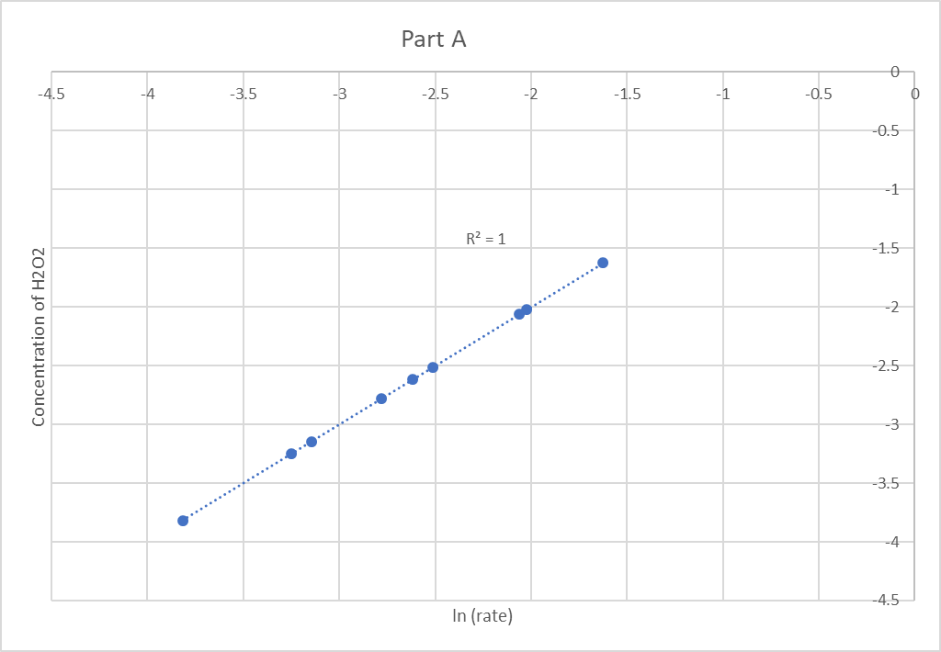

Figure 4.2: Part B, graph of ln (Rate) over 1/T with respect to overall class trials
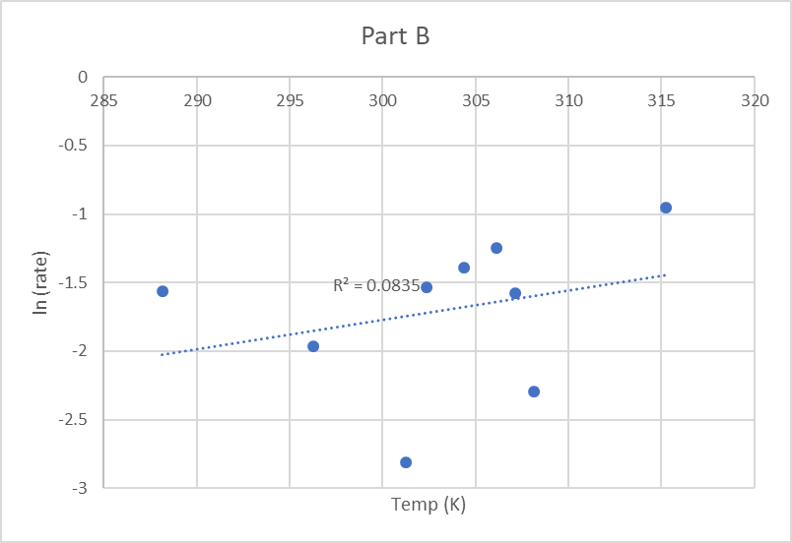
Figure 4.3: Part B, graph of ln (Rate) over 1/T with respect to overall class trials

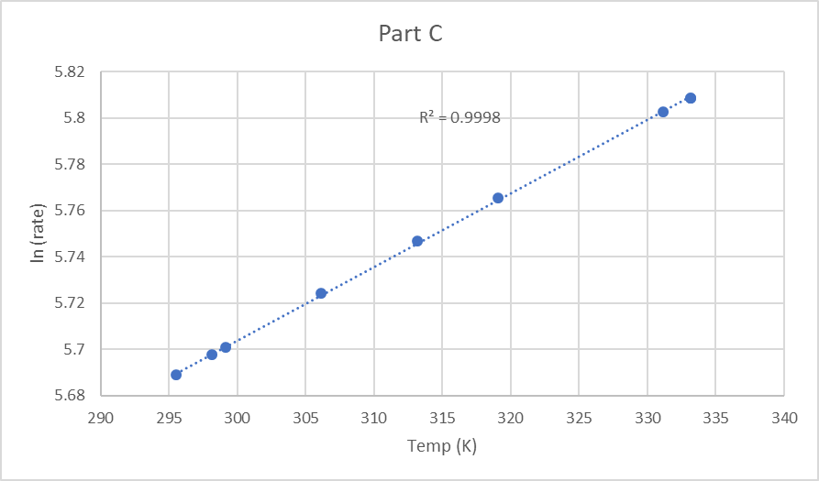

Quantitative Observations:
Table 1.1: 3 mL water and 2 mL H₂O₂
Trial 1
Time (sec) | Pressure (kPa)
0 | 102.32
20 | 103.54
60 | 103.75
100 | 104.79
140 | 106.63
170 | 107.51

Table 1.2: 3 mL water and 2 mL H₂O₂
Trial 2
Time (sec) | Pressure (kPa)
0 | 101.73
20 | 104.41
60 | 105.39
100 | 106.29
140 | 106.24
170 | 103.90

Table 1.3: 3 mL water and 2 mL H₂O₂
Trial 3
Time (sec) | Pressure (kPa)
0 | 101.99
20 | 103.74
60 | 105.04
100 | 105.31
140 | 106.71
170 | 106.32

Table 2.1: 2 mL water and 3 mL H₂O₂
Trial 1
Time (sec) | Pressure (kPa)
0 | 100.30
20 | 103.16
60 | 107.81
100 | 109.30
140 | 109.44
170 | 110.07

Table 2.2: 2 mL water and 3 mL H₂O₂
Trial 2
Time (sec) | Pressure (kPa)
0 | 101.70
20 | 104.66
60 | 108.48
100 | 109.73
140 | 110.30
170 | 111.10

Table 2.3: 2 mL water and 3 mL H₂O₂
Trial 3
Time (sec) | Pressure (kPa)
0 | 101.22
20 | 104.33
60 | 107.45
100 | 108.45
140 | 109.75
170 | 110.25

Table 3.1: 2.5 mL water and 2.5 mL H₂O₂
Trial 1
Time (sec) | Pressure (kPa)
0 | 100.95
20 | 101.75
60 | 101.74
100 | 103.27
140 | 103.41
170 | 104.87

Table 3.2: 2.5 mL water and 2.5 mL H₂O₂
Trial 2
Time (sec) | Pressure (kPa)
0 | 101.48
20 | 102.11
60 | 105.97
100 | 107.32
140 | 108.14
170 | 107.77

Table 3.3: 2.5 mL water and 2.5 mL H₂O₂
Trial 3
Time (sec) | Pressure (kPa)
0 | 100.65
20 | 103.34
60 | 105.17
100 | 106.48
140 | 107.02
170 | 106.70

Calculations:

Part A: Trial 1 Concentration H₂O₂ :

m =0.75(0.002 L) =1.5 x 10⁻³ g
n = (1.5 x 10⁻³ g)/ (34 g/mol) =1.47 x 10⁻⁵ mol
C1= (1.47 x 10⁻⁵ mol) / (0.002 L) = 7.35 x 10⁻³ mol/L
Formula: C1V1=C2V2
C2=(C1V1) / (V2) = [H2O2]
C2 = (7.35 x 10⁻³ mol/L) (0.002 L)/0.01 L=1.47 x 10⁻³ mol/L

Part A: partial order using H₂O₂ Concentration:

Rate=k[H2O2]^{x} [catalyst]^{y}
(0.3102) / (0.07924) = ((0.0123) / (1.47 x 10⁻³ mol/L)) ^{x}
3.914 = (8.367) ^{x}
x=0.987 = 1
Rate = k[H₂O₂] [catalyst] ^{y}
0.07924 = k (1.47 x 10-3 mol/L)
Rate = 53.9 [H₂O₂]

Activation Energy:

k=Ae-EA/RT
EA= -R (ln k2k1) (1T2-1T1)-1
EA= -(8.314) (-2.81) (1/308.15 K – 1/301.25 K) ⁻¹
EA=314 kJ

Activation Energy of KI-catalysed decomposition of H₂O₂:

k=Ae-EA/RT
EA= -R (ln k2k1) (1T2-1T1)-1
EA= -(8.314) (5.71) (1/333.15 K – 1/295.55 K) ⁻¹
EA = 124 KJ

Qualitative Observations:

Extracted from lettuce, catalase is an enzyme naturally found in the vegetable. Enzymes are biological catalysts, working to speed up rates of reactions by lowering the amount of activation energy required for the reaction to take place. For this experiment, the activation energy barrier was the one that existed for the decomposition of hydrogen peroxide.

Part B:

For Part B of the test, various amounts of hydrogen peroxide were used by diluting it with distilled water to produce a maximum final volume each time. Each concentration was then checked for better outcomes by three different experiments. The purpose of this experiment was to use the data obtained together with the measurements and conceptual portion of the laboratory studied in class to measure the direction of the reaction and to determine the overall rate.

Every time, the catalase volume was kept constant at 10mL. The equipment used was connected to a source of error that might have occurred in the laboratory. Since a 10mL graduated cylinder was used to measure out the catalase for each trial, it was not accurate to two decimal places and could have easily changed slightly with each trial due to the apparatus.

Another mistake was that while trying to measure the initial pressure, the pressure was continuously fluctuating. It would remain stable around a certain size, accurate to two decimal places, but it would switch again within a few seconds, raising the difficulty of obtaining a precise and practical measurement, thereby altering the resulting measurements. Then it was decided to wait for a value that lasted about five seconds and record that, but in the hundredth decimal place it may have been unreliable. One of the factors affecting reaction speed is collision with ample activation energy and collisions in the correct orientation of the particles. Through shaking the Erlenmeyer flask manually, the geometry of these collisions was greatly affected.

This would result in shaking / stirring at an erratic rate due to probable human error by the shaking of the flask by human hands. This would cause continuous variance throughout the experiment, resulting in variations in the amount of time it takes to finish the reaction. This could influence the enzyme and catalase-related properties that were the catalyst in the experiment. In the future, one way to avoid this problem is to use a stirring machine rather than a person, so there is no human error that could change the results.

In the experiment, it was determined that the estimated partial order for hydrogen peroxide was approximately 0.99 through the chart obtained by measured values. Since this has been observed experimentally, our overall rate order is 0.99, the sum of all orders should be 0.99. Like all laboratory experiments, however, this value is correlated with a certain degree of error.

Part C:

The third part of this experiment involved the use of a hot plate and an ice water bath of different temperatures. This experiment also showed how, in the presence of catalase, to determine the minimum activation energy required for hydrogen peroxide to decompose. The experiment was conducted at different temperatures to achieve this value while the material concentration remained the same. Originally, according to the Arrhenius equation, it was assumed that the frequency would also increase with a catalyst and an increase in temperature.

If the data and procedure were correct, the calculated activation energy on a catalase catalyzed reaction was approximately 314 Joules. As this experiment required temperature changes, the time frame and the temperature are two variables that require extra care as the temperature of the solution needed to be at a certain temperature. A possible source of error could be that the temperature was not exactly precise and that there may have been measurement errors, like measuring out the catalase from the beaker.

Part D:

Potassium iodide as well as the hot plate and cold bath again were the last part of the experiment. Compared to catalase, the activation energy of the decomposition reaction was lowered when KI is applied to hydrogen peroxide. Thus, while the rate of the decomposition reaction is reduced, the rate of hydrogen peroxide decomposition increases. The activation energy would be easily obtained if the data were properly collected with little error in the process and system. Once again, the rate is determined at different temperatures using the theory of the Arrhenius equation and is observed to rise as the temperature increases.

This is also referred to as the graph's slope. Through taking the ln from both ends, the activation energy can be measured. Through the data and calculations, it was found that the activation energy for a KI catalysed reaction of hydrogen peroxide was 314 Joules. The source of error for this portion of the experiment is identical to Portion C, as both involve changes in temperature, which allows the experiment to be sensitive to temperature. As well, there could have been measurement errors, when measuring out the hydrogen peroxide and the KI.

Conclusions:

In Part A, lettuce was blended to extract catalase. In Part B, the partial order was found to be a first order reaction for a catalase catalyzed reaction of hydrogen peroxide. The activation energy of the catalysed hydrogen peroxide decomposition using potassium iodide was more effective at 124 KJ when catalysed by catalase compared to 314 KJ, which means KI is the higher catalyst. The identified experimental errors should be kept in mind in order to improve this experiment for future repetitions, and suggested changes should be considered in order to maximise results accuracy.

Citations:

Cheung, D. (2007, January 01). Investigating activation energies. Retrieved November 28, 2018, from https://eic.rsc.org/feature/investigating-activation-energies/2020172.article
Helmenstine, A. M. (2017, March 8). Understand Chemical Kinetics and Rate of Reaction. Retrieved December 3, 2018, from https://www.thoughtco.com/definition-of-chemical-kinetics-604907
Lin, J., & Clark, J. (2018, November 26). 14.2: Measuring Reaction Rates. Retrieved December 4, 2018, from https://chem.libretexts.org/Textbook_Maps/General_Chemistry/Map:_General_Chemistry_(Petrucci_et_al.)/14:_Chemical_Kinetics/14.02:_Measuring_Reaction_Rates
Schwarcz, J. (2017, May 11). Hydrogen Peroxide: The body's best defence system. Retrieved November 28, 2018, from https://www.mcgill.ca/oss/article/general-science-you-asked/hydrogen-peroxide-bodys-best-defence-system
Shahbaz, S., Iskandar, A., & Lower, S. (2018, November 26). Reaction Order. Retrieved December 4, 2018, from https://chem.libretexts.org/Textbook_Maps/Physical_and_Theoretical_Chemistry_Textbook_Maps/Supplemental_Modules_(Physical_and_Theoretical_Chemistry)/Kinetics/Rate_Laws/The_Rate_Law/Reaction_Order
Venkateswaran, R. (n.d.). A Kinetic Study: Catalase. Retrieved December 2, 2018, from https://uottawa.brightspace.com/d2l/le/content/79012/viewContent/1845053/View
Vyazovkin, S. (2000). Modification of the integral isoconversional method to account for variation in the activation energy. Journal of Computational Chemistry, 22(2), 178-183. doi:10.1002/1096-987x(20010130)22:23.0.co;2-#
Willekens, H. (1997). Catalase is a sink for H2O2 and is indispensable for stress defence in C3 plants. The EMBO Journal, 16(16), 4806-4816. doi:10.1093/emboj/16.16.4806

Raw Data:


