Experiment Title:
Acid Base Titrations

Author(s) Name(s):
Youssef Yacout (0300106440)

TA (Demonstrator)’s Name:
Mr. Ali Mansour

Date Experiment Performed:
Thursday, Nov 7th, 2019

Date Experiment Submitted:
Thursday, Nov 21st, 2019

Introduction:
Acids and bases are crucial as they have application in commercial product and food manufacturing. The ability to control pH, allows the user to utilize acids and bases for everyday operation. To control the pH, the ratio of acid to base to that produces a certain pH must be known. Titration is used to quantify amounts of acid and base. Titration is the process of taking an acid and slowly adding a base to determine the ​equivalence point. ​ The equivalence point is when the all the acid in the solution has been used up to ​neutralize ​ the base. A ​neutralization reaction ​ is one where and acid and base combine to form water and a salt.
The Brønstead-Lowry definition ​ of acids and bases states that acids and bases are complementary as acids are proton donors and bases are proton acceptors. The reactions can be defined according to the Arrhenius definition. Since hydrogen has a single positive charge and no electrons, it is referred to as a ​proton. For example, HNO₃ dissolves in water to form a hydrogen ion and nitrate ion.
HNO₃ → H⁺_{(aq)} +NO₃⁻_{(aq)}
This represents the general equation for the dissociation of acidic ions in water. Bases follow similar steps, such as the reaction between water and Sodium Hydroxide:
NaOH_{(aq)} Na⁺_{(aq)} + OH⁻_{(aq)}
The base or acid breaks apart or ionizes. Ionization is the process through which a substance breaks down into its component ions. Furthermore, a strong influence in the concentration of an acid or base is its strength.
C₁V₁=C₂V₂
While observing a titration, the endpoint and equivalence point must be close. The endpoint of a titration is while the indicator changes color. The indicator is a weak acid that produces a color when it dissociates in a certain pH. The endpoint must be close to the equivalence point to know how much base is needed to neutralize the acid.

Data:

Table1: NaOH solution prepared by dilution
Substance | Volume(mL)
NaOH | 5
Water | 250
Diluted NaOH | 5+250=255

Table 2: Calibrating the drop counter
Calibration | Volume(mL) | Drops | Volume per drops
1 | 5 -3 = 2 | 38 | 0.053

Table 3: Standardization of the dilution of NaOH
Run | Substance | Concentration(M) | Volume(mL) | Volume of water used to dilute the solution (mL)
1 | HCl | 0.1 | 10 | 100
2 | Unknown acid | Unknown | 10 | 111
3 | HCl | 0.1 | 10 | 100
4 | Unknown acid | Unknown | 10 | 111

Table 4: NaOH volume inside the plastic burette
Run 1: Titrating HCl | 1 | 2
Volume(mL) | 40 | 40

Run 2: Titrating Unknown Acid | 1 | 2
Volume(mL) | 40 | 40

Table 5: Qualitative data
Substance | Observations
NaOH | - Clear  - Colorless  - Odorless
HCl | - Clear  - Colorless  - Odorless
Unknown Acid | - Clear  - Colorless  - Odorless

Graphs:

Figure 1: The pH and first derivative of pH for the standardization of NaOH with HCl – Trial 1
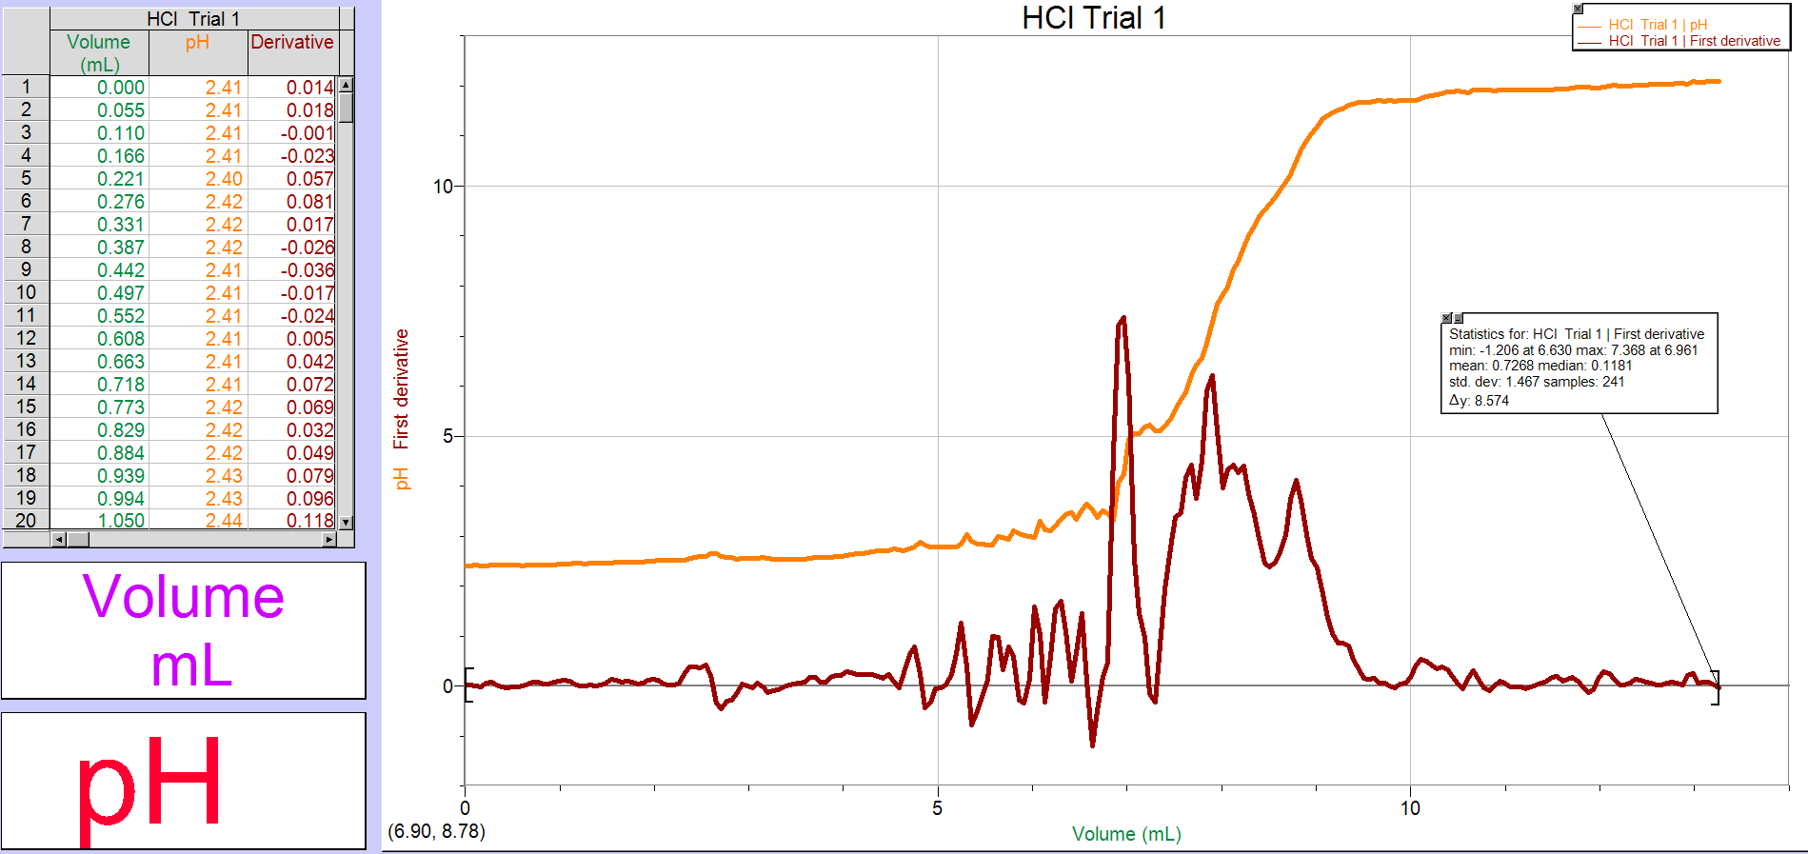

Figure 2: The pH and first derivative of pH for the standardization of NaOH with HCl – Trial 2
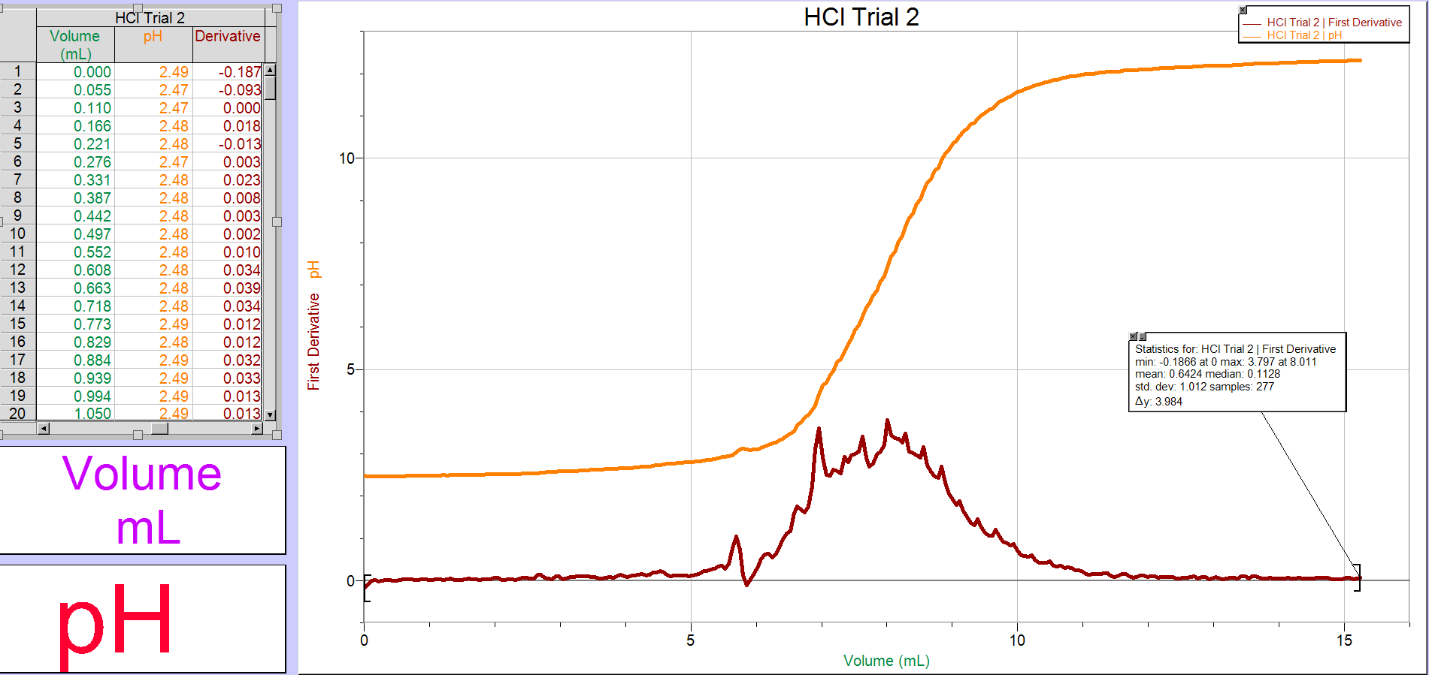

Figure 3: The pH and first derivative of pH for titration of NaOH with unknown acid – Trial 1
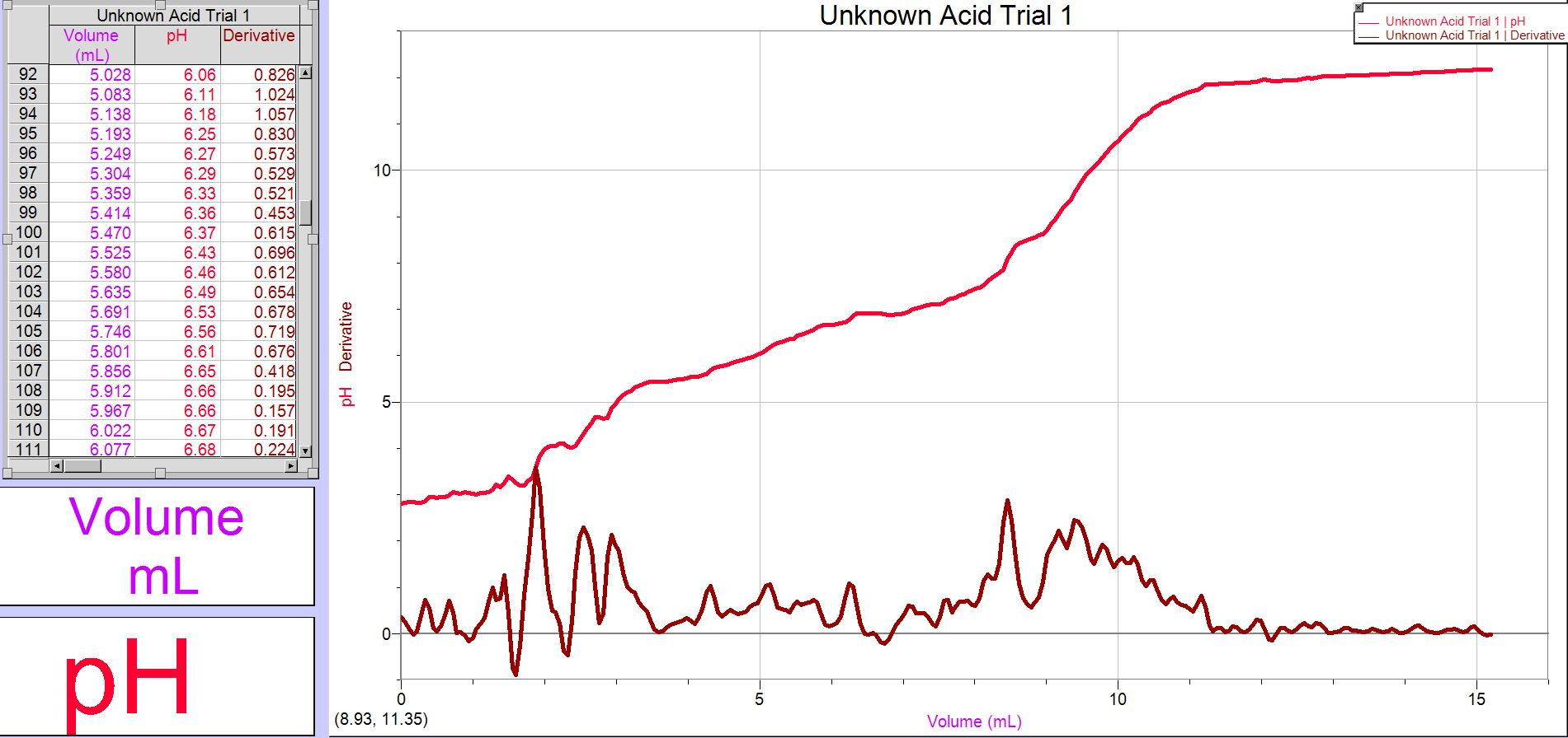

Figure 4: The pH and first derivative of pH for titration of NaOH with unknown acid – Trial 2
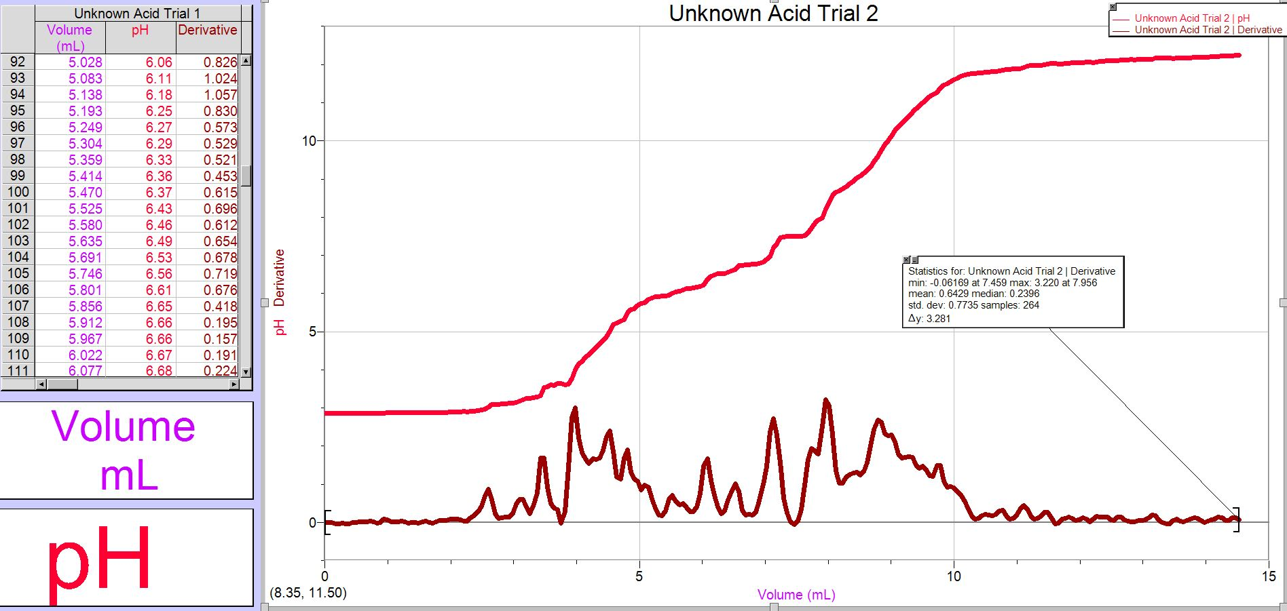

Calculations:
- C₁V₁ = C₂V₂
(6 mol/L) (0.005 L) = C₂ (0.250 L)
C₂ = 0.1 mol/L

- HCl Trial 1:
V_{NaOH} = 6.961 mL
C_{NaOH} = (V_{HCl}.C_{HCl})/ V_{NaOH}
C_{NaOH} = (0.01 L) (0.1 mol/L) / (0.006961 L)
C_{NaOH} = 0.144 mol/L
HCl Trial 2:
V_{NaOH} = 8.011 mL
C_{NaOH} = (V_{HCl}.C_{HCl})/ V_{NaOH}
C_{NaOH} = (0.01 L) (0.1 mol/L) / (0.008011L)
C_{NaOH} = 0.125 mol/L
Avg. C_{NaOH} = (0.144 + 0.125)/2
Avg. C_{NaOH} = 0.135 mol/L

- Unknown Acid Trial 1:
V_{NaOH} = 8.453 mL
C_{NaOH} = (V_{NaOH}.C_{NaOH})/ V_{NaOH}
C_{NaOH} = (0.008453 L) (0.125 mol/L) / (2) (0.01 L)
C_{NaOH} = 0.0571 mol/L
Unknown Acid Trial 2:
V_{NaOH} = 7.956 mL
C_{NaOH} = (V_{NaOH}.C_{NaOH})/ V_{NaOH}
C_{NaOH} = (0.008453 L) (0.125 mol/L) / (2) (0.01 L)
C_{NaOH} = 0.0537 mol/L
Avg. C_{H2A} = (0.0537 + 0.0571) / 2
Avg. C_{H2A} = 0.0554 mol/L

Discussion:

To start off, NaOH solution had to be made by dilution before beginning the experiment. To be able to approximately calculate the concentration of the solution, it was important to know how much of the concentrated NaOH was used in this dilution.
The human errors performed during the experiment may also affect the results. For example, for any of the trials, the endpoint was not recorded. Because the endpoints were not identified during the experiment, the graphed titration curves had to be used to approximate them. Having chosen a suitable indicator, we can assume that the endpoints are close to the equivalence points.
The endpoint usually occurs immediately after the equivalence point; for this reason, to approximate the pH of endpoints, 0.10 was applied to the pH of the equivalence points. We could also assume the titrations were perfect and conclude that the endpoints and equivalence points are identical. This error can result in the endpoints being underestimated or overestimated.
Another human error occurred when the data were collected to construct the titration curve graphs. The data collection was stopped before the point at which the solution's pH reached at least 11 in the first HCl titration trial (Figure 1).
This error resulted in a complete failure to obtain a titration curve graph. The calibration of the data collection tool was unintentionally disrupted in the first trial of the titration of the diprotic acid (Figure 3), resulting in a distorted titration curve shape and the inability to provide data for a second equivalence point and endpoint (Van Zanten, 1980).
An important human error to consider is that the amount of base used in each trial was noted rather than the amount of acid used.
Since the protocol suggests that approximately 10 ml of acid was used in each sample, it was concluded that exactly 10 ml of acid was used every time in the calculations. This error could influence the calculated concentration of unknown acid #2, which would result in a concentration either too high or too low.
A general error that may occur during a titration experiment is the identification of the endpoint. Different individuals may identify the endpoint at different shades of the colour of the indicator, resulting in the recording of various possible endpoints (Van Zanten, 1980).
This could result in the endpoint being too high, meaning the endpoint is recorded when the solution colour is too dark. Overcoming the true endpoint means that in this case there is an excess of the titrant, NaOH, that has been added to the solution; this will make the solution's concentration appear higher than it is when the calculations are made (Van Zanten, 1980).
Another possible source of error is that the equipment was not adequately rinsed which may have affected the results. To remove contaminants from previous experiments, the equipment was rinsed with distilled water. However, the equipment was not rinsed with the remedies.
This will lead to lower concentration solutions. The solution's lower concentrations would change the amount of titrant needed to achieve equilibrium and endpoint. This mistake can cause inaccuracy in the measured concentration as the amount of titrant is used in the concentration measurement (Fang, 2001).
As mentioned earlier, the endpoints were approximated immediately after the equivalence points, assuming the titration was not perfect, and the equivalence point and endpoint were not the same. In view of this, at the endpoints, the volume of NaOH will be higher than the volume observed at Logger Pro's equivalence points (Fang, 2001).
Lastly, due to the drop counter mechanism, there was a failure in this experiment. During all the tests, the base's first few drops dropping into the acid were not recorded and therefore the findings were marginally changed. This would result in the measured concentration of acid being less than the laboratory calculation. To minimise this cause of error and to ensure that each drop is compensated for, the drop counter will have to be measured and closely monitored.

Conclusion:
The data shows that it takes more of a base to hit the equivalence point when titrating a diprotic acid. This is based on acid theory that acids are a donor of protons. Diprotic acids therefore need more protons to donate, so more base is needed to neutralize all the extra protons.

References:

Fang, G., & Gao, S. (2001). A New and Sharp Ternary Indicator System for Argentometric Titration of Microamounts of Iodide. Microchimica Acta, 136(1-2), 9-13.
Van Zanten, A., & Van Den Ende, A. (1980). Conductometric titration of hydrochloric acid in gastric juice. Clinical Chemistry, 26(13), 1895-7.

Raw Data: 

