Experiment Title:
Enthalpy of Various Reactions
(Thermochemistry)

Author(s) Name(s):
Mustafa Warsame (0300116411)
&
Youssef Yacout (0300106440)

Submitting Author’s Partner:
Mustafa Warsame

Date Experiment Performed:
Thursday, Oct 3rd, 2019

Date Experiment Submitted:
Thursday, Oct 10th, 2019

Introduction:

According to Reardon, (2006), change in energy in a chemical process is calculated by measuring the amount of heat transmitted, q, between a system and its surroundings. If heat is absorbed or released under constant pressure, its therefore presented as q in the following equation:
q = ΔU + PΔV = ΔH

ΔU is the internal energy, that includes the sum of all energies of a system such as heat and work. Work can be derived from the formula -PΔV, where P is pressure, ΔV is the volume change. The transfer of heat is represented by the variable q. Hence, the definition of enthalpy is the transfer of heat of a system under constant pressure, the variable q equals to the change of enthalpy change, represented by the variable ΔH.

q can also be determined using a different equation which is much easier:
ΔH = q = c ⋅ m ⋅ ΔT
c, [in units of J/(g ⋅ K)] is the specific heat capacity. Which is the amount of heat needed to change the temperature of one gram of substance by 1°C. m is the mass (in grams) and ΔT is the change in temperature (in °C).
A coffee cup calorimeter is used to determine the enthalpy of solution (ΔH_{sol}) which is also equivalent to q and is the sum of the lattice dissociation enthalpy of an ionic compound (ΔH°_{lattice dissociation}) and the enthalpy of hydration of a gaseous ion (ΔH°_{hydration}) as the following:
ΔH_{soution} = ΔH°_{lattice dissociation} + ΔH°_{hydration}

The purpose of this lab is to chemically design at prototype of a container that can cool down a drink with volume of 100cm³ by 5°C in less than 5 minutes. Ammonium chloride and ammonium nitrate both were analyzed since they were a possibility. Research on ammonium nitrate suggested that its latter’s chemical properties are both dangerous and explosive (Bowen, 1926). Also, financially it’s $0.22 more expensive and would require a lot since it has a higher solubility. Since, it’s been proven that smaller enthalpy of solutions is considered more controllable and safer since the product is ingested by athletes. Ammonium chloride has an enthalpy of solution of 17 kJ/mol, unlike ammonium nitrate which has 25 kJ/mol, so ammonium chloride was therefore chosen.
Since the reaction of water and ammonium chloride is not vigorous, a coffee cup calorimeter was used. Coffee cup calorimeters are inexpensive, their purpose is to measure the heat transfer between the system and its surroundings.

Fig.1: Calorimeter diagram
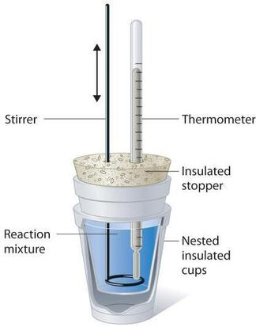
Figure 1 represents a visual representation of calorimeter. This calorimeter differs from the one used in lab, there were some modifications. First variation: There was a container within the calorimeter which had no lid (can). In the gap, there was water and ammonium chloride. Second variation: Instead of using insulated cork stopper, a Styrofoam lid was used. Third variation: Stirrer was not used, since there is no hole present. Instead, slight shaking of the cup was enough. Figure 1: LibreTexts (2019).

Table 1: Relationship between variable and it’s type:
Variable | Variable Type
Ammonium chloride mass (m_{NH4Cl}) | Independent
Water mass (m_{w}) | Constant
Time | Independent
Calorimeter ΔT | Dependent

Limitations:

There are three limitations present in this experiment. First limitation: Dr. Helmenstine states that “an isolated system is a thermodynamic system that cannot exchange either energy or matter outside the boundaries of the system.”(2019). Since the coffee cup calorimeter is not perfectly isolated, small amounts of energy exchanges between ammonium chloride, water, and system outside the calorimeter. Thus, the system absorbed heat from the outside of the calorimeter which results in temperature change less than expected.
Second limitation: during the calculations, it’s assumed that the surrounding only contains water and aluminum can, however, the metal thermometer probe is neglected despite being part of the surrounding and losing heat to the system. Thus, temperature change was less than what was expected.
Third limitation: According to Ernest, specific heat capacity changes as temperature does (2014). The heat capacity of aluminum used in calculations is assumed to be at SATP which is 25°C. During this calorimeter reaction, there’s been a transfer of heat, which causes a change in temperature. As a result, the specific heat capacities were fluctuating as the chemical reaction went forward. The calculations assume that specific heat capacity is constant, it’s not. Thus, the calculations are incorrect.
All in all, these limitations add up and cause a significant deviation in the results obtained.

Equipment:

Apparatus & Materials
Coffee Cup Calorimeter
200mL beakers
Thermometer probe
Aluminum Pop can with no lid
Square sheets of paper (3)
Scientific Counting Scale
Chemical Scoopula
LabQuest 2.0
50 g of NH₄Cl
500 – 600mL H₂O
Table 2: All apparatus and materials used in the experiment

Procedure:

Procedure during experiment:
- Take the weight of the empty can.
- Add 100 mL of water into the can.
- Add 100 mL of water into the calorimeter.
- Weigh out 13.2 grams of NH₄Cl, since the enthalpy of solution is lower.
- Pour salt into can and then immediately close the lid of the width of the thermometer inserted.
- Record initial temperature of water
- Shake calorimeter gently during experiment, as it distributes the NH₄Cl salt evenly, which could avoid a large amount of human error.
- Lastly, record the final temperature using ΔT = T_{f} – T_{i}.

Explanation of Procedure:
As a coffee cup calorimeter was obtained, fill the small beaker with 100 mL of water, then repeat the same step, to ultimately get a total of 200 ml of water. 100 mL of water is poured into the calorimeter, and 100 mL of water is poured into the pop can. The four members in the group, then calculated the mass of ammonium chloride through these calculations:

Table 3: Calculations to obtain the mass of ammonium chloride for Trial 1
NH₄Cl NH₄⁺_{(aq)} + Cl⁻ _{(aq)}  ΔH°_{Solution} = ΔH°_{Lattice} + ΔH°_{Hydration}  ΔH°_{Solution} = 705 KJ/mol + (-381KJ/mol + (-307KJ/mol)  ΔH°_{Solution} = 17 KJ/mol | m = 0.2L  c_{H2O} = 4.18J/g°C  ΔT = 5°C  q = mcΔT  q = (0.2) (4.18) (5)  q = 4.18KJ | n = q/ΔH°_{Solution}  n = 4.18/17  n = 0.2459 mol | M_{NH4Cl} = 53.441 g/mol  m = n*M  m = (0.2454) (53.441)  m = 13.2g

Table 4: Amount of NH₄Cl used for each trial
Trials | Calculated Mass of NH₄Cl
1 | 13.2g
2 | 15.0g
3 | 16g

Both teams started using an electronic balance and small sheets of paper to get their calculated masses. (13.02g, 15g, 16g, the increase in mass was to achieve a successful decrease in temperature which will be conversed in the discussion section).
The trials all followed the same order of operation. The initial temperature of the water was taken before the experiment started. Lab Quest 2.0 was used for the following parameters:
- Time (from 0 to 5 minutes) as the independent variable
- The temperature (in degrees Celsius) as the dependent variable, where the temperature was recorded once every 5 seconds.
The ammonium chloride was then poured into the calorimeter and stirred in. Then, with the Lab Quest 2.0 tool set up, the Start button was selected immediately after. The pop can with distilled water was placed in the calorimeter, and the entire calorimeter was swirled randomly during the trial. When the time came to 5 minutes or 300 seconds, the stop button on the lab 2.0 was pressed. Hence, the formula ΔT = T_{f} – T_{i}, is used as we have the final temperature and initial temperature.

Observations:

Table 5: Description of observed materials
Material | Description observed
H₂O_{(l)} | Clear liquid that has no color, taste, or smell
NH₄Cl | White crystalline solid; powder and cubes
Aluminum can | Silvery-greyish, white spots at the bottom and sides
NH₄Cl + H₂O_{(l)} | Clear and colourless liquid.

Table 6: Quantitative numbers observed during the experiment
Trial | Mass (g) | Initial Temperature (°C) | Final Temperature (°C) | Temperature Change (°C)
1 | 13.2g | 22.3°C | 19.5°C | -2.8°C
2 | 15.0g | 22.3°C | 18.5°C | -3.8°C
3 | 16.0g | 21.7°C | 19.0°C | -2.7°C

Graphs:
Fig.2: This graph represents the relationship between the decrease of temp & time (Trial 1)
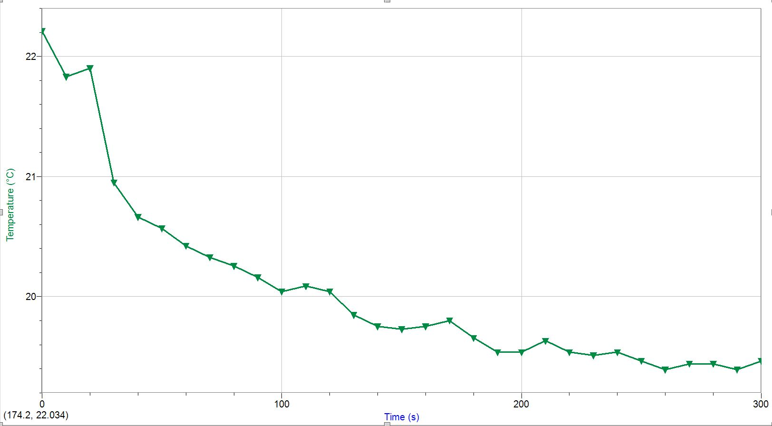
Fig.3: This graph represents the relationship between the decrease of temp & time (Trial 2)
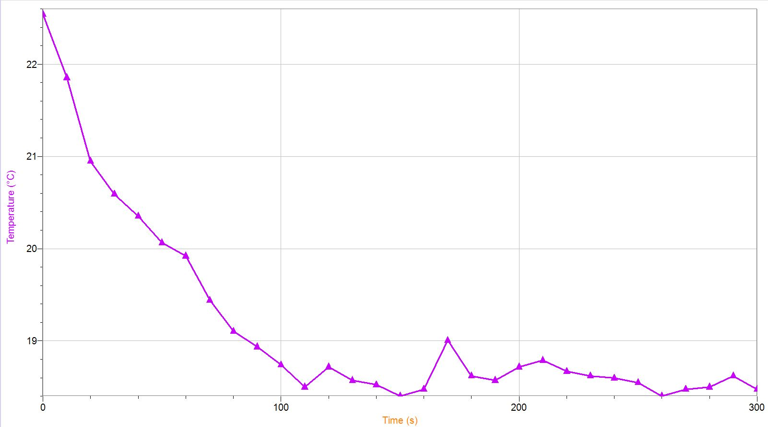

Fig.4: This graph represents the relationship between the decrease of temp & time (Trial 3)
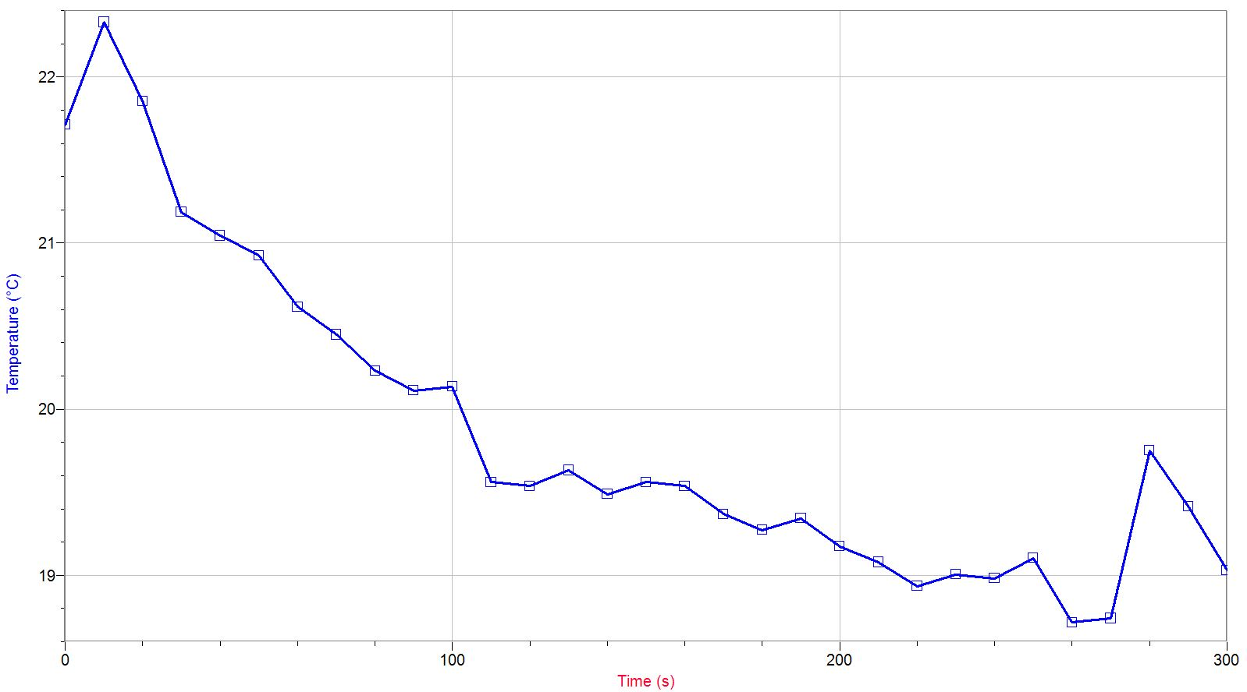

Discussion:
It was assumed that the water outside the can (the ammonium chloride solution) had the same exact specific heat capacity as the water inside the can. With that assumption the theoretical mass of ammonium chloride was calculated. This method was flawed, being that the solution outside the can, was no longer just water, thus it absolutely couldn't have a specific heat capacity equal to that of water. As it was a solution of ammonium chloride, there should have been a different specific heat capacity for the solution outside the can. This incorrect assumption of heat capacities would have led to a different amount of joules absorbed by the surrounding, which would lead to a different amount of joules absorbed by the ammonium chloride solute in order to cool the water. Thus, a different theoretical mass of ammonium chloride would have been produced. The specific heat capacity of ammonium chloride should have been given to us, or we should have been able to calculate for it.
Solid ammonium chloride in its crystallized form is hygroscopic, meaning that ammonium chloride will absorb water moisture from the surrounding air. The ammonium chloride mass that was measured before starting the experiment was not 100% ammonium chloride mass stated theoretically. Ammonium chloride already contained water, with some of the mass containing moisture. Thus, the calculated and measured masses of ammonium chloride in the experiment most likely did not evaluate the temperature change properly.
During the experiment, it was observed that there did exist a few white spots at the bottom of the can. These white spots were the residue from the reaction between the can and the ammonium chloride solution. This could be an error being that this reaction potentially involved a transfer of heat as well. This would have been a transfer of heat that was not included by the equation when calculating the theoretical mass. Had this transfer of heat being included, then the number of joules that ammonium chloride had to absorb to the water would have changed; thus, a different mass of ammonium would have been predicted.
The errors stated in the discussion could have been avoided if more information was given such as the specific heat capacity of ammonium chloride. Blatant human error was also noticed during the experiment, with a group member randomly shaking the calorimeter which led to an increase in temperature rather a decrease. This random shake on the calorimeter, which was used to evenly distribute the ammonium chloride, increased the temperature as it added kinetic energy to the solution, which possibly changed our final temperature. From the first trial to the last trial there was only a difference 0.1°C. The masses were increased through each trial to obtain the decrease in 5°C, however the decrease in temperature could not be obtained. This is due to the potential errors listed above and the lack of mass increase during each trial.

Conclusion:
In conclusion, the temperature did not decrease by 5°C for 5 minutes. The theoretical mass of ammonium chloride was calculated to be 13.2 grams. This mass was not successful as we did not achieve the results expected, however success would have obtained if errors would have been avoided and the mass of ammonium chloride was increased.

References:

Reardon, F. D., Leppik, K. E., Wegmann, R., Webb, P., Ducharme, M. B., & Kenny, G. P. (2006, July 25). The Snellen human calorimeter revisited, re-engineered and upgraded: design and performance characteristics. Retrieved from https://link.springer.com/article/10.1007/s11517-006-0086-5.
Bowen, N. L. (1926, June 1). Properties of Ammonium Nitrate. I. Retrieved October 9, 2019, from https://pubs.acs.org/doi/10.1021/j150264a001.
Helmenstine, A. M. (2019, March 6). What an Isolated System Means in Science. Retrieved from https://www.thoughtco.com/definition-of-isolated-system-605270.
Ernest, D. (2014, February 19). How does specific heat change with temperature? Socratic. Retrieved from https://socratic.org/questions/how-does-specific-heat-change-with-temperature.

Raw Data/written calculation:
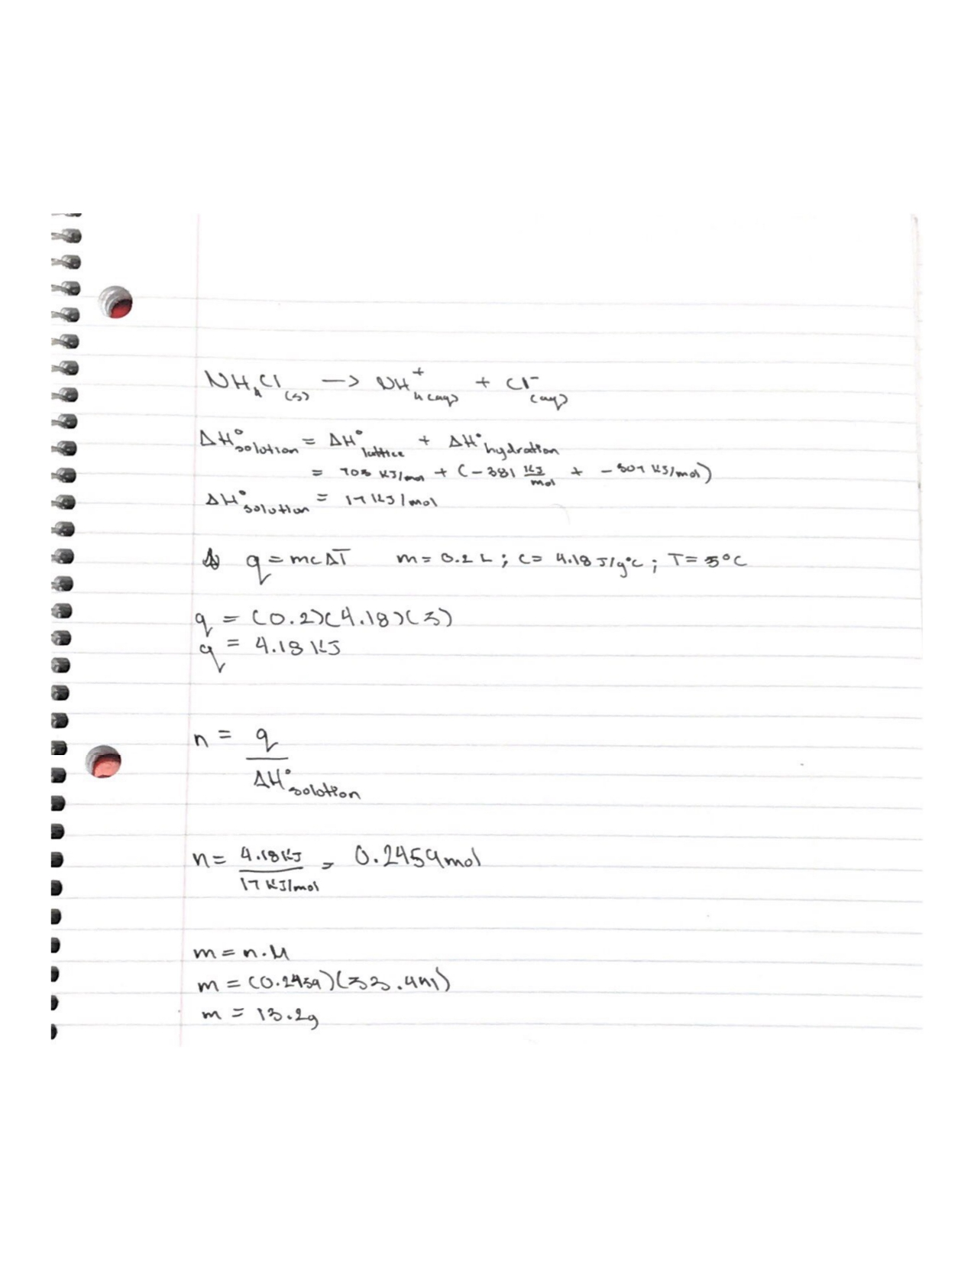
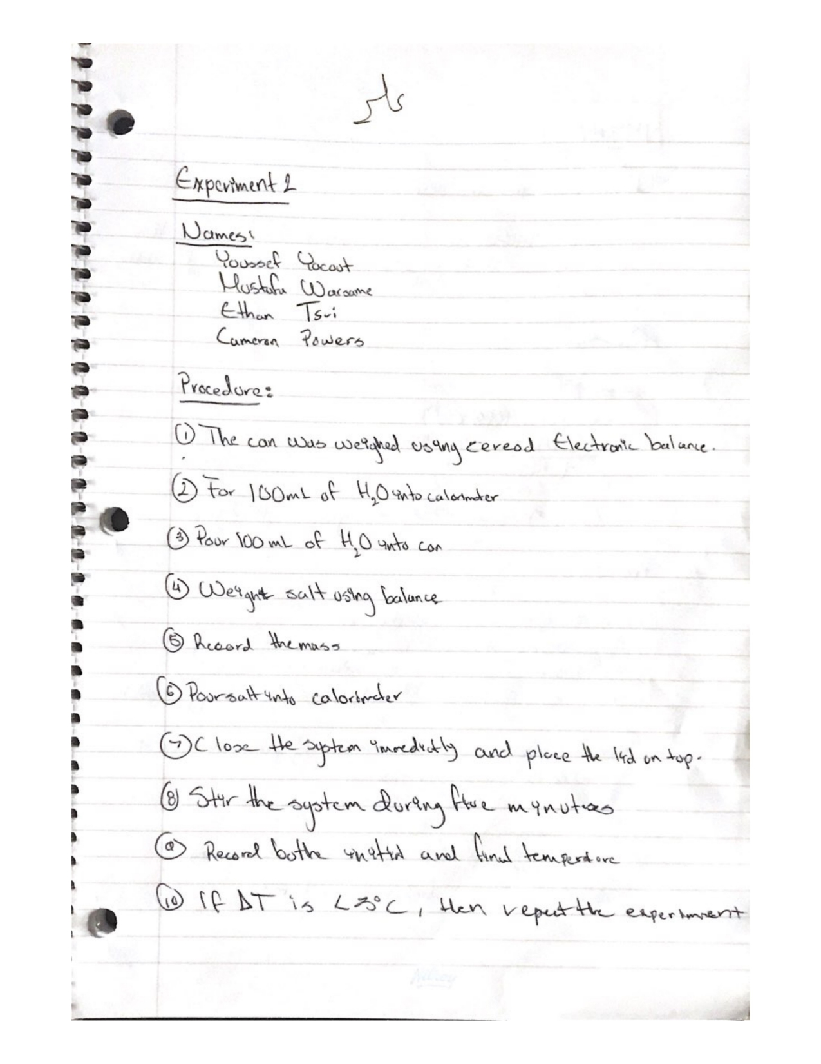
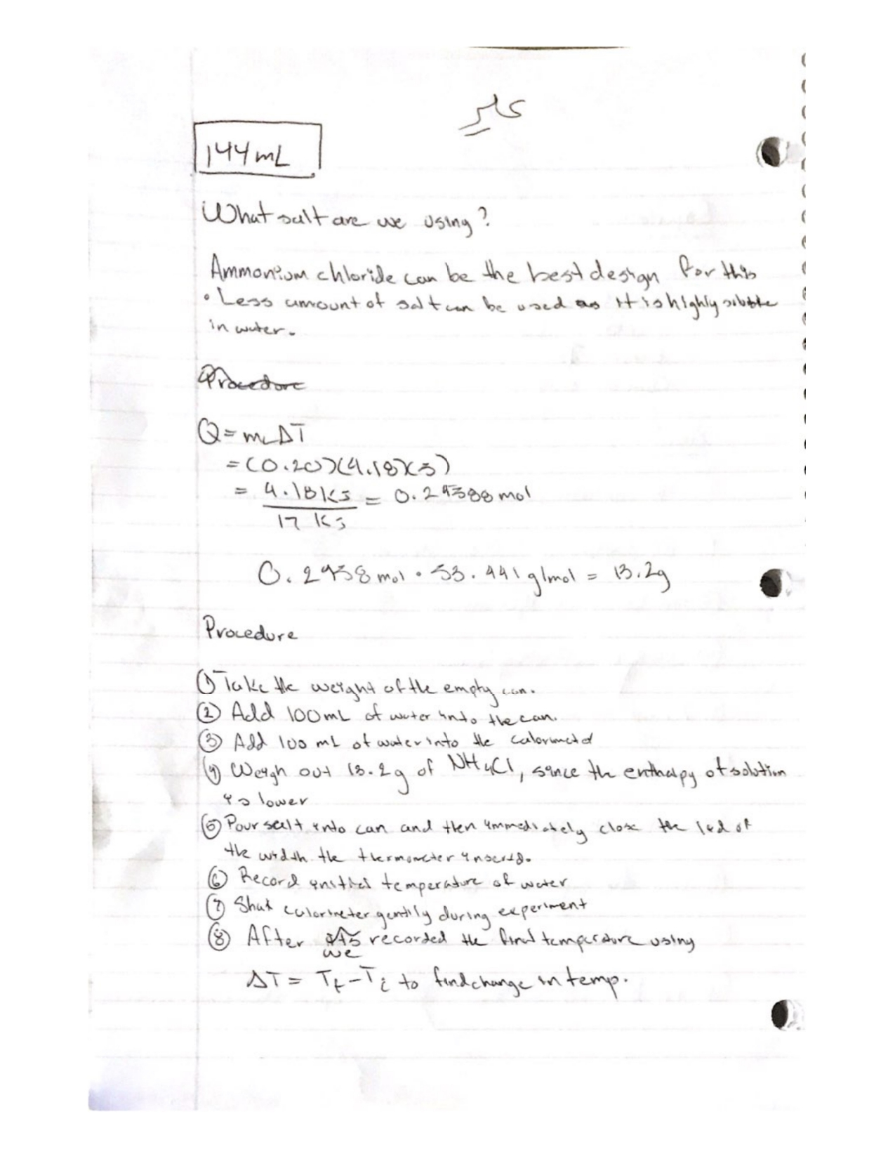

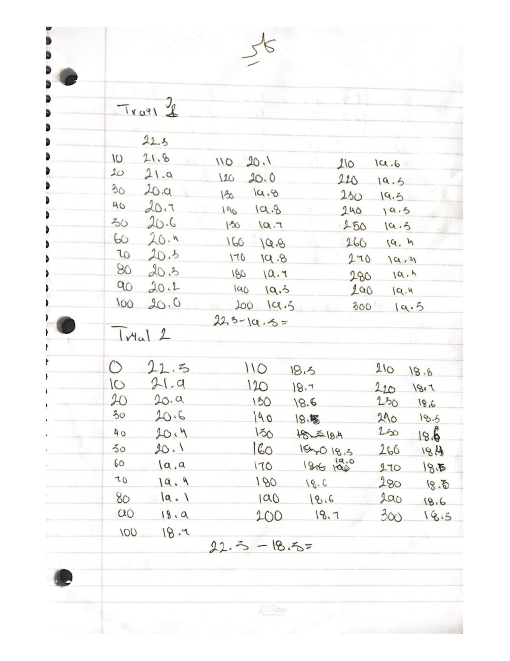

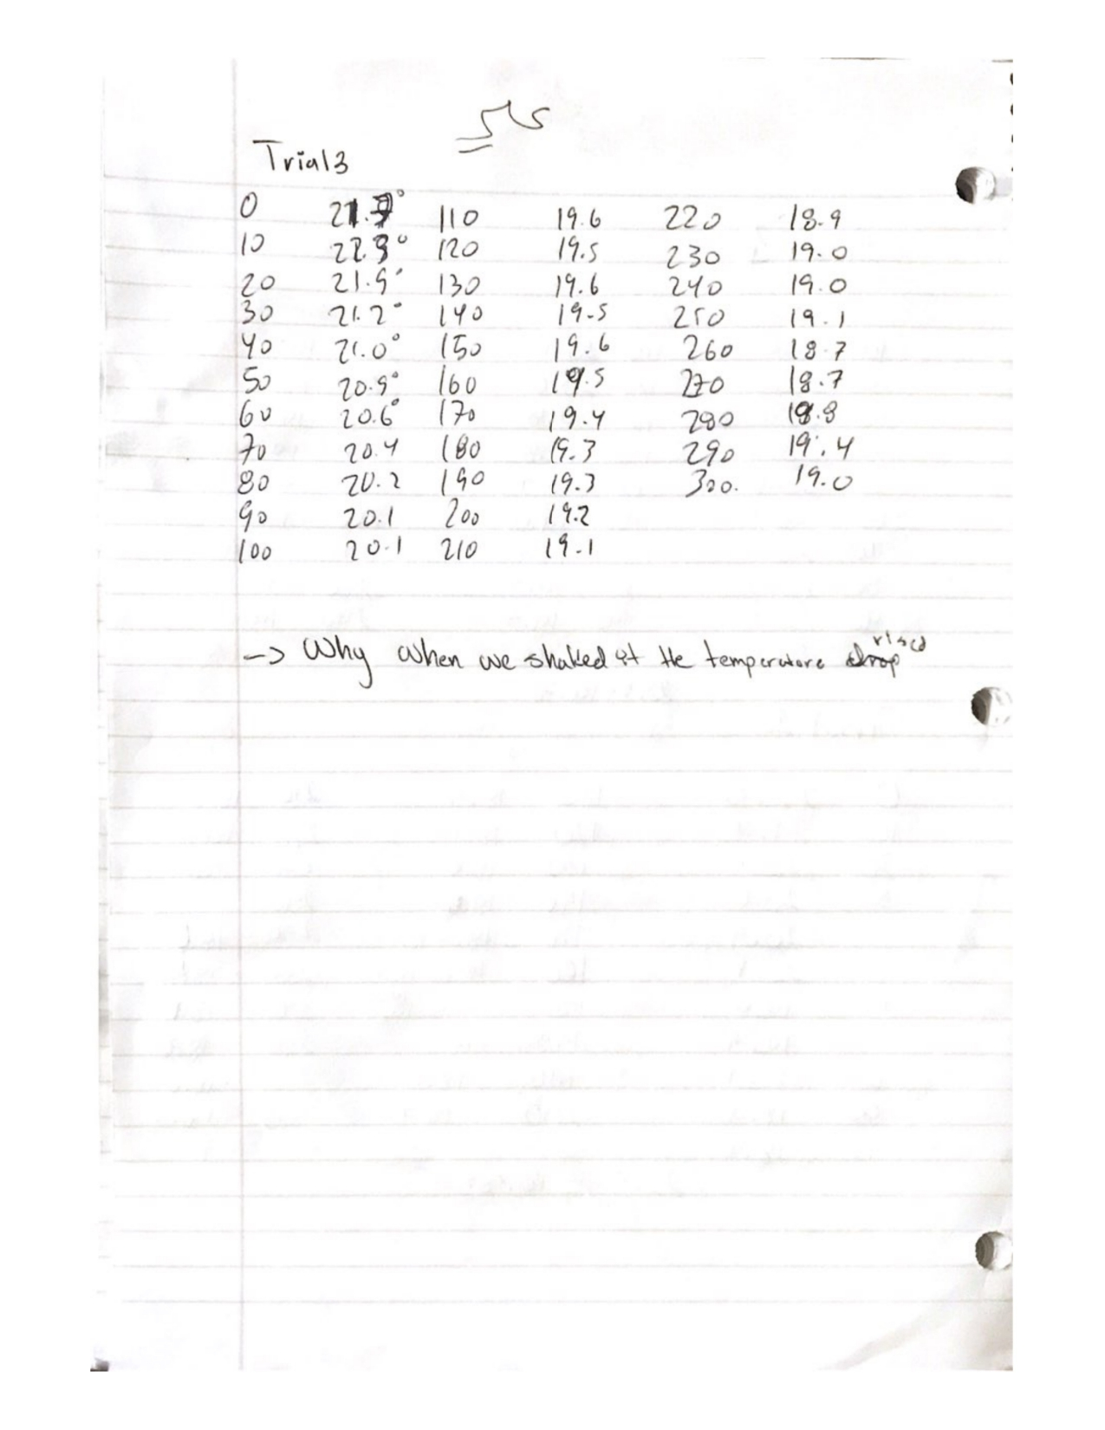

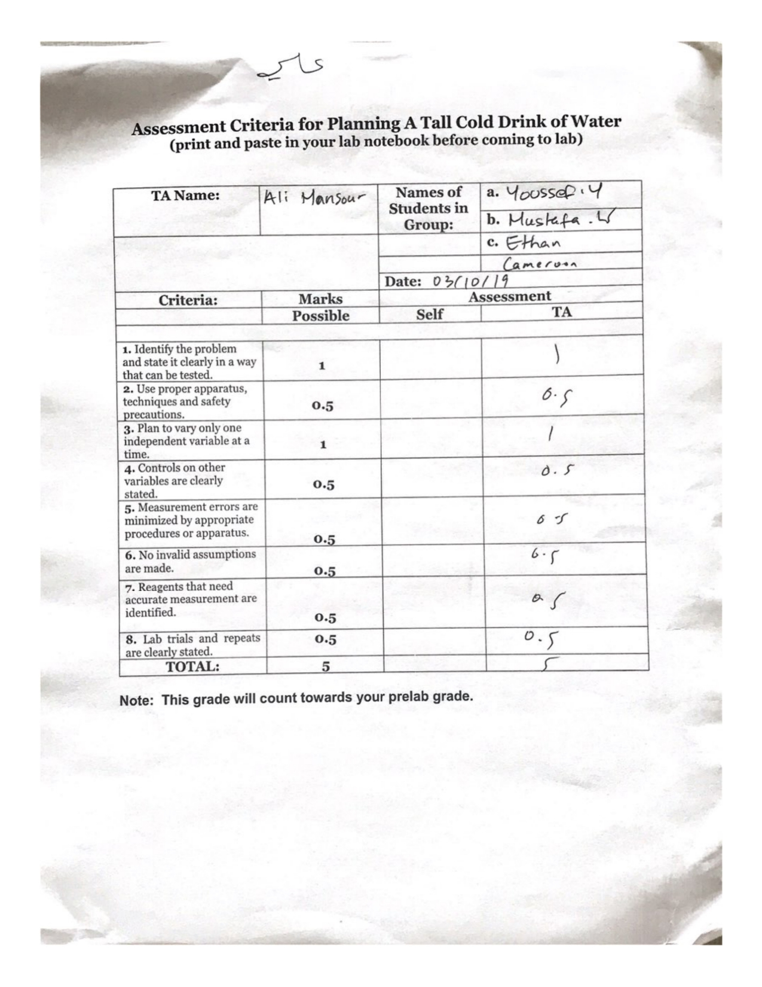

Peer Evaluation Form:


