Experiment Title:
Verification of Gas Laws

Author(s) Name(s):
Mustafa Warsame (0300116411)
&
Youssef Yacout (0300106440)

TA (Demonstrator)’s Name:
Mr. Ali Mansour

Date Experiment Performed:
Thursday, Sep 19th, 2019

Date Experiment Submitted:
Sunday, Sep 22nd, 2019

Procedure:
Verification of Charles’ Law:
All steps are as outlined in the lab manual
Verification Boyle’s Law:
- The counter is fully cleaned from water and any other intoxicants since an electrical device will be used.
- The Gas Pressure Sensor was connected to the LabQuest 2.
- The valve of the Gas Pressure Sensor was attached to the syringe.
- The plunger of the 20mL syringe was pulled to 10mL.
- The plunger was held at 10mL (initial volume mark).
- “Keep” button was tapped and volume was entered plus 0.8, after the pressure stabilized. Ok was pressed to proceed.
- Different measurements were taken at different volumes being, 7mL, 6mL, 3mL, 5mL, 8mL, 10mL.
- Data was recorded on paper.
- Graph was manually created on Lab Quest 2.
Discussion:
Charles’ Law:
This table contains the numerical values obtained from the experiment in all three trials.
Trial | V_{EF} | V_{2gas} | V_{1gas} | ΔT | T​_{IBT} | T​_{BW} | k=ΔV/ΔT
1 | MIA | 150mL | MIA | MIA | 7°C | 101°C | MIA
2 | 30.9mL | 150mL | 119.9mL | 91.5°C | 9.9°C | 101.4°C | 0.3377
3 | 32.4mL | 150mL | 117.6mL | 93.5°C | 8.6°C | 102.4°C | 0.3465

Trail 2
a)  V₂ = V_{2gas} - V_{EF}  V₂ = 150 mL – 30.9 mL  V₂ = 119.9 mL | b)  ΔT= |T₂ – T₁|  ΔT= |9.9°C – 101.4°C|  ΔT= 91.5°C | c)  ΔV_{EF} = kΔT  k = ΔV_{EF} / ΔT  k = 30.9mL / 91.5°C  k = 0.34

Trial 3
a)  V₂ = V_{2gas} - V_{EF}  V₂ = 150 mL – 32.4 mL  V₂ = 117.6 mL | b)  ΔT= |T₂ – T₁|  ΔT= |8.6°C – 102.1°C|  ΔT= 93.5°C | c)  ΔV_{EF} = kΔT  k = ΔV_{EF} / ΔT  k = 32.4mL / 93.5°C  k = 0.35

Verification of Charles Law
k₂ = 0.3377
k₃ = 0.3465
% Error = k₂- k₃
% Error = 0.3465-0.377
% Error = 0.0088
% Error = 0.88%

The general thesis in this experiment is correct. In the first trial, the Erlenmeyer flask was tilted, and the lid was not fully submerged, and then balanced in the water. Lack of attention to detail and understanding led to air bubbles, due to the misunderstanding of step 10(when the lid is fully submerged the finger can be released). An excess amount of water was also put in the ice bath, increasing the temperature of the ice bath temperature which went against step 7. This made the first trial become a failure as human error was overwhelming and producing flawed numbers. The second and third experiment were successful, proving the relationship between V=kT. The k values of trial 2 and trial 3, only vary 0.0088 from each other, having a difference of 0.88%.
When the Erlenmeyer flask was in the beaker for about 6-7 minutes, we then obtained the ice right before the Erlenmeyer flask was taken out of the beaker, ultimately keeping the ice bath temperature as low as possible. The water volumes in the ice bath was an uncontrolled/dependent variable in this experiment, which potentially could have affected the time that was needed to cool the flask. Since large volumes of water at the same temperature would absorb more kinetic energy from the previously heated submerged flask, it decreases the amount of time required to cool the flask.
Further uncontrolled variables were encountered with the temperature of the gas in the boiling beaker not being of the same temperature with the boiling water. The rubber beaker would be of danger to the person covering it. This raises question to how much kinetic energy the gas really had? And if it wasn’t placed in the boiling water for the ideal amount of time.
Boyle’s Law:

Fig.1.1 - Data collected from Boyle’s law Trial 1 presented in a tabular form
Volume (mL) | Pressure (kPa)
10.8 | 102.08
7.8 | 144.70
6.8 | 161.08
3.8 | 225.23
5.8 | 191.08
8.8 | 123.09
10.8 | 102.98

Fig.1.2 - Data collected from Boyle’s law Trial 2 presented in a tabular form
Volume (mL) | Pressure (kPa)
10.8 | 102.26
7.8 | 141.73
6.8 | 159.30
3.8 | 225.23
5.8 | 191.42
8.8 | 125.11
10.8 | 102.49

Graphs:
Fig.2.1 - Data collected from Boyle’s Law Trial 1 presented in a graph
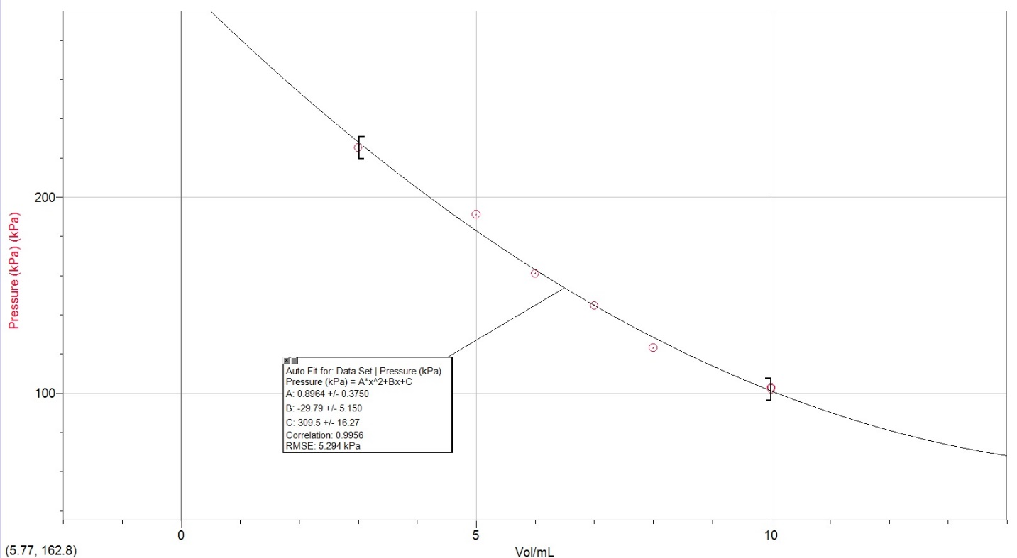

Fig.2.1 - Data collected from Boyle’s Law Trial 1 presented in a graph
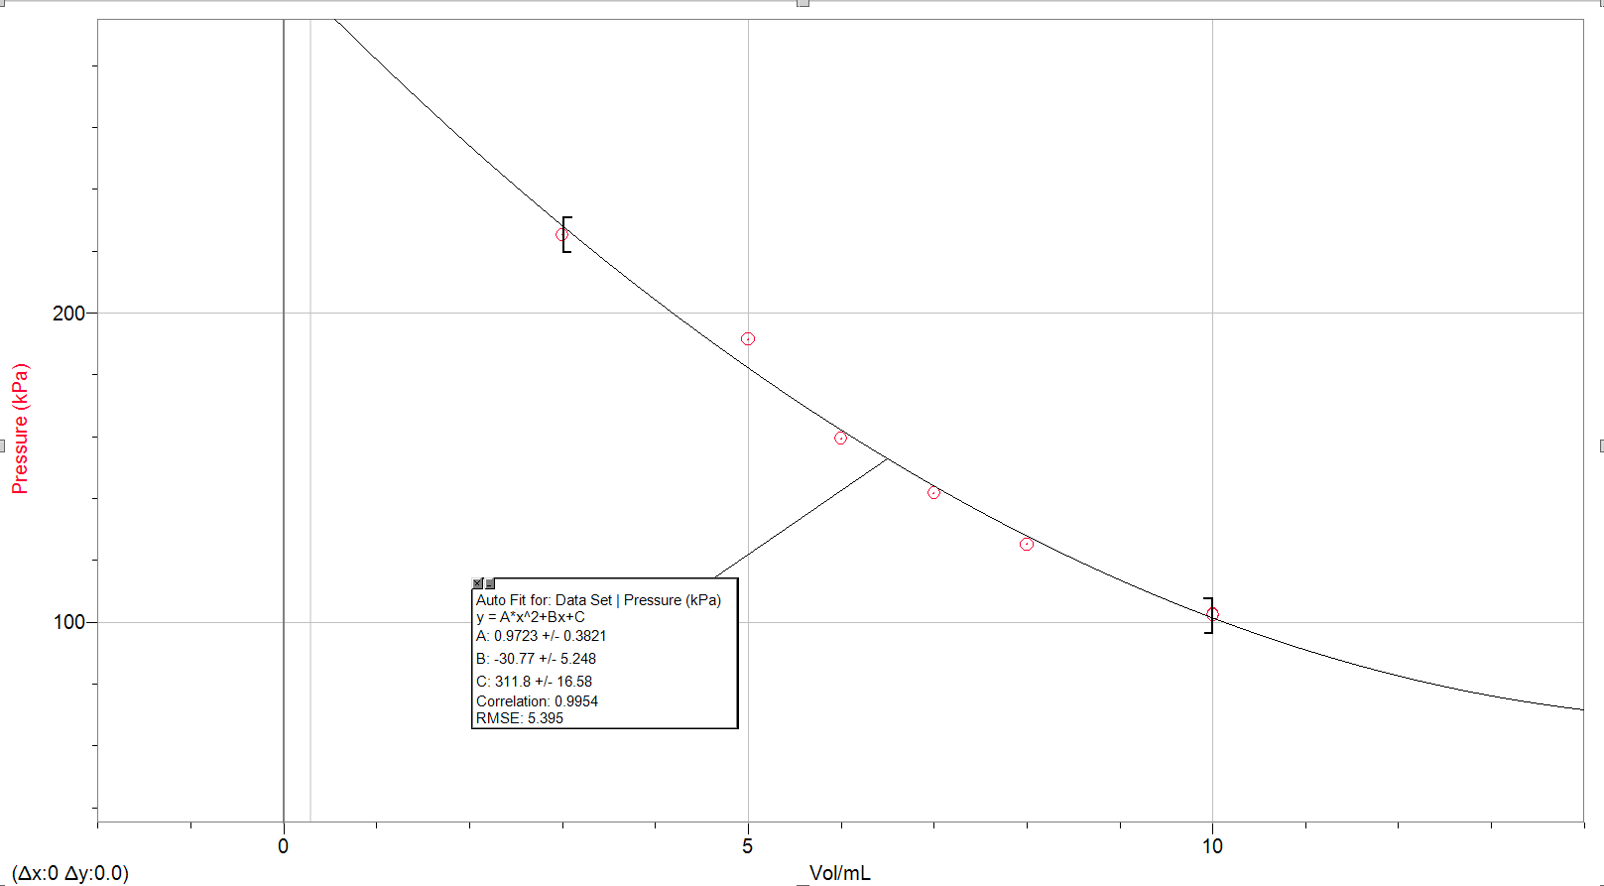

Boyle’s Law Calculations
Trial 1:
K₁ = P ₁ V ₁ = (102.08 kPa) * (10.8 mL) = 1102.46
K₂ = P ₂ V ₂ = (144.7 kPa) * (7.8 mL) = 1128.66
K₃ = P ₃ V ₃ = (161.08 kPa) * (6.8 mL) = 1095.34
K₄ = P ₄ V ₄ = (225.23 kPa) * (3.8 mL) = 848.27
K₅ = P ₅ V ₅ = (191.08 kPa) * (5.8 mL) = 1108.26
K₆ = P ₆ V ₆ = (123.09 kPa) * (8.8 mL) = 1083.19
K₇ = P ₇ V ₇ = (102.98 kPa) * (10.8 mL) = 1112.18

Avg Constant (k) = (K₁ + K₂ + K₃ + K₄ + K₅ + K₆ + K₇) / 7
Avg Constant (k) = (1102.46 + 1128.66 + 1095.34 + 848.27 + 1108.26 + 1083.19 + 1112.18) / 7
Avg Constant (k) = 1068.38

Trial 2:
K₁ = P ₁ V ₁ = (102.26 kPa) * (10.8 mL) = 1104.41
K₂ = P ₂ V ₂ = (141.73 kPa) * (7.8 mL) = 1105.49
K₃ = P ₃ V ₃ = (159.30 kPa) * (6.8 mL) = 1083.24
K₄ = P ₄ V ₄ = (225.23 kPa) * (3.8 mL) = 855.87
K₅ = P ₅ V ₅ = (191.42 kPa) * (5.8 mL) = 1110.23
K₆ = P ₆ V ₆ = (125.11 kPa) * (8.8 mL) = 1100.97
K₇ = P ₇ V ₇ = (102.49 kPa) * (10.8 mL) = 1106.89

Avg Constant (k) = (K₁ + K₂ + K₃ + K₄ + K₅ + K₆ + K₇) / 7
Avg Constant (k) = (1104.41 + 1105.49 + 1083.24 + 855.87 + 1110.23 + 1100.97 + 1106.89) / 7
Avg Constant (k) = 1070.12
Percentage error (%) = ((1070.12 – 1068.38) / 1070.12) * 100
Percentage error (%) = 0.16 %
Fig.1.3 expresses differences in constants in both trials.

Robert Boyle proposed a question: if temperature (T) and amount (n) are kept constant, then how does that affect Pressure (p) and volume (v)? The relationship between pressure and volume was determined to be inversely proportional. Thus, as volume decreases, pressure increases and on the contrary, as volume increases, pressure decreases. To derive Boyle’s equation:
P ∝ 1/v
This equation means that pressure is proportional to the inverse of volume. In order to get rid of the proportional sign, its as follows:
P = k(1/v)
The proportional symbol is replaced by an equal sign and a constant of proportionality (k). This equation can be rearranged by multiplying both sides by (v).
Pv = k
Therefore, Boyle’s Law stated that at constant temperature and constant amount of gas, should return the same value if the volume of the gas is multiplied by the internal pressure. The constants that were received from the experiment is as follows:
Trial 1 |  |  | Trial 2
mL | k | Δk | mL | k | Δk
10.8 | 1102.46 | - | 10.8 | 1104.41 | -
7.8 | 1128.66 | 26.2 | 7.8 | 1105.49 | 1.08
6.8 | 1095.34 | -33.32 | 6.8 | 1083.24 | -22.25
3.8 | 848.27 | -247.07 | 3.8 | 855.87 | -227.37
5.8 | 1108.26 | 259.99 | 5.8 | 1110.23 | 254.36
8.8 | 1083.19 | -25.07 | 8.8 | 1100.97 | -9.26
10.8 | 1112.18 | 28.99 | 10.8 | 1106.89 | 5.92
Fig.1.3 – This table presents differences in the constant (k) for both trials.

Theoretically, k should be consistent all throughout. However, Δk seems to experience similar decrease of value in both trials. The occurrence of such decrease becomes evident in further analysis. To start off, gas inside syringe is a real gas not an ideal one. This means that the particles within, have a mass and do exert force upon one another. This would explain why differences in the constant was apparent since the formula used, assumes “ideal gas” laws. In addition, the connection between the GPS and the syringe is not fully sealed since it’s not airtight. As the pressure was increased, and volume was decreased, gases probably escaped out of the syringe. Thus, the initial volume of 10.8 mL varies throughout the experiment as it may be less.
Moreover, the syringe’s volume graduation is considered vague and not precise since it reads to the nearest mL. The pressure applied to syringe by the plunger was never stabilized and consistent since students’ hands were not steady.
To prove the outlined points, in fig. 1.3, at 10.8mL, the first and second readings of pressure were different. The pressure in the second reading is slightly higher than the first reading. This suggests that either gas was lost, or force was not applied equally in both readings. Such flaws in the experiment result into different variations of Δk.

References:

Raw Data:
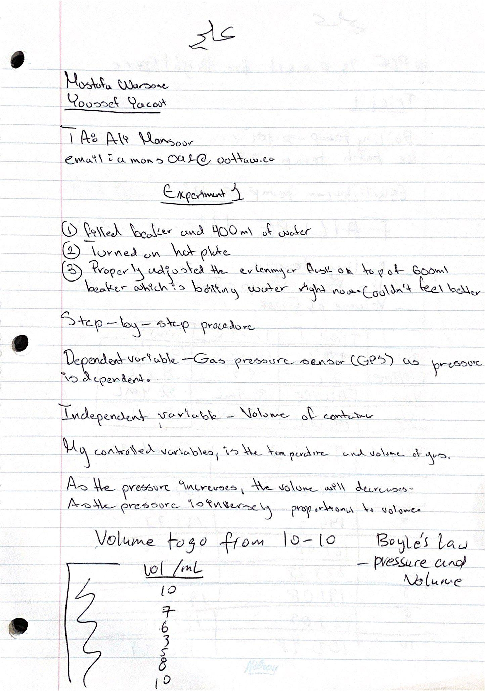
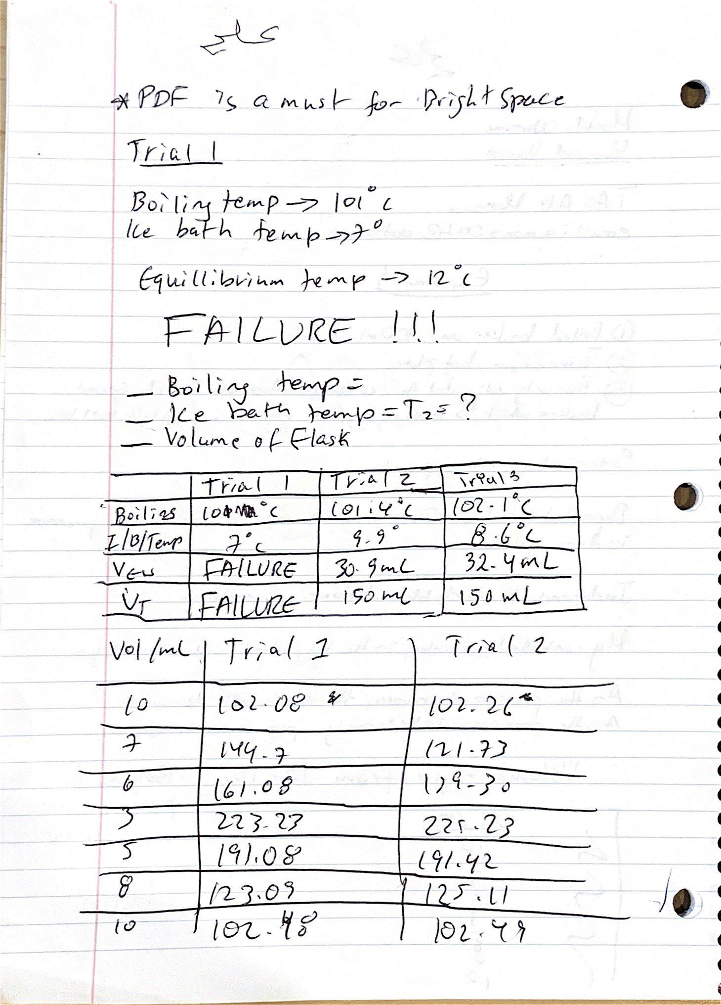
Sample Calculations, Charles’ Law:
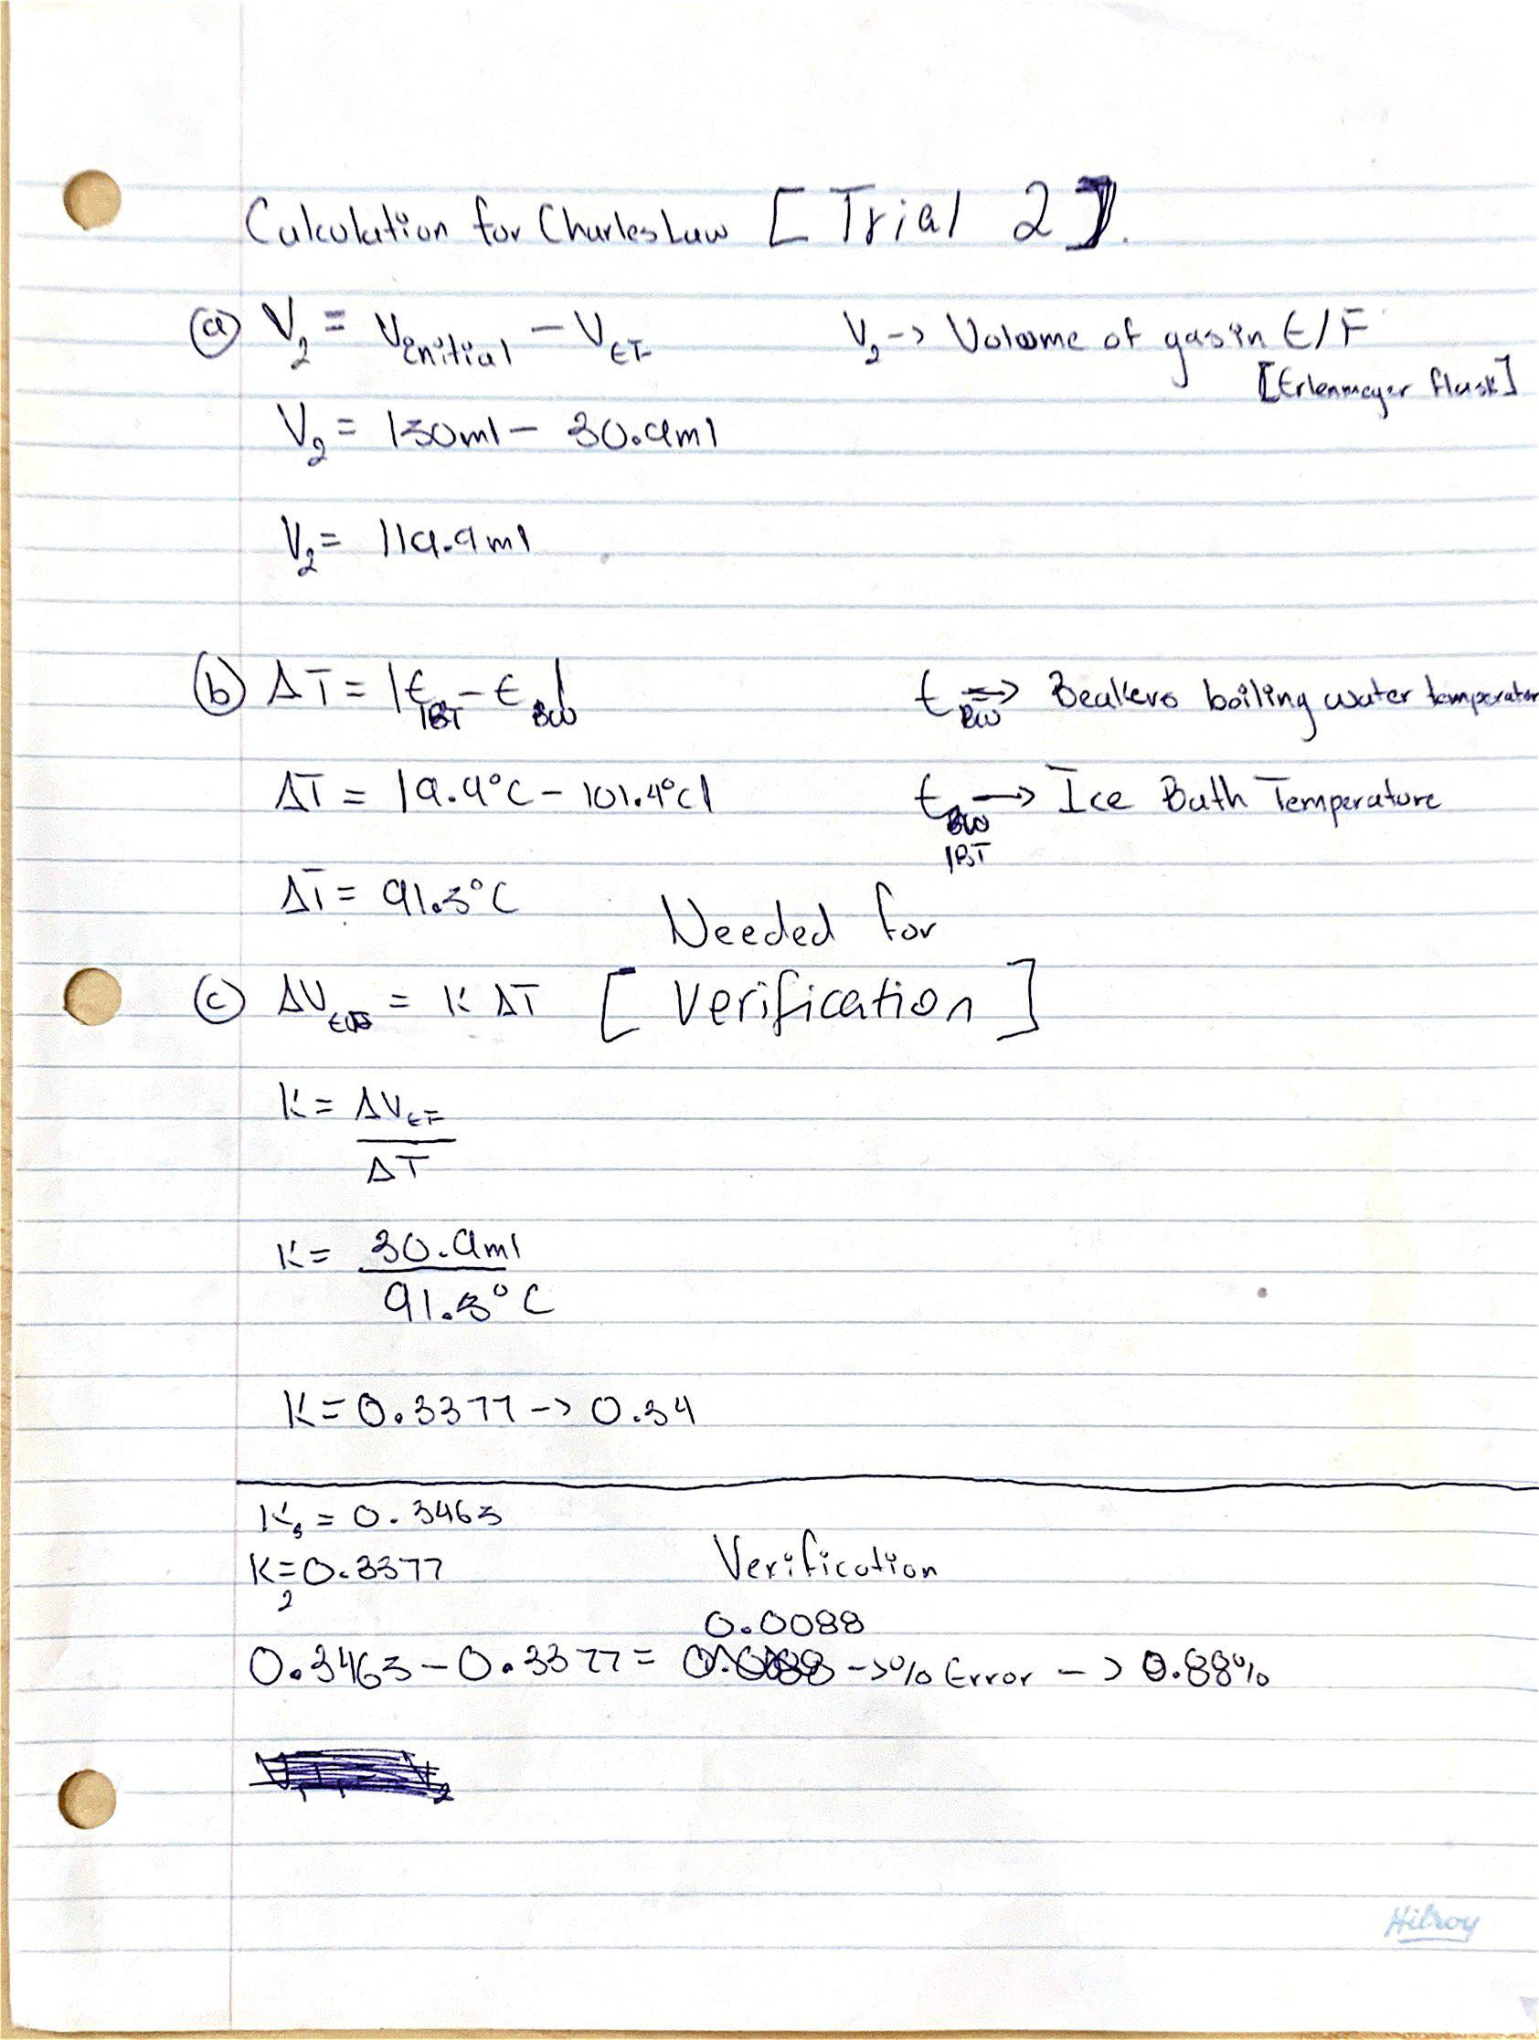

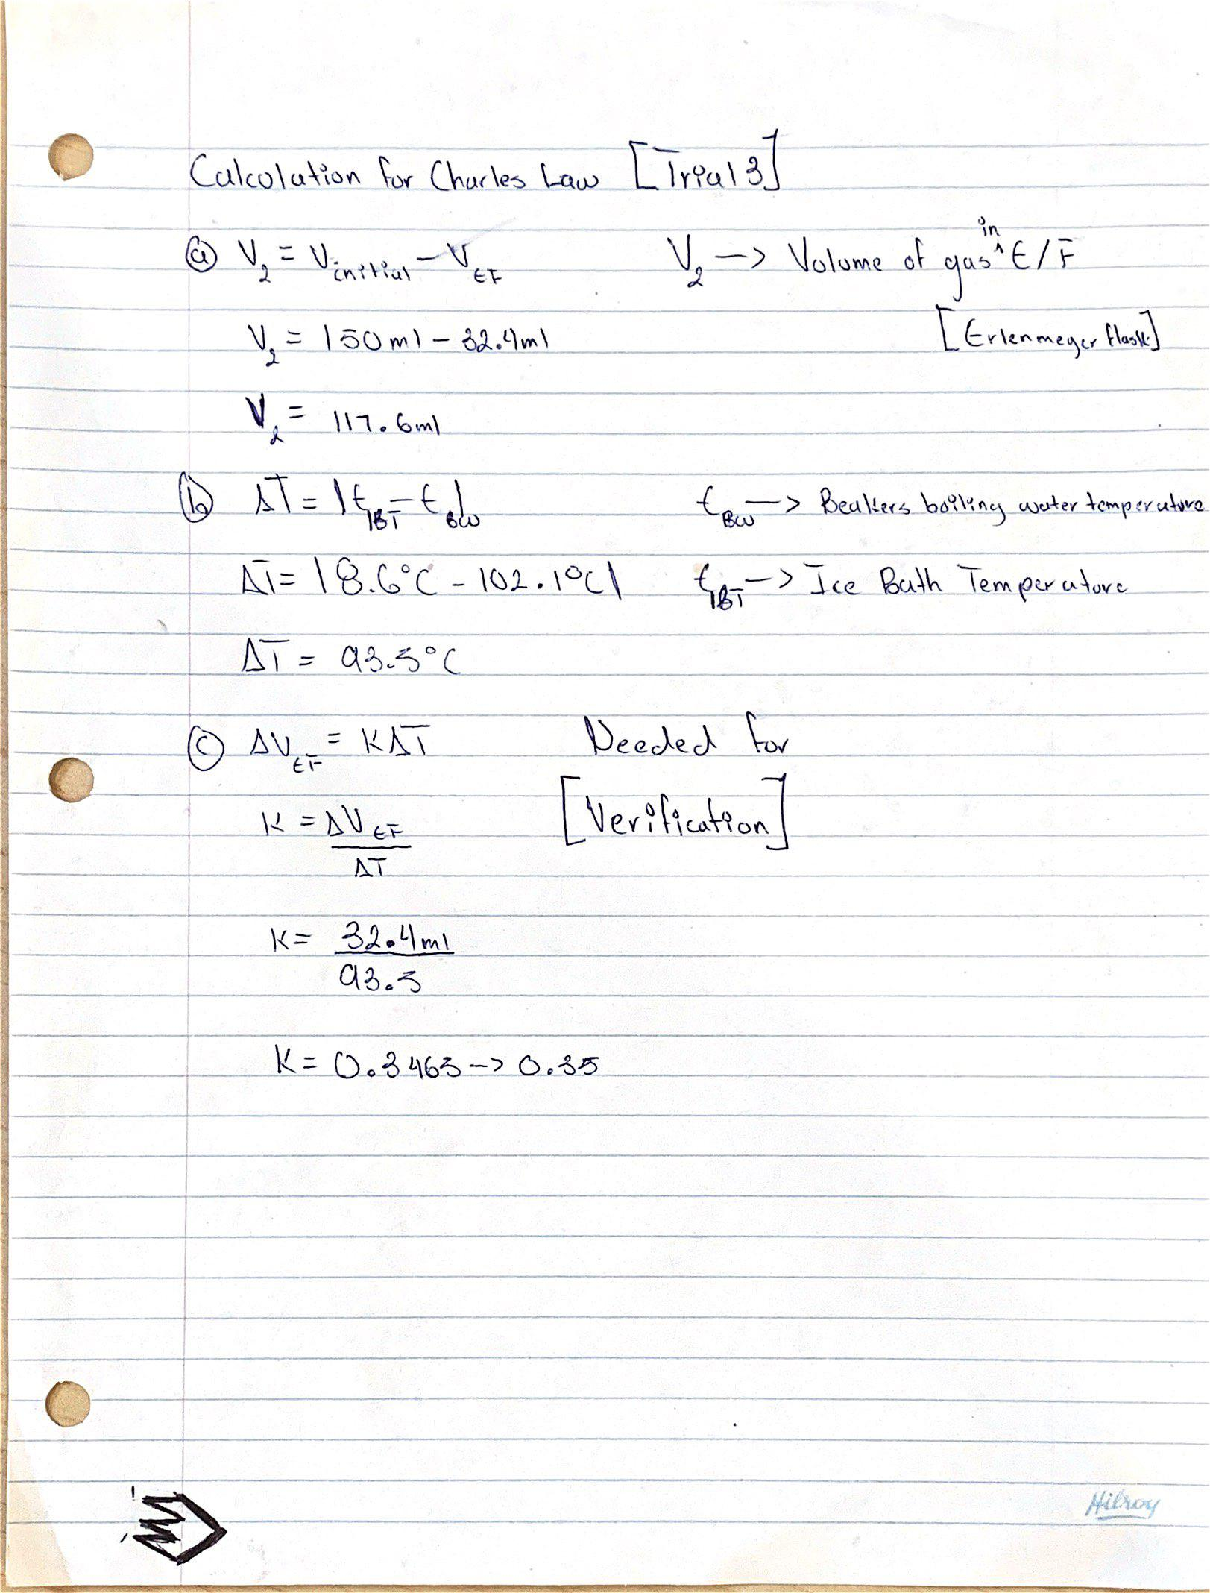
Assessment Criteria Sheet:

