“Do I Dare Disturb the Universe?”
Verification of Gas Laws
CHM 1711 Group Z01 Section A

Team Members:

Teaching Assistant:

Date of Experiment: Wednesday, September 11, 2019
Date of Submission: Wednesday, September 18, 2019

Procedure - Charles’ Law
- As outlined in the lab manual

Procedure - Boyle’s Law
- Obtain gas pressure sensor, 20 mL gas syringe, USB key and LabQuest 2.
- In an observation table, list the volume (mL) as the independent variable and the pressure (kPa) as the dependent variable. Take note of the temperature as the control variable.
- Select the starting point as 10 mL and the ending point as 14 mL. Note the interval of change as 2 mL.
- Make sure to add 0.8 mL to each volume reading as there is an additional space of 0.8 mL inside the pressure sensor.
- Record the initial pressure as 101.325 kPa.
- Reduce the volume in the syringe by the 2 mL interval until the syringe volume reaches 4 mL simultaneously recording the changed pressure with every 2 mL interval change.
- Begin increasing the volume in the syringe by the 2 mL interval until the syringe value reaches 14 mL while simultaneously recording the changed pressure with every 2 mL interval change.

Discussion
Table 1: Qualitative Observations of Volume regarding Temperature
 | Trial 1 |  | Trial 2
 | Initial | Final | Initial | Final
Temperature (K) | 373.15 | 278.65 | 373.15 | 278.45
Volume (mL) | 150.0 (V₁) | 27.0 (V_{cw}) | 150.0 (V₁) | 36.0 (V_{cw})

During the execution of the procedure for Charles’ law, there were two experimental sources of error encountered. Firstly, it was difficult to place the Erlenmeyer flask in the ice bath without inadvertently releasing the hot gas and therefore it took a substantial amount of time to lower the flask into the ice bath. This caused a shift in the results. As shown in trial 1 of Table 1, the temperature of the gas within the flask had reduced as it was exposed to room temperature, 26°C. As a result, the gas began cooling down quickly. From what was discovered in trial 1, the experiment was executed with more efficiency in terms of the procedure in trial 2. The flask was transported to the ice bath immediately after it was taken out of the boiling water in the preceding trial. The increased temperature of the flask in trial 2 as opposed to trial 1 demonstrates that when placed in the ice bath, hotter gas escaped the flask and increased the temperature of the ice bath. The recorded V_{cw} was smaller in trial 1 as the temperature of the gas in the flask cooled down quicker before being placed in the ice bath. As gas cools, atmospheric pressure pushes water into the flask. Due to the fact that the flask was cooler in trial 1, it did not cool down as much as the flask in trial 2. As a result, less water was pushed into the flask which was represented by the smaller volume of water. Secondly, the initial temperature was inaccurately measured in both trials. In step 7 of the Charles’ law procedure, it mentions that the temperature of the ice bath should reach 6°C. It was subsequently assumed that 6°C would be the initial temperature. However, the boiling water that heated the Erlenmeyer flask increased the temperature of the gas inside to 100°C (373.15 K) which should have been listed as the initial temperature. The results of the experiment validate Charles’ law that volume and temperature are directly proportional to one another; when volume increases, temperature will as well and vice versa. The results demonstrate that the lower the temperature of the flask, the smaller the volume of water pulled into the flask through atmospheric pressure.

Table 2: Qualitative Observations of Pressure regarding Volume
Volume (mL) | Pressure (kPa)
10.8 | 99.08
8.8 | 123.03
6.8 | 162.21
4.8 | 225.12
6.8 | 160.12
8.8 | 121.47
10.8 | 100.03
12.8 | 84.66
14.8 | 72.24

Graph 1: Qualitative Observations of Pressure regarding Volume
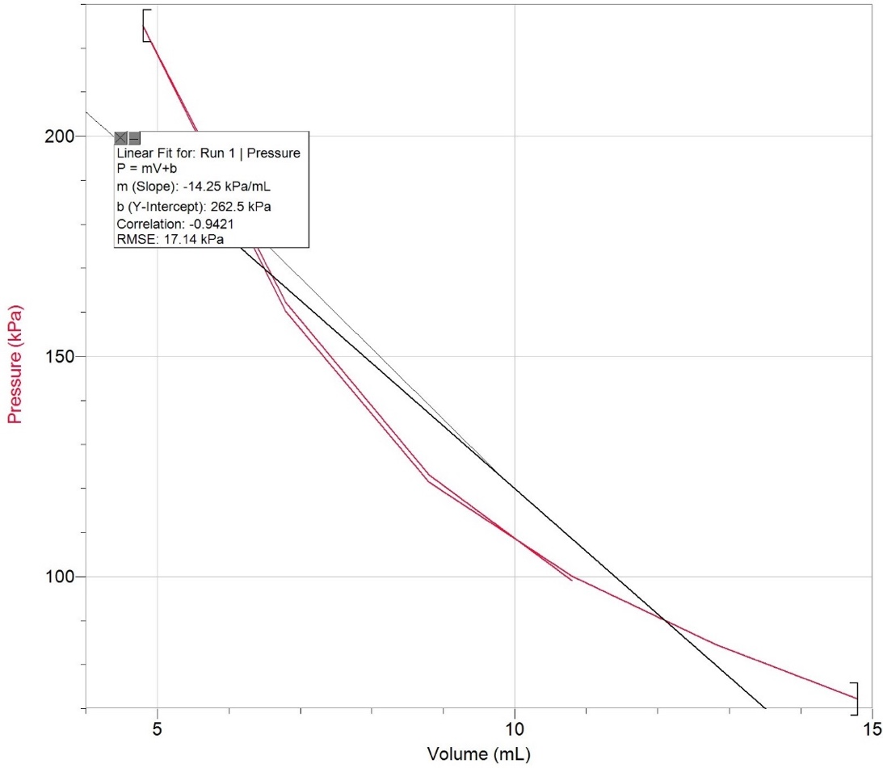

During the execution of the procedure for Boyle’s Law, there was one procedural and one experimental source of error. Firstly, the TA made it clear that the information in the procedure had to be specific and therefore should identify the independent, dependent, and control variables as well as the values and measurements for those who would perform the experiment using the step-by-step procedure (see appendix E and F). Mr. Brazeau-Henrie also illustrated that it would not be possible to push the syringe down to 0 mL because there is no volume and accordingly no pressure. Additionally, it would be physically impossible to push the syringe down to 0 mL. In order to produce accurate results, all variables besides the independent and dependent variables needed to be controlled. Gay-Lussac’s law states that when the temperature of a gas in a closed container is increased, the pressure of the gas increases as well. The increase in kinetic energy results in a greater pressure. As recorded by the thermometer linked to LabQuest 2, the temperature during the experiment remained at room temperature, 26°C, and therefore did not affect the results. Another method of producing accurate results is by taking multiple readings of the pressure at specific volume measurements. This ensures that LabQuest 2 will give accurate results as repeating readings confirm that the results are both precise and exact. In addition to producing accurate results, LabQuest 2 also determines the line of best fit for the plotted data points. Two points on the line can be used to determine the equation of that line. The ‘m’ value in the slope formula, y=mx+b, represents Boyle’s constant. The results of the experiment validate Boyle’s law that pressure and volume are indirectly proportional to one another; when volume increases, pressure decreases and vice versa. The results demonstrate that a smaller volume resulted in more pressure. On the other hand, a larger volume resulted in less pressure.

Conclusion
In conclusion, the results of the experiment validate both Charles’ and Boyle’s laws.

Reference(s)
- “What in the World ISN’T Chemistry”, General Chemistry Laboratory Manual, Dr. Rashmi Venkateswaran, 2019.
- “Charles Law Lab.” YouTube, YouTube, 8 Dec. 2011, https://www.youtube.com/watch?v=5M8GR6_zIps.
- Hall, Nancy. “Boyle's Law.” NASA, NASA, https://www.grc.nasa.gov/www/k-12/airplane/boyle.html.
- “14.5: Gay-Lussac's Law.” Chemistry LibreTexts, Libretexts, https://chem.libretexts.org/Bookshelves/Introductory_Chemistry/Book:_Introductory_Chemistry_(CK-12)/14:_The_Behavior_of_Gases/14.05:_Gay-Lussac's_Law.

Appendix
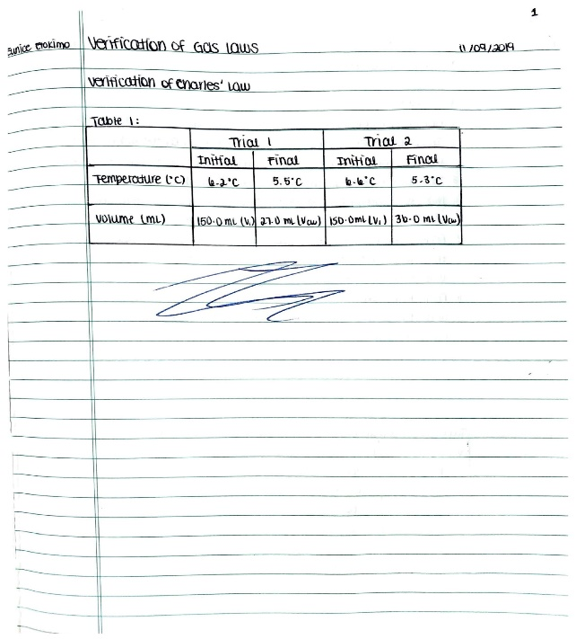
Appendix A
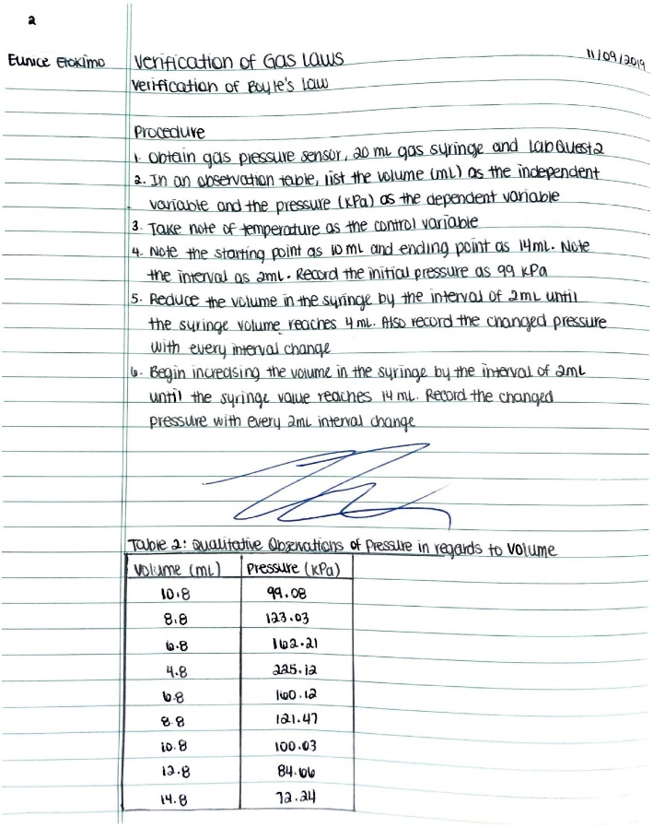
Appendix B
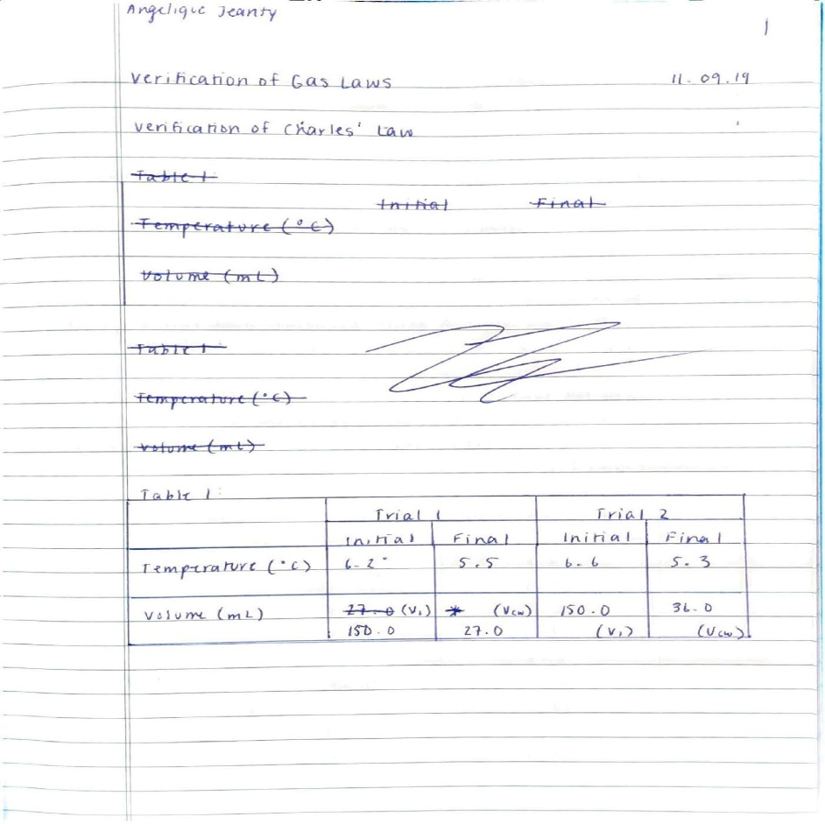
Appendix C
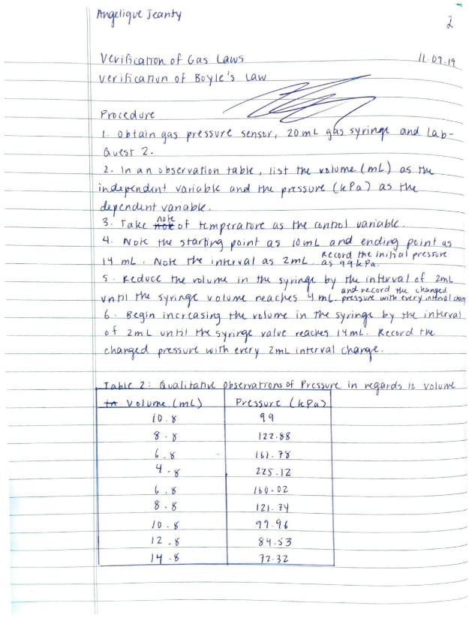
Appendix D

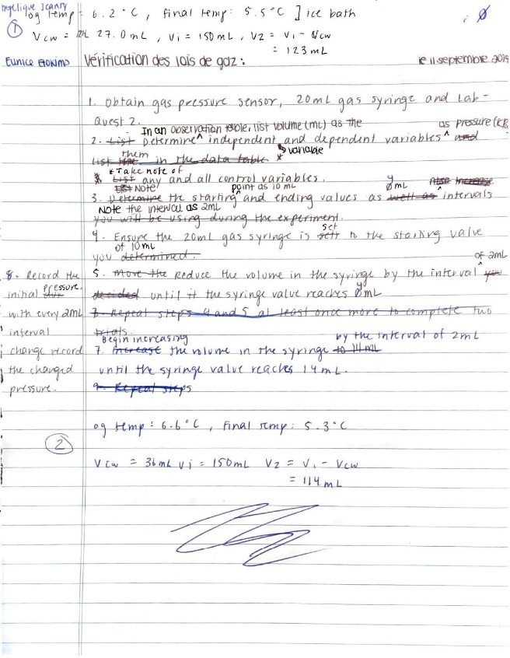
Appendix E
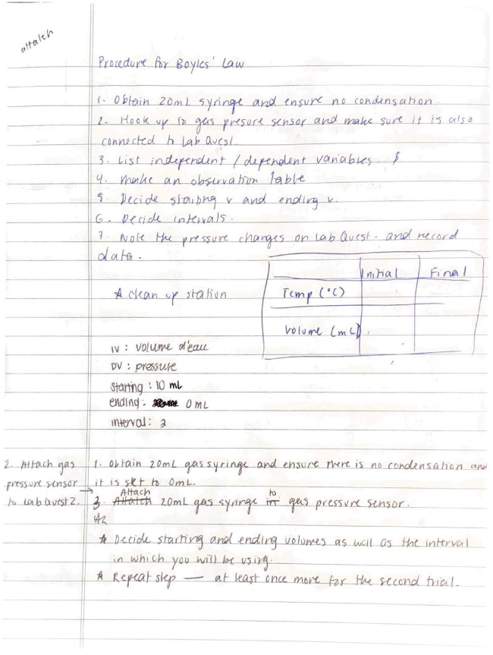
Appendix F
Sample Calculations, Charles’ Law
Table 3: Calculations for Final Volume
 | Trial 1 | Trial 2
Calculated V₂ | V₂ = V₁ - V_{cw}  = 150 mL - 27 mL  = 123 mL | V₂ = V₁ - V_{cw}  = 150 mL - 36 mL  = 114 mL
Average of V₂ | $\frac{V_{1}+V_{2}}{2}$  = $\frac{123mL+114mL}{2}$  = $119mL$
% Error | $\frac{\frac{V_{1}}{T_{1}}-\frac{V_{2}}{T_{2}}}{\frac{V_{1}}{T_{1}}}×100\%$  = $\frac{\frac{150mL}{373.15K}-\frac{123mL}{278.65K}}{\frac{150mL}{373.15K}}×100\%$  = $\frac{-0.0394308435mL/K}{0.4019831167mL/K}×100\%$  = $-9.81\%$ | $\frac{\frac{V_{1}}{T_{1}}-\frac{V_{2}}{T_{2}}}{\frac{V_{1}}{T_{1}}}×100\%$  = $\frac{\frac{150mL}{373.15K}-\frac{114mL}{278.45K}}{\frac{150mL}{373.15K}}×100\%$  = $\frac{-7.426113×{10}^{-3}mL/K}{0.4019831167mL/K}×100\%$  = $-1.85\%$

Sample Calculation, Boyle’s Law
- Boyle’s constant calculation (slope)
  - P = -14.25 kPa/mL + 262.5 kPa or rewrite it as P = -14.25x + 262.5 (LoggerPro helped determine the equation)

Peer Evaluation



