CST8101 Computer Essentials (Lab 1)

`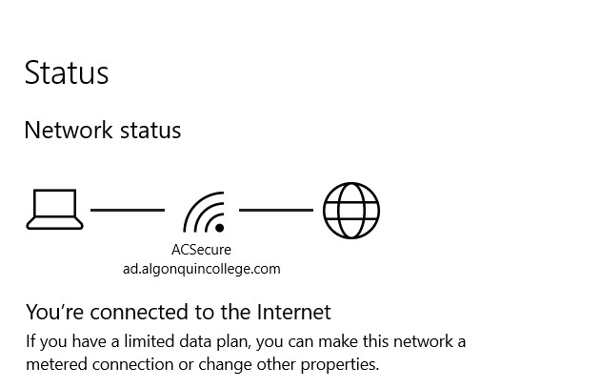
Figure 1/ For this first figure we have a screen capture showing that my laptop is connected to the AC Secure Network at Algonquin College.

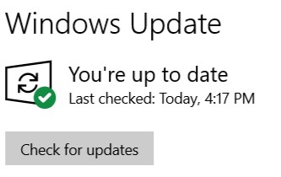
Figure 2/ For this Second Figure we have a screen capture of my laptop showing all essential operating system updates are installed on the laptop and the operating system is up to date.
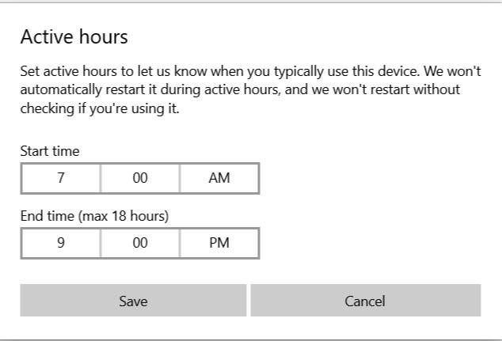
Figure 3/ For this third figure we have a screen capture showing active hours on my laptop. Preventing automatic restarts of the system. I have chosen my active hours with the mindset of it being 1 hour before my earliest class and 1 hour after my last class.

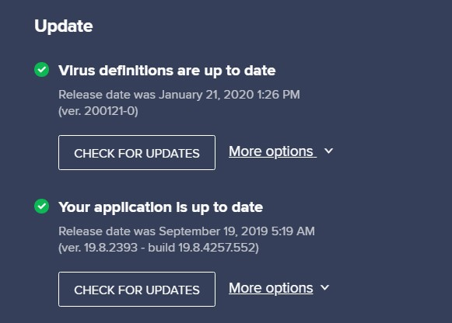
Figure 4/ For this fourth figure, this screen capture is showing an anti-virus program is installed , the hard drive has been scanned and is virus free as well as everything being up to date.

