Chapter 1

- Human want partially satisfied by producing and consuming goods/services

Production activities --> theory of firm
Consumption activities --> theory of consumer
Exchange activities --> theory of markets

- Economic actresses: consumers and producers
- Economy produces g/s by combining resources (land, labour, capital) into a technology of production

Economic Resources
- Tangible or intangible
- Limited resources, unlimited wants = scarcity

- Land: natural resources or any derivative thereof (crops, minerals, land itself)
- Labour: human effort
- Capital: something that is used to make something else (structures, vehicles, plant/equipment, machinery)
  - Not altered/consumed in production, depreciates

Scarcity: condition of wanting more than we can get with available resources
- We can only produce so many things, how to divide amongst the people
- Forces consumers + producers to make a choice

Opportunity Cost: the value of what you have to give up (highest forgone alternative)
- $ amount of opp. Cost = total value of other option
- No scarcity, no choices, no opp. cost
- Every decision has opp. cost (reallocate funding somewhere it could be better used)

Marginal Decision Making: compare additional benefits of a choice against the additional cost

Sunk Costs: costs already incurred that can't be recovered (should not influence decision-making)

Three Coordination Tasks
- What g/s should be produced + in what quantities?
- How should they be produced?
- For whom are the g/s produced?

Market Economy: highest/best used of resources

Coordination Tasks | Key Features
Profitable g/s | Decentralised (allocative decision-making, producers aren't restricted by government)
Least costly way possible | Inegalitarian
g/s distributed amongst  those who have $ | Efficient
 | Dynamic

Price System: market economy
- Market determines production
- Produce less of what ppl stop buying
- Allocative decisions made by producers
  - ie. Gas guzzling cars vs. eco-friendly cars (cost of gas began to rise, gas guzzling cars weren't practical, also environment conscious society shuns gas guzzlers)

Command Economy: antithesis of market economy

Coordination Tasks | Key Features
Output quotas | Centralized (all production = approved by bureaucrats)
Allocates input + specifies the  technique | Egalitarian
g/s rationed | Inefficient (long chain of command)

Price System: command economy
- Centralized Planning Agency determines production
- Change in market does not mean change in production
- Decisions/reallocation must be approved by Central Planning Agency

Correlation: statistical association between two variables
- Change in x related to change in y
- Increasing = positive correlation
- Decreasing = negative correlation
- Zero = unrelated

Causation: "cause and effect"
- Changes in x cause y, not converse
- X = cause
- Y = effect

Chapter 2
Production Possibilities
Drawing the Production Possibilities Frontier (PPF): line or curve that shows all the possible combinations of outputs that can be produced using all available resources (also called a Transformation Curve)
*ie. Shirt v. wheat production
- Inefficient to produce only one item
- Points represent different combination of good produced
- Opportunity cost increases as more of a good is produced because skills vary among workers
- Depicts how efficient/productive producers/would be trader partners are at producing the two items in question
- Economies want PPF to be as far out as possible (greater economic well-being and higher living standards)
- PPF depicts production constraints (cannot produce something outside the curve) [Q1: What are the wants and constraints of those involved?]

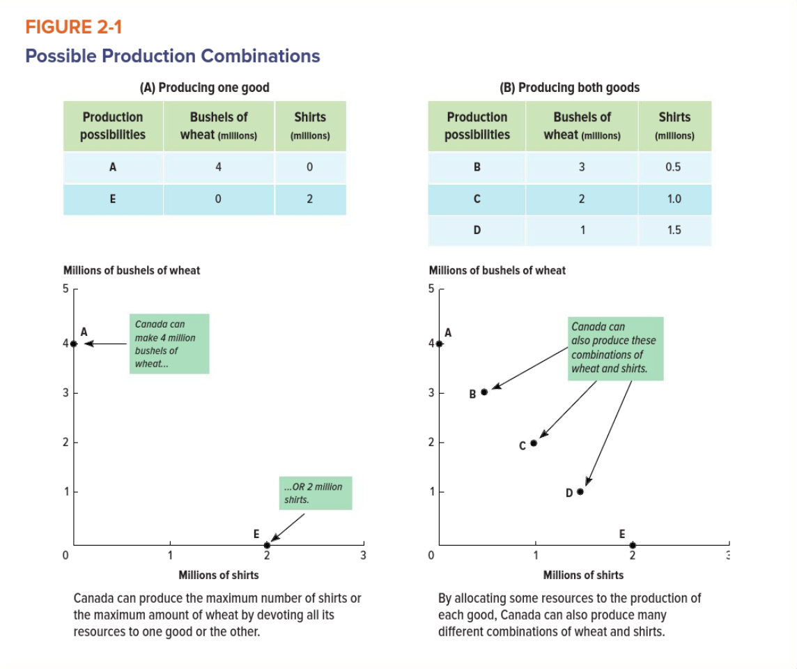

Four Major Points Regarding the PPF
- Points inside are feasible, while points beyond the PPF are unattainable
  - Due to scarcity
  - Points inside represent a situation of under-utilised resources
  - Points on the frontier are productively efficient

- The PPF has a negative slope
  - Due to scarcity
  - Reflects trade-off
  - Trade-off between quantities produced, if more shirts, someone has to stop producing wheat
    - OPPORTUNITY COST of one shirt = two bushels of wheat [Q2: What are the trade-offs?]

- The PPF has a bowed-out shape
  - Nothing to do with scarcity
  - Due to assumption that the economy's resources are not equally well suited for the production of both goods (resources are specialised)

- The PPF can expand outward or contract inward
  - Contract inward = economic hardship (layoffs, bankruptcies, declines in living standards)
    - Usually due to natural disaster, SARS, political instability or terrorism

- Expand Outward = previously unattainable production points become feasible
  - Can emerge through investment in capital goods as well as in human resources
    - Right: removal of inter-provincial barriers to trade and tax cuts, Cut business taxes, Invest in infrastructure
    - Left: invest heavily in social services and programs

Other points concerning the PPF:
- If producing a combination that lies on PPF, conclude that all resources are being exhausted
  - We don't know specific combo that will be chosen, just analyzing possibilities
- Opp. cost is always measured in terms of the other good given up
- EVEN trade-off (straight line in PPF) means constant OC, implying interchangeable resources
- INCREASING trade-off (curve in PPF) means falling OC

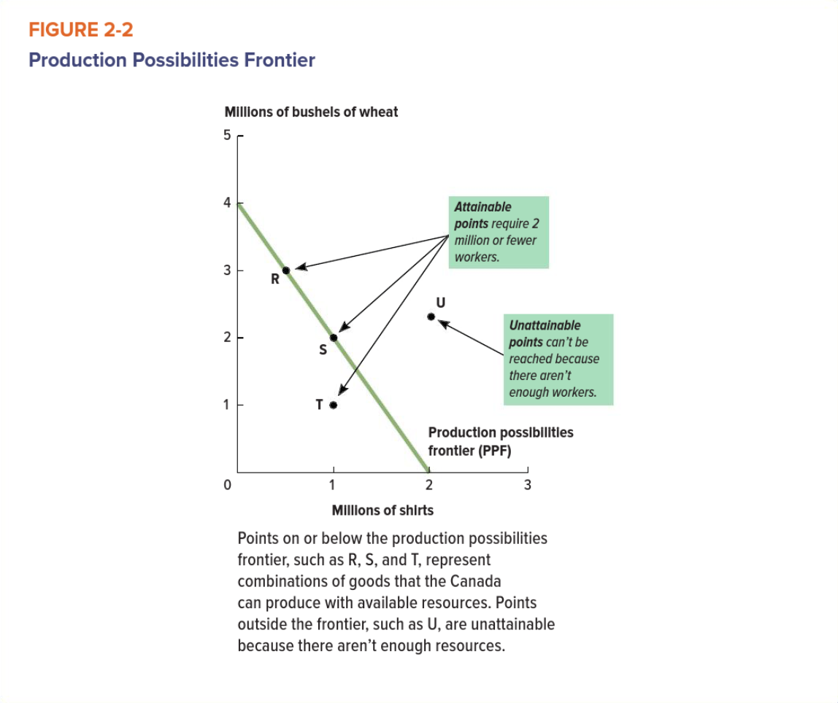
- Moving up the slope = more wheat, less shirts
- Moving down = more shirts, less wheat
- Slope = -2 --> OC of one shirts is always 2 bushels of wheat
- The slope of a production possibility frontier between two points if the ratio of the difference in the vertical distances and the horizontal distances of the points from the origin

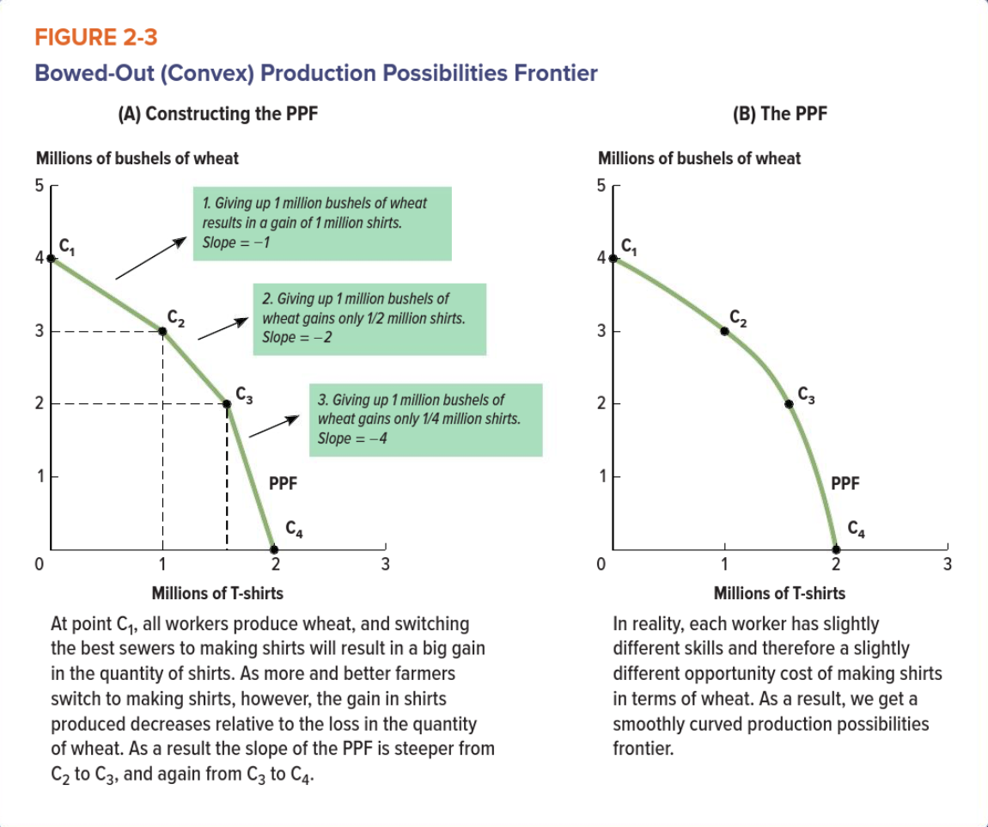
- Translate increasing opportunity cost into PPF
- For every bushel of wheat, some can make one shirt; they're the ones between C1 and C2
- For every bushel of wheat, some can make only 1/2 of a shirt (between C2 and C3)
- For every bushel of wheat, some can only make 1/4 of a shirt (between points C3 and C4)

OPPORTUNITY COST = what you sacrifice / what you gain

- Down the curve better at making shirts, OC of making shirts over growing wheat, increases

Choosing Among Production Possibilities
- Economies can produce at points inside the frontier + on it
  - Choosing points within means there are more resources to exhaust, can move up without sacrificing
- Points that lie on the frontier are most efficient, squeeze most output possible from all available resources
- Points within the frontier are inefficient because do not use all available resources

Shifting the Production Possibilities Frontier
- PPF illustrates the change in market and understanding how it affects the constraints and trade-offs the country faces
- Increase in population = more people = increase in production = OUTWARD SHIFT
- Improvement in technology = same ppl, more product = increase in production = OUTWARD PIVOT

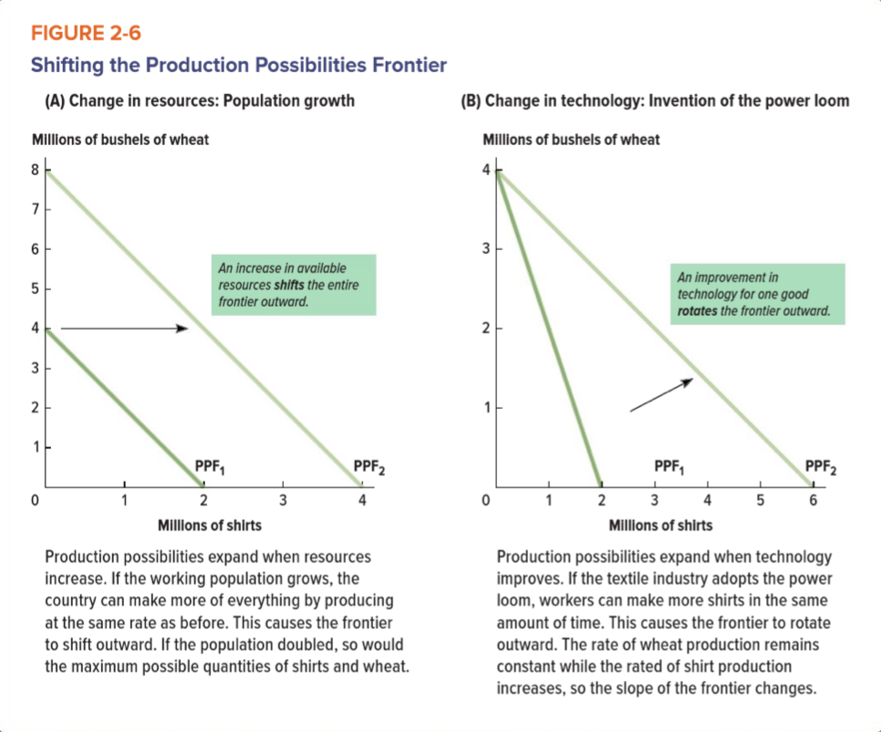
Absolute and Comparative Advantage
Absolute Advantage: when a producer can generate more output than others with a given amount of resources
ie. With our technology/advances Canadian workers can make 50 shirts or grow 200 bushels of wheat per day, a Chinese worker could only produce 25 shirts and 50 bushels of wheat per day because they don’t have the advances, Canada has absolute advantage
- Curve furthest out on graph has absolute advantage
- Determined by pattern of absolute productivity
  - Whichever country/person is more productive has absolute advantage
  - PRODUCTIVITY = OUTPUT / INPUT
  - Want productivity as high as possible
  - Measured in output per person-hour of labour
- Not relevant for trade/specialization
- Relevant for determining living standards

Comparative Advantage: when a producer can make a good at a lower opportunity cost than other producers
ie. OC of Canada producing 1 shirt = 4 bushels of wheat (200 bushels/50 shirts)
OC of China producing 1 shirt = 2 bushels of wheat (50 bushels/25 shirts)
- Canada has a lower opportunity cost for producing wheat than China = comparative advantage at wheat production
- If produces good with a LOWER opp. cost, they have comp. advantage
- Can have comparative advantage without having absolute advantage
- When you have comparative advantage, you usually partner with another country for the other good (TRADE)
- Determines trade pattern (who will you export from, what will you import?)
- Drives pattern of specialization
- Export goods produced, important what cannot produce
- Canada: oil, natural gas, automobiles, automobile parts, lumber, software, film production, wheat and grains, telecommunications

ie. If John is a poor teacher but strong researcher and Alice is a strong teacher and strong researcher. John would specialize in researching because he has a comparative advantage in it. He would trade his time that he spends teaching with the time his colleague does doing research. By doing this exchange, the total output of teaching combined with research output will increase, even though they teach equally well.

Calculating Comparative Advantage
- Examine opportunity costs between production of the two goods within each person separately

- Compare the opportunity cost ratio between the two parties (take number for OC and make common denominator of one (across the two producers)

Example:
Australia can produce EITHER 20 units of food OR 5 units of electronics per work per month. Korea can produce EITHER 8 units of food OR 4 units of electronics per work per month.

It is apparent that Australia possesses the absolute advantage in the production of both food and electronics. It produces food two and one half times as efficiently as Korea (20 / 8), and it produces electronics 25 % more efficiently (5 / 4). Australia is more productive, or more efficient, in the production of both goods. Opportunity cost does not enter into the determination of absolute advantage.

There are 3 ways to determine comparative advantage, and they are all mathematically equivalent. They will always yield the same answer, provided that you have applied them correctly.

Way 1: Using relative efficiencies: Australia is four times more efficient in the production of food as it is in the production of electronics (20 / 5). Korea is only twice as efficient in the production of food as it is in the production of electronics (8 / 4). Since 4 > 2 (the two ratios - think of 4 to 1 versus 2 to 1), Australia has a comparative advantage in food. In other words, Australia is much, much better at producing food than Australia is at producing electronics, while Korea is only much better at producing food than Korea is at producing electronics. The productivity gap within Australia > the productivity gap within Korea, so comparative advantage in food production goes to Australia. By default, comparative advantage in electronics goes to Korea.

Way 2: Using opportunity costs for electronics: Divide the output levels in Australia by 5 in order to determine the opportunity cost of electronics in terms of food. Divide the output levels in Korea by 2 in order to determine the opportunity cost of electronics in terms of food. We thus determine that the opportunity cost of producing 1 more unit of electronics in Australia is 4 units of food foregone, while the opportunity cost of producing 1 more unit of electronics in Korea is only 2 units of food foregone. Since 2 < 4, Korea has a comparative advantage in the production of electronics. In order to expand production of electronics, it has to give up less food than Australia. Since its opportunity cost of producing more electronics is lower, comparative advantage in electronics production to Korea
Way 3: Using opportunity costs for food: Divide the output levels in Australia by 20 in order to determine the opportunity cost of food in terms of electronics. Divide the output levels in Korea by 8 in order to determine the opportunity cost of food in terms of electronics. We thus determine that the opportunity cost of producing 1 more unit of food in Australia is 0.25 units of electronics foregone, while the opportunity cost of producing 1 more unit of food in Korea is 0.5 units of electronics foregone. Since 0.5 > 0.25, Australia has a comparative advantage in the production of food. In order to expand production of food, it has to give up less in terms of electronic production than Korea. Since its opportunity cost of producing more food is lower, comparative advantage in food production goes to Australia.

Basic Idea: by exporting the good which one has a comparative advantage and importing the good which one has a comparative disadvantage, these transformation rates of one good into the other are more favorable than they would be in autarky

Why Trade?
Specialization: the practice of spending all your resources producing a particular good
- If you have a comparative advantage, you usually partner with another country that produces the other good
- Total production increases during specialization
- By specializing in the good in which one has a comparative advantage and trading for the other good, BOTH partners can attain consumption points that lie beyond their production possibilities frontiers
- Driven by comparative advantage (produce what they're best at)

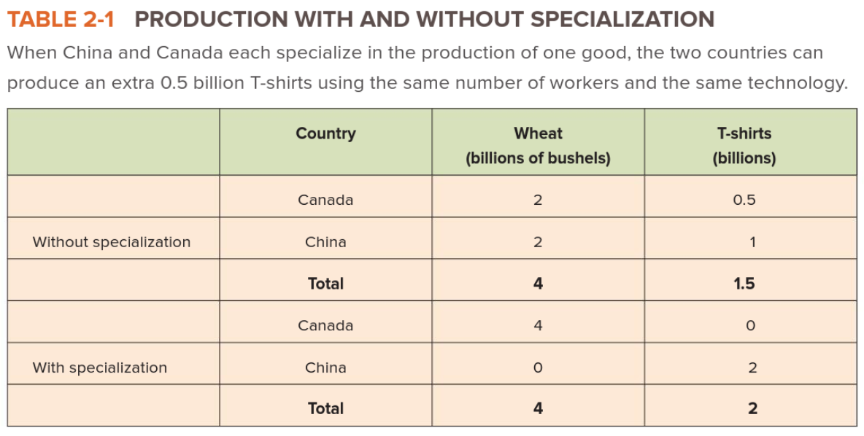

- By specializing, China + Canada can produce same amount of wheat + 0.5 billion more shirts --> INCREASE IN TOTAL PRODUCTION

Gains from Trade: nature of the gains from trade is that it allows both partners to consume bundles beyond their own PPF
- improvement in outcomes that occurs when specialized producers exchange goods and services
- Specialization means one good in each country --> TRADE
- Advantageous for countries, firms, individuals to specialize in production of couple g/s and trade the majority of their g/s
- International trade = economically beneficial
- AUTARKY: Robinson Crusoe economy of total self-sufficiency
  - Specialization/Trade = more production available for consumption than autarky

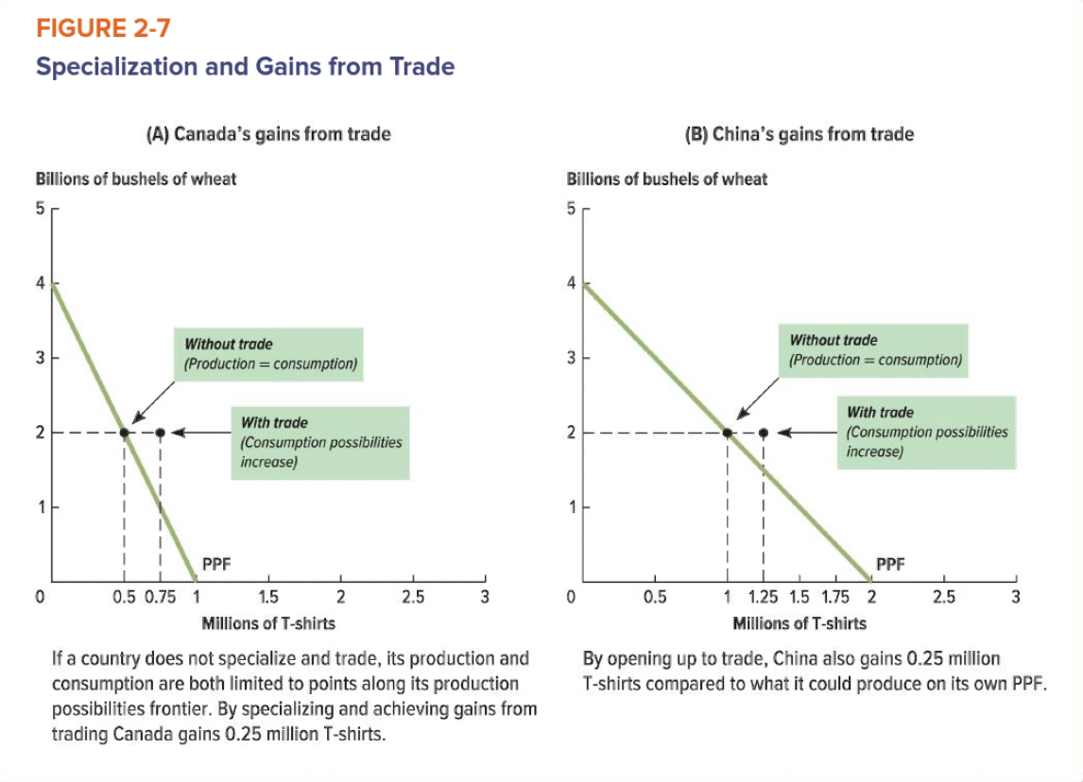
- Trade can be driven entirely by self-interest
  - Specialization/trade allow ppl to get more things than if they were self-sufficient

- OUR MODEL = NO PPF EXPANSION THROUGH TRADE, INCREASE IN LIVING STANDARDS

Comparative Advantage Over Time
- Shifts occur due to industry changes
- Production relocates to countries with cheaper production costs
  - Usually cheaper labour
- Lose comparative advantage in one area, gain in another
- Relocation = more specialized workers
  - Workers begin working in more skilled industries, more money
  - Production shifts to countries with less-skilled workers

Invisible Hand (Adam Smith): no need for government to intervene in market, supply/demand and wants will drive economy

NOTES ON TRADE AND GLOBALIZATION
- Growth rate of trade exceeded growth rate of income, trade = largest economic activity
- Bulk of trade = goods not services
- 35% of Canada's exports = resource based, 60% = 60% manufacturing based

Why Free Trade is Good:
- Rich and poor countries benefit
- Consumers obtain a wider variety of goods
- Consumer prices are much lower
- Foreign markets are available for efficient producers
- Expansion of exports creates jobs
  - NEG: producers compete with import prices
- Pressures high-cost producers to shape up or ship out (survival of the fittest)
- Promotes research and innovation (ie. Blackberry)

Why Free Trade is Bad:
- Demotes Canadian business, competing with imports
- Labor standards/environmental standards/social services will decline to lower costs
- Reinforcing income inequality
- Terms are dictated by wealthy nations
  - Underpay for imports but overcharge for exports
- Economically exploits poor countries

Chapter 3
Market: buyers and sellers who trade a particular g/s, not a physical location
Purpose: to analyze the allocation of the production of goods and services across industries of the economy
- Responds to Q question: what g/s should be produced and in what quantities
- Interaction of the forces of demand (buyers) and supply (sellers) which determine the price at which goods are bought and sold, and the quantity exchanged
- Relative Price: how many units of one good must be given up to acquire an additional unit of a different good
- Amazon is example of a non-physical market

Competitive Market: a market in which fully informed, price-taking buyer and sellers easily trade a standardized good or service

Standardized Good: no matter where you buy it, any two units are the same/interchangeable

Transaction Costs: costs incurred by buyer and seller in agreeing to and executing a sale of g/s

Price Taker: buyer/seller who cannot affect the market price (ie. Gas)

Five Characteristics of Perfectly Competitive Markets
- Standardized Good: any two units of the good have the same features and are interchangeable
- Full Information: market participants know everything about the price and features of the good
- No Transaction Cost: there is no cost to participate in exchanges in the market
- Perfect mobility of resources: there are no barriers for resources to move from firm to another
- Participants are price takers: neither buyers nor sellers have the power to affect the market price

Demand: how much of something people are willing and able to buy under certain circumstances
- Total relationship between price (P) and quantity demanded (Qd)
- Depends solely on the behaviour of consumers

Market Demand: all individual choices (different costs people are willing to pay, option that they choose, what they think is worth it)

Quantity Demanded: total amount of a good or service that all consumers are able and willing to buy given a price per unit of time
- Usually, lower price = higher demand
- Point found on horizontal axis of demand curve

Law of Demand: the inverse relationship between price and quantity demanded
- Ceteris paribus: Latin for "all other things being the same"
  - When all else is held equal, demand rises when price falls
  - Easier to predict impact of a change on a single variable
- Assume nothing other than price changes (simplicity model)
- Lower opp. cost, higher demand
- If price falls, the quantity demanded rises, and if price rises, the quantity demanded falls

Demand Schedule: table which shows the quantities of a particular g/s that consumers are willing to purchase (demand) at various prices

Demand Curve: graph that shows the quantities of a particular g/s that consumers will demand at various prices (visually displays the demand schedule)
- Also demonstrates "willingness to buy": highest amount consumers will pay for any given quantity
- Quantity = x-axis, Price = y-axis
- Downward-sloping line that reflects the inverse relationship between price/quantity
- If price falls, move down demand curve (higher quantity)
- If price increases, move up demand curve (lower quantity)

Determinants of Demand: anything that influences demand
- Curve represents relationship between price + quantity demanded with everything else held constant
  - If not held constant, curve will shift (non-price factors change)
- Reflects trade-offs that people face between:
  - The benefit they expect to receive from a good
  - The opportunity cost they face for buying it
- Anything that changes trade-offs, change willingness to buy/purchasing decisions

Non-Price Determinants of DEMAND: consumer preferences, prices of related goods, incomes, expectations of future prices, number of buyers in the market
- Affect either benefits or the OC of buying a good (even if price stays the same)

- Consumer preferences don't need to be understood, just understand that these preferences affect purchase behaviour
  - Tend to be fairly constant (personality traits/cultural beliefs)
  - More favourable: demand shifts right
  - Less favourable: demand shifts left

A Buy Canadian ad campaign appeals to national pride, increasing the demand for Canadian-made sneakers

An outbreak of E. coli decreases the demand for spinach

- Prices of Related Goods: substitutes v. complements
  - Substitutes are goods that serve similar-enough purposes that a consumer might purchase one instead of the other (pasta and rice)
    - Close substitutes are goods that are quite similar (salmon and trout)
    - P of good B increase: demand for good A increases
    - P of good B decrease: demand for good A decreases
  - Complements are goods that are consumed together (peanut butter and jelly, phones and phone cases)
    - P of good B increase: demand for good A decreases
    - P of good B decrease: demand for good A increases

A decrease in the price of hot dogs increases the demand for relish, a complementary good

A decrease in taxi fares decreases the demand for subway rides, a substitute good

- Incomes affect consumers demand for goods and services
  - Normal goods = increase in income, increase in demand (vise versa)
    - More likely to buy new cell phone when income rises
    - Income increase: demand shifts right
    - Income decrease: demand shifts left
  - Inferior goods = income increases, demand decreases (vise versa)
    - More likely to buy fresh products over instant noodles when income rises
    - Income increase: demand shifts left
    - Income decrease: demand shifts right

An economic downturn lowers incomes, increasing the demand for corn beef, an inferior good

An economic downturn lowers incomes, decreasing the demand for steak, a normal good

- Number of Buyers is represented on the demand curve
  - Increase in buyers = increase in demand

An increase in life expectancy increases the demand for nursing homes and medical care

A falling birthrate decreases the demand for diapers

Shifts in the Demand Curve
Shifts in the demand curve are caused by changes in the non-price determinants of demand
- "change in demand"= demand curve shifted
- New relationship between Qd and P
- Price of thing doesn’t change, resources (income) do
  - More money = more likely to purchase phone at any price
- Causes an increase or decrease in demand (whole thing shifts)

Movement along the curve occurs when there is a change in price
- "change in quantity demanded" = movement along the demand curve
- To see the quantity that consumers will want to purchase at a given price
- Change in price causes increase/decrease in quantity demanded

PRICE IS ONLY FACTOR THAT MOVES ALONG THE DEMAND CURVE, ALL ELSE SHIFTS

Illustration
- During 1970s, it was possible to obtain a high paying job without a university degree, now not so
  - Preferences given to those with degrees
  - Demand for degrees increases (shifts to right)
  - At each possible price (tuition) people are willing and able to buy
  - New relationship between P and Qd

Supply: describes how much of a g/s producers will offer sale under given circumstances
- Overall market supply found by adding up the individual decisions of each producers
  - Total relationship between P and Qs
- Supply varies with price bc of trade-off between the benefit of production v. OC of time/resources of production
  - If cost of resources remain the same but price of good increases, increase in supply
- Depends solely on the behaviours of producers

Law of Supply: all else held equal, quantity supplied increases as price increases (vice versa)
- The higher the price of a good, the more of that good producers will want to sell
- Direct relationship between price and Qs
- If price falls, willingness to sell/produce decreases
- If price rises, willingness to sell/produce increases

Quantity Supplied: the amount of a particular g/s that producers will offer for sale at a given price during a specified period

The Supply Curve: represents the quantities of a product that a particular number of producers will supply at various prices in a given market

Supply Schedule: a table that shows the quantities of a particular g/s that producers will supply at various prices

Determinants of Supply
- Non-price factors determine the OC of production (willingness to supply)
  - When a non-price determinant supply changes, entire curve will shift

PRICE IS ONLY FACTOR THAT MOVES ALONG DEMAND CURVE, ALL ELSE SHIFTS SUPPLY

Non-Price Determinants of SUPPLY: prices of related goods, technology, prices of inputs, expectation, number of sellers
- Determines the OC of production relative to given benefit (ie. Price) and therefore the trade-off

- Prices of Related Goods determine supply bc it affects the OC of production
  - Choosing to produce one good over the other
  - If something has more value, its supply will increase

- Technology increases firms' abilities to produce efficiently
  - Uses fewer resources to make a given product
  - Lowers production cost, increases quantity produced

- Prices of Inputs
  - High input prices = high production cost = lower production
  - Prices of inputs + technology of production = costs of production

- Number of Sellers is considered to be fixed on supply curve
  - Sellers in market will supply more if the price of a good is higher
  - Number of sellers doesn't change based on price (in short term)
  - Non-price factors can cause sellers to enter/leave the market which shifts the supply curve

Shifts in the Supply Curve
Shifts occur when non-price determinants increase/decrease supply
- Increase = shift right
- Decrease = shift left

Movements along the curve occur when there is a change in price

Illustration
- What happens if technology improves
  - Increase in productivity
  - Production costs fall
  - At each possible price, they are willing to produce/supply more than before
  - Supply increases (shifts to right)

Market Equilibrium: the point where the demand curve intersects the supply curve
- Markets work best when quantity supplied = quantity demanded
- Markets will always gravitate back to equilibrium when changes occur

Equilibrium Price: the price at equilibrium point
- Low equilibrium price = bad for producers
- High equilibrium price = bad for consumers

Equilibrium Quantity: quantity at equilibrium point
- Quantity generated on the horizontal axis

- Quantity supplied = quantity demanded: point where buyers/sellers agree on quantity of good they're willing to exchange at a given price
  - A PRICE AND QUANTITY THAT CONSUMERS AND PRODUCERS AGREE ON
- High prices = sellers want to sell more than buyers want to buy (increase in Qs)
- Low prices = buyers want to buy more than sellers are willing to sell (increase in Qd)

Reaching Equilibrium
- Market naturally driven towards equilibrium
  - Sellers adjust price based on customers' behaviour
- Surplus: supply higher than demand
  - Incentive to lower costs to attract customers/increase sales
- Shortage: quantity demanded higher than quantity supplied
  - Incentive to raise costs, people are willing to pay

Changes in Equilibrium
- Shifts in Demand
  - Increase in demand - curve shifts right
    - Consumers are willing to pay a higher price for the same quantity
  - Supply curve is stationary
  - Equilibrium price increases

- Shifts in Supply
  - Increase in supply - curve shifts right
    - Consumers are willing to pay a lower price for the same quantity
  - Demand curve is stationary
  - Equilibrium price decreases

- Shifts in Supply and Demand
  - Both curves shift right
  - New equilibrium quantity
  - Impact on equilibrium price uncertain

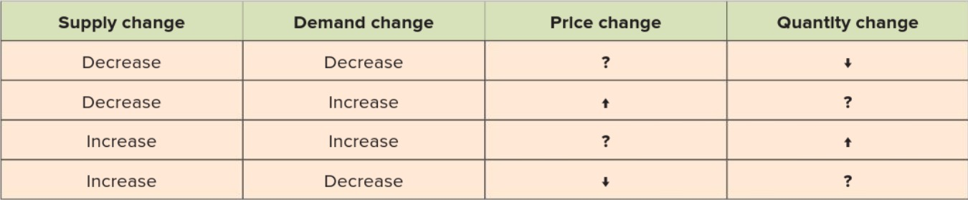

- Increase in Supply/Demand = buyers/sellers agree that at any given price, they are willing to exchange a higher quantity

- Decrease in supply/demand = buyers/sellers agree that at any given price, they are willing to exchange a lower quantity

How to analyze how an event will affect the market:

- Always start with an equilibrium. Draw a graph of the market, label the axes and the equilibrium price and quantity.
- Identify the event that has occurred, and link it into one of the categories of determinants.
- Determine whether the determinant will affect demand or supply and how it will do so
- Draw the effect on the graph (e.g., an increase in demand will result in a rightward shift of the demand curve) Be capable of explaining why it shifts in the direction that it does, as opposed to the other direction.
- Assume price has not changed yet. Determine the disequilibrium condition (in the above example, an increase in demand implies that at the going price, quantity demanded >quantity supplied).
- Identify the new equilibrium price and quantity. Work through the logic of the adjustment in writing.

Note that before you draw the graph, you may already know that the increase in demand is likely to cause the equilibrium quantity to increase. When you shift the demand curve to the right, you will see that the price begins to rise, and that increase in price will cause the quantity supplied to increase (a movement along the supply curve).

Chapter 4
Elasticity: how responsive demand and supply are to the factors that influence them
- Can be applied to supply or demand
- Measures responses to a change in the price of a good, a change in the price of a related good or a change in income

Price Elasticity of Demand: describes the size of the change in the quantity demanded of a g/s when its price changes
- Measure of consumers' sensitivity to price changes
- Consumers' buying decisions are highly influenced by price = demand curve is more elastic
  - Small change in price = large change in demand
- Consumers' not sensitive to price changes = demand curve is less elastic
  - More likely to buy at any price point

Three Ranges of Elasticity
- PED > 1 = ELASTIC
  - Consumers are responsive
  - PED = infinity: perfectly elastic
    - Horizontal demand curve
  - Decrease in P = increase in TR
- PED = 1 = UNITARY ELASTIC
- PED < 1 = INELASTIC
  - Consumers are unresponsive
  - PED = 0: perfectly inelastic
    - Vertical demand curve
  - Increase in P = increase in TR

Calculating Price Elasticity of Demand: (mathematically) the percentage change in the quantity of a good that is demanded in response to a given percentage change in price

Price of Elasticity of Demand = $\frac{\% change in Q demanded}{\% change in P}$

Percentage change in quantity = $\left[\frac{Q2-Q1}{Q1}\right]X 100$

Percentage change in price = $\left[\frac{P2-P1}{P1}\right]X 100$

- Price elasticity of demand will always be a negative number
  - Price and Qd move in opposite directions
  - Some drop negative (absolute value)

Using the Mid-Point Method: measures the percentage change relative to a point midway between the two points

% change in Q = $\frac{change in Q}{average of Q}$

Mid-point of Q = $\frac{Q1+Q2}{2}$

Mid-point of P = $\frac{P1+P2}{2}$

Price elasticity of demand using mid-point method
= (Q2-Q1)/[(Q1+Q2)/2] / (P2-P1)/[(P1+P2)/2]

Determinants of Price Elasticity of Demand
- Consumers are more sensitive to price changes for some g/s than for others (ie. Socks v. coffee)

- Availability of Substitutes
- Increase in price of good with close substitute = consumers purchase substitute instead
- If close substitutes are available, demand for that good = more elastic (higher PED)
  - ie. If cranberry juice gets expensive, people switch to grape

- Degree of Necessity
- Necessary goods will be bought even when price increases (maintain comfort)
- If price decreases, demand doesn't increase (demand not elastic)
  - ie. Heat and socks aren't elastic, just because its cheaper doesn't mean you're gonna heat your house more
- Demand for luxuries (vacation, cars, jewelry) = elastic (higher PED)

- Most people will do without when price rises
- Definition of necessity depends on standards/circumstances
  - ie. In Florida AC= necessity, heating = luxury

- Cost Relative to Income
- If consumers spend little of income on g/s, demand = less elastic
  - Years supply of salt for couple dollars
- If consumers spend a lot of income on g/s, demand = elastic (higher PED)
  - If cost of resorts increases, people will do something else with their vacation

- Adjustment Time
- Goods have more elastic demand in long run (higher PED bc substitutes become avail)
- Adjusting to price changes takes time
  - Short-term: cancel trip but still have to do normal driving to work/school
  - Long-term: bus pass/fuel-efficient car

- Scope of the Market
- Each determinant depends on how you define the market for a g/s
  - Price elasticity of demand for bananas = high because there's other fruit to pick from if bananas get expensive
  - Price elasticity of demand for fruit = low because there's no close substitute for all fruit

Using Price Elasticity of Demand
- Extremes:
  - Perfectly elastic demand: the demand curve is horizontal
    - Consumers are very sensitive to price (demand drops to 0 when price increases even a little)
  - Perfectly inelastic demand: the demand curve is vertical
    - Qd is the same no matter what the price

- Between Extremes:
  - Elastic: when the abs. value of the price elasticity of demand is greater than 1
    - A given percent change in price of a g/s will cause larger percentage change in Qd
  - Inelastic: when the abs. value of the price elasticity of demand is less than 1
    - A given percentage change in price will cause a smaller change in Qd
  - Unit-elastic: when abs. value of elasticity = 1
    - Same percent change in price and Qd
- Total revenue = amount that a firm receives from the sale of g/s
(quantity sold x price paid per unit)
- If price increases and total revenue increases - INELASTIC DEMAND
- If price increases and total revenue decreases - ELASTIC DEMAND
- Increase in price affects total revenue two ways:
  - Quantity effect: decrease in revenue that results from selling fewer units of the good
  - Price effect: increase in revenue that results from receiving a higher price for each unit sold

Price Elasticity of Demand Conclusions:
- Ceteris paribus, as substitutes for a given good become increasingly available, the PED for a good should rise (become more elastic) vice versa
- Ceteris paribus, as a good comes less important in a consumer's budget, PED should fall (become less elastic) vice versa
- Ceteris paribus, if the nature of any good changes such that it becomes more a necessity (think AC, which used to be considered a luxury), its PED should fall and vice versa
- Ceteris paribus, as time passes, the PED should become more elastic and vice versa

Price Elasticity of Supply: the size of the change in the quantity supplied of a g/s when its price changes
- Measures producers' responsiveness to a change in price

Calculating Price Elasticity of Supply
Price Elasticity of Supply = $\frac{\% change in Q supplied}{\% change in P}$

Price Elasticity of Supply = (Q2-Q1)/[(Q1+Q2)/2] / (P2-P1)/[(P1+P2)/2]

- Answer is always positive (between 0 and infinity)
- Elastic: value greater than 1
- Inelastic: value less than 1
- Unit-elastic: value = 1

Determinants of Price Elasticity of Supply
- Supply elasticity depends on the supplier's ability to change the quantity produced in response to price changes

- Availability of Inputs
- If low avail. of inputs, cost of extra inputs is higher = unlikely to increase Qs
- Some goods can be easily expanded by purchasing more inputs (S = elastic)
  - ie. Bakery can increase supply by buying more flour
- Some goods can't be easily expanded (inelastic, steep S curve)
  - ie. If price of a Picasso increases, nothing can be done bc he's dead
- High prices encourage producers

- Flexibility of the Production Process
- Easiest way to adjust: switch production from goods w/ high price or reassign capacity when prices fall
  - ie. Price of corn is high, farmers produce more corn. Price of corn low, produce another crop
  - Some producers can't do this (specialized producers)

- Adjustment Time
- Supply is more elastic over long periods
- Producers can more adjustments in long-run
  - Number of hotel rooms = fixed short term, long-term they can renovate and expand

Other Elasticities
- Cross-Price Elasticity of Demand: describes how the quantity demanded of one good changes when the price of a different good changes
  - ie. If the price of Tim's coffee falls, but Starbucks stays the same, Qd of Starbucks is expected to go down as ppl switch to cheaper alternative

Cross-Price Elasticity of Demand = $\frac{\% change in quantity of A demanded}{\% change in price of B}$

- Positive = substitute goods
- When two goods are substitutes, cross-price elasticity of demand expected to be positive (increase in price of A, increase in Qd of B)
- Negative = complement goods
- When two goods are complements, cross-price elasticity of demand expected to be negative (increase in price of A/B, decrease in Qd for A+B)

- Income Elasticity of Demand: describes how much the quantity demanded changes in response to a change in consumers' incomes
- Some goods ppl aren't sensitive to chane in income (salt, toothpaste, toilet paper)
- Other goods are very sensitive to change in income (vacation, clothes)

Income Elasticity of Demand = $\frac{\% change in quantity demanded}{\% change in income}$

- Income elasticity tells us how much the demand for inferior and normal goods change
  - More money = buy Starbucks (income-elastic)
  - Less money = make coffee at home, some people deem coffee a necessity (income-inelastic)
- Positive for normal goods (Qd rises when incomes rise)
  - Necessities + Luxuries = normal goods
  - Necessity: income elasticity of demand = positive but less than 1
  - Luxury: income elasticity of demand = positive but more than 1
- Negative for inferior goods (Qd falls when incomes rise)

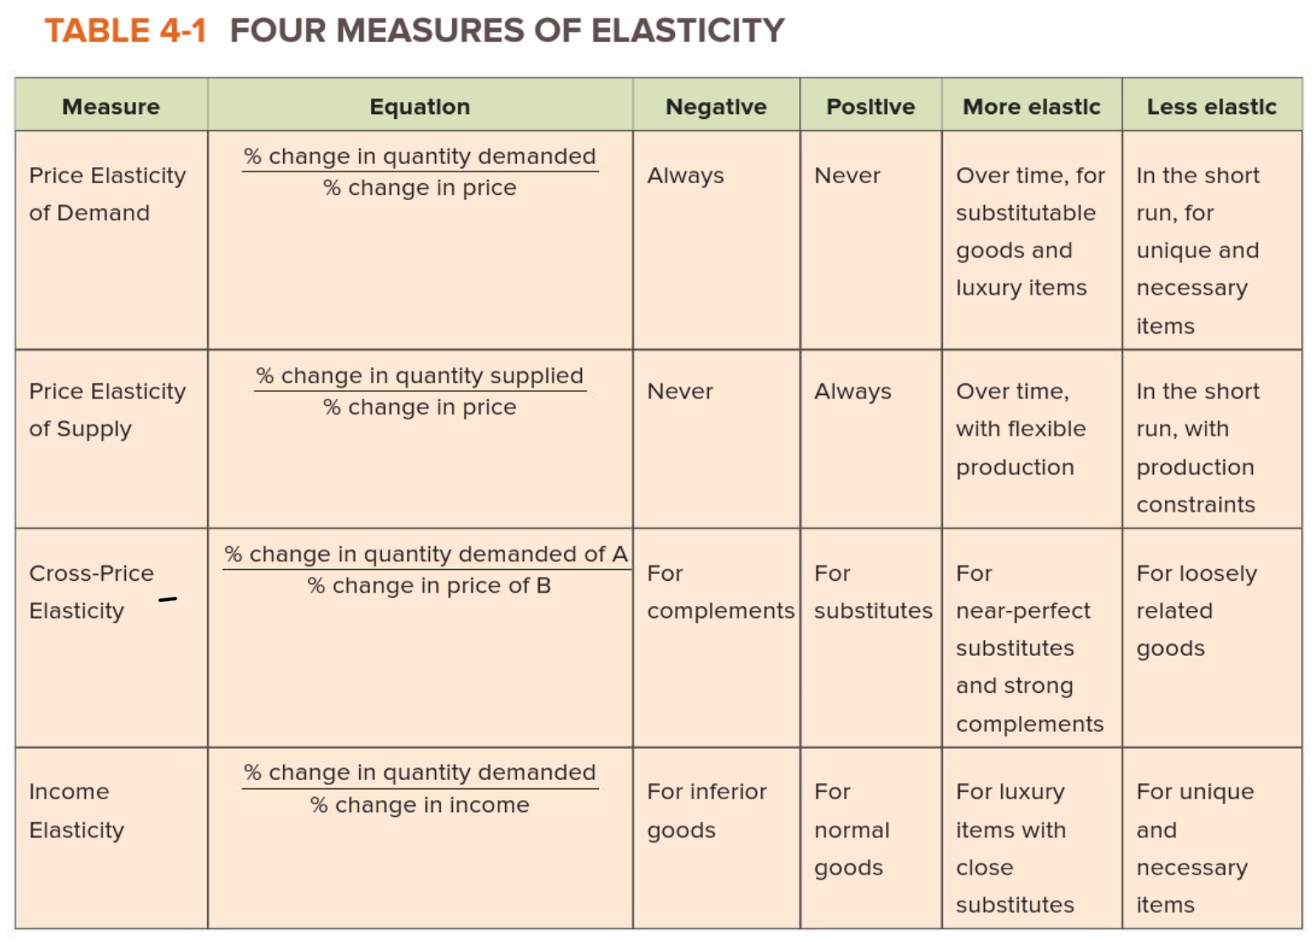

Chapter 5
- Q is efficient if: welfare of producers on S side PLUS welfare of consumers on the D side is at its highest

Surplus: measures the benefit that people receive when they buy something for less than they would have been willing to pay or sell something for more than they would have been willing to accept
- Best way to look at the benefits people receive from successful transactions
- Indicates who benefits and who loses from policies (ie. Taxes, minimum wage)
- Enabling people to trade amongst each other can make them better off

Efficiency: maximizing total surplus

Willingness to Pay and Sell
Willingness to Pay: maximum price a buyer is willing to pay
- On eBay you can see it - people don't auction past a certain point
- Buyers want cheapest price

Willingness to Sell: the minimum price a seller is willing to accept
- Reserve price on eBay indicates the lowest amount seller will accept as bids
- Sellers want highest price

Willingness to Pay and the Demand Curve
- Demand curve is driven by consumers' willingness to pay
- Graph points of potential buyers
  - Not necessarily smooth (low number of buyers - staggered graph)
- Willingness to pay = maximum
  - Would pay lower, therefore includes all price points until maximum
    - (ie. Everyone would bid at 100$ but only one person would bid at 350$)
  - Declines with consumption (ie. Gin and tonics)
- Prices above maximum willingness to pay: OC is greater than benefits
  - Point at which buyer would rather spend their money on something else
- Prices below maximum willingness to pay: OC is less than benefits
- Different for everyone

Willingness to Sell and the Supply Curve
- Supply curve is driven by suppliers’ willingness to sell
- Opposite demand curve
- Willingness to sell = minimum
  - Would accept higher, therefore includes all price points until minimum
- Sellers at least want to break-even in sale, otherwise they stop producing
- OC determined by different factors

Measuring Surplus
Surplus: way of measuring who benefits from transactions and by how much
- Difference between the price at which a buyer/seller would be willing to trade and the actual price
- If you sell for more than you wanted or buy for less than you wanted = GOOD
- Portion you would've paid but didn’t = surplus
- Value of something vs. actual price

Consumer Surplus: difference between willingness to pay and amount actually paid (consumer welfare)
- Measure of consumer well-being that reflects the payment rendered
- ie. Would spend up to 500$ on camera, only paid 160$, surplus = 340$
- Buy nothing, spend nothing = surplus of 0
- Total consumer surplus = add all surplus together
- Surplus shrinks as price increases, surplus grows as price decreases
- How the allocation of resources (input/output) affects economic well-being
- Price = willingness to pay
- As consumption rises, level of CS diminishes
- Consumer surplus at margin = 0

Producer Surplus: the net benefit that a producer receives from the sale of a g/s, measured by the difference between willingness to sell and the actual price (producer welfare)
- Benefit that firms receive from producing in the market
- Producers want to increase surplus = more profit
- Surplus shrinks as price decreases, raises as price increases
- No sale/last unit = surplus of 0
- Total surplus = add all surplus together
- Derived from supply curve
- Price = willingness to supply a given quantity
- Area below the price, above supply curve

Total Surplus: measure of the combined benefits that everyone receives from participating in an exchange (global/total welfare)
- Supply and demand curves
- Intersection is market price
- Consumer surplus: between market price and demand curve
- Producer surplus: between market price and supply curve
- Total surplus = consumer surplus + producer surplus

Zero-Sum Game: situation in which whenever one person gains, another loses an equal amount so that net = 0
ie. Gambling- whatever someone wins is what someone lost

Using Surplus to Compare Alternatives
Market Equilibrium and Efficiency
- Equilibrium makes the total well-being of all participants in market as high as possible
- When market moves from equilibrium, surplus changes
  - ie. eBay seller has no bidding, only price of 300$. Less people are willing to buy at this price, graph shifts, surplus changes
- Market is most efficient at equilibrium
  - No one can be made better off without someone becoming worse off

Changing the Distribution of Total Surplus
- High prices above equil. = lower surplus
  - Less transactions (fewer ppl willing to buy) CONSUMERS
    - Fewer transactions but higher surplus when g/s is bought so not entirely loss for PRODUCERS
- Low prices below equil. = lower surplus
  - Less transactions (fewer producers willing to sell) PRODUCERS
    - Fewer transactions but CONSUMERS have higher surplus purchasing at lower cost

Deadweight Loss: the loss of total surplus that results when the quantity of a good that is bought and sold is below the market equilibrium quantity
- Any intervention that moves market away from equilibrium
- Surplus lost, what was produced before change

Deadweight Loss = total surplus at market equilibrium before intervention – total surplus after a market intervention

Missing Markets: no place for potential buyers/sellers to exchange a particular g/s
- Can be missing for many reasons (ie. Illegal goods, against public policy, lack of technology/information)
- eBay is best example (took advantage of missing market)
- Before eBay, buyers were limited to immediate surroundings
  - Now market open to find nearly anything
- Creating markets creates surplus
  - Small changes (ie. Cell phones in India, loans from banks) don’t redistribute to poor, also expands pie

Chapter 6
Why Intervene?
Three Reasons to Intervene
- Correcting Market Failures
  - Market failures: situations in which the assumption of efficient, competitive markets fails to hold
  - Intervention can create surplus
ie. One producer who faces no competition can charge high prices

- Changing the Distribution of Surplus
  - Efficient outcomes can still be unfair
ie. Governments impose minimum wages so workers don't fall below poverty line while employers become rich
- Redistributed wealth from employers

- Encouraging or Discouraging Consumption
  - "Bad" products banned altogether (hard drugs)
  - HIGH TAX on products government wants to discourage but not ban (cigarettes/alcohol)
  - SUBSIDIES to promote use of certain goods (free public education to promote education, vaccinations to encourage protection from disease, cash for eco-friendly car)

Positive analysis: facts
Normative analysis: values/opinions

Price Controls: regulations that set a maximum or minimum legal price for a particular good
- Holds price of good steady when market shifts to prevent a new equilibrium

Price Ceilings: maximum legal price at which a good can be sold
- Usually on staples (gas, food, electricity) so everyone can afford necessities
- Causes surplus to fall: sellers are selling fewer quantities at lower prices
- Total surplus will fall: market moved away from equilibrium
- Causes shortage, goods have to be rationed
  - Food coupons
  - First-come, first-served
  - Preference given
- Shortage opens door for bribery
- Non-Binding: ceiling placed above equilibrium
  - Has no affect on buyers/sellers
  - Can still buy/sell at equilibrium
- Good for consumers at expense of producers

Price Floors: minimum legal price at which a good can be sold
- Common in agriculture sector in Canada
  - Farming is difficult, unpredictable and unsafe work, price floor ensures minimum income
- Changes distribution of surplus
  - Calculated by calculating difference between Qs and Qd
- Good for producers at expense of consumers
- If surplus > deadweight loss: price floor incr. producer well-being
- If surplus < deadweight loss: price floor decr. producer well-being
- Government can buy excess Qs to prevent producers from receiving 0
  - Tax payer money, costs to purchase
- Non-Binding: floor placed below equilibrium
  - Has no affect on buyers/sellers
  - Can still buy/sell at equilibrium

Taxes: main way gov. raises revenue to pay for public programs
- Buyer/seller must pay extra to the gov. on top of sale price
- Qs and Qd decreases, government raises money

Tax on Sellers
- Decreases supply
  - Sellers must pay gov. x amount for each unit sold
    - See price received from good as x amount less
    - Market price must be x amount more than it was before tax
- Demand stays the same
  - Tax doesn't change any determinants of demand
  - Buyers desire to purchase at any given price remains unchanged
    - Qd can change
- Equilibrium price rises and Qd falls

- Tax Wedge: difference between the price paid by buyers and the price received by sellers, which equals tax (received by government)
Tax Wedge = P_{buyers} - P_{sellers} = tax

Government Tax Revenue = (Tax)(Q_{post-tax})

- Tax causes deadweight loss and redistributes surplus
  - Deadweight loss caused by reduced number of trades
    - Surplus lost to buyers/sellers who would've been willing to make trades at pre-tax equilibrium price
  - Producers and consumers lose surplus
    - Consumers spend more for less than what they were receiving before tax
    - Producers receive less for the same amount
    - Surplus doesn't disappear, becomes gov. revenue
      - Revenue can pay for services that might transfer surplus back

Tax on Buyers
- Supply remains the same
  - Tax does not change producers incentives
  - Non-price determinants of supply are not affected
- Demand decreases
  - Price buyers must pay is now x amount more
  - Buyers behave as if price is x amount more
- Equilibrium price and quantity fall
- Tax Wedge/Revenue

Tax Burden
- Equal Burden: supply and demand have same relative elasticity, buyers and sellers share burden equally
- Sellers pay more: demand is more elastic than supply, sellers shoulder more burden than buyers
- Buyers pay more: supply is more elastic than demand, buyers shoulder more burden than sellers
- Tax Incidence: relative tax burden borne by buyers and sellers
  - Determined with relative elasticity of the supply and demand curves
  - Price elasticity: how much the Qs or Qd changes in response to a change in price
  - Side of market that is more price elastic will be more able to adjust to price changes and will shoulder less of the tax burden

Four Effects that result from taxes:
- Equilibrium quantity falls
- Buyers pay more for each unit and sellers receive less – creates tax wedge
- Gov. receives revenue equal to the amount of the tax multiplied by the new equilibrium quantity
- Tax causes deadweight loss – value of gov. revenue is always less than the reduction in total surplus caused by the tax

Subsidies: requirement that the government pay an extra amount to producers/consumers of a good (reverse of tax)
- Encourage production/consumption of goods
- Qs and Qd increases, government spends money

Subsidy on Sellers
- Supply increases
  - Amount received per unit is higher than at market price
  - Behave as if price is x amount more
  - Market price can be x amount less to supply same amount as before subsidy
- Demand stays the same
  - Consumers are not affected by the subsidy
- Equilibrium price decreases and equilibrium quantity increases

- Subsidy benefits buyers and sellers, increasing total surplus within the market
- Weighed by comparing value of incr. in production and reduced cost to consumers v. opportunity cost (what the gov. could've done with the money spent on subsidy)

Subsidy on Buyers
- Demand increases
  - Amount paid per unit is lower than at market price
  - Behave as if price is x amount less
  - Market price can be x amount more to buy same amount as before
- Supply remains the same
  - Suppliers aren't affected by subsidy
- Equilibrium price decreases and equilibrium quantity increases

Subsidy Burden
- Same as tax burden
- Side of market that is more price elastic receives more of the benefit

Four effects that result from subsidies:
- Equilibrium quantity increases
- Buyers pay less and sellers receive more for each unit sold – amount of the subsidy forms a wedge between buyers and sellers prices
- Government has to pay for subsidy, cost equals amount of subsidy by new equilibrium quantity
- Subsidy causes a deadweight loss

Evaluating Government Interventions
- Price controls have opposing impacts on Qs and Qd, causing shortage or surplus in supply
- Taxes and subsidies move Qs and Qd in same direction, allowing market to reach equilibrium
- Taxes discourage buying/selling of particular good, raise government revenue, impose a cost on buyers/sellers
- Subsidies encourage buying/selling of particular good, cost government money, provide benefit to buyers/sellers

How Big is the Effect of a Tax or Subsidy?
- Effect of tax/subsidy can be predicted ahead of time if you know price elasticity of s/d
- More elastic = greater change in quantity
- Tax/Subsidy = change in price (elasticity)

Intervention | Reason for using | Effect on P | Effect on Q | Who gains and who loses?
Price floor | To protect producers' income | Price cannot go below the set minimum | Qd decreases and Qs increases, creating excess Qs | Producers who can sell all their goods earn more revenue per item; other producers are stuck with an unwanted surplus Qs
Price ceiling | To keep consumer costs low | Price cannot go above the set maximum | Qd increases and Qs decreases, creating a shortage | Consumers who can buy all the goods they want benefit; other consumers suffer from shortages
Tax | To discourage an activity or collect money to pay for its consequences; to increase gov. revenue | Price increases | Equilibrium Q decreases | Government receives increased revenue; society may gain if the tax decreases socially harmful behaviour.  Buyers and sellers of the good that is taxed share the cost.  Which group bears more of the burden depends on the price elasticity of s/d
Subsidy | To encourage an activity; to provide benefits to a certain group | Price decreases | Equilibrium quantity increases | Buyers purchase more goods at a lower price.  Society may benefit if the subsidy encourages socially beneficial behaviour.  The gov. and taxpayers bear the cost

Price Elasticity and the effect of a $0.20 tax
- Inelastic supply and demand – when both supply and demand are relatively price-inelastic, the equilibrium quantity does not decrease significantly because of a tax
- Inelastic supply and elastic demand – when supply is inelastic but demand is relatively elastic, the equilibrium quantity decreases significantly because of tax
- Elastic supply and inelastic demand – when supply is relatively elastic compared to inelastic demand, the equilibrium quantity decreases more than it does in panel A in response to a tax
- Elastic supply and demand – the greatest decrease in the equilibrium quantity occurs when both demand and supply are relatively elastic; both buyers and sellers react strongly to the change in price that is caused by a tax

Long-Run versus Short-Run Impact
- Determinant of price-elasticity = period over which it is measured
- Elasticity is greater in long-run v. short-run
  - Demand: consumers have opp. to make gradually larger changes over-time
  - Supply: producers have opp. to gradually produce more, Qs increase over time
- Results can seem disappointing at first

Chapter 7

The Basic Idea of Utility
- Utility is a measure of the amount of satisfaction a person derives from something

Utility and Decision Making
- People get utility from g/s they consume and experience
- Things you like increase utility
- Things you dislike reduce utility (won't even consume if it's free)

Utility Maximization: people make decisions by choosing to do the things they think will give them the most utility, given all of the available options

Revealed Preference
- We can tell what maximizes other people's utility by observing their behaviour
- Watch what people do over what they want to do

Utility Functions
- Formula for calculating the total utility that a particular person derives from consuming a combination of g/s
- Bundle: each unique combination of g/s that a person could consume
- Utility = subjective measure that can't be readily quantified
  - Utility measurements = relative not absolute

Marginal Utility: the change in total utility that comes from consuming one additional unit of a g/s

Diminishing Marginal Utility: the additional utility gained from consuming units of a g/s tends to be smaller than the utility gained from the previous unit
- Particularly noticeable w food items (ie. Ice cream)
- Indifference towards g/s = zero marginal utility
- Don't want = negative marginal utility

Maximizing Utility within Constraints:
- People have wants but are constrained by time/money
- Rational utility maximizers: spend resources on bundle of g/s to maximize utility
- Budget Constraint: a line composed of all of the possible combinations of g/s a consumer can buy with their income

Utility and Society
- Utility can help us think about a range of human emotions
- Utility out of good deeds

Utility and Status
- Utility comes from two sources: direct effect, other people's reactions
  - Outside perceptions v. inner preference
- Assumptions people will make about you/how people will view you v. what you want

Utility and Altruism
- Altruism: a motive for action in which a person's utility increases simply because someone else's utility increases
  - Behaving altruistically: when people behave selflessly by doing something for others, with no obvious benefit for themselves
- Altruistic/selfish or image-conscious motivations can coexist perfectly
  - Single action can produce utility in various places
- Acting in self-interest = maximizing personal utility, not selfish

ie. Doctors without Borders – helping others (utility), telling people about it (utility)
Buying a concert ticket for your friend – friend gets to go to concert (utility), you don't go alone (utility)

Utility and Reciprocity
- Reciprocity: responding to another's action with a similar action
  - Doing good things for those that do good things for us
- Negative reciprocity: decreasing someone's utility in response to being harmed yourself
  - Guy down the hall keeps you up, steal his toothpaste

Chapter 12

The Building Blocks of Business: Revenues, Costs and Profits
Profit is Revenue minus Costs
- Total revenue: the amount a firm receives from the sale of g/s
- Total cost: the amount a firm pays for all of the inputs that go into producing g/s
  - One-time expenses: buying machinery
  - Ongoing expenses: rent, salaries, raw materials, advertising
- Profit: difference between total revenue and total cost

Equations
Profit = total revenue – total cost
Revenue = quantity x price

Fixed and Variable Costs
- Fixed Cost: don't depend on the quantity of output produced
  - One-time payment: upfront cost that has to be made to begin production (equipment)
  - Ongoing payment: cost that has to be made to continue production (rent)
- Variable Cost: depend on the quantity of output produced
  - Includes raw materials, labour costs, etc
    - Things that need to be purchased to continue production
  - If production stops, VC = 0
    - Stuck with fixed costs
- Can incur fixed costs without variable costs (if good is produced but not ready for sale, company has incurred fixed costs)
- Total cost = combination of fixed costs + variable costs

Explicit and Implicit Costs
- Explicit Costs: require a firm to spend money
  - Fixed and variable costs
  - Pay someone else to acquire
- Implicit Costs: costs that represent forgone opportunities
  - Opportunities that could have generated revenue if the firm invested otherwise
  - Choice to not earn money

ie. Pfizer owns warehouse – could be rented out for $4000
- No explicit cost: don't have to pay anyone for the warehouse
- Implicit cost: $4000 (could've rented it out)

Economic and Accounting Profit
- Accounting profit: total revenue minus explicit costs
- Economic profit: total revenue minus explicit and implicit costs

Production Function: relationship between quantity of inputs and the quantity of outputs
- Inputs: materials that are used for production
- Outputs: g/s produced

Marginal Product: the increase in output that is generated by an additional unit of input
- Difference between past production and current production
- Diminishing Marginal Product: marginal product of an input decreases as the quantity of the input increases
- Average Product: number of output produced per worker on average
  - # of workers/total production
- Production decisions on the margin: compare the marginal product of an input to its marginal cost when deciding to employ or build

Cost Curves
Total and Average Costs
- Total cost = fixed costs + variable costs
- Average Fixed Cost (AFC) = fixed cost/quantity
  - Curved downward – fixed costs remain the same as quantity produced increases, so the fixed cost per unit of production decreases
- Average Variable Cost (AVC) = variable cost/quantity
  - U-shaped curve
  - Initially slops downward as first few employees have increasing MP
  - Diminishing MP kicks in = trend upward
- Average Total Cost (ATC) = total cost/quantity
  - U-shaped curve (less than AVC) – increases in AVC are cancelled out by the decreases in AFC

Marginal Cost
- Marginal decision-making: ask what additional cost they will incur by producing one additional unit of output
- Marginal Cost: change in total cost/change in quantity
- If MC of increasing production by one unit is less than current avg. cost, extra unit will decrease avg. cost (vise-versa)

Cost | Description | Calculation
Total Cost (TC) | The amount that a firm pays for all of the inputs (fixed and variable) that go into producing g/s | TC = FC + VC
Fixed Cost (FC) | Costs that don't depend on the quantity of output produced
Variable Cost (VC) | Costs that depend on the quantity of output produced
Explicit Cost | Costs that require a firm to spend money
Implicit Cost | Costs that represent forgone opportunities
Average Fixed Costs (AFC) | Fixed costs divided by the quantity of output | AFC = FC/Q
Average Variable Costs (AVC) | Variable costs divided by the quantity of output | AVC = VC/Q
Average Total Costs (ATC) | Total costs divided by the quantity of output | ATC = TC/Q
Marginal Cost (MC) | The additional cost incurred by a firm when it produces on additional unit of output | MC = ΔTC/ΔQ

Production in the Short Run and the Long Run
- Supply is more flexible overtime
  - Things take time

Costs in the Long Run
- Fixed costs depends on what timescale you're thinking in
  - Rent = fixed in short-term, not long-term
    - Have to wait until lease is over, afterwards they can move
- Long-term is not defined as certain amount of time
  - Short-term v. long-term represents how quickly changes can be made

Returns to Scale
- When planning for long-term, firms consider at which scale they want to operate
  - Bigger/smaller premises, build or close factories
- Returns to scale: the relationship between the quantity of output and avg. total cost
- Economies of scale: when increasing a firm's scale lowers avg. costs
  - When cost per unit does down as output increases
  - Bulk orders = cheaper
- Diseconomies of scale: when increasing a firm's scale raises avg. costs
  - When cost per unit increases as output increases
- Constant returns to scale: when a firm can operate without experiencing higher or lower avg. costs
  - When cost stays constant as output increases
- Achieve economies of scale by expanding – long-run ATC curve slopes down (decreases as output increases)
- Diseconomies by expanding – long-run ATC curve shown with flat portion in middle (various diff. levels of output at which firm achieves constant returns to scale)
- Long-run ATC curve covers more output than short-run
  - Short-run: all firms are stuck on smaller cost curve
    - Constrained by limited capacity of fixed inputs
  - Long-run:
    - By increas./decreas. Its scale, a firm can move along the long-run ATC curve from one short-run ATC curve to another
    - When a firm moves along the long-run cost curve, it does so by choosing to move to the short-run cost curve that would be associated with a larger or smaller firm
- Efficient Scale: when a firm cannot lower its avg. cost by increasing or decreasing its scale
  - Producing the quantity of output at which ATC is minimized

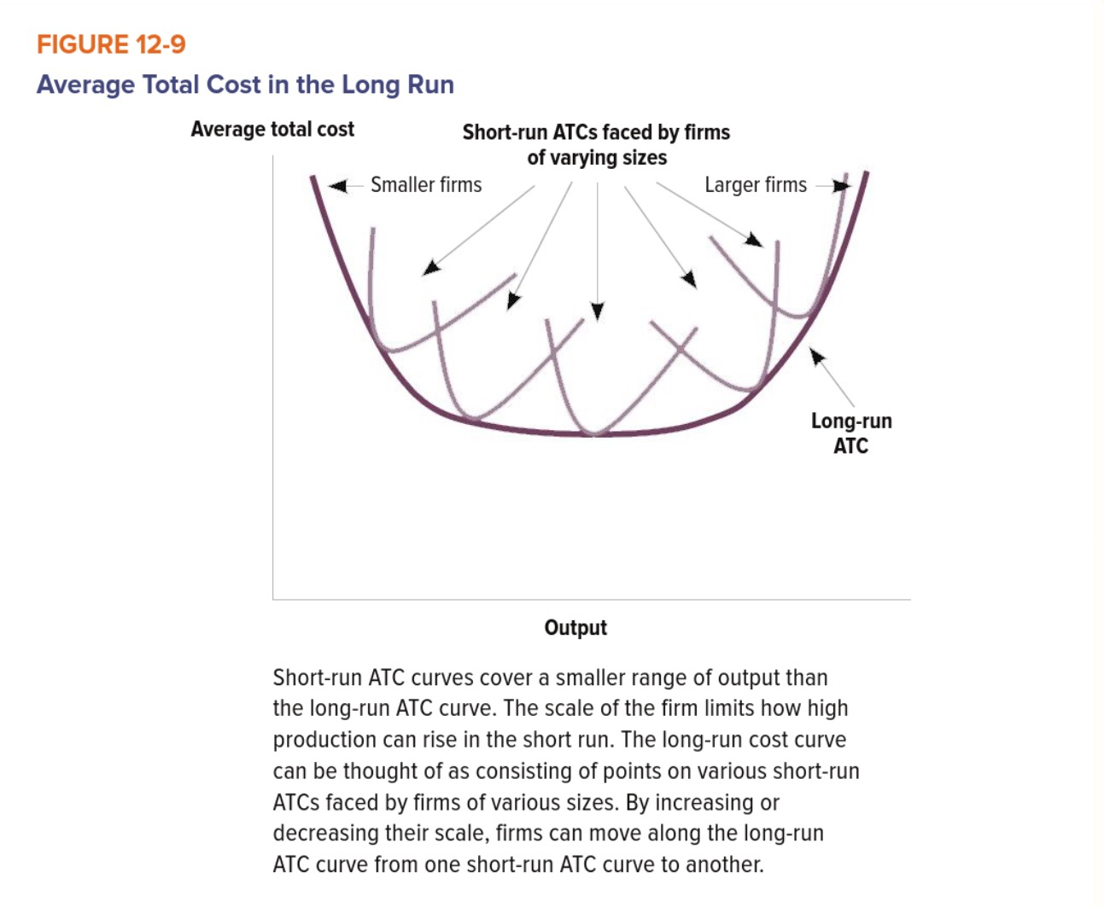

Chapter 13

Competitive Market
Characteristics of a Competitive Market
  - Individuals Can't Affect the Going Price
    - Buyers are price-takers: going price is going price
      - Opposite = market power: ability to noticeably affect market prices
    - Individuals decisions are much smaller than market size, can't affect market

  - Goods and Services are standardized
    - Interchangeable, no difference from seller to seller
      - must sell at market price, higher prices = go to another seller, no incentive for lower prices
    - Commodities: at same price, producer plays no part – same g/s no matter who made it (ie. Gold, oil, grain, etc)

  - Firms Can Freely Enter and Exit
    - Keeps existing firms on toes – promotes innovation, cost-cutting and quality improvements
    - Easier to enter certain markets (ie. Plantain over crude oil) – start-up costs

Revenues in a Perfectly Competitive Market
In a perfectly competitive market, producers are able to sell as much as they want without affecting the market price
  - Assume firms in a competitive market can sell any quantity of output at MP
  - Total Revenue: the price that a firm receives for each good, multiplied by the quantity of the good that it sells (P x Q)
  - Average Revenue: total revenue/quantity sold [(P x Q)/Q]
    - For any firm selling one product, average revenue is equal to the price of the good
  - Marginal Revenue: revenue generated by selling an additional unit of a good (Market Price)
    - For a firm in a competitive market, marginal revenue is equal to the price of a good

Profits and Production Decisions
  - Quest for profits is the most important driving force behind firms' behaviour
    - How much firms will choose to produce under different circumstances

Deciding How Much to Produce
  - Revenue and cost determined by outside factors
    - Price/quantity of inputs
  - Can increase revenue by increasing quantity of g/s produced, can't affect price it receives for sale
  - Marginal revenue remains the same in a perfectly competitive market
  - A firm should keep producing for as long as marginal cost is less than marginal revenue; it should stop producing as soon as the two are equal
  - The profit-maximizing quantity is the one at which the marginal revenue of the last unit was exactly equal to the marginal cost
  - Marginal cost curve slopes upward, as marginal cost increases w/ Q
  - Horizontal line at price level = marginal revenue
    - Intersection of MC and MR = profit-maximizing quantity to produce
  - Change in going price = change in quantity to produce

Deciding When to Operate
  - Price decrease = lower profit-maximizing quantity
  - MC curve intersects AVC and ATC at lowest points
  - MP below ATC curve – no production can create profit
  - Fixed costs = sunk costs in short-run (still have to pay even if firm shuts down)
    - Fixed costs are irrelevant in deciding whether to shut down production in the short run
  - MP lower than ATC, higher than AVC: produce in short-run
    - More revenue than variable cost
    - Produce at profit-maximizing level
    - Lose money but less than stopping production
  - MP lower than ATC and AVC: stop producing in short-run
    - Pay fixed costs
    - Firm will lose money for every unit produced

Short-run Shutdown Rule: P < min(AVC)

  - MC curve above shutdown point = supply curve
  - Below shutdown point = no production

Behind the Supply Curve
Short-Run Supply
  - Assume # of firms in market is fixed
  - Total quantity of a supplied g/s = sum of quantities each producer is willing to supply
  - Firm's MC curve at points after AVC curve intersection

Zero Economic Profit
  - In long run, firms earn zero economic profit
  - Couldn't earn greater accounting profit by operating in a different market

Chapter 14

Why Do Monopolies Exist?
Monopoly: a firm that is the only producers of a g/s that has no close substitutes
- Single seller
- Perfect monopoly: 100% control of the market
- Monopoly power: slightly less than 100% of the market
- Lack of close substitutes: people can't switch to another g/s

Barriers to Entry
- Contradict free entry and exit feature of perfectly competitive market

- Scarce Resources
- Scarcity in key resource/input
- Country can have monopoly (ie. Rare earth elements in China)

- Economies of Scale (high fixed costs)
- Producing more output = lowered average costs
- Required infrastructure is too costly to replicate
  - ie. Electricity-supply
- Fixed costs are high, larger companies distribute them amongst more consumers
  - Lower costs
- Natural Monopoly: a single firm can produce, at lower cost than multiple firms, the entire output of Qd
  - Drinking water supply + natural gas
    - Would be too costly for new entrants to duplicate process

- Government Intervention
- Government can create/sustain monopolies
  - ie. Alcohol – SAQ, LCBO
- State-Owned Firms: legal prohibition of other firms entering market, heavy subsidies (private companies can't compete)
- Regulation of Property Rights: grant patents or copyrights
  - Give producers temporary monopoly
    - Essentially to ensure they make their money back before competition enters (common in pharmaceuticals)

- Aggressive Tactics
- Offering to buy out new companies
- Exclusive agreements with other producers/countries
- Methods of persuasion
- Not all bad – some hoping they will be bought out

ie. Walmart + Predatory Pricing
- Temporarily slashes prices to drive rivals out of business
- Gives them control over prices, no other place to go
- Predatory Pricing: sustain short-term losses to force smaller rivals out of the market

How Monopolies Work
- Not constrained by "price-taker" concept
  - Can choose market price but constrained by demand

Monopolists and the Demand Curve
- Perfectly competitive market: firms have horizontal demand curve
  - Each firm assumed to be too small for production decisions to affect market price
  - Can sell whatever they want at MP, if they increase, it will be undercut by competitors
- Monopolies have downward-sloping demand curve
  - Can produce at any amount without being undercut
  - Point along slope – consumer's won't buy more or less than what they demand
  - High price, low sales (vise versa)

Monopoly Revenue
- Total revenue = P x Q
  - TR increases on price-elastic section of demand curve
  - TR decreases on non-price-elastic section of curve
- Average Revenue = price
- Marginal Revenue = TR at certain point – TR when quantity is one unit lower
  - Revenue generated by selling each additional unit
  - Marginal revenue in a monopoly market is always less than the price
  - Price/Quantity Effect

Maximizing Profits by Picking Price and Quantity Sold
- At any quantity of output below the intersection of the marginal revenue and marginal cost curves, MR is higher than MC
  - Earn more profits by offering additional units for sale
- At any quantity of output above the intersection, MR is lower than MC
  - Earn more profits by decreasing units for sale
- Profit-maximizing price is price on demand curve that corresponds to profit-maximizing quantity of output (not MR = MC like competitive market)
  - Monopolies – price is greater than marginal revenue, price is greater than marginal cost at optimal production point
- COMPETITIVE MARKET: firms produce at P = MC = ATC
  - If price is higher than MC, other firms will enter the market driving prices down
  - In monopoly, firms cannot enter, can maintain higher prices
- Profit = (P – ATC) X Q
  - If P > ATC, profits = positive

Problems with Monopoly and Public Policy Solutions
The Welfare Costs of Monopoly
- Ability to keep quantities low and prices high, hurts society/consumers
- Doesn't produce at equilibrium point (inefficient)
  - Qd is higher than Qs – total surplus not maximized
  - Producer surplus > consumer surplus
  - Deadweight loss
- Monopolies profit, consumers lose surplus
- Positive Statement: about how things are
- Normative Statement: about how things should be
- Some believe advantages of monopolies outweigh total welfare costs due to lost surplus

Public Policy Responses
- Aim to break up current monopolies, prevent new ones from forming and ease the effect of monopoly power on consumers

The Competition Act
- Promote efficiency and adaptability of the Canadian economy
- Expand opportunities for Canadian participation in world markets
- Ensure that small and medium-sized enterprises have an equitable opportunity to participate in the Canadian economy
- Provide consumers with competitive prices and product choices

- Includes definitions of criminal offenses and civil reviewable matters
- Prohibits monopoly practices like conspiracy, bid rigging, criminally misleading advertising, price maintenance, tied selling/exclusive marketing, deceptive telemarketing and pyramid selling schemes
- Mergers can generate benefits for customers by creating convenience and cost reduction (scale expansion)

Public Ownership
- Natural monopolies pose problem for policy makers
- Argument 1: able to achieve lower costs of production than multiple competing producers would
- Argument 2: chooses to produce at a price that is higher than marginal cost, causing deadweight loss
- Governments are supposed to serve the public interest rather than maximizing profit
  - Examples: Canadian Postal Service, Via Rail
    - Private postal service may not deliver to rural areas/charge high prices
- Publicly owned monopolies may set prices lower than an unregulated monopolist would

Regulation
- Controls on the prices natural monopolies are allowed to charge
  - Utility markets (electricity) – gov. allows private company to operate but caps the amount they can charge

Vertical Splits
- Divides the original firm into companies that operate at different points in the production process

No Response
- Problems caused by intervention might be worse than the effect of the monopoly

Market Power and Price Discrimination
Price Discrimination: charging customers different prices for the same good
- Discriminating between customers based on their willingness to pay
  - Student discount – same good but different price based on assumption students have lower willingness to pay
  - Microsoft charging different prices for students, individual users and businesses

Chapter 18

Externality: the cost or benefit that affects a party who did not choose to incur that cost or benefit

External Costs and Benefits
Private Costs: costs that fall directly on an economic decision maker
- Cost of supplies for a party

External Cost: costs that are imposed without compensation on someone other than the person who incurred it
- Annoyance felt by neighbours who are bothered by the noise

Social Cost: the sum of private and external costs
- Sum of supplies and annoyance

Private Benefits: benefits that accrue directly to its decision maker
- Getting flu vaccination and washing hands often prevents you from contracting the flu

External Benefits: benefits that accrue without compensation to someone other than the person who caused it
- Less likely to transmit the flu to others

Social Benefit: sum of private and external benefits
- Overall reduction in likelihood of the flu spreading

Externalities: external costs and benefits
- Positive externality = external benefit
- Negative externality = external cost
- Most common causes of market failure

Network Externality: effect that an additional user of a good or participant in an activity has on the value of that good or activity for others
- Negative Network Externality: each additional person on the internet slows down the speed
- Positive Network Externality: each person who got a phone, increased the network making it more useful for everyone

Negative Externalities and the Problem of Too Much
- Consumers don't take into consideration external costs
  - Private cost of driving for individual is much smaller than external costs
    - People drive too much – more than they would if they took into consideration social cost
- Easiest way to force consumers to consider social cost: taxation
  - Pollution tax increases private cost, less likely to buy lots of it

Total Surplus = consumer surplus + producer surplus – external cost

Private Externalities and the Problem of Too Little
- Consumers don't take into consideration external benefits
  - Act only if private benefits outweigh private cost
  - When deciding to paint house, homeowner won't consider benefits neighbours receive
    - Houses get painted too little – less than they would if they took into consideration the social benefit
- Easiest way to force consumers to consider social benefit: subsidy
  - Painting subsidy decreases private cost, therefore increasing private benefit

Total Surplus = consumer surplus + producer surplus + external benefit

Taxes and Subsidies
Countering a Negative Externality with a Tax
- Pigovian Tax: taxation meant to counter the effect of a negative externality
  - Increase price paid and reduce quantity to the efficient level
    - Carbon taxes, sin taxes (alcohol, cigarettes)
  - Difficult to set tax at right level
    - Hard to estimate dollar amount on external costs
    - Tax too low: external cost is higher, move closer to efficient equilibrium but remain inefficient
    - Tax too high: market will overshoot, new equilibrium quantity will be inefficient because it's too low
  - Taxes transfer funds to government, but no guarantee government will do anything to help those bearing the external cost
    - Using carbon tax to build centres for treating those with breathing disorders

Capturing a Positive Externality with a Subsidy
- Subsidy can help consumers/producers capture benefits of positive externalities
- Calculate external benefits, offer subsidy of that amount
- Subsidizing cost of education encourages parents to educate their children
  - External benefit: children become active members in economy

Chapter 19

Characteristics of Goods
- When a good is excludable, it is possible for sellers to prevent its use by those who have not paid for it
- When a good is rival in competition (or just rival), one person's consumption prevents or decreases others' ability to consume it

- Private goods = excludable and rival goods

Excludable Goods
- Allows owners to set an enforceable price on a good
  - If you can't prevent people from consuming something, then they have little reason to pay for using it
- Non-Excludable: Street lights – once installed, everyone gets benefit regardless of if they paid for it or not
- Excludable: certain highways with tolls installed

Rival-in-Consumption Goods
- Rivalry has to do with whether or not a good is "used up" when consumed
  - Fishing – once fish is caught, they can't be caught by someone else
- Non-Rival: two people walking down a street enjoy the same amount of light as one person on the street
- Rival: congested highway – every car that gets on the highway increases the amount of traffic, reducing the value of the highway for other drivers

Four Categories of Goods
- Private Goods: goods that are both excludable and rival
  - Usually allocated efficiently by competitive markets
- Public Goods: opposite of private goods, neither excludable nor rival
- Common Resources: rival but not excludable
- Artificially scarce goods: excludable but not rival

The Problems with Public Goods and Common Resources
The Free-Rider Problem
- Caused by non-excludability leading to undersupply of a public good
- When a good is excludable, what people pay may not reflect true value placed
- Solved by making g/s more excludable , government making someone responsible for provision of g/s

The Tragedy of the Commons
- The depletion of a common resource due to individually rational but collectively inefficient overconsumption
- Non-excludability causes consumers to demand more than if they had to pay for what they consumed
- Individually rational: doesn't have to pay for what they take, will likely take more than if they had to pay
- Collectively inefficient: using a common resources imposes a negative externality on others

Dealing with Public Goods and Common Resources
Social Norms
- Expectations and potential disproval prevent certain actions
  - Littering, using back door of bus
- Implements "cost": social disapproval, guilt or conflict with others
- Unregulated, commonly held property is frequently managed better than expected
  - Strong local organizations and social norms

Bans, Quotas and Government Provision
- Governing bodies have the power to impose limits on how much of a resource is consumed or to make up for inadequate supply

Bans and Quotas
- Applied to common-resource problems to reduce inefficiency created by overuse
- Making something illegal changes trade-offs faced – costs for breaking the ban or exceeding quotas
- Cost rule breakers expect to face depends on:
  - Punishment associated and likelihood of being caught and punished
    - Punishment not severe, unlikely to get caught, cost not high enough to change trade-off
- Fail when difficult/costly to monitor/punish rule breakers

Government Provision
- To combat undersupply of public goods (transportation health, education and research, parks, safety)
- When supplying a public good
  - What is right amount to supply
    - Efficient quantity is the one at which the marginal social benefit equals the cost
  - Who will pay for it
- Marginal social benefit: sum of the marginal benefit gained by each individual user
  - Each individual who uses the roads gains some marginal benefit from increased road maintenance

Property Rights
- Common resources aren't allocated efficiently
  - Can leave everyone worse off
- Privatization bears all costs and benefits of choices onto individual
  - Most efficient decisions are made
- Includes patents – turning common resource (knowledge) into private property
  - Common in pharmaceuticals
  - Prevents other companies from stealing ideas and profiting before creator
- Hard to do when people are already using a resource, who owns what?

