The Nature of the Plasma Membrane- Smart Biology Notes
A Selective Hydrophobic Barrier- Lesson 1
-Selective hydrophobic barrier.
-Inner cell and outer cell have different environments (ex. different pH, proteins, molecules, ions).
-In order for chemical reactions to occur a very specific intracellular environment must be maintained thus must be separated from the extracellular environment.
-Selective barrier is essential to allow nutrients in and waste out, and sense extra cellular signals.
-Barrier must be fluid to allow cells grow, divide and change shape.
-Plasma membrane surround all cells in all forms of life.
-Transparent under light microscope, 5nm thick (extremely thin in comparison to the entire cell).
-Hydrophobic lipids prevent mixing of the two hydrophilic aqueous solutions on either side, Proteins regulate traffic.
-Hydrophobic molecules can freely diffuse across the plasma membrane.

Oil and Water- Lesson 2
-Oil and water do not mix due to forces of repletion/ significant attraction. They do not mix because when two hydrophilic molecules come into contact, they attract one another. When a hydrophilic and a hydrophobic molecule come into contact, there is very little attractive force between them causing them to spend less time with one another.
-The plasma membrane is overall hydrophobic.
- When two hydrophobic molecules come into contact with each other, the forces between them are neutral.
- When two hydrophilic molecules come into contact with each other, the forces between them are attractive.

The Lipid Bilayer- Lesson 3
-Hydrophobic barrier is actually a lipid bilayer with hydrophobic tails and hydrophilic heads.
-Molecules that possess both hydrophilic and hydrophobic regions are called "Amphipathic" (ex. phospholipid, glycolipid, triacylglycerol, phosphatidylethanolamine, cholesterol).
-How can such a large hydrophobic surface interface exist around each cell if hydrophilic-hydrophobic interactions are to be kept to a minimum? Amphipathic Molecules.
-Because amphipathic molecules possess both hydrophobic and hydrophilic regions, they essentially covalently attach the hydrophobic-hydrophilic interface.
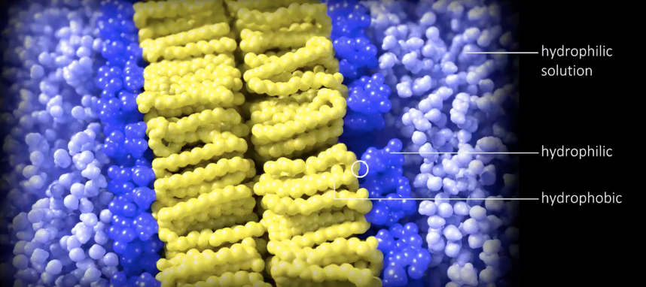

Phospholipids- Lesson 4
-There are three main types of lipids found in the lipid bilayer of plasma membranes; phospholipids, sphingolipids, and cholesterol.
-Phospholipids
- Most abundant
- A phosphate group that attaches a hydrophilic head group (choline, serine) to a glycerol molecule that is attached to two hydrophobic lipid tails (hydrocarbon chain 15-22 carbons)
- Tail bends in the presence one or more double carbon bonds (the tail would be straight if all were single bonds). Generally a phospholipid has one straight tail (saturated carbon attached to max # of Hydrogen) and a second bent tail (unsaturated) containing one or more double bonds.
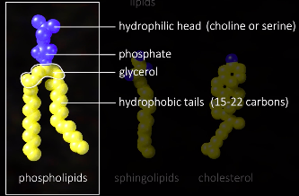

Phospholipid Packing: Part 1 - Lesson 5
-The width of the phospholipid head is similar to the width of the tail region, resulting in a roughly cylindrical shape for the side by side packing of phospholipids.
-Detergents are similar to phospholipids except that they possess only one hydrophobic tail instead of two resulting in a cone shape.
- When packed together, they form a circle/sphere --> Micelle
- In a micelle all of the hydrophobic regions are concealed on the inside (with no empty space) while all hydrophilic regions are on the outside, in contact with the surrounding hydrophilic solution
- With all of the detergent tails facing inward, hydrophilic-hydrophilic interactions are maximized
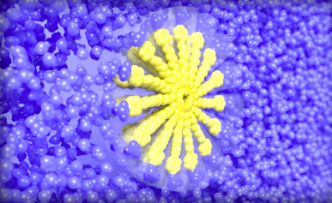
Phospholipid Packing: Part 2 - Lesson 6
-Packing cylindrical phospholipids side by side, we see that adjacent cylinders form a flat plane rather than a sphere.
-In order to shield all of the hydrophobic regions from the surrounding hydrophilic solution, phospholipids must also assemble on the opposite side, in the opposite orientation. This results in two planes that interact back to back, with all hydrophobic regions blocked from interacting with any hydrophilic molecules.
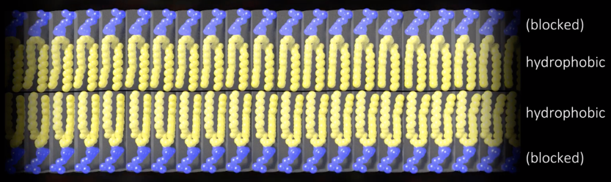
-The only exception is edges of the phospholipid sheet. To solve this problem, the edges of the sheet can join with each other to form a continuous sphere "liposomes". The lipid bilayer thus forms a spherical barrier around the entire cell.
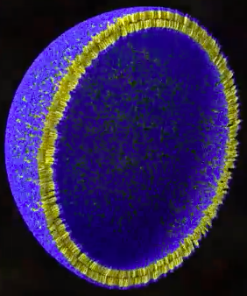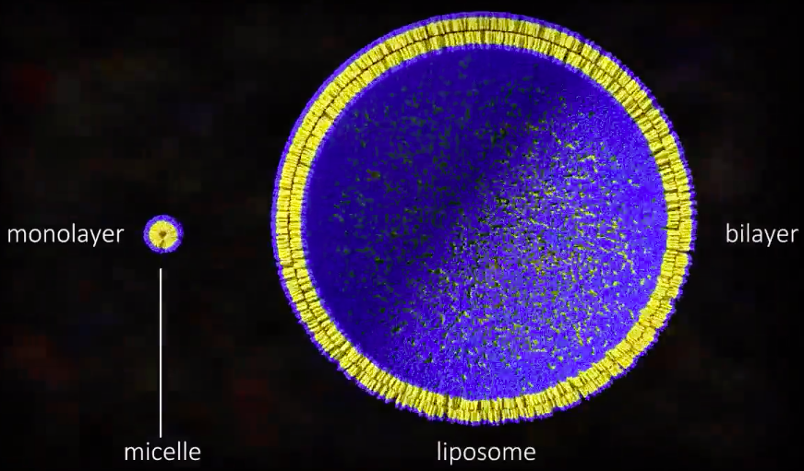
-When phospholipids are added to water they spontaneously rearrange to form such spheres called "liposomes" and can range from 25 nm to 1 mm in diameter.
-Remember that it is the hydrophilic interactions that maintain the integrity of the hydrophobic barrier. Benefits A tear in the plasma membrane that exposes hydrophobic edges would close up very quickly.

Plasma Membrane Functions- Lesson 7
-All cells possess a plasma membrane. Simple bacteria possess a single membrane around the entire cell. Eukaryotes possess additional plasma membranes around the nucleus and other organelles.
-Intracellular compartments that possess plasma membranes include…
- the nuclear envelope
- endoplasmic reticulum
- Golgi
- Mitochondria
- Chloroplasts
- Lysosomes
-All plasma membranes have at least one function in common: They must compartmentalize the aqueous contents inside (via their hydrophobic lipid bilayer) and act as a selective, permeable barrier that allows some molecules to cross over but not others (via their plasma membrane proteins).
-Different collections of plasma membrane proteins demonstrate that the plasma membranes that surround these compartments each have different functions such as…
- Responding to external chemical signals
- Interacting with adjacent cells
- Acting as a scaffold for biological activity
These functions are all carried out by plasma membrane proteins.
-The plasma membrane proteins can also actively pump molecules into or out of the cell or compartment.

The Plasma Membrane is a 2D Fluid – Lesson 8
-The plasma membrane can be thought of as a 2-D fluid.
-Plasma membrane lipids and proteins diffuse in two dimensions throughout the lipid bilayer. Because of this, the plasma membrane is NOT uniform in composition.
-Mosaic because different lipids and different proteins are present throughout the membrane.
-Fluid because individual phospholipids within the bilayer can rotate as fast as 20,000 rpm and diffuse laterally at a rate of 2 μm/sec.
-Fluidity of the plasma membrane is very important as it and highly dynamic…
- Allows proteins to rapidly diffuse from one area to another
- Allows membranes to fuse, mixing their components together.
- Allows the membrane to grow when cells grow and to change shape accordingly
- New lipids can be added without breaking continuity
- The composition and distribution of both lipids and proteins can also constantly be regulated and can change rapidly based on the needs of the cell.
-Lipids rarely switch from one side of the bilayer to the other. Occurs less than once every 30 days for any individual lipid.

Regulating Plasma Membrane Fluidity - Lesson 9
-Several factors affect the degree of fluidity within the lipid bilayer.
- Temperature:
- As the temperature increases, plasma membrane fluidity increases as well. As the temperature decreases, fluidity also decreases.
- ↑ temp = ↑ fluidity

- Number of double bonds in phospholipid tails:
- Increasing the number of double bonds in phospholipid tails leads to increased fluidity.
- The presence of one or more double bonds results in more free space between the tails of adjacent phospholipids, thus allowing them to move more freely.
- The absence of any double bonds, phospholipid tails are packed tight against each other.
- ↑ number of double bonds = ↑ fluidity

- Phospholipid Tail Length:
- Decreasing phospholipid tail length results in more space between adjacent tails, and therefore increases plasma membrane fluidity.
- ↓ tail length = ↑ fluidity

- Cholesterol:
- In animal cells, about 20% of the lipid bilayer is composed of the amphipathic lipid cholesterol.
- Cholesterol fills in the gaps between the tails of adjacent phospholipids. Increasing the amount of cholesterol in the lipid bilayer therefore decreases plasma membrane fluidity.
- ↓ cholesterol = ↑ fluidity
-Because there are multiple factors influencing the fluidity of the plasma membrane, cells can adjust some of these factors in order to maintain fluidity at a constant level.
-Example: Most single-celled organisms must constantly adapt to varying environmental temperatures. If the extracellular temperature decreases, cells can compensate by incorporating phospholipids with more double bonds into their plasma membranes in order to keep membrane fluidity constant.

Lipid Rafts- Lesson 10
-Lipid rafts are regions of the plasma membrane that travel and diffuse through the bilayer as one unit.
-Phospholipids in lipid rafts are much less fluid than the rest of the lipids in the surrounding bilayer.
- They possess about 4 times as much cholesterol and contain more sphingolipids than the surrounding lipid bilayer.
- Double bonds are still present in the phospholipid tails of lipid rafts but to a much lesser extent compared to the surrounding phospholipids.
- Because of the greater number of single bonds (saturated) in lipid rafts, these phospholipid tails are on average more straight, and the phospholipids are thus, on average, taller than the surrounding phospholipids. Lipid rafts therefore appear to be thicker than the rest of the plasma membrane.
-Lipid rafts may have an important function in cellular signaling by concentrating certain proteins and regulating their interaction with other non-raft proteins. Having many proteins clustered together may be important for signal amplification of certain signal transduction pathways.
-The existence of lipid rafts is still controversial, and that this is still an active area of research.

The Plasma Membrane is Asymmetrical- Lesson 11
-The composition of lipids and proteins on either side of the plasma membrane is asymmetrical.
- Different phospholipids are found in different amounts on one side versus the other.
- Ex. Intracellular side = ↑ Phosphatidylserine vs. Extracellular side = ↑ Phosphatidylcholine
- Embedded proteins that span are always present in the same orientation (with one side facing the extracellular environment while the other side faces the cytoplasm)
- Inositol phospholipids, which are important for intracellular signaling events, are found only on the intracellular side.
- Carbohydrate molecules found only on the extracellular or intra-organellar side.
- Such carbohydrate molecules are usually found covalently attached to proteins (referred to as glycoproteins) however about 10% are instead attached to lipids (referred to as glycolipids).
- In animal cells, there are usually enough glycoproteins and glycolipids in the plasma membrane to create a continuous coat of carbohydrates that surrounds the entire cell.

Integral or Peripheral- Lesson 12
-Plasma membrane proteins associate with the lipid bilayer in one of two ways:

- Integrally: Integral membrane proteins are ones which are permanently associated with the lipid bilayer. This includes…
-Transmembrane proteins (the most common type of integral plasma membrane proteins) that penetrate both layers of the lipid bilayer
- Monolayer-associated proteins that are embedded in just one of the two layers
- Lipid-linked proteins that are held in place via covalent attachments to bilayer phospholipids.
- Both integral membrane protein and monolayer-associated proteins must possess hydrophobic domains in order to associate with the hydrophobic region of the lipid bilayer. These proteins are also amphipathic.

- Peripherally
-Peripheral membrane proteins are proteins that are transiently (not permanent) associated with the plasma membrane, usually interacting with integral membrane proteins however they may also interact with the phospholipids directly.

-Disrupting protein-protein interactions would lead to the dissociation of peripheral membrane proteins from the plasma membrane while NOT disturbing the localization of integral membrane proteins.
-If one wishes to remove integral membrane proteins from the plasma membrane (for example, in order to study protein function), the membrane must be disrupted via the addition of detergents. Detergent molecules insert into the lipid bilayer and because of their cone shape, create bends in the otherwise flat plasma membrane. This eventually leads to the dissolving of the plasma membrane into small pieces, freeing the integral membrane proteins.

Three Distinctive Domains- Lesson 13
-Transmembrane proteins possess three distinctive domains…
- A hydrophilic intracellular domain
- A hydrophilic extracellular domain
- A hydrophobic transmembrane domain.
-Because the intracellular environment is chemically different from the extracellular environment, the two corresponding hydrophilic domains of transmembrane proteins are also usually chemically different.
-The two domains may have different functions.
Example: The extracellular domain may function as a signal receptor while the intracellular domain may function as an enzyme.
-For some proteins, the function of the transmembrane domain might be to couple together extracellular and intracellular functions.
Example: In order to link extracellular signal reception to intracellular enzymatic activity.
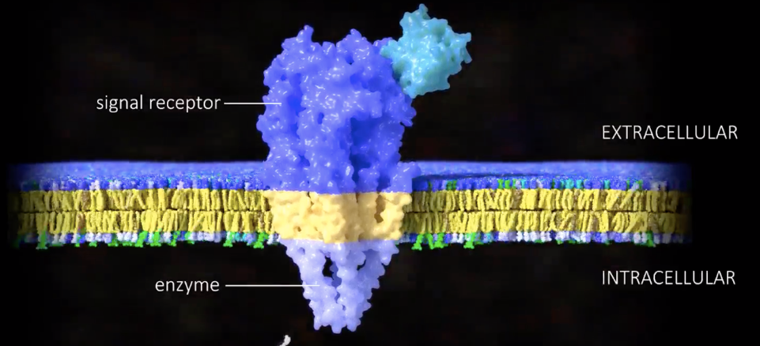

-Peripheral membrane proteins usually associate with the plasma membrane via interactions with either the extracellular or intracellular domains of transmembrane proteins.
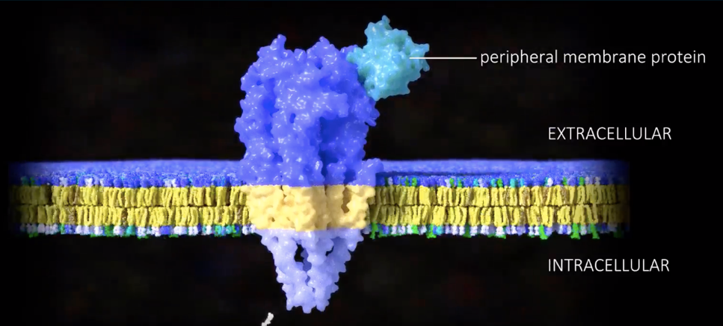

The Transmembrane Domain- Lesson 15
-Transmembrane proteins possess hydrophobic transmembrane domains that interact with the hydrophobic region of the lipid bilayer. The presence of this hydrophobic region holds the protein in place, however the protein is of course free to diffuse along the plane of the lipid bilayer.
-These transmembrane domains are usually composed of…
- single alpha helix
-Transmembrane alpha helicies possess hydrophobic residues around the exterior of the helix and hydrophilic residues concealed on the inside.
-The hydrophobic residues interact with the hydrophobic layer of the lipid bilayer.
-Alpha helicies represent the simplest type of transmembrane domain.

- multiple alpha helicies
-Multiple alpha helical domains are either packed together to form a thick stalk or arranged in a circle to create an aqueous channel that spans the lipid bilayer.

- a beta barrel formed from multiple beta pleated sheets.
-Beta barrels form channels similar to those formed by alpha helicies, however there is one important difference:
- Channels composed of alpha helicies can be formed from a varying number of alpha helicies resulting in channels with varying widths.
- The beta sheets that line the beta barrel interact with each other at a specific angle, essentially locking the width of the central channel to a fixed diameter.

Examples of Transmembrane Proteins – Lesson 16
-Each transmembrane protein is a machine. Different transmembrane protein (machines) have different structures in order to carry out their respective functions.

- Rhodopsin TP:
- Is found in our retinas.
-When it detects light, its seven transmembrane alpha helicies shift position relative to each other and this conformational change triggers an intracellular signaling cascade. The signal travels along neurons to the brain which ultimately allows us to see light.
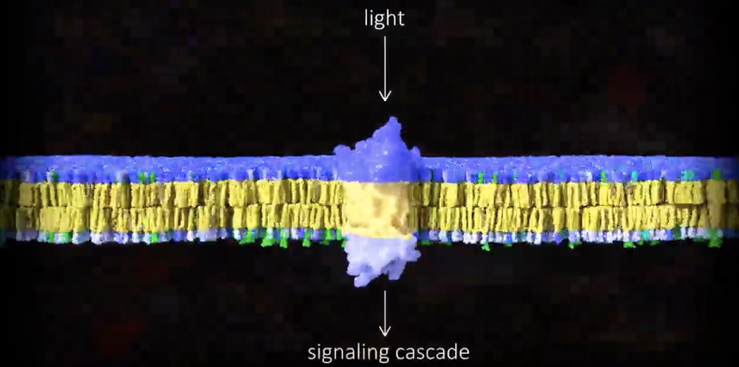

- Epidermal growth factor receptor (EGFR)
-The binding of the extracellular signaling protein epidermal growth factor (EGF) to the EGF receptor (EGFR) leads to a conformational change in the extracellular EGFR domain. This allows two, bound EGFR proteins to dimerize (combine with a similar molecule to form a dimer), leading to activation of their intracellular kinase domains, resulting in the start of an intracellular signaling cascade that eventually triggers the cell to grow.
-EGFR possesses a single transmembrane alpha helix.
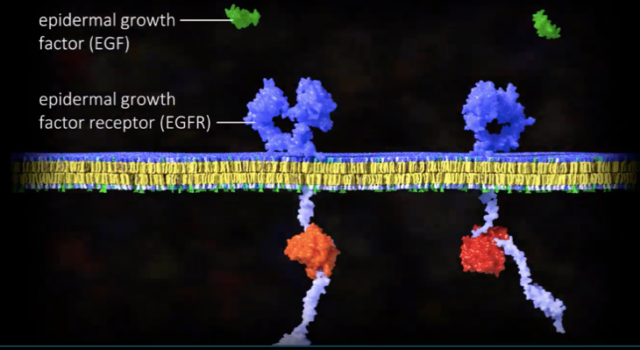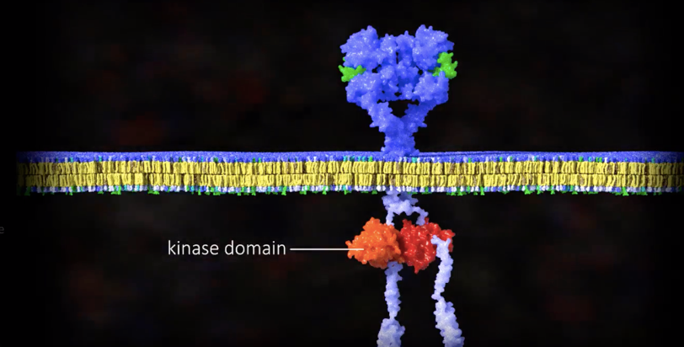

- Cadherin
-In the presence of calcium, an extracellular cadherin domain from one cell binds to the extracellular cadherin domain of an adjacent cell. Meanwhile, the intracellular domains attach to the actin cytoskeleton. In this way, cadherin proteins provide a structural connection point between cytoskeletons from adjacent cells.
-Cadherins possess a single transmembrane alpha helix.
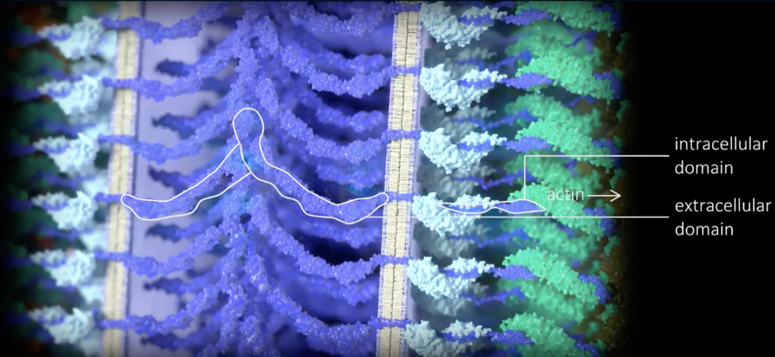

- ATP synthase
-ATP synthase is a molecular turbine composed of more than 20 polypeptide chains. Because of an asymmetrical distribution of protons across the mitochondrial inner membrane, these protons flow down their electrochemical gradient, turning the transmembrane domain of ATP synthase as they flow. As the transmembrane domain turns, it rotates a rotor (he rotating assembly in a turbine), which in turn changes the conformation of six head domains sequentially. This energy, in the form of conformational changes, is used to create ATP from ADP and Pi.
- ADP + PI ATP


