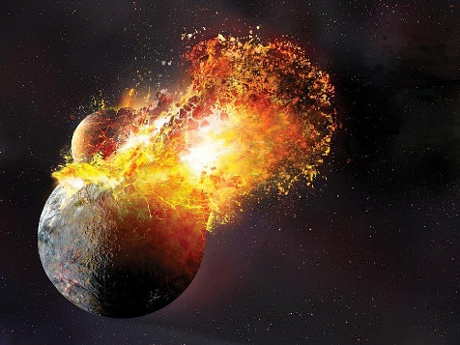
Intro to Earth Systems Geological Time
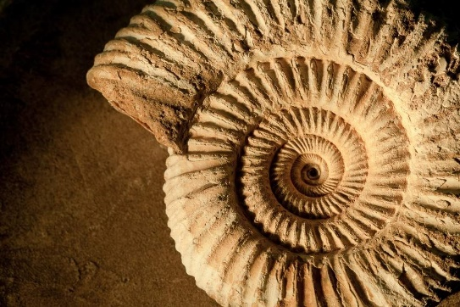


1. What is relative dating one of the geochronology?
Compare 2 or more entities to determine which is older
2. What is numerical dating on the geochronology?
Specifying the actual number of years that have passed since an event occurred (also known as absolute age dating)
3. What is the first rule to compare rocks that are not located near one another?
Principle of Uniformitarism (Hutton): Same processes act throughout time, but possibly different rates/more influential than catastrophes – hurricanes, floods, impacts
4. Is the Principle of Uniformitarism good for general cases?
Yes. (Rivers flow downhill, volcanoes erupt lava)
5. Is the Principle of Uniformitarism good for specific cases?
No. (There has not always been rivers, volcanoes not always erupted the same composition lava)
6. How is the Principle of Uniformitarism useful?
It is useful to determine how rocks are positioned
7.What is the Law of Superposition?
It says that most sediments settle water/wind
Also, young rock material (sediment) is deposited on top of earlier, older deposits
8. What is the Principle of Horizontality?
Layers of sediment (& lava) are generally deposited in a horizontal position
When/if tilted, how to identify upper or top surface
9. What is the Principle of Cross-cutting Relationships?
Intrusive (igneous) formation must be younger than rock it cuts across; also used for faults
10. What are some key parts of identifying vertical correlations?
Superposition/horizontality/x-cutting relations
11. What are some key parts of identifying vertical correlations?
12. What is correlation?
Matching of rocks of similar ages in different regions
13. What is lithostratigraphic?
Matching up continuous rock sequences
14. What is chronostratigraphic?
Matching up rocks of the same age; usually done with fossils using biostratigraphy
15. What does chronostratigraphic rely on?
Fossils
16. How can relative age of fossils be determined?
Using superposition & horizontality to determine age of rock/fossil within rocks
17. What is the Principle of Fossil Succession?
Fossil organisms succeed one another in a definite and determinable order, and therefore any time period can be recognized by its fossil content
18. What is index fossils?
Short-lived, widespread organisms
19. What is conformable sequences in rock correlations?
Layers of rock deposited with or without interruption
20. What is unconformity in sequences in rock correlations?
It is a gap or break in the rock record produced by erosion and/or nondeposition of rock units
21. What is disconformity?
It is strata on either side if the unconformity is parallel, but ages differ
22. How to determine rock correlations?
Composition change/deposition style change/paleosol (ancient soil)/conglomerate or breccia/color change
23. What is nonconformity as special type of unconformity?
Metamorphic or igneous rocks in contact with sedimentary strata
24. On what does common numerical dating relies on?
It relies on the rate of decay of radioactive isotopes within minerals
25. What are key parts of radioactivity?
Spontaneous changes (decay) in the structure of atomic nuclei
Nucleus: Protons – particles + with mass/ Neutrons - neutral particles with mass/ Electrons – particles – that orbit the nucleus
26. What is Rutherford-Soddy Law?
It is the number of radioactive atoms decaying at any time ‘’t’’ is proportional to the number ‘’n’’ of atoms present
27. The law produces isotopes,, can you describe and isotope?
Isotopes are new form of element; same number of protons, but different number of neutrons thru emission or capture of subatomic particles
28. What is a parent isotope?
It is an unstable (decaying) radioactive isotope
29. What is a daughter isotope?
The isotope resulting from the decay of a parent
30. What is a half-life isotope?
It is defined by the decay constant λt for each isotope – the time required for one-half of the radioactive nuclei in a sample day
31. What can we not tell by Principles of Numerical dating?
We cannot tell when exactly the individual (kernel/atom) will convert (pope/decay)
32. What can we tell by Principles of Numerical dating?
We know the probability that it will occur in the next time interval
33. What is the first type of decay Alpha Emission?
Alpha particle = 2 protons & 2 neutrons (ex. He)
Nucleus decays (expulsion of alpha particle particle)
Mass number reduced to 4
Atomic number is lowered by 2
34. What is the second type of decay Beta Emission?
Beta particle = electrons
Originate from breakdown of neutron in nucleus
Increases number of protons
Increases atomic number
35. What is the third type of decay Electron capture?
Nucleus steals electron from atom’s own orbiting cloud
Creates a new neutron; decreases atomic number
36. What is the Principle of radiogenic dating?
The percentage of radioactive atoms that decay during one half-life is always the same (50%)
But the actual number of atoms that decay continually decreases
37. What are the principles of radioactive dating-assumptions?
- rates of decay have been measured and do not vary through time
- assume closed system (initial mineral has only parent material; no loss of daughter after mineral forms)
- radiometric clock in minerals starts when daughter product begins to be trapped in mineral (usually controlled thermally)
38. When using the age equation what are the two measurements needed?
Parent: daughter (measurement with mass spectrometer)
Decay constant (λ, measured with scintillometer)
t = ln (P+D)/P
λ
39. What happens to C12 and C14 as long as the organism is alive?
As long as the organism is alive, the proportions of C12 and C14 remain constant due to constant replacement of any C14 that has decayed
40. What happens when the organism dies?
When the organism dies, the amount of C14 gradually decreases as it decays to N14 by the loss of an electron (so one neutron is changed to a proton)
41. How can the radiocarbon date be determined?
By comparing the proportions of C14 and C12 in a sample of organic matter, and knowing the rate of conversion, a radiocarbon date can be determined
42. How does C14 occur?
In organic remains rather than in minerals
43. Is C14 absorbed?
Yes, it is absorbed by all living organisms from the atmosphere or the food they eat
44. What happens to the clock when an organism dies?
The clock is set
45. How is carbon extracted?
From the buried sample
46. What can we say about the ratio of C14 and C12?
It is measured by accelerator mass spectrometer

