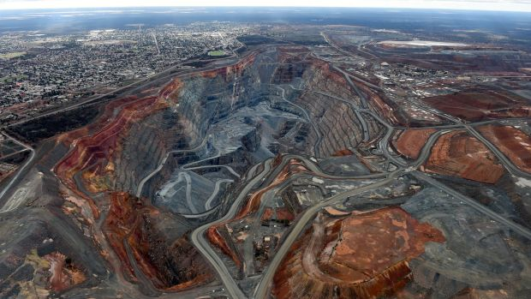
Intro to Earth Systems Economic Geology
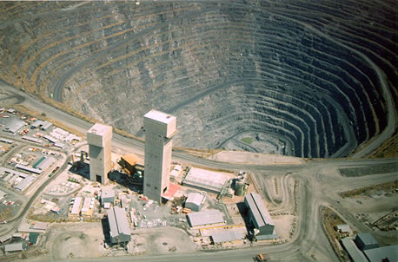
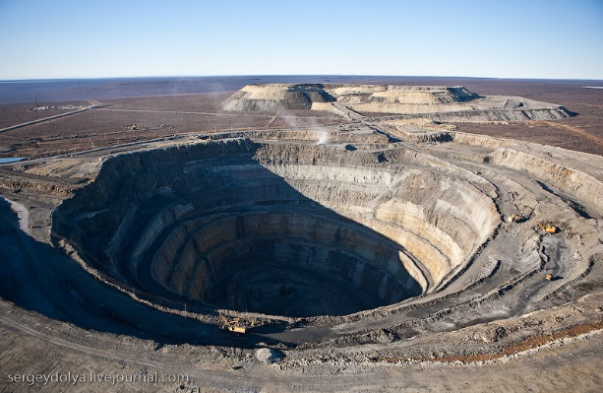

1. How much mined commodities does people in North America use yearly?
20,000 kg/yr
2. What kind of commodities are most common?
Crushed rock/cement/ sand & gravel/fertilizer/oil/metals
3. How many tons of materials are dug out of the earth each year?
54 billion tons
4. How are the most useful metals in the crust?
They are geochemically scarce
5. How do they occur?
Most occur as atomic substitutions in more abundant rock-forming minerals
6. Atoms of metals (nickel, cobalt, copper) substitute for more common atoms to form?
Magnesium and calcium
7. More than 160,000 years ago evidences of mining which materials were found and used for what purpose?
Flint/chert/obsidian for tools
8. Which metals were first used around 20,000 years ago?
Native copper and gold
9. How are most ore minerals of the scarce metals found?
They are found as sulphides (FeS2, ZnS, PbS, CuFeS2)
10. How often do ore minerals occur?
Rarely
11. Ore minerals of tin and tungsten are called?
Oxides
12. How do they occur and what are they called?
They are mixed with other non-valuable minerals, collectively termed ”gangue” (quartz, calcite, feldspar, mica)
13. Name the five ways minerals become concentrated?
- Concentration by hot, aqueous solutions flowing through fractures and pore spaces in rock to form hydrothermal mineral deposits.
- Concentration by magmatic processes within a body of igneous rock to form magmatic mineral deposits
- Concentration by precipitation from modified sea water to form sedimentary mineral deposits
- Concentration by flowing surface water in streams or along the shore, to form placers
- Concentration by weathering processes to form residual or supergene mineral deposits
14. What is the first step of the ore-forming system?
Source: rocks or magma enriched in metals that can be supplied to the “ore-forming” system
15. What is the second step of the ore-forming system?
Transport: melt or fluid that can carry metals from a source to a site of deposition
16. Trap: physical or chemical process that concentrates the metals into an ore deposit
17. What are the three combinations of ore-forming systems?
- Layered mafic intrusion/Fractional crystallization/Sulphide settling
- Volcanic eruptions/Geothermal fluids/Hydrothermal precipitation
- Erosion of source/Fluvial transport/Gravity concentration
18. Where are mineral deposits found?
Mineral deposits are found in a variety of plate tectonic settings depending on where these processes operate

19. Diagram of metals and deposits in different settings:
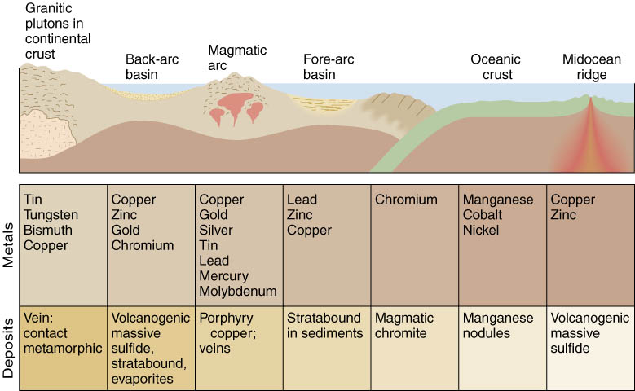

20. What is the first type of magmatic ore deposits and describe briefly?
Fractional crystallization/magmatic differentiation
- Heavy minerals that crystallize early, settle and concentrate on the bottom of the magma chamber
- High density minerals, such as chromite, sink to the bottom of the magma chamber
21. What is the second type of magmatic ore deposit and describe briefly?
Immiscibility
- Segregation of metal-rich (sulphide) liquid from the crystallizing magma
- Dense, metal-sulphide melt settles to the bottom of the crystallizing magma chamber
22. What is the third type of magmatic ore deposits and describe briefly?
Pegmatites
- Melt remaining in last stages of crystallization of granitic magma is rich in volatiles and rare elements
- Such a melt is very fluid and invades cracks and results in large crystals
23. What do pegmatites look like?
They look like hydrothermal veins but they are injections of granitic melt
24. What are pegmatites mined for?
Uranium, thorium, beryllium, lithium, tantalum
25. Describe deposits associated with metamorphism.
Many important ore deposits are produced by metamorphism of country rocks adjacent to an intrusion (especially reactive carbonate-rich rocks which act as a chemical trap for metals)
26. What are these carbonate-rich rocks named?
Skarns
27. Give three examples of skarns?
- sphalerite (zinc)
- chalcopyrite (copper)
- scheelite (tungsten)
28. What are skarns?
Contact metamorphism
29. What are hydrothermal ore deposits associated with?
Igneous activity
30. What is the first type of hydrothermal ore deposits and describe briefly?
Veins (associated with igneous activity)
- Some of the best known and most important ore deposits are generated from hot water
- Many originate from hot, metal-rich fluids expelled from crystallizing intrusions
- Fluids move along fractures, cool, and precipitate the metallic ions to produce vein deposits (Quartz and calcite are among the most common vein minerals)
31. Where are vein deposits usually located?
They are concentrated in areas of intense faulting
32. Describe the first way hydrothermal fluids can come from?
Some originate when water dissolved in magma is released as the magma crystallizes
33. Describe the second way hydrothermal fluids can come from?
Some are formed from rainwater that circulates deep in the crust, close to hot intrusions
34. Describe the third way hydrothermal fluids can come from?
In the oceans, such as near midocean ridges, hot seawater is circulated into the ocean crust
- These fluids are corrosive and can leach metals from the rocks
- Dissolved metals precipitate from the fluids as they rise and cool
35. What is the second type of hydrothermal ore deposits and describe briefly?
Disseminated (associated with igneous activity)
- Metals can also occur as disseminated deposits in which the metals are distributed throughout the rock body, rather than concentrated in veins (low grade, large volume)
- Most of the world’s copper comes from hydrothermal veins and disseminations derived from large porphyritic intrusions (these are referred to as porphyry copper deposits)
36. What is the second type of hydrothermal ore deposits and describe briefly?
VMS (associated with igneous activity)
- Volcanogenic Massive Sulphide (VMS) deposits are lenses of sulphide minerals that accumulate on the seafloor from hydrothermal vents
37. Describe the six steps of VMS:
- Influx of cold seawater
- Alteration of oceanic crust
at <150°C
- pH drops to ~3 (acidic)
- Heating of seawater to
~400°C
- Leaching of Cu, Zn, Fe, Au
and S from surrounding
rocks
- Formation of hydrothermal
precipitates in contact
with cold seawater
38. What is hydrothermal ore deposits associated with sediments called?
It is sometimes called sedimentary exhalative deposits (SEDEX)

39. How do SEDEX occur?
Massive sulphide deposits form from seafloor hydrothermal vents in sedimentary basins
40. What do SEDEX form in the sedimentary rock?
They form a thin layer of metallic sulphide (Sullivan mines, BC)
41. Where do SEDEX deposits usually occur?
SEDEX deposits typically occur in the sedimentary that fills rift basins
42. What is another hydrothermal ore deposit associated with sediments?
Unconformity-Associate uranium
43. How do ore deposits occur with unconformity-Associate uranium?
Oxidized uranium-bearing brines moving through coarse-grained sedimentary rock are forced upward into reduced sediments, which promotes the precipitation of reduced uranium minerals
44. What is the last hydrothermal ore deposit associated with sediments?
Mississippi Valley-type deposit
45. How do ore deposits occur with Mississippi Valley-type deposit?
Oxidized metal-bearing brines migrate toward a basin edge and infill cavities in limestone (karst environments)
46. What is banded iron formation?
A long time ago the oceans allowed for dissolved iron to accumulate in ocean basins and thus photosynthesizing bacteria generated enough oxygen to precipitate iron oxide minerals
47. What are placer deposits?
They are formed when heavy metals are mechanically concentrated by currents in rivers

48. Diagram of concentration of placer deposits in stream beds:
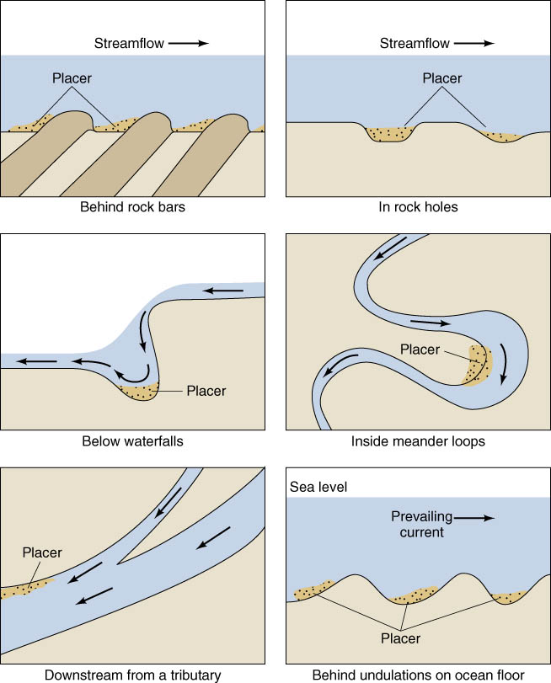

49. Where is the largest concentration of gold deposit?
In the ancient placer deposits of the Witwatersrand basin
50. What are the main characteristics of laterite a deposit associated with weathering?
- Residual enrichment – concentrating metals into economically valuable concentrations
- Laterite (enriched in Fe, Al, Ni) forms by deep weathering of the parent rock and leaching out elements such as silica
- Forms in rainy, tropical climates; not found in glaciated regions
51. What are the main characteristics of supergene weathering associated deposit?
- The enrichment occurs when soluble minerals are dissolved near the surface and reprecipitated at depth near the water table
- Low-grade primary ores in large porphyry Cu deposits are enriched by supergene processes
- Form in arid climates
52. Where are most diamonds found?
They are found in rare ultramafic igneous rocks called kimberlites
53. How does kimberlite travel?
Kimberlite originates from great depths and rises quickly to the surface, picking up diamonds from the upper mantle
54. How do diamonds form?
They form at high pressure, deep in the crust, under old/cold lithosphere
55. How does Oil & Gas come from?
Derived from the remains of marine plants and animals rich in protein lipids & carbohydrates
56. How is the formation of Oil & Gas?
Complex and incomplete
57. What is the petroleum window?
It is the zone where the depth and temperature allows oil and gas to form and be trapped
58. What is bitumen oil?
Viscous and immature oil that cannot be pumped
59. Where are they found?
In unconsolidated material, plus shales and limestone
60. Give five impacts of shale gas?
- More environmental impact than expected
- Domestic water contamination
- Leaking of methane into atmosphere
- Use unknown chemicals during fracking (the process of injecting liquid at high pressure into subterranean rocks, to open existing fissures and extract the oil & gas)
- Earhtquakes
61. What is gas hydrates?
Gas found in cold temperature relatively high pressure at the bottom of ocean basins in hydrated sediment layers. The methane is produced from the breakdown of biological materials

