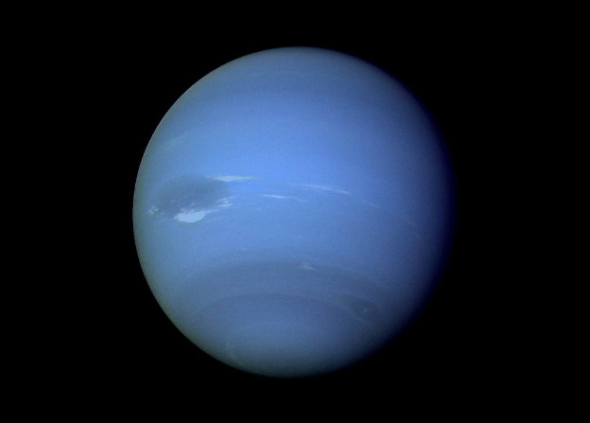
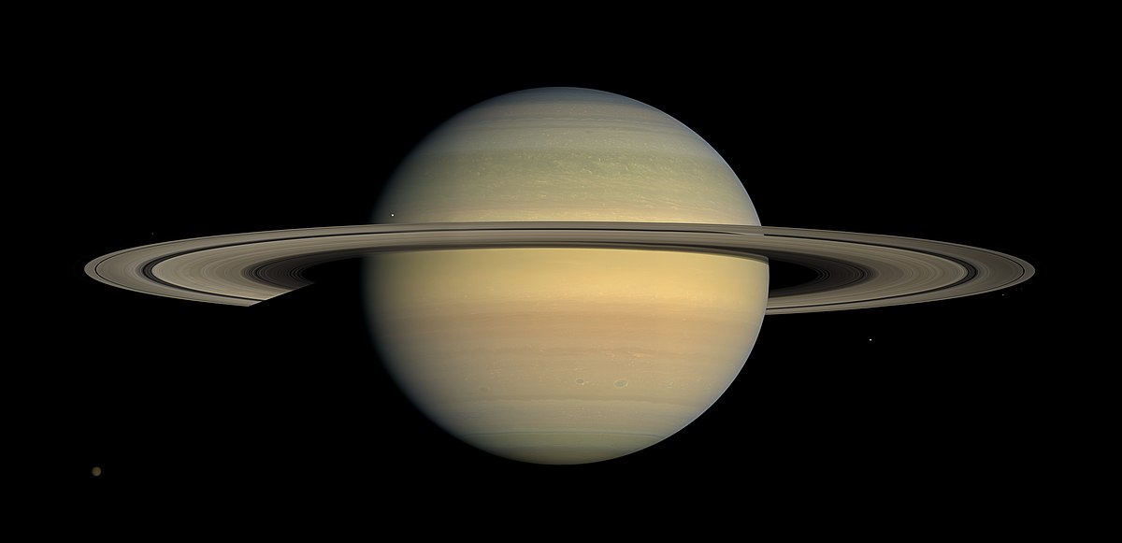
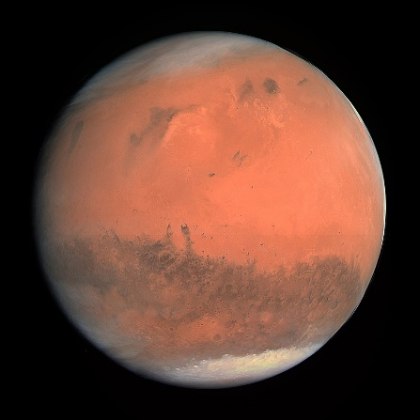
Intro to Earth Systems Planets

1. What does the solar system consist of?
Star/Sun/planets/satellites/asteroids
2. Where is our solar system located?
It is located on the arm of a very large spiral galaxy
3. How are the system of stars held together in the Milky Way?
They are held together by gravity
4. Which idea did the church deeply entrenched?
Geocentric Universe
5. What is Geocentric Universe?
Simple spheres containing the planets and the sun revolving around the Earth did not explain the retrograde motion of planets
6. What is the law of ellipses?
The orbit of each planet is an ellipse with sun at one focus
7. What is the law of orbital harmony?
For any planet, the square of the orbital period in years is proportional to the cube of the planet’s average distance from the sun
8. What is the law of equal areas?
A line drawn from a planet to the sun sweeps out equal areas in equal time (the orbital velocity changes)

9. How does geology compared to astronomy in terms of years studied?
Geology is a very young science
10. How many satellites does Mercury have?
0 satellites
11. What is the composition of Mercury?
70% metallic & 30% silicate composition
12. How is the layering?
It is internally layered
13. What is specific of the temperature on Mercury?
It has the largest temperature range
14. What is the hypothesis on the fault scraps on Mercury’s surface?
The planet cooled which caused the fault scraps rather than plate tectonics on Earth
15. How many satellites does Venus have?
0 satellites
16. How does Venus resemble Earth?
In size, also called Earth’s twin
17. What kind of volcanic activity is there on Venus?
There are ancient volcanoes
18. What hint do we have that Venus might have had plate tectonics?
Maybe there has been plate tectonics long ago due to the impact craters on Venus
19. How is the atmosphere of Venus?
Thick (deadly) inhibits telescopic observation
20. What are the volcanoes on Venus called?
They are called pancake volcanoes, similar to composite volcanoes

21. How did the moon occur?
It came form early solar system when something hit the Earth which made the moon come out on the other end
22. How does the density of the moon compare to that of the earth?
Less dense than the Earth
23. What is the darker part of the moon called?
It is called Maria (flood basalt)
24. What is the lighter part of the moon called?
Highland (feldspar)
25. Describe the moon evolution:
-Formation of the crust
-Lunar Highlands
-Maria basins
-Rayed craters
26. How many satellites does Mars have?
2 satellites
27. What are some characteristics of Mars?
Ancient Volcanoes & Tectonics/Internally layered/Crust Basalt
28. What led to the belief that Mars once had water?
The cliffs on Mars led to that theory
29. How does the lower elevation zones on Mars compare to the higher elevation zones?
The lower elevation zones appear to be younger due to less crater than the higher elevation zones
30. How many satellites does Jupiter have?
63 satellites
31. How is the surface of Jupiter?
It is liquid hydrogen
32. How is the atmosphere on Jupiter?
It is layered and has giant storms
33. How is the composition of Jupiter?
Core region is surrounded by dense metallic hydrogen which extend outwards to about 78% of the radius of the planet
34. What is unique of the Galilean Satellites?
The planets change shape depending on how close to Jupiter
35. How is volcanic activity on lo?
It is volcanically active/Melting from tidal energy/fountains of lava gushing
36. How is the core of Saturn and how does it compare to Earth?
Saturn has a solid core surrounded by a deep layer of metallic hydrogen an intermediate layer of liquid hydrogen and liquid helium and an outer gaseous layer Brings a magnetic field
37. What is special about the titan moon?
It has lakes and seas and is one of the rare moons to have an atmosphere
38. The twins (Uranus/Neptune) have what kind of composition?
A rocky center, and icy mantle and an outer gaseous hydrogen/helium envelope (ice:water, ammonia and methane)
39. Is ice dominating over gases on Neptune/Uranus?
Ice dominating = Ice giants
40. What kind of volcanic activity on Triton satellite?
Ice volcanism = Cryovolcanism
41. What is special about the axis of rotation of Uranus?
The axis of rotation is laying down
42. What are the differences between Terrestrial and Jovian planets?
Terrestrial: Hard silicate rocky surfaces/Close to the Sun/larger ones have atmospheres/ Dense metallic cores/few satellites

Jovian: Very large outer planets/Turbulent/composed of gases H, He,NH3/Very low density/many satellites
23. How can we determine the density of planets?
The behaviour of how a planet orbits the sun and how it rotates on its axis gives us insight on how dense the planet is
24. In which direction do planets revolve around the Sun?
All planets revolve around the Sun in CCW
25. How is the revolving of planets?
The revolving is ecliptic
26. On their axis how do planets revolve?
Planets revolve CCW on their axis (Except for Venus CW, and Uranus tilted)
27. How are the axes of rotation of the sun and planets?
They are nearly all perpendicular to the ecliptic
28. What is the solar nebula theory?
-Very long ago, gravitational contraction, cloud initiates rotation
-Gravitational collapse increased T and light elements driven towards outer edges of disk
-Planets result from accretion of dust, planetisimals
-Sun originates from concentration of mass at the centre
29. What are some hints we can use to determine the age of the solar system?
-Meteorites (4.53 to 4.58 Ga)
-Moon rocks (4.4 to 4.5 Ga)
-Oldest rock on Earth, Acasta Gneiss 4.03 Ga (Earth is tectonically active/rocks keep getting recycled)
-Oldest mineral on Earth zircon in Australia is 4.4 Ga
30. What are meteors?
They are glowing fragments of rock that are outside the Earth’s atmosphere (shooting stars)

31. What are meteoroids?
They are meteorites before it hits the surface
32. What are meteorites?
They are pieces of rock from outer space that hits the Earth
33. What are fireballs?
Very bright meteors
34. What are meteor showers?
When Earth’s orbit passes through a belt of cosmic dust and rock
35. What is the most common type of meteorite?
Stone which resemble rocks found from Earth
36. What is The Asteroid Belt?
Between Mars and Jupiter, a swarm of 100,000 objects called asteroids – small rocky bodies of irregular shapes
37. What is a comet?
It is a body that orbits around the Sun with eccentric orbit
38 What gives the comet its trail?
ice + rock /solar radiation generates gases from evaporation of comet’s surface, giving the comet it’s tail
39. What are the effects of impacts on Earth?
-Massive Earthquakes
-Dust and ash released into the atmosphere blocking solar radiation (cool)
-Widespread wild fires (more dust and ash)(cool)
-If impact into ocean, large amount of water vapor/H2O + CO2 scatters solar radiation and has long residence in atmosphere (warm)
-Shock would produce nitrogen oxides; combined with water = nitric acid (acid rain)
-If impact into ocean = tsunami

