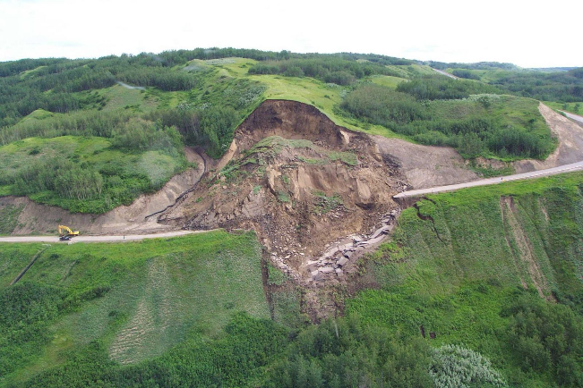
Intro to Earth Systems Mass Movements/Unstable Ground
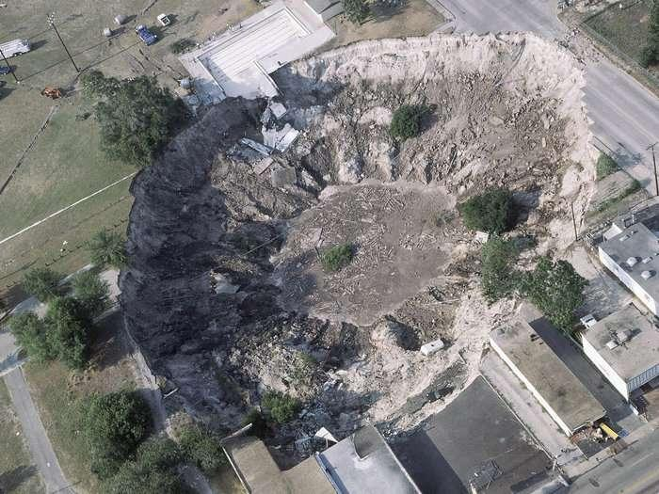
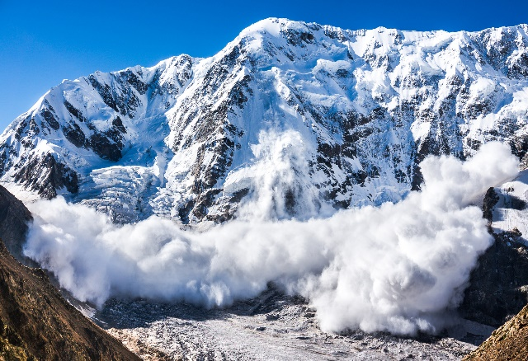

1. Which two Canadian provinces have the highest fatality record by landslides?
British Columbia, Quebec
2. In Canada which type of landslide is the most fatal?
Rock slide followed by snow slide
3. What is mass movements at the surface?
Processes that transport Earth material down slope by pull of gravity
4. When does mass movements at the surface occur?
Occurs when factors that drive material downslope overcome factors that resist downslope movement
5. What are the two ways failures can happen?
Failures may be catastrophic and sudden or slow and gradual
6. With respect to geological time all slopes are?
Inherently unstable
7. Catastrophic mass movements usually occur when?
Something has triggered it (earthquake?)
8. How are most mass movements failures triggered by?
Usually failures are complex and occur with time

9. Immediate failures are triggered by?
Earthquakes/Volcanoes/Heavy rains/thawing of frozen ground/Human mismanagement of (water, mining, building house/roads)
10. What are the five key factors of slope failures?
- Slope angle/slope support: slope increases by downcutting of landscape by rivers or waves
- Slope composition: weathered, fractured rock, high clay concentration, or unconsolidated material = unstable
- Vegetation: presence of vegetation anchors unconsolidated material (forest fire can decrease the strength of the slope)
- Weight: water, overlying sediment
- Water: (In little amounts holds unconsolidated material together) (In large amounts reduces friction between grains and acts by buoying up the weight of slope material)
11. What are the internal causes of slope failures related to adverse geological structures?
- Ancient slip surfaces: sliding creates a smooth, slick layer of ground-up materials that can easily slide over and over again, especially when wet
- Exposed bedding:
Layers at flatter angle than hillside “daylighted” or exposed bedding allows slippage
Layers at steeper angle than hillside difficult slip
- Structures within rocks: Not cemented together/clay layers/soft rock layer on strong layer/split apart by fractures/ ancient fault slide surface
12. What is Exfoliation?
It is a decrease in cohesion (composition); rocks that are buried compress into smaller volumes
13. What happens to the rocks that are uplifted during exfoliation?
Rocks uplifted to the surface expand in volume, fracture and increase in porosity reduces strength of rock, increases openings for water to further weaken the rock

14. What is the first inherently weak material?
Clays: form during chemical weathering of rocks/clay crystals are very small, shaped like books
15. How does altering the chemical composition of clay change the texture?
Changing the chemical composition of clay can alter strength, size and water content altering strength of rock
16. What is the second inherently weak material?
Expansive and Hydrocompacting soils with clay: some clays expand (increase in volume) when water is added
17. What is the third inherently weak material?
Quick clays: most mobile of all deposits – fine rock flour scoured by glaciers, deposited in seas and later exposed above water
Weak solid – loosely packed, “house of cards” structure held together by salt
18. What is the main difference between expansive clays and quick clays?
The difference is that the quick clays form in marine environment (salt water environments)
19. How is water an internal cause of slope failures?
Water weakens earth minerals by:
- Weight: water is heavier than air that usually fills pore spaces of sedimentary rocks in slopes
- Absorption and adsorption: water is absorbed (internally) and adsorbed (externally) by clay minerals decreasing their strength, because positive side of water molecule attaches easily to negatively charged clay surfaces
- Dissolving (natural) cement: water flowing through rocks can dissolve minerals holding rock together
- Piping: water flowing through rocks can physically erode away (remove) loose material
- Pore-water pressure: Pressure on water in pore spaces of rocks increases with increasing weight of sediment piled on top of rocks
- Quicksand: sand grains are supersaturated with pressurized water water-pressurized sand in depression is quicksand, high-viscosity liquid. Water-pressurized sand on slope flows downhill
- Water-table: top of groundwater; gravity pulls water down to saturate open spaces in subsurface rocks as groundwater
20. How is ground surface soil in terms of its water composition?
It is unsaturated (little water) by water
21. What is the water table and what lies below is?
The water table is the line where ground surface soil becomes into water saturated soil
22. Diagram to memorize (Except Topples & Spreads):
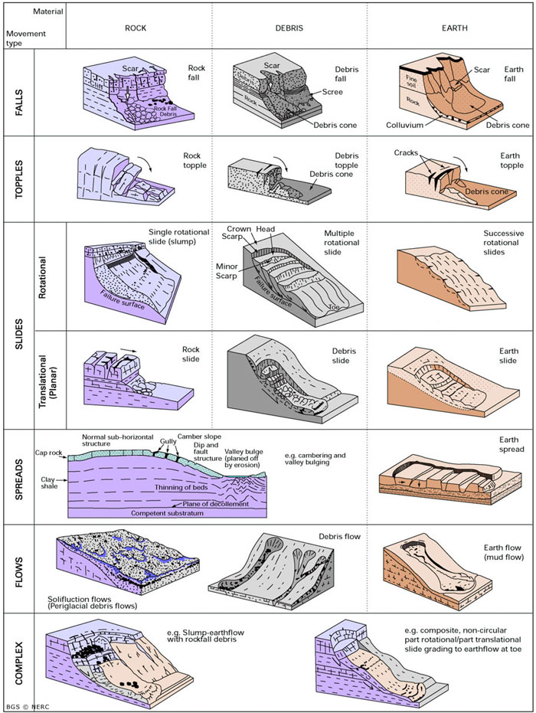

23. What is a creep?
- It is the slowest and most widespread form of slope failure
- Practically impossible to notice downhill movement of soil
- Shrinking and swelling of soil in response to: freezing and expanding of water in pores, absorption of water, expansion of clay minerals, heating by Sun and increase in volume.
24. How does the soil shrink in a creep?
The soil shrinks straight downward in response to gravity
25. How does the soil expand in a creep?
The soil expands perpendicularly to the ground surface
26. What is Solifluction?
Permafrost regions of steep slopes, sun thaws top layer of soil and it flows slowly over frozen subsoil
27. How do rocks act during Earthflow?
Rocks layers tilt seaward, contain bentonitic clay, and ocean waves erode toe and keep ancient earthflow moving seaward
28. What are volcanic ashes (associated with earthflow)?
They can be thought as volcanic clay
29. Describe the case in California where Earthflow occurred?
The development of houses was built on the surface above the unstable ground adding weight and weakening the ground. In addition, the wave action on the coast weakened the front part of the cliff.
30. What are slides?
It is the movement of block above the failure surface

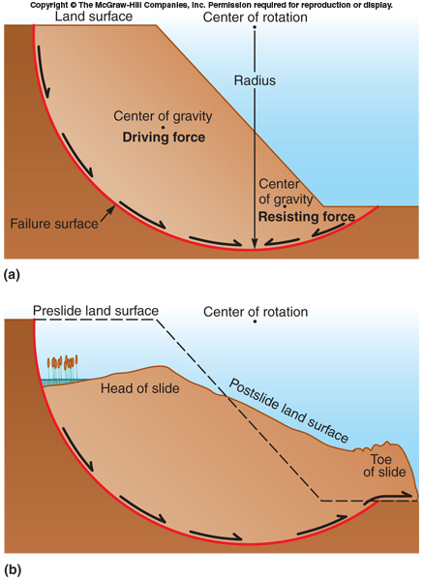
31. What are rotational slides (slump)?
Head is moving down, and toe is moving out
32. What are slumps?
Slumps are preceded by arcuate cracks in hillside
Cracks widened, area slid slowly
33. What are translational slides?
Move on planar slip surface such as fault, joint, clay-rich layer
Moves as long as on downward-inclined surface
34. How is translational slides different form other slides?
- It remains coherent as a block
- Deform and disintegrate to form debris slide
- Underlying material fails so overlying material slides
-Horizontal motion/ very little transformation
35. What are rock falls?
They are not debris or soil but rocks
36. What can be the trigger to a debris avalanche?
Earthquake which cause the avalanche into a flow and into rocks
37. What are long-runout debris flow?
The most spectacular, complex movement – massive rocks falls that convert into highly fluid, rapid debris flows that travel far (Also called Sturzstroms)
38. Explain the steps of Sturzstrom?
- Water provides lubrication and fluidlike flow
- Steam liquefies and fluidizes moving mass
- Frictional melting fluidizes moving mass
- Falling mass traps air beneath and rides trapped air
39. How do Snow avalanches behave?
Behave like earth mass movements – creep, fall, slide, flow
40. How do Snow avalanches occur?
Small avalanches typically fail at one steep point, in loose, powdery snow, which triggers more and more snow moving downhill
41. How much snow it usually takes for snow avalanches to occur?
It usually begins when snow reaches 0.5 to 1.5 m deep
42. How does the size of the avalanche relate to the snow?
When there is thicker snow the avalanches are bigger and more devastating
43. What is a loose powder avalanche?
Low cohesion with up to 95% volume as pore space
44. What is a slab-avalanche?
Slabs of snow that break free from base like translational slides, turning into flows on way down
45. How is the slow slabs of slab-avalanches?
Snow mass composed of layers with different ice, snow characteristics different strength
46. How does the texture of the snow change the avalanche?
Dry snow forms faster avalanches than wet snow
47. What are falls?
Elevated rock mass separates along joint, bedding or weakness and falls downward through air in free fall until hitting the ground, bouncing and rolling
48. What are subsidence?
Ground surface gently sags or catastrophic drops as voids in rocks close

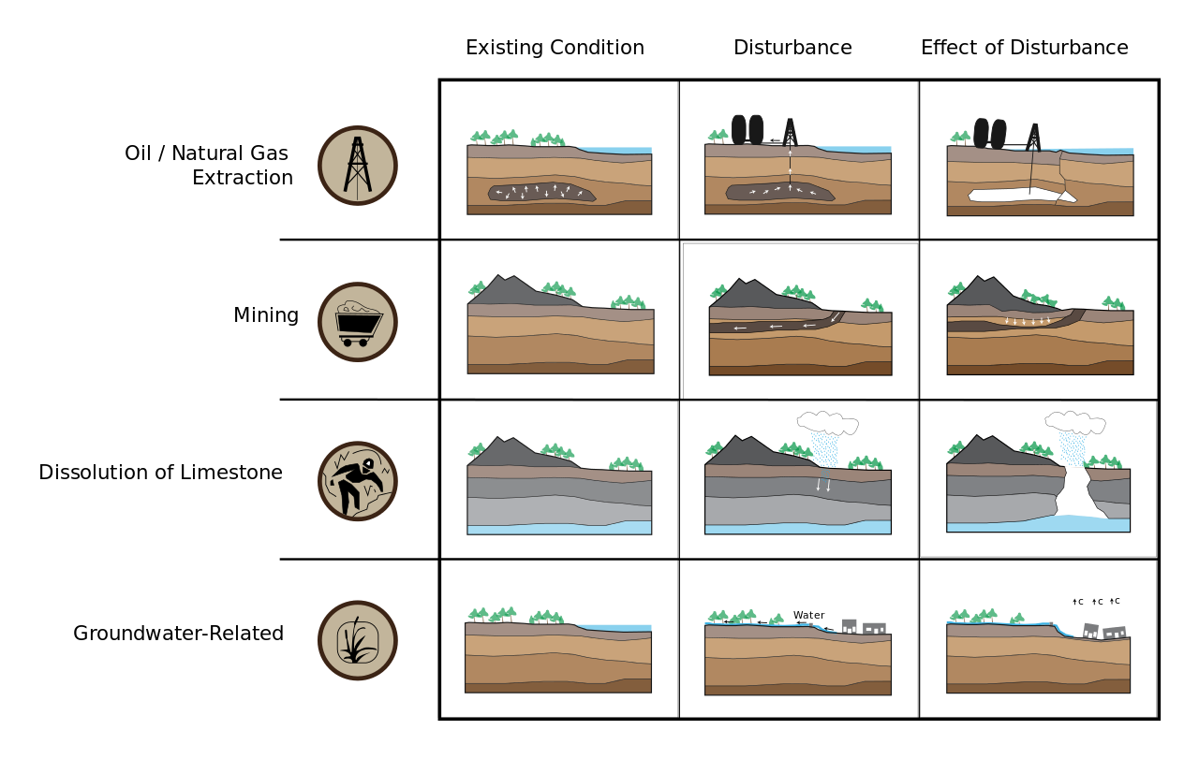
49. Diagram that displays subsidence:

50. What is subsidence cause by rock dissolution?
Caves: usually occur in limestone
51. What is the equilibrium equation to create or dissolve limestone?
Right to left – limestone is precipitated
Left to right – limestone is dissolved
Controlled by amount of carbonic acid, which is controlled by amount of carbon dioxide
52. Where do stalagtites grow?
They come from the ceiling of the cave and grow down
53. Where do stalagmites grow?
They come from the floor of the cave and grow up
54. What are columns?
When stalagmite and stalagtite meet they form a column
55. What are sinkholes and how do they occur?
Sinkholes occur when the roof of caverns collapse due to the drop-in groundwater levels and the support of buoyant water holding up cavern roofs is removed
56. What is a karst landscape?
Karst landscapes is similar to landscapes in caves or as in the following picture
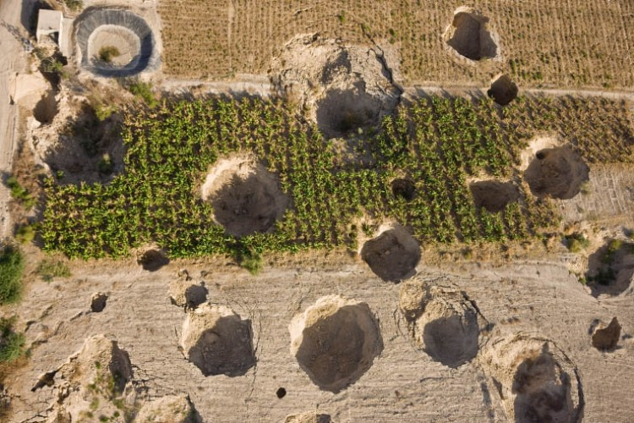
57. What causes karst landscapes?
When limestone is the dominant bedrock
58. What is subsidence caused by mine collapse?
Underground coal mining creates mine voids that can collapse and cause the earth’s surface to subside
59. What other type of mine can cause mine collapses?
Salt mine
60. Which areas are most prone to mine collapse?
Historical mining locations, where many mines have operated for many years
61. What is subsidence caused by fluid withdrawal?

62. What is a real-life example of subsidence due to fluid removal?
Mexico City has been withdrawing water with well from the ground for water and today the city is sinking due to the weight added by buildings
63. Can subsidence due to fluid removal be reversed?
No, it is not reversable
64. With what other liquid can subsidence cause by fluid removal occur?
Pumping oil and gas
65. What is subsidence caused by sediment compacting?
Delta: loose pile of water-saturated sand and mud at the end of rivers compacts and sinks
66. What happens when water saturated sand is added weight to?
Dewatering occurs, the sand moves away to the sides due to weight (ex. walking on wet sand)
67. Diagram explaining subsidence due to sediment compacting:

68. How is New Orleans going through subsidence caused by sediment compacting?
New Orleans is sinking by sediment compacting, dewatering, isostatic adjustment (45% of city is below sea level)

69. Why is the tower of Piza tilted?
It is tilted due to its water saturated clay foundation which the weight of the tower increases the water pressure causing the tilt
70. How does Venice attempt to protect itself against the rise in sea level?
Venice is built on soft sediments that compact with weight causing the sink. They protect against increase in sea level with movable floodgates across the entrance to the lagoon
71. What are three slope movement sensors used to monitor mass movements?
Slope movement sensor/Rain gage/Geophone
72. What are some ways we can protect from falling rocks from cliff?
Wire mesh nets holding rocks in place and catch fallen rocks
73. What are some techniques of controlling flows of earth or snow?
1) Removing rock and decreasing the slope
2) Brick walls blocking debris
3) Building steps in the slope to decrease the slippage
4) Avalanche tunnels protecting roads from avalanches
5) Avalanche fences blocks the avalanche from expanding
6) Cannon to cause an avalanche to avoid it from happening when not expecting

