Intro to Earth Systems Oceans

1. What is the photic zone and how deep is it?
It is the zone where there is sufficient light for photosynthesis, usually < 200 m deep
2. Compare the temperature range on land and sea-surface:
Land temperature range 146 C
Sea-surface range 38 C
3. What are two properties of water that affect Oceans?
High heat capacity: Highest of all liquids except ammonia; prevents extreme temperature heat transfer by currents is large
High Latent heat: Highest except ammonia; Acts as thermostal important in transferring heat and water to atmosphere
4. What are some consequences of water’s chemistry on the ocean?
Salinity: salts dissolved in water
5. What drives the vertical currents and deep ocean currents?
- Upwelling and downwelling near the coasts
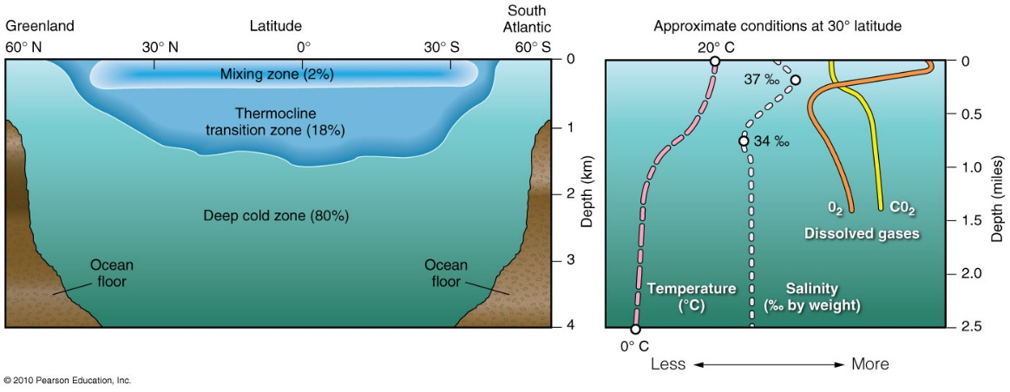
- Differences in density, temperature, and salinity between the surface waters and the deep ocean waters

6. What is thermohaline circulation?
It is what drives the vertical and deep ocean currents as described above
7. What is Giant Conveyor Belt Circulation?
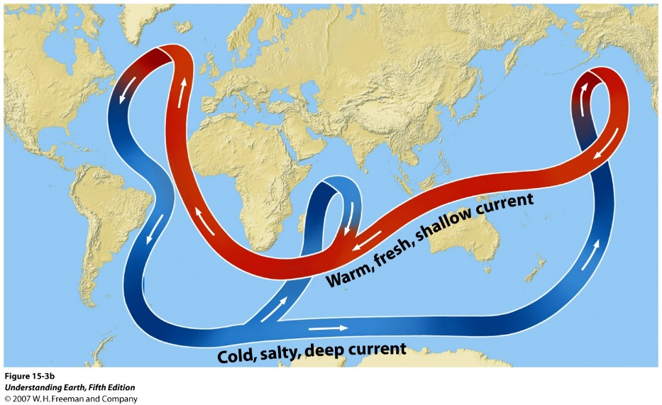
slow-moving (10-20 km/yr), density-driven currents
- Cold, salty waters of N. Atlantic sink and flow southward along bottom
- Warm up and rise to join surface currents
- Cool and sink
… gigantic loop integrating deep-water and surface circulation termed
8. What causes fluctuations in water level?
- Long term changes in sea level
- Local effects such as uplift or subsidence along a coast line
- Eustatic sea level: changes are the result of either changing the volume of water in the oceans or changing the shape of the oceans
9. What causes tides?
- Due to the gravitational attraction of Moon
- To a lesser extent, the Sun acts the same way
10. Why does the Moon have a greater effect on the tides than the Sun?
The Moon has a larger affect because it is closer to the Earth than the Sun, and it causes the Earth to bulge toward the moon
11. How many high tides and low tides are there per day?
Two high tides and two low tides

12. How does tidal currents vary in narrow inlets than along coasts?
In narrow inlets currents can be strong and fast and cause variations in sea level up to 16m
13. What causes highest high tides?
Occur because the Sun also exerts a gravitational attraction on the Earth
14. What causes lowest high tides?
Occur when the Sun and the Moon are not opposed relative to the Earth (Quarter Moon)
15. What are monthly tidal cycles controlled by?
When the Sun and the Moon are on the same side of the Earth (New Moon) or on opposite sides of the Earth (Full Moon)
16. What is a flood tide?
Rising, elevates water, advances shore leftward
17. What is an ebb tide?
Falling, lowers water surface, shore recedes
18. What is a tidal bore?
Flood tide whose upstream motion is turbulent
19. On what does the amount of change in water level depend on?
It depends on coastline shape and size of body of water
20. What are surface ocean currents?
Ocean currents that are mainly driven by the wind
21. What does the wind do to the surface of oceans?
Winds drag the surface of oceans creating a current of water that is usually no more than about 50 m deep
22. Ocean currents are something because of?
Coriolis effect, circulation is clockwise in the northern hemisphere and counter clockwise in the southern hemisphere
23. How does cooler what circulate?
In each hemisphere cooler waters from higher latitudes circulate toward the equator where they are warmed and circulated back toward the poles
24. How does surface waters act as it approaches coasts?
As surface waters approach the coast, they have to push the water down in order to make room for more water to come in. This results in downwelling currents. If surface waters move away from the coast, water from below rises to replace the water removed, resulting in upwelling
25. How do ocean currents flow in the middle latitudes?
In the middle latitudes ocean currents run generally eastward, flowing clockwise in the northern hemisphere and counterclockwise in the southern hemisphere
26. What are wave heights?
The vertical distance between crest and trough
27. What is the crest of a wave?
Highest point on wave
28. What is the trough of a wave?
The lowest point on a wave
29. What is the wavelength?
Horizontal distance between two crests or troughs
30. What is the wave period?
The time for one wavelength to pass
31. How doe water travel in a wave?
Water travels in loops
32. Why does the diameter of the loops decrease with depth?
Because the surface is affected by wind
33.

