Intro to Earth Systems Earthquakes
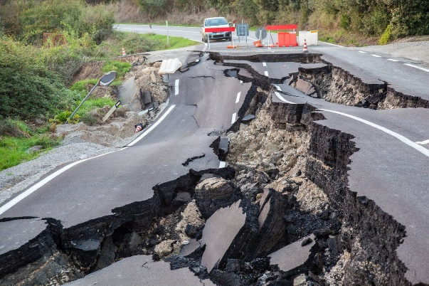
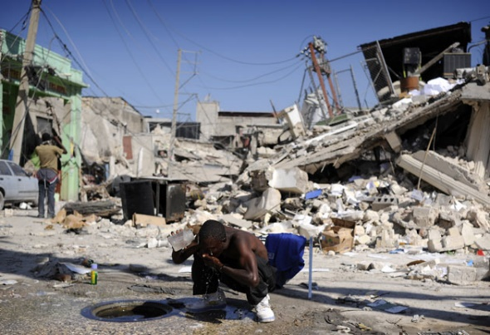
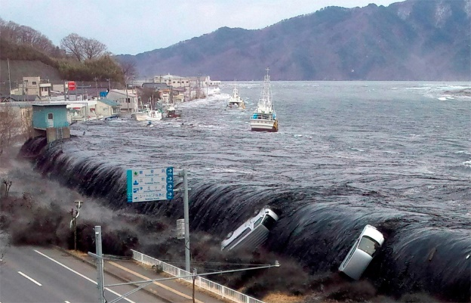

1. Briefly explain plate tectonics?
The composite of ideas that explain the observed motion of Earth’s lithosphere thru mechanisms of subduction & sea-floor spreading which generate continents & ocean basins
2. What are plate tectonics composed of?
tectonic plates are composed of the relatively rigid, brittle lithosphere
3. What happens at divergent boundaries?
Plates move apart
4. What happens at transform boundaries?
Plates slide past one another
5. What happens at convergent boundaries?
Plates move together
6. What does gravity do at plate boundaries?
It is the driving force old plates sink at convergent margins formed at divergent margins like a conveyor belt, they get recycle in the mantles
7. What can be the cause or effect of circulation set up by (slab-pull/slab-push)?
Mantle convection
8. Where does divergent boundaries usually occur?
Within ocean or continent and always leads to the creation of ocean basin
9. How dos the crust become at divergent boundaries?
The crust is stretched and thinned
10. What causes melting at divergent boundaries?
Decompression
11. How are hot rocks at divergent boundaries?
They are thermally buoyant
12. What does mark rift zones?
Normal faults
13. What is a material that behaves elastically?
When deformed material return to original shape after stress removal
14. What is a material that has ductile deformation?
It involves bending plastically
15. What is a material that has brittle deformation?
It involves fracturing/rupture
16. What is stress?
It is the result of irreversible changes in shape or size of rock (the applied force)
17. What is strain?
It is the change in shape or size of a rock that has undergone stress (the deformation)
18. What are folds?
The wave-like undulations in rock layers
19. How do folds occur?
It is the result form horizontal or vertical compressional forces
20. What is a dome?
Upwarped displacement of rocks (older rocks “strata” in the middle)
21. What is a basin?
Downwarped displacement of rocks (older rocks “strata” on the outside)
22. What are faults?
They are fractures in bedrock along which movement has occurred
23. What does the surface of faults look like?
There is a loss of cohesion of the body under influence of deforming stress
24. Where do faults usually occur?
They usually occur along sub-planar surfaces that separate zones of coherent material
25. What are joints?
They are fractures or cracks in bedrock which essentially no movement has occurred
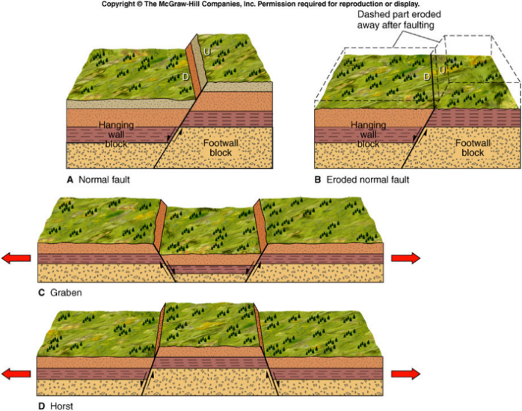
26.What are multiple joints called?
Joint sets
27. What is a normal fault?
Hangingwall moves down with respect to the footwall
28. Where do younger layers end up?
On top of older layers
29. What is the result of normal fault to the crust?
It results in thinning of the crust also called extension
30. What kind of igneous activity is there at transform plate boundaries?
None
31. What happens to plates?
The plates are conserved
32. What are strike -slip/transform faults?
Hangingwall and footwall slide past each other in horizontal plane
33. How does the rock unit order under react?
It is uninterrupted
34. What are the two types of strike-slip/transform faults?
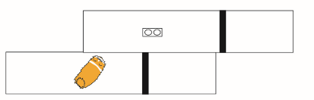
Right-lateral:

Left-lateral:
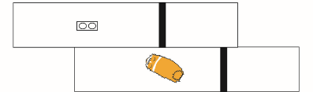

35. What are the different collisional zones of convergent boundaries?
Compression / crustal thickening / thrust faults / high relief / igneous activity
36. On what does the nature of boundary depends on?
Plates (continental / Oceanic)
37. What does ocean to ocean convergence result in?
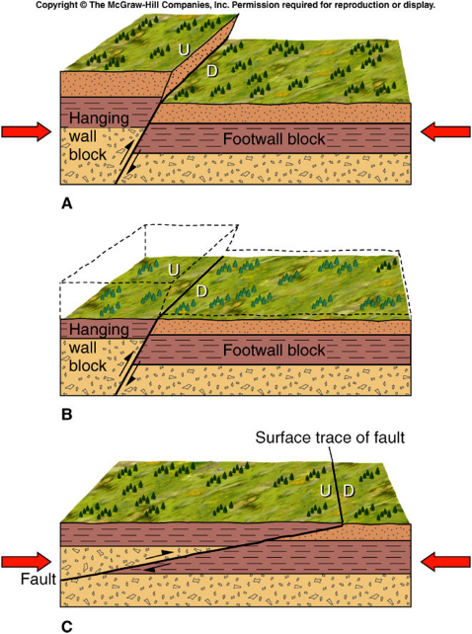
Deep ocean trench and volcanic island arc (subduction zone)
38. What are reverse / thrust faults?
Hangingwall moves up with respect to the footwall
39. Where do younger crust layers end up?
Below older rock layers
40. What is the result of reverse / thrust faults to the crust?
The duplication of rock units and thickening (compressional forces)
41. What makes one plate subduct below another?
The density of the plate, denser plates tend to go back into the mantle
- Density depends on composition and temperature
42. What does ocean to continent convergence result in?
Ocean trench, volcanic arc and mountain belt (subduction zone)
43. What kind of igneous activity is there at ocean to continent convergent boundaries?
Moderate thermal heating / voluminous igneous activity / moderate crustal shortening
44. What does continent to continent convergence result in?
Mountain belts and thrust faults
45. What kind of igneous activity is there at continent to continent convergent boundaries?
Extreme thermal heating / igneous activity / extensive crustal shortening
46. What is the epicenter of an earthquake?
It is the point on the surface that corresponds to the point where the earthquake occurred deeper in the ground
47. What is an Earhtquake?
It is produced by the movement of rock bodies past one another The stress has to exceed the strength of the rocks in brittle manner (cohesion is lost)
48. What is a fault creep?
The slow migration of crust along fault plane; weak vibrations
49. How do rocks react to faults?
Rocks bend & store elastic energy (build-up of strain)
50. When does an earthquake occur?
When frictional resistance holding rocks together is overcome
- Release of strain (slippage)
- Elastic rebound of rock (as rock tries to return to original shape)
51. What is the center of the earthquake called and what happens form there?
The center is called the focus or hypocenter and energy released radiates in all directions
52. What is the location on the surface directly above the focus?
Epicenter
53. How is the energy in the form of waves measured as?
Magnitude; felt / observed as intensity
54. What is seismology?
The study of earthquake waves
55. What is the instrument that records seismic waves called?
Seismographs / seismometer
56. On what does the seismometer rely on to record motion?
Inertia
57. What is a P wave?
(compressional) 6-8 km/s, Parallel to direction of movement (slinky), like sound waves
58. What is a S wave?
(shear) 4-5 km/s, Perpendicular to direction of movement (rope), result form the shear strength of materials, does not pass liquids
59. What is a surface wave?
Results in horizontal & vertical-orbital motions with long period & great amplitude; travel along outer part of the earth.
- Love (L) waves: side to side
- Rayleigh (R) waves: like an ocean wave, most destructive
60. How is the epicenter located?
Using the difference in velocities of P & S waves a circle with a radius equal to the distance to the epicenter is drawn around each station the point where all three circles intersect is the earthquake epicenter
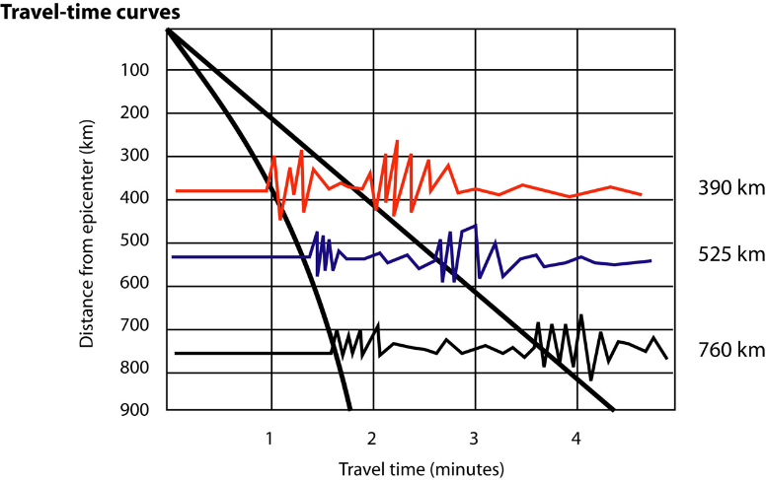
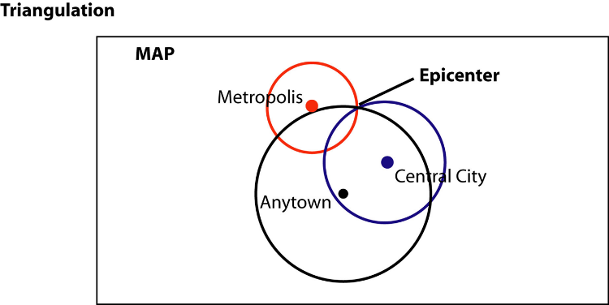

61. There are two measurements that describe the size of an earthquake, can you describe them?
Intensity: measure of the degree of earthquake shaking at a given locale based on the amount of damage
Magnitude: estimates the amount of energy released at the source of the earthquake
62. Briefly describe the Richter scale.
Based on the magnitude of the largest seismic wave recorded 100 km from epicenter
Accounts for the decrease in amplitude when increased distance
1 unit of Richter magnitude increase = 10x increase in wave amplitude (shaking) & 33x energy increase
63. What is the moment-magnitude scale?
Gauges earthquakes total energy

64. What is are the most pivotal characteristics of earthquakes that cause damage?
Intensity & duration of the vibrations
Nature of the material upon which the structure rests
Design of the structure
Floods and landslides (dam breaks & courses of river changes)
Ground movement & fire (building collapsing)
65. What is liquefaction?
It is the process of unconsolidated materials saturated with water converts into a mobile fluid
66. What are seiches?
It is the rhythmic sloshing of water in lakes, reservoirs, & enclosed basins
67. What can be the speed of a tsunami waves?
It can generate waves up to the speed of 500-800 km/h in open ocean
68. What can be the height of a tsunami wave?
In shallower costal waters the water piles up to heights that occasionally exceed 30 meters.
69. What are some short-term Earthquake predictions (Not reliable)?
swarms of (micro)foreshocks
tilt/bulge in crust or land surface
changes in seismic wave velocity
changes in gas (Radon) & groundwater (levels & chemistry)
strain monitors
paleoseismology
70. What are some long-term predictions (More reliable)?
seismic gaps - locked segments of a fault which have been ’quiet’, use of time series analysis
strain monitors & ground deformation
71. In Earthquake activity data, what is risky?
Areas where Earthquake activity has not been recorded, where there is a “gap” because stress is accumulating

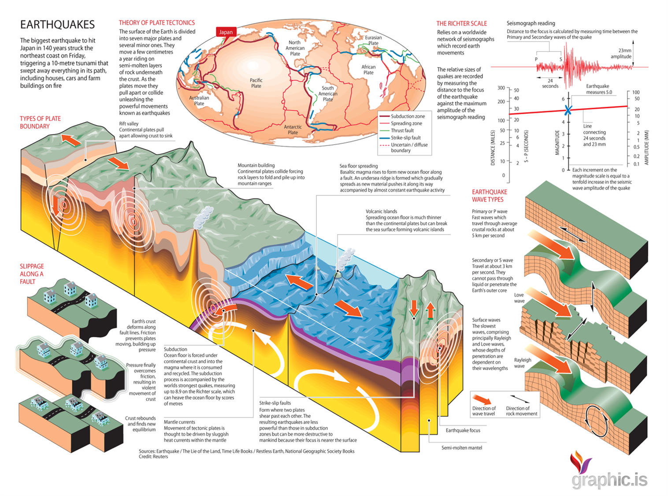
Summarizing Picture:

