PSY 1102 – Midterm 2 Review
Stress and Health:
Basic concepts:
Stress: process by which we perceive and respond to certain events (stressors) that we believe are threatening or challenging
- Stressors can vary from one person to another
- Short-lived stressors can be good (ex: energize you for the flight-or-fight response)
- Chronic stressors can damage us (ex: abuse experienced during childhood, stress of battle/war, or oppressive work environment)
Examples of stressors:
- Natural disaster
- Family disruptions (moving, losing a job, breakups)
- Serious illness
- Financial concerns
- Traffic, being late
- State of the world (terrorist attacks, sagging economy)
The stress response system:
- 1929: Walter Cannon demonstrated that stress response is a unified mind-body system.
- Physical stressors cause release of epinephrine and norepinephrine from core of adrenal gland through sympathetic nervous system. Causes increased heart rate, respiration, blood flow to muscles, dulled pain and release of sugar from fat storage = fight-or-flight response
- 2nd stress system (identified more recently): glucocorticoids (ex: cortisol) released from cortex of adrenal glands. This response can choose to withdraw and conserve energy.
- GAS: General adaptation syndrome (body’s general undifferentiated alerting system) proposed by Hans Selye. 3 phases:
- Alarm reaction: mobilize ressources (increased HR, BP respiration because of activation of sympathetic nervous system)
- Resistance: cope with stressors (everything remains high, but you can only maintain this state for a little while before acting)
- Exhaustion (post-stress period): can be more vulnerable to illness or (extreme) death.

Dealing with stress:
- Engage
- Or withdrawing and conserving energy (this is more common among women than men, may be because women secrete more of the stress-moderating hormone: oxytocin)
Oxytocin: “love drug”: associated with breast feeding, pair-bonding and comforting
Susceptibility to disease:
How is this studied:
- [PAST] psychosomatic illness
- [TODAY] behavioral medicine, health psychology and psychoneuroimmunology
Immune system is like a surveillance system and police force which detects threats and responds quickly and effectively. Affected by:
- Age
- Stress
- Nutrition
- Genetics
- Body temperature
Psychoneuroimmunology:
Immune system uses 2 types of white blood cells:
- B (form in bone marrow and release antibodies to fight bacteria)
- T (formed in thymus and attack cancer cells, viruses and others)
Also uses:
- Macrophages: eat invaders or old cells
- Natural Killer Cells: interact with diseased or cancerous cells
Immune system can make 2 errors:
- Over-react: attacking own tissue = auto-immune disease (ex: arthritis or allergic reaction)
- Under-react: enables multiplications of cancer cells and eruption of virus (ex: cold sores or genital herpes)
Women typically have stronger immune systems; however, more prone to auto-immune diseases like lupus or multiple sclerosis
Immune system can become less active with stressors (ex: slow healing surgical wounds, susceptibility to colds, lower effectiveness of vaccines)
Stress HIV and AIDS(disease of being infected by HIV):
- Used to be death sentence, but now drugs are available to made the disease livable.
- Primary symptom is a weakened immune system, which means people with AIDS would die from cancer, pneumonia or other diseases.
- Stress and negative emotions can lead to a faster progression from HIV infection to full AIDS and the rate of decline of the patient. Therefore, de-stressing techniques are used (exercise, bereavement support and relation training)
Stress and Cancer:
Same as aids. Some studies have found links between:
- Colon cancer rate 5.5 times higher in people with workplace stress, but not all studies show this.
HOWEVER: people who gave experienced enormous stress (ex: prisoners of war or concentration camps) did NOT show increased cancer rates.
Attitude and behavior on cancer:
- Positive = protection against carcinogens
- No benefit in blaming someone in getting cancer
THUS: evidence is mixed. We think that stress DOES NOT CREATE cancer cells, but may create conditions which foster their growth by reducing the strength of the immune system.
Stress and Heart Disease:
Increase BP increases risks or coronary heart disease. May have 2 types of people:
- Type A: competitive, verbally aggressive, easily angered. “combat-readiness” = autonomic activation. More prone to heart attacks.
- Type B: laid-back
- Type D: suppress negative emotions=distress during social interactions. Higher risks for non-fatal heart attacks, but also a higher mortality rate.
Stress and Illness (general)
- Pessimism is linked to a higher incidence of heart disease.
- Depression increases the risk of cardiovascular disease and death from non-natural causes (suicide)
- Prolonged stress = inflammation which can lead to asthma or clogged arteries.
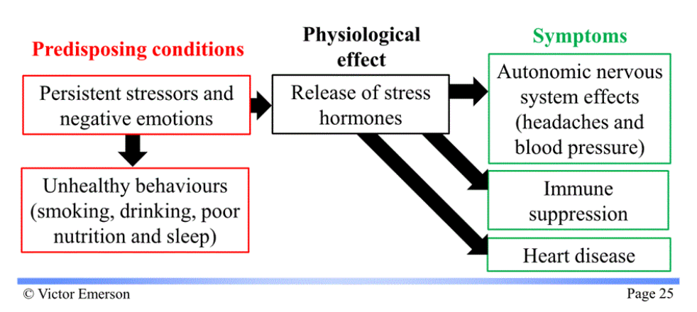
Health and coping
Coping with stress:
- Problem-focused coping (directly deal with source of stress, when we have a sense of control)
- Emotion-focused coping (seeking support, when we feel like we have no control over the stressor)

Personal control over circumstances lead to healthier and longer life and less stress. This may be because stress hormones are in higher concentration when control is lost.
Learned helplessness (when people feel a loss of control). Ex: “why should I try when I’m probably going to fail”, “what’s the point in making an effort”. People in this state are more vulnerable to health challenges, but re-engineering environement can have positive effects.
Locus of control (who do you believe controls your life):
- External: lives governed by external factors
- Internal: they control their own destiny
Self-control: delay instant gratification in order to get linger-term reward.
- Associated with greater health, higher income and better grades.
Optimism and health:
- Optimism = perception of control = handle stress better and are healthier
- See humor in life = like optimists
Coping with stress with social support:
- Close relationships predict health (rich social ties = live longer; married people live longer)
- Some evidence that pets can lead to better health (promote healing in ppl recovering from a heart attack)

To reduce stress:
- Exercise (increases heart and lung fitness= good for body health; better manage stress, more self-confident, less depressed and fatigued); can reduce depression scores (may involve endorphins, serotonin or norepinephrine)
- Relation and meditation (biofeedback: people learn to control brain waves or unconscious behavior vs. relation techniques same results as biofeedback); meditation can control HR, BP and oxygen consumption, can increase survival rates in patients
- Faith communities and health (religion can be a source of comfort)

Personality:
Personality: individual’s characteristic pattern of thinking, feeling and acting
Theoretical approaches to personality:
- Psychodynamic theories: Freud, Jung, Horney and Adler
- Freud proposes an all around view of human behavior (includes bad thoughts, jokes, contrarily to more observable behavior)
- Humanist theories: Abraham Maslow, Carl Rogers
- Trait theories: What are traits, how do we assess them?
- Social cognitive theories: evaluation of behavior in a social context
The unconscious
Freud hypothesized that neurological disorders might have psychological causes. He took notes on behavior and verbalizations on a couch – so they could relax and fostered a conversation. This technique is called psychoanalysis. He said most of the dynamics driving our behavior are unconscious.
Freud’s personality structure:
Said human personality is composed of 3 parts:
- ID: animalistic (deals with basic motivations – sexual and aggressive drives, driven by the pleasure principle)
- SUPEREGO: conscience (conforms with moral standards and ideals)
- EGO: between the two (operates based on reality principle)
Ex:
- Sex: ID wants to satisfy sex drive, SUPEREGO wants to adhere to moral principle and EGO does courtship leading to sex in a socially acceptable manner.
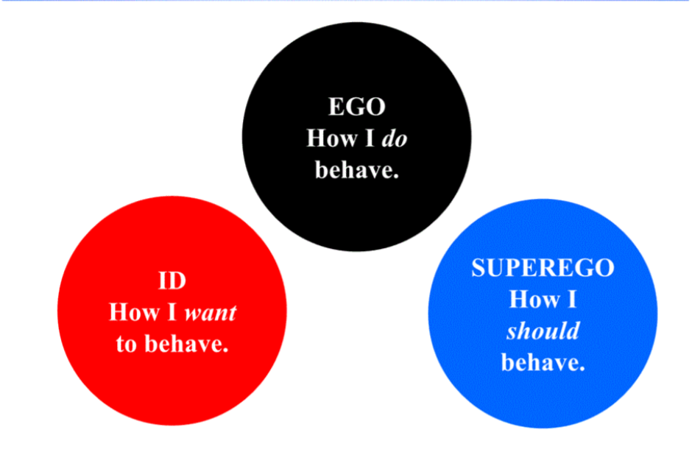

Freud’s personality development:
- People go through psychosexual stages (each with own erogenous zone)
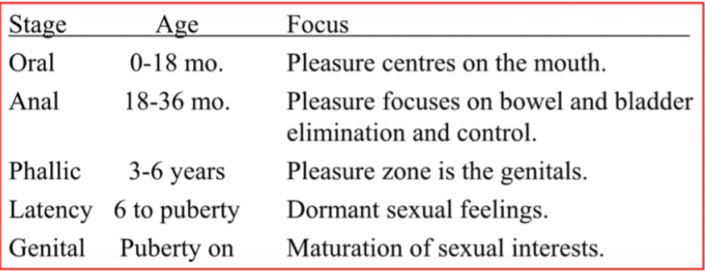
- Phallic stage occurs early in boys (according to Freud, during this time, sexually attracted to mother and sees father as competitor = Oedipus complex)
- In girls- the Electra complex: period of identification with parent of same sex, could contribute to gender identity according to Freud.
Females:
- Hysteria: how Freud explained females symptoms

- Freud proved that unresolved conflicts during development could appear in adulthood as maladaptive behavior

Development and defense mechanisms:
Freud proposed personality develops defense mechanisms to cope with anxiety
Example:
- Repression (burying feelings)
- Regression (going back to past behavior)
- Reaction formation (impulses made to look opposite
- Projection (put our problems onto other)
- Rationalization (self0justification of our actions)
- Dis placement (aggressive or sexual impulses redirected towards something
- Denial
Neo-Freudians (Adler and Horney): social, not sexual tension which make childhoods so important in personality development.
- Shifted control from unconscious to conscious mind
- De-emphasized sexed and aggression as primary motivations
Adler: child’s struggle to overcome feelings of inferiority which guided development
Horney: childhood anxiety which drove need for love and security.
- Freud’s idea of “penis envy” does not affect women
- Women do not have weaker superegos than men
Jung (Neo-Freudian continued): agreed with Freud’s notion of unconscious, but extended it to the collective unconscious
The Unconscious
Freud proposed that dreams could help us tap into unconscious.
Projective tests (developed to probe unconscious)
- Thematic Apperception Test (TAT) : individuals see picture and make story to accompany it.
- Rorschach inkblot test: ask person to interpret inkblot
Psychoanalyst then use an individuals response as indication of unconscious forces driving behaviour
Argument for: useful to stimulate vocalisation
Argument against: potentially dangerous due to potential of miscommunication and are therefore not reliable
However consensus when it comes to assessing anxiety and hostility
Evaluating Psychodynamic theories
Repression: true that some people who have experienced traumatic experiences are often unwilling to experience them.
Modern view of the unconscious mind:
- Large amount of our menal processes accur without our direct knowledge = unconscious
- Also have a false consenssys effect
Humanist theories:
John Watson and BF Skinner proposed behaviourist approach (denies existence of anything NOT observable); behaviours = observable, motivations and emotions are not.
Humanistic theory emerged in 1960s, focusing on how the personalities of healthy people develop
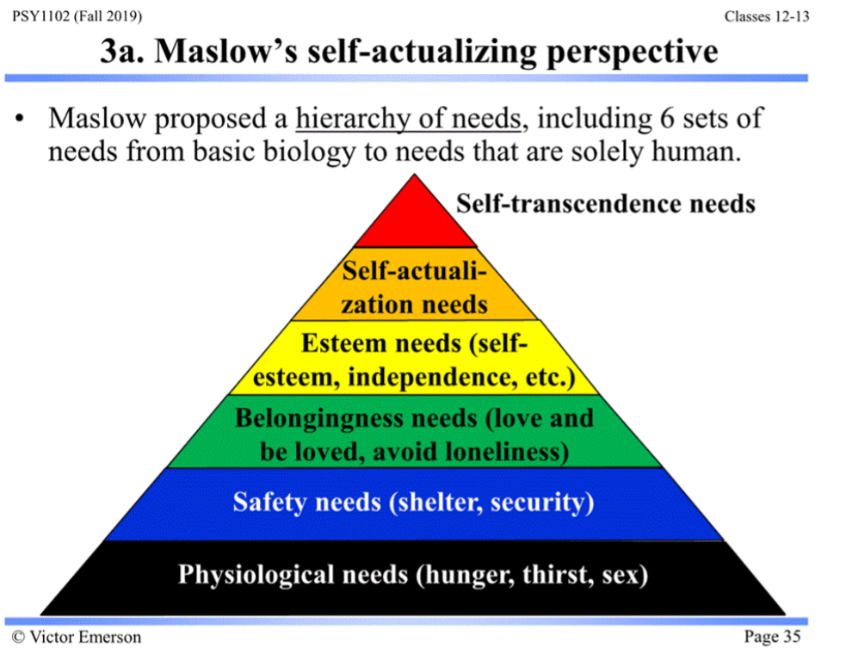
In this system:
- Humans only satisfy upper needs when lower needs are fulfilled
- Studied “normal people” not just people seeking help
Rogers – agreed with Maslow- believed that people are fundamentally good and are primed to strive from self-actualisation. Proposed 3 conditions for personal growth:
- Genuineness (open about feelings, share info about themselves, drop facades)
- Acceptance (when others offer unconditional positive regard, valuing the human being) – Okay to disapprove of behaviour, but not of the person.
- Empathy (actively sharing feelings of another person)
Central to Rogers’ perspective is the idea of the self-concept, is how we describe ourselves to ourselves, we all have an ideal self. If we have a negative self-concept, we never measure up to our ideal. If we have a positive self-concept, we tend to see the world more positively.
Assessing the self: constant challenge
- Rogers asks “who are you , actually” and “what would you ideally like to be”. If the 2 answers are close, the self-concept is positive

Trait perspective: person is a group of traits , developed by Gordon Allport. A trait can be a behaviour or a motive. He wanted to describe traits, not explain them.

Personality type : way to sort people, uses the Myers-Briggs Type Indicator (MBTI)
This test is based on Carl Jung’s ideas. He suggests an introvert-extravert axis and proposed two dichotomous pairs of cognitive functions (rational -like thinking and feeling- and irrational -like perceiving functions). Myers and Briggs created 16 types based on 4 dichotomies:
- Extraversion (E) – Introversion (I)
- Sensing (S) – Intuition (I)
- Thinking (T) – Feeling (f)
- Judgement (J) – Perception (P)
Factor analysis is a tool that looks for clusters or attributes.

Facts about biology and personality:
- Extroverts seek stimulation because normal level of brain arousal is slow. Activity of a frontal lobe area responsible for inhibition of behaviour is more active in introverts
- Dopamine related activities more common in extroverts
- Reactivity of autonomic nervous system is lower in curious people rather that fearful or anxious ones.
Assessing Traits:
Traits assessed by personality inventories (long questionnaire which asses several traits at once)
MMPI: first one, items are backed by research.
Personality inventories are scores objectively/no interpretation

The Big 5 Factors (across cultures and geography): stable in adulthood, hereditability is generally around 50%
- (C) Conscientiousness : rises in the 20s
- (A) Agreeableness: rises in the 30s
- (N) Neuroticism (emotional stability and instability)
- (O) Openness
- (E) Extraversion
Big five and predictive values:
- Highly conscious people get better grades in higher education and are “,morning people”
- If partners score differently on A, N and O, marital and sexual satisfaction may suffer.
Theories on evaluating traits:
- Person-situation controversy: to what extent is someone the same across different situations? What characteristics are the same?
- Personality traits become more stable with age; however, specific behaviour changes from situation to the other
Personality is constant, actions are not. Therefore, personality tests do not predict behaviour well?
Social cognitive perspective on personality:
History: started by Albert Bandura in 1980s.
This perspective looks at the existence of traits, but emphasises interactions with situational effects. It looks at learned behaviour (learned by observing others or by taking into account the situation)
Social cognitive perspective vs. behaviourism:
- Behaviourists posits that we process a stimulus and emit a response. Therefore cognitive processes are irrelevant.
- Social cognitive perspective believes response to stimuli is modulated by cognitive processes such as memories schemas and expectations.
Reciprocal Influences:
According to Bandura, interaction between person and environment is reciprocal determinism. Basically several factors are interlocking in relationship with each other. Although we are influenced by our environment, we also help create it.
- Choosing environments: different people pick different environments
- Personalities: they shape how we interpret and react to events. They help create situations to which we reach.
- Biopsychology:
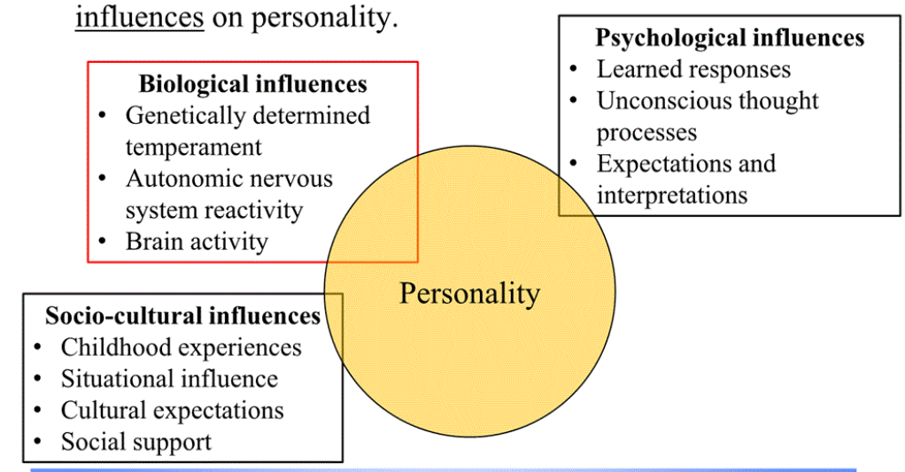

Personal control and locus of control from social-cognitive perspective:
- To what extent do we control our environment and to what extent does it control us.
- Internal locus of control: people sense that they are in charge (usually these people achieve more, have better health, feel less depressed and are more independent than internals
- External locus of control: outside forces control what happens to them.
- Self-control: abilities to control impulses and delay gratification. Associated with less depression, better grades and social success.
Personal control and learned helplessness (associated with externals):
- Learned helplessness is the apparent hopelessness and passive resignation learner with enable to avoid repeated aversive events
- Giving people individual control – empowerment
- But too much freedom can be counter productive

Optimism vs. pessimism:
Optimists:
- Outlive pessimists
- Have fewer illnesses (may be because feeling of control associated with stronger immune system)
- Excessive optimism can be counterproductive (can’t be blind to one’s own incompetence)
Assessing behaviour in situations:
- Social cognitive perspective uses a situational approach to evaluate someone. Basically think that a person’s existing behaviour patterns are a better predictor of situational behaviour than other measures (tests or interviews).
Evaluating the social cognitive perspective: behaviour occurs in a context where the situation is affected by, and affects the individual.
- May over value situation and undervalue individual traits.
Exploring the self:
- According to Markus: many selves which reflect our goals and help guide behaviour towards them.
- Spotlight effect: other people notice aspects about us that we do
Benefits of self-esteem (one’s feeling of self-worth):
- Good self-esteem tends to lead to happier, less pressure conforming, less anxious and lonely and more persistent people. Can also report employment, salary and job satisfaction.
- Low self-esteem: increased racial prejudice, critical of others and self-inflation
- Self-serving bias: we do not evaluate ourselves objectively, so we could blames others for things that are our fault,.
Ex: people accept more responsibility for good deeds than bad ones or people thinking they are better than average.

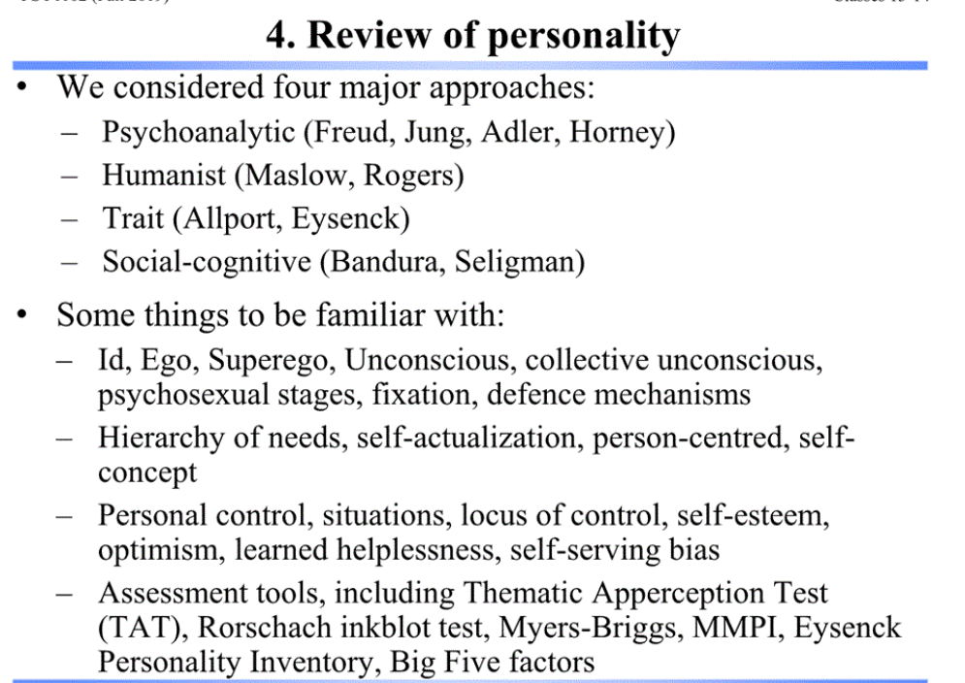

Psychological disorders:
a syndrome (or collection of syndromes) market by a clinically significant disturbance in an individual’s cognition, emotion regulation or behaviour
Classifying psychological disorders:
- Alphabetically
- According to characteristics
Classifying helps describe a disorder which can help predict future course, siggest treatment options and stimulate research.
First step is to name it. Then to have the disorder, the person must meet all the criteria. Names and criteria may change throughout time.
A category must be reliable (diagnosis by one profession will be confirmed independently by another). The inter-rater reliability of diagnosis by two psychologists is important.

Labelling psychological disorders:
Why do some psychologist criticize diagnostic labels?
Could “pigeonhole” the person. Also guide how people could view others.

The rate of psychological disorders:
We determine the incidence of psychological disorders with 3 methods:
- Current year
- - previous year
- Lifetime
Factors affecting vulnerability to psychological disorders:
- Poverty shows a strong correlational link to psychological disorders. Stress of poverty could contribute o psychological disorder and how a psychological disorder could contribute to poverty.
Ex: the immigrant paradox: recent immigrants have a lower incidence of psychological disorders than people with Mexican heritage who were born in the US
- Age of onset: 75% have the first symptoms by 24.
- Symptom of antisocial personality disorder and phobias appear around 8 or 10
- Symptoms of alcohol dependency, OCD, bipolar disorders and schizophrenia appears around 20
- Major depressive disorder first appears at around 25

Anxiety disorders, OCD and PTSD
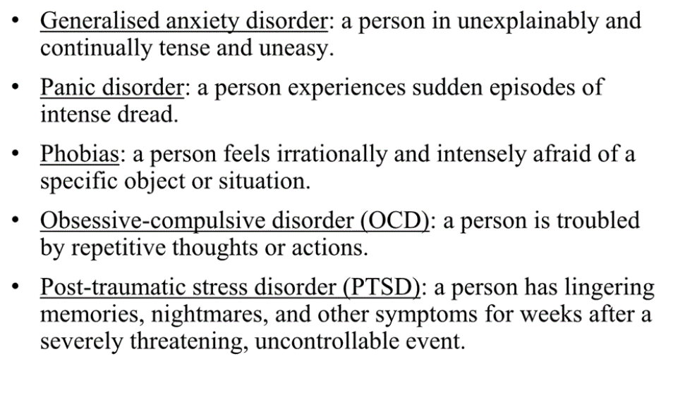
Generalized anxiety disorder: Person is continually tense, apprehensive and in a state of autonomic nervous system arousal.
- Difficulty concentrating, poor sleeping, continual worry, agitation
- More common in women than men
- Disabling, can lead to depression or physical problems (ulcers and hypertension)
- Rarer beyond 50
Panic disorders: unpredictable minutes-long episodes of intense dread in which a person experiences terror, chest pain and chocking
- Panic attacks , tachycardia, shortness of breath trembling or dizziness
- More common in smokers than non-smokers
Phobias: anxiety disorder marker by persistent irrational fear and avoidance of a specific object, activity or situation
- Anxiety focused on one object or situation
- Can have specific or broad phobias
Obsessive-compulsive disorder (OCD): unwanted repetitive thoughts (obsessions) tha persistently interfere with everyday life.
- Compulsive behaviour could be cleaning items or the hands, checking that items are positioned properly, locked.
- Symptoms usually decrease with age
Post-traumatic Stress Disorder (PTSD): reoccurring haunting memories or insomnia
- Called shell shock or battle fatigue for soldiers
- Can also follow disasters like plane Cashers, sexual assault
- Twice as high in women than men
- The greater emotional reaction the greater the likelihood of PTSD
- Post-traumatic growth is positive psychological changes as a result of struggling with extremely challenging circumstances and life crises.
How do conditioning, cognition, and biology contribute to the feelings and thoughts hat mark anxiety disorders, OCD and PTSD?
- Freud’s theory proposed that people repress intolerable feeling and that the resulting submerged mental energy could create anxiety
- 3 different psychological perspectives:
- Conditioning (learning)
Fear conditioning can generalise from one specific event to anxiety in the environment.
2 learning processes can contribute to that anxiety:
- Stimulus generalisation can occur when someone is attacked by a dog comes to fear all dogs.
- Reinforcement maintains phobias and compulsions
- Cognition (thinking): observational learning (ex: being afraid of clown after watching it)
- Biology
- People cautious about predators and other environments (via natural selection) may have an increased likelihood of surviving to produce offspring
- Some people may have predisposed anxiety because of their genes. Ex: anxiety genes may affect level of serotonin with influences sleep, mood.
- Over arousal of specific parts of the brain is associated with PTSD, panic attacks, generalized anxiety and OCD.
- Epigenetic effects: genetic vulnerability could be expressed as a result of a long-term trauma such as child abuse.
Depressive disorders and bipolar disorder
Two major forms of mood disorders:
- Major depressive disorder, including persistent depressive
- Bipolar disorder
Major Depressive Disorder:
- Main reason why people seek help from mental health services
- Leading cause of disability around the world
- When at least 5 signs of depression last two or more weeks and are not caused by drugs or medications
Ex: of signs:
- Reduced interest or enjoyment in most activities
- Feeling worthless, or feeling unwarranted guilt
- Problems in thinking, concentration or making decisions
- Episodes of major depression usually end with or without therapy
Persistent depressive disorder (dysthymia)
- Mildly depressed mood (2 years or more)
- Feeling hopeless
- Poor self-esteem
- Reduced energy levels
- Problems regulating sleep
- Problems regulating appetite
Bipolar disorder (person alternates between the hopelessness and lethargy or depression and the overexcited state of mania):
- Alternation between episodes of depression and mania
- Creativity associated with periods of mania

Understanding depressive disorders and bipolar disorder:
- Background:
- Inactivity, lack of motivation, focus on negative aspects, half also show anxiety and substance abuse
- Geographical and cultural extent of depression
- Self-termination of most depressive episodes
- Stressful events can proceed depression
- Greater incidence and earlier onset with each generation.
- Biological:
- Genetic influences:
- in identical twins, 50% incidence if an identical twin is diagnosed with major depression, 70% in the case of bipolar disorder
- heritability pf major depression estimated to be 35%-40%
- linkage analysis (could like depression to a specific gene, but not there yet)
- The depressed brain:
- In functional MRI and PET scans: lower brain activity during depressed stages and higher activity during manic stages; smaller frontal lobes in people with severe depression; Neurotransmitter influences levels in depression and higher in mania; more smoking during depression; serotonin is lower during depression, suggesting a stress-gene interaction; physical exercise increases serotonin and reduces depression.
- Social-cognitive:
- Negative thoughts and negative moods interact: self-defeating beliefs may be a products of learned helplessness. Pessimistic outlook contributes to severe depression. Greater individualism and the decline of religion have been proposed as a contributing factor in western societies
Ex: 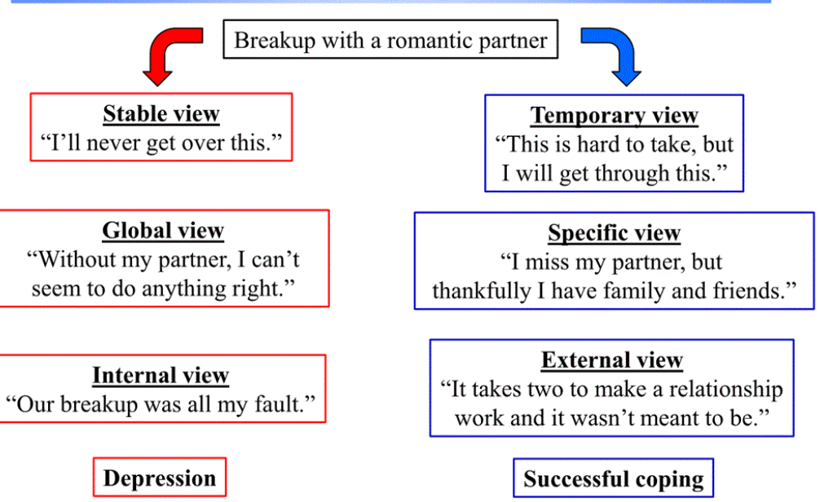

- Depression’s vicious cycle: having a depressed mood affects how the depressed person sees the world and thinking and acts, this leads once again to stressful experiences where other people may react negatively to the depressed person.

- Suicide and self injury:
- Suicide is 5x as great for people who have been diagnosed with depression.
- Can be a way of sending a message to others or to deal with distress.
- Non suicidal self-injury can through pain, provide relief from intense negative thoughts, attract attention and perhaps get help or help relieve guilt.
Schizophrenia:
Key symptoms: disturned perceptions, disorganized thinking and speech and diminished and inapropriae emotions.
- Positive symptoms (hallicinations, talk in a disordered manner, exhibit inappropriate emotions)
- Negative emotions (lack emotion in their voices, lack expressiveness in their face, mute or rigid bodies)
Disturbed perception (hallucination – sensory experience without sensory stimulation): most are auditory (voices)
Disorganized thinking and speech: fragmented, disconnected logically. May exhibit false beliefs (delusions), people with paranoid tendencies may exhibit delusions od persecution, may have problems with selective attention
Diminished and inappropriate emotions: catatonia or agitation
Onset and development of schizophrenia:
- Age: arrives in young people maturing into adulthood
- Gender: more males than females (more severe and at younger age)
- Predictors: thin young men not breast fed are more vulnerable than others
- Suddenness of onset: can appear quickly or gradually
- Prognosis: negative and chronic = recovery is doubtful. Acute or reactive with positive symptoms is more likely to respond to drug treatment
Causes:
- Brain abnormalities:
- Dopamine over-activity: many more dopamine receptors meaning could be excess of dopamine causing signals to intensified (hallucination and paranoia); also low levels of glutamate are associated with symptoms of schizophrenia.
- Abnormal brain activity: low activity in frontal lobes; high activity in thalamus during hallucinations; also amygdala activity increased. Fluid-filled area in brain are enlarged; cerebral cortex and thalamus are reduced in size.
- Prenatal environment and risk: low birth weight and oxygen deprivation may increased likelihood of schizophrenia
- Genetic factors:
- Likelihood of getting it is greater is you have a family member who has it
- For identical twins : 60% chance for same placenta
- Environmental triggers:
- Mother with severe long-lasting schizophrenia
- Birth complications
- Separation from parents
- Short attention span
- Disruptive behaviour
- Emotional unpredictability
- Solo play
Overall evidence of schizophrenia :
- Genetic factors
- Viral link (second trimester of pregnancy0
- Heightened dopamine levels
- Larger fluid pools in brain and smaller cortex and thalamus
Dissociative disorders (a disorder of consciousness):
- Person exhibits two or more distinct and alternating personalities who typically are not aware of each other’s existence.
Arguments against DID:
- Hypnotized “normal “students were able to create a second personality
- Different facades that we present to others
- Rise in diagnoses and increased number of personalities
Argument for DID:
- Evidence of a change in handedness and changes in visual function
- Form of coping with post-traumatic stress, especially related to childhood abuse
Cannot predict who will get DID.

Personality disorders (disruptive inflexible and enduring behaviour patterns that impair ones’s social functioning) has different clusters:
- Avoidance of personality disorder: withdrawn, fearful to rejection
- Schizotypal personality disorder: emotional disengagement and eccentric behaviour
- Borderline personality disorder, narcissistic personality disorder and antisocial personality disorder can sometimes be dangerous
Antisocial personality disorder (sociopaths or psychopaths):
- Lack of conscience, lower emotional intelligence
Understanding it:
- Biological relatives have more chances of getting it
- Little autonomic arousal when faced with stressful events and have lower levels of stress hormones
- Without sense of responsibility, may develop criminal behaviour
- PET scan: reduced frontal lobe activity.
- Childhood maltreatment and gene altering NT levels can oredict antisocial behaviour

Eating Disorders:
Body is disposed to maintain a normal weight and have stores when food isn’t available.
Anorexia nervosa: most common in adolescent females.
- Begins ins dieting, but after achieve lower body wight, still ercieve as overweight
- May enter binge-purge-depression cycle
Bulimia nervosa:
- Gorges on food for break from a diet, followed by purging (vomiting) excessive exercise or fasting
- May be followed by a period of depression
Binge-eating disorder:
- Is later remorseful, may become overweight
Incidence of eating disorders/contributing factors:
- Mother focuses on her own weight as well as daughters weight and appearance
- Familia link
People with eating disorders may have:
- Low self-esteem
- Perfectionists standards
- Fear of not living up to expectation
- Concerned about how others see them
Genetics appear to be relevant: identical twin have same eating disorders more than fraternal twins
Cultural and gender components are relevant:
- Ideal body varies based on culture
- Fashion promotes ideal body type

