Topic 1 : The human Body

Intro to anatomy and physiology

- Different types of anatomy (slide 9)

- Gross anatomy (macroscopic)

: deals with the structure of organs and tissues that are visible to the naked eye.

- Microscopic anatomy

: The study of the structure of cells, tissues, and organs of the body as seen with a microscope

- Developmental anatomy

: The study of the structural changes of an individual from fertilization to adulthood.

- How are anatomy and physiology related? (slide 11)

: they are inseparable due to the Principal of Complementarity

- Structure determines the function
- Function reflects the structure

- What are the levels of structural organization (slide 12)

In order…

- Chemical level
- Cellular level
- Tissues level
- Organ level
- Organ system level
- Organismal level

- What are the eight necessary life functions? (slide 13)

- Maintaining boundaries (plasma membrane, skin)
- Movement (skeletal, cardiac & smooth muscle)
- Responsiveness (breathing control & withdraw reflex)
- Digestion (food intake, breakdown & absorption)
- Metabolism (catabolism & anabolism)
- Excretion (carbon dioxide, feces & urine)
- Reproduction (cellular & organism)
- Growth (Increase in cell size, body parts or organism)

Cells & Organ Systems

- Cells and organ systems (slide 14)

- Digestive system
  - Takes in nutrients and breaks them down
  - Eliminates unabsorbed matter (feces)

- Cardiovascular system
  - Oxygen and nutrients are distributed to all body cells through the blood
  - Delivers wastes and carbon dioxide to disposal organs (respiratory system)

- Respiratory system
  - Takes in oxygen and eliminates carbon dioxide

- Urinary system
  - Eliminates nitrogenous wastes (urea and uric acids) and excess ions

- Integumentary system
  - Protects the body as a whole from the external environment

*view ‘diagram 1’ for visuals
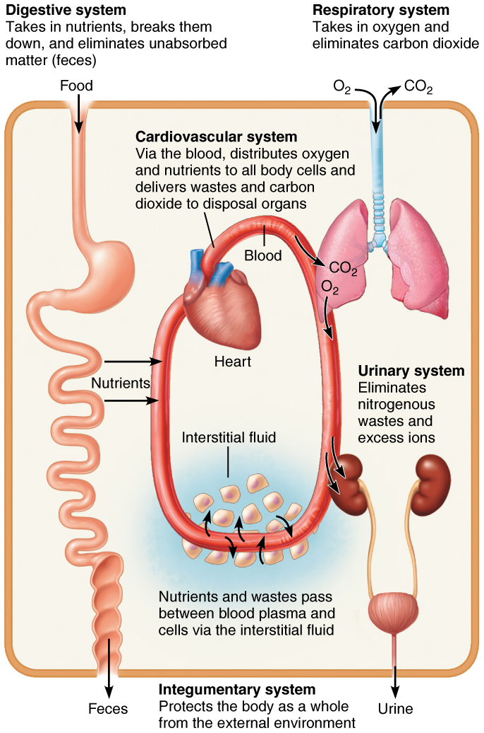
*5.1: Diagram 1

6) Covers, support or contracts (slide 15)

- Integumentary system
  - Forms the external body covering, such as skin, hair and nails
  - Protects deeper tissues from injury
  - Synthesizes vitamin D
  - Houses cutaneous receptors (pain, pressure, etc)
  - Houses sweat and oil glands

- Skeletal system
  - Protects and supports body organs
  - Provides a framework that the muscles use to cause movement
  - Blood cells are formed within bones
  - Bones store minerals

- Muscular system
  - Maintains posture
  - Produces heat
  - Assists movements

7) Control (Slide 16)

- Nervous system
  - Responds to internal and external changes by activating a specific muscles and glands

- Endocrine system
  - Glands secrets hormones that regulate processes such as growth, reproduction, and metabolism

8) Transport (Slide 17)

- Cardiovascular system
  - Blood vessels transport blood
  - Blood carries oxygen, carbon dioxide, nutrients, wastes, etc
  - The heart pumps blood

- Lymphatic system / Immunity
  - Picks up fluids leaked from blood vessels and returns it to blood
  - Houses White Blood Cells (lymphocytes) involved in immunity

9) Maintenance (slide 18)

- Respiratory system
  - Keeps blood constantly supplied with oxygen and removes carbon dioxide
  - These exchanges occur through the wall of the air sacs of the lungs (alveoli)

- Digestive system
  - Breaks down food into absorbable units that enter the blood for distribution to body cells
  - Indigestible foodstuffs are eliminated as feces

- Urinary system
  - Eliminates nitrogenous wastes from the body (uric acid, urea)

10) Continuity (slide 19)

K) Male Reproductive System

- Female Reproductive System

11) What is the Anatomical Position of a human being (Slide 21)

- Body erect
  - Feet slightly apart

- Palms facing Forward
  - Thumbs point away from body

*12) View Slide 22~26 For Diagrams on -Directional Terms, -Anterior/Ventral, -Posterior/Dorsal, -Body Planes &Sections, -Body Cavities

13) What are the Four Abdominopelvic Quadrants (Slide 27)

- Right upper quadrant (RUQ)
- Left upper quadrant (LUQ)
- Right Lower Quadrant (RLQ)
- Left Lower Quadrant (LLQ)

14) What are the Nine abdominopelvic Regions (Slide 28)

Right Hypochondriac region | Epigastric region | Left Hypochondriac region
Right lateral region | Umbilical Region | Left lateral region
Right inguinal (iliac) region | Pubic (hypogastric) region | Left inguinal (iliac) region

*view diagram (a) on slide 28 for location

12) What body cavities are exposed to environment? (Slide 29)

  - Oral and digestive cavities
  - Nasal cavity
  - Orbital cavities
  - Middle ear cavities

13) What body cavities are NOT exposed to environment? (Slide 29)

  - Synovial cavities

14) What is the ‘Cell Theory’ (Slide 30)

- Cell is a structural and function unit of life
- The activity of an organism depends on individual and collective cell functions
- Biochemical activities of cells are dictated by the shape of cell
- All living organisms are made of cells and come from other living cells

15) What are the basic parts of human cells? (slide 32)

  - Plasma membrane
  - Cytoplasm
  - Nucleus

16) What is the role of Plasma Membrane? (slide 33)

  - Separates intracellular and extracellular

17) What cytoplasmic organelles are membranous? (Slide 35)

  - Mitochondria
  - Endoplasmic reticulum
  - Golgi apparatus
  - Peroxisomes
  - Lysosomes

18) What cytoplasmic organelles are non-membranous? (slide 35)

  - Ribosomes
  - Cytoskeleton
  - Centrioles

19) What is the function of the Ribosomes? (Slide 36)

  - Protein synthesis

20) What is the function of the Rough Endoplasmic Reticulum? (slide 36)

  - Produce and process specific proteins

21) What is the function of the Smooth Endoplasmic Reticulum? (slide 36)

  - Makes cellular products like hormones and lipids
  - Distributes these products throughout the cells and into organisms

22) What is the function of the Golgi Apparatus? (slide 36)

  - process and packages the macromolecules such as proteins and lipids that are synthesized by the cell

23) What is the function of the Mitochondria? (Slide 36)

  - performs cellular respiration
  - takes in nutrients from the cell, breaks it down and turns it into energy

24) What is the function of the Lysosomes? (slide36)

  - digests excess or worn out organelles, food particles, and engulfed viruses or bacteria
  - Lysosomes are like the stomach of the cell
  - Main function is digestion

25) What is the role of Peroxisomes? (slide 36)

  - Primarily involved in lipid metabolism
  - turns of hydrogen peroxide into safer molecules such as water and oxygen

26) What is Centrosome and what is its function? (slide 38)

: centrosome is the “cell center” located near the nucleus

  - generates microtubules (which supports and gives shape to the cell)
  - organizes mitotic spindle (involved in cell divison)

27) What is the function of centrioles? (slide 38)

  - forms the basis of cilia and flagella

    - Cilia and Flagella (slide39)
      - They whip back and forth and help cells move around in cellular fluids.
      - They also help particles move past the cell.

    - Microvilli (slide 39)
      - Finger-like extension of the plasma membrane

28) What is the function of microfilaments? (slide 41)

  - movement of the cell
  - how??
    - Dynamic (constantly changes depending on the need of the cell)
    - they can lengthen and shorten very frequently
    - lengthens in the process of actin polymerization
    - shortens in the process of actin depolymerization

  - example of microfilaments helping to move the cell
    - during cell division, the cell pinches the cell and divides. Microfilaments help pinch the cell and move to create two separate cells
    - when amoeba is trying to capture food, amoeba must extend its pseudopods and move around the food particle and microfilament helps so

29) What is the function of Intermediate Filaments? (slide 41)

  - provides structural support for the cell (resists mechanical stress)
  - Can be compared to the springs on the mattress
    - In the sense when you sit on the mattress, you might squish a little bit but when you stand up, the mattress reverts to its original shape

30) What is the function of Microtubules? (slide 41)

  - helps support and gives shape to its cell
  - Their primary cell division function is to connect to the chromosomes, help those chromosomes complete their first split, and then move the new chromosomes to their places in the new daughter cells

31) What is the function of Centriole?

  - Reproduction
    - They release microtubules that split the cell during cell division

32) What is the function of Cilia? (slide 33)

  - Movement of the cell
    - Pairs of microtubules slide back and forth to create movement

  - Can be found in cells lining the respiratory tract
    - Cells lining the tract secretes a thin layer of mucus and everytime we inhale, we bring in dust and pollen along with air and they get stuck on mucus. If they stayed there, it’d get clogged and get sick. Therefore, cilia sweeps the mucus upward to get rid of the unwanted substances.

33) what is the function of flagella? (41)

  - Movement of the cell
  - Whip-like tail structure
  - Sperm cells
    - Whips back and forth and creates a propeller like movement

34) What is the function of Microvilli? (slide 41)

  - Hair like things on the surface of the cell that increases the surface area
  - More surface area = better/more absorption
    - Present in cells that specialize in absorption
      - Small intestines
      - Kidneys

35) What is the function of Nucleus? (slide 41)

  - Brain of the cell
  - stores the DNA
  - coordinates cell’s activities
    - such as growth, synthesis of protein and reproduction
      - Directs the synthesis of ribosomes and expression of our genes
        - Synthesis of ribosome’s importance reads RNA and synthesize protein

36) What is the function of Nuclear Membrane? (slide 41)

  - Double membrane structure that surround the nucleus
  - Double membrane structure provides a barrier between the nucleus content and cytosol and protects the DNA from materials in the cytoplasm

37) What is the function of Nucleoli? (slide 41)

  - As the nucleus is the "brain" of the cell, the nucleolus could loosely be thought of as the brain of the nucleus. The nucleolus takes up around 25% of the volume of the nucleus
  - Main function:
    - mainly involved in the production of subunits which then together form ribosomes. Therefore, nucleolus plays an important role in protein synthesis and the production of ribosomes in eukaryotic cells.

38) What is the difference between nucleus and nucleolus(nucleoli)?

Nucleus | Nucleolus
Large in size. | Very small in size.
Bounded by the nuclear envelope. | It has no limiting membrane.
It contains chromosomes. | It does not hold any chromosomes
It is rich in DNA, the genetic material. | It is rich in RNA.

39) What are the 4 possible theories/opinions on Cell Aging?

- Wear and tear theory
- Mitochondrial theory
- Immune system disorders
- Genetic theory (telomers)

40) What does all cells depend on to stay alive?

  - Organ system

Tissues

41) What is Tissue (slide 44)

  - Groups of cells similar in structure that perform common or related function

42) What is Histology? (slide 44)

  - Study of tissues and their cellular organization

43) What are the four Primary tissue types? (slide 45)

  - Nervous tissues
: internal communication

  - Muscle tissue
: contracts to cause movement

  - Epithelial tissues
: forms boundaries between external environment, protects, secrets (sweat), absorbs, filters

  - Connective tissue
: supports, protects, bind other tissues together

44) What are the main component of nervous system? (slide 47)

- Brain
- Spinal cord
- Nerves to regulate and control body functions

45) What is the function of Neurons? (slide 47) *see the slide for more info

  - Generate and conduct nerve impulses

46) What is the function of Neuroglia? (slide 47)

  - Support, insulate and protect neurons

47) What are the three types of Muscle tissues? (slide 48)

- Skeletal muscle
- Cardiac muscle
- Smooth muscle

48) What are muscle tissues responsible for? (slide 48)

- For most types of movement

49) What is the function of the Skeletal Muscle? (slide 48)

- Voluntary movement (kicking, lifting, etc)

Ex) usually attached to bones or occasionally on skin

50) What is the function of the Cardiac muscle? (slide 48)

- As it contracts, it propels blood into the circulation
- Involuntary control

Ex) the walls of the heart

51) What is the function of Smooth muscle? (slide 48)

- moves substance along internal passageways (food particles, urine, etc)
- Involuntary control

Ex) mostly in the walls of hallow organs (stomach, small intestines, urinary bladder, etc)

52) What are the two main types of Epithelial tissue and what differentiates them? (slide 49)

- The Location of the tissues differentiates epithelial tissue into two types…
  - Covering and lining epithelial on external and internal surfaces
  - Glandular epithelial secretory tissues in glands

53) What is the difference between Simple Epithelia and Stratified epithelia? (slide 51)

- Simple epithelia = single layer of cells

- Stratified epithelia = two or more layers of cells
  - Shape can change in different layers
  - Classified by cell shape in the apical layer

54) What are the three types of Epithelial cells and explain (slide 52)

- Squamous cells
  - Flattened and scale-like
  - Nucleus flattened

- Cuboidal cells
  - Boxlike
  - Nucleus round

- Columnar cells
  - Tall, column shaped
  - Nucleus elongated

55) SEE SLIDE 53~58 FOR DIFFERENT TYPES OF EPITHELIUM

56) What is a gland? (slide 59)

  - Cells that produce and secrete an aqueous fluid (a secretion: protein, lipids or steroids)

57) What differentiates endocrine versus exocrine

- Endocrine
  - Ductless
  - Produce hormones

- Exocrine
  - Ducts
  - Non-hormonal substances (ex. Mucus, sweat, salivary glands & liver, pancreas)

58) What are the functions of Connective tissues? (slide 62)

- Binding & supporting
- Protecting
- Insulating
- Storing reserve fuel
- Transporting substances

59) What are some of the characteristics of Connective Tissue that are different from other primary tissues? (slide 63)

  - Common mesenchyme origin
  - Varying degrees of vascularity (blood supply)
  - Extracellular matrix
    - CT is not mainly composed of cells
      - Largely nonliving extracellular matrix
        - Can bear weight, withstand tension, endure abuse

60) What are the three structure elements of CT? (slide 64)

  - Ground substance
  - Fibers
  - Cells

*see slide for more infor*

61) *See slide 65~66 for cell and CT types

61) What are the types of Loose CT? (slide 65)

  - Areolar
  - Adipose
  - reticular

62) What kind of CT is the universal packing between other tissues? (slide 67)

  - Loose CT –> Areolar

63) Describe what Areolar is (slide 67)

  - Gel like matrix with all three fiber types
    - Fibroblasts
    - Macrophages
    - Mast cells
    - And some WBC

64) What are the main functions of Areolar (Loose CT)? (slide 67)

  - Supporting and binding body parts by wrapping and cushioning organs
  - Stores body fluid
  - Defense (anti infection)
  - Stores nutrients such as fat

65) where would Areolar be commonly found? (slide 67)

  - Under epithelia of body

66) What are the two types of fat in Adipose? (slide 68)

  - White fat
  - Brown Fat

67) What is the difference between White Fat and Brown Fat in Adipose? (slide 68)

- White fat
  - Very similar to areolar but stores more nutrients
  - Abundant adipocytes (a cell that is specialized for storage of fat, found in CT)

- Brown Fat
  - Rich in mitochondria
  - Uses lipid fuels to heat bloodstream to warm the body, rather than to make ATP

68) What does Loose CT-Reticular resemble and what is it? (slide 69)

  - Resembles areolar
  - Reticular is a network of reticular fibers

69) What is the function of Reticular? (slide 69)

- Supports free blood cells
  - How?
    - Fibers form a soft internal skeleton called stroma (internal framework)
  - Where?
    - In lymph nodes, the spleen and bone marrow to support free blood cells

70) What is Dense Regular CT and its function? (slide 70)

- Closely packed bundles of collagen fibers parallel to direction of pull
71) What are the key characteristics of Dense Regular CT that we should remember? (slide 70)

- White structures have great resistance to pulling
- Fibers are slightly wavy so they only stretch a little bit
- Fibroblasts makes fibers and ground substances
- There are few cells
- They are poorly vascularized

72) What is Dense irregular CT and its function? (slide 71)

- Sense irregular have the same structural elements as dense regular
  - Except Dense irregular has thicker bundles of collagen and are arranged irregularly

Function
- Resists tension from many different directions such as…
  - Dermis
  - Fibrous joint capsules
  - Fibrous of some organs

73) What is Dense CT- Elastic and its main characteristics? (slide 72)

  - More stretchy than dense regular
  - Can be found in the walls of the larger arteries

74) What is Cartilage and what are some characteristics we should remember? (slide 73)

  - They are very tough and flexible
  - Made up of 80% of water
  - Lacks nervous fibers
  - Avascular (they receive nutrients from surrounding membrane)

75) What are the 3 types of cartilage? (slide 73)

  - Hyaline cartilage
  - Elastic cartilage
  - Fibrocartilage

76) What are bone tissues also known as? (slide 74)

  - Osseous tissue

77) What are the functions of bone tissues? (slide 74)

  - Supports and protects body structures
  - Stores calcium, fat and synthesizes blood cells in cavities

78) what do Osteoblasts produce? (slide 74)

  - Produces matrix

79) what does osteocytes do? (slide 74)

  - Maintains matrix

80) what are some of the characteristic of bone we should know about? (slide 74)

  - Richly vascularized
  - More collagen than cartilage
  - Calcified matrix

81) what is the main function of blood? (slide 75)

  - Acts as transport vehicle and transports such as…
    - Respiratory gasses
    - Nutrients
    - etc.

82) *View slide 76 for classification

83) Which membrane covers the body surface? (slide 77)

  - Cutaneous membrane (the skin)

84) Which membrane lines body cavities that are open to exterior? (slide 77)

  - Mucous membrane
    - Nose
    - Mouth
    - esophagus
    - Lung bronchi
85) which membrane line the body cavities that are closed to the exterior? (slide 77)

  - Serous membrane
    - Surrounds the…
      - Lungs (pleurae)
      - Heart (pericardium)
      - Digestive organs (peritoneum)

86) What is the process of Epithelium Regeneration? (slide 78)

- Inflammation sets the stage

  - Injury to the tissue cells, mast cells, and other cells, causes inflammatory chemicals to be released
  - Inflammatory chemicals make local blood vessels leaky, which allows WBC, fluid, clotting proteins and other plasma proteins to flow into the injured area
  - Clotting seals off the injured area and prevents bacteria, toxins and other harmful substances from spreading

- Organization restores the blood supply

  - The clot is replaced by Granulation tissue, which restores the vascular supply
  - Fibroblasts multiply and produce growth factors
  - Collagen fibers bridge the gap
  - When healing is complete, these fibroblasts return to the resting stage and undergo apoptosis (cell suicide)
  - Macrophages phagocytize the dead or dying cells
  - Surface epithelial cells multiply and begin to migrate over the granulation cells

- Regeneration and fibrosis effect permanent repair

  - Fibrosed areas mature and contracts, pulling the margins of the wound together
  - As it regenerates, the epithelium thickens under the scab, which detaches
  - Fully regenerated epithelium underlies the areas of scar tissue
  - Scar may be visible as a white line, depending on the severity of the wound

