Trent University
COIS1020H Fall 2019
Assignment 1

Lisha Nedumthodan
0639643

Cases to be considered:

- a negative number of donuts,

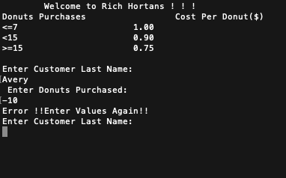

- between 0 and 7 donuts, between

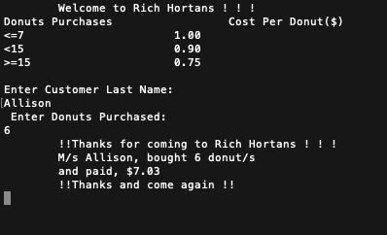

- 8 and 11 donuts,

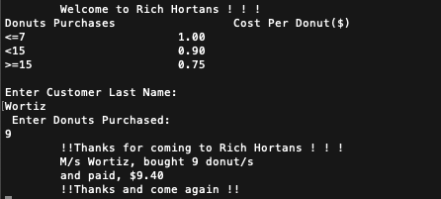

- between 12 and 15 donuts, and

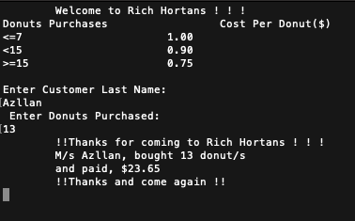

- greater than 15 donuts.


