Child Victims and Witnesses

HISTORY
- Over the years the way in which child victims and witnesses have been viewed by the justice system has changed dramatically.
  - The attitude toward child witnesses has mainly been skepticism.
  - Negative attitude
- Research started in Europe to test validity of negative attitudes.
  - Belief was that children were highly suggestible and had a hard time separating reality from fantasy and couldn't provide accurate testimonies.
  - Not sure what research these conclusions were based off of.
- 4 factors that led to renewed interest in child witnesses.
  - Expert psych testimony was more acceptable in court
  - Social scientists were interested in research that could be applied to real world problems.
  - Studies on adult eyewitness testimonies were increasing
  - Legal community gained interest in behavioral science research regarding child witnesses.
    - THIS was due to increasing reports of sexual and physical abuse where children were victims or witnesses (e.g preschools).
- How is the decision made on whether alleged child abuse cases move forward toward possible prosecution?
  - Police are contacted then in many jurisdictions they are responsible for deciding this.
- Researchers wanted to know the amount of influence police placed on the quality of interview questions when making decisions on moving a case forward
  - RESULTS: revealed 2 key themes: whether there was corroborative evidence and whether suspect denied the allegations.
  - Questioning technique wasn't considered-> technique used wasn't the best for getting accurate info
  - 1995 case (BOX 6.2) shows that interviews involving leading questions and rewards will make children say what they think you want to hear therefore in this case children made crazy child abuse claims and physical evidence wasn't consistent with these claims so some convictions were overturned due to the interview techniques used.

RECALL FOR EVENTS
- Research has found that children are capable of accurately recalling forensically relevant details of events. They can recall accurately.
- Challenge: determine if children are recalling accurately or fabricating
  - Fabricating: making false claims
- Research points out that the accuracy of children's reporting is highly dependent on how they are asked to report.

Free Recall vs. Directed Questioning
- When children are asked to report everything they can remember with a free narrative approach, their accuracy in reporting is comparable with that of older adults.
  - But, children have a hard time reporting information only giving very little. Direct questions are needed to get the required info; "What else do you remember".
- Children that are asked leading questions are more likely to produce a erroneous response, compared to being asked direct questions. Also interviewers that provide approving/disapproving statements to accurate/inaccurate info can elicit more inaccurate info from a child.
- Impt Canadian Researcher in children's suggestibility: Laura Melnyk Gribble
  - Found that the timing of suggestive interviewing can also be influential on children's responses.
    - Repeated interviewing close in time to the event can heighten misinformation effects.
  - She uses a misinformation design in her methodology.
    - Children go to a school event, 1/2 weeks later they talk to child about event then 1/2 weeks after that they ask child about event again and assess the accuracy of their reports.
- The older you are the more resistant you are to leading questions.
- Direct questions that require a yes/no response or use a forced-choice format are problematic for preschoolers.
- Study where children were shown photographs and asked yes/no questions about them as well as 5W's questions, the children only knew answers to half of each type of question. Results showed:
  - Answerable Questions: Children performed similar to both type of Q's.
  - Unanswerable Question: "IDK" is the right answer, children were more likely to say idk for 5W questions than for yes/no questions.
    - Yes/no questions are problematic for children because they rely on recognition rather than recall, increasing likelihood of error.
- Recall (e.g free-narrative approach) may give brief/little info but responses are more likely to be accurate.
- Another study examined transcripts from children's testimony in sexual abuse cases and found that "How" questions, specifically "How did you feel" gave the most evaluative information.

Why are Children More Suggestible Than Adults?
- 2 approaches used to understand why children are more suggestible
- Social compliance/Social Pressure:
  - Children respond to interviewer's in the manner they feel the interviewer desires. Why?
    - They trust and want to cooperate with adult interviewers, even when they don't understand or know answers to questions
    - To keep with the general idea of questioning children will infer the response desired.
  - In a study even when asked questions that were illogical such as "Is milk bigger than water" children answered yes/no rather than "I don't know".
  - Although children respond to suggestibility, memory of actual event is intact. If not suggestively questioned later they might give the right response.
- Changes to Cognitive System
  - Research has found developmental differences in how children and adults encode, store and retrieve memories as well as in forgetting and retention.
  - Children "misattribute" where information came from. If they are told about an event that happened they might later report it as if it happened to them.
  - Overall, social and cognitive factors are responsible for children's suggestibility and reporting false information.
    - Must be careful when asking questions. Still relying on free recall is best to get accurate info.
- Some techniques, protocols and procedures that are used with child witnesses are outlined below.

Anatomically Detailed Dolls
- Props can be useful when children have difficulty speaking about what they witnessed or experienced.
- Anatomically detailed dolls: A doll, sometimes like a rag doll that's consistent with the male or female anatomy.
  - These dolls can be used when interviewing children suspected of being sexually abused.
  - Used since children have difficulty speaking about what happened and interacting with the dolls will demonstrate the events they experienced. BUT some research is contradictory to this.
    - Research:
      - Expt 1. concluded that use of dolls did not add any benefit and if used inappropriately could have a negative effect.
      - Another study found that younger Especially when asked suggestive/leading questions.
      - Research that supports use of dolls was found when 3-10 yr olds that were touched during an exam reported being touched only with the dolls and not verbally.
      - Another study that examined various interview techniques when sexual abuse was suspected found that although dolls were used the least out of all the techniques they yielded the highest rate for confirming info. There was a higher confirmatory rate with the dolls which could be due to evaluators having extensive time with the children and could better determine the specific technique that might be beneficial for each child.
- Should the dolls be used?
  - Fantasy play with dolls can be misinterpreted as abuse indicator's.
  - Number of difficulties have been found with determining if sexual abuse occurred using the dolls.
    - No set specifications or guidelines are available for manufacturers of the dolls. Not consistent.
    - No standard procedures for scoring behaviours children exhibit when interacting with the dolls.
    - Not enough research done for how abused vs. Non abused children interact with the dolls.
  - OVERALL: the use of dolls for diagnosing sexual abuse can be inaccurate and dangerous.
  - If used psychologists should videotape, record, or write detailed procedures used. Must provide rationale (research) for how dolls are used and how results were interpreted.

Other Techniques for Interviewing Children
- Human Figure Drawings (HFD):
  - It's believed that HFD's can be more useful than dolls as children as better able to understand the representational nature of a 2-D drawing vs 3-D model.
    - But can children as young as 2 accurately use HFD's to indicate they have been abused?
  - Research shows that the problems that arise with dolls may also arise with HFD's.
- Criterion-Based Content Analysis (CBCA):
  - CBCA: Analysis that uses criteria to distinguish truthful from false statements made by children.
    - Now part of a more comprehensive protocol called Statement validity analysis (SVA): for credibility assessment for sexual abuse allegations. Consists of 3 parts:
      - Structured interview of the child witness
      - A systemic analysis of the verbal content of the child's statements (using CBCA)
      - The application of a statement validity checklist
    - CBCA is considered the most important part and is often used as a stand-alone protocol.
      - Underlying assumption of CBCA is that descriptions of real life events differ in quality and content from memories that are fabricated.
      - 18 criteria developed to discriminate between true and fabricated events of sexual abuse (page 170). True events are more likely to contain CBCA criteria than fabricated events.
    - CBCA has been critiqued:
      - Inconsistencies with the number of criteria that must be present to conclude truthfulness and the different decision rules needed for reaching a conclusion.
      - Age is a factor as younger children don't have the cognitive abilities and command of the language to give statements as detailed as those of older children. Meaning younger children may be missing more CBCA criteria and their truthful statements may be doubted.
      - Concerns about forensic suitability of CBCA for discriminating between children's accounts of real vs fabricated events-> CBCA scores influenced by how familiar event is to child and the age of the child.
    - Overall CBCA scores are calculated by using a truth-lie classification where the assessor must classify the statement as true or false based on his/her own interpretation of the statement. VERY SUBJECTIVE.
    - Used SVA with adult statements with greater success.
- Step-Wise Interview:
  - Step-wise interview: Interview protocol with a series of "steps" designed to start the interview with the least leading and directive type of questioning, and then proceed to more specific forms of questioning, as needed.
  - Aims to keep false claims at a minimum. Objective: provide the child with lots of opportunity to report by using a free narrative before other types of questioning are used.
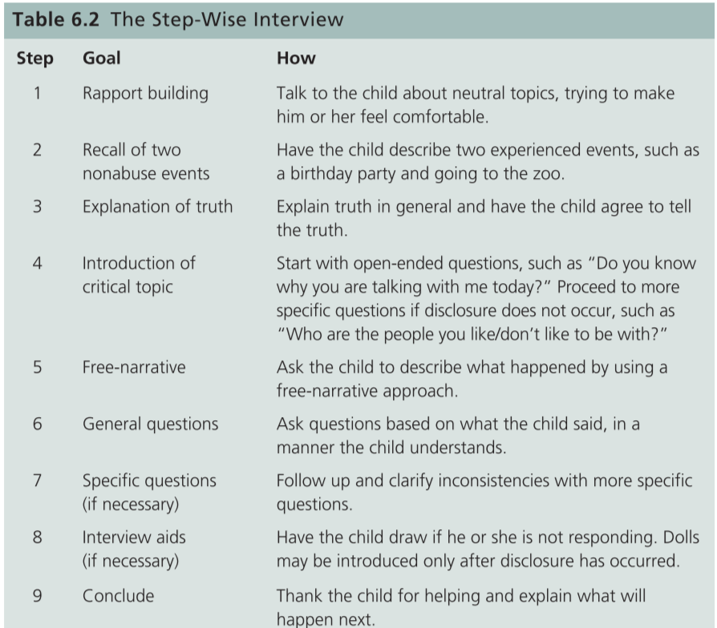
- Study shows that the step-wise procedure is consistent with what we know about children's recall abilities and how to elicit accurate info.
- Narrative Elaboration:
  - Narrative elaboration: An interview procedure whereby children learn to organize their story into relevant categories: participants, settings, actions, conversation/affective states, and consequences.
    - A card containing a line drawing is available for each category ->
    - Visual cues help children state all they can. Children practise telling stories with each card before being questioned about event.
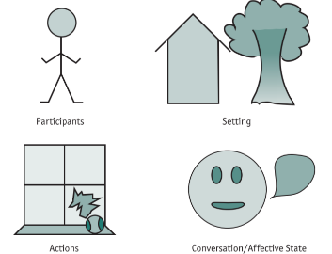

- Then they're asked for a free narrative about the critical event. Lastly, children are presented with each card and asked, "Does this card remind you to tell something else?"
- Study: Children interviewed with the narrative elaboration procedure reported more accurate information but not more inaccurate information for the staged event compared with when just the cue cards were presented without training or the standard interview. Also, children did not fabricate more information with the narrative-elaboration procedure. POSITIVE RESEARCH.
- Did another study in attempts to improve this technique if it was coupled with mental reinstatement (making victim feel like they're at the scene). Results showed that children trained in narrative elaboration reported almost twice as much information and were more accurate compared to no training of the narrative elaboration approach (control).
  - Mental reinstatement didn't increase accuracy.
  - In general research found that simply asking children to report what they saw and heard, or to talk about info across categories was sufficient to produce increases in info recalled.
- National Institute of Child Health and Human Development (NICHD) Interview Protocol:
  - Relies on open-ended questioning with two types of prompts available to interviewers
    - Time prompts: "what happened next?" helps child fill in details and form a timeline.
    - Cue question prompts: details that child has reported are used in the question and children are asked to elaborate. "you said the teacher took off his belt, tell me more about that?"
  - Protocol provides direction on how to start the interview and how to introduce topic of abuse.
  - Studies conducted on this technique and results shown are good.
    - Protocol is superior to standard interviewing procedures mostly with school-aged children.
    - Then a revised NICHD protocol was tested and it was designed to improve rapport-building as well as provide extra support in a non-suggestive manner for more reluctant suspected victims. Results show that children were more likely to report their abuse than when standard NICHD protocol was used.
  - Children have issues with multipart prompts where interviewers ask 2 questions together. Eg. "can you tell me everything about how he caught you? When did it happen? Multipart prompts are NOT RECOMMENDED.
- Cognitive Interview:
  - Children interviewed with a cognitive interview reported more accurate information than children interviewed in control conditions.
- All of these protocols limit the use of direct questioning and attempt to have the child provide as much information as possible by using a free-recall format.

RECALL MEMORY FOLLOWING A LONG DELAY
- Can people forget a traumatic event like abuse? Only to recall it many years later? Centre of a heated debate about memory repression.
  - Some people say that childhood sexual abuse memories are so traumatic that people repress them. Only adults with the help of therapy can come to recall the abuse, through recovered memories.
  - Others say only through therapy and using suggestive techniques can people believe they were sexually abused as children when in fact they weren't -> false memories.
- False Memory Syndrome: Term to describe clients' false beliefs that they were sexually abused as children, despite having no memories of this abuse until they enter therapy to deal with some other psychological problem, such as depression or substance abuse.

Can Traumatic Memories Be Forgotten?
- Study showed women that reported forgetting the abuse for a period of time were also less able to remember semantic facts about their childhood (names of teachers and friends), than the abused women who didn't report a period of forgetting, as well as women not abused.
- Having a period of amnesia is known as subjective forgetting. Having a period of subjective forgetting was more common among males and with cases of more severe abuse.
  - Objective memory for details of the abuse didn't differ between those who reported having a subjective period of forgetting vs. those that did not.
  - Overall, in most cases the abuse was not actually forgotten just actively not recalled.
- Not having any memory of the abuse is different than preferring not to think about it. Memories should be interpreted cautiously when there is actually no memory of the abuse and only suggestive techniques help remember it.
- Lindsay and Read (1995) suggested 5 criteria to consider when determining the veracity of a recovered memory.
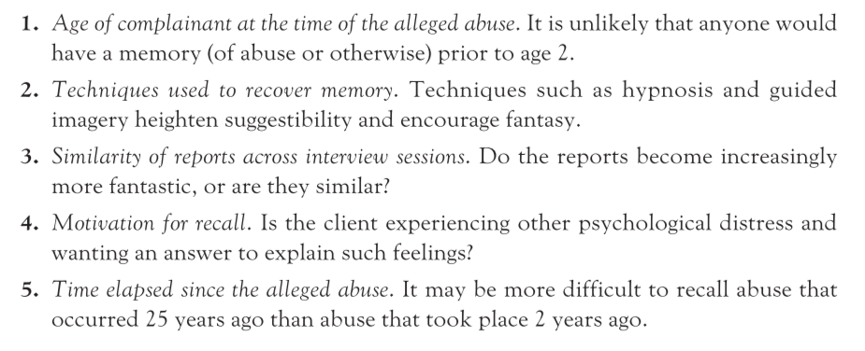
- Courts are seeing a number of cases where there has been a delay in reporting the abuse, AKA:
  - Historic child sexual abuse (HCA): Allegations of child abuse having occurred several years, often decades, prior to when they are being prosecuted.
  - Victims do not claim to ever have forgotten the abuse. In Canada there's no time limit during which a victim must report sexual abuse.
  - Box 6.5
    - 93% of the HCA's prosecuted before a jury, a guilty verdict was reached. Guilty verdicts were lower with older-aged victims. Fewer guilty verdicts obtained when experts provided their opinion for one side or the other, but not when there was an expert on both sides.
      - Surprisingly: when an expert testified on behalf of the crown fewer guilty verdicts were reached.
      - Also more guilty verdicts when abuse was accompanied by threats and when defendants had a familial relationship with the victim.
    - 69% of the HCA's prosecuted before a judge alone, a guilty verdict was reached.
      - Increase of likelihood of acquittal corresponded with increase in length of delay.
      - Guilty verdicts more likely when a claim of repression was made than when no repression claim was made.
      - Guilty verdicts also more likely with more intrusive sexual abuse and when defendant was a family member.
      - When defence has an unchallenged expert testify, guilty verdicts less likely than if no expert testified.

RECALL FOR PEOPLE
- Culprit descriptions are also known as recall for people for child witnesses. Children will have to not only report events that happened but also describe the culprit.

Describing the Culprit
- Study shows that when asked for descriptions of a stranger younger children (age 6-7) recalled fewer items and less interior facial features than older children (age 10-11). Older children could better recall interior facial features such as freckles and nose. The most mentioned feature by both was hair, especially exterior feature of hair.
  - Exterior features of the hair such as colour and style were predominant and accurately reported by 10-14 year-olds and adults. Interior facial features continue to be problematic for both groups.
- Studies found children and youth have difficulty reporting accurate height, weight and age. This may be due to children not understanding the relation b/w height and weight- taller people are heavier than shorter people of similar girth.
- Another study revealed children are more likely to accept positive, inaccurate information than negative, inaccurate information. Therefore, positive info was more likely to be accepted.
- Another study found that regardless of age misleading gestures in an interview resulted in significantly more misinformation being provide by the children.
- OVERALL: interviewers must not introduce their own biases or inaccurate information when interviewing children.
  - Children should be asked to describe the culprit in terms of what he/she did and looked like, by using a free-narrative approach.
  - Event recall techniques can also be useful for person recall.

RECOGNITION
- Another task that a child victim or witness may be asked to perform is an identification of the culprit from a lineup.
  - Study to compare children and adult's identification abilities.
  - Results showed that children over age 5 produced comparable correct identification rates to adults, provided the culprit was present in the lineup (target-present lineup).
  - However, when the culprit was not in the lineup (target-absent lineup), children as old as age 14 produced greater false positives than adults. Children were more likely to select an innocent person from a lineup than adults
  - Another study that identified accuracy across the life-span, found that there was an increasing trend for correct identification and correct rejection with children less accurate than adults.

Lineup Procedure and Identification Rates
- Study examined if line up procedure used affected identification rates in children vs. adults.
  - Sequential lineup instead of simultaneous presentation of adults is known to decrease false positive reports, still debate about this.
  - Examined whether sequential lineup with children decreases their false-positive responding. Results showed the opposite, sequential lineup for children actually increases the false-positive rate compared to adults where it decreases it.

An Identification Procedure for Children
- Attempted to develop an identification procedure that decreases children's false positive responding.
- Pozzulo and Lindsay (1999) proposed a 2 judgement theory of identification accuracy.
  - Witnesses must conduct 2 judgements to come up with an accurate identification decision: relative and absolute.
    - Relative: witnesses compare across lineup members and choose the most similar looking line up member to the culprit.
    - Absolute: witnesses compare the most-similar line-up members to their memory of the culprit and decide if it's actually the culprit.
    - Conclusions: children produce more false positives than adults because they fail to make an absolute judgement.
  - Researchers explain how a failure to make an absolute judgment would result in greater false positives.
    - With target-present lineups, a relative judgment is sufficient to lead to a correct identification because it is likely that the culprit looks most like himself or herself compared with the other lineup members. -> culprit is selected.
    - In contrast, with target-absent lineups, solely relying on a relative judgment may lead to an identification of an innocent person because the most similar-looking lineup member is not the culprit. An absolute judgment is necessary with target-absent lineups.
  - Based on this they developed an identification procedure for children.
    - Elimination lineup: lineup procedure for children that first asks them to pick out the person who looks most like the culprit from the photos displayed. Then children are asked whether the most similar person selected is the culprit for real.
    - This is consistent with the two-judgement theory of identification accuracy.
    - The elimination lineup procedure requests two judgements from the child:
      - All lineup photos are presented to the child, and the child is asked to select the lineup member who looks most like the culprit (relative judgment). Once this decision is made, the remaining photos are removed.
      - The child is asked to compare his or her memory of the culprit with the most similar photo selected in the first stage and to decide if the photo is of the culprit (absolute judgment).
    - Studies show this procedure significantly decreased children's false-positive responding with target absent-lineups compared to the simultaneous procedure. OVERALL: children's correct rejection rate increased by using the elimination procedure compared to the simultaneous procedure.
  - Another study was done where culprit underwent a change in appearance.
    - Results show that correct identification rates decreased following a change in appearance regardless of the witness’s age and lineup procedure used.
    - Children had an overall lower correct-rejection rate compared with adults.
    - Still compared with the simultaneous procedure the elimination procedure was more effective at increasing correct rejections when there was no change in the culprit's appearance from crime to lineup identification.

Social versus Cognitive Factors Responsible for Children's False-Positive Responding.
- Another study on 2010 examined whether children would continue to produce a higher rate of false-positive responding comapred to adults even when the target was familiar to them (e.g cartoons).
  - Results: In target absent condition, social factors (e.g pressure to make an identification) may exert their influence on children more than memory problems, prompting them to make an erroneous identification.

TESTIFYING IN COURT
- Before 2006 children in Canada under the age of 14 had to pass a competency inquiry before testifying.
  - Competency Inquiry: Questions posed to child witnesses under the age of 14 to determine whether they are able to communicate the evidence and understand the difference between the truth and a lie, and, in the circumstances of testifying, to see if they feel compelled to tell the truth.
  - The old act had two parts the first young children could demonstrate an ability to communicate as common questions were asked like "what grade are you in?". The second part was more difficult as children had to understand the meaning behind oath. They had to define terms and religion and church.
  - Then Bill C-w came into effect 2006. The new Canada Evidence Act, there's a presumption that children have a capacity to testify. Children (under 14) are asked simple questions about past events to determine their ability to understand and respond to questions. Children are requested to promise to tell the truth and testify under that promise. No questions are asked about their understanding of the notion of oath or truth.

Courtroom Accommodations
- Child witnesses can experience extreme stress and trauma because of having to testify in court while facing the defendant. There's alternatives to testifying in court in the presence of the defendant.
  - Children can testify behind a screen or from another room by way of closed-circuit TV. Bill C-2 allows this to apply to any offence for which a child testifies.
  - Bala (1999) identified a number of alternatives to in-court testimonies that have been used in the Canadian System and can now be used by any witness under the age of 18 and to vulnerable witnesses upon application.
    - A shield/screen to separate the child and defendant so that the child does not see the defendant’s face. However, the child is visible to the defendant and the rest of the courtroom and may be able to see the defendant’s feet.
    - The child is allowed to provide testimony via a closed-circuit television monitor. The child and lawyers are in a separate room from the courtroom and the child’s testimony is televised to the courtroom where the defendant, judge, and jury are present. The defendant can be in touch with his or her lawyer by telephone.
    - The child may have a support person with him or her while providing testimony. The child can decide whom he or she wants, although a person who is a witness in the same case cannot be a support person unless he or she has already provided testimony.
    - A child may be video-recorded while being interviewed about the details of the crime. The video may be admitted into evidence, so that the child does not have to repeat the details in court.
    - Generally, previous statements made by a witness are considered hearsay and are not admissible. However, in sexual abuse cases, judges can apply the rules liberally, and statements made by the child during the initial disclosure of the abuse may be allowed as evidence. For example, a mother may testify about what her child said when disclosing the abuse.
    - The judge may close the courtroom to the public and/or media to protect the privacy of the child. A publication ban prohibiting any information that would identify the complainant or any witness also may be granted to protect the child’s
identity.
- This is also available in the U.S.A.
- Children under 18 can also no longer be cross-examined personally by the accused.

CHILDREN MALTREATMENT
- Other forms of maltreatment a child may experience. Other forms of maltreatment require the same considerations as sexual abuse.
- The Child Maltreatment Section (CMS) of Health Canada distinguishes 4 categories of child maltreatment:
  - Physical abuse: is defined as the deliberate application of force to any part of a child’s body that results or may result in a non-accidental injury. Examples include shaking, choking, biting, kicking, burning, and poisoning.
  - Sexual abuse: occurs when an adult or youth uses a child for sexual purposes. Examples include fondling, intercourse, incest, sodomy, exhibitionism, and exploitation through prostitution or the production of pornographic materials.
  - Neglect/failure to provide: occurs when a child’s caregivers do not provide the requisite attention to the child’s emotional, psychological, or physical development. Examples include failure to supervise or protect leading to physical harm (such as drunk driving with a child), failure to provide adequate nutrition or clothing, failure to provide medical treatment, and exposing the child to unhygienic or dangerous living conditions.
  - Emotional maltreatment: is defined as acts or omissions by caregivers that cause or could cause serious behavioural, cognitive, emotional, or mental disorders. Examples include verbal threats, socially isolating a child, intimidation, exploitation, terrorizing, or routinely making unreasonable demands on a child.
- Likely that children experience multiple forms of maltreatment simultaneously.
- Government can remove children from their caregivers when they are maltreated or are at risk of it. Child can also be removed if a caregiver is unwilling or unable to prevent abuse by a third party, can be removed because caregiver shows neglect, drug, alcohol abuse etc.
- In need of protection: A term used to describe a child's need to be separated from his/her caregiver because of maltreatment.
- All Canadian jurisdictions require the reporting of children suspected to be in need of protection.
- Incidence vs. Prevalence
  - Incidence: Number of new child maltreatment cases in a specific population occurring in a given time period, usually a year.
  - Prevalence: In the study of child abuse, the proportion of a population at a specific point in time that was maltreated during childhood.
- Neglect, exposure to domestic violence and physical abuse were the 3 primary categories of substantiated maltreatment reported to and investigated by child welfare services.

Risk Factors Associated with Child Maltreatment
- Risk Factors: A factor that increases the likelihood for emotional and/or behavioural problems.
- Identified for sexual and physical abuse.
- Can be categorized as child, parental and social factors.

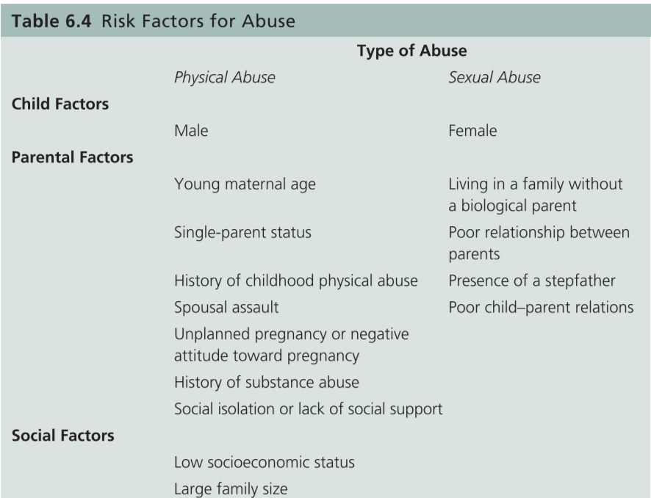
- Physical and sexual abuse factors differ.
  - Physical: varied and include a parent's past childhood physical abuse as well as parent's attitude towards the pregnancy.
  - Sexual: revolve around family composition.

Short and Long-Term Effects of Physical Abuse
- Researchers found that domestic violence, parental drug and alcohol use, prior child abuse and neglect, being on public assistance, and child behaviour problems were related to a greater likelihood of substantiated physical abuse compared to the unsubstantiated physical abuse cases.
- Short term effects include: greater perceptual-motor deficits, lower measured intellectual functioning, lower academic achievement, externalizing behaviour such as aggression, and internalizing mental health difficulties such as hopelessness and depression.
  - Neglect and physical abuse were related to heavy episodic drinking during adolescence and young adulthood.
    - additional instances of maltreatment and physical abuse were related to faster increases in heavy episodic drinking during adolescence and greater use during young adulthood.
  - physical abuse at home and emotional abuse are risk factors for social peer rejection, which in turn is a risk factor for psychological distress.
- Long-term effects: strong relations between physical abuse and nonfamilial and familial violence. Physically abused persons, especially males, engage in more nonfamilial violence than non-abused persons.
  - 30% of physically abused or neglected persons abuse their own children.
  - experiencing physical abuse appears to increase the likelihood of perpetrating physical abuse.

Short and Long-Term Effects of Sexual Abuse
- Short-term effects: behaviour problems, lowered self-esteem, inappropriate sexuality, and symptoms consistent with post-traumatic stress disorder.
  - within two years of being abused, children report a number of physical difficulties such as sleep disturbance, eating disorders, stomach problems, and headaches.
  - After two years have passed there is a decrease in psychiatric problems compared to within the first year.
- Putnam (2003) identified three categories of outcomes in adults with a history of childhood sexual abuse:
  - (1) psychiatric disorders: major depression in adulthood has been found to be strongly related to sexual abuse in childhood.
  - (2) dysfunctional behaviours: sexualized behaviour.
  - (3) neurobiological dysregulation: magnetic resonance imaging (MRI) studies have found reduced hippocampal volume in adults who experienced sexual abuse as children, similar to that found in war veterans experiencing post-traumatic stress disorder.
- adults who were sexually abused as children have an increased risk of being sexually abused as adults.
- Long-term risks: depression, self-injurious behaviours, anxiety, and interpersonal distrust.
- Study found suicide attempts were twice as likely among both men and women who had reported experiencing child sexual abuse compared with those who had not reported experiencing it. Also, there was an increased risk of alcohol problems, illicit
drug use, and family problems when respondents had experienced child sexual abuse.
- Criminal offence to use the Internet to communicate with a child for the purpose of committing a sexual act

A caveat to the outcomes of Child Maltreatment
- not all children who experience maltreatment will suffer negative outcomes.
- no one factor in childhood can predict outcomes in adulthood with absolute accuracy.

SUMMARY
- The accuracy of children’s reporting is highly dependent on how they are asked to report. When children are asked to recall memories using the free-narrative method, the children’s recall is as accurate as adults’. A number of procedures and protocols to increase children’s accurate responding have been investigated, including statement validity analysis, the step-wise interview, and narrative elaboration. Leading questions and the use of anatomically correct dolls are problematic for accurate reporting.
- Children report few person descriptors when asked to describe a stranger or culprit. Interior facial items such as freckles and nose shape are more likely to be reported by older children than younger children. However, accurately reporting these features is difficult. The exterior feature of hair is frequently mentioned by both children and adults. Height, weight, and age are unlikely to be reported accurately by children and youth.
- Children produce comparable correct identification rates with adults’ when presented with a target-present lineup. However, children are more likely than adults to select an innocent person with a target-absent lineup. The elimination lineup procedure decreases children’s false-positive responding compared with a simultaneous lineup procedure.
- Historically in Canada (and other countries), children under the age of 14 had to pass a competency inquiry before being allowed to testify. Under the new Bill C-2, children are asked simple questions to demonstrate their ability to communicate. Children testify under a promise to tell the truth. Also as a result of Bill C-2, a number of alternatives to in-court testimony (e.g., screens, a pre-recorded interview, and the presence of a support person) are available for persons under the age of 18.
- Maltreatment can be categorized into sexual abuse, physical abuse, neglect/failure to provide, and emotional abuse. A number of short-term and long-term effects can result from physical abuse, for example, perceptual-motor deficits, lower measured intellectual functioning, lower academic achievement, externalizing behaviour, internalizing mental health difficulties, and nonfamilial and familial violence. A number of short-term and long-term effects can result from sexual abuse, for example, behaviour problems, lowered self-esteem, inappropriate sexuality, physical symptoms consistent with post-traumatic stress disorder, and continued abuse when an adult.

