Economics Chapter 2 Notes:
- Scientific Method: Observation, Theory, and More Observation
  - Economists use theory and observation while trying to develop theories
- Role of Assumptions:
  - Economists make assumptions to simplify the complex world and make it easier to understand
  - Economists use different assumptions to answer different questions
Economic Models:
- Model: a highly simplified representation of a more complicated reality
- Economists use models to learn about the world; often composed of diagrams and equations
- Models omit many details to allow us to see what’s important, but doesn’t include every feature of the economy (too complicated)
- Circular-Flow Diagram: a visual model of the economy that shows how dollars flow through markets among households and firms
  - This model is simplified for two types of decision makers – households and firms
  - Firms produce goods and services uses inputs such as labour and land (natural resources) and capital (buildings and machines)
  - These inputs are called the factors of productions
  - Households own the factors of production and consume goods and services firms produce
  - In markets for goods and services households are buyers and firms are sellers
  - Market for factors of production, households are sellers and firms are buyers
  - inner loop of the diagram represents flows of inputs and outputs
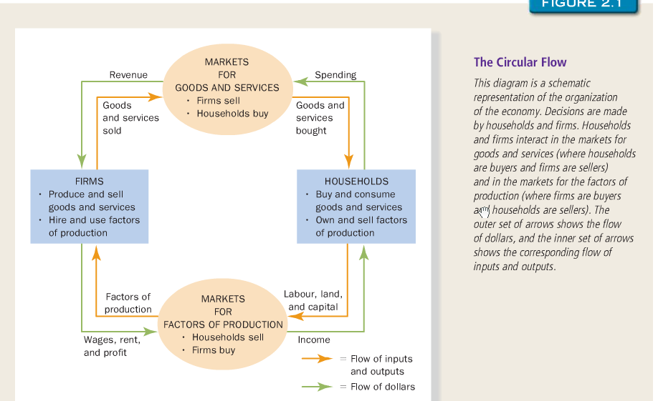
  - Outer loop represents the corresponding flow of dollars

- Production Possibilities Frontier: a graph that shows the combinations of output that the economy can possibly produce given the available factors of production and the available production technology
  - Two end points of the frontier represent extreme possibilities of producing max of one good and none of the other
  - Economy can produce at any point on or inside the production possibilities frontier, can’t produce at points outside of it
  - An economy is considered efficient if it is producing on the points of the PPF
  - Producing on the inside of the curve is considered inefficient; also could be due to unemployment
  - Moving from one point to another and determining how much of one good to produce and how much of the other demonstrates opportunity cost because you have to realize how much to give up to produce the other
  - Opportunity cost of a product = the slope of the frontier
  - Shows the tradeoff between outputs of different goods at a given time
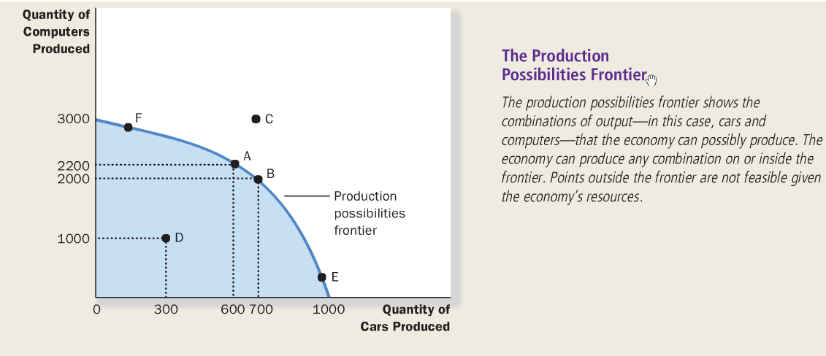
  - Illustrates scarcity, efficiency, tradeoffs, opportunity cost, and economic growth

- Microeconomics and Macroeconomics:
  - Microeconomics: study of how households and firms make decisions and how they interact in markets
  - Macroeconomics: study of economy-wide phenomena, including inflation, unemployment, and economic growth
  - They are both closely intertwined
  - It is impossible to understand macroeconomic developments without considering the associated microeconomic decisions due to large amounts of individuals making decisions
Economist as Policy Adviser:
- When economists are trying to explain the world, they are scientists; when they are trying to help improve it, they are policy advisers
- Positive vs Normative Analysis:
  - Positive statement: claims that attempt to describe the world as it is (fact or statement)
  - Normative statement: claims that attempt to prescribe how the world should be (opinion)
  - We can confirm or refute positive statements by examining evidence
  - Normative conclusions can’t come from positive analysis alone; they involve value judgements as well
  - Most of economics is positive
- Economists in Ottawa:
  - Tradeoffs are involved in many policy decisions
  - Many economists influence many decisions made in Canada
Why Economists Disagree:
- Economists may disagree about the validity of alternative positive theories about how the world works
- Economists may have different values and therefore different normative views about what each policy should try to accomplish
- Difference in Scientific Judgments:
  - Economists sometimes disagree because they have different hunches about the validity of alternative theories or about the size of important parameters
- Difference in Values:
  - Economists give conflicting advice sometimes because they have different values
  - Perfecting the science of economics will not solve the problem of different values
- Perception vs. Reality:

Summary:
- Economists try to address their subject with a scientist’s objectivity: like all scientists, they make appropriate assumptions and build simplified models in order to understand the world around them. Two simple economic models are the circular flow diagram and the production possibilities frontier
- The field of economics is divided into two subfields: microeconomics and macroeconomics. Micro economists study decision making by households and firms and the interaction among households and firms in the marketplace. Macroeconomists study the forces and trends that affect the economy as a whole
- A positive statement is an assertion about how the world is. A normative statement is an assertion about how the world ought to be, When economists make normative statements, they are acting more as policy advisers than scientists
- Economists who advise policymakers offer conflicting advice because of differences in scientific judgments or because of differences in values. At other times, economists are united in the advice they offer, but policymakers may choose to ignore it.

