Anatomy Bell Ringer #3
Cranium
- Coronal suture
- Sagittal suture
- Lamboid suture
Temporomandibular joints (TMJ)
- One joint connecting the jawbone to the skull
- Bilateral synovial articulation between temporal bone and mandible below
- Head of mandible, articular tubercle of temporal bone, mandible fossa of temporal bone
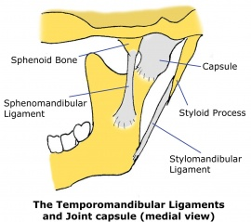
Three ligaments enhance the joint:
- Lateral ligament (tempo mandibular ligament)
  - Attaches temporal bone to mandible
- Spheno-mandibular ligament
  - Attaches to sphenoid and mandible
- Stylo-mandibular ligament
  - Attaches to styloid process and mandible

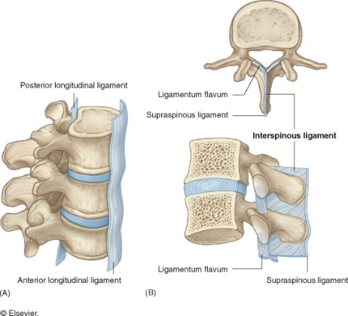
Joints of the vertebral bodies
- Intervertebral (IV discs) and ligaments
  - Articulation between vertebral bodies (cartilaginous for weight bearing and strength)
- Anulus Fibroses: outer fibroses part
- Nucleus pulposus: Central core of IV disc
Ligaments enhancing IV joints
- Anterior longitudinal ligament
  - Runs down the vertebral bodies
- Posterior longitudinal ligament
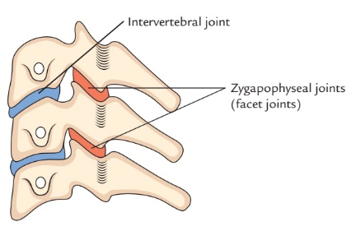
  - Runs within the vertebral canal
Zygapophysial joints/ facet joints
- Connects vertebral arches
- Plane joints between sup. and inf. articular processes of adjacent vertebrae
Ligamenta flava/ yellow ligament
- Connects vertebral arches
- Enhance facet joints
- Bind adjoining vertebrae together
Nuchal ligament:
- Extends from occipital protuberance to spinous processes of cervical vertebrae
- Connects skull and vertebral column
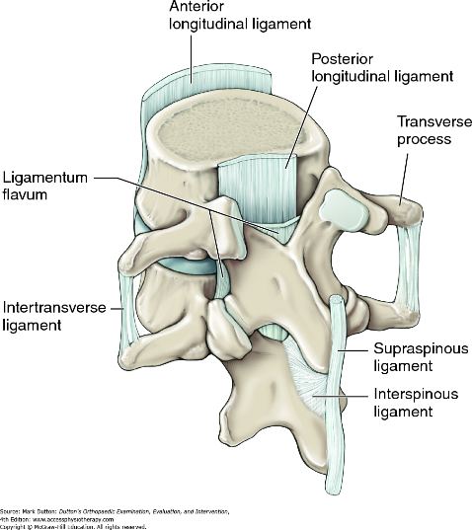
Intertransverse ligament:
- Connecting adjacent transverse processes
Interspinous ligaments
- Connect adjoining spinous processes
Supraspinous ligament:
- Connects apices of spinous processes from C7 to sacrum
Atlanto-occipital joints:
- Articulation between lateral masses of atlas and occipital condyles of occipital bone, no IV disks

