Experiment 1:
VALIDATION OF GAS LAWS

VALIDATION OF GAS LAWS

Author(s) Name(s):
LU

Submitting Author’s Partner:
MN

TA (Demonstrator)’s Name:
Sarah Osterholm

Date Experiment Performed:
September 13th, 2019
Date Experiment Submitted:
September 20th, 2019

Procedure – Charles’ Law:
As outlined in the lab manual¹
Procedure – Boyle’s Law:
- Obtain a 20ml gas syringe and Vernier gas Pressure Sensor. Connect pressure sensor to Logger pro.
- Draw on plunger of syringe to fill it with an initial volume of 10ml of gas.
- Attach Syringe to gas pressure sensor and ensure there is no space for air to escape.
- With an initial volume of 10ml of gas, record the pressure in kPa within the barrel of the syringe using lab Quest.
- Adjust plunger to increase/decrease volume to 8ml, 12ml, 14ml, 16ml, 18ml, 20ml. Record the respective pressure measurements within the syringe for each volume.

Discussion:
Charles’ Law
Charles’ Law is one that defines the relationship between the volume of a gas and its temperature at a fixed pressure. The goal of the experiment below was to prove that the volume of a gas is directly proportional to its temperature. Meaning as temperature increases, there is a linear increase in volume with respect to the temperature. This can be described in the equation $\frac{V_{1}}{T_{1}}=\frac{V_{2}}{T_{2}}$. As temperature increases, kinetic energy among the particles increase as well causing the gases to occupy a larger volume as space between them increases.²
Table 1: Initial Volumes and respective Temperatures of enclosed Gas
Total initial volume of gas (V₁) | 142.5ml
Initial temperature of gas in flask (T₁₎ | 373.15 K
Final volume of gas (V₂) | 106.5ml
Final temperature of gas | 286.68 K
In the experiment, when the volume of the gas was at boiling point, 100 degrees Celsius or 373.15K, the volume of the gas was 142.5ml. However, when the temperature dropped to 13.5 degrees Celsius (286.65K), the volume of the gas decreased to 106.5ml showing the directly proportional relationship between the two variables. To verify the linear relationship, the correlation between volume and temperature had to be the same at any given temperature and its respective volume. This linear relationship was shown below as the relationship between the initial volumes and temperatures and the final volumes and temperatures were both similar by a factor of approximately 0.4, with a percentage error of 2.7% difference. This error margin could have potentially originated due to an inaccurate final volume of gas. This could have occurred due to air bubbles escaping from the flask, increasing the room for water to fill and therefore decreasing the actual volume of the cooled gas. This would result in a slightly higher volume for a given temperature.
In this experiment, it is important for pressure and amount of gas to remain constant so as to be sure that the relationship between the temperature and the volume is not skewed by external pressure.
Due to time restrictions only one trial could be completed.

Boyle’s Law
Boyle’s law describes the relationship between volume and pressure of a fixed amount. In addition to quantity, the temperature of the gas is another variable that must remain constant. This is because in order to establish the relationship between pressure and volume, quantity and temperature should not affect the dependent variable, which is pressure in this case.
Boyles law states that the pressure of a gas is inversely proportional to its volume. This relationship can be modelled by the expression P ∝ 1/V

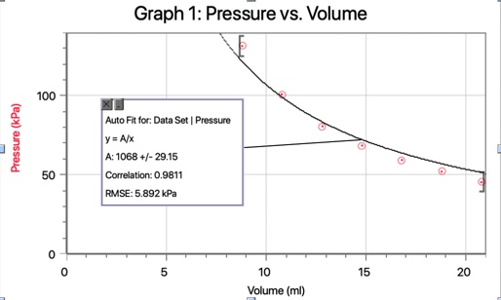
x
y
As modelled in the graph above, the results from the experiment shows that as volume increases, pressure decreases. Therefore, proving the inverse relationship between the two. Based on this relationship P ∝ 1/V, to calculate Boyle’s constant the equation PV=k is used.
Using data obtained during experiment, it was found that the constant did not remain the same. An approximate value of 1100 was calculated however, the differences in the constants is an indication that temperature and/or gas quantity did not remain constant. This could be attributed to gas escape when the syringe is attached to pressure sensor. If gas escaped the syringe, this would affect pressure because less gas would yield lower pressure at fixed constants. This is why it would be important to take multiple readings of the dependent variable (pressure) for the same value of the independent variable (volume). It would ensure that collected data is accurate.

Conclusion:
The “Verification of Gas Laws” experiment provided proof for Charles’ and Boyle’s gas laws. The data obtained during the experiments validated the equations
P₁V₁= P₂V₂ and $\frac{V_{1}}{T_{1}}-\frac{V_{2}}{T_{2}}$.

Reference(s):
¹“What in the World ISN’T Chemistry”, General Chemistry Laboratory Manual, Dr. Rashmi Venkateswaran, 2019.
²Finkelstein N D, Adams W K, Keller C J, Kohl P B, Perkins K K, Podolefsky N S, Reid S and LeMaster R 2005 Phys. Rev. Spec. Top. Phys.—Educ. Res. 1 010103
Appendix:
Raw Data:
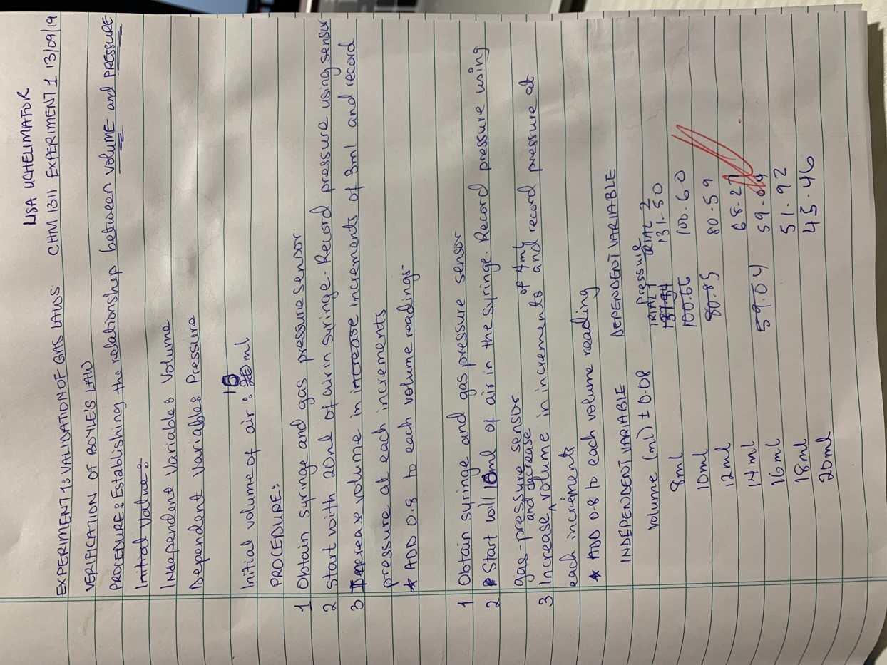

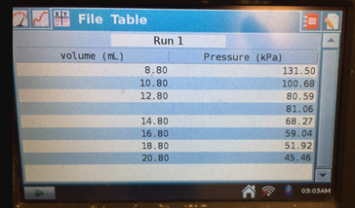
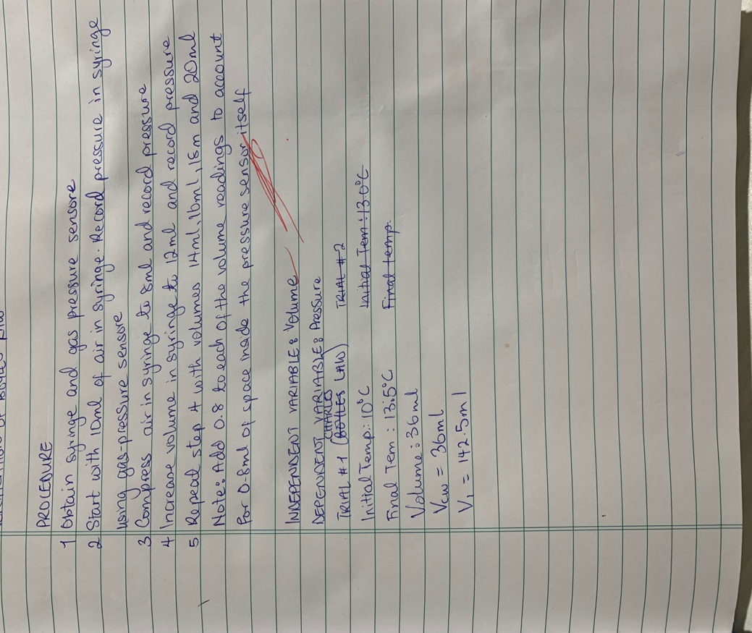

Sample Calculations, Charles’ Law
V₁=142.5ml  T₁= 100°C+273.15  T₂=373.15 k  $\frac{V_{1}}{T_{1}}=\frac{142.5}{373.15}$  $\frac{V_{1}}{T_{1}}=0.3819$ | V₂=V₁-V_{CW}  V₂=142.5ml-36ml  V₂=106.5ml  T₂= 13.5°C+273.15  T₂=286.65 k  $\frac{V_{2}}{T_{2}}=\frac{106.5}{286.65}$  $\frac{V_{2}}{T_{2}}=0.3715$
$$\% Error=\frac{\frac{V_{1}}{T_{1}}-\frac{V_{2}}{T_{2}}}{\frac{V_{1}}{T_{1}}}×100\%$$
$$\% Error=\frac{\frac{142.5}{373.15}-\frac{106.5}{286.65}}{\frac{142.5}{373.15}}×100\%$$
$$\% Error=2.710$$

Sample Calculations, Boyle’s Law/Boyle’s constant
P₁V₁= P₂V₂
(131.50)(8)=(10.8)(100.60)
1052$≈$1086.48

PV=k
1100$≈$k

