ENG1D04 Lecture 01 2019-09-09
- Computers store and manipulate information
- Program a sequence of instructions to determine the behaviour of a computer
- Hardware enables massive amounts of data to be stored and manipulated with great speed and accuracy
- Software provides the means to control the behaviour of the hardware with extraordinary power and flexibility
- Modes of Program Execution
  - Direct interpretation line-by-line
    - Advantages: supports interactive development, debugging of code
    - Disadvantages: slower than executing compiled code
  - Compiled into bytecode for a virtual machine that is either interpreted or compiled
    - Advantages: programs are more portable
    - Disadvantages: slower than native code
  - Compiled into a native machine code
    - Advantages: optimized to run fast
    - Disadvantages: code development is difficult
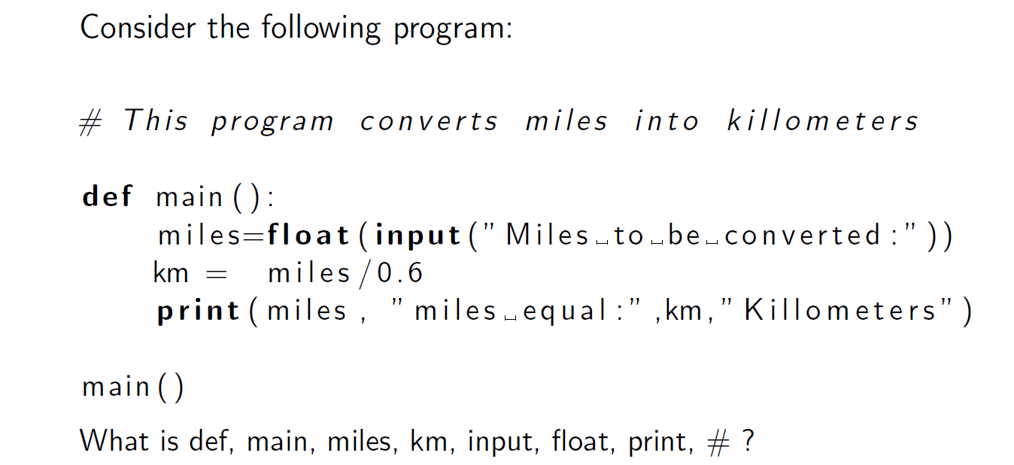
- def a keyword that defines the start of a program
- main the name of the program
- miles a variable that holds a floating-point value given by the user
- km a variable that holds a floating-point value of variable miles divided by 6
- input a keyword that takes input from the user from the keyboard
- float a primary datatype that stores decimal values
- print a keyword that prints the given information onto the display log
- # a keyword that acts as a comment delimiter
- Identifier a name used in any program; may consist of any combination of characters and digits, but may NOT begin with a digit; CANNOT have a space or other punctuation characters
- Reserved Words some identifiers have been used by the Language
- Literals explicit data values that are used in a program
  - ie. A string in quotes
- Expression a syntactic entity that denotes a value
- Atomic Expression an identifier or a literal
- Compound Expression formed by applying an operator to other expressions
- Value of an expression obtained through evaluating the expression
- Datatype a syntactic identity that denotes collection of values of similar form
  - bool true or false
  - int set of machine integers
  - float set of floating-point numbers
  - str set of strings
  - list set of lists
- Type Error occurs when a value of one type is used for where a value of another type was expected
- Variable a linguistic entity whose meaning can vary
  - In Python, it is a name bound to a value
    - A name is bound to a value through an assignment expression
      - name = expr
    - both readable and writable
- Constants a linguistic entity whose meaning is fixed
  - In Python, implemented as a variable whose value never changes
  - Also called immutable variables
    - In convention, user-defined constants are written in full capitalization
- Statement a syntactic identity that states something to be done
  - Effect of a statement obtained by executing the statement
- Program a sequence of statements
- Compound Statement a statement composed of other statements
    - for definite loops
    - while indefinite loops
    - if conditional statements
    - try-except catching exceptions
    - def defining functions
- Comments denoted by the # keyword, everything written beyond that is ignored
  - Should be in your code to denote what you are doing
- Functions several statements that jointly carry out a sub-task
- Loop for repeating a statement a known and/or unknown number of times (Iterations)

ENG1D04 Lecture 2 2019-09-16
- list stores a sequential collection of elements
- Sequence an enumerated collection of objects in which repetitions are allowed
  - same element can appear multiple times at different positions in the sequence
- Sequence Type a type of values that represent finite sequences
  - Built-in sequence types are as follows:
    - str immutable ASCII strings
    - list mutable list of values
  - They share the following finite sequence operators:
    - Len length
    - + concatenation
    - * repetition
    - x[i] ith member
    - x[i:j] slice from i to j
- a literal of type list is a finite sequence of values surrounded by square brackets and separated by commas
  - ex. [6,28,496,8128], [0.””.[]]
- can be created in several ways:
  - list1 = list(); list2 = list([2,3,4])
  - list3 = []; list4 = [2,3,4]
- lists are mutable via assignment:
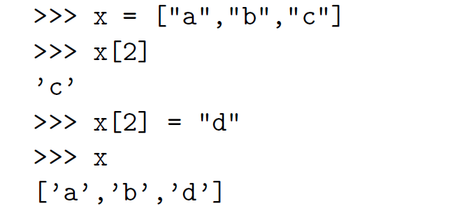
- string a finite sequence of characters
- type str represents immutable strings of characters
- a literal of type str is marked by either single or double quotes
  - ex. “A blue moon is not blue.”
- character a string of length 1
  - non-printable characters are represented using a backslash
    - ex. ‘\n’ for the new line character
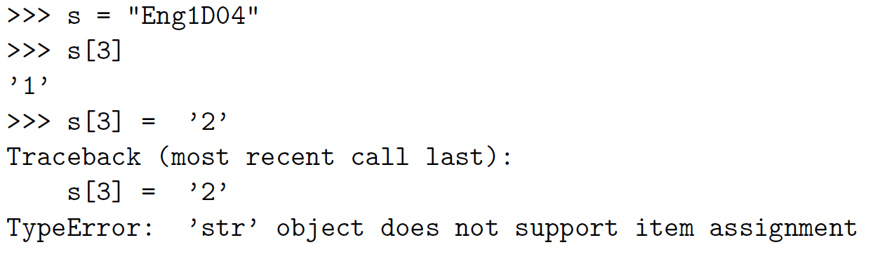
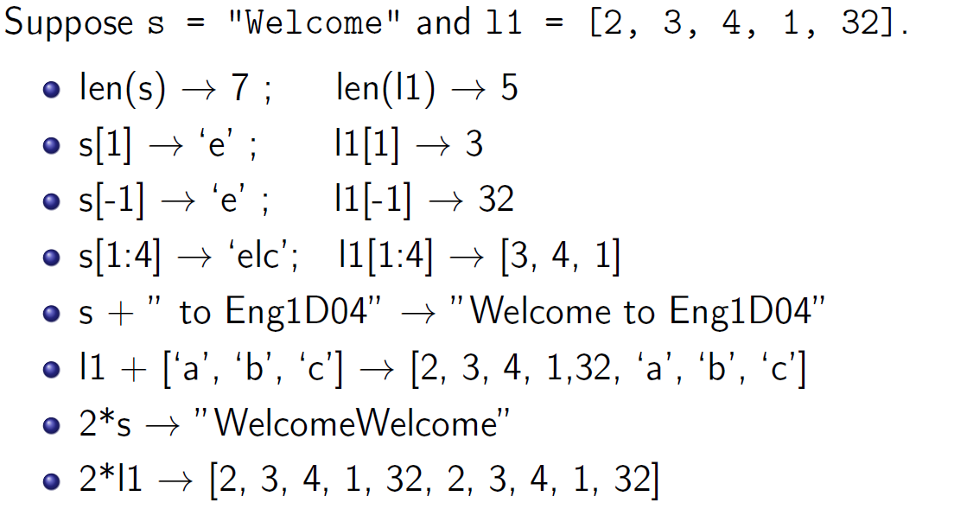
- all data, including numbers and strings, are objects
- a predefined method can be used by any object with a dot operator (.)
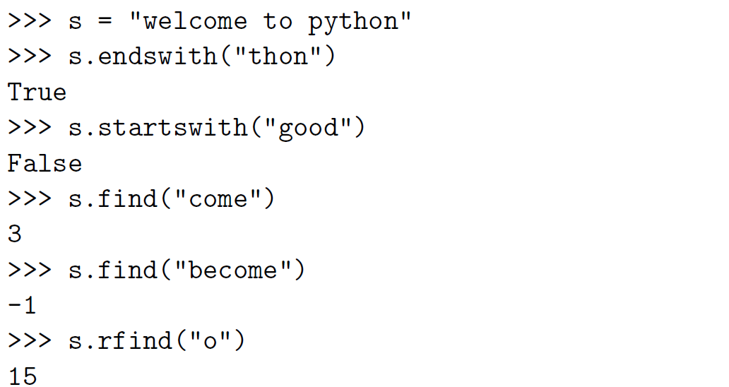
- characters represent graphemes (the units of the writing system)
  - ASCII American Standard Code for Information Interchange
    - 128 characters total (94 printable, the space, and 33 non-printable)
    - Characters are represented by 7- or 8-bits
  - Unicode intended to represent the graphemes of the world’s major writing systems
    - More than 110,000 characters from 100 writing systems
    - Represented by 8-, 16-, or 32-bits
- ord(ch) returns the ASCII code for the character ch
- chr(code) returns the character represented by the code
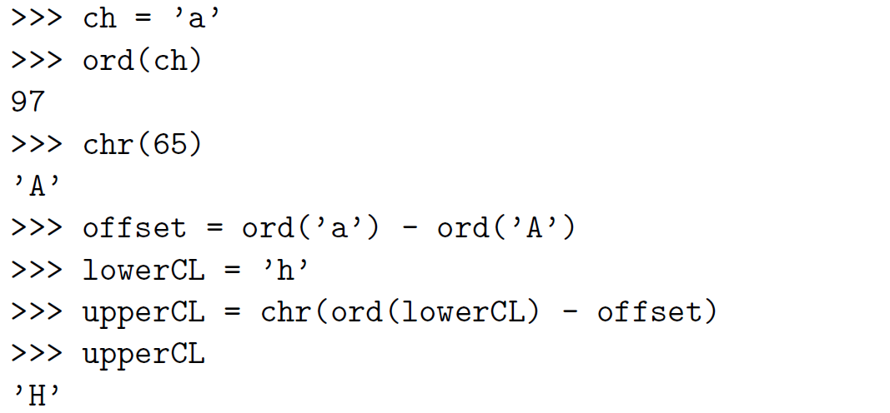
- every engineer needs to have a sophisticated understanding of computing
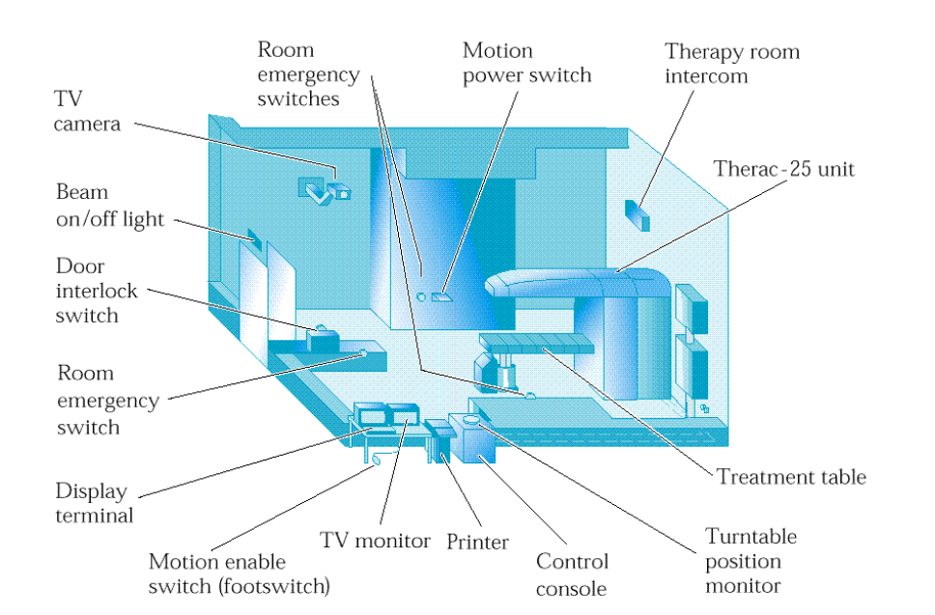
- Case Study: Therac-25
  - Therac-25 was a radiation therapy machine for treating cancer
  - 6 separate cases of the machine delivering overdoses of radiation
  - Causes of failure:
    - Inadequate software design
    - Inadequate software development process
    - Software was ignored during reliability modelling
    - No hardware interlocks to prevent the delivery of radiation
- Alan Turing (1912-1954)
  - 1937 developed a model of computation based on the idea of the Turing Machine
  - Lead the British team that broke the code of the German Enigma Machine
  - 1945 designed the Automatic Computing Engine (ACE) electronic computer
  - 1950 designed the Turing Test for determining whether a software system exhibits intelligence

ENG1D04 Lecture 3 2019-09-23
- Easiest way to represent numbers is to convert everything to binary digits
- Bit the smallest storage unit in a computer
  - n-bits can represent 2^{n} binary values, with largest being 2^{n} – 1
- Problem: Given that number systems are infinite, how can they be represented on a computer?
  - Represent each member of the system using a fixed number of bits
    - Advantage: efficiency in use of space and time
    - Disadvantage: only finitely many members can be represented
  - Represent each member of the system using an unbounded number of bits
    - Advantage: all members can be represented
    - Disadvantage: Inefficiency in the use of time and space
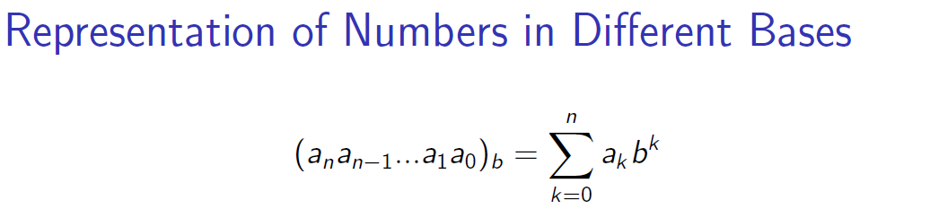
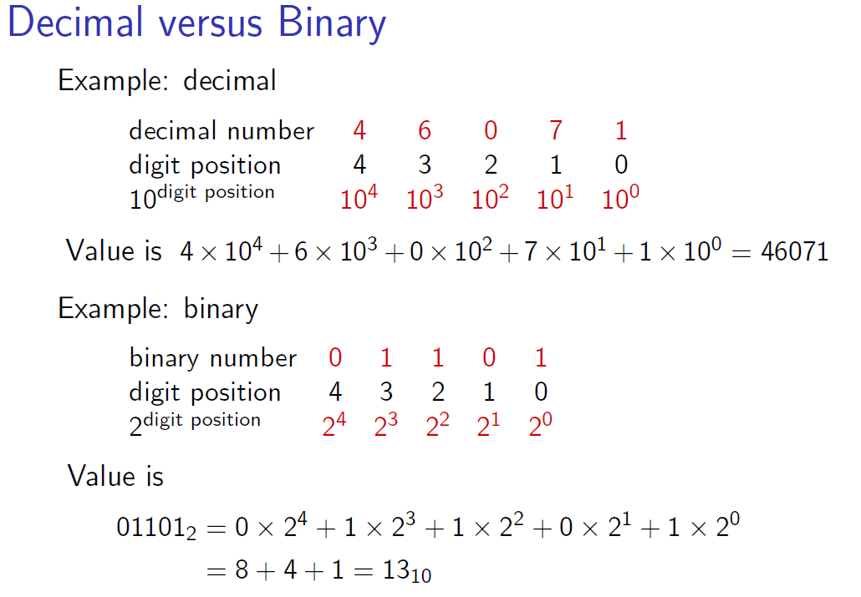
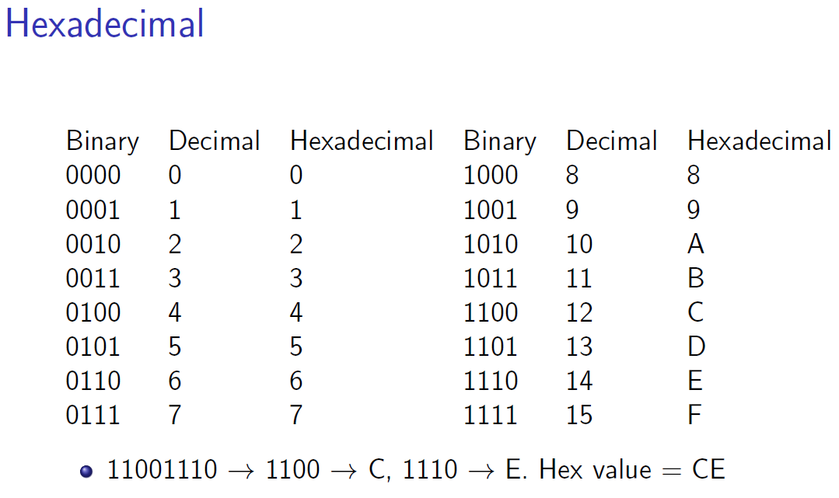
- Converting from Decimal to Binary
  - Divide by two until you reach a quotient of 0
  - Write out the remainders in reverse order
- In signed magnitude approach, the first bit is used for the sign (0 is +ve, 1 is -ve)
  - Has the issue of two zeroes
- In two’s complement, the bits are flipped and then 1 is added
  - First bit is a sign
    - If negative, then the value is the value of the two’s complement
- A byte is 8 bits
  - Largest unsigned number: 255
  - Largest signed number: 127
  - Smallest signed number: -128
- 2 bytes have 16 bits, drastically increasing range
- If you add one to the largest signed integer, the number overflows into the negative range
- Real numbers are approximated using floating point numbers
  - Ex. 807.504 — no unique representation, until the decimal point is fixed
- Float has a 64-bit representation
  - 1 sign bit, 11 bits for representing exponent, 52 bits for the fractional part
- Python implicitly converts values in numeric expressions of mixed types

ENG1D04 Lecture 4 2019-09-30
- Object mutable active value that combines the data and operations and communicated via message passing
- Field set of variables that define the object’s state—the set of information that is stored in the object
- Method defines the object’s behaviour
- Accessor a method that retrieves information about the state of an object
- Mutator a method that modifies the state of an object
- Class a template for a type of object
- Instance a member of the class type
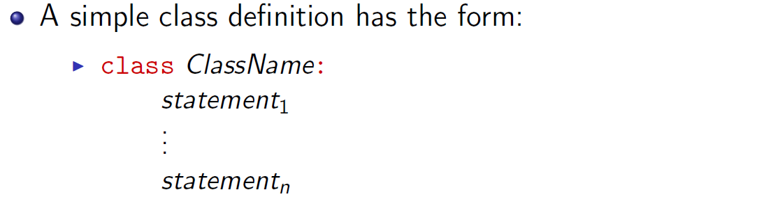
- Constructor creates a new object of the type ClassName and then calls the class’ init method to initialize the fields of the object
- Object-oriented Programming a program consists of a collection of class definitions and behaves as a collection of interacting objects that:
  - send and receive messages
  - provide and use services
- graphics module provided at http://mcsp.wartburg.edu/zelle/python/
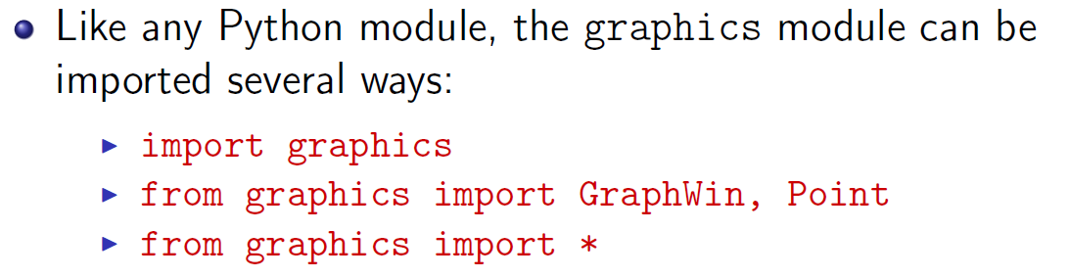
  - includes classes that enable the user to create window objects and graphics objects
- GraphWin Class windows composed of a grid of pixels
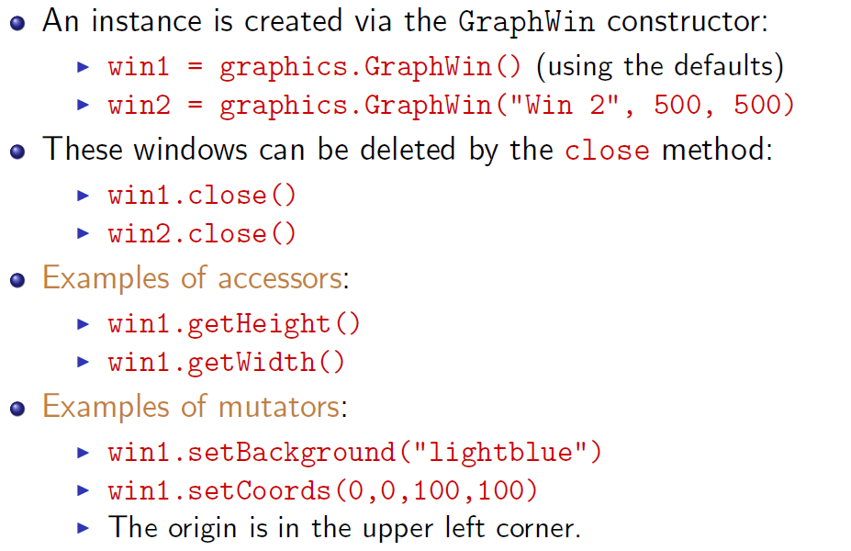
- Circle Class circle objects
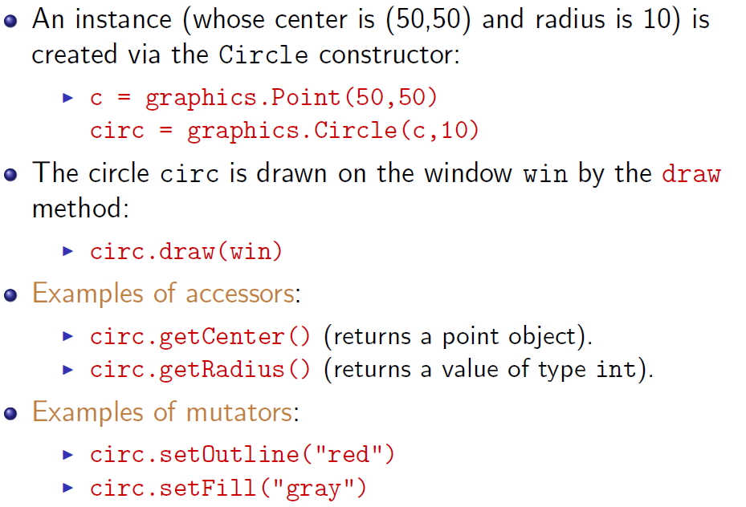
- Is operator returns true if two variables reference the same object
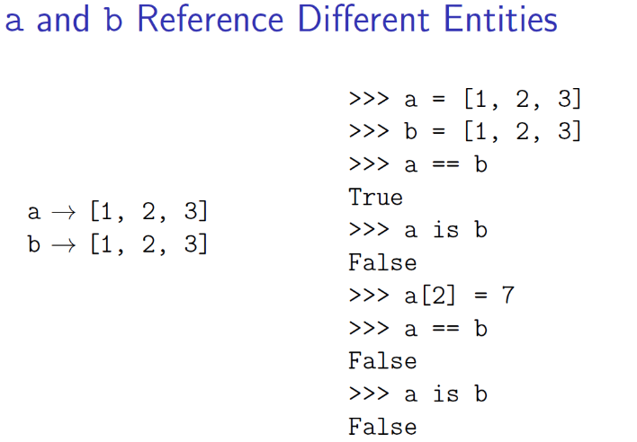
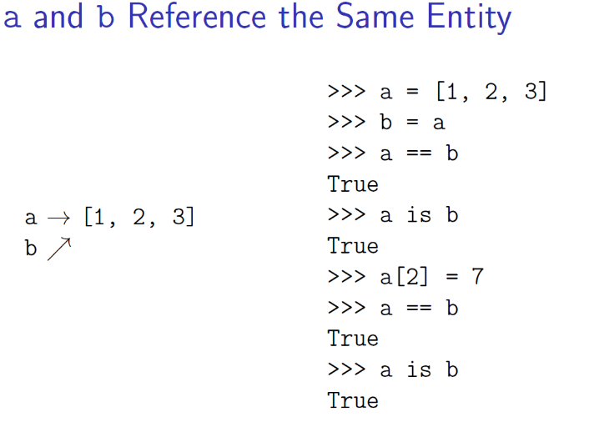
- External input information received from an input device such as a keyboard or mouse
- External output information sent out to an output device such as a screen or printer
- Program input and output are usually files or string
- File a finite sequence of data stored on a persistent data storage
  - The data are usually characters or bits
  - Text files vs. binary files
    - .exe, .txt., .doc, .docx, etc….
  - Allow sharing of data between programs, users, computers, and storage devices
  - Can be very large
  - Can be used as both input and output
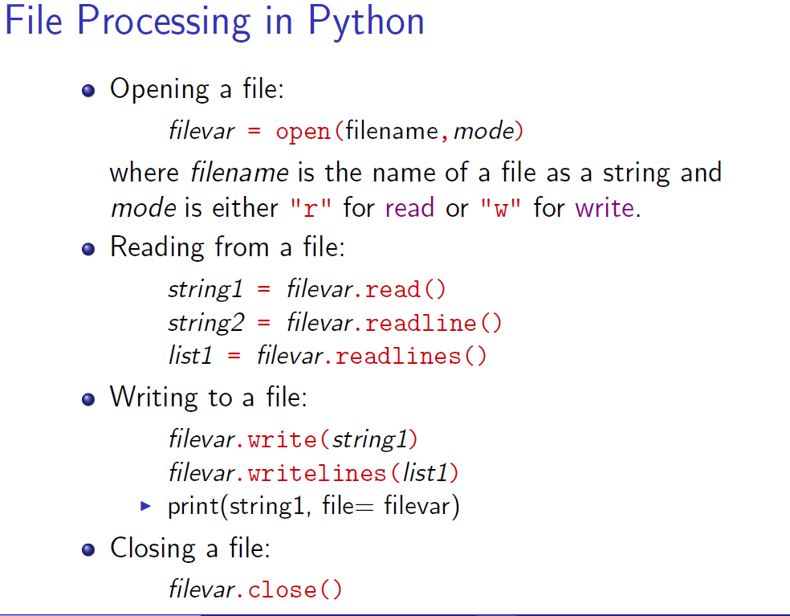

ENG1D04 Lecture 5 2019-10-21
- Duplication of code in a program is usually bad because it can make the program long and verbose, expensive to maintain, hard to understand, hard to reuse
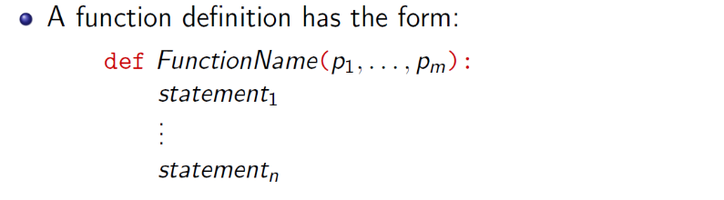
- Formal parameters represent the inputs to the function
  - When called, they become the local variables
- Function application also called function invocation, it is an expression that calls the function
- Actual parameters values that are used as the input of the function where the type must match the formal parameter
- A function is evaluated in four steps:
  - Calling program’s execution is suspended
  - Formal parameters are bound to the values of the actual parameters
  - Body of the function is executed
  - Output value of the function is returned to the calling program and the calling program’s execution is resumed
  - Named as the call-by-evaluation strategy
- If no value is explicitly returned, the special object None is returned
- Namespace a mapping of names to programming entities
  - Same name may be in different namespaces
- Scope a region of a program where a namespace is accessible
  - Determines the namespace a name is in
  - Are nested, meaning that all inner names in inner namespaces are also accessed by outer namespaces
  - A variable created outside the innermost namespace is read-only to the innermost namespace
- Principle of least privilege the principle that a subject should be given only the information and resources that the subject needs to fulfill its responsibilities
  - Need to know principle is a special case of the principle of least privilege
  - Scope of a variable should be as narrow as possible
  - Fields of an object should not be accessible outside of the object
  - A constant value should be represented by a constant rather than a variable

ENG1D04 Lecture 6 2019-10-21
- Boolean a standard truth value, either true or false
  - Named after the English mathematician George Bool (1815-1864)
- Boolean expression also called a formula; an expression of type bool
  - Used to makes decisions
- Python has 3 boolean operators:
  - And (Conjunctive) : and
  - Or (Disjunctive) : or
  - Not (Negation) : not
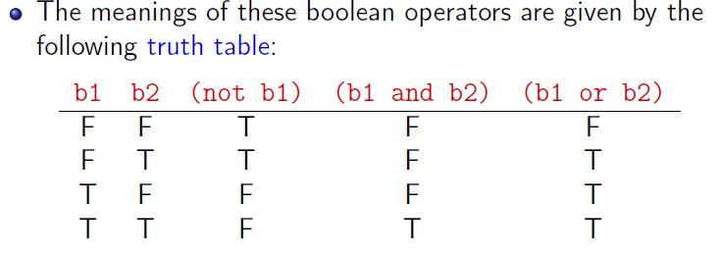
- Boolean operators and and or are implemented by short-circuit operators
  - If a evaluates to False, then a and b evaluates to False without b being evaluated
  - If a evaluates to True, then a or b evaluates to True without b being evaluated
- The values of built-in nonboolean are implicitly converted to boolean values
- Boolean operators can be used as selection operators
- Conditional Statement selects a statement for execution based on whether a condition represented as a boolean expression evaluates to true or false
- Python has several kinds of conditional statements
  - If statements
  - If-else statements
  - If-elif-else statements
  - Try-except statements
  - While statements
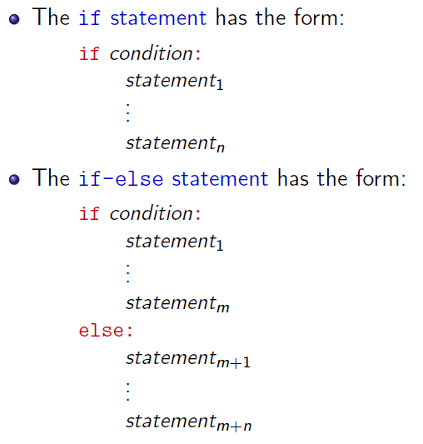
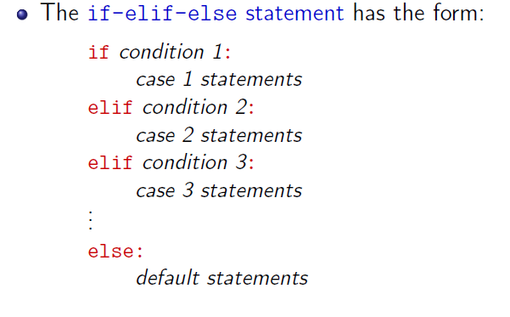
- Tests for x == y or x != y should be avoided if x and y are floats
- Only a small amount of real numbers is exactly represented by floats
- When trying to resolve expressions for floats, use abs(f(x)) < epsilon for some small value of epsilon which can be changed
- Anomaly an unexpected behaviour of a service
- Exception a signal to the client of a service than an anomaly has been exhibited by the service
  - An exception is either thrown or raised when the anomaly occurs
- A thrown exception is caught by an appropriate exception handler that tries to handle the exception
- Ways an exception can be handled :
  - An attempt is made to recover from the anomaly
  - The exception is thrown higher up the uses chain
  - The state of the program providing the service is repaired as best as possible and the service can fail
- An exception is an instance of the exception class
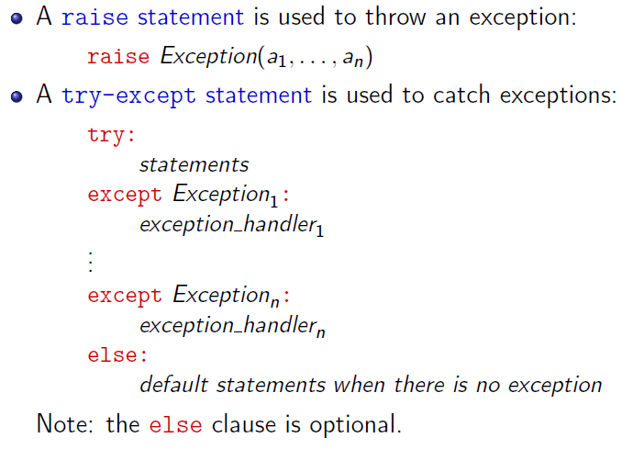

ENG1D04 Lecture 7 2019-11-02
- Definite Loop will execute a definite number of times
- Indefinite Loop will execute an indefinite number of times until a condition is met
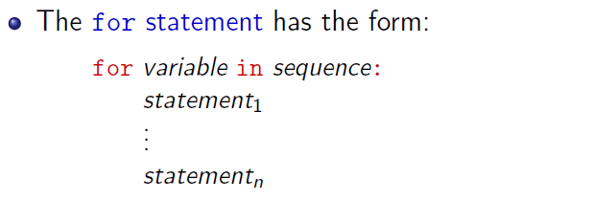
- The for statement defines a definite loop and can work with any sequence type
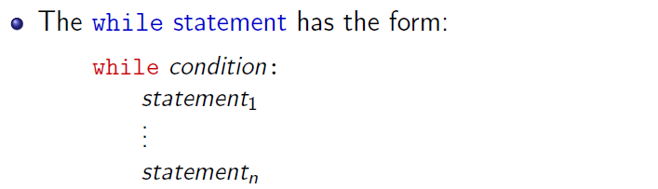
- the while statement defines an indefinite loop that, if not used correctly, can become an infinite loop—a loop that has no termination
  - implementations of while loops:
    - count-controlled loop loop repeats for a specific number of times
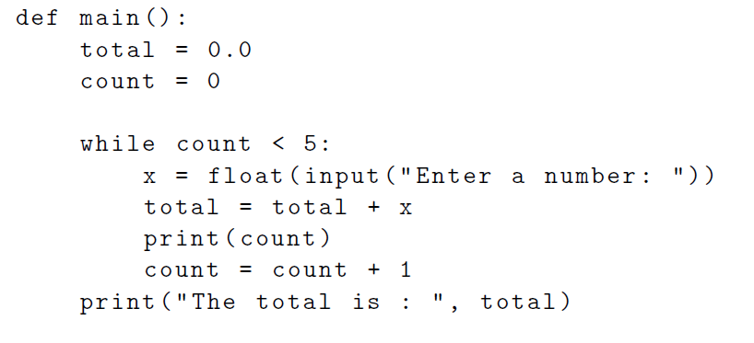
    - interactive loop user can repeat the loop as many times as needed
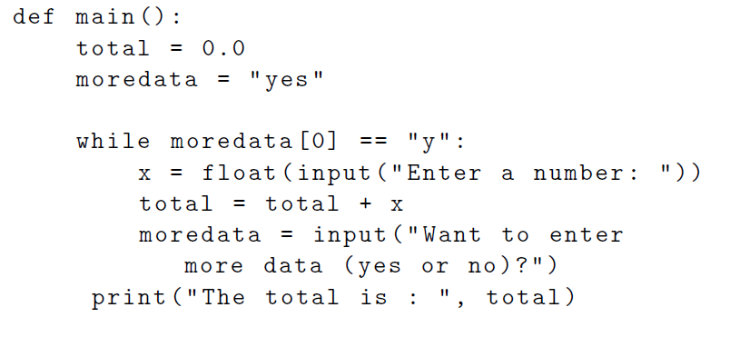

    - sentinel loop loop is repeated until a sentinel value is reached
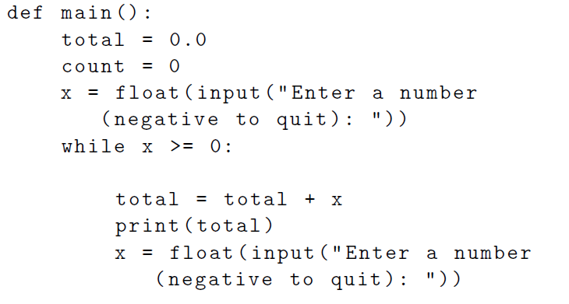
    - file reading loop loop iterates through a file until the end of file is reached
    - infinite loop the loop is intended to run indefinitely (ex. Operating system, user interfaces)
- break statement allows you to leave the loop if required and is particularly useful for getting user input
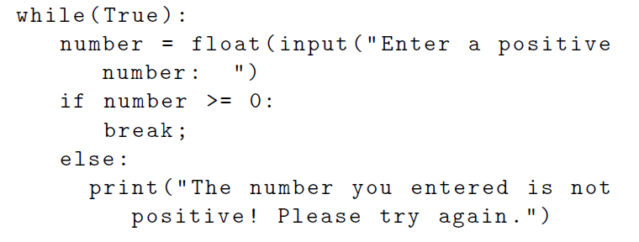
- continue statement allows you to skip certain statements if a condition is met
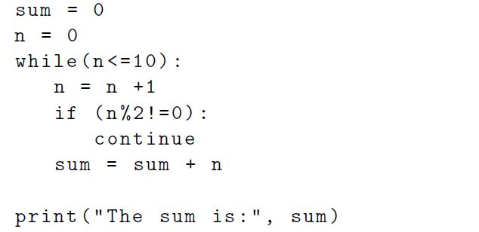
- Gottfried Leibniz German polymath who developed calculus (1684)
  - Developed the binary number system
  - Invented the Staffwalze (Stepped Reckoner), a machine that could do addition, subtraction, division, and multiplication, and square roots
  - Postulates the calculus ratiocinator that computes statements in the characteristica universalis
  - Motto was “calculemus!” which means “Let us calculate!”

ENG1D04 Lecture 8 2019-11-02
- Simulation a powerful technique for solving real world problems by modelling the real-world process
- Software development phases :
  - Problem Identification What is the problem that needs to be solved?
  - Requirement Specifications What are the product requirements that need to be satisfied? What objectives, functions, and constraints are relevant?
  - Design How will the problem be solved? How will the product requirements be satisfied?
  - Implementation What is a solution to the problem? What is an executable implementation of the design?
  - Testing and Verification What behaviour does the product exhibit? Is the behaviour correct?
  - Delivery and Maintenance How will the product be delivered and maintained?
- Software development process a rational development process to produce quality software
  - Any proposed rational process is necessarily an idealization
    - Humans inevitably make errors
    - Communication between humans is imperfect
    - Many things are not understood at the start
    - Supporting technology always has limitations
    - Requirements change over time
- Software development models :
  - Waterfall development follows the logical order of the phases given above in linear fashion
  - Spiral steps of the waterfall process are repeatedly applied until a suitable product is obtained
  - Refinement (Top-Down) the product requirements are stepwise refined through a series of designs until an implementation of the product is reached
  - Prototyping a prototype of the product is developed first and then thrown away
  - Incremental a partial product is developed and then incrementally extended until a full product is obtained
- Software engineering an area of engineering that deals with the development of software products
  - “the application of a systematic, disciplined, quantifiable approach to the development, operation, and maintenance of software” (IEEE 1990)
  - “a multi-purpose construction of multi-version software” (David Parnas)
- Software engineering principles :
  - rigor reasoning should be precise
  - separation of concerns different concerns should be isolated and considered separately
  - modularity complex system should be divided into smaller parts
  - least privilege each subject should be given the fewest privileges needed for it to perform its task
  - formality reasoning should be done using a language with a formal syntax and a precise semantics
  - abstraction what is important should be separated out from what is irrelevant
  - anticipation of change future change should be anticipated and planned for
  - generality whenever possible, a more general problem should be solved instead of the problem at hand
  - incrementality a problem should be attacked by producing successively closer approximation to the solution
- modular decomposition the top-down process of dividing a system into modules (divide and conquer approach)
- modular composition the bottom-up process of building a system out of modules (interchangeable parts approach)
- testing most important technique for analyzing the quality of a software product
  - can shows instances of incorrectness, but not practical for demonstrating correctness
  - can be used to assess reliability and robustness
  - kinds of test case selection :
    - blackbox test cases selected to cover the behaviour of the code based on only the specification of the code
    - whitebox test cases selected to cover the behaviour of the code based on the code itself
    - statistical random test cases selected to measure reliability using an operational file
    - wild random test cases selected to measure robustness using a uniform random distribution
  - test the smallest components first
  - test all possible paths through a program
  - test all types of cases including :
    - cases along the boundaries (at or beyond limits)
    - extreme cases (very small and very large input)
    - degenerate cases (such as an empty file)
    - erroneous cases (such as name of a non-existing file)

ENG1D04 Lecture 9 2019-11-13
- object a mutable active value that combines data and operations
  - data is a set of variables called fields
    - field defines the object’s state, the set of information that is stored in the object
  - operations are performed via a set of methods
    - method defines the object’s behaviour
  - each object is an instance of a class
- class a template for a type of objects
  - instances of the class are members of the type
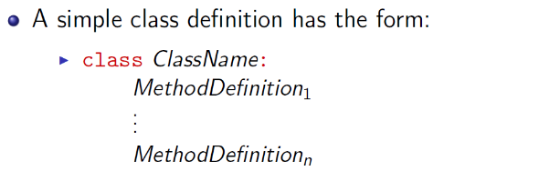
  - methodDefinition₁ is usually the definition of the __init__ method
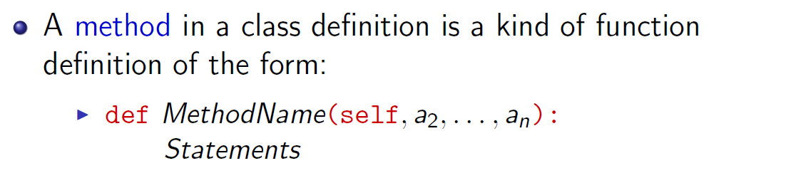
  - first parameter, typically self, bound to the object to which the method belongs
- constructor a special method used to create an object of a class
  - name of the method is same as the class, does not need to be defined, and uses the __init__ method for initialization
- __init__ a special method that defines the fields of an object and initializes those fields
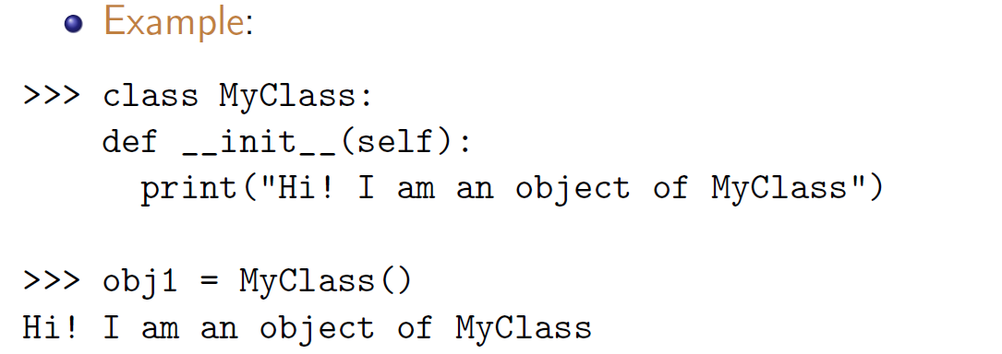
- dot operator used to invoke methods apart from the constructor
  - instance variables are referenced using dot operator with self
  - when a method is invoked, self parameter is not passed, instead supplied by Python
- inheritance a new class is derived from an existing one
  - has access to all the variables and methods defined in the original class

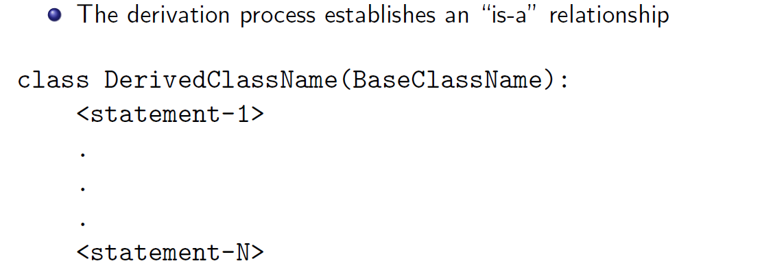
  - a new class can be derived from more than one base class
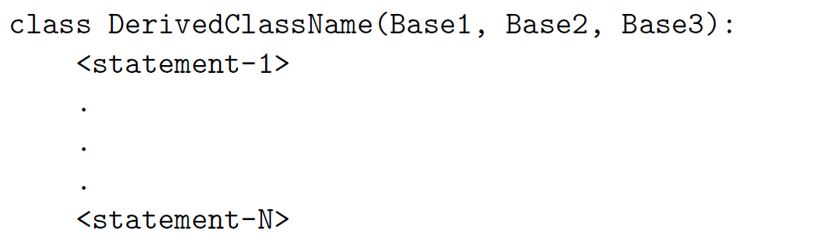
  - when object uses a variable, first checks derived class before parent class
  - allows for method overriding
    - adds different functionality to a method inherited from the parent class
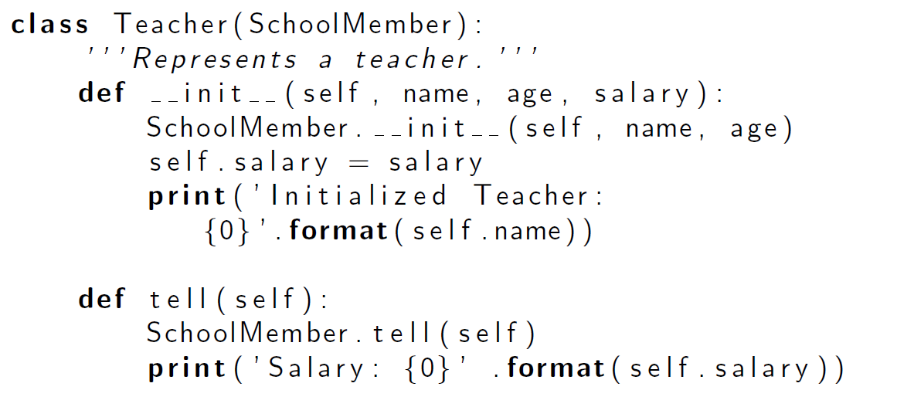
- benefits of the object-oriented program paradigm
  - objects are modular units of data and operations
    - have both state and behaviour
    - data and operations that work together are bundled together (encapsulation)
    - implementation details are hidden inside the object (information hiding)
    - object communicate by calling each other’s methods (message passing)
  - a type of objects is defined via a class definition
    - new instances of the class can be created as needed
    - instances share attributes of the class
  - new classes defined by extending old classes (inheritance)
  - a method can be applied to objects of different classes (polymorphism)

ENG1D04 Lecture 10 2019-11-18
- algorithm a step-by-step process used to solve a specific problem
  - implementation methods:
    - manual operation by a person or a group of people
    - an automated operation performed by a computer or other mechanical means
    - a combined manual and automated operation
  - algorithms are fundamental tools in engineering
- algorithm design the discipline of creating algorithms that solve problems
- algorithm analysis the discipline of determining the efficiency of algorithms
- efficiency the measure of how many resources the algorithm uses
- algorithm design and analysis focussed on two resources:
  - time the time it takes for the algorithm to complete
  - space the space the algorithm needs during its operation
- searching the process of looking for a value with certain properties
- linear search a process that examines the values one by one linearly
  - generally easy to design but are time-inefficient when the search space is large
- binary search a process that eliminates half the search space with each step
  - much more time-efficient but requires the list to be sorted ahead of time
- sorting process of putting a sequence of values into a certain order

ENG1D04 Lecture 11 2019-11-28
- dictionary a collection that allows accessing of information based on arbitrary key-mapping
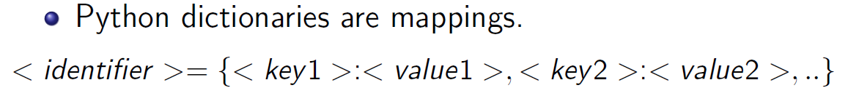
- recursion a method of defining something in terms of itself
  - alternative to iterations, as well as a fundamental idea of computing
  - each recursive call stores data into a stack which has finite size
    - if the recursion calls are too many, then a StackOverflow could occur
- steps to solve a problem recursively:
  - simplest instance of a problem is solved directly
  - every other instance is solved by reducing it to a simpler instance
  - repeat the second step until the first step is reached, thus using that as the basis to solve every other instance
  - note this employs a divide and conquer strategy

