Module 14: Infancy and Childhood
- Maturation: the orderly sequence of biological growth.
- Severe deprivation or abuse can retard development, yet the genetic growth tendencies are inborn. Maturation (nature) sets the basic course of development; experience (nurture) adjusts it.

- Brain Development:
- In your mother’s womb, your brain formed nerve cells at a rate of nearly one-quarter million per minute. The developing brain cortex actually overproduces neurons.
- From infancy on, brain and mind develop together.
- On the day you were born, you had most of the brain cells you would ever have.
- After birth, the branching neural networks that eventually enabled you to walk, talk, and remember had a wild growth spurt.
- From ages 3 to 6, the most rapid growth was in your frontal lobes, which enable rational planning.
- The association areas – those linked with thinking, memory, and language- are the last cortical areas to develop. As they do, mental abilities surge.
- A “use it or lose it” pruning process shits down unused links and strengthens others.

- Motor Development:
- The developing brain enables physical coordination. As an infant’s muscles and nervous system mature, skills emerge.
- 25 % of babies walk by age 11 months, 50% within a week after their first birthday, and 90% by age 15 months.
- Genes guide motor development; identical twins begin walking on nearly the same day.
- Maturation creates our readiness to learn walking at about age one.

- Brain Maturation and Infant Memory:
- Our earliest memories seldom predate our third birthday.
- Other studies confirm that the average age of earliest conscious memory is 3.5 years.
- As children mature, from 4 to 6 to 8 years, childhood amnesia is giving way, and they become increasingly capable of remembering experiences, even for a year or more.
- The brain areas underlying memory, such as the hippocampus and frontal lobes, continue to mature into adolescence.
- Although we consciously recall little from before age 4, our brain was processing and storing information during those early years.
- Traces of forgotten childhood languages may persist.
- What the conscious mind does not know and cannot express in words, the nervous system somehow remembers

Cognitive Development.
- Cognition refers to all the mental activities associated with thinking, knowing, remembering, and communicating.
- Piaget’s studies led him to believe that a child’s mind develops through a series of stages, in an upward march from the newborn’s simple reflexes to the adult’s abstract reasoning power.
- Piaget’s core idea is that the driving force behind out intellectual progression is an unceasing struggle to make sense of our experiences.
- To this end, the maturing brain builds schemas, a concept or framework that organizes and interprets information.
- By adulthood, we have built countless schemas.
- To explain how we adjust our schemas, Piaget proposed to more concepts: first, we assimilate new experiences- we interpret our new experiences in terms of our existing schemas. We also have to accommodate our schemas by adapting our current understandings (schemas) to incorporate new information.

- Piaget’s 5 Stages of Development:
- Sensorimotor Stage
- The stage from birth to about 2 years of age during which infants know the world mostly in terms of their sensory impressions and motor activities.
- Very young babies seem to live in the present: out of sight, out of mind. Young infants lack object permanence.
- Object permanence: the awareness that things continue to exist even when not perceived.
- By 8 months, infants began exhibiting memory for things no longer seen.
- Preoperational Stage
- The stage from about 2 to 6 or 7 years of age, during which a child learns to use language but does not yet comprehend the mental operations of concrete logic.
- Before age 6, children lack the concept of conservation: the principle that quantity remains the same despite changes in shape.
- Egocentrism: in Piaget’s theory, the preoperational child’s difficulty taking another’s point of view.
- Theory of mind: people’s ideas about their own and other’s mental states- about their feelings, perceptions, and thoughts, and the behaviors these might predict.
- Concrete Operational Stage
- The stage of cognitive development from ages 6 or 7 to 11 years of age during which children gain the mental operations that enable them to think logically about concrete events.
- Piaget believed that during the concrete operational stage, children become able to comprehend mathematical transformations and conservation.
- Formal Operational Stage
- The stage of cognitive development, usually around age 12, during which people begin to think logically about abstract concepts.

Social Development
- From birth, babies in all cultures are social creatures, developing an intense bond with their caregivers.
- At about 8 months, soon after object permanence emerges and children become mobile, a curious thing happens: they develop stranger anxiety.
- Stranger anxiety: the fear of strangers that infants commonly display, beginning by about 8 months of age.
- The brain, the mind, and social-emotional behavior develop together.

- Origins of Attachment
- No social behavior is more striking than the intense and mutual infant-parent bond.
- This attachment bond is a powerful survival impulse that keeps infants close to their caregivers.
- Infants become attached to those who are comfortable and familiar.
- Contact is one key to attachment. Another is familiarity.
- In many animals, attachments based on familiarity form during a critical period – an optimal period when certain events must take place to facilitate proper development.
- Imprinting: the process by which certain animals form attachments during a critical period very early in life.

- Attachment Differences
- Sensitive, responsive mothers- those who noticed what their babies were doing and responded appropriately- had infants who exhibited secure attachment.
- Insensitive, unresponsive mothers often had infants who were insecurely attached.
- Some babies are born difficult- irritable, intense and unpredictable.
- Some babies are born easy- cheerful, relaxed, and feeding and eating on predictable schedules.
- Erikson believed that securely attached children approach life with a sense of basic trust- a sense that the world is predictable and reliable.

- Deprivation of Attachment
- If secure attachment nurtures social competence, what happens when circumstances prevent a child from forming attachments?
- Babies locked away at home under conditions of abuse or extreme neglect are often withdrawn, frightened, even speechless.
- Most children growing up under adversity are resilient; they become normal adults.
- So do most victims of childhood sexual abuse.
- But others, especially those who experience no sharp break from their abusive past, don’t bounce back so readily.
- A primate experiment confirmed the abuse-breeds-abuse phenomenon; in one study, 9 or 16 females who had been abused by their mothers became abusive parents, as did no female raised by a non-abusive mother.
- In humans too, the unloved may become the unloving. Most abusive parents-and many condemned murderers- have reported being neglected or battered as children.
- Although most abused children do not later become violent criminals or abusive parents, extreme early trauma may nevertheless leave footprints on the brain.

- Parenting Styles
- Authoritarian: parents impose rules and expect obedience.
- Permissive: parents submit to their children’s desires. They make few demands and little punishment.
- Authoritative: parents are both demanding and responsive. They exert control by setting rules and enforcing them, but also explain reasons for the rules.

Module 15: Adolescence
Physical Development
- Primary sex characteristics - the reproductive organs and external genitalia
- Secondary sex characteristics – the non-reproductive traits such as breasts, facial hair
- If a boy develops early, are usually stronger and more athletic, more popular, self-assured, but at more risk for alcohol use, delinquency, and premature sexual activity
- Girls developing early – if hormone-fed feeling out of sync with her emotional maturity, or friends’ physical dev’p she may begin associating with older adolescents or may suffer teasing
- In puberty, brain stops “rewiring” new neural connections, instead it “prunes” getting rid of unused connections
- Frontal Lobe continues to develop.
- Myelin, fatty tissue that forms around axons and speeds NT, enables better communication with other brain regions bring better judgment, impulse control, and long-term planning speeds up nerve conduction
- Makes early adolescence the BEST TIME TO LEARN!!
- Frontal lobe lags behind Limbic System

Cognitive Development
Developing Reasoning Power
- Jean Piaget: Formal Operations: applying new abstract reasoning tools to the world around them
- Have a greater understanding of the world and deeper meaning of things – can lead to debates with parents
Developing Morality
- Piaget & Kohlberg: moral reasoning guides moral actions
- Much of functioning occurs not on the “high road” or deliberate, conscious thinking, but on the “low road” of unconscious automatic thinking
Moral Reasoning:
- Piaget: children’s moral judgments build on their cognitive development
- Kohlberg: agreeing with Piaget, sought to describe the development of moral reasoning, the thinking that occurs as we consider right and wrong
- Proposed moral dilemmas (steal medicine to save life), and asked children, teens, and adults whether action was right/wrong
- Findings proposed 3 basic levels of moral thinking: preconventional, conventional, and postconventional
- Form a moral ladder (critics noted postconventional stage is culturally limited, appearing mostly among ppl who prize individualism)
Moral Intuition
- Jonathan Haidt: much of our morality is rooted in moral intuitions – quick gut feelings or affectively laden intuitions
- Mind makes moral judgments as it makes aesthetic judgments – quickly and automatically (feel disgust when seeing ppl do degrading acts)
- Ex. 5 ppl will be killed by a trolley but you can turn a switch to make it only kill 1 – Kill 1 save 5, most ppl said yes. But when the option of pushing that one person onto the track in order to save them, they said no

Social Development
- Erikson contended that each stage of life had its own psychosocial task – a crisis that needs resolution
- Young children: trust, autonomy (independence), then initiative
- School aged: strive for competence, feeling able and productive
- Adolescence: to synthesize past, present, and future possibility into a clearer sense of self search for identity

Forming an Identity
- Adolescence try out different “selfs” in different situations
- Social identity often forms around their distinctiveness
not always! Erikson noticed that some forge their identity early, simply by adopting their parent’s values and expectations – or other peer groups (jocks, preps, geek, goth)
- Young Americans’ self esteem falls in early-late teens, and rebounds during late teens – early 20’s
- Erikson contended that the adolescent identity stage is flowed in young adulthood by developing capacity for intimacy – forming emotionally close relationships
- Those who enjoy high-quality relationships with family and friends tend to enjoy high quality romantic relationships, and leads to better adulthood
- Foreclosure: defying parents or peers
Parent and Peer Relationships
- Girls with affectionate relationships with mothers enjoy intimate friendships with girlfriends
- Teens close to parents do better in school and are healthy and happy
Emerging Adulthood
- Today, <1/2 of 30 year old women and 1/3 of men have achieved either finishing school, leaving home, become financially independent, married, or have a child
- Later independence and earlier sexual maturity have widened teenage years
- Emerging adulthood: between 18 and mid 20’s

Module 23 – Studying and Building Memories

Memory- learning that has persisted overtime, info stored and can be retrieved
- Recall- retrieving info not in your conscious awareness but that was learned at an earlier time. (fill in the blanks)
- Recognition – identifying items previously learned (multiple choice)
- Relearning – learning something more quickly when you learn it a second time
- father, 92 suffered stroke. Could keep personality, stayed mobile, but memory was out of place. Couldn’t remember what he had for lunch, or day of week, and kept forgetting that his brother in law died.
-Russian journalist, Shereshevskii, could repeat up to 70 words back. Most people can only do 7-9 digits.

Measures of Retention
Three measures of retention: recall, recognition, relearning.
People can recall people if they see their face or names, but otherwise it is hard.
Recognition memory vast and quick – “is your friend wearing a new or old outfit?” “old”. Our mind knows the answer before we even say it
Relearning – German philosopher Hermann Ebbinghaus, used nonsense syllables in experiments. Randomly selected sample of syllables, practiced them, and tested himself. To get a feel, he read them over loudly 8 times and looked away to try to recall the items. Ebbinghaus’ retention curve – the more times you learn something, the easier it is to relearn it.

Memory Models
Create memory models to helps us think about how our brain forms and retrieves memories. Information-processing models = analogies that compare human memory to a computer’s operations. To remember, we must:
- Get information into our brain, (encoding)
- Retain information (storage)
- Later get information back out (retrieval)
Parallel processing = processing many things simultaneously, even unconsciously
Connecionism = an information processing model views memories as products of interconnected neural networks.
- Everytime you learn something new, your brain’s neural connections change, forming and strengthening pathways that allow you to interact and learn

Model of Memory Formations
Richard Atkinson and Richard Shiffrin (1968)
- Stimuli recorded by our senses and held briefly in sensory memory
- Some info processed into short-term memory, encoded through rehearsal
- Info moves into long-term memory to be retrieved later
**others have updated this model, included newer concepts such as working memory and automatic processing

Working Memory
Alan Baddeley challenged Atkinson and Shiffrin’s view of short-term memory as a small, brief storage space for recent thoughts and experiences
- It’s an “active desktop” where your brain processes information, making sense of new input and linking it with long term memories.
Working memory: focusing on active processing that takes place in the middle stage
- Baddeley suggested the central executive (focuses attention) handles this focused processing of information

Dual-Track Memory: Effortful Vs Automatic Processing
- Atkinson and Shiffrin focused on how we process explicit memories (facts and experiences we can consciously know and declare) – also declarative memories
- Our mind works on 2 tracks – it processes explicit memories via conscious, effortful processing
- Behind the scenes, other info skips our conscious encoding and goes right into storage.. automatic processing happens without awareness produces implicit memories (aka nondelarative memories)
2 track memory system reinforces an important principle of parallel processing: we split information into different components for separate and simultaneous processing.

Building Memories
Encoding and Automatic Processing
- Procedural memory well practiced knowledge like word meaning (riding a bike)
- Conditioned associations smell triggers memory of certain places , happens automatically
- info about time, going back in time if you lost something
- info about frequency, like “this is the 3rd driver I’ve passed today”
- info about space, picturing where things are when walking into a room

Sensory Memory
- immediate very brief recording of sensory info before its processed into short/long term memory BRIEF! Sensory memory consists of 3-4 seconds echos, or 1/20th of a second image
**you can retrieve the last 8 words from echoic memory
Iconic Memory: a fleeting sensory memory of visual stimuli (Sperling experiment)

Capacity of Short-Term and Working Memory
- George Miller proposed that short-term memory can retain 7 information bits
- Lloyd and Margaret Peterson experiment (1959)
- Working memory uses focus, analysis, thinking and linking – greater capacity than short term

Effortful Processing Strategies:
Chunking: grouping words/letters together to remember easier
**peg word system – a technique of visually associating new words with an existing list already memorized along with numbers
Hierarchies: developing expertise in an area- seeing what’s more/less important than the rest

Distributed Practice
- Massed practice (cramming) info all at once in a short period of time
- Spacing Effect – spacing out info overtime (Noted by Ebbinghaus late 1800’s)
Distributed Practise produces better long-term recall
- Harry Bahrick experiments found that the longer the space between practice sessions, the better their retention up to 5 years later
Testing effect – repeated self testing

Levels of Processing
We process verbal information at different levels, and depth affects our long-term retention. Shallow processing – encodes on a very basic level, Deep processing – encodes semantically based on the meaning of the words

- Self- reference effect relating material to ourselves/ our lives aids encoding and retention

Module 24: Retaining Information in the Brain

- We do not store information like libraries store books, rather many parts of the brain interact as we encode, store, and retrieve information that forms memories
- When emotions get involved, another part of brain can mark/flag them for quicker retrieval

Explicit-Memory System: Frontal Lobes and Hippocampus
Explicit memories: includes frontal lobes and hippocampus
- When you summon up a mental encore of past experience, many brain regions send input to frontal lobes for working memory
- Left and right f. lobes process different memories: eg. Recalling a password=left, calling up party scene=right
Hippocampus acts as “save” button for explicit memories (names, images, and events)
- Left hippocampus damage – trouble remembering verbal info, no trouble recalling visual designs/locations
- Right hippocampus damage – opposite
- Subregions of hippocampus also serve different functions: faces, spatial mnemonics, rear area = spatial memory
Hippocampus switches short term to long term memory (48 hours after) much done during sleep

Implicit-Memory System: Cerebellum and Basal Ganglia
- Woman with brain damage had to get introduced to doctor everyday, but when he shook hands with a thumbtack, she refused to the next day because of classical conditioning – she didn’t know why!
- Cerebellum forms and stores conditioned responses
- Without it, ppl cannot develop certain conditioned responses – implicit memories needs cerebellum!
**can store responses without even knowing why
- Basal Ganglia – controls and forms procedural memory and movement *we can ride bike even if we don’t remember learning
Infantile Amnesia
- Implicit memory, like skills and conditioned responses, can be retained from infancy
- Explicit memory only goes back to about 3 years old
3 year blank = infantile amnesia
**encoding: memories not stored well because hippocampus is one of the last brain areas to develop
also, mind thinks in verbal narrative and has trouble recalling preverbal memories
Flashbulb memory: emotionally intense event remembered, eg 911

Amygdala: helps “tag” important memories if they are of emotional importance
- Emotional arousal sears certain events into the brain while disrupting memory for neutral events around the same time

Synaptic Changes
- James Schwartz, Eric Kandel observed synaptic changes during learning in the sending neurons of the California sea slug
- Sea slug classically conditioned via electric shock
- With increased synaptic activity, long-term potentiation occurs (signals sent more efficiently)
- After LTP has occurred, passing an electric current through brain wont disrupt old memories, but will wipe out recent ones
Eg, boxers getting knocked out don’t remember moments before – working memory didn’t have enough time to consolidate info into long-term
- Results in reduction of prompting need to send a signal and increase in the # of NT receptor sites

Summery:
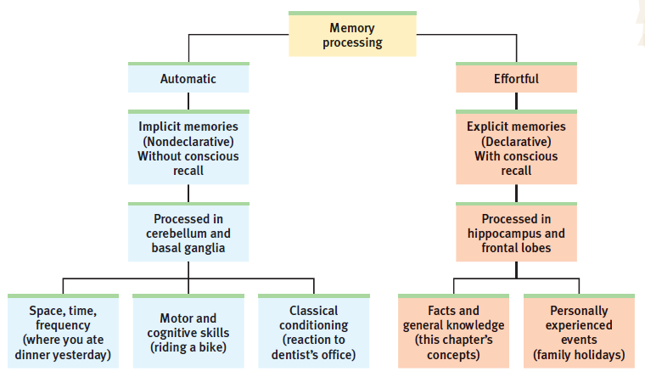

Module 27: Thinking

Concepts: mental groupings of similar objects, events, ideas, and people.
- Concepts provide mental shorthand, economizing cognitive efforts

We form concepts by developing prototypes mental image or best example of a category – the most typical instance
Eg. Robin is more of a bird than penguin because a robin is closer matched to the bird prototype – the closer something matches, the easier we recognize it

- Prototypes fail us when examples stretch our definitions as in considering if a stool is a chair
- Prototypes fail us when the boundary between concepts is fuzzy, as in judging blue-green colors or computer blended faces
- Prototypes fail us when examples contradict our prototypes, such as considering if a whale is a mammal or if a penguin is a bird

Exemplars – individual instances, held in memory, of a concept/category

Problem Solving: Strategies and Obstacles
- Trial and error
- Algorithms = step by step procedures that guarantee a solution – strategy involving following specific rules, procedure or methods that produce the correct solution
- Heuristic = simpler thinking strategies – mental shortcuts to reduce the # of solutions, although guaranteed solution is lost (eg. SPLOYOCHYG = PSYCHOLOGY, shortcut by grouping few words together and excluding 2 letters that aren’t usually together)
- Insight = an abrupt, true seeming, and often satisfying solution (insight of getting a bird out of a narrow 30 inch deep hole – pouring sand in until the bird can stand up on the pile and slowly raising the pile)
Works by the frontal lobe first trying to figure out problem, and then suddenly aha! Feeling comes from the temporal lobe
Confirmation bias: A tendency to search for information that supports our preconceptions and to ignore or distort contradictory evidence

Obstacles to Problem Solving:
Fixations: Inability to see a problem from a new perspective
Mental Set: tendency to approach a problem with a mindset that’s worked in the past

- We seldome take the time and effort to reason systematically
- Follow our intuition – our fast, automatic unreasoned feelings and thoughts

The Availability Heuristic
- Heuristic takes over when we need to act quickly
- Tversky and Kahneman researched the availability heuristic, and showed how generally helpful shortcuts can lead people into dumb decisions
- Eg. Slot machines make big sounds and lights for small wins but almost make the big losses invisible
- Often fear extremely rare things like plane crash when we fly – play a plane crash in our heads

Overconfidence
- The tendency to overestimate the accuracy of our knowledge and judgments
- Can have adaptive value
Belief Perseverance
- Clinging to our beliefs in the face of contrary evidence
- Simple remedy exists to rein in the belief perseverance phenomenon: consider the opposite - having imagined and pondered opposite findings, people become much less biased in their evaluations of the evidence

The Effects of Framing
Framing: the way an issue is presented (eg; 9/10 people survive w.e, or 1/10 ppl die gets different reactions)

Module 28: Language

Language Structure
- Phonemes – smallest distinctive sound units in a language (eg. Bat – b,a,t)
- Morphemes – smallest units that carry meaning in a given language
- Grammar – system of rules that enables us to communicate with one another
Receptive Language
- Beginning of the development of babies’ receptive language, and their ability to understand what is said to and about them.
Productive Language
- Ability to produce words, matures after their receptive language

- By first bday, most children enter one word stage
- By 18 months, enter two word stage – utterin 2-word sentences in telegraphic speech

Explaining Language Development
- 7000 languages in the world diverse
- Noam Chomsky argues that they share some basic elements, universal grammar
- We start speaking in verbs rather than nouns
Statistical Learning
- When adults listen to unfamiliar language, syllables run all together
- Babies discern word brakes, and statistically analyze which syllables go together often
Critical Learning
- Childhood seems to represent critical period for mastering certain aspects of language before learning-window closes
- By age of 7, those who haven’t been exposed to language gradually lose their ability to master any language

The Brain and Language
Aphasia – an impairment of language, which can result from damage to any of several cortical areas. (some can read but cant speak or speak but cannot read)
- Damage to Broca’s area: can comprehend speech but hard to speak
- Damage to Wernicke’s Area: people can speak meaningless words
Big points to remember: In processing language, as in other forms of information processing, brain operates by dividing its mental functions-speaking, perceiving, thinking, remembering – into subfunctions
- Conscious experience of reading seems indivisible, but brain is computing each word’s form, sound, and meaning using neural networks
what you experience as a continuous, indivisible stream of experience is actually but the visible tip of a subdivided information-processing iceberg!

Thinking and Language
Language Influences Thinking
- Benjamin Lee Whorf (linguist): language determines the way we think – Hopi had no past tense for verbs, couldn’t readily think about the past
- His linguistic determinism too extreme – can think of a shade of blue u cannot name, also, we routinely have unsymbolized (wordless, imageless) thoughts
- Different languages makes you think differently depending on the amount of words used to describe something and how rich the language is in that area
Our words don’t determine what we think, rather influence our thinking

Thinking in Images
- We think in images, not words
- Someone who dances or something, even watching it will activate the brain’s internal simulation of it
- Outcome simulation: had little effect on students (imagining the feeling of getting an A+)
- Process simulation: had greater effect (imagining reading the textbook, going over notes, etc) better spending fantasy time planning how to get somewhere rather than the feeling of destination

- -> Language influences thinking, but if thinking didn’t affect language, there would never be new words. New words express new ideas!
our ingenuity at problem solving and our extraordinary power of language mark humankind as almost “infinite in faculties”

Module 32: Basic Motivational Concepts and Hunger
Motivation: A need or desire that energizes behavior and directs it towards a goal

Instincts and Evolutionary Psychology
- In beginning of 20th century, it was fashionable to classify all behaviors as instincts
- If ppl criticized themselves, it was because of their “self-abasement instinct”
- If ppl boasted, it was because of their “self-assertion instinct”
*Naming a behavior is not to explain it
*To qualify as an instinct, a complex behavior must have a fixed pattern throughout a species and be unlearned
- Even though instinct theory fails to explain most human motives, the assumption that genes predispose behaviors is strong as ever (could apply perspective in explaining human similarities, animals’ biological predisposition to learn certain behaviors, and more)

Drives and Incentives
- Drive reduction theory replaced instinct theory
physiological need creates an aroused state that drives the organism to reduce the need by, say, eating or drinking
- When physiological need increases, so does a psychological drive
- The aim of drive reduction is homeostasis – a steady internal state (of being not hungry/thirsty anymore)
- Pushed by needs to reduce drives, but also pulled by incentives – positive/negative environmental stimuli that lure or repel us
- For each motive we can ask, “How is it pushed by our inborn physiological needs and pulled by incentive s in the environment?”

Optimum Arousal
- Sensation seekers
- Human motivation aims not to eliminate arousal but to seek optimum levels of arousal

Hierarchy of Motives
- If deprived of water, thirst will preoccupy you, but if deprived of air, your thirst will disappear
- Abraham Manslow “Humans strive to ensure that basic needs are satisfied before they find motivation to pursue “higher goals””
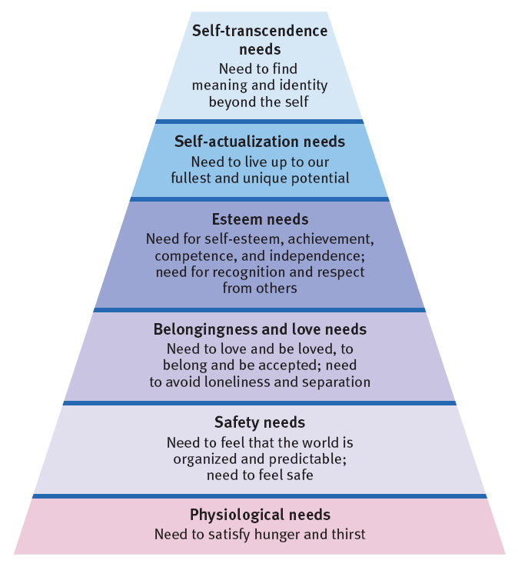

Hunger

Experiment by Ancel Keys studying semi-starvation by cutting food intake of men in half. Began conserving energy; they appeared listless and apathetic. Dropped 25% below starting weights.
Psychological effects: They became food obsessed (consistent with Maslow’s idea of needs hierarchy)
- Preoccupied by unfulfilled basic needs, they lost interest in sex and social activities
- Illustrates power of activated motives to hijack our consciousness – when hungry, thirsty, tired, aroused, little seems to matter. When you’re not, food, sex, etc don’t seem like big things in life.

The Physiology of Hunger
- Keys’ patients felt hunger because of a homeostatic system designed to maintain normal body weight and an adequate nutrient supply
- Energy homeostatic: long-term matching of food intake to energy expenditure

Body Chemistry and the Brain
Increases in insulin diminish blood glucose, by converting it to stored fat. If your blood glucose levels drop, you wont consciously feel the change. But your brain automatically monitors blood chemistry and internal state, and will trigger hunger. Signals from stomach, intestines and liver all signal to the brain whether to motivate eating or not.
- Work done by several neural areas in hypothalamus – if area destroyed, even starving animals won’t feel hungry
- The opposite happens when you electrically stimulate the appetite suppressing area: Animals will stop eating, but when you destroy it, they will keep eating and eating and become very fat
- Ghrelin: hunger arousing hormone secreted by empty stomach
- Leptin and PYY: both decrease hunger, Orexin: triggers hunger
If body weight rises: hunger decreases and expenditure increases
If body weight falls: hunger increases and expenditure decreases

- Body regulates weight by control of food intake, energy output, and basal metabolic rate – rate at which a body uses energy for vital functions (at rest)
- Weight drops or increases body responds by adjusting hunger and energy use to bring weight back to stable amount
- Researchers think that slow, sustained changes in body weight can alter one’s set point
- Prefer the word settling point to indicate the level at which a person’s weight “settles” in response to caloric intake and expenditure

Variations from the Norm of Body Weight
- In some cases, the set point drifts from a healthy weight
- Psychological disorders can over-ride set point, ignore biological signals and lead to weight loss
- Or can drift upwards towards obesity

Psychology of Hunger
- Knowing when to eat is our memory of our last meal (Rozin expirament)
- Neophobia – dislike of things unfamiliar, we often are scared of new foods

How much do we eat? = Depends on social situations
Social facilitation: what others are doing – we often eat more when around others
Unit bias: we may eat only one serving but eat more if serving size is larger
Buffet effect: food variety makes us eat more
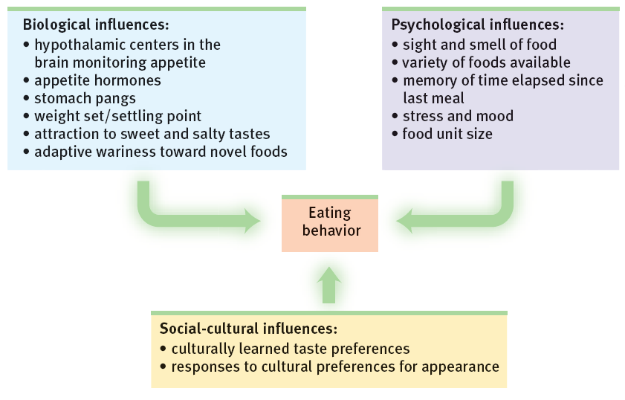
Obesity and Weight Gain
Why is it hard to change obesity?
- Adaptive for our ancestors to crave energy-rich foods when available
- Also adaptive to slow down our burning of fat when food is scarce in povery/crash diets, our body slows down weight loss

Social Effects on Obesity
- Leads to depression

Physiology of Depression
- Once fat, we require less food to maintain our weight than we did to attain it. Fat has lower metabolic rate – it takes less food energy to maintain, so when obese person drops below previous set point, hunger increases and metabolism decreases. Thus, body adapts to starvation by burning off fewer calories
- Even when weight loss succeeds, the obese person will have to eat less than the average person just to prevent weight gain!
- Sleep loss creates vulnerability to obesity
- If a friend became obese, its more likely that you will. And will triple if it’s a close friend

Module 35 – Emotions
- Emotions are a mix of bodily arousal (heart pounding), expressive behaviors (quick-ended pace), and conscious experience, including thoughts and feelings
- How do these pieces fit together? 2 questions:
- Chicken-and-Egg debate: Does your bodily arousal come before or after your emotional feelings?
- How do thinking and feeling interact? Does cognition always come before emotion? (did I think about a kidnapping threat before I reacted emotionally?)
*Historical emotional theories + research answer these questions

Historical Emotion Theories
James-Lange Theory: Arousal Comes Before Emotion
- To pioneering psychologist William James, this commonsense view of emotion had things backwards – “we feel sorry because we cry, angry because we strike, afraid because we tremble”
- Carl Lange also proposed this idea

Cannon-Bard Theory: Arousal and Emotion Occur Simultaneously
- Walter Cannon disagreed with James-Lange theory – body’s responses are too similar and change too slowly to cause the different emotions
- Him and Phillip Bard concluded that our bodily responses and experiences emotions occur separately but simultaneously
*my heart began pounding as I experienced fear
- People with lower-spinal injuries that couldn’t feel legs reported little change in emotion’s intensity – people with high spinal injuries (neck down) reported high amount of emotional change – “anger doesn’t have the heat it used to… more of just a mental kind of anger”
- Other emotions expressed in bodily areas above the neck were felt more intensely – our bodily responses seemingly feed our experienced emotions
- Most researchers agree that emotions involve cognition

Cognition Can Define Emotion: Schachter and Singer
- Believed that an emotional experience requires a conscious interpretation of arousal
- Two-factor theory: emotions do not exist until we add a label to whatever body sensations we are feeling
- Spillover effect: arousal from a soccer match can fuel anger, which can descend into rioting or other violent confrontations (eg. You get home from run, and find out that you got the job you wanted. With lingering arousal from the run, would you feel more elated if you received the news after a nap?)
- Arousal fuels emotion; cognition channels it interpretation completes the emotion

Cognition May Not Precede Emotion: Zajonc, LeDoux, and Lazarus
- Zajonc contended that we actually have many emotional reactions apart from, or even before, our interpretation of a situation. liking someone or something immediately without even knowing why (eg. Ppl repeatedly view stimuli flashed too briefly for them to interpret, the come to prefer those stimuli w/o even knowing why)
- Emotions traveling the “high-road” like love, hatred, go through thalamus to the brain’s cortex. Then it is analyzed and labeled before being sent out to amygdala
- Sometimes emotions (esp. simple likes, dislikes, fears) take what LeDoux called the “low road” a neural shortcut that bypasses the cortex
- Goes directly to amygdala
- Shortcut enables super fast response before our intellect intervenes
- Flashing people with fearful eyes super quickly triggered increased amygdala activity, but a control condition that presented happy eyes did not trigger activity
- Amygdala sends more neural projections to the cortex than it receives back which makes it easier for our feelings to hijack our thinking
- Lazarus conceded that our brains process vast amounts of information without our conscious awareness, and that some emotional responses do not require conscious thinking
- Much of emotional life operates via speedy low road
- Asked, how would we know what we are reacting to if we did not in some way appraise the situation
- Appraisal of stimuli (top-down function) may be effortless and we may not be conscious of it, but its still a mental function to know if stimulus is good or bad, brain must have some idea of it
- THERFORE, emotions arise when we appraise an event as harmless or dangerous, whether we truly know it is or not (Lazarus)
**Table 35.1 – shows theories and explanations

Embodied Emotion
Emotions and the Autonomic Nervous System
- Emotional Arousal: like a crisis control center, the ANS arouses the body in a crisis and calms it when danger passes
The Physiology of Emotions
- Different emotions don’t have distinct biological signatures, and do not engage sharply distinct brain regions
- Research determined some real but subtle physiological distinctions among the emotions eg. Finger temperatures and hormone secretions that accompany fear and rage do sometimes differ, fear and joy stimulate different facial muscles
- Negative moods trigger right-frontal lobe activity, Positive moods trigger left-frontal lobe activity

Module 40: Psychodynamic Theories
Views human behavior as a dynamic interaction between the conscious and unconscious mind (incl. associated motives and conflicts)

Freud’s Psychoanalytic Perspective: Exploring the Unconscious
- Free association: patients relax and say anything that comes to mind
- Assumed a line of mental dominoes fallen from the past to the troubled present
- Believed that it would allow him to retrace that line, following a chain of thought leading into patients unconscious, where memories could be released
- Psychoanalysis: Freud’s theory of personality and the associated treatment techniques
- Some thoughts in the unconscious are stored temporarily in the preconscious area, where we can retrieve them into conscious awareness
- Some thoughts we repress because they would be too unsettling to acknowledge

Personality Structure
- What is personality? characteristic patterns of thinking, feeling, and acting
- Id: unconscious psychic energy, strives to satisfy basic drives to survive, reproduce, and aggress.
- Operates pleasure principle: immediate gratification
- Ego: operates on the reality principal, seeks to gratify id’s impulses in realistic ways that will bring long-term pleasure
- Ego contains partly conscious perceptions, thoughts, judgments, and memories
- Superego: voice of our moral compass (conscious) that forces the ego to consider not only what is real but ideal
- Focuses on how we are supposed to behave
- Strives for perfection, judging actions and producing positive feelings of pride/negative feelings of guilt
- Strong superego: always guilty, Weak superego: remorseless, self-indulgent
ego struggles to reconcile between id and superego

Personality Development
- Personality forms during first few years of life
- Psychosexual stages: children pass through series of these, where the id’s pleasure seeking energies focus on distinct pleasure-sensitive areas of the body called erogenous zones (each stage goes through own challenges with conflicting tendencies)
- During phallic stage, boys seek genital stimulation and develop unconscious sexual desires for mother and jealousy for their father (considered a rival)
- Also experience fear and punishment from father (Oedipus complex)
- Girls also experience parallel electra complex
- Eventually cope with this and begin to act like rival parent
- Identification process: children’s superegos gain strength as they incorporate parent’s values leads to gender identity
- At any point in the oral, anal, or phallic stages, strong conflict could lock/fixate person’s pleasure seeking energies in that stage. Therefore adults who need oral satisfaction may smoke or eat a lot

Defense Mechanisms
- Anxiety: ego fearing losing control between the id and superego leaves us unsettled but unsure why
- Ego protects itself with defense mechanisms – tactics that reduce or redirect anxiety by distorting reality
- ALL DEFENSE MECHANISMS ACT INDIRECTLY AND UNCONCIOUSLY
- Repression banishes anxiety-arousing wishes and feeling from consciousness – repression underlies all the other defense mechanisms
- However, because repression is often incomplete, repressed urges may appear as symbols in dreams or slips of tongue in casual conversation

The Neo-Freudian and Psychodynamic Theorists
- Neo-Freudians accepted his basic ideas (id, ego, superego; unconscious; shaping of personality in childhood; and the dynamics of anxiety and defense mechanisms)
- Adler and Horney believed that childhood social, not sexual tensions are crucial for personality formation
- Adler: proposed inferiority complex; believed that much of behavior is driven be efforts to conquer childhood inferiority feelings that trigger strivings for superiority and power
- Horney: childhood anxiety triggers desire for love and security
- Jung placed less emphasis on social factors and agreed that unconscious exerts influence
- Jung: unconscious contains more than our repressed thoughts and feelings
- Believed we have a collective unconscious common reservoir of images (archetypes)

Assessing Unconscious Processes
- Projective Tests: asking test-takers to describe an ambiguous stimulus or tell a story about it
- Clinician may presume that any hopes, desires, and fears that people see are projections of their own inner feelings and conflicts
- Rorschach inkblot test: describing what people see in various inkblots on a childhood game

Evaluating Freud’s Psychoanalytic Perspective and Modern Views of the Unconscious
Modern Research Contradicts Many of Freud’s Ideas
- No access to DNA/NT studies or to all we’ve learned about human development, thinking, and emotion
- Today we see development as lifelong, not fixed to childhood
- Also doubt that conscience and gender identity form as the child resolves the Oedipus complex at age 5 or 6

Modern Research Challenges the Idea of Repression
- Psychoanalytic theory assumes that human mind often represses offending wishes, banishing them into unconscious until they resurface
- Today researchers agree that we sometimes spare our egos by neglecting threatening information many contended that repression, if it even occurs, is a rare mental response to terrible trauma
- Some believe that extreme prolonged stress might disrupt memory by damaging the hippocampus however, common reality is that it increases memory

The Modern Unconscious Mind
- More than ever, we fly on autopilot
- Baumeister found that people tend to see their foibles and attitudes in others a phenomenon that Freud called projection and that today’s researchers call the false consensus effect the tendency to overestimate the extent to which others share our beliefs and behaviors

Module 41: Humanistic Theories
Humanistic Theories: view personality with a focus on the potential for healthy personal growth

Abraham Maslow’s Self-Actualizing Person
- we are motivated by a hierarchy of needs
- when we achieve self esteem, we seek self-actualization (process of fulfilling our potential) and self-transcendence (meaning, purpose, and communion beyond the self)
- Maslow studied healthy people rather than troubled people concluded that they had one thing in common: self-aware and self-accepting, open and spontaneous, loving and caring, and not paralyzed by other’s opinions

Carl Rogers’ Person-Centered Perspective
- Growth promoting climate requires 3 conditions:
- Genuineness: open with their own feelings, drop facades, and are transparent and self-disclosing
- Acceptance: offer unconditional positive regard an attitude that of grace that values us even knowing our failings.
- Empathy: When empathetic, people share and mirror others’ feelings and reflect their meaning
- For Rogers and Maslow, a central feature of personality is one’s self-concept – all the thoughts and feelings we have in response to “Who am I?”

