Microeconomics first class
Microeconomics taking a close up look on details of the economy
For example: wages in specific industries, how do individuals make the best decisions in society.

What is economics?
- Scarcity
- We always want things but have limited resources to use
- Trade offs
- Decision making and prioritizing
- Opportunity cost
- Comparative advantage : instead of trying to do everything for ourselves, we specialize in specific areas and buy things that we don't do well from the people who do.
- Incentives

- Economics comes from greek meaning household. This means trying to figure out how to manage a household which is like the principle of economics.

The economic problem
- What will be produced?
- How much?
- How?
- Who gets it?
This gets solved by people's self interests within order

What is the economy?
- A network
- A system
- A region
- Solves the economic problem

Kinds of economics
- Market
- Command (government dictates everything; north Korea)
- Mixed
- Free market, free enterprise, capitalism; laissez- faire

The legitimate role of the government in the economy
- Rule of law ( property rights; contract enforcement; judiciary)
- Solid currency and bank system
- Health and safety legislation
- Social programs

Government role in microeconomics
- Addressing “market failure” ( monopoly; deadweight loss)
- Provision of public goods
- Laissez faire or more government intervention

What is an economic model?
- A representation of reality
- Simplified
- Minimal detail and assumptions

Types of economic models
- Description
- Diagrams such a circular flow model
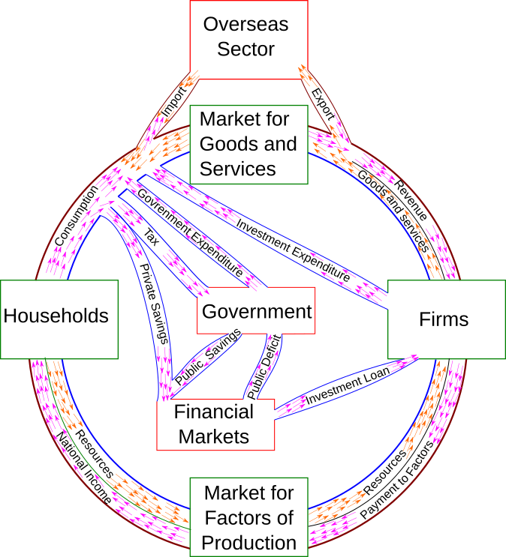
Households sell stuff to the market who than get an income. The entrepreneur then gets profit and the payment going to the firms and flows through to the households.
- Graph
- System of equations

Outputs
- Good and services (products
- Produced by firms in order to create revenue
Inputs
- Factors of production
- land , labor, capital, entrentship
- Owned and hired by households to receive income
- Purchased by firms in order to produce goods and services

Market
- Where supply meets demand so a transition can take place
- Factor markets
- Product markets
- Many sub markets (financial markets, labour markets)

The government sector ( public sector)
- Provides services mandated by electorate ( spends money on thi
- s)
- Transfer payments (takes from rich gives to poor)
- Taxes
- Borrowing

Foriegn sector
- International trade
- Important
- Exports
- Foriegn investments (financial assets)

Importance of international trade
- Specialization and trade allows each person to consume a greater variety of higher quality goods and services than they co8ld produce themselves more cheaply and thereby enjoy a higher standard of living
- This is called comparative advantage
- The same logic applies to individuals applies to international trade
- International trade makes everyone better off

