CHAPTER 1: Marketing: Creating & Capturing Customer Value

The Marketing Process

Step 1: Understanding the Marketplace and Customer Needs
Step 2: Designing a Customer-Driven Marketing Strategy
Step 3: Preparing an Integrated Marketing Plan and Program
Step 4: Building Customer Relationships
Step 5: Capturing Value from Customers

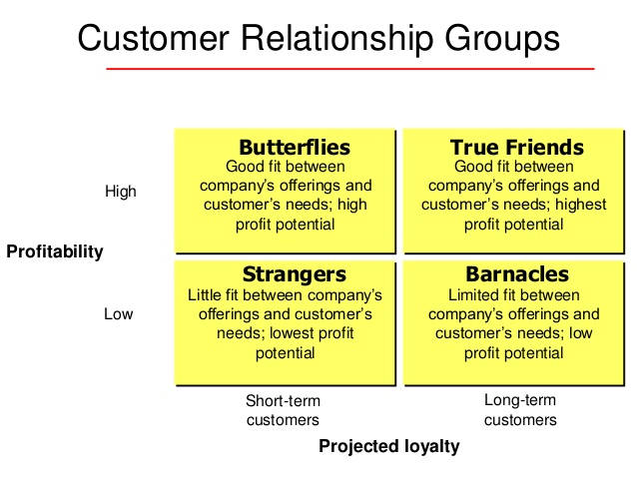

CHAPTER 2: Company and Marketing Strategy: Partnerships to Build CRships
Strategic Planning
Step 1: Defining a Market-Oriented Mission Statement
Step 2: Setting Company Objectives and Goals
Step 3: Designing the Business Portfolio (BCG Matrix, SBUs, P-M Exp. Grid)
Step 4: Planning Marketing and Other Functional Strategies

Managing the Marketing Effort
Step 1: Marketing Analysis (SWOT)
Step 2: Marketing Planning (WHAT & WHY)
Step 3: Marketing Implementation (WHO, WHEN, WHERE, HOW)
Step 4: Marketing Control

CHAPTER 4 : Analyzing the Marketing Environment
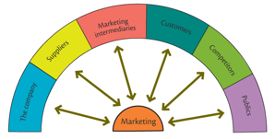
The Microenvironment (value-delivery network)

The Macroenvironment

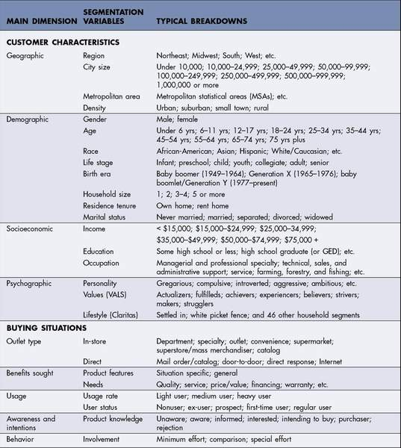

Major Segmentation Variables for Consumer Markets

CHAPTER 5 : Managing Marketing Information to Gain Customer Insights
Marketing Research
Step 1: Defining the Problem and Research Objectives (explor., descr., causal)
Step 2: Developing the Research Plan (primary, secondary data, collect. method)
Step 3: Implementing the Research Plan (collect, process, analyze)
Step 4: Interpreting and Reporting the Findings (conclude, report to management)

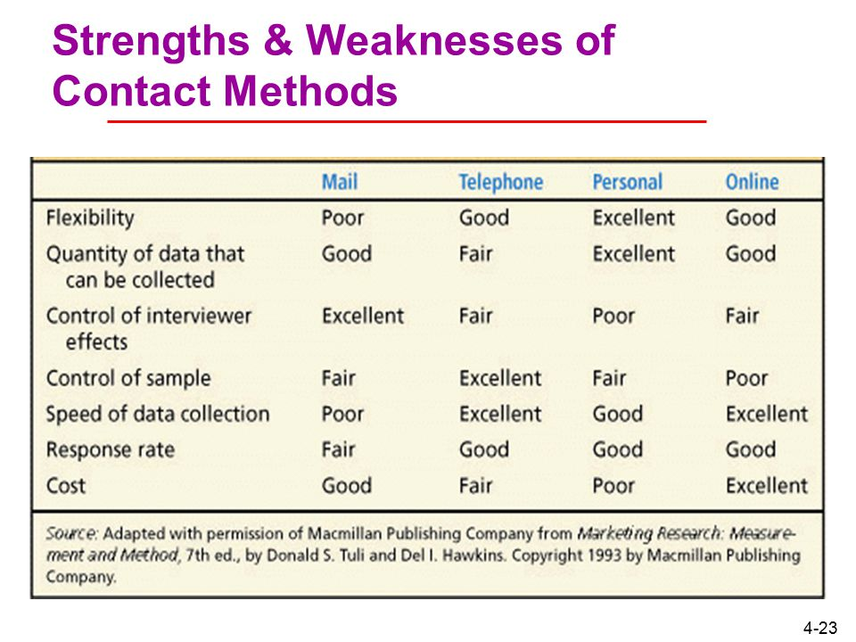

CHAPTER 6 : Understanding Consumer and Business Buyer Behaviour

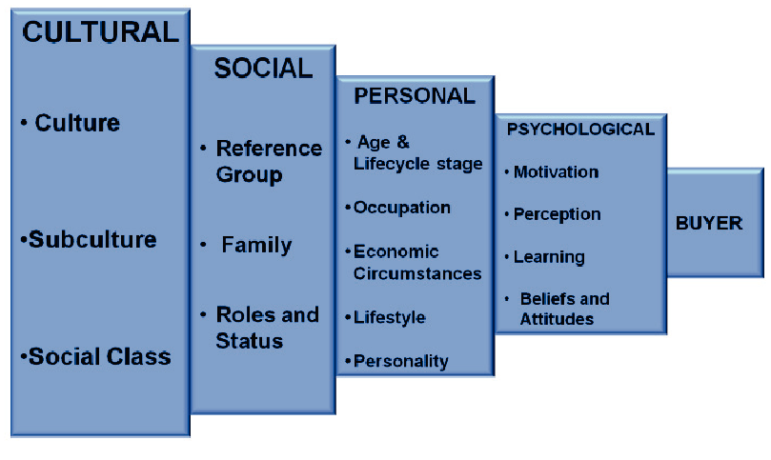
Factors Influencing Consumer Behaviour

PERSONAL
Brand Personality: the specific mix of human traits that may be attributed to a particular brand.
There are 5 brand personality traits:
1. Sincerity: down-to-earth, honest, wholesome, cheerful
2. Excitement: daring, spirited, imaginative, and up to date
3. Competence: reliable, intelligent, and successful
4. Sophistication: glamorous, upper class, charming
5. Ruggedness: outdoorsy and tough

PSYCHOLOGICAL
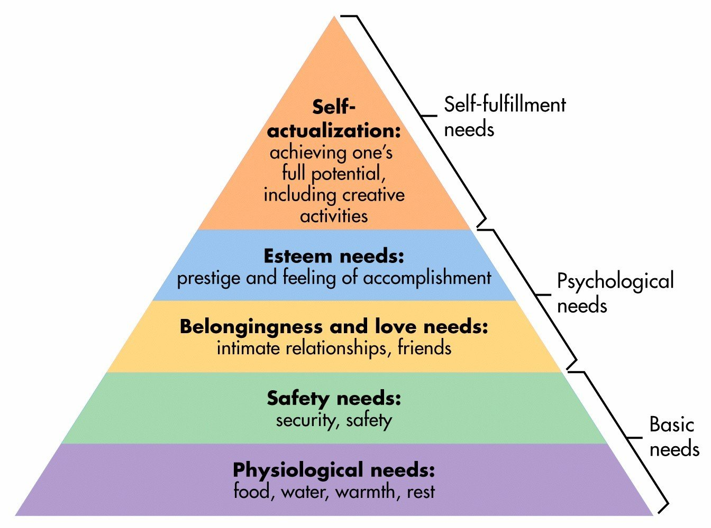

Maslow’s Hierarchy of Needs

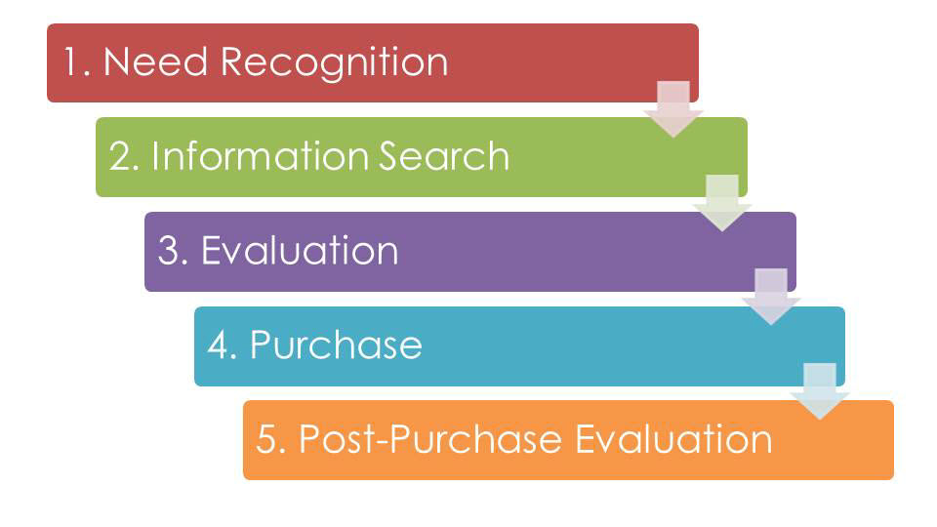
The Buyer Decision Process (existing products)
Stages in the Adoption Process (new products)
1. Awareness: consumer knows existence but does not have info
2. Interest: consumer seeks out info about product
3. Evaluation: does trying the product make sense?
4. Trial: consumer tries the new product on small scale
5. Adoption: consumer decides to make full and regular use of product

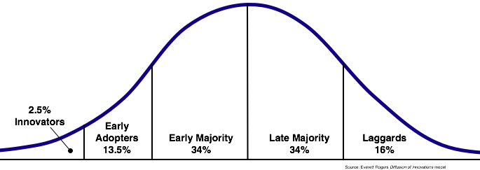

Diffusion of Innovation Model

CHAPTER 7: Segmentation, Targeting, and Positioning

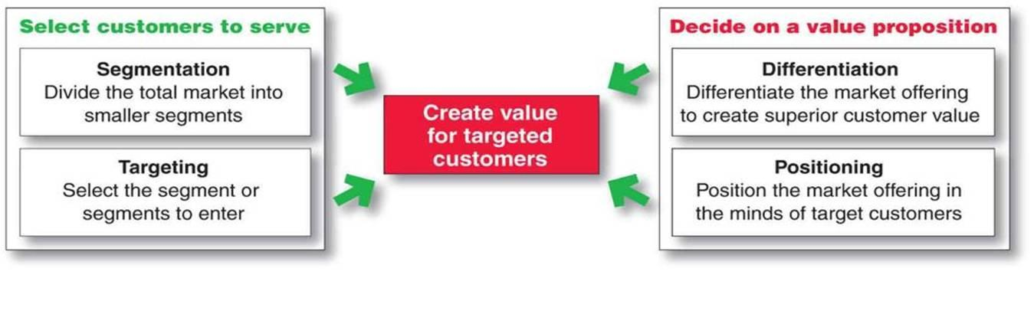

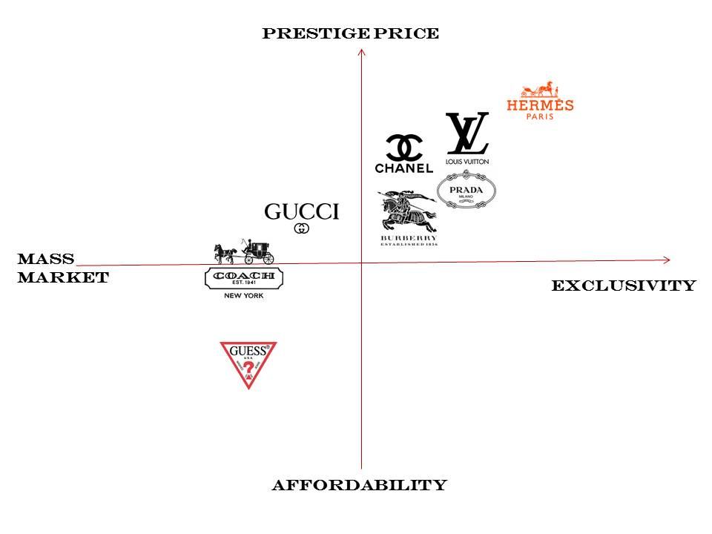

Positioning/Perceptual Map:
Show consumers’ perceptions of their brands vs. competing products on important buying dimensions
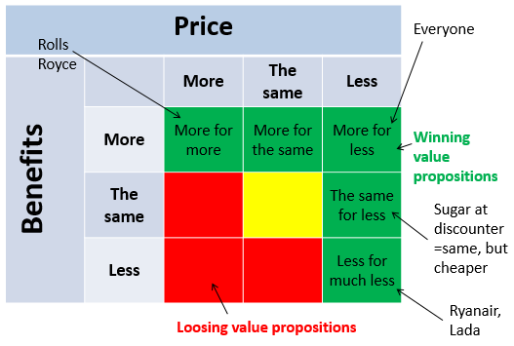

Possible Value Propositions

CHAPTER 8: Developing and Managing Products and Services

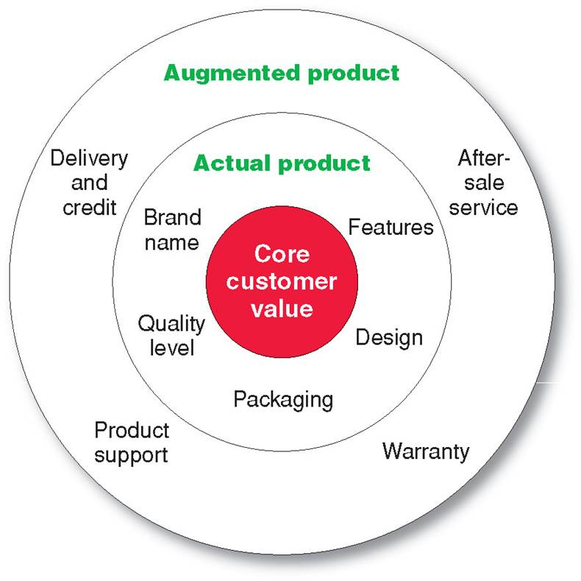

Three Levels of Product (ex: smartphone, iPhone, AppleCare)

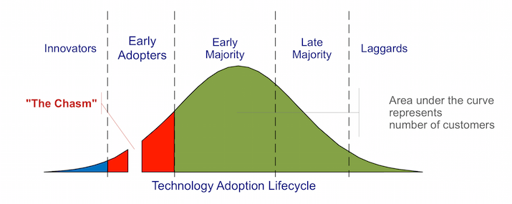
New Product Development

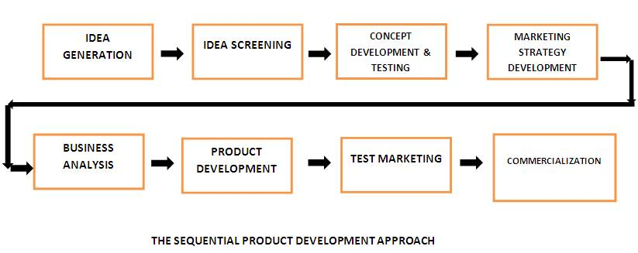
Major Stages in New Product Development

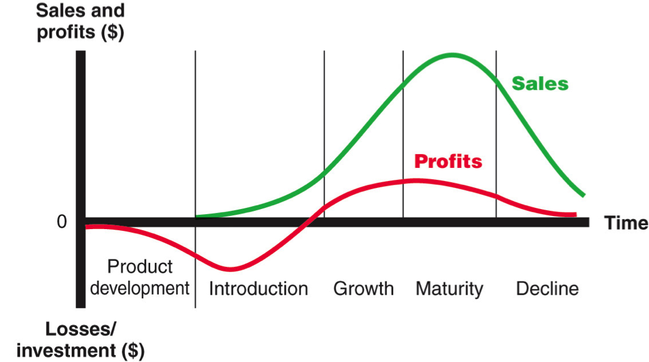
New Product Life Cycle

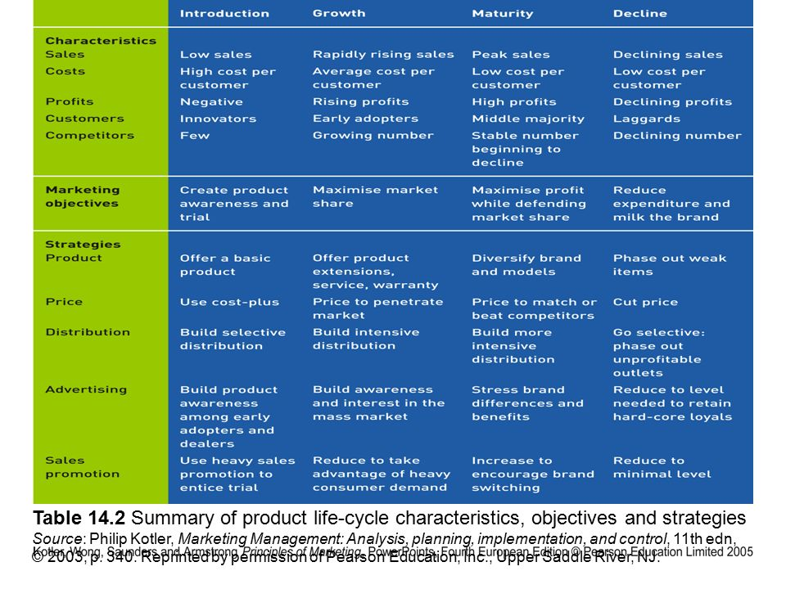
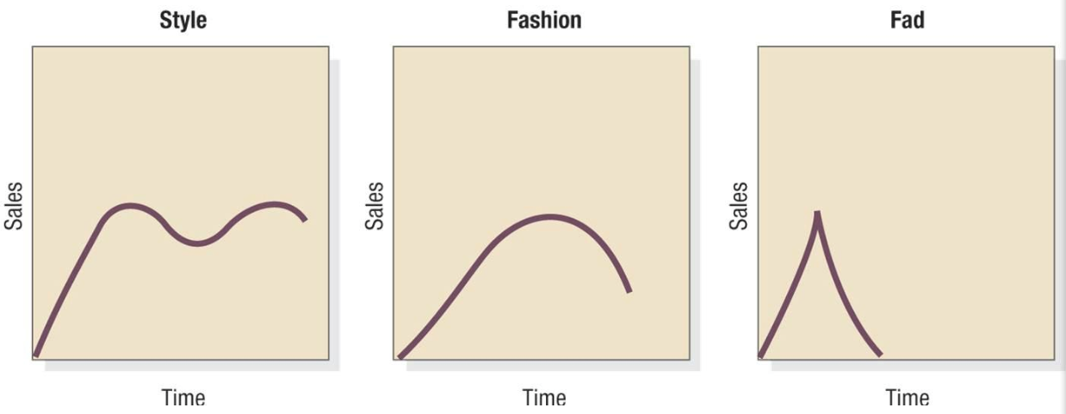

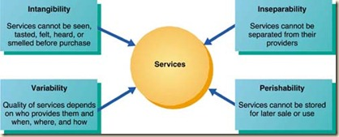
Special Characteristics of Services

An important aspect of the service-profit chain is internal marketing: orienting and motivating contact employees and supporting service people to work as a team to provide customer satisfaction.
Internal marketing should come before external marketing!

CHAPTER 9: Brand Strategy and Management

CHAPTER 10: Pricing: Understanding and Capturing Customer Value

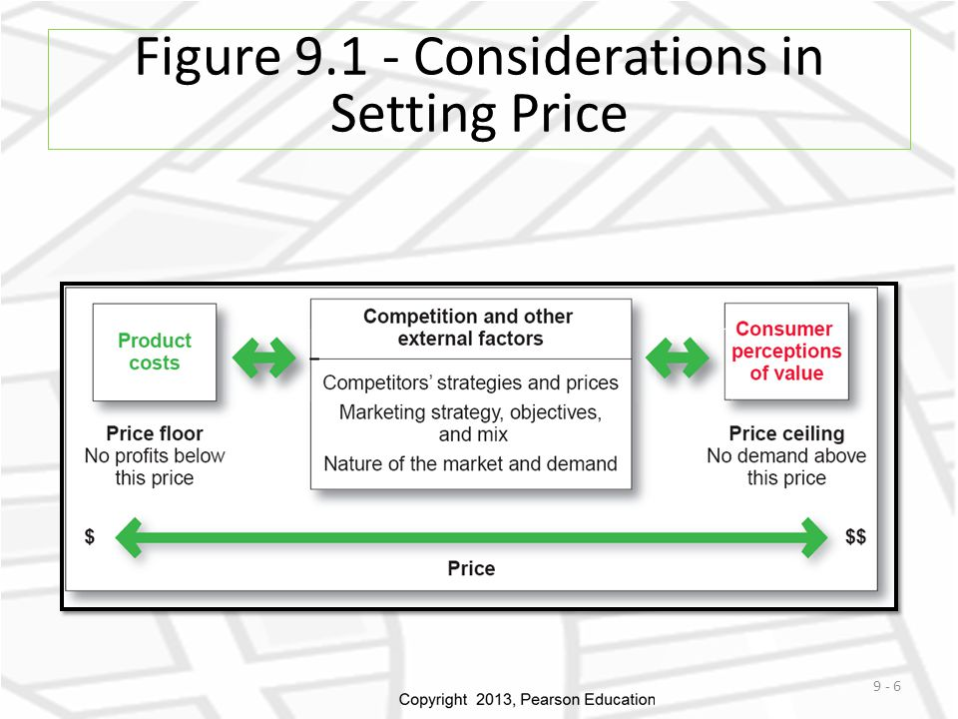

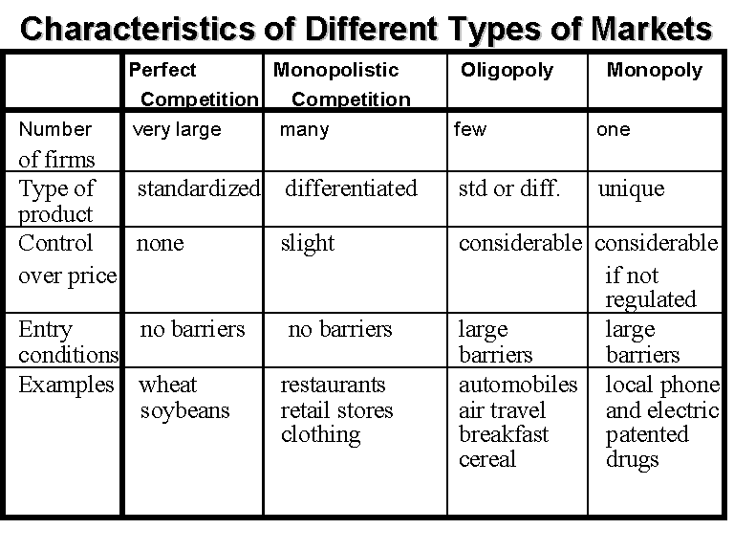
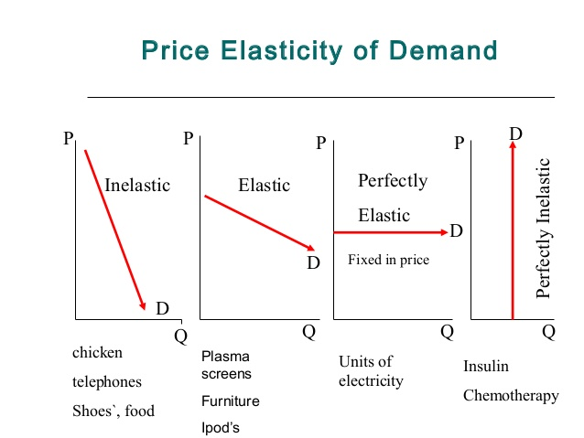

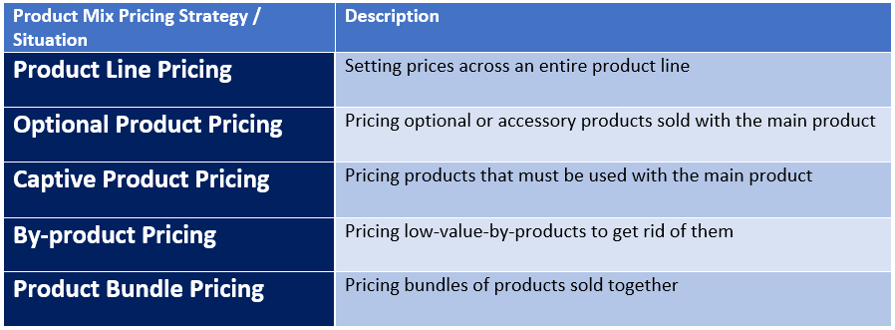
Product Mix Pricing

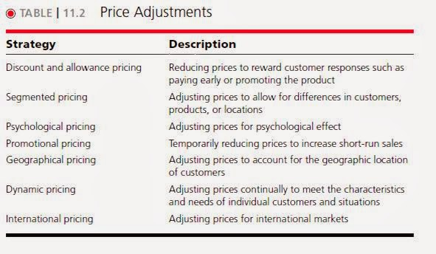

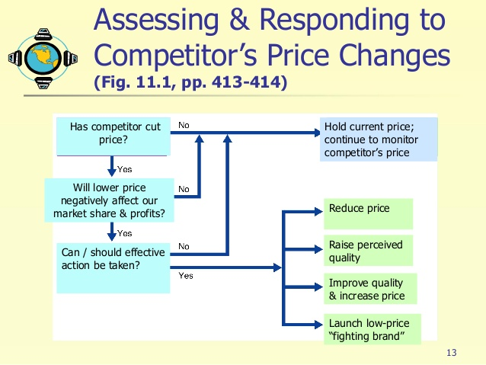
CHAPTER 11: Marketing Channels
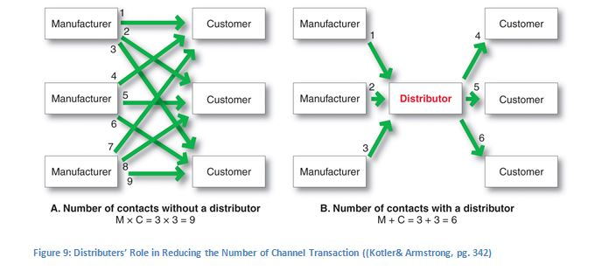
Direct Marketing vs. Distribution Channel

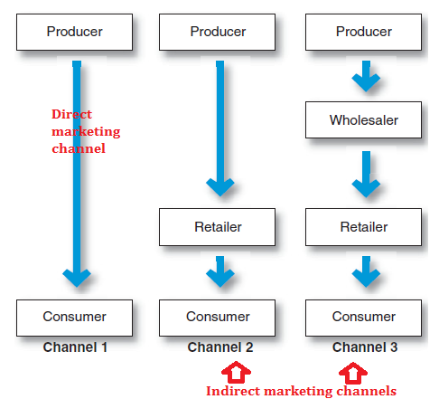

Organization and Management of Channels

Step 1: Select Channel Partners
Step 2: Decide How Many Channel Levels to Create
Step 3: Decide Between Vertical and Horizontal Marketing Systems
Step 4: Manage/Motivate Channel Partners & Avoid Channel Conflict

Marketing Channel Design

Step 1: Analyzing Customer Needs
Step 2: Setting Channel Objectives
Step 3: Types/Responsibilities of Channel Members
Step 4: International Distribution Channels

CHAPTER 13: Communicating Customer Value: Advertising & Public Relations

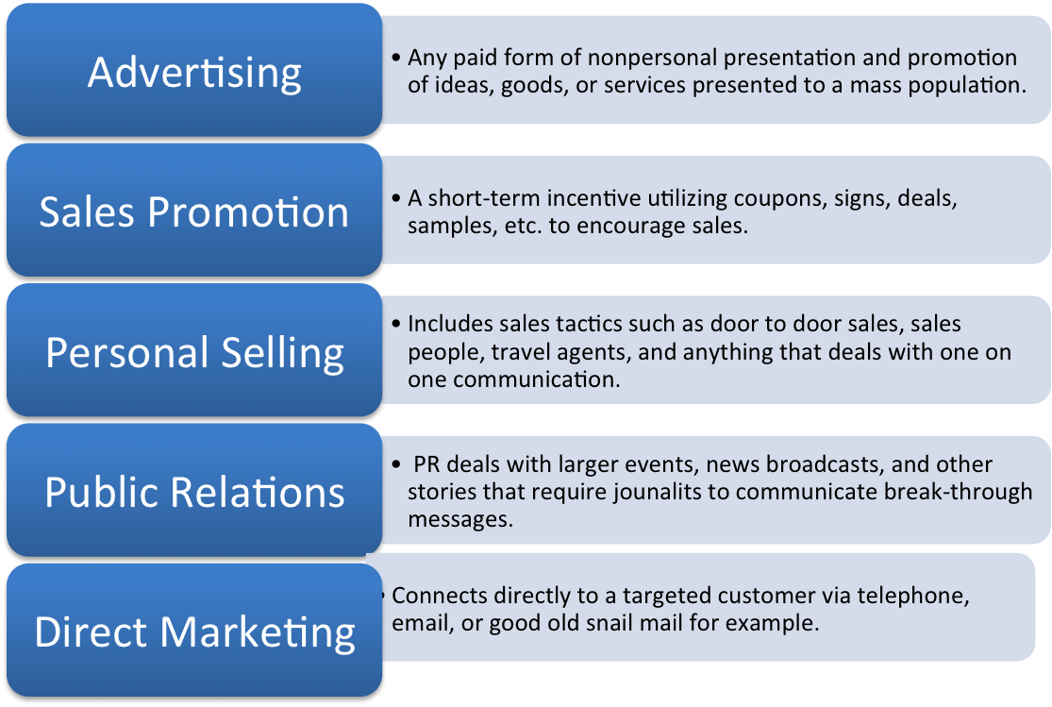
The Promotion Mix (Marketing Communications Mix)

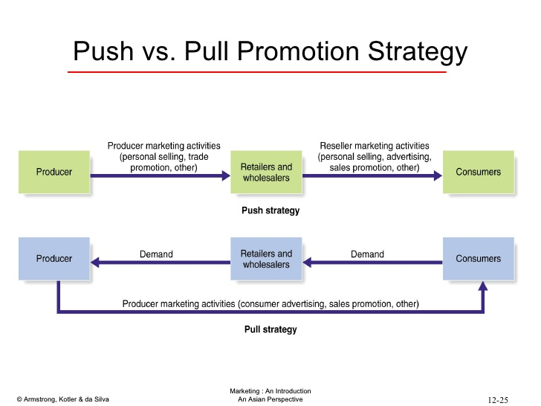
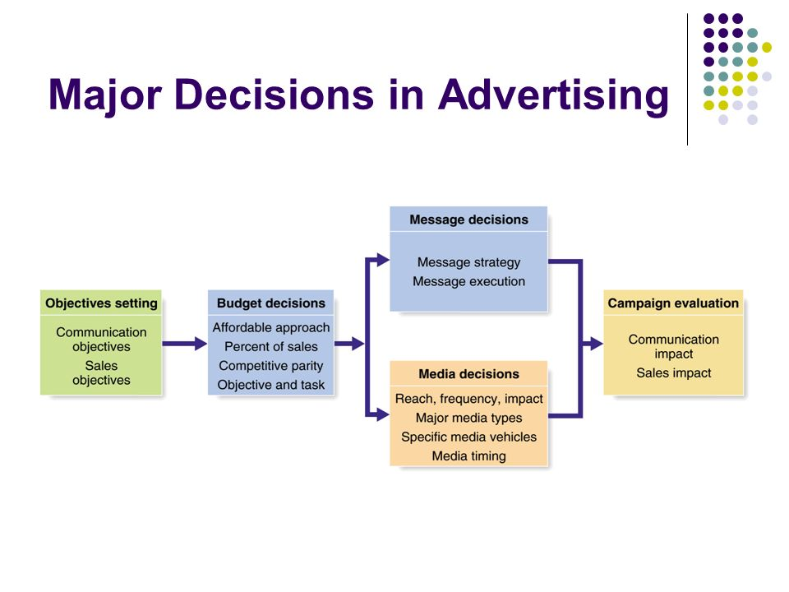
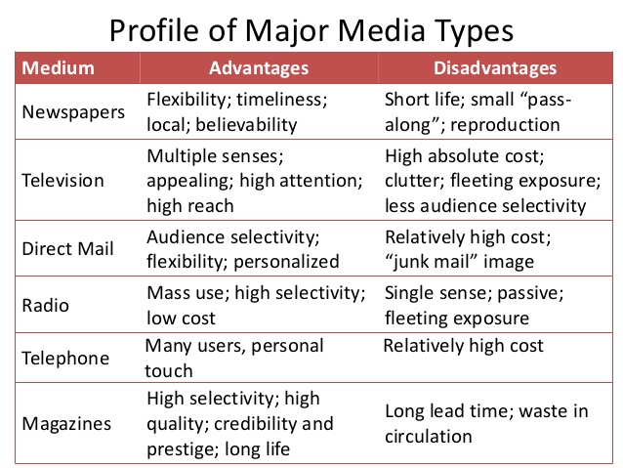
CHAPTER 16: The Global Marketplace
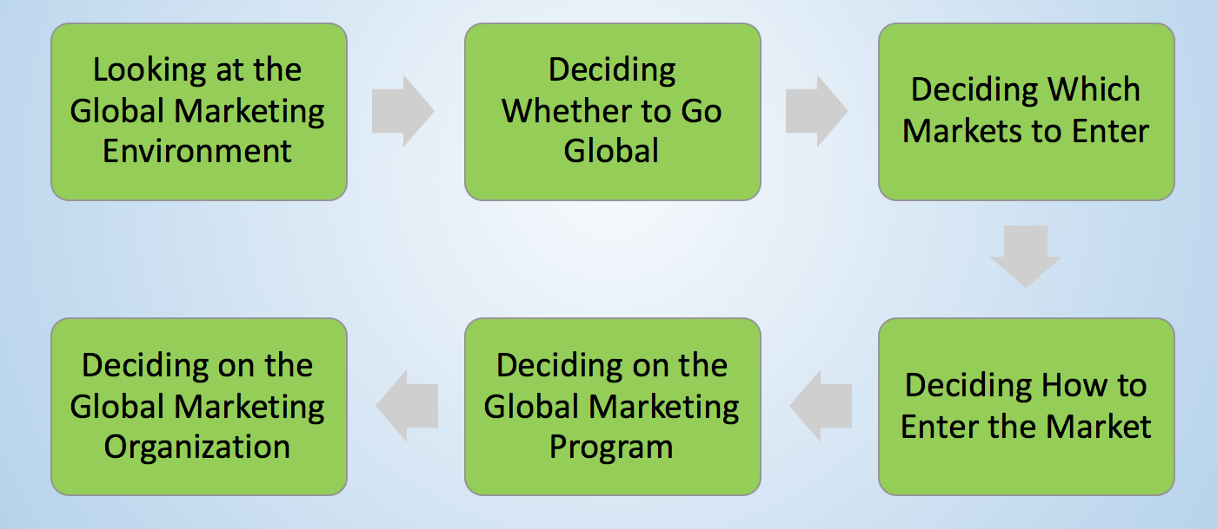
Major International Marketing Decisions

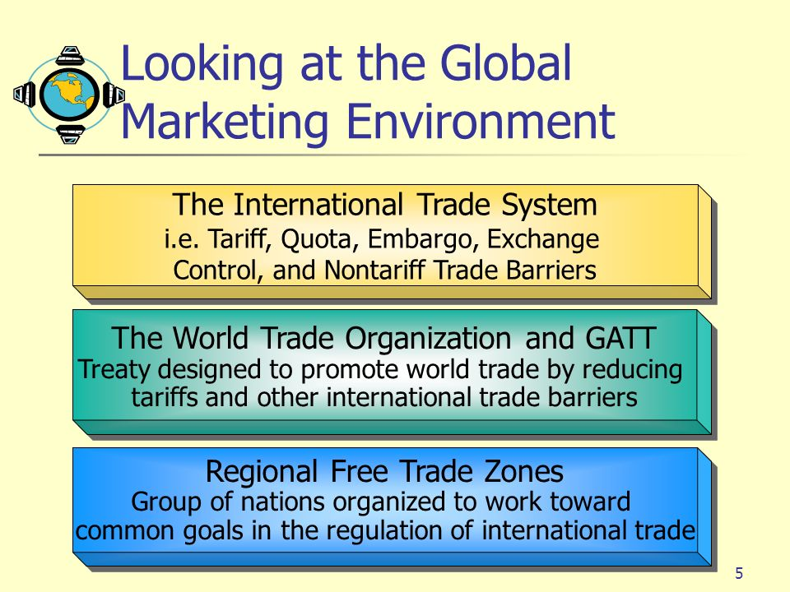
STEP 1
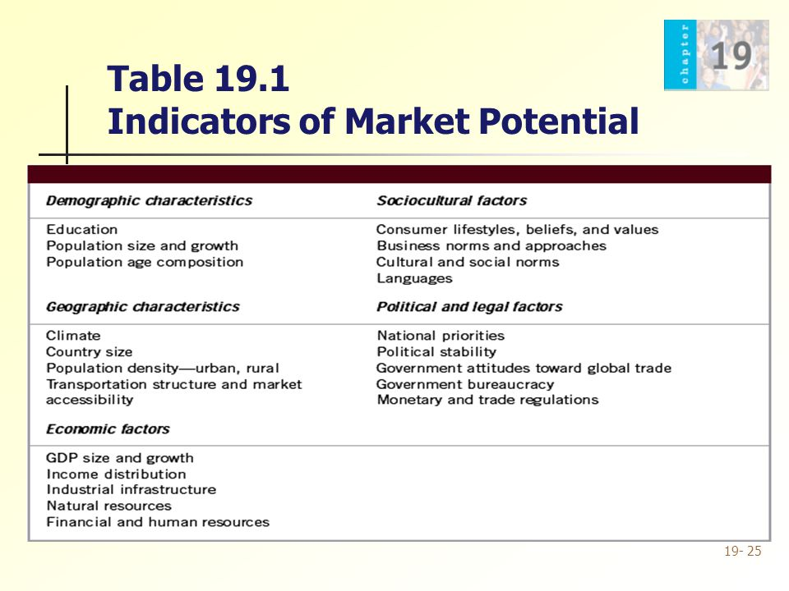
STEP 3: Deciding Which Markets to Enter
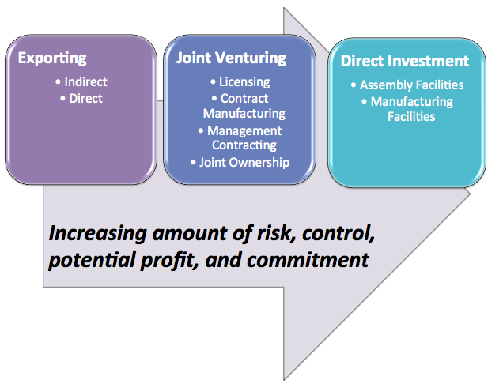
STEP 4: Deciding How to Enter the Market
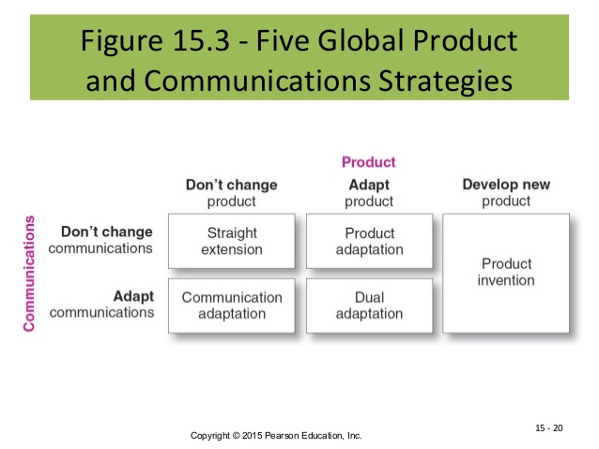
STEP 5: Deciding on the Global Marketing Program

CHAPTER 3: Sustainable Marketing, Social Responsibility, and Ethics


