Experiment 2: A Tall Cold Drink of Water

Date Experiment Performed: October 1, 2019

Date Experiment Submitted: October 8, 2019

Introduction

In a chemistry experiment a calorimeter can be used to measure the amount of thermal energy which is lost or gained in a chemical reaction. The amount of transferred heat in the reaction can also be determined by a calorimeter for any given reaction. The behaviour of a substance can be identified through heating or cooling it using a calorimeter to determine the nature of the material. It is necessary for the experiment to be conducted under controlled conditions, which in this case is the constant volume of water and type of calorimeter. The key assumption made in this experiment is that no energy is lost or gained from within the calorimeter or surroundings, however, energy does escape in different forms and this can cause variation in the results.

The formula used to obtain thermal energy is denoted by Q = mCΔT. By using the mass of the substance being used in the calorimetry experiment, the specific heat capacity of water (4.18 J/g°C) and the change between the initial and final temperature in Celsius, the change in thermal energy can be calculated. If the value obtained for q is a negative that means that the reaction was exothermic and the reaction released energy, however, if the q value is positive that indicates that the reaction was endothermic, and the reaction absorbed energy. In this experiment since the objective is to cool water a positive q value should be calculated, due to this reaction being endothermic.

Using the mass of the can, the theoretical amount of ammonium chloride that was needed to lower the temperature of water in the by 5°C can was 13.29g. Therefore, theoretically after adding 13.29g of ammonium chloride to a calorimeter containing 100mL of water the water should cool by 5°C after 5 minutes.

The most sufficient salt to use for this experiment is ammonium chloride, mainly due to the fact that ammonium nitrate is hazardous and can cause safety issues due to its chemical structure as well as the fact that ammonium chloride has a lower price.

Procedure

- A tin can was filled with 100mL of water
- A calorimeter was obtained and filled with 100mL of water. The tin can was placed inside of it
- The theoretical mass of ammonium chloride needed to cool the water by 5°C was calculated and found to be 13.29g
- 13.23g of ammonium chloride was measured using a scale, and added to the water inside of the calorimeter
- The lid of the calorimeter was immediately put on with a thermometer placed inside that was connected to LabQuest 2, which was measuring and recording the temperature of the water inside the tin can 6 times per minute
- The calorimeter was then swirled for 5 minutes to ensure the contents inside the calorimeter were fully mixed
- The contents inside the calorimeter and tin can were properly disposed into the inorganic waste container, the materials were then rinsed and dried
- Steps 1-7 were repeated two more times using 14.25g and 15.25g of ammonium chloride

Discussion/Observations

Trial 1: Trial 2: Trial 3:
Time (min) | Temperature (°C) | Time (min) | Temperature (°C) | Time (min) | Temperature (°C)
0.0 | 23.2 | 0.0 | 23.6 | 0.0 | 23.9
0.5 | 22.2 | 0.5 | 21.3 | 0.5 | 23.1
1.0 | 21.8 | 1.0 | 20.7 | 1.0 | 21.4
1.5 | 21.2 | 1.5 | 20.5 | 1.5 | 21.6
2.0 | 21.0 | 2.0 | 20.5 | 2.0 | 21.8
2.5 | 20.5 | 2.5 | 20.5 | 2.5 | 21.7
3.0 | 20.6 | 3.0 | 20.4 | 3.0 | 21.4
3.5 | 20.6 | 3.5 | 20.4 | 3.5 | 21.2
4.0 | 21.2 | 4.0 | 20.4 | 4.0 | 21.4
4.5 | 21.1 | 4.5 | 20.4 | 4.5 | 21.1
5.0 | 21.0 | 5.0 | 20.2 | 5.0 | 20.9

Graphs:

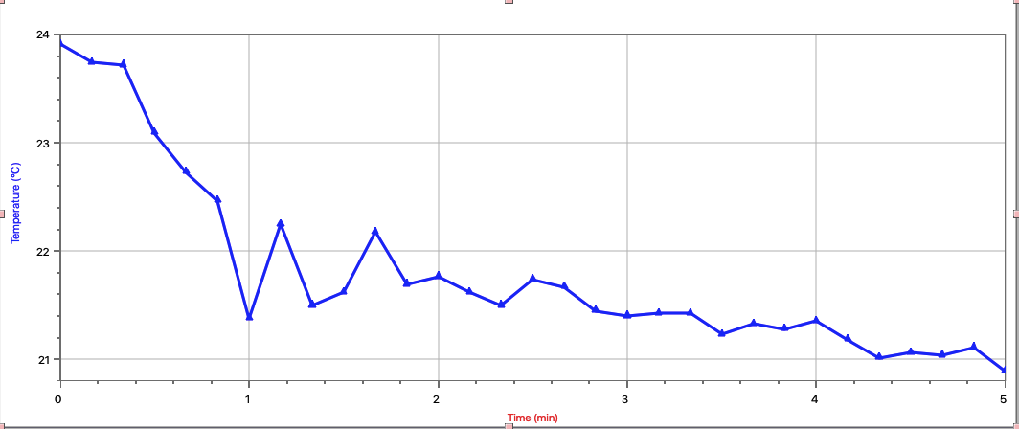
Trial 1: Temperature of Water in a Calorimeter over 5 Minutes (13.23g of NH4Cl)

Trial 2: Temperature of Water in a Calorimeter Over 5 Minutes (14.25g of NH4Cl)

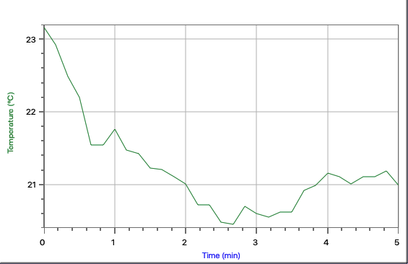

Trial 3: Temperature of Water in a Calorimeter Over 5 Minutes (15.25g of NH4Cl)

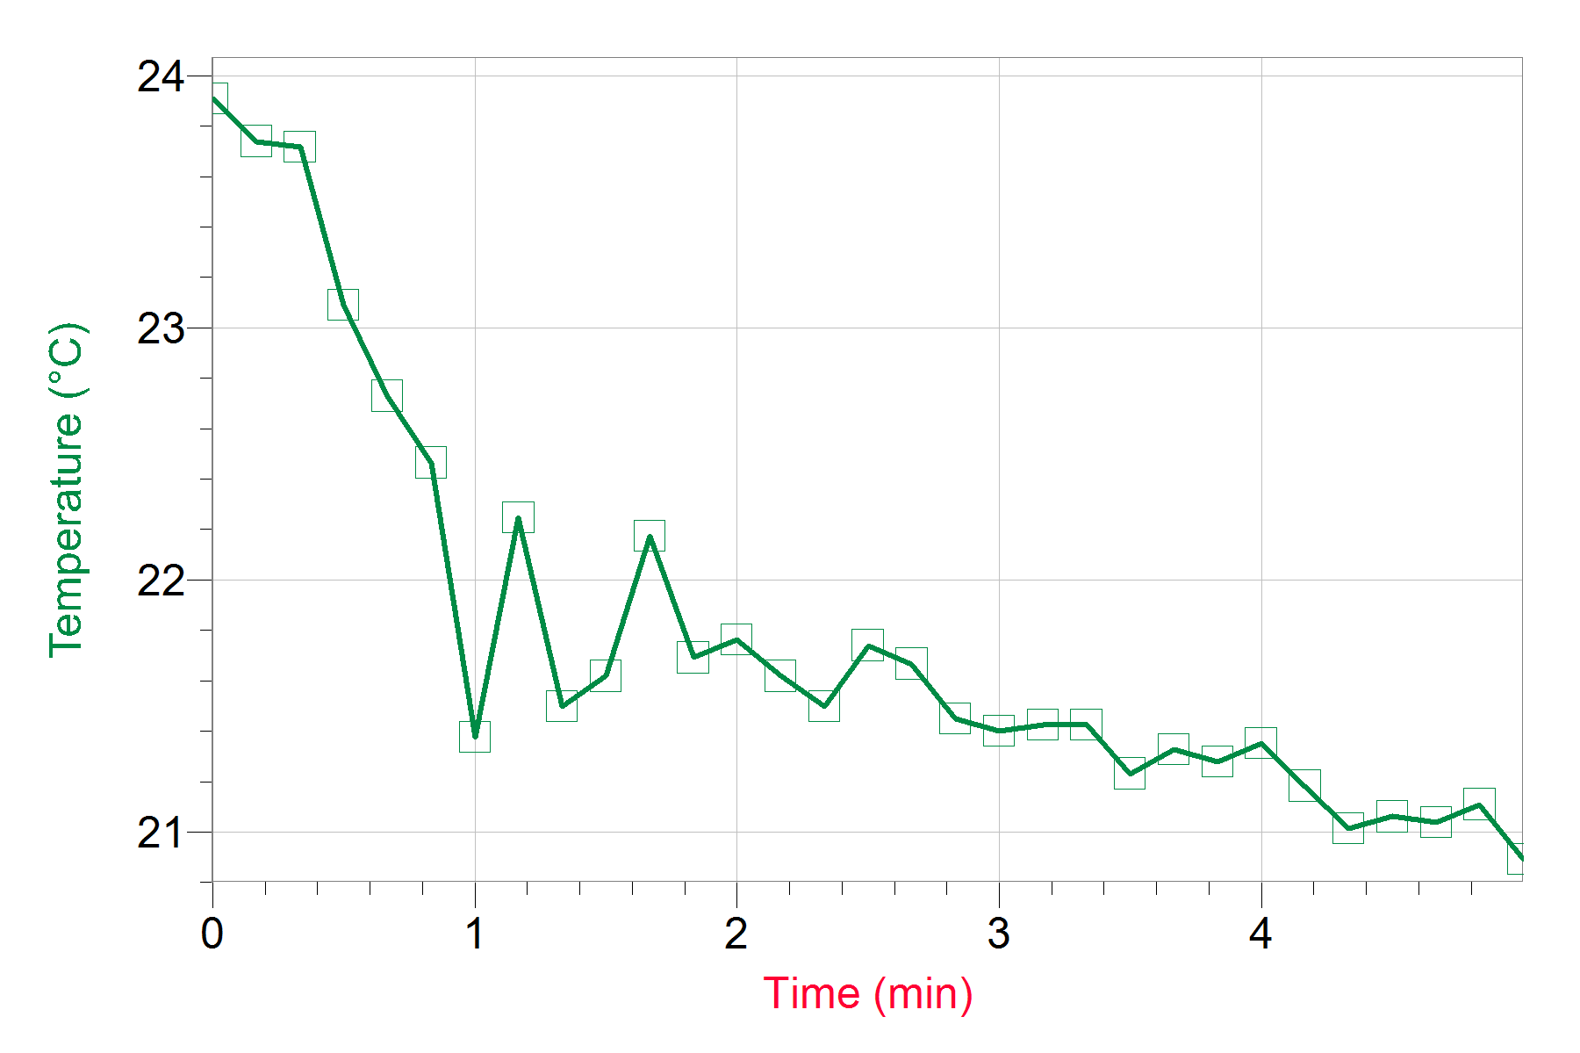

This data reveals the relationship between the independent variable time, and the dependent variable temperature for 100mL of water in a calorimeter. As time passes in the experiment, the temperature of the water decreases because of the solution of ammonium chloride and water mixing in the outer calorimeter and creating an endothermic reaction. Theoretically, it would have taken 13.29g of salt to cool the water by 5 degrees, but as shown in the test results, when 13.23 g of salt was added, the temperature dropped by 2.2 degrees in 5 minutes, proving that the design did not yield the predicted result. In Trial 3, 15.25g of salt was added because the 14.25g of salt in Trial 2 wasn’t enough to lower the temperature of the water by 5 degrees. After 5 minutes the calorimeter lowered the temperature of water by 3 degrees as shown in the third graph. The impact of these results is that is reveals that the system we used wasn’t perfect therefore we weren’t able to lower the temperature of 100mL of water by 5°C in 5 minutes even when using different amounts of ammonium chloride. To improve our results, we could have been more careful with the thermometer in trials 1 and 2, as the thermometer made contact with the bottom of the can and created variation in the temperature that was recorded. In Trial 3 we tried placing paper towel underneath the top of the calorimeter so that the thermometer didn’t touch the bottom and it produced our best result.

The limitations of this experiment are related to energy being lost to the surroundings as in the case of this experiment, perfect heat transfer didn’t occur. In this experiment we assumed that perfect heat transfer occurred, but heat could have entered the calorimeter from the surroundings before the top was put on or before the thermometer was in the appropriate position to measure the temperature. Due to this limitation we weren’t able to obtain the result we were looking for, however, my group learned an important lesson about the reality of calorimetry; in that non perfect conditions can cause large variations in thermal energy experiments.

Conclusion

In Trial 3, 15.25g of ammonium nitrate was not enough to lower the temperature of 100mL of water by 5°C suggesting that energy may have been lost to the surroundings or been absorbed before the top of the calorimeter was placed on. In addition, because of the quality of the calorimeter used in the experiment and other factors such as thermometer placement inaccurate results were obtained.

Appendix

Calculations
Theoretical Amount:
ΔHsol(NH4Cl) = 17KJ/mol
qtotal = [qH2Oincan + qH20outside] + qcan
= (mCΔT)H2O + (mcΔT)can
= [(100mL+100mL)(4.18 J/g°C)(5°C)] + [(9.35)(.902)(5°C)]
= 4.18kJ + 0.0422kJ
= 4.2222kJ
Moles of NH4CL= q/ΔH = 4.2222KJ/17KJ/mol = 0.24836471 moles
Mass of NH4CL = Moles of NH4CL x Molar Mass of NH4CL = 0.24836471 mol x 53.491 g/mol = 13.29g

Experimental Amount: 15.25 grams of NH4CL lowered the temperature of the drink by 3.0°C.

References:

Principles of Thermal Analysis and Calorimetry, Royal Society of Chemistry. https://pubs.rsc.org/en/content/chapterpdf/2006/9781847551764-00001?isbn=978-0-85404-610-2&sercode=bk

Raw Data


