CHAPTER 7
Understand the difference between rational vs nonrational decision making model
- Rational model of decision making
  - explains how managers should make decisions
  - assumes managers will make logical decisions that will be optimum in furthering the organization’s best interests
  - also called the classical model
- Nonrational models of decision making
  - assume that decision making is nearly always uncertain and risky, making it difficult for managers to make optimal decisions
  - Two nonrational models are:
    - Satisficing - managers seek alternatives until they find one that is satisfactory, not optimal.
    - Intuition - making a choice without the use of conscious thought or logical inference. Stems from both:
      - Expertise—a person’s explicit and tacit knowledge about a person, a situation, an object, or a decision opportunity—is known as a holistic hunch
      - Automated experience – the involuntary emotional response to those same matters

What is Bounded Rationality?
- suggests that the ability of decision makers to be rational is limited by numerous constraints such as complexity, time and money, and their cognitive capacity, values, skills, habits, and unconscious reflexes

What are the stages in rational decision-making process?
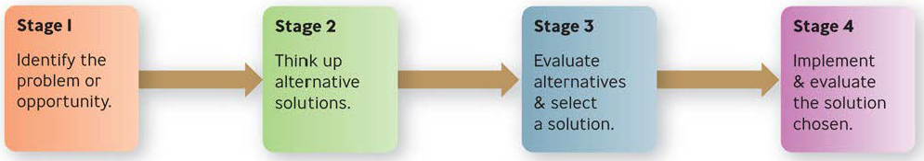

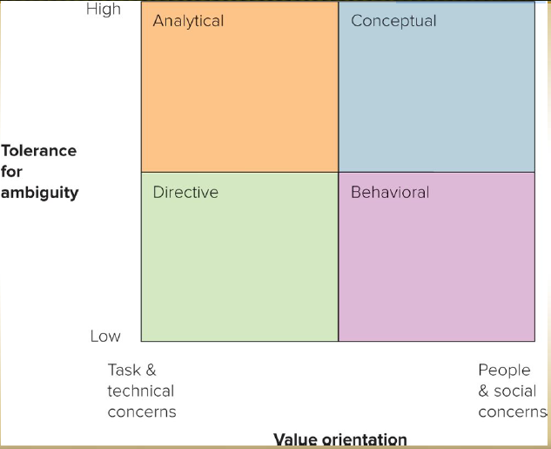
What are the 4 decision making styles?
- Directive
  - people are efficient, logical, practical, and systematic in their approach to solving problems
  - action oriented, decisive, and like to focus on facts
- Analytical
  - considers more information and alternatives
- Conceptual
  - takes a broad perspective to problem solving
  - likes to consider many options and future possibilities
- Behavioral
  - supportive, receptive to suggestions, show warmth
  - prefer verbal to written information

CHAPTER 8
Organizational (corporate) culture – The set of shared, taken-for-granted implicit assumptions that a group holds and that determines how it perceives, thinks about, and reacts to its various environments

Organizational Culture—What are norms, values, assumptions?
- Norms are organized and shared ideas regarding what members should do and feel, how this behavior should be regulated, and what sanctions should be applied when behavior does not coincide with social expectations.
  - behaviors and rules of conduct that specify what should or should not be done in specific situations
- Values - ideas & beliefs regarded as important to a person or group
  - Espoused values
    - explicitly stated values and norms preferred by an organization
  - Enacted values
    - represent the values and norms actually exhibited in the organization
- Basic Assumptions
  - represent the core values of the organization’s culture
  - those taken for granted and highly resistant to change

What is the competing values framework?
A theory developed from research conducted on the major indicators of effective organizations. Based on statistical analyses of a comprehensive list of effectiveness indicators, two major dimensions of underlying conceptions of effectiveness were discovered.
- Organizational focus, from an internal emphasis on the well-being and development of people in the organization to an external focus on the well-being and development of the organization itself.
- Organizational preference for structure and represents the contrast between stability and control and flexibility and change.
- The horizontal dimension—inward or outward focus? This dimension expresses the extent to which an organization focuses its attention and efforts inward on internal dynamics and employees (“internal focus and integration”) versus outward toward its external environment and its customers and share-holders (“external focus and differentiation”).
- The vertical dimension—flexibility or stability? This dimension expresses the extent to which an organization prefers flexibility and discretion versus stability and control. Combining these two dimensions creates the four types of organizational culture based on different core values—namely, clan, adhocracy, market, and hierarchy
- Together, the two dimensions form four quadrants

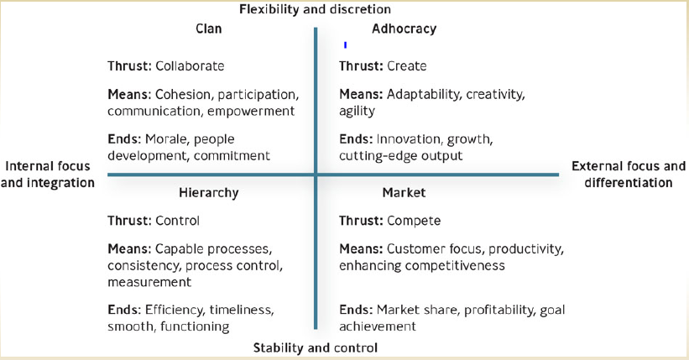
Understand the types of cultures
- Clan culture
  - Internal focused
  - values flexibility rather than stability
  - encourages collaboration among employees
- Adhocracy culture
  - attempts to create innovative products by being adaptable, creative, and quick to respond to changes in the marketplace
- Market culture
  - focused on the external environment
  - driven by competition and a strong desire to deliver results
- Hierarchy culture
  - apt to have a formalized structured work environment aimed at achieving effectiveness through a variety of control mechanisms

What is the three levels of organizational culture?
Level 1: Observable artifacts
- physical manifestations such as manner of dress, awards, myths and stories about the company
- visible behavior exhibited by managers and employees
Level 2: Espoused Values
- Espoused values
  - explicitly stated values and norms preferred by an organization
- Enacted values
  - represent the values and norms actually exhibited in the organization
Level 3: Basic Assumptions
- represent the core values of the organization’s culture
- those taken for granted and highly resistant to change

What is the difference between espoused vs. enacted values?
Espoused values: explicitly stated values and norms preferred by an organization
Enacted values: represent the values and norms actually exhibited in the organization

How do employees learn the organizational culture?
- Symbols: an object, an act, a quality, or event that conveys meaning to others
- Stories: narrative based on true events repeated—and sometimes embellished upon—to emphasize a particular value
- Heroes: person whose accomplishments embody the values of the organization
- Rites and rituals: activities and ceremonies that celebrate important occasions and accomplishments
- Organizational socialization: the process by which people learn the values, norms, and required behaviors of an organization

What are the common elements of an organization?
- Common Purpose: The Means for Unifying Members - An organization without purpose soon begins to drift and become disorganized. The common purpose unifies employees or members and gives everyone an understanding of the organization’s reason for being.
- Coordinated Effort: Working Together for Common Purpose - The common purpose is realized through coordinated effort, the coordination of individual efforts into a group or organization wide effort. Although it’s true that individuals can make a difference, they cannot do everything by themselves.
- Division of Labor: Work Specialization for Greater Efficiency - Division of labor, also known as work specialization, is the arrangement of having discrete parts of a task done by different people. Even a two-person crew operating a fishing boat probably has some work specialization—one steers the boat and the other works the nets. With division of labor, an organization can parcel out the entire complex work effort to be performed by specialists, resulting in greater efficiency.
- Hierarchy of Authority: The Chain of Command – Unity of Command. A control mechanism for making sure the right people do the right things at the right time. If coordinated effort is to be achieved, some people—namely, managers—need to have more authority, or the right to direct the work of others. Even in member-owned organizations, some people have more authority than others, although their peers may have granted it to them.
- Span of Control: The span of control, or span of management, refers to the number of people reporting directly to a given manager. There are two kinds of spans of control:
- Narrow (or Tall): This means a manager has a limited number of people reporting—three vice presidents reporting to a president, for example, instead of nine vice presidents. An organization is said to be tall when there are many levels with narrow spans of control.
- Wide (or Flat): This means a manager has several people reporting—a first-line supervisor may have 40 or more subordinates, if little hands-on supervision is required, as is the case in some assembly-line workplaces. An organization is said to be flat when there are only a few levels with wide spans of control.
- Authority, Responsibility, and Delegation: Line versus Staff Positions - Male sea lions have to battle other males to attain authority over the herd. In human organizations, however, authority is related to the management authority in the organization; it has nothing to do with the manager’s fighting ability or personal characteristics. With authority goes accountability, responsibility, and the ability to delegate one’s authority.
- Authority – rights inherent in a managerial position to make decisions and utilize resources
- Accountability – managers must report and justify work results to the managers above them
- Authority, responsibility, & delegation (cont.)
- Responsibility – obligation you have to perform the tasks assigned to you
- Delegation – process of assigning managerial authority and responsibility to managers and employees lower in the hierarchy

- Centralization versus Decentralization of Authority Who makes the important decisions in an organization? That is what the question of centralization versus decentralization of authority is concerned with.
- Centralized authority – important decisions are made by higher-level managers
- Decentralized authority – important decisions are made by middle-level and supervisory-level managers

How does a manager determine the organizational structure?
Organizational structure
A formal system of task and reporting relationships that coordinates and motivates an organization’s members so that they can work together to achieve the organization’s goals.
Organization Chart
Box-and-lines illustration showing the formal lines of authority and the organization’s official positions or work specializations

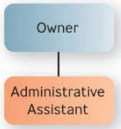
Traditional Designs
Simple structure
Authority is centralized in a single person with few rules and low work specialization

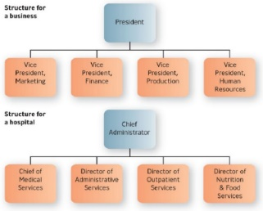

Functional structure
People with similar occupational specialties are put together in formal groups

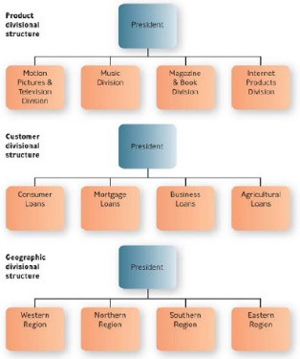

Divisional structure
People with diverse occupational specialties are put together in formal groups by similar products, customers or geographic regions

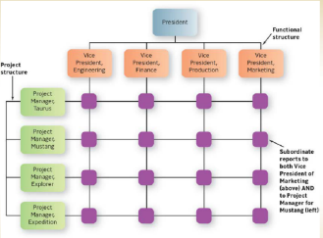

Matrix structure
an organization combines functional and divisional chains of command in a grid so that there are two command structures-vertical and horizontal

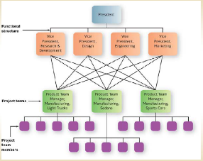

Horizontal design
Teams or workgroups, either temporary or permanent, are used to improve collaboration and work on shared tasks by breaking down internal boundaries

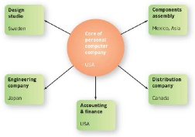
Hollow structure
The organization has a central core of key functions and outsources other functions to vendors who can do them cheaper or faster

Modular structure
Firm assembles product chunks, or modules, provided by outside contractors

Virtual organization
Organization whose members are geographically apart, usually working with e-mail, collaborative
computing, and other computer connections

Virtual structure
Company outside a company that is created “specifically to respond to an exceptional market opportunity that is often temporary

CHAPTER 9
Definition of human resource management and what components does it entails?
Human resource management consists of the activities managers perform to plan for, attract, develop, and retain an effective workforce. Planning the human resources needed consists of understanding current employee needs and predicting future employee needs.
- Establish the mission & the vision
- Establish the grand strategy
- Formulate the strategic plans
- Plan human resources needed
- Recruit & select people
- Orient, train, & develop
- Perform appraisals of people
- Purpose: Get optimal work performance to help realize company’s mission & vision

What is human capital?
The economic or productive potential of employee knowledge, experience, and actions

Why is important for a manager to value HR?
Staffing is important to a company’s success
Putting employees first has been the foundation for a business’s success

What is the difference between job analysis, job description, and human resource inventory?
- Job analysis – Determining the basic elements of a job by observation and analysis
- Job description – Summarizes what the holder of the job does and how and why he or she does it
- Job specification – Describes the minimum qualifications a person must have to perform a job successfully
- Human resource inventory – Report listing your organization’s employees by name, education, training, languages, and
other important information

What is recruiting?
- Process of locating and attracting qualified applicants for jobs open in the organization
- “5% of your workforce produces 26% of your output”
- Internal – hiring from the inside
- External – from the outside

What are the advantages and disadvantages of internal and external recruiting?
INTERNAL RECRUITING
ADVANTAGES | DISADVANTAGES
Employees tend to be inspired to greater effort and loyalty. Morale is enhanced because they realize that working hard and staying put can result in more opportunities. | Internal recruitment restricts the competition for positions and limits the pool of fresh talent and fresh viewpoints.
The whole process of advertising, interviewing, and so on is cheaper. | It may encourage employees to assume that longevity and seniority will automatically result in promotion.
There are fewer risks. Internal candidates are already known and are familiar with the organization. | Whenever a job is filled, it creates a vacancy elsewhere in the organization.
EXTERNAL RECRUITING
ADVANTAGES | DISADVANTAGES
Applicants may have specialized knowledge and experience. | The recruitment process is more expensive and takes longer.
Applicants may have fresh viewpoints. | The risks are higher because the persons hired are less well known.

What is the process of selection including interviewing, employment tests and background information?
- Selection process - The screening of job applicants to hire the best candidate
- Three types of selection tools are background information, interviewing, and employment tests.
  - Background Information: Application Forms, Resumes, and Reference Checks Application forms and resumes provide basic background information about job applicants, such as citizenship, education, work history, and certifications.
  - Unstructured interview
    - no fixed set of questions and no systematic scoring procedure
    - involves asking probing questions to find out what the applicant is like
  - Structured interview
    - Involves asking each applicant the same questions and comparing their responses to a standardized set of answers
    - Situational - focuses on hypothetical situations
    - Behavioral - explores what applicants have actually done in the past
  - Employment Tests: Ability, Personality, Performance, Integrity, and Others
    - legally considered to consist of any procedure used in the employment selection decision process
    - reliability - the degree to which a test measures the same thing consistently
    - validity - the test measures what it purports to measure and is free of bias

What is performance management?
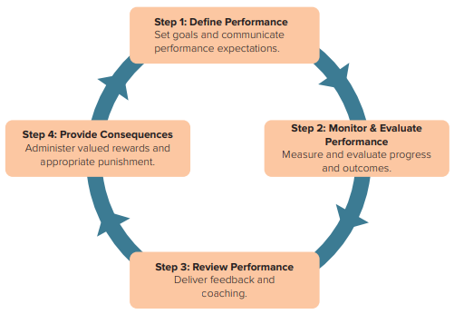
A set of processes and managerial behaviors that involve defining, monitoring, measuring, evaluating, and providing consequences for performance expectations. It consists of four steps: define performance, monitor and evaluate performance, review performance, and provide consequences

Describe the 4 steps in the performance management process?
Step 1: Define Performance
Set goals and communicate performance expectations.
Step 2: Monitor & Evaluate Performance
Measure and evaluate progress and outcomes.
Step 3: Review Performance
Deliver feedback and Coaching
Step 4: Provide Consequences
Administer valued rewards and appropriate punishment.

CHAPTER 10
What are the two types of change (Proactive vs. reactive)? —How does a manager behave in each type of change?
Two types of change are reactive and proactive. Forces for change may consist of forces outside the organization—demographic characteristics; technological advancements; shareholder, customer, and market changes; and social and political pressures. Or they may be forces inside the organization—human resources concerns and managers’ behavior.
- Reactive change: Responding to Unanticipated Problems and Opportunities
  - Making changes in response to problems or opportunities as they arise
- Proactive change: Managing Anticipated Problems and Opportunities
  - involves making carefully thought-out changes in anticipation of possible or expected problems or opportunities
  - also called planned change

What are the forces for changes both internal and external?
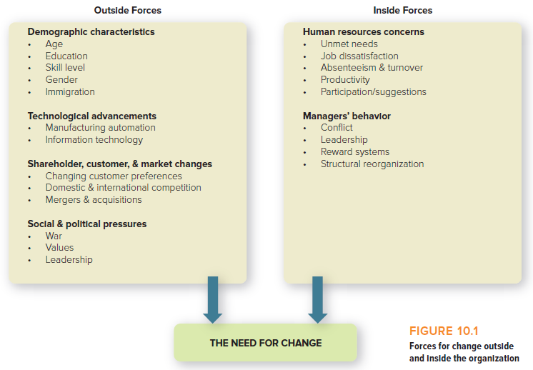

What is a change agent?
A consultant with a background in behavioral sciences who can be a catalyst in helping organizations deal
with old problems in new ways.

What are the reasons employees resist change?
- Individual’s predisposition toward change
- Surprise and fear of the unknown
- Climate of mistrust
- Fear of failure
- Loss of status or job security
- Peer pressure
- Disruption of cultural traditions or group relationships
- Personality conflicts
- Lack of tact or poor timing
- Non-reinforcing reward system

How can a manager do when employees resist change?
- Have the courage to follow your ideas
- Inspire with vision
- Effectively engage employees - Overcome opposition
- Implement change in several stages
- Communicate change effectively - Give one consistent explanation for the change
- Allow room for failure - Respond calmly to mistakes
- Provide affirmation
- Tie job performance to collaboration
- Share progress
- Encourage emotional awareness
- Look for opportunities in unconventional ways

Describe Lewin’s change model—How can it be used by a manager?
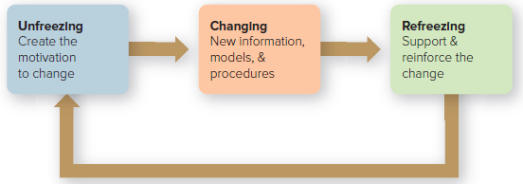
- In the unfreezing stage, managers try to instill in employees the motivation to change, encouraging them to let go of attitudes and behaviors that are resistant to innovation. Managers also need to reduce the barriers to change during this stage.
- In the changing stage, employees need to be given the tools for change: new information, new perspectives, new models of behavior. Managers can help here by providing benchmarking results, role models, mentors, experts, and training.
- In the refreezing stage, employees need to be helped to integrate the changed attitudes and behavior into their normal ways of doing things. Managers can assist by encouraging employees to exhibit the new change and then, through additional coaching and modeling, by reinforcing the employees in the desired change.

What is Organizational Development (OD)?
A set of techniques for implementing planned change to make people and organizations more effective.

How can OD be used in organizations?
- Managing conflict: An OD expert or “executive coach” can help advise on how to improve relationships within the organization.
- Revitalizing organizations: OD experts can help by opening communication, fostering innovation, and dealing with stress.
- Adapting to mergers: OD experts can help integrate two firms with varying cultures, products, and procedures.
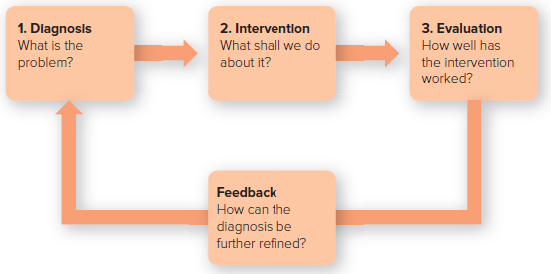
The OD Process

CHAPTER 11
What is personality?
Personality – the stable psychological traits and behavioral attributes that give a person his or her identity

The Big Five Personality Dimensions?
- Extroversion. How outgoing, talkative, sociable, and assertive a person is.
- Agreeableness. How trusting, good-natured, cooperative, and soft-hearted one is.
- Conscientiousness. How dependable, responsible, achievement-oriented, and persistent one is.
- Emotional stability. How relaxed, secure, and unworried one is.
- Openness to experience. How intellectual, imaginative, curious, and broadminded one is.

Proactive personality - someone who is more apt to take initiative and persevere to influence the environment.

What is the difference between Self-esteem vs. self-efficacy vs locus of control?
- Self-efficacy: Belief in one’s ability to do a task
  - Learned helplessness
    - The debilitating lack of faith in one’s ability to control one’s environment
    - Associated with low self-efficacy
  - What can managers do?
    - Give constructive pointers and positive feedback
    - Create goals that are progressively more challenging
    - Offer guided experiences, mentoring, and role modeling
- Self-esteem: The extent to which people like or dislike themselves
  - High self-esteem: more apt to handle failure better, emphasize the positive and to take more risks
  - Low self-esteem: tend to focus more on one’s weaknesses, may be more dependent on others
  - What can managers do?
    - Reinforce employees’ positive attributes and skills
    - Provide positive feedback whenever possible
    - Break larger projects into smaller tasks and projects
    - Express confidence in employees’ abilities to complete their tasks
    - Provide coaching when employees are struggling to complete task
- Locus of control: Indicates how much people believe they control their fate through their own efforts
  - Internal locus of control: you believe you control your destiny
  - External locus of control: you believe external forces control you
  - What can managers do?
    - Employees with internal locus of control should probably be placed in jobs requiring high initiative and lower compliance
    - Employees with external locus of control might do better in highly structured jobs requiring greater compliance
    - Internals may prefer and respond more productively to incentives such as merit pay or sales commissions

Emotional stability: The extent to which people feel secure and unworried and to which they are likely to experience negative emotions under pressure
- Low levels are prone to anxiety and tend to view the world negatively
- High levels tend to show better job performance

Emotional intelligence: Ability to monitor your and others’ feelings and to use this information to guide your thinking and actions

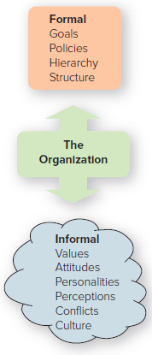
What is Organizational Behavior—Values, attitudes?
Interdisciplinary field dedicated to better understanding and managing people at work.
- tries to help managers not only explain workplace behavior but also to predict it, so that they can better lead and motivate their employees to perform productively
- Individual behavior: Attributes such as values, attitudes, personality, perception, and learning.
- Group behavior: Norms, roles, and teams.
- Values – abstract ideals that guide one’s thinking and behavior across all situations
- Attitude – a learned predisposition toward a given object
  - Affective - consists of feelings or emotions one has about a situation
  - Cognitive - beliefs and knowledge one has about a situation
  - Behavioral - also known as the intentional component, is how one intends or expects to behave toward a situation
- Cognitive dissonance
  - the psychological discomfort a person experiences between his or her cognitive attitude and incompatible behavior
  - Importance, control, rewards

What is employee engagement and job satisfaction?
- Employee engagement - an individual’s involvement, satisfaction, and enthusiasm for work
- Job satisfaction - extent to which you feel positively or negatively about various aspects of your work

What are the four important workplace behaviors managers should pay attention to?
- Evaluating Behavior When Employees Are Working: Performance and Productivity
- Evaluating Behavior When Employees Are Not Working: Absenteeism and Turnover
- Evaluating Behavior That Exceeds Work Roles: Organizational Citizenship Behaviors
  - Organizational citizenship behaviors are those employee behaviors that are not directly part of employees’ job descriptions—that exceed their work-role requirements.
- Evaluating Behavior That Harms the Organization: Counterproductive Work Behaviors
- The flip side of organizational citizenship behaviors would seem to be what are called counterproductive work behaviors (CWB), types of behavior that harm employees and the organization as a whole.

CHAPTER 12
What is motivation?
The psychological processes that arouse and direct goal-directed behavior. The way motivation works actually is complex, the result of multiple personal and contextual factors.
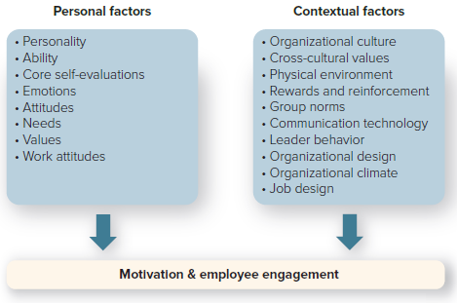
Maslow’s hierarchy of needs theory - proposes that people are motivated by five levels of needs.
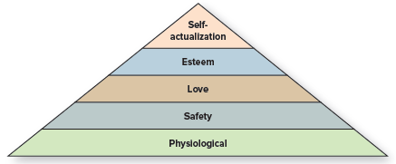
- Physiological need—the most basic human physical need: Need for food, clothing, shelter, comfort, self-preservation. Workplace example: these are covered by wages.
- Safety need: Need for physical safety, emotional security, avoidance of violence. Workplace examples: health insurance, job security, work safety rules, pension plans satisfy this need.
- Love need: Need for love, friendship, affection. Workplace examples: office parties, company softball teams, management retreats
- Esteem need: Need for self-respect, status, reputation, recognition, self-confidence. Workplace examples: bonuses, promotions, awards
- Self-actualization need—the highest level need: Need for self-fulfillment: increasing competence, using abilities to the fullest. Workplace example: sabbatical leave to further personal growth.
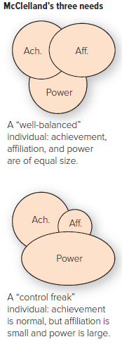
McClelland’s acquired needs theory
- States that three needs - achievement, affiliation, and power - are major motives determining people’s behavior in the workplace. McClelland believes that we are not born with our needs; rather, we learn them from the culture—from our life experiences.
- Managers are encouraged to recognize three needs in themselves and others and to attempt to create work environments that are responsive to them. The three needs, one of which tends to be dominant in each of us, are as follows:
- Need for achievement - “I need to excel at tasks.” This is the desire to excel, to do something better or more efficiently, to solve problems, to achieve excellence in challenging tasks.
- Need for affiliation - “I need close relationships.” This is the desire for friendly and warm relations with other people.
- Need for power - “I need to control others.” This is the desire to be responsible for other people, to influence their behavior or to control them.
- McClelland identifies two forms of the need for power—personal and institutional.
  - The negative kind is the need for personal power, as expressed in the desire to dominate others, and involves manipulating people for one’s own gratification.
  - The positive kind, characteristic of top managers and leaders, is the desire for institutional power, as expressed in the need to solve problems that further organizational goals.

Deci and Ryan’s self-determination theory
- Assumes that people are driven to try to grow and attain fulfillment, with their behavior and well-being influenced by three innate needs: competence, autonomy, and relatedness.
- The Three Innate (inborn)
- Competence - “I want to feel a sense of mastery.” People need to feel qualified, knowledgeable, and capable of completing a goal or task and to learn different skills.
- Autonomy - “I want to feel independent and able to influence my environment.” People need to feel they have freedom and the discretion to determine what they want to do and how they want to do it.
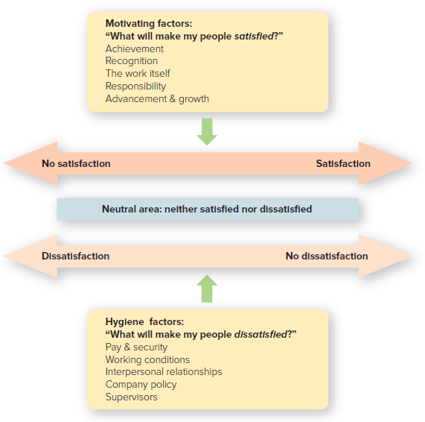
- Relatedness - “I want to feel connected to other people.” People need to feel a sense of belonging, of attachment to others.

Herzberg’s two-factor theory - Proposed that work satisfaction and dissatisfaction arise from two different factors:
- work satisfaction from so-called motivating factors
  - Motivating factors - “What will make my people satisfied?” The higher level needs, motivating factors, or simply motivators, are factors associated with job satisfaction - such as achievement, recognition, responsibility, and advancement - all of which affect the job content or the rewards of work performance
- work dissatisfaction from so-called hygiene factors
  - Hygiene factors - “Why are my people dissatisfied?” The lower-level needs, hygiene factors, are factors associated with job dissatisfaction - such as salary, working conditions, interpersonal relationships, and company policy - all of which affect the job context in which people work.

What is the difference between extrinsic vs. intrinsic rewards
- Extrinsic rewards - satisfaction in the payoff from others. An extrinsic reward is the payoff, such as money, a person receives from others for performing a particular task. An extrinsic reward is an external reward; the payoff comes from pleasing others.
- Intrinsic rewards - satisfaction in performing the task itself. An intrinsic reward is the satisfaction, such as a feeling of accomplishment, a person receives from performing the particular task itself. An intrinsic reward is an internal reward; the payoff comes from pleasing yourself.

Define Equity theory, Justice theory and Expectancy theory
- Equity Theory
  - A model of motivation that explains how people strive for fairness and justice in social exchanges or give-and-take relationships.
  - Equity theory is based on cognitive dissonance, the psychological discomfort people experience between their cognitive attitude and incompatible behavior
  - Focuses on employee perceptions as to how fairly they think they are being treated compared to others
  - The key elements in equity theory are inputs, outputs (rewards), and comparisons
    - Inputs - “What do you think you’re putting into the job?” The inputs that people perceive they give to an organization are their time, effort, training, experience, intelligence, creativity, seniority, status, and so on.
    - Outputs or rewards - “What do you think you’re getting out of the job?” The outputs are the rewards that people receive from an organization: pay, benefits, praise, recognition, bonuses, promotions, status perquisites (corner office with a view, say, or private parking space), and so on.
    - Comparison - “How do you think your ratio of inputs and rewards compares with those of others?” Equity theory suggests that people compare the ratio of their own outcomes to inputs against the ratio of someone else’s outcomes to inputs. When employees compare the ratio of their inputs and outputs (rewards) with those of others—whether coworkers within the organization or even other people in similar jobs outside it—they then make a judgment about fairness. Either they perceive there is equity, and so they are satisfied with the ratio and don’t change their behavior, or they perceive there is inequity, and so they feel resentful and act to change the inequity.
- Justice Theory
  - Equity theory began to expand into an area called organizational justice, which is concerned with the extent to which people perceive they are treated fairly at work. Three different components of organizational justice have been identified:
    - Distributive justice - “How fairly are rewards being given out?” Distributive justice reflects the perceived fairness of how resources and rewards are distributed or allocated.
    - Procedural justice - “How fair is the process for handing out rewards?” Procedural justice is defined as the perceived fairness of the process and procedures used to make allocation decisions.
    - Interactional justice - “How fairly am I being treated when rewards are given out?” Interactional justice relates to the “quality of the interpersonal treatment people receive when procedures are implemented.”
- Expectancy Theory: How Much Do You Want and How Likely Are You to Get It?
  - Expectancy theory suggests that people are motivated by two things: (1) how much they want something and (2) how likely they think they are to get it. In other words, assuming they have choices, people will make the choice that promises them the greatest reward if they think they can get it.
  - The Three Elements:
    - Expectancy - “Will I Be Able to Perform at the Desired Level on a Task?” Expectancy is the belief that a particular level of effort will lead to a particular level of performance. This is called the effort-to-performance expectancy.
    - Instrumentality - “What Outcome Will I Receive If I Perform at This Level?” Instrumentality is the expectation that successful performance of the task will lead to the outcome desired. This is called the performance-to-reward expectancy.
    - Valence - “How Much Do I Want the Outcome?” Valence is value, the importance a worker assigns to the possible outcome or reward.

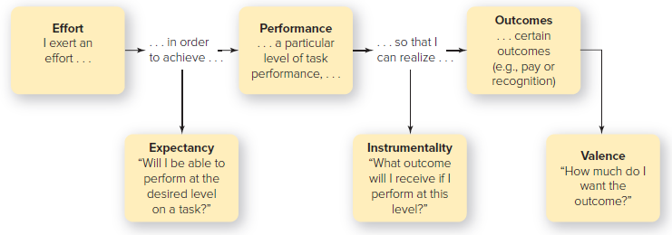

How can organizations use Job design to improve motivation? Job simplification, Job enlargement, Job enrichment
- Job design - Division of an organization’s work among its employees and the application of motivational theories to jobs to increase satisfaction and performance
- There are two different approaches to job design—one traditional, one modern—that can be taken in deciding how to design jobs. The traditional way is fitting people to jobs; the modern way is fitting jobs to people
  - Fitting people to jobs is based on the assumption that people will gradually adapt to any work situation.
    - One technique is scientific management (job simplification), is the process of reducing the number of tasks a worker performs.
  - Fitting jobs to people is based on the assumption that people are underutilized at work and that they want more variety, challenges, and responsibility.
    - Two techniques for this type of job design are (1) job enlargement and (2) job enrichment.
      - Job Enlargement: Putting More Variety into a Job The opposite of scientific management, job enlargement consists of increasing the number of tasks in a job to increase variety and motivation.
      - Job Enrichment: Putting More Responsibility and Other Motivating Factors into a Job Job enrichment is the practical application of Frederick Herzberg’s two factor motivator-hygiene theory of job satisfaction. Specifically, job enrichment consists of building into a job such motivating factors as responsibility, achievement, recognition, stimulating work, and advancement.

What are ways to motivate employees both monetary and nonmonetary?
- Monetary
  - Pay for performance. Also known as merit pay, pay for performance bases pay on one’s results. Thus, different salaried employees might get different pay raises and other rewards (such as promotions) depending on their overall job performance.
  - Bonuses. Bonuses are cash awards given to employees who achieve specific performance objectives.
  - Profit sharing. Profit sharing is the distribution to employees of a percentage of the company’s profits.
  - Gainsharing. Gainsharing is the distribution of savings or “gains” to groups of employees who reduced costs and increased measurable productivity.
  - Stock options. With stock options, certain employees are given the right to buy stock at a future date for a discounted price.
  - Pay for knowledge. Also known as skill-based pay, pay for knowledge ties employee pay to the number of job-relevant skills or academic degrees they earn.
- Nonmonetary
  - Work–life benefits. Work–life benefits are employer-sponsored benefit programs or initiatives designed to help all employees balance work life with home life.
  - Flexible workplace—including part-time work, flex-time, a compressed workweek, job sharing, and telecommuting
  - Vacations and sabbaticals
  - Thoughtfulness
  - Surroundings
  - Skill-building & educational opportunities

CHAPTER 13
What is the difference between a group vs. team?
- Group
  - A Collection of People Performing as Individuals
  - Defined as (1) two or more freely interacting individuals who (2) share norms, (3) share goals, and (4) have a common identity
- Team
  - A Collection of People with Common Commitment
  - Small group of people with complementary skills who are committed to a common purpose, performance goals, and approach for which they hold themselves mutually accountable

Why is teamwork important?
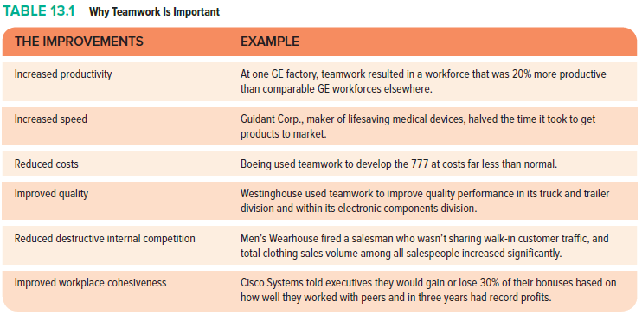

What are some types of teams?
- Work teams: have a clear purpose that all members share; usually permanent, and members must give their complete commitment to the team’s purpose in order for the team to succeed
  - Advice teams
    - created to broaden the information base for managerial decisions
    - Committees, review panels
  - Production teams
    - responsible for performing day-to-day operations
    - Assembly teams, maintenance crews
  - Project teams
    - work to do creative problem solving, often by applying the specialized knowledge of members of a cross – functional team
    - Task forces, research groups
  - Action teams
    - work to accomplish tasks that require people with specialized training and a high degree of coordination
    - Hospital surgery teams, airline cockpit crews, police SWAT teams
- Project teams: assembled to solve a particular problem or complete a specific task, such as brainstorming new marketing ideas for one of the company’s products
- Cross-functional teams: include members from different areas within an organization, such as finance, operations, and sales
- Self-managed teams: groups of workers who are given administrative oversight for their task domains
- Virtual teams: work together over time and distance via electronic media to combine efforts and achieve common goals

What is groupthink?
- Groupthink occurs when group members strive to agree for the sake of unanimity and thus avoid accurately assessing the decision situation. Cohesiveness isn’t always good. When it results in groupthink, group or team members are friendly and tight-knit but unable to think “outside the box.” Their “strivings for unanimity override their motivation to realistically appraise alternative courses of action.”
- Symptoms of Groupthink
  - Sense of invulnerability. Group members have the illusion that nothing can go wrong, breeding excessive optimism and risk taking. They may also be so assured of the rightness of their actions that they ignore the ethical implications.
  - Rationalization. Rationalizing protects the pet assumptions underlying the group’s decisions from critical questions.
  - Illusion of unanimity and peer pressure. The illusion of unanimity is another way of saying that a member’s silence is interpreted as consent. If people do disagree, peer pressure leads other members to question the dissenters’ loyalty.
  - “The wisdom of crowds.” Groupthink’s pressure to conform often leads members with different ideas to censor themselves—the opposite of collective wisdom.

What are Team Roles? Norms? Formal versus informal group?
- Roles: A socially determined expectation of how an individual should behave in a specific position. As a team member, your role is to play a part in helping the team reach its goals.
  - Task roles: Consists of behavior that concentrates on getting the team’s tasks done; i.e. initiator, information seeker, opinion giver, elaborator, coordinator, evaluator, recorder
  - Maintenance roles: Consists of behavior that fosters constructive relationships among team members; i.e. encourager, harmonizer, compromiser, standard setter, follower
- Norms: General guidelines or rules of behavior that most group or team members follow. Norms are more encompassing than roles. Norms point out the boundaries between acceptable and unacceptable behavior. Although some norms can be made explicit, typically they are unwritten and seldom discussed openly; nevertheless, they have a powerful influence on group and organizational behavior.
  - Why are norms followed?
    - To help the group survive - “Don’t do anything that will hurt us.” Norms are enforced to help the group, team, or organization survive. Example: The manager of your team or group might compliment you because you’ve made sure it has the right emergency equipment.
    - To clarify role expectations - “You have to go along to get along.” Norms are also enforced to help clarify or simplify role expectations. Example: At one time, new members of Congress wanting to buck the system by which important committee appointments were given to those with the most seniority were advised to “go along to get along”—go along with the rules in order to get along in their congressional careers.
    - To help individuals avoid embarrassing situations - “Don’t call attention to yourself.” Norms are enforced to help group or team members avoid embarrassing themselves. Examples: You might be ridiculed by fellow team members for dominating the discussion during a report to top management (“Be a team player, not a show-off”). Or you might be told not to discuss religion or politics with customers, whose views might differ from yours.
    - To emphasize the group’s important values and identity - “We’re known for being special.” Finally, norms are enforced to emphasize the group’s, team’s, or organization’s central values or to enhance its unique identity.
- Formal groups - created to accomplish specific goals. A formal group is a group assigned by organizations or its managers to accomplish specific goals. A formal group may be a division, a department, a work group, or a committee. It may be permanent or temporary. In general, people are assigned to them according to their skills and the organization’s requirements.
- Informal groups - created for friendship. An informal group is a group formed by people whose overriding purpose is getting together for friendship or a common interest. An informal group may be simply a collection of friends who hang out with one another

Understand Tuckman’s 5 stages of group/team development--What role does a manager/leader play at each stage
and what questions should the leader be asking?
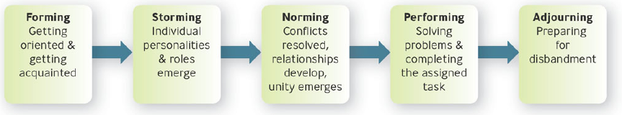
- Forming
- Process of getting oriented and getting acquainted
- “Why are we here?”
- “Where do I fit in here?”
- Leaders should allow time for people to become acquainted and socialize
- Storming
- characterized by the emergence of individual personalities and roles and conflicts within the group
- “What’s my role here?”
- “Why are we fighting over who’s in charge and who does what?”
- Leaders should encourage members to suggest ideas, voice disagreements, and work through their conflicts about tasks and goals
- Norming
- conflicts are resolved, close relationships develop, and unity and harmony emerge
- Group cohesiveness
- “What do the others expect me to do?”
- “Can we agree on goals and work as a team?”
- Leaders should emphasize unity and help identify team goals and values
- Performing
- members concentrate on solving problems and completing the assigned tasks
- “How can I best perform my role?”
- “Can we do the job properly?”
- Leaders should allow members the empowerment they need to work on tasks
- Adjourning
- members prepare for disbandment
- “What’s next?”
- “Can we help team members transition out?”
- Leaders can help ease the transition by rituals celebrating “the end” and “new beginnings

What are the foundational elements of teamwork?
- Collaboration - the Foundation of Teamwork
Collaboration is the act of sharing information and coordinating efforts to achieve a collective outcome.
- Trust: “We Need to Have Reciprocal Faith in Each Other”
Trust is defined as reciprocal faith in others’ intentions and behaviors. The word reciprocal emphasizes the give-and-take aspect of trust - that is, we tend to give what we get: Trust begets trust, distrust begets distrust. Trust is based on credibility - how believable you are based on your past acts of integrity and follow-through on your promises.
- Performance Goals and Feedback
Collective purpose needs to be defined in terms of specific, measurable performance goals with continual feedback to tell team members how well they are doing
- Motivation through Mutual Accountability and Interdependence
- Being mutually accountable to other members of the team rather than to a supervisor makes members feel mutual trust and commitment - a key part in motivating members for team effort.
- Team member interdependence reveals the extent to which team members rely on common task-related team inputs, such as resources, information, goals, and rewards, and the amount of interpersonal interactions needed to complete the work.
- Team Composition: reflects the collection of jobs, personalities, values, knowledge, experience, and skills of team members.
- Roles: How Team Members Are Expected to Behave
Roles are socially determined expectations of how individuals should behave in a specific position.

Conflict—What are the different types of conflict styles? Why is conflict needed in organizations?
- The Nature of Conflict - Disagreement Is Normal
- Dysfunctional conflict - bad for organizations. From the standpoint of the organization, dysfunctional conflict is conflict that hinders the organization’s performance or threatens its interests. As a manager, you need to do what you can to remove dysfunctional conflict, sometimes called negative conflict.
- Functional conflict - good for organizations. The good kind of conflict is functional conflict, which benefits the main purposes of the organization and serves its interests. There are some situations in which this kind of conflict - also called constructive conflict or cooperative conflict - is considered advantageous.
- Four Kinds of Conflict
  - Personality conflicts - Clashes Because of Personal Dislikes or Disagreements
    - interpersonal opposition based on personal dislike, disagreement, or differing styles
    - Personality clashes, competition for scarce resources, time pressure, communication failures
  - Intergroup conflicts - Clashes among Work Groups, Teams, and Departments
    - Inconsistent goals or reward systems - when people pursue different objectives.
    - Ambiguous jurisdictions - when job boundaries are unclear. “That’s not my job and those aren’t my responsibilities.”
    - Status differences - when there are inconsistencies in power and influence.
  - Multicultural conflicts - Clashes between Cultures
  - Work-Family Conflicts - occurs when the demands or pressures from work and family domains are mutually incompatible.
- Devices to Stimulate Constructive Conflict
  - Spur competition among employees
  - Change the organization’s culture & procedures
  - Bring in outsiders for new perspectives
  - Use programmed conflict
    - Designed to elicit different opinions without inciting people’s personal feelings
    - Devil’s advocacy
    - Assigning someone to play the role of critic to voice possible objections to a proposal and thereby generate critical thinking and reality testing
    - Dialectic method
      - Two people or groups play opposing roles in a debate in order to better understand a proposal
- Five Conflict-Handling Styles
  - Avoiding - “Maybe the problem will go away”
  - Accommodating – “Let’s do it your way”
  - Forcing – “You have to do it my way”
  - Compromising – “Let’s split the difference”
  - Collaborating – “Let’s cooperate to reach a win -win solution that benefits both of us”

CHAPTER 14
Define leadership: Leadership is the ability to influence employees to voluntarily pursue organizational goals.

What is the difference between a manager and a leader?
- Broadly speaking, managers typically perform functions associated with planning, investigating, organizing, and control, and leaders focus on influencing others. Leaders inspire others, provide emotional support, and try to get employees to rally around a common goal.
- Being a Manager: Coping with Complexity
  - Determining what needs to be done – planning and budgeting
  - Creating arrangements of people to accomplish an agenda - organizing and staffing
  - Ensuring people do their jobs - controlling and problem solving
- Being a Leader: Coping with Change
  - Determining what needs to be done - setting a direction
  - Creating arrangements of people to accomplish an agenda - aligning people
  - Ensuring people do their jobs – motivating and inspiring

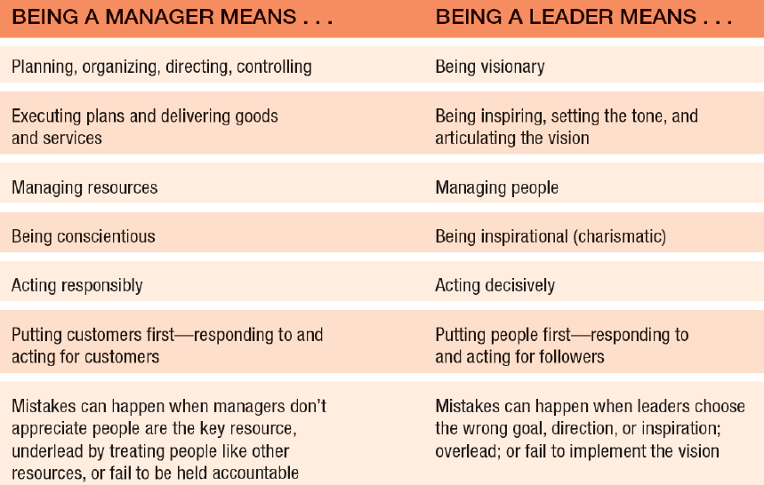

Understand the integrated model of leadership.
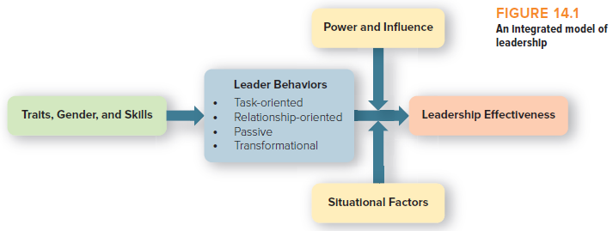
Leadership effectiveness is the outcome we want to explain. The center of the model shows this outcome is influenced by four types of leadership behavior: task-oriented, relationship-oriented, passive, and transformational. In turn, our ability to effectively engage in these leader behaviors is affected by traits, gender, and leadership skills (the left side of the model).
The relationship between leader behavior and leadership effectiveness is affected by two other considerations: power and influence and situational factors. For example, people with more power and strong influence skills are better suited to execute the four types of leader behavior in a more effective manner. Similarly, you will be more effective if you exhibit the four leader behaviors at the right time. Different situations call for different leader behaviors.

Define trait leadership theory—what are some common characteristics and skills of leaders?
- Trait Approach: one of the first systematic attempts to study leadership
  - We cannot ignore the implications of leadership traits
  - The positive and “dark triad” traits suggest the qualities you should cultivate and avoid if you want to assume a leadership role in the future.
  - Organizations may want to include personality and trait assessments in their selection and evaluation processes
  - A global mind-set is an increasingly valued task-oriented trait.
- Great Man Theory
  - Studied as early as 1869
  - Based on hereditary background
  - Focused on identifying innate qualities and characteristics possessed by great social, political, & military leaders
  - Leaders were born and summoned by some unfathomable process
- Personality Characteristics
  - Intelligence – Verbal, perceptual, and reasoning capabilities. Ex. Bill Gates
  - Self-Confidence – Certainty about one’s competencies and skills. Ex. Steve Jobs
  - Determination – Desire to get the job done (i.e., initiative, persistence, drive). Ex. Lance Armstrong
  - Integrity – The quality of honesty and trustworthiness.
  - Sociability – Leader’s inclination to seek out pleasant social relationships.
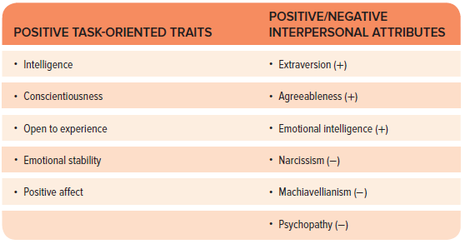
- Negative Interpersonal Attributes
  - Narcissism is defined as having “a self-centered perspective, feelings of superiority, and a drive for personal power and glory.” Narcissists have inflated views of themselves, seek to attract the admiration of others, and fantasize about being in control of everything. Although passionate and charismatic, narcissistic leaders may provoke counterproductive work behaviors in others, such as strong resentments and resistance.
  - Machiavellianism. Displays a cynical view of human nature and condones opportunistic and unethical ways of manipulating people, putting results over principles. This view is manifested in such expressions as “All people lie to get what they want” and “You have to cheat to get ahead.” Like narcissism, Machiavellianism is also associated with counterproductive work behaviors, especially as people begin to understand that they are being coldly manipulated.
  - Psychopathy. Characterized by lack of concern for others, impulsive behavior, and a dearth of remorse when the psychopath’s actions harm others. Not surprisingly, a person with a psychopathic personality can be a truly toxic influence in the workplace.
- Four Basic Skills for Leaders
What Leaders Need | And Why
Cognitive abilities to identify problems and their causes in rapidly changing situations | Leaders must sometimes devise effective solutions in short time spans with limited information
Interpersonal skills to influence and persuade others | Leaders need to work well with diverse people
Business skills to maximize the use of organizational assets | Leaders increasingly need business skills as they advance up. Three valuable skills that most people can develop are mindfulness, curiosity, and optimism.
Strategic skills to draft an organization’s mission, vision,  strategies, and implementation plans | Strategic skills matter most for individuals in the top ranks of an organization. Entrepreneurs may have their strategic skills tested on a regular basis.

What is the difference between Task-based vs relationship-based leadership?
- Task-oriented leadership behaviors: These ensure that people, equipment, and other resources are used in an efficient way to accomplish the mission. Two types:
  - Initiating-structure leadership organizes and defines what employees should be doing to maximize output.
  - Transactional leadership clarifies employees’ roles and task requirements and provides rewards and punishments contingent on performance.
- Relationship-oriented leadership: Primarily concerned with the leader’s interactions with his or her employees. Four types:
- Consideration: Leader behavior that is concerned with group members’ needs and desires and that is directed at creating mutual respect or trust
- Empowering leadership: Represents the extent to which a leader creates perceptions of psychological empowerment in others
- Psychological empowerment
  - Employees’ belief that they have control over their work
  - Leading for meaningfulness: inspiring and modeling desirable behaviors
  - Leading for self-determination: delegating meaningful tasks
  - Leading for competence: supporting and coaching employees
  - Leading for progress: monitoring and rewarding employees
- Ethical leadership: Represents normatively appropriate behavior that focuses on being a moral role model
- Servant leadership: Focuses on providing increased service to others - meeting the goals of both followers and the organization - rather than to oneself

Leadership Theories - Explain the behavioral approach to leadership - what are the important implications for behavioral approaches?
- Behavioral leadership approaches
  - Attempt to determine the distinctive styles used by effective leaders
  - Divided into four categories
    - Task-oriented behavior
      - These ensure that people, equipment, and other resources are used in an efficient way to accomplish the mission.
      - Two types
      - Initiating-structure leadership organizes and defines what employees should be doing to maximize output.
      - Transactional leadership clarifies employees’ roles and task requirements and provides rewards and punishments contingent on performance.
    - Relationship-oriented behavior
      - Primarily concerned with the leader’s interactions with his or her employees
      - Four types
      - Consideration
      - Empowering leadership
      - Ethical leadership
      - Servant leadership
    - Passive behavior
      - form of leadership behavior characterized by a lack of leadership skills
      - Laissez-faire leadership - a form of “leadership” characterized by a general failure to take responsibility for leading
    - Transformational behavior transforms employees to pursue organizational goals over self-interests
- Practical Implications of the Behavioral Approaches
  - A leader’s behavior is more important than his or her traits. It is important to train managers on the various forms of task and relationship leadership.
  - There is no one best style of leadership. How effective a particular leadership behavior is depends on the situation at hand.

What is contingency, LMX and Path goal theory?
- Fiedler’s contingency leadership model determines if a leader’s style is (1) task-oriented or (2) relationship-oriented and if that style is effective for the situation at hand.
  - Task-motivated - Low LPCs (least preferred coworker) - Leaders are concerned primarily with reaching a goal
  - Relationship-motivated (High LPCs) - Leaders are concerned with developing close interpersonal relationships
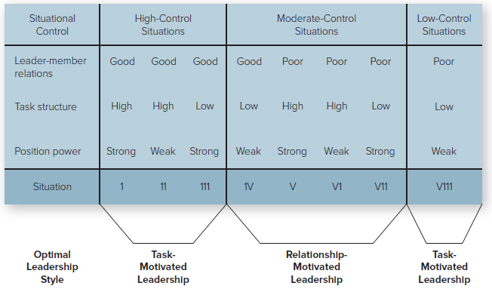
- Leader–Member Exchange (LMX) Leadership: Having Different Relationships with Different Subordinates
  - Proposed by George Graen and Fred Dansereau
  - Emphasizes that leaders have different sorts of relationships with different subordinates.
  - Looks at the quality of relationships between managers and subordinates
  - Assumes each manager - subordinate relationship is unique
  - In-Group Exchange versus Out-Group Exchange The unique relationship, which supposedly results from the leader’s attempt to delegate and assign work roles, can produce two types of leader–member exchange interactions.
    - In-group exchange: trust and respect. In the in-group exchange, the relationship between leader and follower becomes a partnership characterized by mutual trust, respect and liking, and a sense of common fates. Subordinates may receive special assignments and special privileges.
    - Out-group exchange: lack of trust and respect. In the out-group exchange, leaders are characterized as overseers who fail to create a sense of mutual trust, respect, or common fate. Subordinates receive less of the manager’s time and attention than those in in-group exchange relationships.
- Path-goal theory
  - holds that the effective leader makes available to followers desirable rewards in the workplace and increases their motivation by clarifying the paths, or behavior, that will help them achieve those goals and providing them with support.
  - centers on how leaders motivate subordinates to accomplish designated goals
  - Emphasizes the relationship between
    - the leader’s style - effectiveness and behaviors
    - the characteristics of the subordinates-employee characteristics
    - the work setting-environment setting
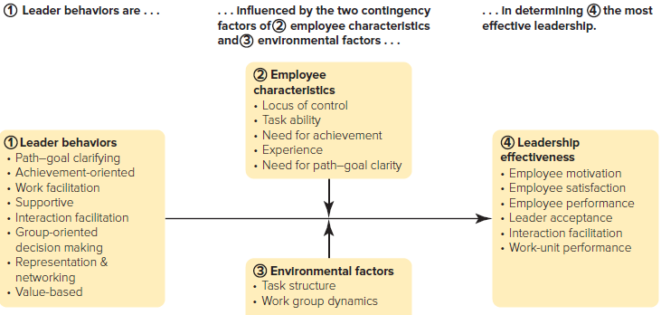

What are the four behaviors of Transformational Leaders?
- Inspirational motivation: “Let me share a vision that transcends us all.”
- Idealized influence: “We are here to do the right thing.”
- Individualized consideration: “You have the opportunity to grow and excel here.”
- Intellectual stimulation: “Let me describe the great challenges we can conquer together.”

What are the 5 sources/types of power?
- Legitimate Power: Influencing Behavior Because of One’s Formal Position
- Reward Power: Influencing Behavior by Promising or Giving Rewards
- Coercive Power: Influencing Behavior by Threatening or Giving Punishment
- Expert Power: Influencing Behavior Because of One’s Expertise Expert
- Referent Power: Influencing Behavior Because of One’s Personal Attraction

CHAPTER 16
What is controlling?
Defined as monitoring performance, comparing it with goals, and taking corrective action as needed
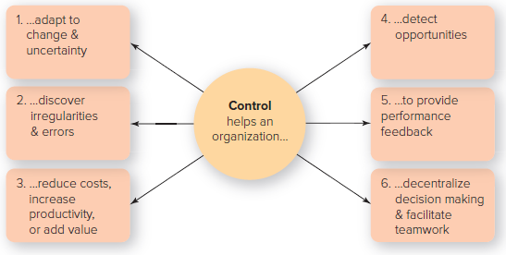
Why are controls needed in business?
- To adapt to change & uncertainty
- To discover irregularities & errors
- To reduce costs, increase productivity, or add value
- To detect opportunities
- To deal with complexity
- To decentralize decision making & facilitate teamwork

What are the steps in the control process?
- Establish Standards: “What Is the Outcome We Want?”
- performance standard is the desired performance level for a given goal
- best measured when they can be made quantifiable
- Measure Performance: “What Is the Actual Outcome We Got?”
- usually obtained from written reports, oral reports, and personal observations
- Compare Performance to Standards: “How Do the Desired and Actual Outcomes Differ?”
- Management by exception – control principle that says managers should be informed of a situation only if data show a significant deviation from standards
- Take Corrective Action, If Necessary: “What Changes Should We Make to Obtain Desirable Outcomes?”
- Make no changes
- Recognize and reinforce positive performance
- Take action to correct negative performance
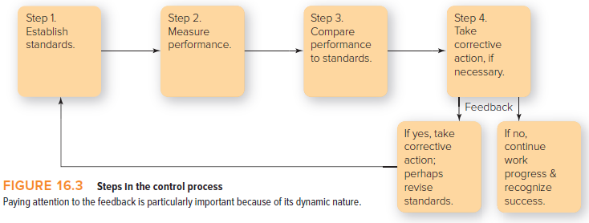

What are the levels of control and six areas a manager should control?
- Levels of Control
  - Strategic control (by Top Managers)
    - monitoring performance to ensure that strategic plans are being implemented and taking corrective action as needed
  - Tactical control (by Middle Managers)
    - monitoring performance to ensure that tactical plans - those at the divisional or departmental level - are being implemented
  - Operational control (by First-Line Managers)
    - monitoring performance to ensure that operational plans - day-to-day goals - are being implemented and taking corrective action as needed
- Six Areas of Control
  - Physical
    - The physical area includes buildings, equipment, and tangible products.
  - Human Resources
    - The controls used to monitor employees (personality tests, drug testing, performance tests, performance evaluations, employee surveys)
  - Informational
    - Production schedules, sales forecasts, environmental impact statements, analyses of competition, and public relations briefings
  - Financial
    - Are bills being paid on time? How much money is owed by customers? How much money is owed to suppliers? Is there enough cash on hand to meet payroll obligations? What are the debt-repayment schedules? What is the advertising budget?
  - Structural
    - How is the organization arranged from a hierarchical or structural standpoint? Two examples are bureaucratic control and decentralized control:
      - Bureaucratic control - an approach to organizational control that is characterized by use of rules, regulations, and formal authority to guide performance
      - Decentralized control - an approach to organizational control that is characterized by informal and organic structural arrangements
  - Cultural
    - The cultural area is an informal method of control. It influences the work process and levels of performance through the set of norms that develop as a result of the values and beliefs that constitute an organization’s culture.

What are the 4 steps in Deming’s Management System?
- Quality should be aimed at the needs of the consumer
- Companies should aim at improving the system, not blaming workers
- Improved quality leads to increased market share, increased company prospects, & increased employment
- Quality can be improved on the basis of hard data, using the PDCA cycle (Plan-Do-Check-Act)

What are the keys to Successful Controls and Barriers to effective measurement?
- The Keys to Successful Control Systems
- They are strategic & results oriented
- They are timely, accurate, & objective
- They are realistic, positive, & understandable & encourage self-control
- They are flexible
- Barriers to Control Success
- Too much control
- Too little employee participation
- Overemphasis on means instead of ends
- Overemphasis on paperwork
- Overemphasis on one instead of multiple approaches

What is the balanced Score card approach and Strategy Maps? How should a manager use these tools?
- Balanced scoreboard (A Dashboard-like View of the Organization)
  - gives top managers a fast but comprehensive view of the organization via four indicators:
    - customer satisfaction
    - internal processes
    - innovation and improvement activities
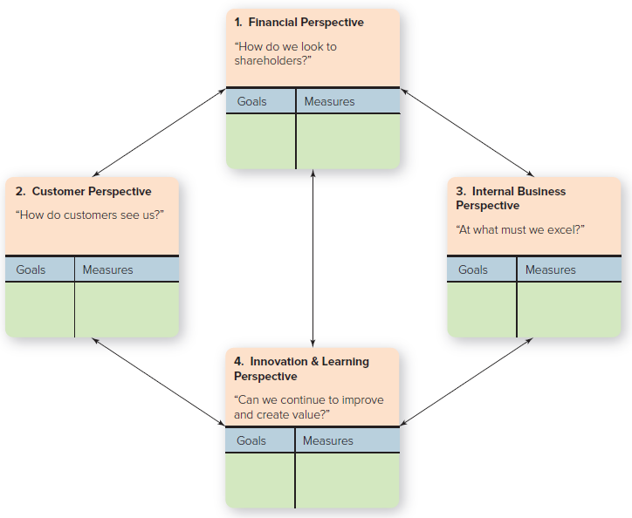
    - financial measures
  - The balanced scorecard establishes (a) goals and (b) performance measures according to four “perspectives,” or areas - financial, customer, internal business, and innovation and learning.
    - Financial
      - “How Do We Look to Shareholders?”
      - profitability, growth, shareholder values
    - Customer
      - “How Do Customers See Us?”
      - priority is taking care of the customer
    - Internal business
      - “What Must We Excel At?”
      - quality, employee skills, and productivity
    - Innovation & learning
      - “Can We Continue to Improve and Create Value?”
      - learning and growth of employees
• Strategy map
- visual representation of the four perspectives of the balanced scorecard
- a “visual representation of a company’s critical objectives and the crucial relationships among them that drive organizational performance.”
- Enables managers to communicate their goals so that everyone in the company can understand how their jobs are linked to the overall objectives of the organization

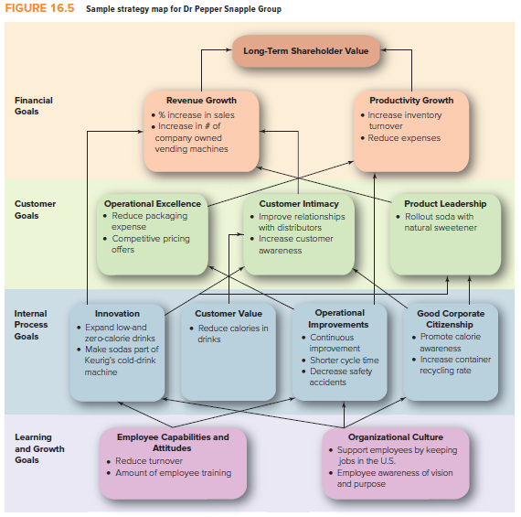

Productivity - what is it? How do you increase productivity?
- Productivity can be applied at any level, whether for you as an individual, for the work unit you’re managing, or for the organization you work for.
- Defined by the formula of outputs divided by inputs where: outputs are the goods and services produced, and inputs are labor, capital, materials, and energy

- You can increase overall productivity by making substitutions or increasing the efficiency of any one element: labor, capital, materials, energy. For instance, you can increase the efficiency of labor by substituting capital in the form of equipment or machinery, as in employing a backhoe instead of laborers with shovels to dig a hole. Or you can increase the efficiency of materials inputs by expanding their uses, as when lumber mills discovered they could sell not only boards but also sawdust and wood chips for use in gardens. Or you can increase the efficiency of energy by putting solar panels on a factory roof so the organization won’t have to buy so much electrical power from utility companies.
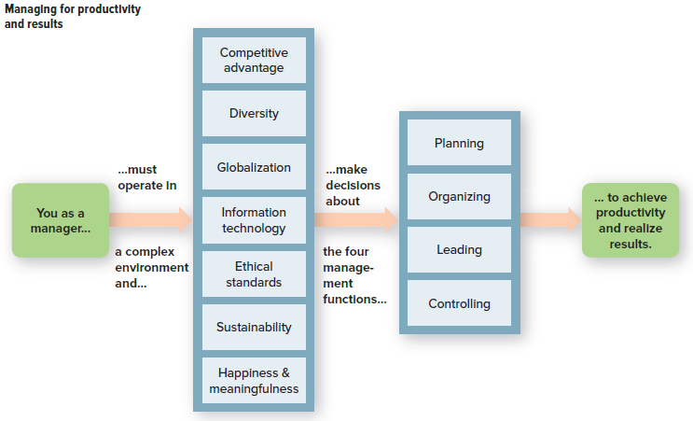

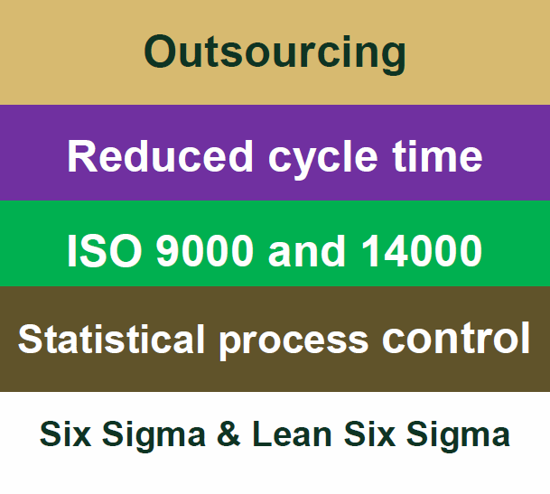
Total Quality Management (TQM)
Some TQM Techniques
- A comprehensive approach - led by top management and supported throughout the organization - dedicated to continuous quality improvement, training, and customer satisfaction
- Two Core Principles of TQM
- People orientation
- Everyone involved in the organization should focus on delivering value to customers
- Delivering customer value is most important
- People will focus on quality if given empowerment
- TQM requires training, teamwork, and crossfunctional efforts
- Improvement orientation
- Everyone should work on continuously improving work processes
- It’s less expensive to do it right the first time
- It’s better to do small improvements all the time
- Accurate standards must be followed to eliminate small variations
- There must be strong commitment from top management

The Keys to Successful Control Systems
- They are strategic & results oriented
- They are timely, accurate, & objective
- They are realistic, positive, & understandable & encourage self-control
- They are flexible

Barriers to Control Success
- Too much control
- Too little employee participation
- Overemphasis on means instead of ends
- Overemphasis on paperwork
- Overemphasis on one instead of multiple approaches

Keys to Your Managerial Success
- Find your passion and follow it.
- Encourage self-discovery, and be realistic.
- Every situation is different, so be flexible
- Fine-tune your people skills
- Learn how to develop leadership skills
- Treat people as if they matter, because they do
- Draw employees and peers into your management process
- Be flexible, keep your cool, and take yourself lightly

