Growing up in the 21st century where social status is a big part of many students life since it can affect you tremendously, how students dress and how good you look and what you do in public matters can impact your life is a big deal to many people when it becomes mental health for the individual it is a big issue. This disorder can associate many other mental health issues such as anxiety, stress, insecurity, depression and more which can result in you losing focus in school assignments, tests, work-life, outside life and relationship that cause a significant impact on the student's life.

While there may seem to be nothing you can do about the symptoms of social phobia, there are many things that can help in reality. Challenging your attitude/mentality is a big leap into overcoming it. Patients with social anxiety have negative thoughts and beliefs that lead to their anxiety and fears. If an individual doesn't find a way to overcome with or cope with the other mental health and symptoms, any student or person will lose focus and motivation to be committed on their academic career, life, work, family and more.

In order to provide Algonquin Students with the chance to change and overcome social phobia in a mental and basis, it is recommended that visits, checks and discussions happen with Centre for Cognitive Therapy.

Table of Contents
This content will be covering what will be provided from the results of the research to aid the recommendation of a student discount for the Centre for Cognitive Therapy. The information has been prepared in this list:

- Overview of Centre for Cognitive Therapy
- Mental Health Benefits of Treatments
- Side effects along with social phobia
- Location
- Costs for therapy
- Experience of therapy
- Has therapy healed people?
- Overview of Cognitive Therapy

Cognitive Therapy is a method of healing that involves meeting with a therapist where you discuss why you are receiving negative thoughts, why you feel like this and more for the duration of 15 to 20 weeks for 30mins to 1hr for each session:

During these sessions, your therapist will be working with you to comprehend your goals, aspiration and the problems that must be treated. Once your therapist understands you as a person, they will be targeting your negatives thoughts to understand why you feel like everyone is looking at you and what the cause of your social anxiety is. They will be applying CBT (Cognitive Behavioural Therapy) to you, and it works by improving people's attitudes and behaviours by reflecting on the feelings, beliefs and attitudes of an individual and how these thoughts contribute to a person's behaviour as a way to deal with emotional issues.


Figure 1: Cognitive Therapist understanding her patients’ negative thoughts

At each session, everything you discuss with your therapist is kept on a strict degree. No information can be released without you signing an informed approval release of information, giving you a sense of comfort in each session, not making you nervous but welcomed. As the treatment goes on, you will be improving mentally, making you a better version of your current state with Cognitive Therapy.

Mental Health Benefits of Cognitive Therapy
When using cognitive therapy, you teach the mind a new way of learning and seeing things in the world so you don’t get stressed or social anxiety but along with it come benefits in a mental aspect. Here are benefits you would expect:

- Less Anxiety
- More Rational
- Control over emotions and thinking
- Less Stress
- Calmer and relax
- Love yourself again

Side Effects of Social Phobia
Ordinary, everyday social situations cause so much anxiety, fear, and self-consciousness for a person with a social anxiety disorder that isolation appears to be a relief. The person can go to great lengths to find many excuses to avoid public events or presentations. She may not even have the opportunity to eat with friends or shop at the grocery store, let alone go to a party and be surrounded by other people. However, here are side effects that are associated with it:

- Blushing
- Difficulty to speak
- Sweating
- Can’t make eye contact
- Nausea
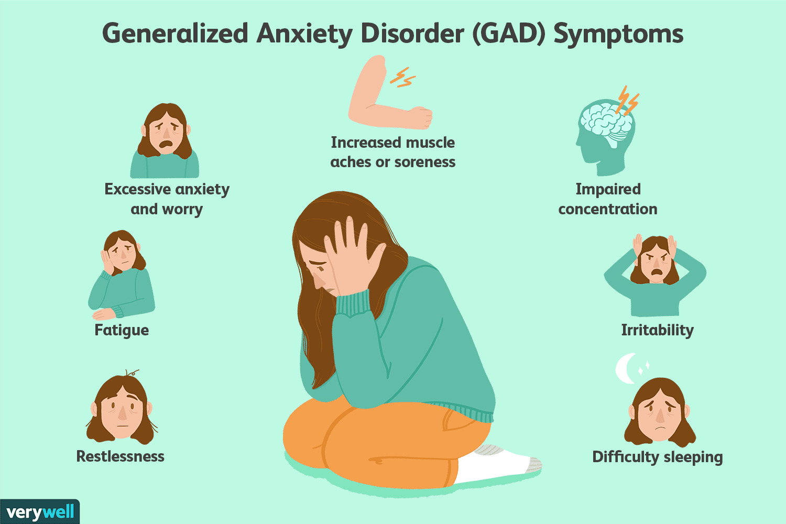
Figure 2: Diagram shows side affects associated with social phobia
Location
Centre for Cognitive Therapy is located at 1309 Carling Ave Suite 3, Ottawa, ON K1Z 7L3 close to downtown Ottawa in the Westgate Shopping Centre. It is nearby the proximity of the Algonquin College campus, making it easy to travel in a bus which takes up to thirty minutes [30].

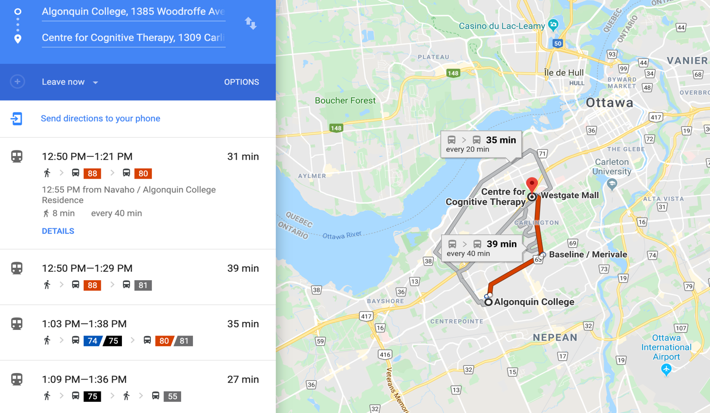
Figure 3: Google map directions to Centre for Cognitive Therapy from Algonquin

Hours of Operation
Centre for Cognitive Therapy Is open 5 days a week from 9am through 6pm in the afternoon. These hours make it easy and accessible for students to access this since many students have morning classes and afternoon classes which give them time to get treated.

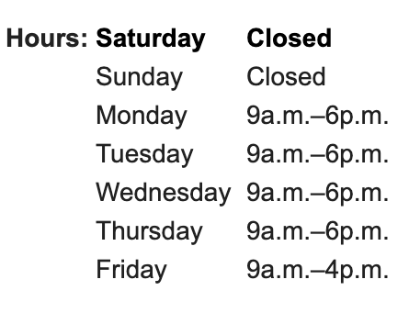
Figure 4: Shows hours of operation for Centre for Cognitive Therapy
Costs of Therapy At Centre For Cognitive Therapy

At Centre for Cognitive Therapy they don’t provide a cost that tells us what the prices of each session or month is because when you want to get treated you choose your therapist that specializes in a certain area then they provide you an estimate but usually each session costs around $75 – 200.

Although at Algonquin College campus they offer services for counselling, from what I have hard it doesn't really work and that they usually charge $50 – 100 which isn't an excellent service and they just provide a piece of advice.

If Centre for Cognitive Therapy can provide a discount for students at Algonquin, it is a better option to receive the service form them as it would be at a reasonable price and would serve you financially plus they would do a professional job.

Is it Worth It?

Throughout the time that new research is being made and found everyday Cognitive Therapy has been proven to be one of the best psychological treatments by evidence which has been developed and improved as an effective treatment for problems such as depression, chronic pain, disordered eating, anger issues, addiction, and low self-esteem. Cognitive Therapy gives you a new way of understanding and being aware of your surroundings plus improving your thinking skills to make you a better version of yourself. If you have social phobia or any other type it is recommended to get treated at Centre for Cognitive Therapy because if you don’t it will just get worse and you will not improve in life but rather being stuck in the same position. In short, it is worth it to put your money into therapy to treat yourself.
It is proven and understood that many people have social phobia, and it can harm a student's academic life and in general. It is proven that cognitive therapy is the best option to improve students well being and mentally providing great mental health benefits.

Centre for Cognitive Therapy is the best location for students to get treated because its distance is close to Algonquin College campus also has fantastic hours of operation that is flexible for any student, its service is also much better than the one offered on campus.

Final Steps

Finally due to the amount of time I wasn’t able to arrange a meeting or call with Centre for Cognitive Therapy to discuss more about doing a deal with Algoqnuin College to retrieve a student discount.

As I wasn’t able to do this part of the job it is recommended to take these steps into action to arrange a deal:
- Speak with the owner/manager about why Algonquin College shoould receive a discount
- Discuss with Algonquin Students Association of implenting this in students tuition and creating a partnership

By following these steps and providing enough information claiming this is beneficial to students, this recommndation can advance.

References

- Centre for Cognitive Therapy - Ottawa. (n.d.). Retrieved November 13, 2019, from https://ocbt.ca/.
- Social anxiety disorder. (2019, November 18). Retrieved from https://en.wikipedia.org/wiki/Social_anxiety_disorder.
- Social Anxiety Disorder. (n.d.). Retrieved from https://anxietycanada.com/disorders/social-anxiety-disorder/.
- Cognitive behavioural therapy CBT. (n.d.). Retrieved from https://www.camh.ca/en/health-info/mental-illness-and-addiction-index/cognitive-behavioural-therapy.
- Martin, B. (2019, June 19). In-Depth: Cognitive Behavioral Therapy. Retrieved from https://psychcentral.com/lib/in-depth-cognitive-behavioral-therapy/.
- Algonquin College of Applied Arts. (n.d.). When you need to talk, we're here to help. Retrieved from https://www.algonquincollege.com/counselling/.
- Kathleen Davis, F. N. P. (2018, September 25). Cognitive behavioral therapy: How does CBT work? Retrieved from https://www.medicalnewstoday.com/articles/296579.php.
- Bhandari, S. (2019, May 20). Social Anxiety Disorder: When It Happens & What It Feels Like. Retrieved from https://www.webmd.com/anxiety-panic/guide/mental-health-social-anxiety-disorder#1.

