CHAPTER 9 – MEASURING EARNINGS
- FCFF BASED ON AFTER-TAX OPERATING EARNINGS
- FCFE Start with net income

ACCOUNTING VERSUS FINANCIAL BALANCE SHEETS

- A firm includes both investments already made (assets in place), and investments yet to be made (growth assets)
- A firm can either borrow the funds it needs (debt), or raise it from its owners’ (equity):
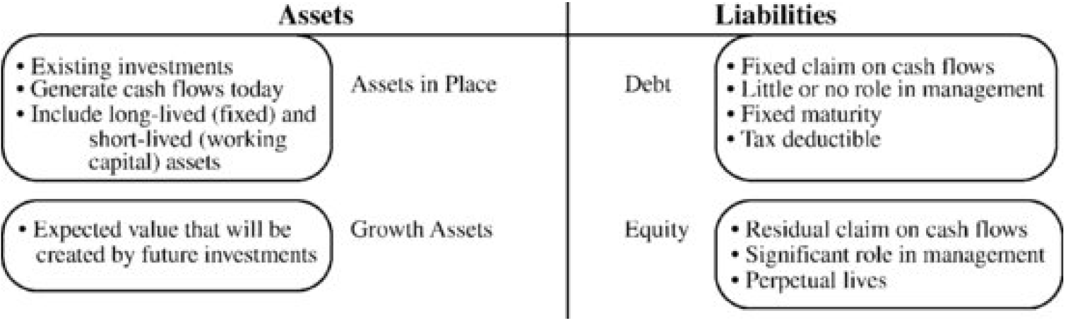

ADJUSTING EARNINGS

- Income statement provides a measure of both the operating and equity income of the firm in the form EBIT & Net income.
- Keep in mind to use the most updated estimate possible, as well as know that the reported earnings of firm have little resemblance to the true earnings, (due to accounting rules and firms actions)

IMPORTANCE OF UPDATING EARNINGS

- Since we do our valuations throughout the year, the most recent financial statement can be several months old.
- If firm is changing rapidly over time, you cannot base yourself on theses old reports.
- SEC requires quarterly reposts you can add them up over the four recent quarters and use that. these are called trailing 12-month revenues and earnings
- Not all items in the annual report are updated in the quarterly reports:
  - e.g.: many firms do not reveal details about options outstanding in quarterly reports, while they do reveal them in annual reports
- Either use the numbers in the last annual report, or estimate their values at the end of the last quarter
  - You can use the options outstanding as of the last annual report, or assume that the options outstanding today have changed to reflect changes in the other variables:
  - Ex. if revenues have doubled, you can assume that the options have doubled as well
- Some do not have quarterly reports use unofficial resources

CORRECTING EARNINGS MISCLASSIFICATIONS

- 3 types of expenses:
  - 1.Operating expenses (generating current benefits): ex. fuel used by an airline in the course of its flights or labor cost for an automobile company associated with producing vehicles
  - 2.Capital expenses (generating benefits over multiple periods): ex. expense associated with building and outfitting a new factory for an automobile manufacturer as it will generate several years of revenue.
  - 3.Financial expenses (associated with non-equity capital raised by a firm): ex. interest paid on a bank loan
- The operating income for a firm, if measured correctly, should be equal to its revenues less its operating expenses only Neither financial nor capital expenses should be included
- The net income of a firm should be its revenues less both its operating and financial expenses
  - Capital expenses will be depreciated over the period that firm obtains benefits form this expense
- Next, due to the misclassifications of these expenses, we can see how the accounting measures of earning could be misleading.
- 2 Common misclassifications:
  - 1.the inclusion of capital expenses such as R&D in operating expenses skewing the estimation of both operating and net income.
  - 2.financial expenses such as operating lease expenses that are treated as operating expenses affects operating income and FCFF

CAPITAL EXPENSES TREATED AS OPERATING EXPENSES

- Because the products of research are uncertain and difficult to quantify, accountants are required to expense all R&D expenses in the period they occur
- Consequence: the value of the assets created by research does not show up on the balance sheet as part of the total assets of the firm
  - This creates ripple effects for the measurement of capital and profitability ratios for the firm

CAPITAL EXPENSES TREATED AS OPERATING EXPENSES

- R&D expenses should be capitalized (i.e. used to increase the firm’s assets)
  - STEP 1: We estimate how long it takes for R&D to be converted into commercial products (the "amortizable life“):
    - Amortizable life varies across firms
    - Pharmaceutical companies have long amortizable lives, since the approval process for new drugs is long
    - Software firms have shorter amortizable lives, because products tend to emerge from research much more quickly

  - STEP 2: Next, collect data on past R&D expenses ranging back over the amortizable life of the asset:
    - If 5 years amortizable life, get data of past 5 years
    - Estimate of the residual value (i.e. unamortized) of the research asset today as:
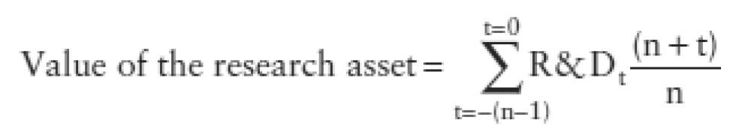

    - –e.g. with a 5-year life:
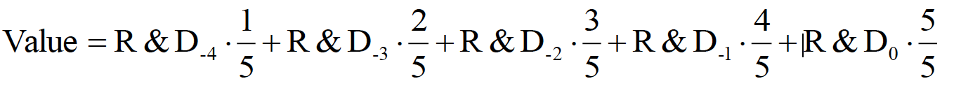

    - This increases the value of the assets of the firm and consequently the book value of equity
  - STEP 3: Finally, adjust the operating income to reflect the capitalization of the R&D Expense:
    - 1.Add back the current R&D expenses that were subtracted
    - 2.Amortize the research asset (just like a depreciation) by subtracting it:
    - 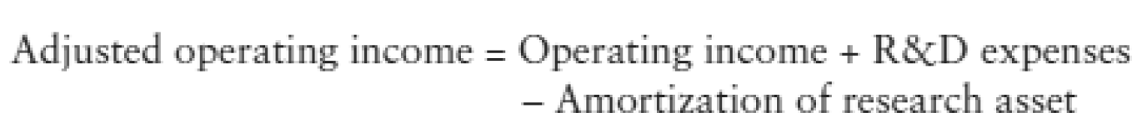
    - Same effect on Net Income.
    - SINCE R&D IS entirely tax deductible we don’t need to only add back tax shield.
    - TABLE: YEAR | EXPENSE | Unamortized portion | Amortization this year(reapply the rule)

CAPITALIZING OTHER EXPENSES

- Consumer product companies (Gillette, Coca-Cola) could argue that a portion of advertising expenses should be treated as capital expenses:
  - they are designed to augment brand name value
- For a consulting firm, the cost of recruiting and training its employees could be considered a capital expense:
  - The consultants who emerge are at the firm's assets, and provide benefits over many years
- Caution: There should be substantial evidence that the benefits from the expense accrue over multiple periods – need to know what these expenses are and how long the benefits accruing from these expenses last.
- How to do it:
  - STEP 1: Determine the period over which the benefits from the operating expense will flow
  - STEP 2: Estimate the value of the asset (like the research asset) created by these expenses:
    - If the expenses are SG&A expenses, this would be the SG&A asset
  - STEP 3: Adjust the operating income for the expense and the amortization of the created asset:
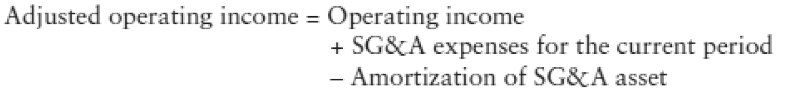

ADJUSTMENTS FOR FINANCING EXPENSES

- The second adjustment is for the financing expenses that accountants treats as operating expenses
  - Ex. operating lease expenses are treated as operating expenses, and capital leases are treated as debt (Liability for the firm)
  - For valuation, we need to increase the debt of the firm by the value of the operating leases
- Two primary types of leases: capital and operating:
  - Capital leases are non-cancelable, and must meet at least one of the following requirements:
    - The lease transfers ownership of the asset
    - the lease contains a bargain purchase option
    - the duration of the lease is 75% or more of the asset's expected economic life and/or the lease is worth at least 90% of the asset's value
    - An operating lease is one that meets none of these criteria
  - Operating Lease A contract that allows for the use of an asset, but does not convey rights of ownership of the asset.
    - An operating lease is not capitalized; it is accounted for as a rental expense
- Basic procedure to convert operating leases into debt:
  - STEP 1: discount future operating lease commitments back at the firm's pretax cost of debt.
  - STEP 2: The PV of the operating lease commitments is then added to the conventional debt of the firm to arrive at the total debt outstanding:
- Now that lease has been categorized as debt, adjust the operating incomes
  - STEP 3: Adjust the operating income:
    - 1. Add back the operating lease expense, since it is a financial expense
    - 2. Subtract the depreciation on the leased asset:
    - Alternative: If depreciation ≈ principal portion of the debt, the adjusted operating income can be approximated by adding back the imputed interest expense on the debt value of the operating lease expense:

ACCOUNTING EARNINGS AND TRUE EARNINGS

- Because firms are so focused on meeting and beating analysts’ estimates of earning each quarter, they may adopt some questionable accounting techniques. This is why you have to correct operating income for these accounting manipulations.

THE PHENOMENON OF MANAGED EARNINGS

- Whispered earning are implicit earning estimates that firms have to beat to surprise the market, since usually they always beat analysts’ estimates.
- Because it is expected now that firms will beat estimates, whispered earnings are usually higher building in expectations that the firm has beating earnings estimates historically.

WHY DO FIRMS MANAGE EARNINGS?

Firms generally manage earnings because they think they will be rewarded for delivering higher earnings than estimates consistently

Firms manage earnings for fear of getting punished by the market if they do not meet expectations

Some financial managers believe that investors take earnings numbers at face value

Managers know that they are more likely to be fired when earnings drop significantly, or maybe they have bonuses that depends on earnings?

Efforts by the Financial Accounting Standards Board (FASB) to change the way earnings are measured are fought with vigor, even when the changes make sense

TECHNIQUES FOR MANAGING EARNINGS

One methods of good earnings managments is the care and nurturing of analyst expectations (Microsoft):

Executives at the firm monitored analyst estimates of earnings, and stepped in to lower expectations when they believed that the estimates were too high, they also let them know when their estimates where too low so they could maintain their credibility.

- Not all techniques are bad, and some may indeed be considered prudent management:

Planning ahead:

Firms can plan investments and asset sales to keep earnings rising smoothly.

Revenue recognition:

Firms have some leeway when it comes to when revenues have to be recognized.

Windows 1995, Microsoft: the firm had accumulated $1.1 billion in unearned revenues by the end of 1996 it could borrow on to supplement earnings in a weaker quarter

Booking revenues early:

Opposite from Revenue Recognition, firms sometimes ship products during the final days of a weak quarter to distributors and retailers and record the revenues

Capitalizing operating expenses: Is a given expense an operating or capital expense?

AOL's practice of capitalizing and writing off the cost of the CDs and disks it provided with magazines, for instance, allowed it to report positive earnings through much of the late 1990s

Write-offs:

A major restructuring charge can lower current income, but provides 2 benefits to the firm taking it:

1.it allows the firm to separate the expense from operations

2.It also makes beating earnings easier in future quarters

EX. IBM wrote off old plants when they were closed and was able to drop depreciation expenses to 5% percent of revenue from 7%, a difference of $1.64 billion, or 18% of the company's $9.02 billion in pretax profit

Use of reserves:

Firms are allowed to build up reserves for bad debts, product returns, and other potential losses:

Some firms are conservative in their estimates in good years, and use the excess reserves in other years

Income from investments:

Firms with financial investments at book value can liquidate them at market value, which results in large capital gains, which can boost income in the period.

ADJUSTMENTS TO INCOME

Since firms manage earnings, you have to be cautious about using the current year's earnings as a base for projections.

We consider a series of adjustments that we might need to make to stated earnings before using the number as a basis for projections:

1) the differences between one-time, recurring, and unusual items

2) how best to deal with the debris left over by acquisition accounting

3) how to deal wih income from holdings in other companies and investments in marketable securities

4) Finally, we look at a series of tests that may help us gauge whether the reported earnings of a firm are reliable indicators of its true earnings

1) Extraordinary, Recurring, and Unusual Items Simple rule for estimating both operating and net income:

“Operating income should reflect continuing operations and should not include any items that are one-time or extraordinary”

4 types of extraordinary items:

1.One-time expense or income that is truly one-time

Look at the past history of the firm to make sure

2.Expenses and income that do not occur every year but seem to recur at regular intervals:

E.g., a firm that took a restructuring charge every 3 years for the past 12 years

Ignoring such an expense would overstate future operating income –=> spread out the expense on an annual basis

3.Expenses and income that recur every year but with considerable volatility:

normalize them by averaging the expenses across time

4.Items that recur every year that change signs—positive in some years and negative in others.

E.g.: foreign currency translations on income: may be negative or positive

Ignore them for cash flow purposes; you may or may not adjust discount rates for the risk created by the variability

2) Adjusting for Acquisitions and Divestitures

The most common by-product of acquisitions is the amortization of goodwill:

Amortization reduces reported income Should we consider it as an operating expense?

No, since it is both a noncash and often a non-tax-deductible charge.

Safest strategy: look at earnings prior to the amortization

Tech companies trick:

They call their goodwill “in-process R&D” and expense it (because the R&D they do internally is expensed)

writing off in-process R&D creates a noncash and non-tax-deductible charge and we should look at earnings prior to their write-off

Divestitures can generate income in the form of capital gains:

Infrequent divestitures can be treated as one-timeitems and ignored

If a firm divest assets on a regular basis:

Best to ignore the income associated with the divestiture, but to consider the CFs associated with divestiture, net of capital gains taxes, when estimating net CAPEX

E.g.: a firm with $500 million in CAPEX, $300 million in depreciation, and $120 million in divestitures every year would have a net CAPEX of $80 million:

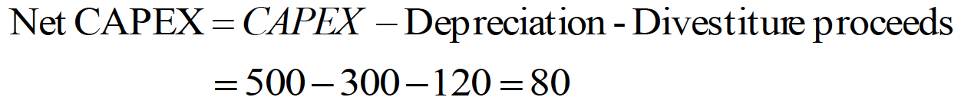

Chapter 10 – From Earnings to Cash Flows

- Why cash flows? Because the value of an asset comes from its capacity to generate cash flows.
- When valuing firm: cash flows should be after taxes & reinvestment but before debt payments
- When valuing equity: cash flows should be after debt payments
- 3 basic steps to estimating cash flows:
- Estimate the earnings generated by a firm on its existing assets and investments (previous chapter)
- Estimate the portion of this income that would go towards paying taxes
- Develop a measure of how much a firm is reinvesting back for future growth
- Chaper focus is on last two steps:
  - Start with investigating the difference between effective & marginal taxes, as well as the effects of net operating losses carried forward
  - To know how much a firm is reinvesting, we will break it down into:
    - (Net Capital expenditures): tangible and long-lived assets
    - (Working Capital): short term assets
    - Reinvestment will include investement in R&D and acquisitions as part of CAPEX

The Tax Effect

- After-tax operating income= EBIT * tax rate
- This is complicated by 3 issues:
- The wide differences you observe between effective and marginal tax rates for these firms: which to choose?
Effective Tax Rate = _ Taxes Due .
Taxable Income
- Firms with large losses: leading to net operating losses that are carried forward and can save taxes in future years
- The capitalizing of R&D and other expenses: because these expenditures can be expensed immediately they have much higher tax benefits for the firm

Effective Versus Marginal Tax Rate

- Choice between the two tax rates:
- Choice 1: Effective tax is the most widely reported tax rate, computed from the income statement as follows:
Effective tax rate = Taxes Due .
Taxable Income
- Choice 2: Marginal tax rate is the tax rate the firm faces on its last dollar of income
- Reflects what firms have to pay as taxes on their marginal income
- Ex. U.S federal tax rate on marginal income is 35% with additional state taxes a corporate firm can have over 40% tax rate

Reasons for Differences Between Marginal and Effective Tax Rates

- Given that most firms are at the top tax bracket, why is the effective rate so low? (why are they different?)
- Many firms follow different accounting standards for tax and for reporting purposes
- Firms use straight line depreciation for reporting purposes
- Accelerated depreciation for tax purposes
- Thus, the reported income is significantly higher than the taxable income, on which taxes are based
- Firms sometimes use tax credits to reduce the taxes they pay
- These credits can reduce the effective tax rate below the marginal tax rate
- Firms can sometimes defer taxes on income to future periods
- If deferred: taxes paid in current period less so effective tax rate will be at a lower rate than the marginal tax rate
- Later, when firm pays deferred taxes effective tax rate will be higher than the marginal tax rate
- Firm that generate substantial foreign income with lower tax rates do not have to pay domestic taxes until that income is repatriated back home

Marginal Tax Rates for Multinationals

- When a firm has global operations, its income is taxed at different rates in different locales
- 3 ways to deal with different tax rates:
- Use a weighted average of the marginal tax rates of each country weights based on income from each country
- Problem: the weights will change over time, if income is growing at different rates in different countries
- Use the marginal tax rate of the country in which the company is incorporated, because:
- Income generated in other countries will eventually have to be repatriated to the country of origin
- Keep the income from each country separate and apply a different marginal tax rate to each income stream

Effects of Tax Rate on Value

- CHOOSE MARGINAL TAX RATE if the same tax rates has to be applied to earnings every period
- The safer choice is the marginal tax rate because:
- None of the four reasons noted can be sustained in perpetuity
- As new capital expenditures taper off, the difference between reported and tax income will narrow
- Firms eventually do have to pay their deferred taxes
- No one is obliging you to keep the same tax rate over time, for example, if your effective tax rate is 24% now but you marginal tax rate (the one we should use is 35%) you can use the 24% as your marginal tax rate this period and increase it until it reaches the 35% in future periods.
- GOOD PRACTICE: the tax rate you end up using in perpetuity to compute the terminal value should be the marginal tax rate.
- One can start from the effective tax rate and progressively increase it towards the marginal rate
- Note: when we value equity we usually use after-tax earning (net income) this does not avoid the problem of estimating tax rates as maybe the current periods tax is higher/lower depending on if the effective tax rate is higher/lower than the marginal tax not right to assume that firm will continue to this in the future (eventually they should be equal)

Effect of Net Operating Losses

- For firms with large net operating losses carried forward or continuing operating losses:
- There is potential for significant tax savings in the first few years that they generate positive earnings
- There are 2 ways of capturing this effect:
- Firms with current negative earnings (change (raise) the tax rate over time):
- Early on: zero taxes (losses carried forward offset income)
- As the net operating losses decrease Increase tax rates toward the marginal rate
- Tax rates used to compute both after-tax cost of debt and cost of capital need to change. – so in beginning when losses shelter income the tax rate used you cost of capital and after-tax cost of debt should be zero.
- Firms with positive earnings, but with a large net operating loss carried forward:
- Value the firm ignoring the tax savings generated by net operating losses,
- Then, add to this amount the expected tax savings from net operating losses
- Expected tax savings= NOL*Tax
  - Limitation: This assumes that the tax savings are both guaranteed and instantaneous
  - Firms need to generate earnings to create tax savings and there is uncertainty about these earnings
- Thus, this overestimates the tax savings

- Important points on operating losses
  - A potential acquirer can claim tax savings from net operating losses sooner than the firm generates these losses
- This is a source of “tax synergy”
- In some countries, there is a limitation on how far in time operating losses can give a tax benefit
- In this case, the value of these net operating losses may be reduced

The Tax Benefits of R&D Expensing

- If we capitalize R&D, a tax benefit might be missed because
  - firms are allowed to deduct their entire R&D expense for tax purposes but only the depreciation on their capital expense
- To capture this tax benefit you need to add the tax savings on the difference between the entire R&D expense & amortized amount of the research asset to the after tax operating income
- Similar adjustment for any other operating expenses that you choose to capitalize
Operating Earnings _{Adjusted after-tax} = Operating earnings (1-tc) + current years R&D expense – Amortization of research asset

- There are no more R&D expenses makes taxes higher
- There is a new depreciation of the R&D This makes taxes lower
- They are also allowed to deducted only the depreciation on their capital expenses

𝐴𝑑𝑑𝑖𝑡𝑖𝑜𝑛𝑎𝑙 𝑇𝑎𝑥 𝐵𝑒𝑛𝑒𝑓𝑖𝑡𝑅&𝐷 𝐶𝑎𝑝𝑖𝑡𝑎𝑙𝑖𝑧𝑎𝑡𝑖𝑜𝑛 = 𝑁𝑒𝑤 𝐴𝑚𝑜𝑟𝑡𝑖𝑧𝑎𝑡𝑖𝑜𝑛 − 𝐶𝑢𝑟𝑟𝑒𝑛𝑡 𝑅&𝐷 𝐸𝑥𝑝𝑒𝑛𝑠𝑒 ∗ 𝑡𝑎𝑥 𝑟𝑎𝑡𝑒

Tax Books and Reporting Books

- Two sets of books (both legal and accepted): tax purposes (accelerarated dep) and reporting purposes(straight line)
- The income reported to stockholders generally is much higher than the income reported for tax purposes
- When valuing firms, we generally have access to only the one for reporting purposes
- This affects our estimates in a number of ways:
- Dividing the taxes payable by the reported income (which is generally much higher)
- Will yield a tax rate that is lower than the true tax rate using it in our forcasts will overvaluing the company (that’s why we use marginal tax rates)
- If we base projections on the reported income, we will overstate expected future income (since understate tax benefits of dep)
- Since we add depreciation back to after tax income to get CF’s
- The drop in depreciation will offset the increase in earnings but understate the tax benefits from depreciation
- Some companies capitalize expenses for reporting purposes (and for depreciating them in subsequent periods) but expense them for tax purposes
- Using the income and capex from reporting books understate the tax benefits from the expensing
- Generally, it is better to base our valuations on the tax books rather than the reporting books

Reinvestment Needs
- The CF to firm is computed after reinvestments
- Two components go into estimating reinvestments:
- Net capital expenditures (difference between capital expenditures and depreciation)
- Investments in non-cash working capital

Net Capital Expenditures

- In estimating net capital expenditures, we generally deduct depreciation from capital expenditures (since the + CF from dep will pay for at least a portion of CAPEX)
- Forecasting these expenditures can be difficult for 3 reasons:
- Firms can often incur capital spending in chunks (large investments in one year followed by small the following years)
- The accounting definition of capital spending does not incorporate those capital expenses that are treated as operating expenses such as R&D expenses
- Acquisitions are not classified by accountants as capital expenditures
- For firms that grow through acquisitions understatement of the net capital expenditures

Lumpy Capital Expenditures and the Need for Smoothing

- You should normalize CAPEX as firms seldom have smooth CAPEX
- 2 ways to normalize capital expenditures:
- Average capital expenditures over a number of years
  - Cause if they just bought a plant, you would over estimate CAPEX the following years by using that number and vice versa
  - Need to make the choice on how many years to use (depends on how infrequently firm makes large investments), and whether we should average depreciation (leave untouched unless depreciation is as volatile as CAPEX)
- Use industry averages for CAPEX
  - This is for firms with limited histories or have changed their business mix & averaging them is not indicative of true CAPEX needs
  - Usually average is based as a percentage of Rev, total assets, but best is for depreciation.
    - You can also use a subset of firms in same stage or life cycle

Capital Expenses Treated as Operating Expenses

- In past chapter we examined the effect of capitalizing expenses like R&D on earnings there is also an impact on CAPEX , depreciation, and net capital expenditures
- Adjusted CAPEX: If we decide to recategorize some operating expenses as capital expenses:
- We should treat the current period’s value for this item as a capital expenditure
- Ex. If we decide to capitalize R&D expenses, the amount spent on R&D in the current period has to be added to capital expenditures
Adjusted capital expenditures = capital expenditures + R&D expenses in current period
- Adjusted Depreciation and Amortization: since capitalizing an operating expense creates a research asset ,it generates amortization in the current period
Adjusted depreciation and amortization = dep & amort + amort of the research asset
- Now net CAPEX will increase by the difference of the two:
Adjusted net CAPEX = Net CAPEX + R&D expenses in current period – AMORT of research asset
- Note: the adjustment that we make to net capital expenditure mirrors the adjustment we make to operating income
- Since net capital expenditures are subtracted from after-tax operating income, we are nullifying the impact on cash flows of capitalizing R&D

Acquisitions

- When estimating capital expenditures, we should not distinguish between internal (CAPEX in cf statement) and external investments(acquisitions)
  - CAPEX should include aquisitions

Investment in Working Capital

- Second component of reinvestment is the cash that needs to be set aside for working capital needs
- Increases in working capital tie up more cash generating negative cash flows
- Decreases in working capital release cash positive cash flows

Definition Working Capital

- The difference between current assets and current liabilities
- We modify the definition when me measure working capital for valuation purposes:
- We will remove cash and investments in marketable securities from current assets because usually invested in Tbills or CP’s earning a return
  - Only include if it has to maintain a large cash balance for day-to-day operations (earning no return) or in a market with poorly developed banking systems
- We will also back out all interest-bearing debt (short and portion long term debt that is currently due) from the current liabilities as we already consider it in our cost of capital it would be double counting
- Non cash working capital > WC

Estimating Expected Changes in Noncash Working Capital

- The ensure the projections are not the result of an unusual base year you should:
- Tie the changes in working capital to expected changes in revenues or costs of goods sold at the firm over time
  - Non-cash WC as a percentage of rev, with expected revenue changes each period to estimate projected changed in WC over time
- Break working capital down into detail for:
- Firms where inventory and accounts receivables behave in very different ways as revenues grow
- For most firms estimating a composite number for WC is easier and often more accurate than breaking it down into more detail

Negative Working Capital (or Changes)

- Can changes in noncash working capital can be negative – YES!
- Noncash working capital decreases it releases tied-up cash increases the cash flow of the firm
  - For example, managing inventory better or tightening credit terms can effectively reduce WC and be a source of positive CF into the immediate future
  - Cannot be held for longer than 5 years – as any further decrease may have a negative impact on revenues and profit
- Can WC itself be negative yes! a frim with negative working capital is essentially using supplier credit as a source of capital
- Downsides to negative noncash working capital:
- Supplier credit is generally not really free
- Delaying payments of supplier bills may lead to loss of cash discounts
- Make sure you compare this cost to the cost of more traditional forms of borrowing if you want to use this strategy
- A negative noncash working capital generally view as a source of default risk by accountants and rating agencies
  - As rating drop, interest paid by firm increases and costs may be created for other capital by using supplier credit as a source
- For forecasting: cannot assume working capital will continue to become more negative over time. Negative working capital eventually build for increases in working capital

Conclusion

- When valuing a firm, CF’s should be after tax and reinvestment but before debt payments
- Then it became a corrected and updated version of income
- Tax rate: you can use effective tac rate to arrive to after-tax operating income in the early years, but it must converge to the marginal tax rate for future periods/
  - For firms that are losing money, no taxes for a while
- Reinvestment that firms make in their own operations in broken up into two parts:
- Net capital expenditure of the firm
- Difference between capital expenditures (cash outflow) and depreciation (effectively a cash inflow)
- In net capital expenditures we include:
- The capitalized operating expenses (such as R&D) and
- Acquisitions
- Investments in noncash working capital
- Mainly inventory and accounts receivables
- Increases in noncash working capital represents cash outflows to the firm
- Decreases represent cash inflows
- Noncash working capital tends to be volatile and may need to be smoothed out when forecasting future cash flows

CHAPTER 11 – ESTIMATING GROWTH

- There are three basic ways of estimating growth for any firm:
- Look at the growth in a firm’s past earnings – its historical growth rate
- Not good for high-growth firms
- Trust the analyst who follow the firm to come up with the right estimate of growth
- Quality of growth estimates is poor especially in long run
- Estimate growth from a firm’s fundamentals
- How much it has reinvested in new assets and the quality of these investments

The Importance of Growth
- Value of firm come from either
  - Assets in place: asset it owns now that generate CF’s
  - Growth Assets: assets it is expected to acquire in the future that will generate CF’s
- Accounting balance sheets do a poor job summarizing the values of the assets of the firm because they ignore the largest component of value future growth
  - even worse for firms that invest in R&D

Historical Growth
- this section begins by looking at measurement issues that arise when estimating past growth, and the considers how past growth can be used in projections

Estimating Historical Growth
- Measurement problems:
- Historical growth depends on sample size
- Depends on how the average is estimated
- Whether you allow for compounding over time
- Presence of negative earnings in the past or current period
- Arithmetic versus geometric averages
- Geometric mean takes into account the compounding that occurs
- More accurate measure of true growth
  - Especially for firms with volatile earnings and revenues
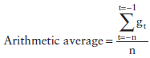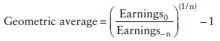
- Linear and Log-Linear Regression Models
- The arithmetic mean weights percentage changes in earnings in each period equally & ignores compounding effects in earnings
- The geometric mean considers compounding, but only considers the first and last earnings
- Ignores information in the intermediate observations and any trend in growth rates that may have developed during that period
- OLS partially overcomes these problems (regressions of EPS over time)
- Linear ordinary least squares (OLS) model:
- EPS_{t} = a+bt
- t = the time
- b = a measure of earnings changes per time period (also known as the slope)
  - Problem: growth is specified in terms of dollar EPS Not appropriate for projecting future growth, given compounding
- Log-Linear version of the OLS model converts the coefficient into % change:
- ln(EPS_{t}) = a+bt
- where ln(EPS) = natural log of EPS in period T
- Now the coefficient b becomes a measure of the % change in earnings per unit of time
- Negative Earnings
- Measures of historical growth are distorted by the presence of negative earnings numbers
- The percentage change in earnings on a year-by-year basis is:
Earnings % change = (EPS_{t} – EPS_{t-1})
EPS_{t-1}
- If EPS_{t-1} is negative, this calculation is meaningless
- Geometric mean is also meaningless if the EPS in the initial period is negative or zero
- Log-linear regressions also face similar problems, since there is no log transformation for a negative number
- Two ways to get meaningful estimates of earnings growth for firms with negative earnings:
- Run the linear regression of EPS against time specified in the previous regression
  - Then g = b/Average EPS_{over time period of regression}
- Use the absolute value of EPS in the previous period
- Use the higher of the two numbers EPS_{T} or EPS_{T-1} in the denominator
- CONCLUSION: since there is no proof that these growth rates are useful When earnings are negative, it is best to ignore the historical growth rate

- Time Series Models to Predict Earnings per Share
- Uses the same historical information as the simpler models previously described
- However, they try to extract better predictions from this data through the use of sophisticated statistical techniques
- Box-Jenkins Models
- A procedure for analyzing and forecasting univariate time series data using ARIMA – autoregressive integrated moving average model
- Model is appropriate as long as data doesn’t show time trend or dependence on outside variables
- Models a value in a time series as a linear combination of past values and past errors (shocks) – denoted by the notation:
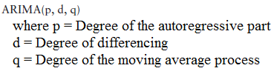
- The mathematical model is:

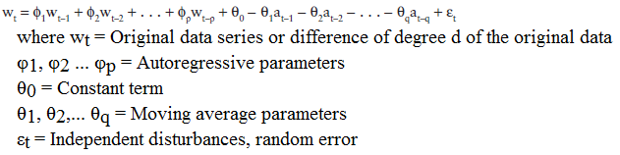
- ARIMA models can also adjust for seasonality in the data:
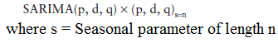
- Time Series Models in Earnings
- Bathke and Lorek (1984) point out that 3 S_{easonal}ARIMA models have been shown to be useful in forecasting quarterly EPS:
- First model, developed by Foster allows for seasonality in earnings:
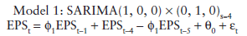
- The second model is an extension of this by Griffin and Watts and allows for moving average parameter:

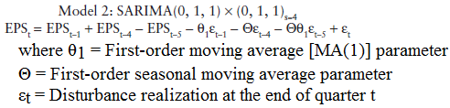
- Third time series model, by Brown and Rozeff is similar in it’s moving average parameter
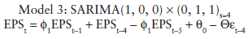
- How Good are Time Series Models at Predicting Earnings?
- Time series models do better than naïve models (just past earnings) in predicting EPS
- Forecast error (between actual and forcasted EPS) from time series models is smaller than the forecast error from naïve models (simple averages)
- Longer-term forecast superiority of time series model declines suggesting estimated time series are not stationary
- There is no evidence that any one of the time series model is dominant in terms of minimizing forecasting errors.
- Limitations in Using Time Series Models to forecast earnings in Valuation:
- Requires a lot of data
- Which is why most of them are based on quarterly EPS
- But Focus is on predicting annual earnings per share in most valuations
- Even with quarterly EPS, number of observations is limited for most firms
- With 10-15 years of data, there are large estimation errors
- Forecast accuracy declines as the forecasting period is extended
- Parameters are not stationary – and we use them to make forecasts for several years so the value of these models if limited
- Analyst forecasts dominate even the best time series models in forecasting earnings
  - Time series models are likely to work best for firms with long history of earnings and where the parameters of the models have no shifted significantly over time
  - The cost of using these models is likely to exceed the benefits

Usefulness of Historical Growth
- Higgledy-Piggledy Growth
- Little (1960) found little evidence that firms that grew fast in one period continued to grow fast in the next period:
- Frequently he found negative correlations between growth rates in the two periods
- The average correlation across the two periods was close to zero (0.02)
- if Past growth is not a reliable indicator of future growth, it is especially true for smaller firms
- Growth rate at smaller firms tend to be more volatile
- Although correlations are higher for shorter term growth rates, they remain to be consistently lower for smaller firms than they are for the rest of the market
- Revenue Growth Versus Earnings Growth
- Revenue growth tends to be more persistent and predictable than earnings growth
- This is because accounting choices have a far smaller effect on revenues than they do on earnings
- So revenue growth is consistently more correlated over time than in earnings
- Historical growth in revenues is a far more useful number when it comes to forecasting than historical growth in earnings
- Effects of Firm Size
  - Growth rate is a % so the size of firm plays a role in the analysis
  - It is easier for a firm with $10 million in earnings to generate a 50% growth rate than it is for a firm with $500 million in earnings
    - Since it becomes harder for firms to sustain high growth rates when they become larger past growth rates for firms that have grown dramatically in size may be difficult to sustain in the future
    - Particular problem when analyzing small and growing firms (as they usually double or triple in size)
- How well does a small firm handle growth?
- Some firms continue to deliver their products and services efficiently as they grow (successful scale up)
- Other firms have had much more difficulty replicating their success as they become larger
- In analyzing small firms, therefore, it is important that you look at plans to increase growth AND it is even more critical that you examine the systems in place to handle this growth

Historical Growth at High-Growth and Younger Firms
- Presence of – earnings, volatile growth rates & rapid changes historical growth is an unreliable predictor for future growth at these firms
- But, there are ways to incorporate information from historical growth into estimates of future growth rates:
- Focus on revenue growth, rather than earnings growth
- Because revenue growth is less volatile & less affected by accounting choices
- Rather than looking at average growth over the past few years, look at the growth each year
- Will tell you how the growth is changing as firm gets larger
- Use historical growth rates as the basis for projections only in the near future (next year or two)
- Since technologies can change rapidly
- Consider historical growth in overall market and in other firms that are serving it
  - will help you decide which growth rate your firm will converge on over time

Analyst Estimates of Growth
- This section considers the process that analysts follow to estimate expected growth and follows up by examining why such growth rates may not be appropriate when valuing some firms

Who do Analysts Follow?

- The number of analysts tracking firms varies widely across firms:
- Firms like Apple, GE, and Microsoft that are followed by dozens of analysts
- There are hundreds of small firms that are not followed by any analysts
- Why are some firms more heavily followed? Determinants of firm following:
- Market Capitalization
- The larger the market cap the more likely it is to be followed by analysts
- Institutional Holding
- Greater the percent of a firm’s stock that is held by institutions, the more likely it would be followed
- Do analysts follow institutions or vice-versa? probability of casualty runs both ways
- Trading Volume
- Analysts are more likely to follow liquid stocks
- worth noting that the presence of analysts and their recommendations may play a role on increasing trading volume

Information in Analyst Forecasts

- Why are analysts forecasts of growth better than historical?
- Because analysts, in addition to using historical data, can use 5 other types of info other than historical earnings that may be useful to predict future growth:
- Firm-specific information that has been made public since the last earnings report
- This information can lead to significant reevaluation of the firm’s expected cash flows & growth
- Macroeconomic information that may impact future growth
- Economic news on GDP growth, interest rates, and inflation analysts can update their projections as new info comes out (for example, change in monetary policy)
- Information revealed by competitors on future prospects
- Pricing policy and future growth
- Ex. Negative earnings report by one telecomm firm can lead to a reassessment of another telecom firms
- Private information about the firm
- Good private information can lead to significantly better estimates of future growth
- in U.S it is prohibited for firms to selectively reveal info to a few analyst but outside of U.S firms routinely do this to the analysts following them
- Public information other than earnings
- Earnings retention, profit margins, and asset turnover are all often ignored by models for forecasting earnings that depend entirely on past earnings however they are useful in predicting future growth and analysts can incorporate this info into variables of their forecast

Quality of Earnings Forecasts

- In general, analysts provide better forecasts of earnings than models that depend purely on historical data
  - Mean relative absolute error: Measures the absolute difference between the actual earnings and the forecast for the next quarter in %
  - This error is smaller for analysts forecasts than for forecasts based on historical data
- 2 other studies shed light on the value of analysts forecasts:
  - Crichfield, Dyckam, and Lakonishok (1978):
    - SARIMA outperforms analysts from April to August, but underperforms from September to January
      - time series outperforms analysts forecasts April to August
    - Hypothesis: it is because more firm-specific information is available to analysts during the latter part of the year
  - O’Brien (1988):
    - Analysts forecasts outperformed SARIMA for 1-2 quarters-ahead forecasts, do as well as SARIMA (time series) for 3-quarters-ahead forecasts, and do worse for 4Q ahead
    - Hypothesis: advantage gained by analysts from firm-specific information seems to deteriorate as the time horizon for forecasting is extended
- In valuation we focus on long-term growth rates in earnings and not next quarter little evidence to suggest that analysts provide better forecasts of earnings when forecasts are over 3-5 years.
- Cragg and Malkiel (1968) compared LT forecasts by 5 investment management firms with actual growth over the 3 years:
- Hypothesis: analysts were poor long-term forecasters
- Vander Weide and Carleton (1988) contested their hypothesis and found that predictions in 5 year growth from I/B/E/S (institutions brokers estimate system) is > than using historical growth to predict
  - The is intuitive basis to argue that analysts do better than models in five-year forecasts because they use more information
  - Conclusion: that although analysts forecasts may be superiors, their superiority is small for long-term forecasts and that historical growth does play a significant role in analysts forecasts
- Another consideration: Analysts forecast EPS, but you need to forecast the growth of operating income
- the growth in EPS is usually not equal to the growth in operating income
- growth rate in operating income usually lower than your growth in EPS so you would need to adjust them

How do you Use Analyst Forecasts in Estimating Future Growth?

- The info of growth rates from analysts can and should be incorporated into the estimation of future growth
- There are 4 factors that determine the weight assigned to analyst forecasts in predicting future growth:
- Amount of recent firm-specific information
- Analysts forecasts include more recent information about the firm and its future prospects
- Advantage is greater for firms that experienced significant changes in management or business conditions (government policy, restructuring)
- Number of analysts following the stock
- The larger the number of analysts: the more informative is their consensus forecast, and the greater should be the weight assigned to it in analysis
- N.B this info gain is diminished a bit as no analysts act independently resulting in a high correlation across analysts revisions of expected earnings
- Extent of disagreement between analysts
- Extent of disagreement measured by the standard deviation in growth predictions
- Quality of analysts following the stock (hard to quantify)
- Look at size of the forecast error relative to models that use only historical data
- The smaller the relative error, the larger the weight that should be attached to analysts forecasts
- Look at effect on stock prices of analyst revisions
- The more informative the forecast, the greater the effect on stock prices
- Some people argue that there are better analysts than others and their analysis should be isolated and weighted more

Fundamental Determinants of Growth

- Now we want to tie growth more closely to the actions business takes to create and sustain that growth
- This section look @ relationship between fundamental & growth in equity income, then looks at determinants of growth in operating income.

Growth in Earnings Equity
- CF to equity we begin with net income (for value of total equity) or EPS (for value of equity per share)
- We will start by looking @ the fundamentals that determine expected growth in earnings per share, and then the same thing for net income.

- Growth in Earnings per Share
- The simplest relationship determining growth is one based on the retention ratio and ROE on its project
- Firm with ↑ retention ratios & ↑ returns on equity growth ↑
- g_{t} = NI_{t} – NI_{t-1} Where: g_{t} = growth rate in net income
NI_{t-1} NI_{t} = net income in year t
- ROE_{t} = NI_{t} .
Book Value of Equity_{t-1}
- Therefore:
- NI_{t-1} = Book Value of Equity_{t-2} x ROE_{t-1}
- NI_{t} = (Book Value of Equity_{t-2} + Retained Earnings_{t-1}) x ROE_{t}
- Assuming that the return on equity is the same every year:
- g_{t} = (Retained Earnings_{t-1}) x ROE
NI_{t-1}
- g_{t} = Retention ratio x ROE_{t-1 =} B x ROE
- Note that this firm is not being allowed to raise equity by issuing new shares (just retained earnings) so EPS and NI growth will be the same with this method

- Growth in Net Income
- We are relaxing our assumptions since retained earnings is not the only source of equity:
- A firm can grow net income by issuing new equity to fund new projects, while earnings per share stagnates
- We need a measure of investment that goes beyond retained earnings.
- One way is to Estimate how much equity the firm reinvests back into its businesses in the form of new capital expenditures and investments in working capital:

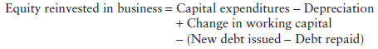
- Dividing this by net income gives a broader measure of the equity reinvestment rate:
  - unlike the Retention ratio, the equity reinvestment rate can be > 100% as the excess can be funded with new equity
  - Expected growth rate in net income = equity reinvestment X ROE

- Determinants of Return on Equity
- Both EPS and NI growth are affected by ROE
- ROE is affected by how much debt the firm chooses to use to fund its projects
- If debt ↑, ROE↑ if the after-tax return on capital exceeds the after-tax interest rate paid on debt:
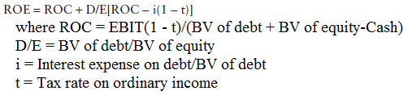
- Since ROE is based on BV, all of the inputs are also stated in terms of book value
- The expanded version of ROE allows to adjust for changes in leverage and evaluate the effects on growth

- Average and Marginal Returns
- ROE measures the quality of both older and new projects:
- Since older investments represent a significant portion of the earnings, ROE may not decrease substantially for larger firms that are facing a decline in returns on new investments
  - so poor returns on new projects will have a lagged effect on overall returns for the firm
- In valuation, it is the returns that firms are making on their newer investments that convey the most information about a quality of a firm’s projects
- To measure these returns, we could compute a marginal return on equity by dividing the change in net income in the most recent year by the change in book value of equity in the prior year:
Marginal ROE_{t} = ΔNI_{t} .
ΔBook Value of Equity_{t-1}

- The Effects of Changing Return on Equity
- So far, we assumed that the overall ROE remains unchanged over time
- By relaxing this we introduce a new component of growth – the effect of changing ROE on existing investments over time :
- Consider a firm with book value of $100 million and ROE of 10%:
- If this firm improves its ROE to 11%, it will post an earnings growth rate of 10% even if it does not reinvest any money
- This additional growth (should be added to g from ROE X RR) can be written as:
Addition to expected growth rate = ROE_{t} – ROE_{t-1}
ROE_{t-1}
- While ↑ ROE, will generate a ↑ in the growth rate in the period of the improvement the reverse is more than proportionally true
- N.B The additional growth that we are estimating here does not come from new investements but by changing the return on existing investments thus called the “efficiency-generated growth”

GROWTH IN OPERATING INCOME

- Just as equity income growth is determined by The equity reinvested back into the business and the return made on that equity investment:
- You can relate growth in operating income (EBIT) to total reinvestment made into the firm and the return earned on capital invested
- We will consider 3 separate scenarios and examine how to estimate growth rate in each:
  - A firm earning a high return on capital that it expects to sustain over time
  - A firm is earning a positive return on capital that is expected to increase over time
  - A firm expects operating margins to change over time, sometimes from negative to positive

- 1) Stable Return on Capital Scenario
- When a firm has a stable return on capital, its expected growth in operating income is a product of the reinvestment rate
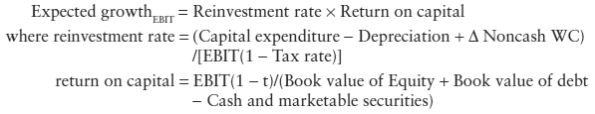
- The reinvestment rate and return on capital should be forward looking ROC should represent the expected return on capital on future investments we now look @ how to estimate ROC & Reinv.Rate

- Reinvestment Rate Estimation (stable scenario)
- The reinvestment rate measures how much a firm is plowing back to generate future growth
- Often measured using the most recent financial statements for the firm, however, it is not necessarily the best estimate for future reinvestment rates:
- Firms with few large projects or acquisitions
- There Reinvestment rates will increase and decrease substantially
- Take an average reinvestment rate over time
- As firms grow and mature their reinvestment needs and rate decrease:
- Firms that have expanded significantly over the last few years their historical rate is likely to be higher than the expected future reinvestment rate
- Take the industry average
- Make sure to treat R&D expenses & operating leases consistently R&D expenses must be categorized as part of capital expenditures for purposes of calculating reinvestment rate

- Return on Capital (stable scenario)
- We assume that the current accounting return on capital is a good measure of the true returns earned on existing investments and that this return is a good proxy for the returns that will be made on future investements
  - They use book value of capital to measure capital invested in these investments
- This assumption is opened to questions for the following reasons:
- Book value of capital may not be a good measure of the capital invested in existing investments since it reflects the historical cost of these assets and accounting decisions on depreciation
- When BV understates the capital invested the return on capital will be overstated
- BV of capital must be adjusted to reflect the value of the research asset or the capital value of operating leases
- The operating income, just like BV of capital, is an accounting measure of the earnings made by a firm
- all the problems regarding using unadjusted operating income mentioned in ch 9 still apply
- Even if first 2 are measured correctly, return on capital on existing investments may not be equal to the marginal return on capital that the firm expects to make on new investment especially in the long run
- Given these concerns you should consider not only ROC, but any trends in this return and industry averages
  - If current return on capital for firm is ↑ than the industry average ROC_{Forcast} should be set lower than the current return to reflect the drop as competition responds
  - Firm that earns a return on capital ↑ than its cost of capital firm is earning an excess return
    - which are the result of the firm’s advantages or barrier to entry if you keep this high excess return it implies that this firm as a permanent competitive advantage

EXTA: Negative Reinvestment Rates: Causes and Consequences
- The reinvestment rate for a firm can be negative if either:
- Its depreciation exceeds its capital expenditures
- Or the working capital declines substantially during the course of the year
- For most firms, this is temporary reflecting lumpy CAPEX or volatile WC:
- Replace the current year’s reinvestment rate with an average or with industry average reinvestment rate
- For other firms, this is because we did not incorporate acquisitions into CAPEX (if the firm grow though acquisitions) or capitalize R&D (or like expenses)
- For some firms, the negative reinvestment rate may be deliberate and how we should deal with this depends on the reasons the firm chose to go on this path:
  - Firms that have overinvested in CAPEX in the past may be able to live off past investment for a number of years, reinvest very little and generating high CF’s during that period:
    - Use the negative reinvestment rate in forecasts and estimate growth based on improvements in return on capital
    - Once firm reached optimal point where it is efficiently using resources, reinvestment rate should reflect expected growth
- More extreme: A firm may have decided to liquidate itself over time, by not replacing assets as they become run-down and by drawing down working capital:
- Estimate the expected growth using the negative reinvestment rate leading to negative expected growth & declining earnings

- 2) Positive and Changing Return on Capital Scenario
- If the ROC changes over time, the expected growth rate for the firm will have a second component:
- Which will increase the growth rate if the return on capital increase and vice versa
- So use this formula when reinvestment rate stays the same but ROC changes
Firm expected growth rate = ROC_{t} x Reinvestment rate + ROC_{t} – ROC_{t-1}
ROC_{t-1}
- Marginal and Average Returns on Capital
- Two measures of ROC:
- Average ROC = The return earned by the firm collectively on all of its investments
  - Changes will result in the additional impact on growth mentioned earlier
- Marginal ROC =The return earned by a firm on just the new investments it makes in a year
  - Changes in marginal return on capital do not create a second-order effect
  - Expected growth = MROC x Reinvestment rate

- Candidates for Changing Average Return on Capital
- What kind of firms are likely to see their ROC change over time?:
- Firms with poor returns on capital that improve their operating efficiency and margins better ROC
- Expected growth rate will be much higher than the product of the reinvestment rate
- Since their ROC is usually very low initially for these firms, even a small change in ROC will translate into big changes for growth (increase from 1% to 2% will double earning & g = 100%)
- Firms that have high ROC on their existing investments, but are likely to see their returns slip as competition enters

- 3) Negative Return on Capital Scenario
- Third scenario for measuring growth: when a firm is loosing money and has negative return on capital
- Since firm loosing money reinvestment rate is likely to be negative
- Steps to estimate growth:
  - 1) Move up income statement and project growth in revenue
  - 2) Use firm’s expected operating margin in future years to estimate the operating income in those years:
    - If expected margin in future years is + expected operating income will also turn positive so we can apply traditional valuation techniques
  - 3) We also estimate investment needed to generate future revenue growth by linking revenues to the capital invested in the firm
- Growth in Revenues
- Many high-growth firms report losses but show large increases in revenues from period to period
- The first step is forecasting revenues in future years usually by forecasting growth rate.
- Keep in mind:
- The rate of growth in revenues will decrease as the firm’s revenues increase
  - a tenfold increase in a $2M revenue makes sense but very unlikely with revs of $2billion
- Compounded growth rates in revenues over time can seem low, but appearances are deceptive
- Keep track of the dollar revenues to ensure that they are reasonable
  - For example, if projected revenue in 10 years would give them 90% market share in a competitive market you should clearly reassess (look at given size of the overall market that the firm operates in)
- Assumptions about revenue growth and operating margins have to be internally consistent
- Firms can post higher growth rates in revenues by adopting more aggressive pricing strategies
- Higher revenues growth will then be accompanied by lower margins
- If a firm sells it products for less this will reduce its margins
- When coming up with an estimate of revenue growth, you have to:
- Make a number of subjective judgments about the nature of competition
- The capacity of the firm that you are valuing to handle the revenue growth
- And the marketing capabilities of the firm

- Operating Margin Forecasts
- For firms to be valuable, the higher revenues eventually have to deliver positive earnings
- In a valuation model, this translates into a firm needing positive operating margins in the future
- The key input in valuing a high-growth firm is then the operating margin you expect in the future
- How do we estimate this margin? look at the business the firm is in and use the average operating margin of their competitors
  - while it may seem conservative, if operating margins were consistently higher than brick and mortar stores everyone would move online increasing competition and driving margin down
- While this gives us a target value, two operating margin estimation issues need to be confronted:
- Given that operating margins are negative in the early stages of the life cycle Consider how the margins will improve from current levels to target values
- usually will improvement will be greatest in earliest year (in % terms) and lower as it matures
- The margin and revenue growth assumptions have to be consistent -> if revenue growing margin should be increasing
- If higher growth but lower margin it is inconsistent

EXTRA: Market Size, Market Share, and Revenue Growth
- Ways for estimating revenue growth rates for a young firm in a new business:
- Work backwards by considering the share of the overall market that you expect your firm to have once it matures, then determine the growth rate you need to arrive at this market share
- Forecast the expected growth rate in revenues over the next 3 to 5 years based on past growth rates. Once you reach years 3 or 5, forecast a growth rate based on the rate at which companies with similar revenues grow currently

Sales-to-Capital Ratio
- Firms need to invest if they want to generate both high revenue growth & positive margins in future years these investments can be internal projects, acquisitions, WC
- To link revenue growth with reinvestment needs look at the revenue generated by each dollar of capital that we invest this is the sales-to-capital ratio:
- This allows us to estimate how much additional investment the firm has to make to generate the projected revenue growth
To estimate the reinvest needs in any year: Reinvestment needs = Revenue growth_{$ TERMS} .
Sales-to-capital ratio
  -  Lower sales-to-capital ratios increase reinvestment needs (reduce cash flows)
  - Higher sales-to-capital ratios decrease reinvestment needs (increase cash flows)
- To estimate the sales-to-capital ratio:
- Look at the firm’s past and the business it operates in
- To measure this ratio for a firm, divide changes in revenue each year by the reinvestment made that year
- Also, look at the ratio industry average of sales to book capital
- Linking operating margins to reinvestment needs is difficult since a firms capability to earn income ans sustain these high returns depends on their competitive advantage
- This competitive advantage comes from both internal investment & acquisitions
- Firms that adopt a two-track strategy in investing where:
- One focuses on generating higher revenues
- And the other on building up competitive strengths
- Should have higher operating margins and values than firms that concentrate only on revenue growth

Imputed Return on Capital
- There is a danger of over/underestimating reinvestment needs if you use the sales-to-capital ratio to do so
  - Correct it by: estimating the after-tax return on capital of the firm each year through the analysis
    - Divide estimated after-tax operating income by total capital invested in that firm that year(sum them up to find the total)
- For firms loosing money today, return on capital will be a negative initially but improve as margins increase
  - If you reinvest too little, the return on capital in the later years will be too high
  - If you reinvest too much, the return on capital in the later years will be too low
  - too low/high relative to what?
    - either average ROC for mature firms in similar business
    - or to the firms own cost of capital

Qualitative Aspects of Growth
- Qualitative factors matter and will need to show up in our quantitative inputs that determine growth
- Growth is determined by a number of subjective factors:
- The quality of management The firms well-regarded management team may be one reason why you allow the firm’s return on capital to remain well above the cost of capital
- The strength of a firm’s marketing strategy: should be reflected in margins & turnover ratio assumptions
  - Ex. brand name as well strength of distribution system
- With our broad definition of reinvestment, there is many ways a firm can grow more effective reinvestment strategies = higher ROC
- Strength of competition determines how high excess returns will be and how quickly they fade to zero
- Qualitative factors are quantified and the growth implications are considered

Conclusion
- Three sources of growth rates (estimating growth)
- The past
  - had to use for firms with volatile or negative earnings
- Analyst estimates of growth
- Analyst get info that is not available to the whole market
- This info does not result in growth rates that are superior to historical growth rates
- Analyst’s emphasis on EPS growth can be a problem when forecasting operating income
- Base it on a firm’s fundamental
  - Relationship between growth and fundamental depends on what g rate we are estimating:
    - To estimate growth in EPS look at return on equity and retention ratios
    - To estimate growth in NI we replaced the retention ratio with the equity reinvestment rate
    - To evaluate growth in OI use return on capital and reinvestment rate
- Common themes that arise from these approaches:
- Growth and reinvestment are linked, and estimates of one have to be linked with estimates of the other
- Firms that want to grow at high rates over long periods need to reinvest to create growth
- The quality of growth can vary widely across firms
- The best measure of the quality of growth is the returns earned on investments
- Firms that earn high returns on equity and capital generate higher growth and add to their value

CHAPTER 12 – CLOSURE IN VALUATION: ESTIMATING TERMINAL VALUE
- Previous chapter we examined the determinants of expected growth rates.
  - Firms that reinvest a lot of their earning and earn high returns on those investement should be able to grow at high rates
- This chapter focuses on for how long this is possible, as well as what happens after that & how the transition occurs.
- Two different ways of bringing closure to a valuation:
  - 1) going concern approach firm delivers CF’s in perpetuity
    - key question: when and how the transition to stable growth will occur?
    - We will look at firm size ( relative to target market), current growth rate & competitive advantage
  - 2) liquidation approach business is shut does and the assets are sold at some point in time.
    - Firm will not last forever and have to be sold
    - We will consider how best to estimate its liquidation value and when we should use this approach instead of the going concern approach

Closure in Valuation

- We do not estimate our CF’s forever
- Usually we use DCF to a certain point, and estimate a terminal value that reflects the value of the firm at the point to compute it’s present value.
- Terminal value is solved in 3 ways:
  - 1) Assume liquidating of firms assets in terminal year and estimate what others would pay for the assets that the firm has accumulated until that point
    - the following 2 ways approaches the value of the firm as a going concern
  - 2) Use multiples of earning, revenue or book value to estimate value in terminal year
  - 3) Assume stable growth at that point, and estimate TV by the perpetuity

Liquidation Value
- we assume firm will stop in the future and sell everything to highest bidder estimate of this price is called liquidation value
- 2 ways to estimate liquidation values:
  - 1) based it on BV of assets and adjust for inflation during the period
    - ex liquidation value = BV_{assets term year} (1+inflation)^{average life of assets}
    - limitation: based on accounting BV and does not reflect earning power of assets
  - 2) estimate value based on earning power of the assets
    - basically estimate future CF’s it will generate and discount back
    - if you want to value equity slightly different:
      - find liquidation value like above
      - solve for estimated value of debt outstanding in terminal year
liquidation value – value of debt outstanding = liquidation proceeds to equity investors

Multiple Approach
- value of firm in future year by applying multiple to the firms earnings or revenues in that year
  - valuing firm value to sales ratio example
  - valuing equity use equity multiples like price/earnings
- limitations: very simple method but where you find your multiple is critical
  - if multiple is found by looking at similar firms relative valuation rather than DCF
    - is a dangerous mix and solves for relative value not intrinsic(what we want in DCF usually)
  - if multiple is estimated using fundamentals it converges on the stable growth model described next
  - The only consisted way of estimating terminal value in DCF is to use liquidation value or stable growth.

Stable Growth Model

- In liquidation model, firm has finite life and sold at end of life
- But firms can reinvest their CF’s into new assets and extend that life
- If you assume CF’s will grow at a constant rate forever the TV is as follows:
  - Terminal value_{t} = CF_{t+1}/(r – g_{stable})
    - Valuing equity CF to equity (FCFE or dividends) r = cost of equity
    - Valuing firm CF is FCFF r =cost of capital
      - Both r & g have to be sustainable forever
- Next, we look at how high g can be, how to estimate when your firm will hit stable growth, and what inputs need to be adjusted as firm enters stable growth.

CONSTRAINTS ON STABLE GROWTH
- Small changes in g make big changes in valuation, especially when g is very close to discount rate.
- We already know that growth rate < growth rate of the economy in which it operates
- Must consider the following 3 questions to be able to find the limit on the growth rates:
  - 1) is the company domestic, or does it operate (or have the capacity to operate) multinationally?
    - The growth rate is limited to the growth in the economy of which(or aspires to) operate
  - 2) Is valuation in nominal or real terms?
    - Growth rate has to match if nominal (include expected inflation component), if real then stable growth rate constraint should be even lower.
  - 3) What currency is being used to estimate cash flows & discount rates in the valuation?
    - If high inflation stable growth rate much higher since g+inflation
- Setting g < g in economy ensure that growth will remain less than discount rate
  - Nominal riskless rate = real riskless rate + expected inflation rate
  - In LT real rf will converge to real growth rate in economy and nomial to nominal g of economy
    - Rule of thumb: stable g < riskless rate
    - Can g be negative? Yes it allows a firm to partially liquidate itself each year until it disappears (between liquidation and going concern)
      - Right choice for industries where technological advances cause them to be phased out (landline phones) or where an external customer is scaling back purchases for the long term

KEY ASSUMPTIONS ABOUT STABLE GROWTH

- Every DCF requires 3 critical assumptions on stable growth:
  - 1) when the firm you are evaluating will become a stable growth firm (length of high growth period)
  - 2) what the characteristics will be of the firm when it becomes stable growth (return on investments, cost of equity & capital)
  - 3) the method your firm will transition from high growth to stable
- First assumption analysis:
- When deciding length of growth period 2 important things to note:
  - 1) all firms will hit the stable growth wall eventually as in the best case firm will become very big and it will be virtually impossible to keep growing at the same rate
  - 2) high growth that creates value comes from earning excess returns on their marginal investments
    - this implies that ROC > WACC or that ROE> cost of equity
    - in a competitive market this will attract new competitors and the excess return will disappear.
- When deciding length of growth period, you need to look at 2 factors:
  - 1) Size of firm look at size of firm and current market share, as well as potential growth in total market for these products and services
    - usually smaller firms have potential for high growth over long periods where large firms do not
    - A firm with large market share may have high growth in spite of this, if the entire market is growing rapidly
  - 2) Existing growth rate and excess returns firms who have rapidly growing revenues in the past are more likely to continue in the future
    - firms with high ROC & excess returns are likely to sustain these return for the next few years
  - 3) Magnitude and sustainability of competitive advantages most important**
    - significant barriers to entry and sustainable competitive advantage maintain high growth for longer period
      - ex. Really good top management is a competitive
    - if not, be more conservative in estimating g
    - CAP (competitive advantage period) measures period that firm can be expected to earn higher returns
      - = capital invested today + PV of excess returns
    - MICAP (market implied competitive advantage period) attempts to measure that length of the competitive advantage period that will sustain a current market value assuming ROC & WACC remain unchanged
      - Compare them across firms in a sector or evaluate on qualitative basis
- Second assumption analysis: as firms move from high to stable growth you need to give them the characteristics of a stable growth firm specifically you need to adjust these variables:
  - average risk
    - equity risk: usually higher growth = more risk either because they are niche players supplier discretionary products or they have high operating leverage
    - set beta between (0.8 – 1.2) usually 1
  - debt ratio
    - high growth firms use less debt than stable, because as firms mature their debt capacity increases
    - Should you change debt ratio? depends on managers view on debt and stockholder power:
      - If managers are willing to change financing policy and stockholders retrain power debt ratio will increase
      - If not leave debt ratio at existing levels
    - The effect of changing debt ratio:
      - When valuing firms debt ratio that we use in WACC needs to be adjusted
      - When valuing equity debt ratio will change both cost of equity and expected cash flows
    - Need to maintain internal consistency so also need to change default risk (Ratings) if you project an increase in earning and CF’s the firm should have a better rating
    - Stable growth firms usually investment grade (Baa or higher) as rating increases your cost of debt needs to be recalculated (usually lower)
    - In practice look at financial leverage of larger more mature firms use industry average debt ratio and cost of debt for the firm in stable growth
  - lower (or no) excess return
    - high growth firms usually have high ROC but this is difficult to maintain in the future, however we don’t want it do drop suddenly
    - Some assume there will be no excess return set ROC to cost of capital
    - but because industries often earn excess returns over longer periods assume firms ROC * ROE will move toward industry averages in the future (better estimate of value)

  - stable growth firms reinvest less than high growth firms
    - need to capture this to ensure firm reinvests enough to sustain its stable growth rate
    - adjustment depends on CF we are discounting (dividends, FCFE, FFFF)
    - if DDM where we focus on expected growth in earnings per share
Retention ratio = expected growth rate/ ROE
    - if FCFE model where we focus on net income growth
Equity reinvestement rate = expected growth rate / ROE
- in FCFF we focus on growth in operating income
Reinvetesment rate in stable growth = stable growth rate / ROC
  - note that lets say result is 20% then 80% can be payed out either as dividends, FCFE or FCFF
- Linking reinvestment rates and retention ratios to stable growth rate make valuation less sensitive to assumptions about the stable growth rate
  - Just changing g can dramatically increase value, but if you change reinvestment rate as well it has an offsetting effect
  - Gains for increasing g will be either partially or completely offset by the loss in CF’s due to the higher reinvestment rate
  - The net effect depends on your assumption on excess returns:
    - If ROC (or ROE) > WACC (or cost of capital) increasing growth rate will increase value
    - If they are equal(no excess returns) increasing stable growth rate will have no effect on value
    - TV_{FCFF} = [EBIT_{n+1} (1-tc)(1- Reinvestment rate)]/[Cost of capital _{n} – g]
- Third assumption analysis: how will the firm change as it approaches stable growth?
- 3 distinct scenarios:
  - 1) from high to stable growth abruptly 2-stage model
  - 2) from high, transitional period, then low 3 stage model
  - 3) firm characteristics change each year n staged model
- Which one gets picked depends on the firm being valued:
  - Use option 1: for firms whit moderate growth rates where the shift would not be too dramatic
  - Use option 2: for firms with very high growth rate in operating income since the transition will allows for gradual adjustments to not only growth but risk characteristics (ROC & reinvestment rates)
  - Use option 3: for very young-firms or firms with negative operating margins, this option choice is prudent
- Can you have an extraordinary growth period for firms that don’t have a high growth rate or a negative growth rate? (<= growth rate of economy) Yes, for some firms:
  - Since stable growth requires more than having a growth rate <= growth rate of economy
    - If ROC or beta too high, need a transition period
  - If negative growth rate needs to move up to stable growth rate

The Survival Issue
- Implicit assumption in DCF is that we view the firm as a going concern with a perpetual life very possible that firms will disappear in 5-10 years with volatile earnings or shifting technology.
- Should the valuation reflect this chance of failure? If yes, how can the probability of the firm not surviving be built in our valuation?

Life cycle and Firm survival
- Young firms with negative earnings and CF’s are more exposed to the risk of running into CF problems and end up being acquired by firm with more resources at a cheap price.
  - Why are they more exposed? Well negative CF’s and significant reinvestment needs can result in very low cash reserves.
  - If the firm could raise additional debt or equity easily, then meeting these funding needs is not problem but when stock prices are down and access to markets are limited these firms run into trouble.
- How to measure potential cash flow problems?
  - CASH BURN RATIO = Cash balance/EBITDA

Likelihood of failure and Valuation
- One view is that you already incorporated the multiple scenarios and those probabilities when you found your expected cash flows.
  - The market risk with firm survival and failure is already incorporated into WACC
  - So firms with high chance of failure would have high discount rates & low CF’s.
- Second view is that DCF is overly optimistic and that the liklehood of failure hasn’t been considered adequately so you would consider DCF to overvalue firms and believe it needs to be adjusted

Should you or Should You not Discount Value for Survival?
- First view appropriate (no adjustment needed): for firms with substantial assets in place and relatively small probability of failure. if you did add an extra discount you would be double counting
- Harder to decide for younger and smaller firms decision depends on how you computed the expected CF’s:
  - If you incorporated the probability of multiple scenarios already no need to make more changes
  - If you didn’t need to discount the value for the chance that the firm does not survive
    - 1) you can estimate probability of failure (P) and compute
      - Adj. value = DCF value (1- P) + Distressed Sale Value x P
    - N.b it is not the chance of failure that reduces the value, but the fact that if it fails it will be sold at a discount from fair value.
- How to estimate probability of distress?
  - Hard to estimate because it depends on magnitude of firms cash reserves (relative to cash needs) & the state of the market
    - If market going good even firms with small cash reserves can survive because they can access market for more funds
    - If market going bad even firms with large cash reserves can be threathened
  - 2 ways to estimate
    - 1) look at past and compare the firms who have failed with firms who haven’t and see what sets them apart.
      - For. High debt ratio + negative CFs = more likely
      - Or use regression for example
    - 2) Use bond rating for the firm to see likelihood of default

Closing Thoughts on Terminal Value

- Critics of DCF argue that too great of a value of DCF valuation comes from TV & that the value of TV is easy to manipulate. They are wrong for both.
  - Yes, a large portion come from TV but its not too much. Think of how you earn a return on a stock for example. If you did invest in a good stock, the money you make from dividends will be small compared to the capital gains (from price appreciation) you receive when you sell it. TV is basically like the capital gains, it would be weird if it wasn’t.
    - Greater growth potential in a business, the higher the proportion of the value will come from the TV.
  - Maybe TV is manipulated often but this is because analysts use either multiples or they violate one or both of the two basic propositions in stable growth models:
    - Either that g <= g of economy
    - Or that firms need to reinvest enough in stable growth rate (so compute reinvestment rate using g)
      - The actual g only affects value to the extent of what oyu assume about excess return in perpetuity.
      - When you assume no excess returns, the changes in growth rate actually have no impact on value. (cant really manipulate in this case)

Conclusion
- Value of a firm is the PV of expected CF’s over its life.
- You apply closure to valuation by:
  - Estimating CF’s over a period
  - Estimating the TV for the end of period
    - Using multiples of earning or revenues
    - Using a constant growth rate more consistent with DCF and view of firm having infinite life as it is a perpetuity
      - This growth rate estimation is important:
      - For small firms that are growing fast and have significant competitive advantages higher growth rate and longer period of growth
- If you don’t believe in that firm has infinite life, estimate liquidation value based on what others will pay for he assets that firms has accumulated during high growth phase.

CHAPTER 13: DIVIDEND DISCOUNT MODELS
- The only CF you receive when you buy shares in a publicly traded firm is a dividend
- This chapter explores the general model as well as specific versions of it tailored for different assumptions about future growth
- It examines issues in using the model, and results of studies that have looked at its efficacy

The General Model

- When you hold a stock you expect 2 kinds of CF’s:
  - Dividends during period stock is held
  - EX(price) at end of holding period this is already determined by future dividends
    - So value of a stock is the PV of dividends through infinity
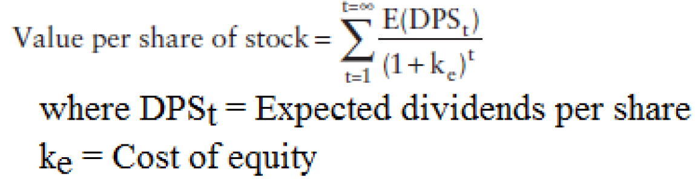
- Two inputs:
  - Expected Dividends we need to makes assumptions on expected future growth rates in earning & payout ratios
  - Cost of equity required rate of return depends on riskiness
    - Riskiness is measured differently by different models, for example, market Beta in CAPM or all the factor betas in the multifactor models

Versions of the Model

- Since projections of dollar dividends cannot be made to infinity, several versions of the dividend discount model have been developed based on different assumptions about future growth.
- Starting with the simplest, the model is designed to value a stock:
  - In a stable growth firm that pays out everything it can afford as dividends
  - Then we will see how we can adapt the model for firms with high growth that may be paying little or no dividends

THE GORDON GROWTH MODEL

  - For Who? For a firm that is in “steady state” with dividends growing @ a rate that can be sustained forever.
  - The Model: Value of Stock = EX(DIVIDEND)_{T=1} / ( Ke – G_{expected in perpetuity})
  - Issue 1: What is a stable growth rate?
    - Not only dividends need to be growing at stable rate, but also the firm’s other measures (net income)
    - Why? Well if earnings are growing @ 2% and dividends are growing @3% eventually dividends will be greater than earnings. (an payout ratio will grow towards 100%)
      - This would not be a firm in a truly steady state.
  - Issue 2: what is a reasonable growth rate tp use?
    - Needs to be <= growth rate of economy in which firm operates
    - ROE we assume in perpetuity should be a longer-term estimate
      - It is important as the payout ratio in stable growth needs to be consistent
      - Payout ratio = g/ROE
    - K_{e} has to be consistent with the firm being mature use B that is close to 1.
  - Limitations Extremely sensitive to assumptions about the growth rate
  - Solution 1) max growth rate < cost of equity 2) if higher growth, then make sure lower payout ratio as growth is not free.
  - Firm model works best for:
    - Firms growing at rate <= nominal growth rate in the economy & has well established dividend payout policies
    - Dividend payout and cost of equity of the firm have to be consistent with the assumption of stability beta close to 1

TWO STAGE DIVIDEND DISCOUNT MODEL

  - Allows for two stages of growth:
    - 1) extraordinary growth rate: initial phases where growth rate is not a stable growth rate g% for n amount of years
    - 2) then a steady state where growth rate is staple g% forever
  - Either you have:
    - High initial growth then low (most common)
    - Or negative growth rates, then revert back to stable growth
  - The model:
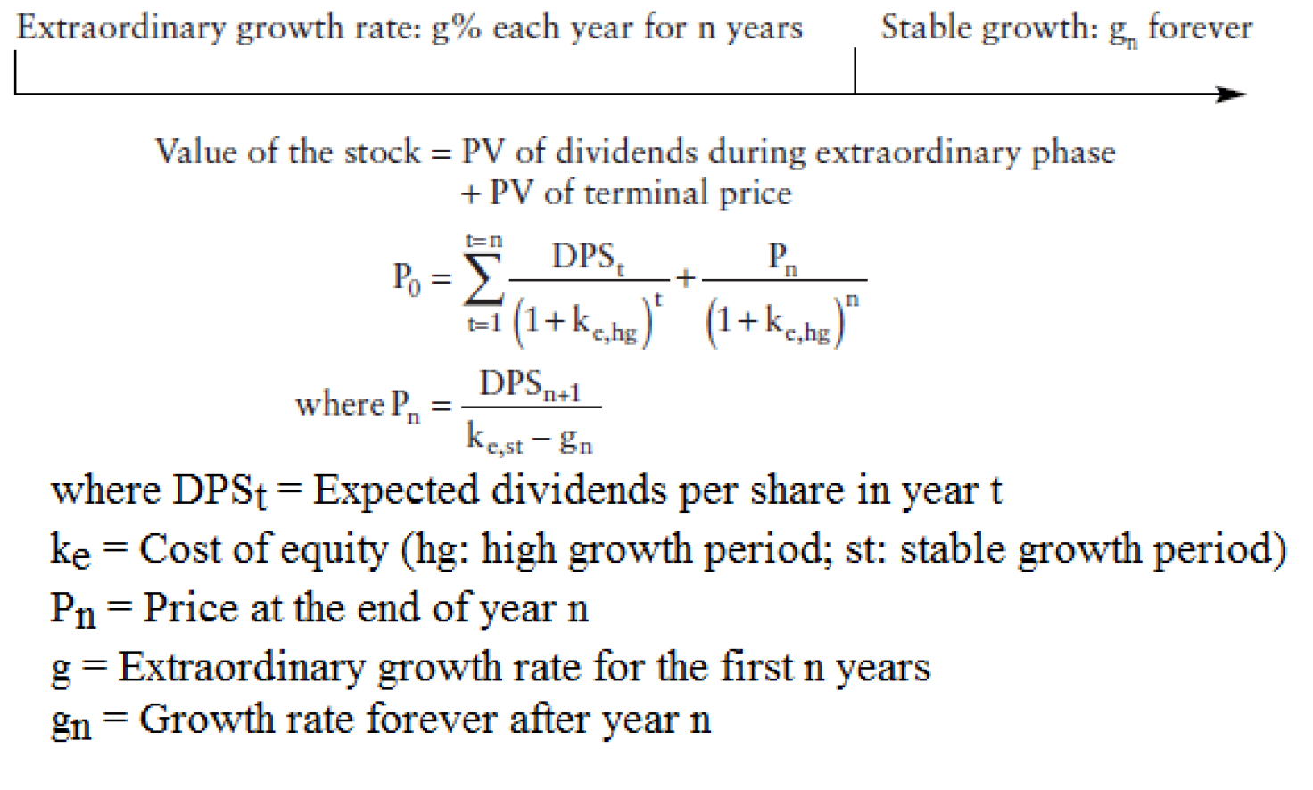
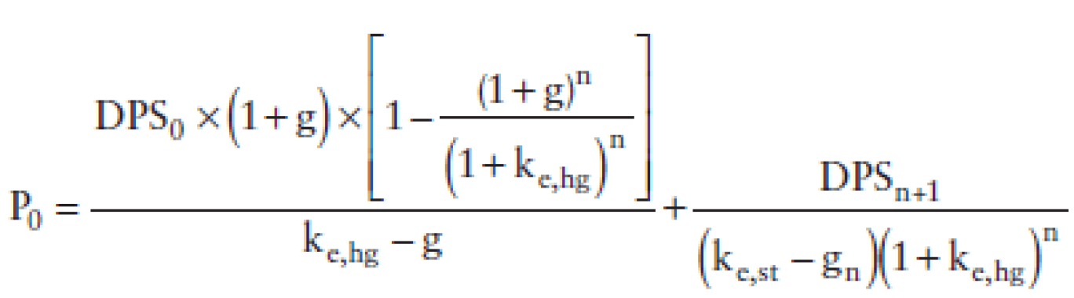
- If the extraordinary growth rate (g) and payout ratio are unchanged for the first n years, we get:

Calculating Terminal Price: terming growth rate still has to be less than nominal growth rate in economy.
- Payout ratio should be > in stable phase than in the growth phase cause now the firm has more money to pay out of its earning to dividends
  - Stable phase payout ratio = 1- (stable growth rate/ stable ROE)
  - Beta between [0.8-1.2]
- Limitations of the model: The first two problems apply to all two-stage models & third for only the dividend discount model (2 stage)
  - 1) Defining the length of the extraordinary growth period (hard to convert the qualitative considerations from chapter 12 into and actual time period)
  - 2) The assumption that the growth rate is high during the initial period and is transformed overnight to a lower stable rate at the end of the period.
    - A gradual shift is more likely
  - 3) The focus on dividends can lead to skewed estimates of value for firms that are not paying out what they can afford to in dividends
    - We will underestimate the value of firms who pay less dividends and accumulate cash instead
- Modifying The Model To Include Stock Buybacks: way of returning cash to stock holders
  - Trend toward stock buybacks is very strong
  - If we only look at dividends we risk missing the significant cash amounts returns to stockholders in the form of buybacks
  - How to incorporate it?:
    - add them onto the dividends and compute an augmented payout ratio:
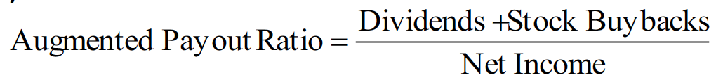
- Since stock buybacks are not smoothed out results could be skewed.
  - A better estimate can be obtained by looking at the average value over a four- or five-year period
- In addition, Firms may sometimes use buy backs to increase leverage. Adjust for this by netting out the new debt issued:
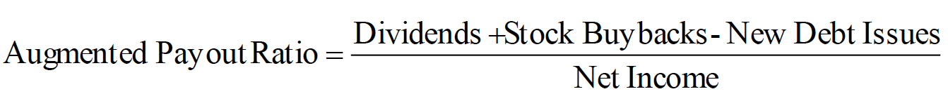
- After adjusting this payout ratio, it will have a ripple effect on growth rate:
- The ROE is also affected by stock buybacks:
  - Book value of equity is reduced by the market value of equity bought back increasing the ROE
    - If we use it as a marginal ROE, we will overstate the value of a firm.
  - Adding back stock buybacks in recent years to the book equity and reestimating the ROE can sometimes yield a more reasonable estimate of the return on equity on investments

- Valuing an Entire Market Using the Dividend Discount Model

- There is no reason why we cannot apply the same model to value a sector or even the entire market using:
  - Market price used = cumulative market price of all stocks in sectors
  - Dividends = cumulated dividends of all the stocks (and could includ stock buybacks by all firms)
  - Growth rate = The growth rate in cumulated earnings of the index
  - The Beta of market = 1 (so no need just add risk premium to risk free rate)
  - One could also use a two-stage model
- Value of growth :Investors pay a premium when they acquire companies with high growth potential
  - It is possible to pay too much for growth Empirical studies show that low P/E stocks return premiums over high P/E stocks in the long term (supports the notion of overpaying for growth)
  - This section will use a two stage DDM to examine the value of growth, and provide a benchmark that can be used to compare the actual prices paid for growth.
- Estimating the value of growth: The value of the equity in any firm can be written in terms of three components:
  - Extraordinary growth (first n years)
  - Stable growth: Value of the firm as a stable growth firm − Value of firm with no growth
  - Assets in place: Value of firm with no growth -the entire earnings are paid out as dividends
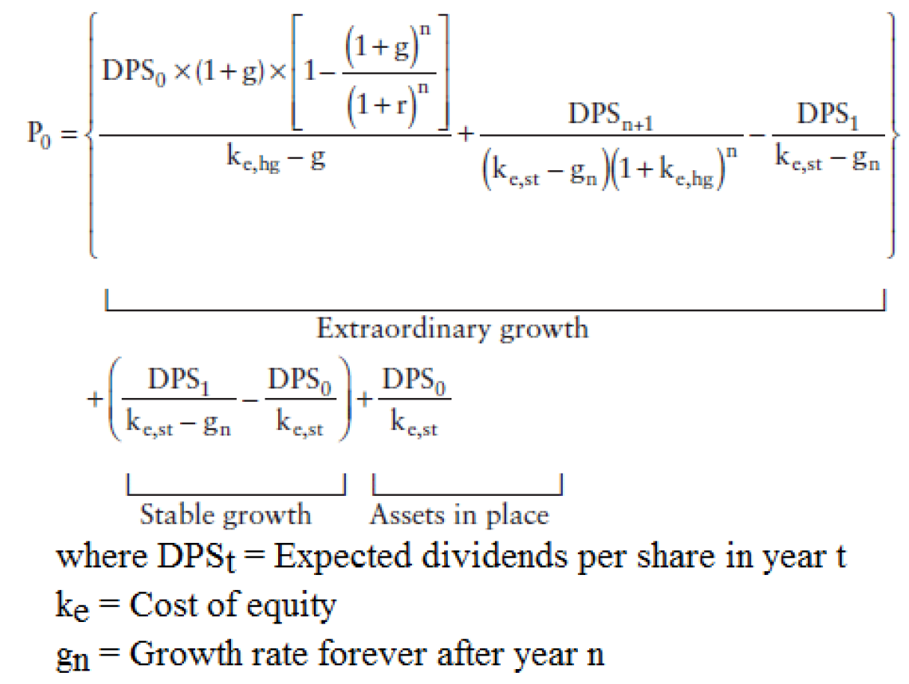
- DETERMINANTS OF THE VALUE OF GROWTH
  - 1.Growth rate during extraordinary period The higher the growth rate in the extraordinary period, the higher the estimated value of growth
  - 2.Length of the extraordinary growth period The longer the extraordinary growth period, the greater the value of growth
  - 3.Profitability of projects: The greater profitability, the greater value of the expected growth
- H MODEL FOR VALUING GROWTH: just like the classic two stage instead of a constant initial growth phase, growth declines linearly over time to reach a stable growth rate in steady state period
- Assumptions:
  - 1) the earnings growth rate starts at a high initial rate (ga) and declines linearly over the extraordinary growth period (2H periods) to a stable growth rate (gn)
  - 2) the dividend payout and cost of equity are constant over time
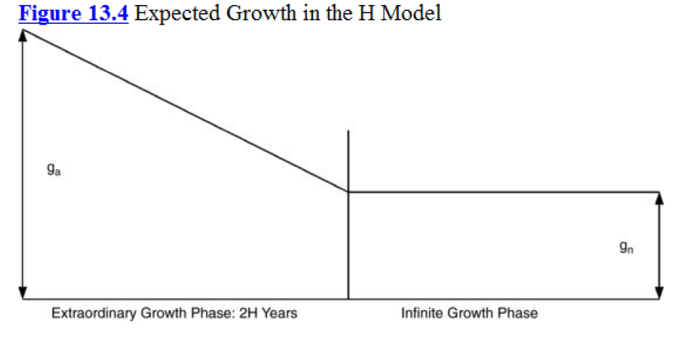
- The expected value of dividends in the H model is:
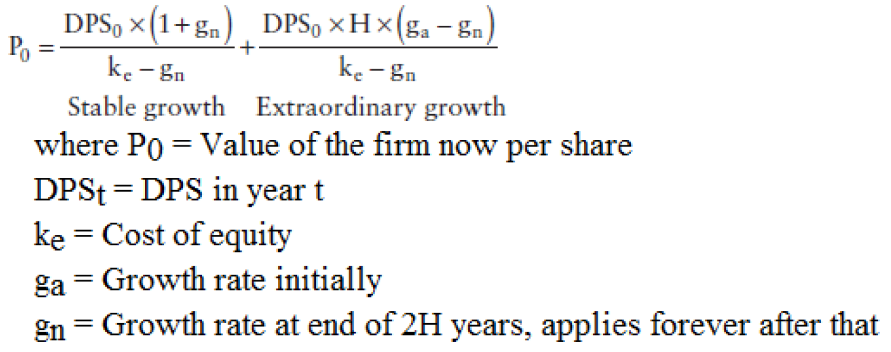
- Limitations:
  - The model avoids the growth rate dropping precipitously from the high growth to the stable growth phase but it does so at a cost:
    - 1.the decline in the growth rate is expected to follow the strict structure laid out in the model large deviations from this can cause problems.
    - 2.the assumption that the payout ratio is constant through both phases of growth exposes the model to an inconsistency as growth rates decline, the payout ratio usually increases
- Firm Model Works Best For: firms that are growing rapidly right now, but growth is expected to gradually decline over time as firms get larger and the differential advantage they have over their competitors declines. (Ex. Mcdees initially, but now it has already established its market share there isn’t room for much growth)
  - Inappropriate for firms who do not pay dividends since payout ratio is constant

THREE-STAGE DIVIDEND DISCOUNT MODEL
- Mix of two stage DDM & H model
- 3 stages: initial growth, period of growth decline, and final stable growth phase
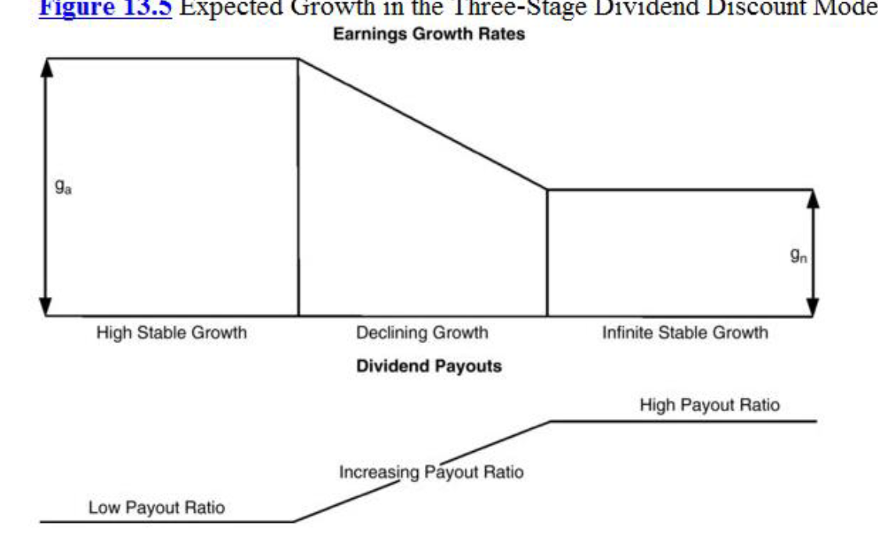

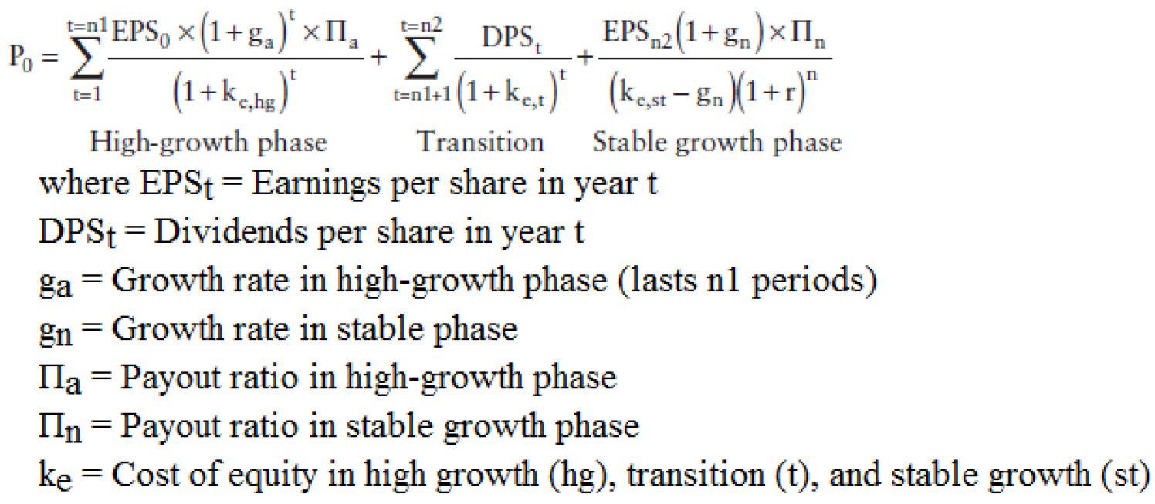
- Assumptions: removes many of the constraints form precious models but needs more inputs:
  - Year specific payout ratios, growth rates and betas
  - More flexible but also much more room for errors
- Firm model works best for: good for any firm that expects a change in growth and in other dimensions such as payout policies and risk.

Issues in Using the Dividend Discount Model

Non-Dividend-Paying or Low-Dividend-Paying Stocks:
  - The notion that it cannot be used for firms who pay low or no dividends is wrong If the dividend payout ratio is adjusted to reflect changes in the expected growth rate, a value can be obtained even for non-dividend-paying firms

Is the Model Too Conservative in Estimating Value?
- For example “unutilized assets” are not priced There is no reason, however, that these unutilized assets cannot be valued separately and added on to the value from the DDM
- Doesn’t account for buyback if you use the augmented version of the model this criticism is also countered

Contrarian Nature of the Model:
- As the market rises, fewer and fewer stocks will be found to be undervalued using the DDM
- Not necessarily true as if the increase if from higher expected growth in economy or lower interest rates could be reflected in DDM by an increase of an equivalent amount
- In other words, If the market increase is due to better economic fundamentals, the values from the DDM will increase
- If the market increase is not due to fundamentals, the DDM values will not follow which is more of a strength than a weakness. this will signal that the market may be overvalued and a cautious investor will pay attention to this

Tests of the Dividend Discount Model
- Ultimate test of DDM is how well it works at finding misprices stocks.
- DDM has been tested and it has been proven that in the long term it can be used to provide excess returns.
  - However not sure if it’s because model can find the mispriced stocks, or because the model makes empirical irregularities relating to P/E ratios and dividend yield well known.
- Sorensen and Williamson valued 150 stocks in 1980 using the DDM They used the difference between the market price at that time and the model value to form five portfolios based on the degree of under or over valuation:
  - In long term, undervalued and overvalued stocks from the DDM outperform and underperform, respectively, the market index on a risk-adjusted basis.

CAVEATS ON THE USE OF THE DDM
  - Although the DDM model provides impressive results in the long term there are some considerations
- The DDM does not beat market every year:
  - Although it beat the market over 5 year time periods, there have been individual years where the model significantly underperformed the market
  - Haugen used the DDM to analyze 250 large cap firms and to classify them into five quintiles, with roughly equal betas
  - The returns on the five portfolios are reported in Table 13.1: The undervalued portfolio earned significantly higher returns than the overvalued portfolio and the S&P 500 for the 1979–1991 period, but it underperformed the market in 6 of the 13 years and the overvalued portfolio in 4 of the 13 years:
- Is the Model Just Proxying for Low PE Ratios and Dividend Yields?
  - The DDM weights expected earnings and dividends in near periods more than those in far periods, and is biased toward finding low P/E stocks with high dividend yields to be undervalued:
    - Fama-French have shown that low-PE-ratio stocks have outperformed high-PE-ratio stocks over extended time periods
    - It’s unclear how much the model adds in value to investment strategies that use PE ratios or dividend yields to screen stocks. Jacobs and Levy (1988b) indicate that the marginal gain is relatively small (average excess return per quarter):
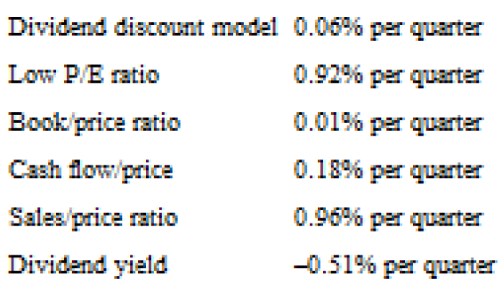
- This suggests that sing low P/E ratios to pick stocks adds 0.92% to your quarterly returns whereas using DDM to pick stocks only adds 0.06 of a %. maybe screening stocks on a basis of PE ratio or CF’s (observables) may provide a larger benefit
- Tax Disadvantages from High-Dividend Stocks:
  - Portfolios created with the DDM are generally characterized by high dividend yield:
    - this can create a tax disadvantage if dividends are taxed at a rate greater than capital gains
    - Since the excess returns uncovered in the studies presented earlier are pretax to the investor, the introduction of personal taxes may significantly reduce these excess returns
    - Summary:
      - For a tax-exempt investor, DDM may be a good tool
      - For a taxable investor, benefits are not so clear or good
      - And for investors with a shorter time horizon, DDM may not deliver on its promised return because of its year to year volatility

CHAPTER 14 – FREE CASH FLOW TO EQUITY DISCOUNT MODELS

- DDM is based on the idea that the only CF’s that stockholders receive are dividends.
  - Even with the modified version that treats stock buybacks as dividends we may misvalue firms that fail to return what they can afford to their stock holders.
- In this chapter, CF’s to equity will be the CF’s left over after meeting all financial obligations and after covering CAPEX and working capital needs.
- It will explain the reasons for differences between dividends and FCFE then presents a discounted FCFE model for valuation.

MEASURING WHAT FIRMS CAN RETURN TO THEIR STOCKHOLDERS

- How do we decide whether a firm is returning too much or too little to their stockholders?
- Simple measure: compare how much cash is available to be paid out to stockholders after meeting reinvestment needs to the actual amount returned to stockholders.

FREE CASH FLOWS TO EQUITY

- FCFE: start with net income & subtract out the firm’s reinvestment needs:
  - Step 1: (-) Any LT capital expenditures (acquisitions included) & (+) Add back depreciation/amortization, which are not cash expenses
    - Net CAPEX = capex – depreciation usually a function of growth characteristics of firm
      - High growth firm High net CAPEX relative to earnings
      - Low growth firm Low or negative net CAPEX
  - Step 2: (-) Δ in noncash WC
    - ↑ WC drain CF’s | ↓ in WC increase CF’s available to equity
    - Firms growing fast in industries with high WC requirements (retailing ex) large increases in WC
  - Step 3: (+) New debt issued but (-) Debt repayments

FCFE = Net income – (CAPEX – DEPRECIATION) - ΔNWC_{non cash} + (Debt_{new}– Debt_{repayed})

- What FCFE represents is the cash flow available to be paid out as dividends.
- Reinvestment by equity investors into the firm is:
  - Equity reinvestement = 𝐶𝐴𝑃𝐸𝑋−𝐷𝑒𝑝𝑟+Δ𝑁𝑊𝐶−𝑁𝑒𝑤𝑑𝑒𝑏𝑡+𝐷𝑒𝑏𝑡𝑟𝑒𝑝𝑎𝑦𝑚𝑒𝑛𝑡𝑠
  - Equity reinvestement rate = Equity Reinvestement/Net income
- Simplified version, by assuming that CAPEX and ΔNWC are both financed by a fixed mix of equity and of debt
  - Let 𝛿= D/(D+E) where 𝛿 represents proportion of net capex & WC that is raised from debt financing
    - We can use either optimal debt ratio or firms average ratio over a period

- 𝐸𝑞𝑢𝑖𝑡𝑦 𝐶𝐹𝑠 𝑓𝑜𝑟𝑓𝑖𝑛𝑎𝑛𝑐𝑖𝑛𝑔𝑛𝑒𝑒𝑑𝑠 of CAPEX and WC = −(𝐶𝐴𝑃𝐸𝑋−𝐷𝑒𝑝𝑟)(1−𝛿)−Δ𝑁𝑊𝐶(1−𝛿)
- So FCFE = 𝑁𝑒𝑡 𝐼𝑛𝑐𝑜𝑚𝑒−(𝐶𝐴𝑃𝐸𝑋−𝐷𝑒𝑝𝑟)(1−𝛿)−Δ𝑁𝑊𝐶∙(1−𝛿)
- NB: debt is no longer included, because we assume that the δ ratio is fixed, hence debt repayments are financed with the same amount of new debt
- To take into account proffered dividends use the following formula, or you can add the expected financing from new preferred stock issues to debt ratio and use the last formula:
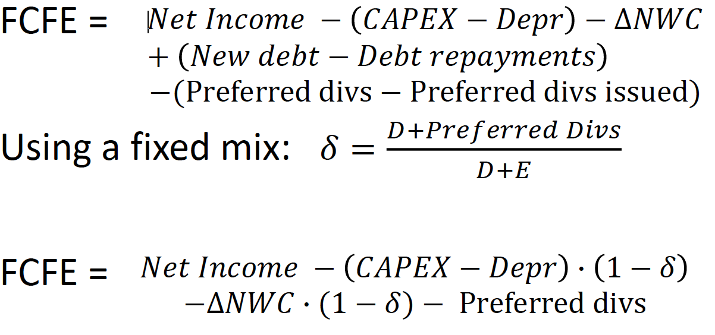

COMPARING DIVIDENDS TO FREE CASH FLOWS TO EQUITY

- Conventional measure of dividend policy dividend payout ratio
  - Payout ratio = Dividends/Earnings
- Modified approach:
  - Cash to stockholders/FCFE ratio = (Dividends + Equity Repurchases)/FCFE
  - This ratio shows how much cash available to be paid out to stockholder is actually returned to them in the form of dividends and stock buybacks
    - If payout = 1 firm paying all that it can back to stockholders
    - If > 1 frim is paying more than it can afford either by using existing cash balance or issuing new securities
    - If <1 firm is paying out less than it can afford to and is using the difference to increase their cash balance or investing in marketable securities
- Trend in cash to stock holders/FCFE in 2010 around 60% is median so firms pay less than they can out of FCFE
- Implications of valuation: if we use the DDM and do not allow for the buildup of cash (as firms usually pay out less than they can afford) we will underestimate the value of equity in firms. (and vice versa)

WHY FIRMS MAY PAY OUT (IN THE FORM OF DIVIDENDS AND BUYBACKS) LESS THAN WHAT IS AVAILABLE

Desire for Stability:

- Firms often refuse to increase dividends, because they want to be certain to continue if they start
  - So if even if earning go up they want to be sure they can maintain these higher dividends (that’s why there is a lag before dividend goes up)
- Variability in dividends < variability in earnings increases in dividends outweigh cuts in dividends 5:1 and is a result of keeping dividends significantly below FCFE

Future Investment Needs:

- Firms are reluctant to pay entire FCFE because:
  - it expects an increase in CAPEX in the future
  - keep as cash to finance future needs such as cost of issuing stocks (floatation costs and issuance fees)
  - if firm is unsure about future financing needs in needs to retain cash to take on both unexpected investments or meet unanticipated needs.

Tax Factors:

- If dividends are taxed higher than capital gains may not want to pay out dividends
- Accentuated when shareholders are already in high tax brackets
  - Ex. Family-controlled firms
- The same is true if tax law favor dividends, the firm may pay out more dividends than they can afford, by borrowing or issuing new stock to do so

Signaling Prerogatives

- Firms often use dividends as signals of future prospects
- Increases in dividends is a positive sign
  - That’s why stock prices usually go up after dividend increases

Managerial Self-Interest:

- Desire for empire building: grow the firm instead of pay out a dividend
- Managers may feel the need to build a cash cushion in case there is a period where earnings dip hiding or reducing the drop may allow them to remain in control

FCFE VALUATION MODELS

- Very similar to DDM expect we discount potential dividends instead of actual dividends using FCFE instead of dividends in the models

UNDERLYING PRINCIPLE:

implicitly assuming that FCFE will be paid out to stockholders
- Two consequences:
  - No future cash buildup in firm (since we payed out all remaining cash after debt payments and reinvestment needs)
  - Expected growth in FCFE will include growth in income from operating assets but not growth in income from marketable securities
- Why don’t we use the augmented version with stock buybacks? Well because usually these buybacks are with the FCFE that wasn’t used. so using just FCFE is a more suitable measure

ESTIMATING GROWTH IN FCFE
- Same approach as the one for estimating the fundamental growth rate in dividends per share
- Since these models assumes FCFE is paid out to stock holders, it makes no sense to use the retention ratio which says what is not paid out is reinvested into the firm.

Expected growth rate = Equity reinvestment rate(instead of Retention ratio) x ROE
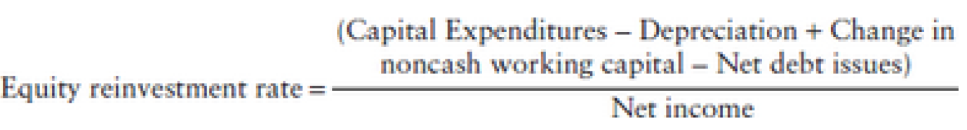
- Value the equity in operating assets then add on cash ROE can also be modified to be the return on non-cash investments as in this model there is no excess cash left in the firm

CONSTANT GROWTH FCFE MODEL
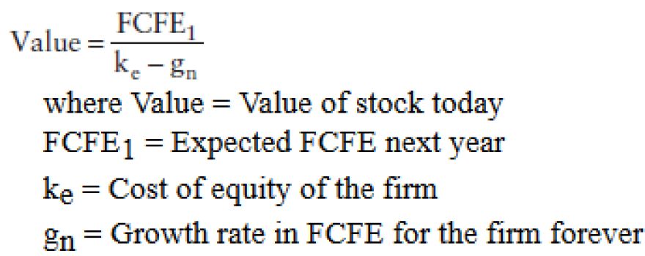

Caveats:
- Very similar to Gordon growth model in its assumptions and works under some of the same constraints:
  - 1) The stable growth rate cannot exceed the growth rate of the economy
- The assumption that firm is in a steady state also implies that it possesses other characteristics shares by stable firms:
  - 2) CAPEX are not disproportionately large, relative to depreciation
  - 3) Firm is of average risk Firm beta should be close to 1
- To estimate reinvestment for a stable growth firm you can:
  - Use typical reinvestment rates for firms in industry using their average CAPEX/dep ratio to estimate a normalized capex for the firm.
    - However, if industry is not in steady state results may be skewed
  - You can use the relationship between growth and fundamentals to estimate the required reinvestment rate:
Expected growth rate in net income = equity reinvestment rate X ROE
So, Equity Reinvestment Rate = Expected growth rate/ ROE
- And finally solve for value (we use the Reinvestment rate to find FCFE from net income)
  - 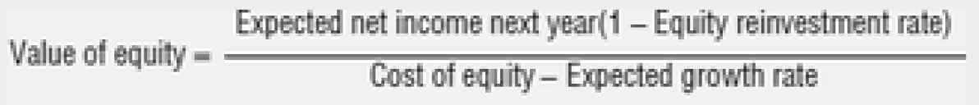

Best Suited for Firms:

- like the stable growth DDM it is best suited for firms growing at a rate <= nominal growth in economy.
- It is a better than DDM for stable firms that pau out dividends that are unsustainably high or much lower than FCFE. If firm payout out all FCFE both model should be the same.
- Increased debt ratio -> increased FCFE & because less is needed from equity investors -> increased value of equity
  - This is not necessarily true, as the risk of the equity increases -> beta increases cost of equity pushed up -> lower equity value
  - Depending on the net effect between increase in CF’s and increase in beta oit may have a negative effect on value

2) TWO-STAGE FCFE MODEL

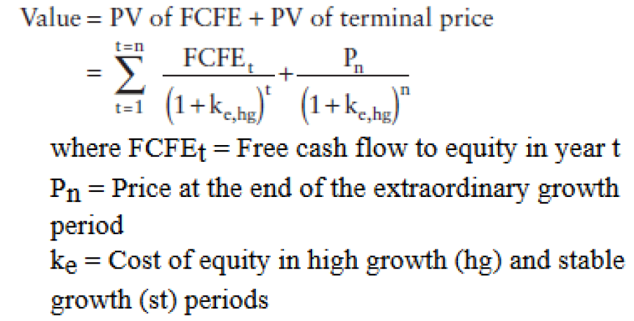

The model:
- For firms that grow much faster than a stable firm in initial period, then a stable rate.

Calculating the Terminal Price
- Use the infinite growth rate model (PV of growing perpetuity)
- The same caveats as past model apply here, however for the first years CAPEX/dep can be much greater initially and narrow as it enters the stable growth phase.
- We can use the same 2 approaches described in the stable growth model industry average of CAPEX requirement or fundamental growth equation (Equity reinvestment rate = g/ROE)
- Make sure to adjust betas and debt ratio in stable growth as stable growth firms have average risk, and use more debt than high-growth firms.

Firm model works best for:
- Same assumptions as two stage DDM but it focused on FCFE. So it is better than the two-stage DDM for firms who do not have a payout ratio =1
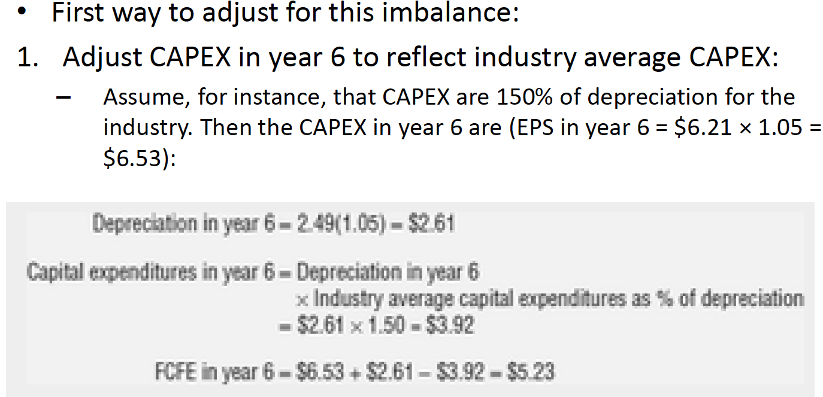
- EXAMPLE:
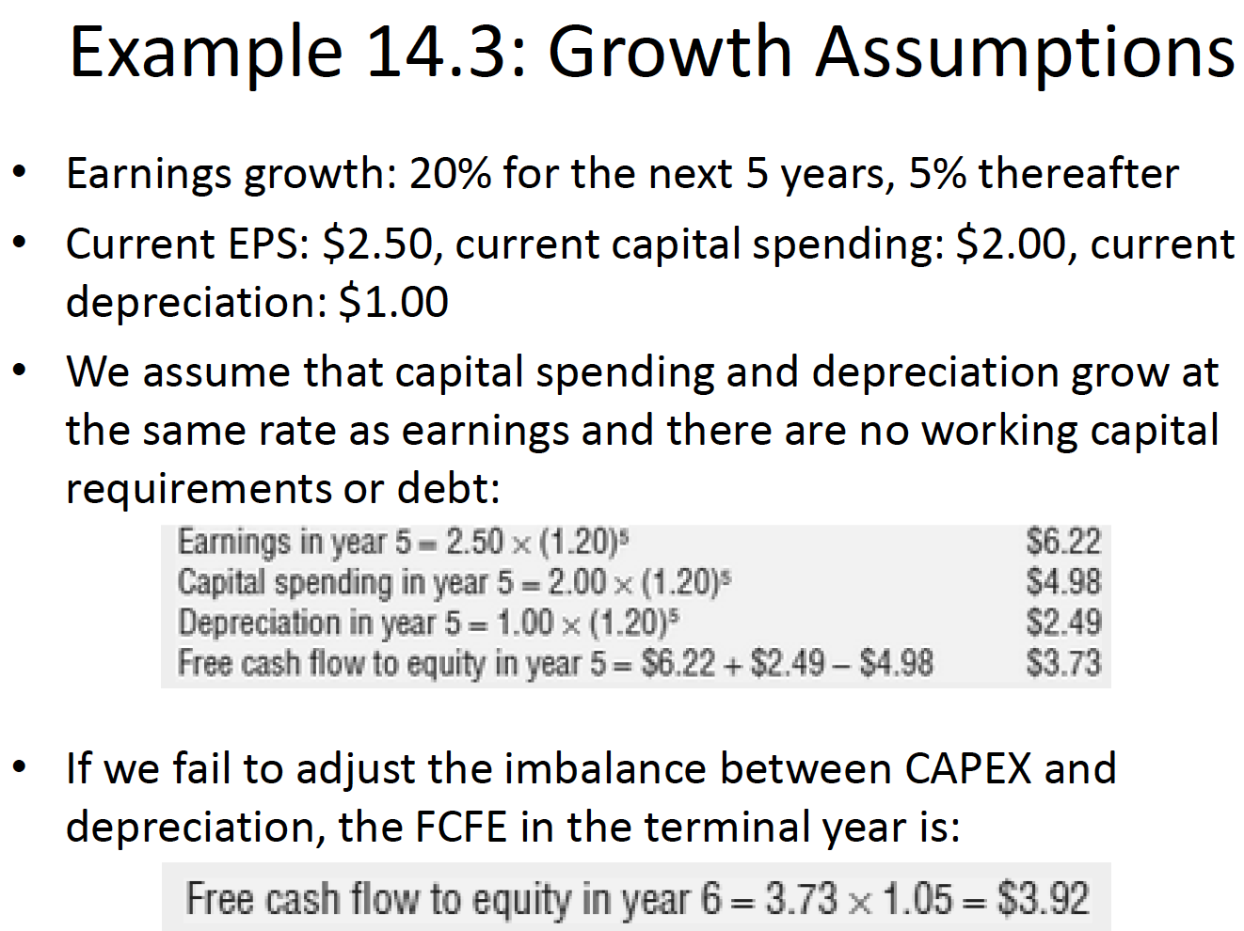

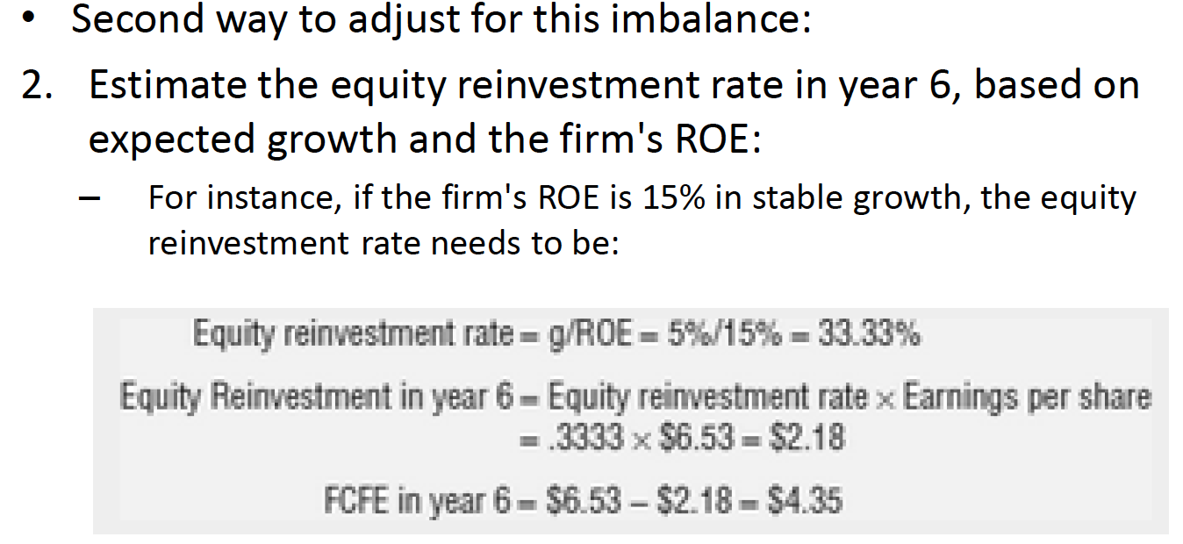

3) E MODEL – A THREE-STAGE FCFE MODEL

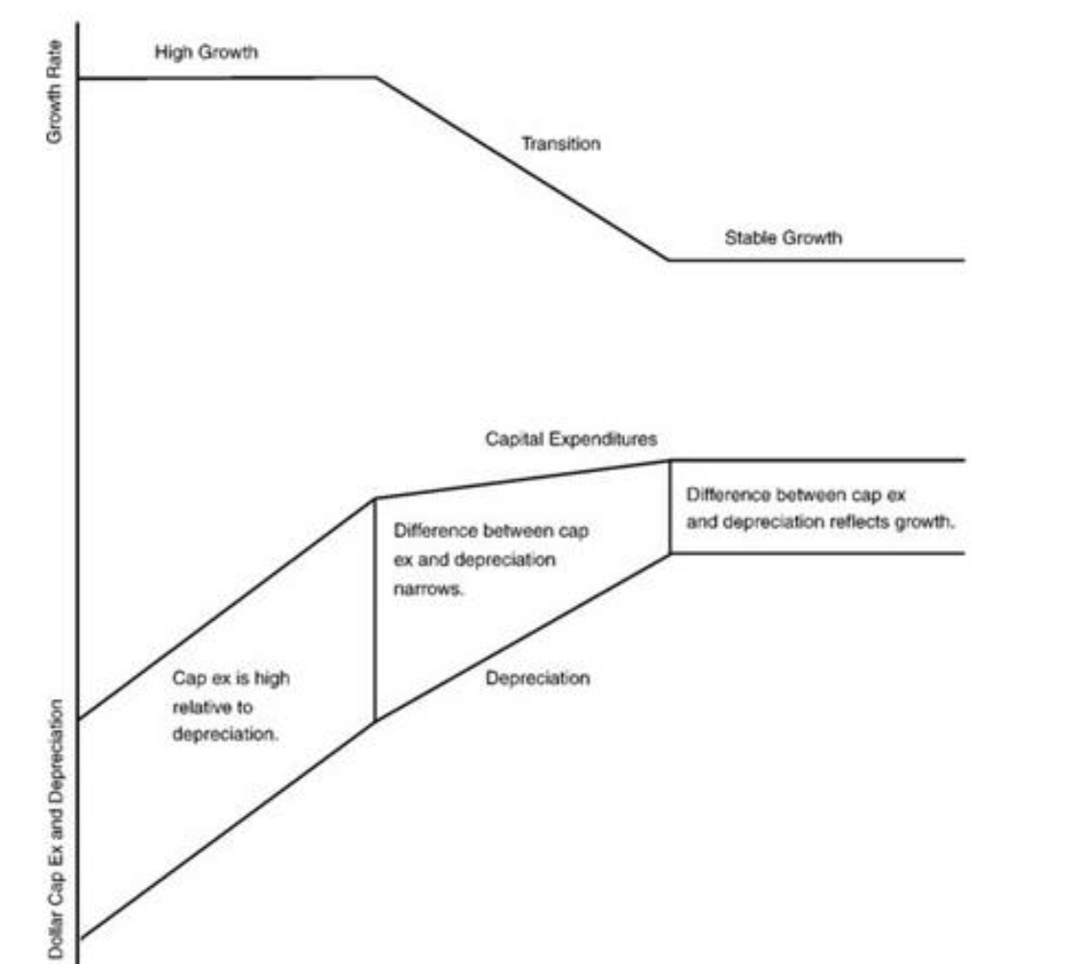
The model:
- Value firms that go through 3 stages, initial high growth phase, transitional period where growth rate declines, and a steady-state period in which growth is stable

Caveats:
- Make sure that the relationship between CAPEX and depreciation changed.
- High growth phase capital spending much higher than depreciation
- Then it narrows and in stable growth, it must reflect expected growth rate.
- Also as growth rate delines beta should move closer to 1.

FCFE VALUATION VERSUS DDM VALUATION
- This section examines when DDM & FCFE provides similar, or different values and what that difference tells us about the firm.

WHEN THEY ARE SIMILAR
- 2 conditions when the values will be the same:
  - when FCFE = dividends
  - When FCFE>dividends & excess cash (FCFE – div) is invested in project with NPV = 0.
    - For example, investing in an asset that is fairly priced should yield and NPV of 0.

WHEN THEY ARE DIFFERENT
- Several cases when they will be different:
  - 1) when FCFE>dividend & (excess cash earns <market interest rates or invested in negative NPV) value from FCFE > DDM
    - for example if a firm invests in an unwise takeover
    - another example, when firms pay out less than they can afford lower debt ratio & higher cost of capital
  - 2) when FCFE<dividend the firm needs to issue either more debt or stock which leads to another 3 negative consequences for value:
    - issuance cost could be substantial for equity & is an unnecessary expenditure that decreases value
    - if they choose to borrow money firm may become overlevered more distress/default risk so loss of value
    - if firms pay too much dividends capital rationing constraints where good projects are rejected thus, loss of value
  - 3) depends on reinvestement and growth rates assumptions
    - If same growth rate FCFE value > DDM value of firm if FCFE > dividends
      - The growth rates used should be different WHY?
      - Because FCFE is supposed to be payed out to stockholder which affects reinvestement rates & ROE used in the FCFE model should reflect return on equity on non cash investements only.
      - For DDM model it we be the overall return on equity
    - Ususally FCFE>dividends so expected g & terminal value is higher in DDM but yearly CF’s higher in the FCFE model. net effect depends on company
    - FCFE uses lower growth rate by allows for more cash to be returned
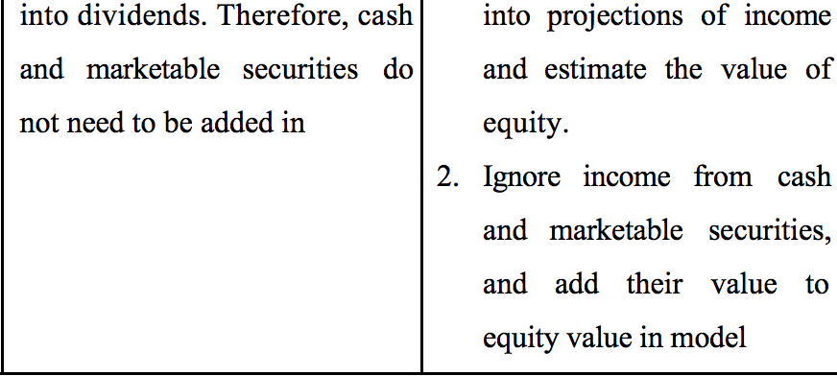
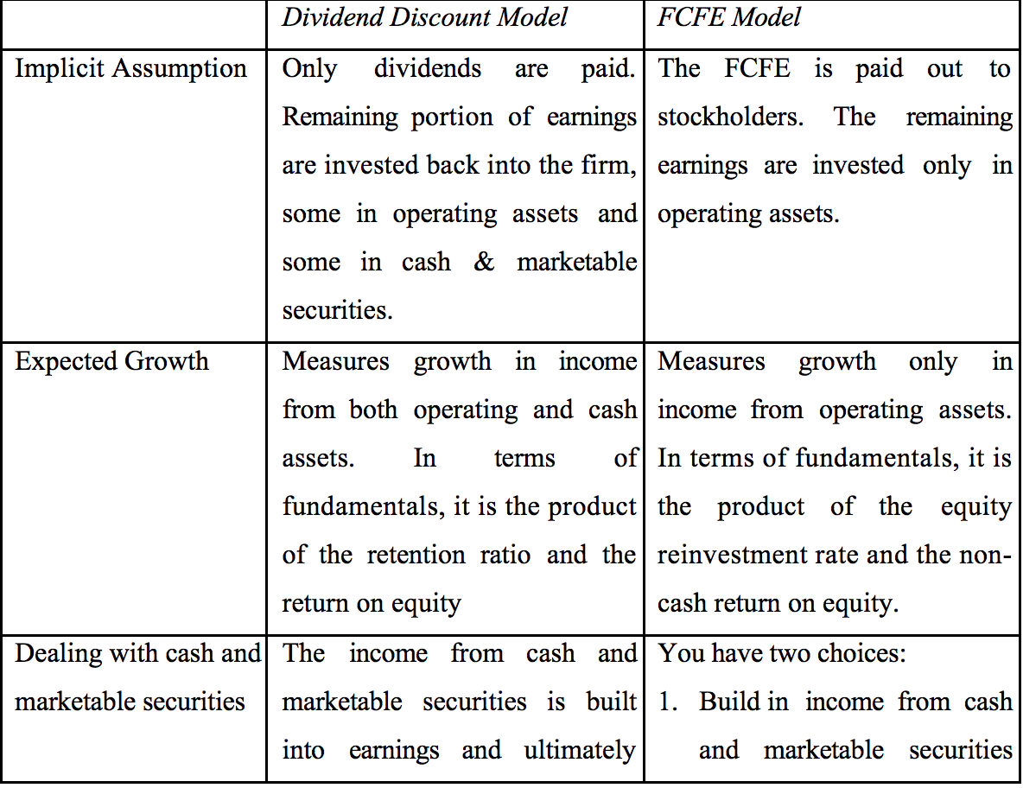

WHAT DOES IT MEAN WHEN THEY ARE DIFFERENT?
- When they are different 2 questions to ask: What does the difference tell us? And Which model is most appropriate?
  - When DDM value > FCFE (less frequent) go with FCFE because these dividends are not sustainable
  - When FCFE value > DDM (most common) difference measure the value of controlling dividend policy. (hostile takeover can change policy to capture higher FCFE value)
- Which one to use depends on openness of the market for corporate control (if highly probable that firm can be takeover or change in management, market price will reflect this) appropriate bench mark is FCFE
- If changes more difficult because of firm size or legal restrictions on takeovers DDM

CONCLUSION

- When valuing firms for takeovers or in valuing firms where there is a reasonable chance of changing corporate control FCFE provides better estimate of value

CHAPTER 15 – FIRM VALUATION: COST OF CAPITAL AND ADJUSTED PRESENT VALUE APPROACHES

- Past two chapters examined two approaches to valuing equity: DDM & FCFE valuation models
- Now we focus on approaches to value entire firm:
  - by either discounting cumulative CF’s to firm by WACC
  - or adding marginal impact of debt on unlevered firm value
- Then, we look at how leverage affects firm value and how the presence of default risk, taxes and agency costs may lead to a decrease in value with increasing leverage.
- That is why we argue that optimal financing mix for a firm is one that maximizes value.

Free Cash Flow to The Firm

- FCFF is the sum of all the CF’s that goes to claimholder of the firm
- 2 ways to measure it:
  - 1) FCFF = FCFE_{or dividends} + Int Expense(1-tc) + Principal repayments – New debt issues + Preff. Dividends
    - Cash flows to equity, lenders and preferred stockholders
    - Basically we are reversing the process we used to get the FCFE simpler way is to estimate CF’s before any of these claims
  - 2) FCFF = EBIT(1-TC) + DEPRECIATION – CAPEX – Δ WC
    - Also referred to as unlevered CF since it is before debt payments
    - does not include tax benefits of interest payments on debt as it is already included in WACC

FCFF AND OTHER CASH FLOW MEASURES

- Difference between FCFF & FCFE is in CF’s associated with debt and non equity claims (preffered shares)
  - For firms at desired debt ratio, who finance capex & working capital needs with the mix of debt and equity, and use new deb issued to finance principal repayments FCFF > FCFE
- EBITDA is widely used and is a rough measure of CF’s from operations but FCFF is more complete as it takes into consideration potential tax liability as well as capex & WC requirements

GROWTH IN FCFE VERSUS GROWTH IN FCFF
- Will they grow at the same rate?
  - FCFE are based on net income or EPS
  - FCFF are based on operating income (i.e. prior to debt payments)
- In general, growth in net income (FCFE) > than growth in operating income (FCFF) because financial leverage can increase FCFE – why?
  - Expected g in net income = Equity reinvestment rate x ROE
  - Expected g in operating income = Reinvestment rate X ROC
  - ROE = ROC + (D/E)[ROC- After-tax K_{b})
    - When a firm borrows money and invests in projects that earn more than the after-tax cost of debt, the return on equity will be higher than the return on capital
    - So higher growth rate in equity income at least in short term
- In stable growth, the growth rates in equity and operating income have to converge
  - Imagine your net income was growing at 6% and operating income at 5% eventually your net income would be larger and that wouldn’t make sense
  - IN STABLE GROWTH- even if ROE>ROC expected growth in both measures of income should be the same! (Reinvestment rates will adjust)
    - So equity reinvestment rate < firm reinvestment rate in stable growth for any levered firm.

Firm Valuation: The Cost of Capital Approach
- Value of firm is by discounting FCFF by the WACC
- Embedded in value are the tax benefits of debt (by using after-tax cost of debt) & expected additional risk associated with debt (higher costs of equity and debt at higher debt ratios)

STABLE GROWTH FIRM
- The model: Value of Firm = FCFF₁/ (WACC – g_{n})
- The caveats: 2 conditions need to be met to use this model
  - 1) g used has to be <= nominal growth in economy or real growth (depending if WACC is in nominal or real terms)
  - 2) Characteristics of firm need to be consistent with stable growth reinvestment rate must be consistent with stable growth rate:
    - Reinvestment rate in stable growth = growth rate/ROC (best way to stay consistent)
    - If reinvestment estimated from net capex or change in WC :
      - Net CAPEX should be similar to firms in industry set (capex/dep) ratio at industry averages
      - Change in WC should not be negative can’t be assumed in perpetuity
      - Beta close to 1
- Limitations: sensitive to assumptions about the expected growth rate
  - Keep growth rate < risk free rate
  - Sensitive to assumption made about CAPEX relative to depreciation if inputs for reinvestment are not a function of expected growth the FCF could be inflated by reducing capex to dep
    - Reinvestment = [CAPEX – DEP + change in non-cash WC]/EBIT(1-t)

GENERAL VERSION OF THE FCFF MODEL (2 STAGE)
- The model: Value of Firm = FCFF_{t} /(1 + WACC)^{t}
- If a firm reaches a steady state after n years and starts growing at a stable growth rate after that:
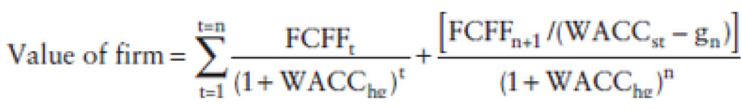
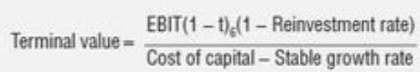
- Where HG = High growth and ST = Stable growth
- Best suited for: firms with either very high/low leverage or are in the process of changing their leverage
  - Why? Because calculating FCFE is complicated when there is volatility in debt payments
  - Also, for a highly levered firm, the value of equity could represent only a small slice of the total value of the firm. If you use FCFE it will be very sensitive to assumptions about growth and risk.
  - N.B these two approaches should yield the same value for equity in real life this is hard to do
- Problem: There are 3 problems with the FCFF model:
  - 1) FCFF has a less intuitive meaning than FCFE it answers the “hypothetical question” of what the firms CF’s would be if it had no debt
    - not intuitive to look at CF’s before debt payments as it is a cash outflow
    - FCFE is a real cash flow that can be traced and analyzed in the firm
  - 2) FCFF focuses on predebt CF’s and can sometime blind us to the real problem with survival.
    - May have positive FCFF(100 million) but negative FCFE (-50 million) by using FCFF we would not have been aware for example, that the firm would need to raise an additional $50 million in equity to survive.
  - 3) The use of a debt ratio in the WACC to incorporate the effect of leverage requires assumptions that might not be feasible or reasonable:
    - E.g. a debt ratio of 30% percent will require a growing firm to issue large amounts of debt in future years to reach that ratio
    - In the process, the book-to-debt ratio might grow huge and trigger negative consequences
    - In fact, we count the expected tax benefits from future debt issues implicitly in the value of equity today

EXTRA: MARKET VALUE WEIGHTS, COST OF CAPITAL, AND CIRCULAR REASONING
- The WACC is estimated through market value weights:
- it is then used to estimate new values for debt and equity that might not match the values used in the original calculation
  - One defense: if you bought all of the debt and equity in a publicly traded firm you would pay the current market value – not your estimated value – and your WACC reflects this.
  - Way out if you don’t agree: use market value weights for debt and equity, but then use the estimated values of debt and equity from the valuation to re-estimate the cost of capital:
    - Feed the new values back and estimate the WACC again
    - Eventually, this will converge to a stable value
    - (excel: go into calculation operation check mark in iteration box then make WACC a function of estimated values of debt and equity. )

EXTRA: NET DEBT VERSUS GROSS DEBT
- In this chapter we use gross debt (total debt outstanding) rather than net debt where cash was subtracted out.
- What is the difference with the two approaches and will the valuations from the two approaches agree?
- You can use either gross debt (total debt outstanding) or net debt (net out cash and marketable securities from debt) but you have to be consistent.
  - If you use gross debt, you consider total interest expenses and all debt ratios used (to compute levered beta and cost of capital) are gross debt ratios.
    - Cash is added to value operating assets operating assets – gross debt
  - If you use net debt, you consider net interest expenses and all debt ratios used are net debt ratios. (As a caveat, if the net debt is negative, set it to zero and consider the excess cash and marketable securities separately)
    - cash is not added back to operating assets -> operating assets – net debt = equity
    - cost of debt_{net}> cost of debt_{gross}
- Recommend using gross debt for 2 reasons:
  - Net debt can be negative consider the excess cash like you would in a gross debt valuation
  - Maintaining a stable net debt ratio is complicated in a growing firm and will require cash balances increase as firm value increases

WILL EQUITY VALUE BE THE SAME UNDER FIRM AND EQUITY VALUATION
- This model (FCFF) values the firm rather than equity
- If you subtract MV of outstanding debt you get value of equity
- Basically, this model can be used as an alternative way of valuing equity two questions need to be ansered:
- 1) Why value firm instead of equity?
  - Because in FCFF you do not need to look at the CF’s from debt, making it much easier with firms with high or changing leverage
  - FCFF only needs info on Debt Ratio & interest rates to estimate WACC
- 2) Will the value of equity from FCFF model be the same at equity value under DDM or FCFE model?
  - They will be the same if and only if you make consistent assumptions about financial leverage. For example even with no growth:
    - If for example, cost of capital is based on MV weights, they will not yield the same value if the firm is not fairly priced in the first place.
    - Make sure no extraordinary or no operating items that affect net income but not operating income
    - Interest expense = pretax cost of debt X MV if older debt has different rate the two approaches will diverge.
  - If there is expected growth it is even worse: you need to make sure you borrow enough money to keep you debt ratio consistent with what you used to compute cost of capital.

Firm Valuation: The APV Approach
- APV starts with valuing firm without debt, then debt is added and the net effect on value is examining considering both the costs and benefits of borrowing.
- Assumptions:
  - Primary benefit of borrowing is the tax benefit
  - Most significant cost is the added risk of bankruptcy
- We estimate the value of the firm in three steps:
  - 1) Estimate the value of the firm with no leverage
  - 2) Consider the present value of the interest tax savings generated by borrowing a given amount of money
  - 3)Evaluate the effect of borrowing the amount on the probability that the firm will go bankrupt, and the expected cost of bankruptcy

- ESTIMATING VALUE OF UNLEVERED FIRM:
  - Discounting FCFF at unlevered cost of equity
  - Value of unlevered firm = E(FCFF₁)/(K_{e unlevered} – g)
    - FCFF= after-tax op.CF = EBIT(1-TC) + DEP – CAPEX – Δ WC
  - Other input needed: E(CF’s), growth rates, and unlevered cost of equity.
  - How to get unlevered cost of equity? With unlevered beta:
    - 
- EXPECTED TAX BENEFIT FROM BORROWING:
  - Value of tax benefits = T_{c}D
  - PV of a perpetuity paying the tax rate applied to the interest on the debt of the firm
  - This represents the tax benefits
  - Tax used is firms marginal tax rate (assumed to stay constant)
- ESTIMATING EXPECTED BANKRUPTCY COSTS & NET EFEFCT
  - Evaluate effect of debt on the default risk of the firm and expected bankruptcy cost
  - In theory, requires estimating probability of default, and both the direct and indirect costs of bankruptcy
  - Since cannot be estimated directly let’s look at each individually.

  - 2 ways to estimate probability of bankruptcy:
    - 1) estimate a bond rating and use the empirical estimates of default probabilities for the rating (that table in the book)
    - 2) Use a statistical approach such as probit to estimate the probability of default, based on the firm's observable characteristics, at each level of debt
  - The bankruptcy cost can be estimated, albeit with considerable error, from studies that have looked at the magnitude of this cost in actual bankruptcies
    - According to research, direct bankruptcy cost are small relative to firm value (around 5%)
    - Indirect costs of bankruptcy can be substantial and vary widely across firms.
      - Shapiro (1989) and Titman (1984) speculate that the indirect costs could be as large as 25 to 30 percent of firm value but provide no direct evidence of the costs
    - Although APV is more flexible, it is important to calculate bankruptcy costs as a firm value will be overstated, especially at high values of debt, where the cost of bankruptcy is clearly not zero.

- COST OF CAPITAL VERSUS APV VALUATION

  - Basically we are adding the net effect of debt to the unlevered firm value
  - In cost of capital approach, we include the effects of leverage --> the tax benefit is incorporated by using the after-tax cost of debt in the WACC and the bankruptcy costs through both the levered beta and pre-tax cost of debt.
    - Will it yield the same value? Not necessarily.
  - 3 reasons we do not get the same values:
    - 1) they consider bankruptcy costs very differently
      - if bankruptcy costs are not well included in pre-tax cost of debt, the APV approach is more conservative
    - 2) they consider tax benefit from debt differently
      - APV using $ debt value, usually based on existing debt better for firms that are funded disproportionately and where debt repayment schedules are known
      - Cost of Capital uses debt ratio, and may require that firms increase their debt in the future. better for firms that are not changing their financial leverage
    - 3) when turning tax benefit into PV, the discount rate used changes results
      - we learnt to discount the benefits by using pre tax cost of debt but other variations of APV use cost of capial or unlevered cost of equity these would lead a closer value to the cost of capital approach

Effect of Leverage on Firm Value
- both approaches make the value of the firm a function of its leverage this means there is a mix of debt/equity that will maximize firm value
- To maximize firm value minimize WACC

- STEPS IN COST OF CAPITAL APPROACH TO FIND OPTIMAL LEVERAGE:
  - 3 inputs: cost of equity, after-tax cost of debt, and weights of each
  - as the debt ratio changes both costs change
  - 1) Estimate cost of equity
    - estimate unlevered beta allowing us to calculate levered beta at every debt ratio [ B_{levered}=B_{unlevered}(1 + (1-t)(D/E)) ]
    - then use the levered beta to compute cost of equity at each ratio
  - 2) Estimate cost of debt: as firms borrow more, their default risk (measured with bond ratings) will increase and so will their cost of debt – 4 steps
    - estimate firms $ debt and interest expense at each debt ratio
      - as firms increase ratio, increase both $ debt and interest
    - at each ratio, compute financial ratios that measure default risk and use ratio to estimate rating on the firm
      - if firm borrows more, rating will decline
    - default spread from this rating is added to RF to get to the pre-tax cost of debt
  - 3) Now estimate WACC at each ratio lowest WACC is one that is the optimal debt ratio
- We are only allowing cost of capital to change but if both operating income and cost of capital were allowed to change the optimal debt ratio would no longer be the one that minimizes WACC would be the debt ratio at which the value of the firm is maximized
- STEPS IN APV TO SOLVE FOR OPTIMAL LEVERAGE
  - Debt level that maximizes firm value is the optimal debt ratio
  - Only things that change at every debt ratio is the expected tax benefits and expected bankruptcy costs 5 steps:
  - 1) Estimate dollar debt outstanding at each ratio – keeping firm value fixed estimate how much debt $ would be at 20% 30 % ect
  - 2) Estimate tax benefits by multiplying the DxTax rate – assumes that debt is permanent and benefit will continue in perpetuity
  - 3) Estimate the rating, interest rate, and interest expense at each ratio
  - 4) Use rating and probability of default
  - 5) Estimate the expected bankruptcy cosy – compute the value of levered firm at each ratio, and the one who is highest is the optimal debt ratio

Conclusion
- This chapter presented alternative approach to DCF – discounting CFFF at WACC to find value of firm, and subtracting out debt to value equity
  - Better because CF’s are before debt payements
- Another approach is the APV – where the effect on value of debt is added to the unlevered firm value.

CHAPTER 5 – OPTION PRICING THEORY AND MODELS
Chapter 5: pp 87- 90 and 95-99

- The value of any asset is derived from the PV of CF form that asset, this is the only exception to the rule and must have these 2 characteristics:
  - 1) the assets derive their value from other assets
  - 2) The CF’s on the assets are contingent on the occurrence of specific events
- USING DCF would understate their value.

Basics of Option Pricing
- Options gives you the right, not the obligation, to buy or sell underlying asset at a predetermined (strike) price
  - two positions in options: long (buyer) or short (seller)
- American options can be excercised at any time, European options only at expiration
  - American options more valuable but also harder to value
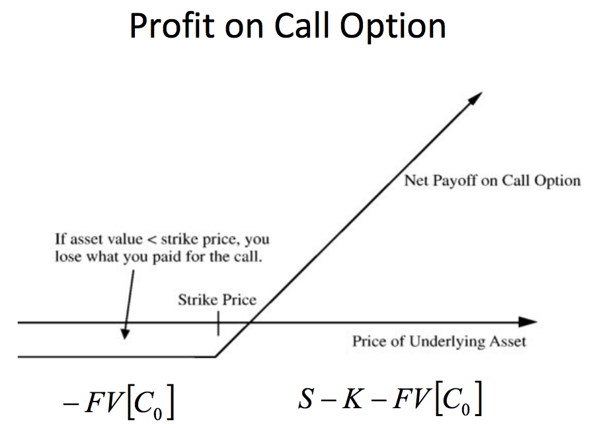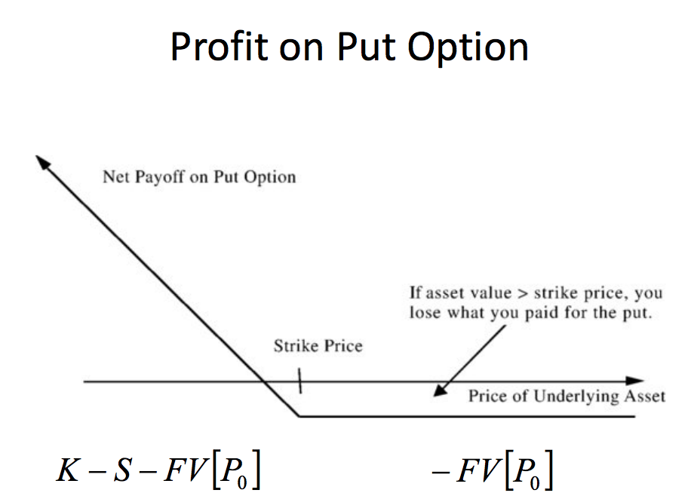

- The value of an option is determined by 6 variables relating to the underlying asset and financial markets:
- 1) Current value of the underlying asset:
  - underlying increases → call increases, put decreases
- 2) Volatility of the underlying asset:
  - volatility increases → call and put increase
- 3)Dividends paid on the underlying asset:
  - dividends increase → underlying decreases → call decreases, put increases
- 4) Strike price of the option:
  - strike increases → call decreases, put increases
- 5) Time to expiration on the option:
  - time decreases → call and put decrease
- 6) Riskless interest rate corresponding to life of the option:
  - interest increases → PV (strike) is cheaper → call increase and put decrease

Black-Scholes Model

- When the price process is continuous, the binomial model for pricing options converges to the Black-Scholes model:
  - S = Current value of the underlying asset
  - K = Strike price of the option
  - t = Life to expiration of the option
  - r = Riskless interest rate corresponding to the life of the option
  - σ = volatility (standard deviation) in the log returns of the underlying asset
- The value of a call is then:
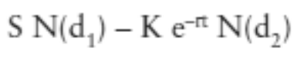
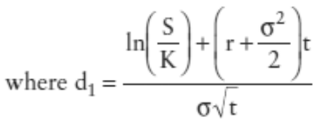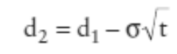

  - Note that e–rt is the PV factor, and reflects the fact that the exercise price on the call option does not have to be paid until expiration.
- N(d1 ) and N(d2 ) are cumulative standardized normal distribution probabilities
- In approximate terms, N(d2 ) is the likelihood that an option will generate positive cash flows for its owner at exercise
  - (i.e., that S > K for the call and K > S for the put.
- The portfolio that replicates the call option is created by:
  - buying N(d1 ) units of the underlying asset, and borrowing Ke–rtN(d2 ).
- This portfolio will have the same CF’s as option, and thus the same value
  - N(d1), which is the number of units of the underlying asset that are needed to create the replicating portfolio, is the option's delta.
- A note on estimating inputs:
- Block scholes requires that inputs be consistent on time measurements. Two places where this affects estimates:
  - 1) since model works on continuous time, rather than discrete time, you need to modify your riskless rate to be continuous time inputs
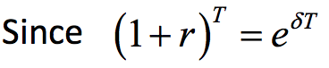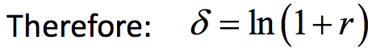
    - if the one-year Treasury bond rate is 6.2 percent, the risk-free rate that is used in the Black-Scholes model should be: 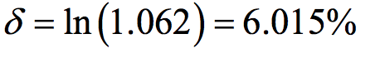
  - 2) the period over which the input are estimates the preceding rate is an annual rate
    - so the variance has to be an annualized variance which is annualized easily because variance are linear in time if the serial correlation is zero.
      - If weekly prices are used to estimate variance do X 52
- Implied volatility: The only input in the Black-Scholes on which there can be significant disagreement among investors is the volatility:
  - Usually estimated by looking at historical data, but the values of options that one gets from this can differ from the market prices
  - For any option, there is a value of the volatility at which the estimated value will be equal to the market price This volatility is called an “implied volatility”
- Model Limitations and fixes
  - Black-Scholes values:
    - European options
    - whose underlying pays no dividends
    - and exercise does not affect the value of the underlying asset
  - When these assumptions are not true:
    - Adjustments exist that, while not perfect, provide partial corrections to the Black-Scholes model.
  - Dividends reduce the stock price, that’s why price drops on ex-dividend day
  - There are two ways of dealing with dividends in the Black-Scholes model:
    - 1) Short-term Options:
      - Modified Stock price = Current Stock Price – PV of expected dividends during the life of the options
      - Use this modified value as S in model
    - 2) Long Term Options: if you assume that dividend yield will remain unchanged during the life of the operation, the black scholes model can be modified to take it into account.
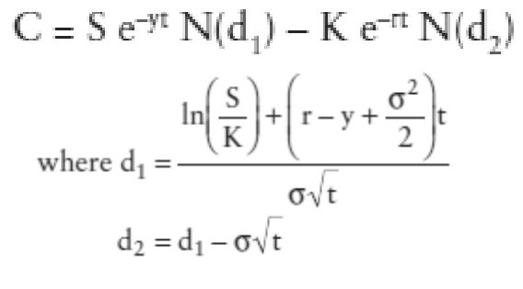
- The adjustment has two effects:
  - 1) the value of the asset is discounted back to the present at the dividend yield to take into account the expected drop in asset values
  - 2) the interest rate is offset by the dividend yield to reflect the lower carrying cost from holding the asset (in the replicating portfolio)
  - The net effect will be a reduction in value of calls estimated using this model

CHAPTER 28 – THE OPTION TO DELAY AND VALUATION IMPLICATIONS
- In traditional investment analysis, the decision to accept a project only when return on project > hurdle rate + NPV projects based on CF’s and discount rates
- Limitation of this view is that it does not consider the options associated with many investments.
- One of the limitations of traditional investment analysis is that it is static and does not do a good job of capturing the options embedded in an investment:
  - the option to delay it
  - The other opportunities in the future that may be available just because we took the investment
  - the option to abandon it, if the cash flows do not measure up.
    - These options all add value to projects and may make a “bad” investment (from traditional analysis) into a good one.
- This chapter considers the option to wait and take the project in a later period
- Why would a firm want to do this?
  - If the PV of CF’s are volatile and can change over time, a project that does not pass now (-NPV), may become valuable in the future
  - Maybe the project has a +NPV, but the firm may gain from waiting because the project has a higher value if taken at a later date
    - Most valuable when a company has exclusive right to invest in a project and becomes less valuable as the barriers to entry decline.
- Three cases where the option to delay can make a difference when valuing a firm:
  - 1) undeveloped land in the hands of real estate investor or company
    - The choice of when to develop depends on owner, and will usually begin to develop when real estate value increases enough to justify it
  - 2) a firm that owns a patent
    - since patent represents a firm with exclusive right to produce a product or service it should be valued as an option so we produce the patented product?
  - 3) a natural resource company that has undeveloped reserves that it can choose to develop at a time of its choosing—presumably when the price of the resource is high

THE OPTION TO DELAY A PROJECT
- Usually we look at CF’s and discount rates and compute the NPV to see if acceptable
- However, CF’s and rates change over time changing NPV so a project that has –NPV today (rejected) may have a +NPV (accepted) in the future
  - For regular firms, the fact that it “may become positive in the future” doesn’t matter as they do not have a special advantage over their competitors (their competitors will have a +NPV too)
- In an environment where project can solely be taken by one firm, due to legal restrictions or other barriers to entry the changes in the projects value over time are relevant and gives it the characteristics of a call option (right to buy) value = (V-X) where X is initial upfront investment, and V is the PV of cash flows to the project

Payoff on the Option to Delay

- NPV_{project} = V – X
  - X: initial up-front investment
  - V= PV of expected cash inflows from investing in project
- Now assuming the firm has exclusive rights if discount rate or cash flows changes the PV of CF’s (V) may change over time while the initial up-front investment (X) stays the same
  - So even if currently it has a –NPV, it may still be a good project if the firm waits.
- Decision rule:
  - If V>X Invest in project as it has +NPV
  - If V<X do not invest
    - if firm does not invest, it will still loose what it invested to get exclusive rights to the project
- Payoff diagram assuming firm has exclusive rights & firm holds out until end of period: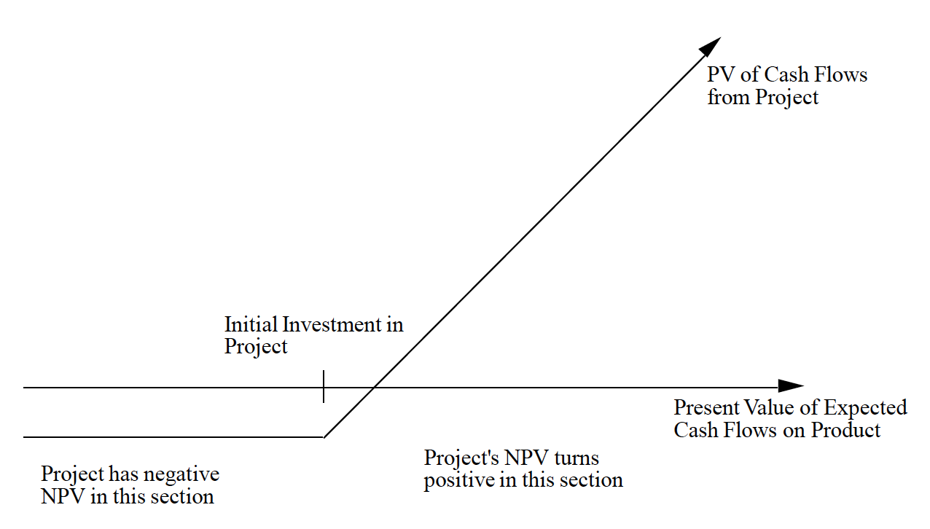
- The profit diagram is that of a call:
  - the underlying asset is the project
  - the strike price of the option is the investment needed to take the project
    - We assume it to be constant
  - the life of the option is the period for which the firm has rights to the project
  - the value and variance of the underlying asset is represented by the PV of the cash flows on this project and the expected variance in this PV

Inputs for Valuing the Option to Delay
- We need the same inputs as any option pricing model: value of underlying asset & the variance in that value, time to expiration of the option, strike price, riskless rate, and the equivalent of dividend yield.
- Value of Underlying Asset:
  - underlying asset is the project that firm has exclusive rights
  - Value _{underlying asset} = PVexpected CF’s not including intial investement
    - Solve PV with DCF using a risk adjusted discount rate
  - May have a lot of error in CF estimates & PV especially for new business or if it involves untested technology
    - This uncertainty is normal, and is what makes the option to delay valuable
- Variance in the Value of the Asset:
  - The uncertainty on CF’s and value of the project today can come from either:
    - Potential market for product unknown
    - Technological shifts can change the cost structure and profitability of product
  - Value of option is largely derived from variance in CF’s higher variance = higher value of the project delay option
    - So value of option to invest in a project in stable business < one in an environment where technology, competition, and markets are changing
  - Variance in PV can be estimated in one of three ways:
    - 1. If we have invested in similar projects in the past, the variance in the cash flows from those projects can be used as an estimate
      - Example. Gillet uses variance of introducing new blades
    - 2. We can assign probabilities to various market scenarios, estimate cash flows and a present value under each scenario, and then calculate the variance across PVs
      - Could also use probabilities for each individual input, like market share and profit margin, and use a simulation to solve variance in the PV’s that emerge.
      - This approach tends to work best when there are only one or two sources of significant uncertainty about future cash flows
    - 3. We can use the variance in the value of firms involved in the same business (as the project we are considering) as an estimate
      - Ex. Average variance of firms involved in software business can be used as the variance in PV for software project.
- Exercise Price on Option:
  - Option to delay is exercised when firm owning rights decides to invest in it so cost of making this investment is the exercise price
  - Assumption: this cost remains constant (in PV $) and any uncertainty in this investment with be reflecting in PV of the CF’s on the product
- Expiration of Option & Riskless Rate:
  - Investments made after option expires assumed to have NPV = 0 as competition would come in and drive down the rate
  - Riskless rate should be rate that corresponds to expiration of option
  - If not patents (whose life is evident) firm must have a competitive advantage use expected period over which advantage can be sustained
- Cost of Delay:
  - An American option generally will not be exercised prior to expiration
  - When you have the exclusive rights to a project, though, and the NPV+, you would not expect the owner of the rights to wait until the rights expire to exercise the option
  - Actually there is a cost to delaying investing in a project, once the NPV turns positive:
    - If you wait an additional period, you may gain if the variance pushes value higher but you also lose one period of protection against competition
  - You need to consider this cost, there are 2 way to estimate it:
    - 1) When CF’s are even: Since the project rights expire after a fixed period, and excess profits are assumed to disappear after that time as new competitors emerge each year of delay translates into one less year of value-creating cash flows
      - value creating cash flows is one that adds to NPV as it is in excess of the required return for investments with the same risk
      - If the cash flows are evenly distributed over time, and the life of the patent is n years, the cost of delay can be written as:
        - Annual Cost of Delay = 1/n
        - So if n = 20, it would be 1/20 in year 1 – 1/19 year 2
    - 2) When CF’s are uneven:
      - cost of delay can be defined in terms of CF that can be expected over the next period to the PV today
        - Cost of delay = CF next period / PV_{now}
  - Either case, more likely that firm will delay early in exclusive rights period – especially if the loss of cash flows from waiting period increases.
- Arbitrage opportunities and option pricing models:
  - Black Scholes and binomial both assume you can create a replicating portfolio, using asset and riskless borrowing or lending, that has same CF’s to those on the option.
    - Not only is replicating the portfolio difficult, bur it is hard to sell (arbitrage)
    - If you want more conservative estimate, either use a higher discount rate to find PV of your project, or value the option and apply a illiquidity discount

PROBLEMS IN VALUING THE OPTION TO DELAY

- It is clear that the option to delay is embedded in many projects
- But there are several problems are associated with the use of option pricing models:
  - 1. the underlying asset in this option, which is the project, is not traded, making it difficult to estimate its value and variance
  - 2. the behavior of prices over time may not conform to the price path assumed by the option pricing models:
    - assumption that value follows a diffusion process and & variance in value remains unchanged over time is hard to justify
    - a sudden technological change may dramatically change the value of a project, either positively or negatively.
  - 3. there may be no specific period for which the firm has rights to the project:
    - Unlike the case of a patent, in which the firm has exclusive rights to produce the patented product for a specified period, the firm's rights to a specific project often are less clearly defined
    - In this case the life of project is uncertain in itself and only an estimate
      - Competitors could enter sooner, or conversely, barriers to entry can increase
      - This uncertainty can increase variance and actually, ironically, increase the expected value of the rights to the project

IMPLICATIONS AND EXTENSION OF DELAY OPTIONS

- Several interesting implications emerge from the analysis of the option to delay a project as an option:
  - 1. Even if a project has a negative NPV, the rights to it may still be valuable because of the option
    - exclusive rights to a non-viable technology option can be worth a great deal
  - 2. a project may have a positive NPV but still not be accepted right away:
    - The firm may gain by waiting
    - A firm is more likely to wait if it has:
      - The rights to the project for a long time
      - Protection against competition
      - The variance in project inflows is high
  - 3. Factors that can make a project less attractive in a static analysis can actually make the rights to the project more valuable:
    - consider the effect of uncertainty about the size of the potential market and the magnitude of excess returns:
    - In a static analysis, increasing this uncertainty increases the riskiness of the project and may make it less attractive.
    - As an option, an increase in the uncertainty may actually make the option more valuable
- We will continue now by considering two cases, a product patent & natural resource reserves, where the project delay option allows value to be estimated more precisely.

OPTION PRICING MODELS

- Although the more general model is the binomial model most practitioners use the Black-Scholes model (more restrictive about price processes and early exercise) instead of the binomial option pricing model:
  - For listed options on traded assets you can do this at a low cost
  - With real options, this can be a problem as it is costly for two reasons:
    - Real options tend to be exercised early, if they are in the money.
      - Black-Scholes does not accommodate this well, and binomial model allows much more flexibility
    - The binomial option pricing model allows for a much wider range of price processes for the underlying asset than the Black-Scholes which assumes that prices are both continuous and log distributed
      - With real options, the assumptions of non-normality and continuous distributions are hard to sustain
- The biggest problem with binomial is that the prices at each node in the binomial tree need to be estimated.
  - As # of periods gets larger, its more difficult to do but can use variance estimate in black-Sholes to come up with the up and down movements used in binomial tree
- All this positivity leaning to binomial model yet we use the Black-Scholes model to value any real options because:
  - 1. It is more compact, elegant and easier to apply
  - 2. We believe that it will provide a lower bound on the value in most cases

VALUING A PATENT
- Product patent is viewed as option, and product is the underlying asset
- A firm will develop a patent only if the PV of the expected cash flows from the product sales exceed the cost of development:
  - I = PV of costs of commercially developing patent
  - V = PV of expected CF’s from development
  - Payoff from owning product patent:
    - If V_{CF’s}> I_{Costs} Payoff = V-I
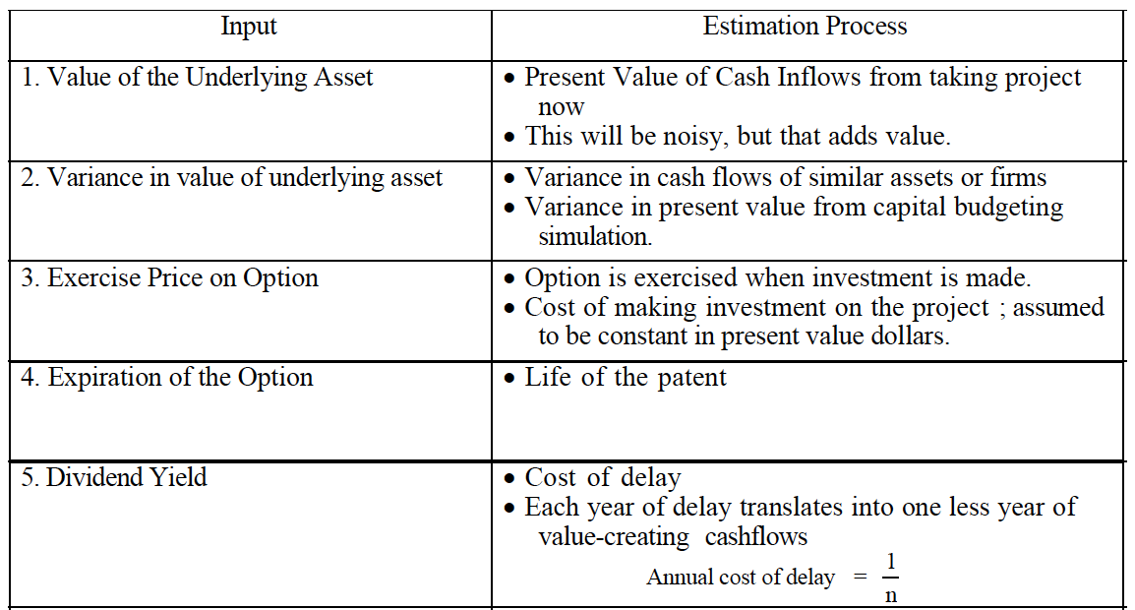
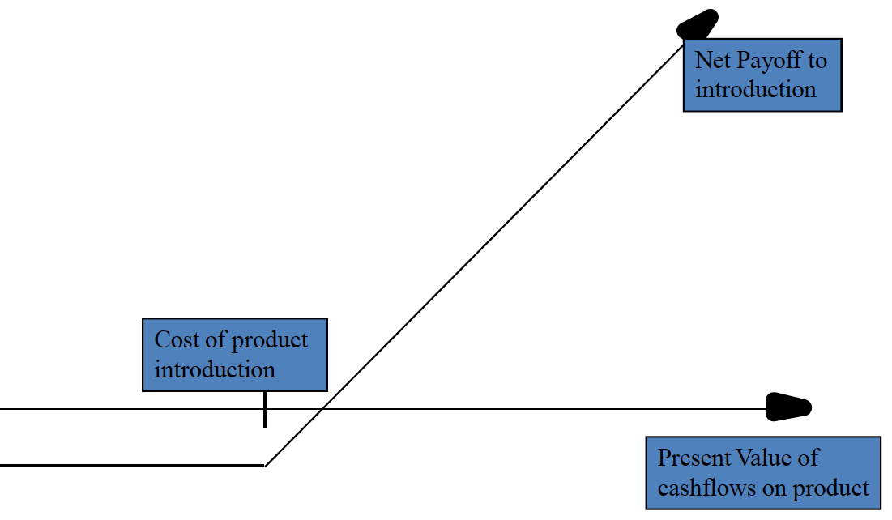
    - If V<= I Payoff = 0

COMPETITIVE PRESSURS AND OPTION VALUES

- Even with a patent, a firm may still face competition from other firms that come up with their own products to serve the same market, for example drugs to treat cancer.
  - Although they patent their own drug, other companies can create a new one that will remove their competitive advantage.
- Implications for the value of the patent as an option:
  - the life of the option will no longer be the life of the patent, but the lead time that the firm believes it has until a competing product is developed
    - This will reduce the value of the option and make it more likely that the drug will be commercially developed earlier rather than later.
  - Rule of thumb: the greater the # of competing products, the less likely that option pricing model will have a higher result than the traditional DCF

VALUING A FIRM WITH PATENTS

- IF the patents of a firm can be valued as options, how can we incorporate this in firm value?
- The value of a firm that derives its value primarily from commercial products that emerge from its patents is a function of three variables:
  - 1. The cash flows it derives from patents that it has already converted into commercial products
  - 2. The value of the patents that it already possesses that have not been commercially developed
  - 3. The expected value of any patents that the firm can be expected to generate in future periods from new patents that it might obtain as a result of its research

Value of Firm =
Value of commercial products [using DCF value]
+ Value of existing patents [using option pricing]
+ [Value of future new patents – Cost of obtaining these patents]

  - The last input measures the efficiency of the firm in converting its R&D into commercial products & is based on perceptions of a firm's research capabilities
    - In special case where we assume that a firm earns its cost of capital from research, this term will become zero.
    - In a more general case, firms that have a history of deriving value from research would have another positive component (and some do have -)
  - If we use this approach, we should be careful not to double count by allowing for a high growth rate, and growth rate period in cash flows (in the DCF valuation).
    - We consider each separately In traditional DCF valuation, the 2nd and the 3rd components of value are captured in the ex growth rate in CFs.
- Biggest limitation of option-based approach: the information we need is usually only available to managers of the firm – some information like variance may not be even be available to insiders and will have to be estimated for each patent best to value small firms with one or two patents and little established assets. Or else use DCF

IS THERE LIFE AFTER THE PATENT EXPIRES?
- We often assumed that the excess returns are restricted to the patent life and disappear after – but in fact, many firms continue to be able to charge a premium price for their products – 2 reasons that might increase value of patent:
  - 1) Due to brand name image: We can adjust for this reality by increasing the PV of the CFs on the project (S) and decreasing the cost of delay (y).
    - The net effect is a greater likelihood that firms will delay commercial development while they wait to collect more information and assess market demand (cause cheaper to wait)
  - 2) Some drug companies have shown to lobby legislators or use the legal system to extend the patent lives of profitable drugs:
    - IF we consider this a possibility increase the expected life of the patent and its value as an option

NATURAL RESOURCE OPTIONS

- Natural resource companies generate CF’s from existing reserves, but also have undeveloped reserves that they could develop if they choose to do so.
  - More likely if price of oil (for example) goes up
  - So can be viewed as a call option
- We start looking at how to value the undeveloped reserves, then we’ll look at how we can value a natural resource firm that has both developed and undeveloped reserves.

UNDEVELOPPED RESERVES AS OPTIONS

- Underlying investment: natural resource (ex. Gold)
- Value of asset: based on estimated quantity and price of resource (gold)
- In most cases, developing the resource (for example mining the gold) isn’t free,
  - So Payoff = Max(0, V-X)
  - Where V= estimated value of the resource & X= cost of development
  - 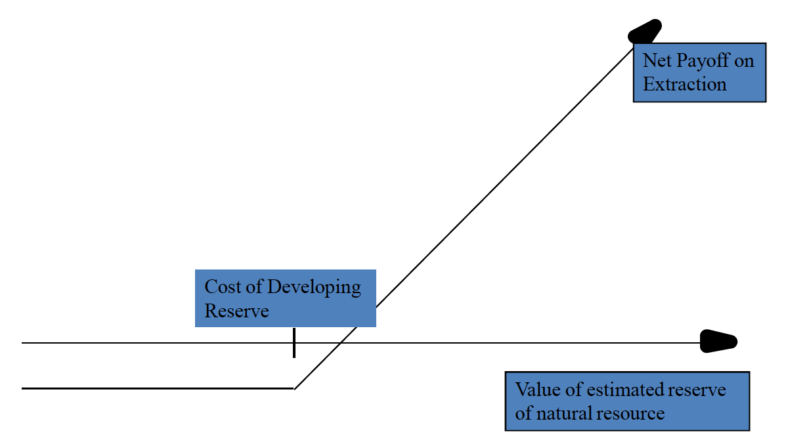
- 1. Available reserves of the resource and estimated value if extracted today:
  - The quantity of the reserve has to be estimated
  - In an oil tract, for instance, geologists can provide reasonably accurate estimates of the quantity of oil available in the tract.
  - The value = Estimated Reserves x Contribution (Price – var.Cost of extraction)
- 2. Estimated cost of developing the resource the exercise price of the option
  - Oil reserve: the fixed cost of installing the rigs to extract oil from the reserve
  - Mine: cost associated with making the mine operational
  - Oil/mining companies have experience to estimate these costs
- 3. Time to expiration of option life of natural resource can be defined in 2 ways:
  - 1. If the ownership of the investment has to be relinquished at the end of a fixed period of time, that period is the life of the option:
    - Offshore oil leases
  - 2. If not, Come up with an estimate of life by using the inventory of the resource and the capacity output rate:
    - A gold mine with a mine inventory of 3 million ounces and a capacity output rate of 150,000 ounces a year will be exhausted in 20 years
- 4. Variance in value of the underlying asset Determined by the variability in the price of the resource and the variability in the estimate of available reserves.
  - If the quantity of the reserve is known with certainty, the variance in the underlying asset's value will depend entirely on the variance in the price of the resource
- 5. Cost of delay: The net production revenue is the annual cash flow that will be generated, once a resource reserve has been developed, as a percentage of the value of the reserve:
  - This is the equivalent of the dividend yield and is treated the same way in calculating option values.
  - Cost of delay -- Once a natural resource option is in-the-money, by not developing the reserve the firm is costing itself the net production revenue it could have generated by doing so
- Important issue to consider is the effect of development lags on the value of these options:
  - Oil is not developed instantaneously, a time lag has to be allowed between the decision to extract the resources and the actual extraction
  - Simple adjustment for this: reduce the value of the developed reserve for the loss of cash flows during the development period:
    - with a 1-year lag, you can estimate the cash flow you would make over the year as a percent of your reserve value, and discount the current value of the developed reserve at that rate.
      - Same as doing PV of cash flows – first year CF’s

MULTIPLE SOURCES OF UNCERTAINTY
- An oil company may estimate its reserves to 50 million barrels, but it is not certain uncertainty about the quantity of the reserve creates a second source of variance that can affect value
- Two ways to address this:
  - 1. Combine the uncertainties into one value:
    - If we consider the value of the reserves to be the product of the price of oil and the oil reserves, the variance in the value should reflect the combined effect of the variances in each input
  - 2. Keep the variances separate and value the option as a rainbow option:
    - A rainbow option allows explicitly for more than one source of variance and allows us to keep the variances separate and still value the option.
    - Good for when for example, the variance of say the price of oil is expected to rise, but the variance in oil reserves may decrease over time

VALUING A FIRM WITH UNDEVELOPED RESERVES

- Individual Reserves versus Aggregate Reserves:
  - Preferred approach: value each reserve separately, add them to get the firm value
    - Since this info is hard to obtain especially for large natural resource firms we developed a variant of this approach
  - Alternative: value the entire firm's undeveloped reserves as one option
    - A purist would argue that valuing an option on a portfolio of assets (this approach) will provide a lower value than valuing a portfolio of options.
      - Nevertheless, the assumption that the only source of variance is the price of the natural resource effectively makes the values of the reserves perfectly correlated and allows us to use the short cut with limited or no cost
- Inputs to Option Valuation to estimate the value of undeveloped resources:
  - Value of Underlying Asset: add up all the firms undeveloped reprices and estimate the value of them (based on price of the resource today and the average variable cost of extracting from these reserves today)
    - Variable cost of extraction may be higher for some reserves than others
    - Assuming that firm would extract all the undeveloped resources at one time and not affect the price of the resource.
  - Exercise Price: consider what it would cost the company today to develop all of its undeveloped reserves, if different find weighted average
  - Life of the Option: Use weighted average of each reserve (as they may have different lives)
  - Variance in the value of the Asset: In this case, there is a strong argument for looking only at oil price as a source of variance, as the firm should have a much more precise estimate of its total reserves, than of each individually
  - Dividend Yield (Cost of Delay): Cash flows a firm gives up if it delays exercise.
    - State this cash flow as a percent of the value of the reserves
    - The development lag reduces the value of this option just as it reduces the value of an individual reserve:
      - undeveloped reserves will be worth more at oil companies that can develop their reserves quicker than at less efficient companies

PRICE VOLATILITY AND NATURAL RESOURCE COMPANY VALUATION
- Implication of this analysis is that value depends on both the price & volatility in that price
  - If the price of oil increases, all oil companies should become more valuable
  - If it drops back to 25$, the value of the oil companies may not decline to their initial levels, since perceived volatility in oil prices may have changed
    - If investors believe that volatility in oil prices ↑, you would expect an ↑ in value. There will be a greater ↑ for companies that derive a ↑ proportion of their value from undeveloped reserves (more options, duh!)
- If you consider undeveloped reserves as options DCF valuation will generally underestimate the value of natural resource companies missing option component of value
  - The difference is greatest in firms with a lot of undeveloped reserves & with commodities whose price volatility is highest

OTHER APPLICATIONS
- Very similar to what we have already discussed.
- Value derives by the exclusivity that you have to commercially develop the asset.
  - Exclusivity for licenses & copyright obtained by legal sanction
  - Exclusivity for undeveloped land scarcity of land
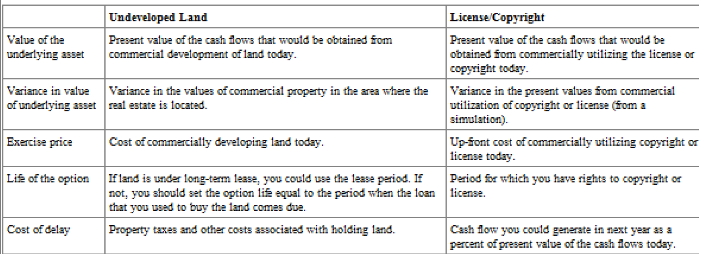

SUPPLEMENT – PG 443 – 447

4 WAYS OF INCORPORATING EXISTING OPTIONS INTO VALUE:

1.Use the fully diluted number of shares to estimate the value per share:
- Simplest method to incorporate outstanding options on value per share:
  - Value of equity = [ value of equity / (# of primary shares + # of options) ]
- Simple, but will lead to too low an estimate of value for 2 reasons:
  - 1) It considers all options outstanding, not just ones that are in-the-money and vested but there are variants of the model that only include in the money and vested options
  - 2) It does not incorporate the expected proceeds from exercise, which will comprise a cash inflow to the firm.
- Also, this approach does not build in the time premium on options into the valuation

2. Estimate expected option exercises in the future and build in expected dilution
- In this approach, you forecast when options will be exercised and build in the expected cash outflows associated with the exercise by assuming that the firm will buy back stock to cover the exercise.
- Biggest Limitation: This requires an estimate of what the stock price will be in the future
  - Given that your objective is to examine whether the price today is correct, forecasting future prices to estimate the current value per share seems circular!
  - So this approach is neither practical or useful in coming up with a reasonable estimate of value

3. Use treasure stock approach

- This is a variant of the fully diluted approach but:
  - # of shares is adjusted to reflect options that are ITM
  - the expected proceeds from the exercise (exercise price times number of options) are added to the value of equity
- Value of Equity = (Value of Equity + Exercise Proceeds) / (# of primary shares + # of in-the-money options)
    - Exercise Proceeds = Exercise Price * # of options
- Limitations: this does not consider the time premium on the options in-the-money and there is no effective way of dealing with vesting (i.e. options that become exercisable)
  - Gives you too high and estimate of value of equity per share
- Advantage: does not require value per share (or stock price) the incorporate the value into per-share value.
  - As we will see next, there is circularity that is created when stock price is an input when estimate value per share

4. Value options using option pricing model
- Correct approach to deal with options:
  - Estimate value of options today, given today’s value per share and time premium on the option.
  - Once estimated, it is subtracted from equity value, then divided by the number of shares outstanding to arrive at value per share
Value of equity per share = (Equity_{value} – Option_{value outstanding})/ # of shares_{primary} outstanding
- When valuing these options, there are 4 measurement issues:
  - 1) Not all options outstanding are vested – and some non-vested options might never be vested
  - 2) Stock price to use: The share value is an input as well as an output!(circularity)
  - 3) Taxation: Firms can deduct a portion of the expense associated with option exercises, and there may be a potential tax saving that is not included here
  - 4) For firms on the verge of a public offering: key inputs in this valuation is stock price and the variance cannot be obtained for these firms but need to be valued nonetheless.

DEALING WITH VESTING

- Usually, employers require employees with options to stay with the firm for a specified period for the options to be vested, so when we look at outstanding options of a firm we are looking as a mix of vested and non-vested options
  - Non-vested options should be worth less than vested options Probability of vesting depends on how in-the-money the options are, and the period left for employer to vest
    - There should be a way of incorporating the possibility that employees leave the firm before vesting & forfeit value of the options but likelihood is small
    - Carpenter (1998) developed a simple extension of the standard option pricing model to allow for early exercise and forfeiture, and used it to value executive options.

WHICH STOCK PRICE TO USE?

- The current stock price is required as an input to find a value to options since stock is traded you can find the current stock price easily
  - However, if you do this to arrive at a value per share that you will then compare to the market price to decide whether a stock is under-or overvalued seems inconsistent
- Solution: We would recommend that the value per share be initially estimated using the treasury stock approach, and that you then converge on the proper value per share by applying iteratively the option pricing model, each time with a different value of the stock
  - AKA 1) find value per share with treasury stock approach, 2) use that stock price in option pricing model, 3) option value that results from using this price is used to compute a new value per share which is fed back to option pricing model and so on
- Another problem: when options excercised increase # of shares outstanding affect stock price
  - Conventional option pricing models, the exercise of the option doesn’t affect stock price
  - Solution: In order to allow for dilutive effect of option exercise adjust for expected effects of dilution (like warrants in chapter 5)

TAXATION

- When options are exercised, the firm can deduct for tax purposes the difference between the stock price at the time and the exercise price as an employee expense this tax benefit reduces the drain on value created by having more options outstanding
  - First way you could estimate the tax benefit by multiplying the difference between the stock price today and the exercise price by the tax rate
    - this would make sense only if the options are in-the-money
    - does not allow for price appreciation over time
  - Alternative way of estimating the tax benefit: compute the after-tax value of the options = Value from option pricing model(1-tc)
    - Allows you to consider the tax benefits from option exercise in valuation considers even potential tax benefits

NON-TRADED FIRMS

- A couple of key inputs (current price per share and variance) cannot be obtained if firm is not publicly traded.
- Two choices in this scenario:
  - A) revert to the treasury stock approach to estimate the value of the options outstanding and abandon the option pricing models
  - B) stay with the option pricing models and estimate value per share from DCF;
    - use the variance of similar firms that are publicly traded can be used to estimate the value of the options

