Gene for Gene hypothesis:
for each resistance gene in a host there is a corresponding gene for avirulence in the pathogen conferring resistance and vise-versa

Plant immunity
defense against infectious pathogens

Mode of entry of pathogens depends on the type of pathogen
bacteria: stomata, hydathodes, and wounds
nematode: stylet
fungi: haustoria

-plant immunity is made up of 2 interconnected tiers of receptors (one outside and one inside the cell)
they govern recognition of microbes and response to infection

- PAMP TRIGGERED IMMUNITY (first level of response)

-PAMP= pathogen associated molecular patterns
sequences that are features of pathogens

-plants have evolved to recognize and respond to PAMPs

-detection by PATHOGEN-RELATED RECEPTORS (PRRs)
aka pattern-recognition receptors (PRR)
located in plasma membrane of plants (extracellular surface)
have LRR’s (leucine rich repeats) :analogous to TLRs in animals

-recognition of PAMPs by PRRs activates PRR response
activation of certain genes which tells the cell that it has been infected by a pathogen

STEP 1: All pathogens express PAMPs as they colonize plants.
plants perceive these via extracellular PRRs and initiate PRR-mediated immunity

- EFFECTOR TRIGGERED IMMUNITY (second level of response)

-pathogen has genes that encode effector proteins
virulence proteins which are required for infection

-Effector proteins has 3 main functions
structural role
nutrient leakage
pathogenic role

-pathogens inject proteins into the plant cytoplasm, and some of these proteins specifically block the ability of the plant to receive and transmit the signal from the PRR receptor to the nucleus

-plant has an internal immune system that has evolved to recognize these effector proteins (virulence factor from the pathogen)
effector molecules recognized by R protein

STEP 2: pathogens deliver virulence effectors to the plant cell interior to back PAMP/MAMP perception.
plants internal immune system can find effector proteins within the cell

-Most plant R genes encode different intracellular nucleotide-binding leucine rich repeat (NLR) receptors.
NLR receptors function intracellularly for the second tier of the plant immune system
specific NLR receptors are activated by specific pathogen effectors

STEP 3: these effectors are addressed to specific subcellular locations wher they can suppress plant immunity and facilitate virulence

-Intracellular NLR receptors can sense effector molecules in 3 ways :

Step 4a
direct receptor-ligand interaction (NLR=receptor, Effector protein=ligand)
binding to effector proteins will trigger immunity gene expression in nucleus through NLR receptor
intracellular nucleotide-binding LRR proteins can bind NLR receptor which activates a signal transduction pathway to activate the plant immune system

For steps 4b and 4c
effector can modify its host cellular target (or decoy of that target)
specific NLR associated with the target or decoy can be activated by the modification

Step 4b
by sensing effector-mediated alteration in a protein that structurally mimics an effector target
plant can also make decoy proteins that look like the effector protein’s target (but is not the actual target) so that when effector proteins bind to it, it activates the immune response
decoy effector binding protein activates NLR receptor inside plant cell

Step 4c
by sensing effector-mediated alteration of a host virulence target.
some of the NLR receptors can detect the effect of the effector on the plant protein.

SUMMARY
internal LRR proteins can either recognize the effector , the decoy protein that the effector is tricked into binding to, or the effect of the effector on the plant protein.

-NLR activation coordinate effector-triggered immunity (intracellular signaling)
leads to 2 things
1)hypersensitive response (HR)
2) production of Reactive oxygen species (ROS)

HR: when the tissue that is infected undergoes programmed cell death. HR is apoptosis specifically in the region of the infected tissue (little spots of dead tissue)
NADH oxidase in plasma membrane makes/pumps out large amount of ROS (hydrogen peroxide) at the site of infection upon detection of pathogens
ROS is toxic – they go out in the plant and kill bacteria

- Resistance to pathogens by GENE-FOR-GENE phenomenon

Gene-for-Gene interaction:

-the plant encodes intercellular or plasma membrane receptor
these genes have resistant alleles
the alleles encoding the genes for these receptors are specific to a virulence factor of a specific pathogen
the plant can become resistant to a particular pathogen if it has an allele for a receptor that binds to the particular virulence factor made by the pathogen

-Example of this specificity
you can make resistant plants by making them transgenic
genetically modified plants that express an effector protein
plants altered to express a specific protein
a specific coat protein for a virus which is the effector protein for an immune response so that the plants become immunized to that virus

-what happens when you express a resistance gene in the plant?
the GMO will express the R allele that confers resistance to that pathogen
they are now resistant to that pathogen

-how are they genetically modified?
they are genetically modified to express one particular Nucleotide-binding LRR protein
this protein is an R protein (resistance factor )
taken from another plant where it is naturally found

- SYSTEMIC ACQUIRED RESISTANCE

-if a plant becomes infected with a virus on one leaf, there will be systemic acquired resistance
-the leaf exposed to the pathogen might die, but in many cases, the plant can become resistant to the virus that infected that one leaf.

if the plant survives, it can become resistant to that virus

-the plant can acquire resistance through immunization
adaptive immune system
involves RNA interference system

RNA Interference system (part of systemic acquired resistance)

-characteristic of most viruses is that they inject dsRNA into the host
-dsRNA is recognized as a potent signal for an RNAi response
RNAi involves the recognition of dsRNA or RNAi
DICER protein recognizes dsRNA or RNAi
DICER cuts the dsRNA to short pieces (siRNA-silencing RNAs) and it presents one of the strands of the dsRNA to a complex of proteins
complex called the RSC complex
the siRNA is presented to the RSC complex and the RSC complex takes the piece of RNA and uses it to look for complementary copies
these copies would be RNA or DNA that’s from the source of that dsRNA (from the pathogen)

the RSC complex is programmed by that piece of RNA to go find (by hybridization/base pairing) RNA that came from the virus and cleave is or suppresses its translation

the RSC can go into the nucleus to find the specific gene (sequence that might be the virus that had integrated into the genome) and cause it to be packaged into heterochromatin so that it shuts off the expression of that gene

- How do plants get this systemic acquired resistance?

-the infected tissues will take some siRNA from the virus and do what was described above

-the RNAi can also make copies of the siRNA and send them out into phloem of the plant
the RNAs will circulate throughout the plant and they will be taken up by cells throughout the plant
they will make more copies of the siRNAs and confer resistance to the healthy tissues which now have RSC complexes programmed with siRNAs
these siRNAs are copies of what they got as dsRNA from the infected tissue

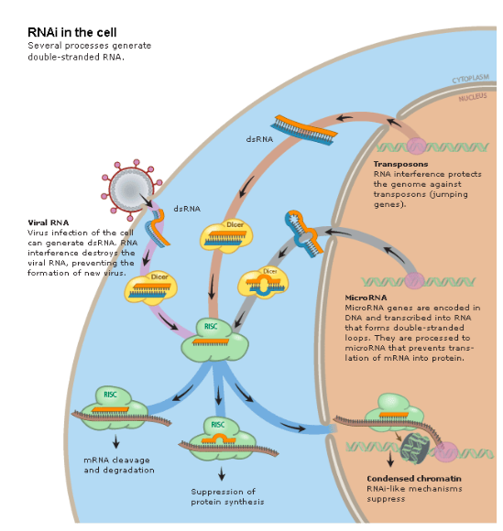

- CRISPR (immune system in bacteria?)

-acquired immunity in bacteria
-genome edition
-Clustered, Regularly , Interspaced, Short Palindromic Repeats
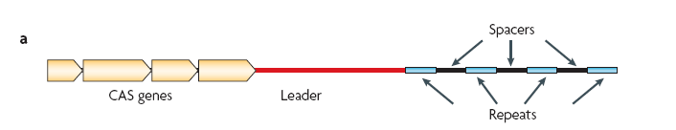

-CRISPR is a locus
a set of 4 genes in the genome of many bacteria, nearby a set of spacers
spacers do not encode proteins
the spacers have the sequence of bacterial phages
therefore, in the genome, there are sequences of the viral gene (in the repeats shown in blue)

-bacteria that have a sequence of a particular bacteriophage in one of the repeats
have resistance/immunity to the virus
this immunity could be acquired

-CRISPR is a system in bacteria that provides acquired immunity to specific viruses through taking a sequence of the viral genome and putting it into the genome of the bacteria
similar to the RNAi system

-the repeats are transcribed into a polycistronic transcript with all of the different phage sequences
the phage sequences are then processed by one of the Cas proteins
the Cas protein will cleave the RNA with the phage sequences with the hairpins to make sRNAs

-the sRNAs are recognized by the Cas proteins (Cas9)
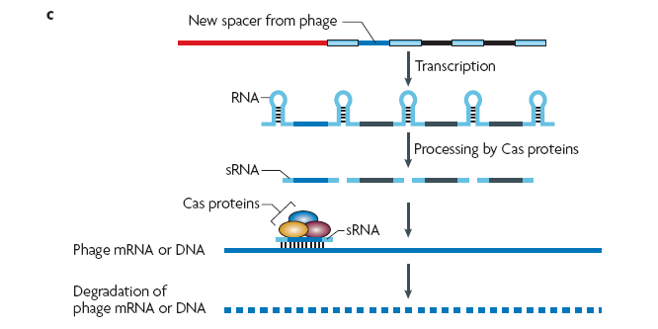
some of the other Cas proteins will bind to the sRNA and use the sRNA and the sequence as a probe to specifically find the DNA of that particular sequence that corresponds to the infectious phage
it finds it by base pairing, and when bp occurs it will cleave the DNA
if DNA is cleaved it cannot replicate

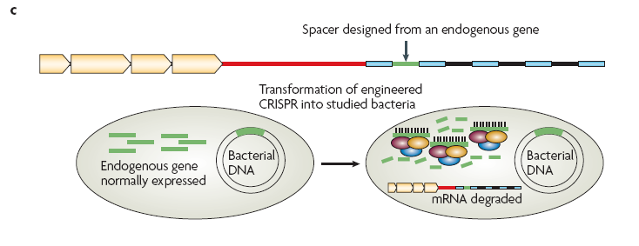

*you can put any sequence into the spacer and it will form sRNA and cleave the genomic DNA

