Chapter 3: Charles Darwin (1809-1882) and Evolution
Education and Family
- Born February 12th, 1809
- Father was a doctor
- Mother was from the Wedgwood family (porcelain)
- Marries (1838) to his cousin Emma Wedgwood (1808-1896)
- Had 10 children, many of them become renounced scientists even after the possibility of genetic problems
- Stops his studies in medicine and takes a more serious interest in religion (CambridgeU)
- Pre-requisite to become a pastor: Bachelor of Arts
- Developed an interest in nature: taxidermy, insect collecting, botany, etc.
The Voyage on the Beagle
- In 1831, he leaves on the Beagle, a ship commissioned by the British government to do the cartography of the coats of South America
- He caught the geologists eye and got a crash course in geology
- Darwin was invited on board as a companion of the captain Fitzroy but quickly became the naturalist of the voyage
- He travels the world and spends most of his time on land to sample the fauna and flora and to study South-American geology.
- The trip is planned for two years, lasted five years.
- When he came back from his adventure, he published a book simply about his travels and it was a bestseller (wasn’t about evolution)
- During the voyage, two books had an impact on Darwin
- William Paley (1743-1805) “Theology, or evidences of the existence and attributes of deity”
- Paley is the father of the Theology of Nature. This theology advocated that harmony and design in nature are indicators of the existence and the acts of God (today-intelligent design)
- Charles Lyell: “Principles of Geology”
- Darwin began his expedition thinking like a good protestant: believing in the Great Flood and in Cuvier’s catastrophism
- When he returned five years later, he was in total agreement with Lyell and Hutton’s ______________-
- Realized things were so complex and told him that things can’t be simply made because every part is too intricate and specialized
- Darwin realized that he made a mistake and had to go back so South America because they forgot something.
- Important thing is they touched all continents and he was able to see the differences between them.
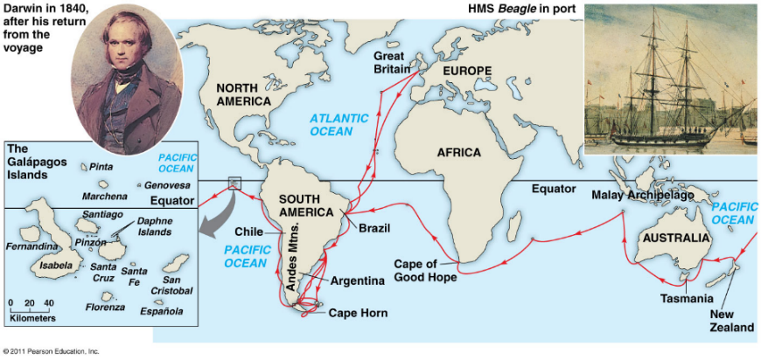
- When he travelled in Chile, there was a huge earthquake and they all survived, and Darwin realized the coast had shifted. He thought that is one earthquake can do this then imagine what many earthquakes could do.
- 3 thousand metres above sea level, he could see fossils.
- He had an explanation from Lyell and Hutton that the cause was because the earth crust had moved over time
The very distinct fauna of South America had a profound effect on Darwin:
- Why do the fauna and flora of Africa, Europe, Australia, and South America have relatively few species in common?
- Why are the animals and plants of the temperate zones of South America resemble the species living in the tropical zones of South America but not the species in temperate Europe?
- Why are the mammal fossils of South America absent from the current fauna (e.g. Giant Sloth)? Why do these fossils show resemblance with current species found only in South America (e.g. three-toed sloth)?
- Wondered why God created different faunas on different continents
- Why do animals have different habitats but look alike
- Found a giant sloth fossil and wondered why there are no more giant sloths
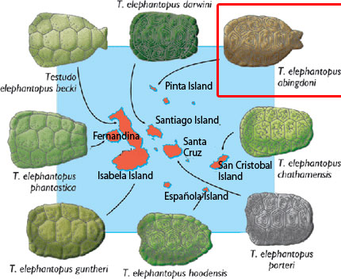
Fauna on the Galapagos Islands surprises Darwin
- Why is the fauna on the islands unique?
- Why does it show resemblance with species on the American continent?
- Galapagos Marin iguana (Amblyrhynchus cristatus)
- Galapagos sea lions are closely related to the Californian sea lion
- Why is there so much shell variability in Tortoises in the Galapagos?
Finches of the Galapagos Islands
- Why so much morphological variability in one group?
- Why does each island, in most cases have their own species?
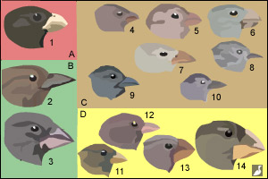

Evolution and Natural Selection:
- In 1837, we find in Darwin’s notes the first mention that species show resemblance to each other because they share a common ancestor
- Rejects the fixity (no change) of species and accepts the concept of descent with modifications (evolution)
- Very materialistic view of life that is in contradiction to the religious dogma of the time
- Rejects Lamarck’s evolutionary mechanism (environmental determinism)
- Then, he begins the search for an evolutionary mechanism
- This explained why the tortoises looked because they shared a common ancestor
- He mentions this in 1837, it took him 22 years to publish book because he potentially wanted to test his theory to make sure its right because it was very controversial.
- This rejects Lamarck’s theory, there is no evidence of his theory
- Evolution affected population and not individual life like Lamarck thought.
- Species change throughout time
- For Darwin, fossils were quite important, and they were the key to identify differences.
- For example, Rock hyrax, Dugong (sea cows), and African elephants show a resemblance and they share a common ancestor
- According to Darwin, big spaces will be filled up by fossils, you can go from a mouse to an elephant.
- 99% of species that have lived on Earth are extinct.
- Most of the evolutionary branches finish in a dead-end (extinction)
- Fossils provides information about missing links. 23 species of humans had existed and showed varying characteristics between humans and chimps
- In 1838, Darwin read “An essay on the principle of population” written by the economist Thomas R. Malthus
- This reading became one of the main sources that inspired him to formulate his famous theory on natural selection
- Darwin didn’t have a mechanism and he tried to understand it
- Thomas was interested in the evolution of human culture and human population.
- Darwin applied the concept of Malthus to other species
- IN his book “An essay on the principle of population (1798), Malthus wrote that:
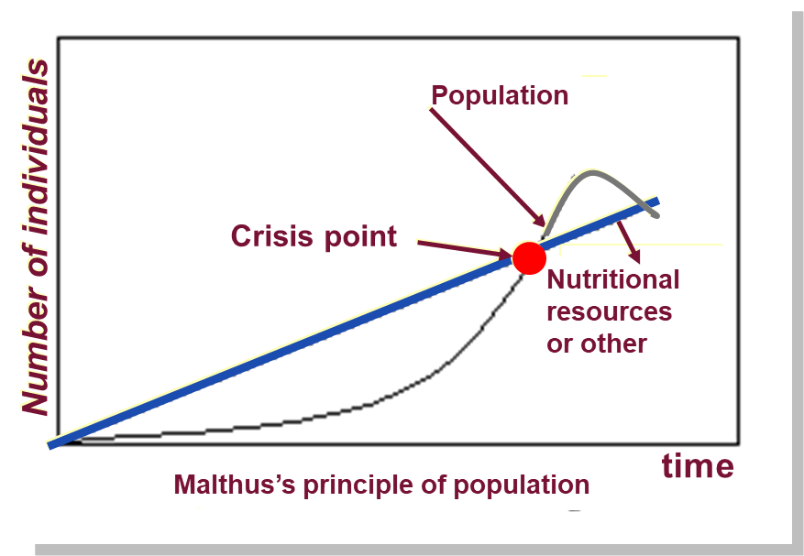
- Every human population tends to increase geometrically whereas the available resources to feed these populations increase arithmetically
- Malthus thought that there was a crisis point when the resources would run out
- There would be winners and losers, ones that could get resources and ones that couldn’t
- The human population increases faster than its capacity to feed itself. This leads to chaos (famine, sickness, war, etc.) and eventually to a substantial reduction in population size.

Darwin’s first observation:
All species can produce more offspring than their environment can sustain and many of these offspring fail to survive and reproduce
- Except for humans who can mostly control the offspring, the rest try to make a lot of offspring, but it usually doesn’t happen, big fish can make 2 million eggs each spawn at once but all of these fish don’ survive
Darwin’s second observation:
Members of a population often vary in their inherited traits
- Characteristics of a winner or maybe the characteristic of a loser.
- The reality of variability within a population became a very important point rather than considering it as not important
- He knew there were traits that were sent from generation to generation and he realized this through the study of artificial selection
Two inferences:
- Individuals whose inherited traits gives them a higher probability of surviving and reproducing in a given environment tend to leave more offspring than other individuals
- From generation to generation, this unequal capacity of survive and reproduce (differential reproductive success) results in an accumulation of favourable traits in a population
- This is NATURAL SELECTION. It enables the emergence of adaptations
- After a few generations, the ones that have the most desired trait would have more offspring and would start to dominate the population
- There is always a change in environment (ex. Global warming) and the most desired trait could change (instead of attacking red fish when the background changes, will attack the red ones now)
- Only one that produces adaptation (which is one evolutionary step)
Evolution and Natural Selection
- It is a letter from Alfred Russel Wallace (1823-1913) received in 1853 that forced Darwin to publicly release his ideas
- Wallace had come to the same conclusions as Darwin concerning the theory of natural selection by observing the fauna of Indonesia (he recognized that Darwin had discovered this first)
- Thus, it was 23 years after his voyage on the Beagle that Darwin publicly released his view on the evolution of species
- On the same day, in 1858, Darwin and Wallace presented a resume of their ideas on natural selection to the Linnean Society of London
- In 1859, Darwin publishes the first edition of his book “On the Origin of Species” This book became an instant bestseller and created great controversy
- The 6th and last edition of his book, published in 1872, contains a chapter dedicated to the most important arguments against his theory. Most of these arguments came form his creationist colleagues
- The most important book in natural history, he provided tons of examples of natural selection and even though there was no genetic evidence, the theory was very probable.
- he doesn’t need to invoke God in any way to start his process
Important notions linked with natural selection:
- Individuals do not evolve, populations evolve.
- Only hereditary traits are subject to natural selection
- For evolution to occur, we need genetic variability
- Natural selection corresponds to differential reproductive success within a population from generation to generation
- With time, natural selection enables individuals to become better adapted to their environment
- Environmental factors vary in time and place; Thus, the selective forces are variable.
- Traits in populations will change and can modify the species
- Darwin didn’t see any evidence that individuals evolve, we may evolve intellectually or culturally but never individually.
- Population evolves (his fish example is a population that evolved)
- Most important realization that Darwin made was that you need genetic variability to have a healthy population
- If there is no genetic variability, then the probability of a population surviving is minimal because the environment is bound to change. They are either all winners or all losers if there is no genetic variability
- Populations with no genetic variability is how species become extinct.
- Only capability of fittest is the capability of species to produce offspring. If you don’t have the genotype of the winner, then you’re not the fittest
- White-tailed deer are everywhere in Canada and in Costa Rica. In Costa Rica they are the same size as a German Shepard because the environment is different, and that size allowed them to survive the most survive the most.
- Migration when considering populations survival is important
- Deer might change their shape as time continues to adapt to their environment
For Darwin this mechanism is valid because:
- It respects the principle of uniformity of Lyell and Hutton
- The results of natural selection are visible in nature
- The mechanism can be verified on current populations (e.g. artificial selection)
- It is a materialistic concept (no divine intervention):
- The mechanism is not random. Natural selection enables individuals that are better adapted to their environment to become more abundant than those who are not (differential reproductive success)
- Not a quest for perfection (evolution is not a directed process). It does not lead to the appearance of “perfect” traits. Organisms only adapt to their environment
- By studying the present, you an speculate the past: principle of uniformity.
- Natural selection is a process that occurs over a very long period. God is not necessary to explain this theory of evolution and natural selection
- Not a directive process, no goal, no purpose, just a consequence of the interaction with the environment
Artificial selection is finalized because the goal, fixed well in advance, precedes the causes. The result can be obtained in a few generations
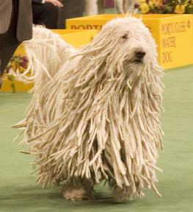
Natural Selection is not finalized. It can take a long time for changes to occur (geological time scale)
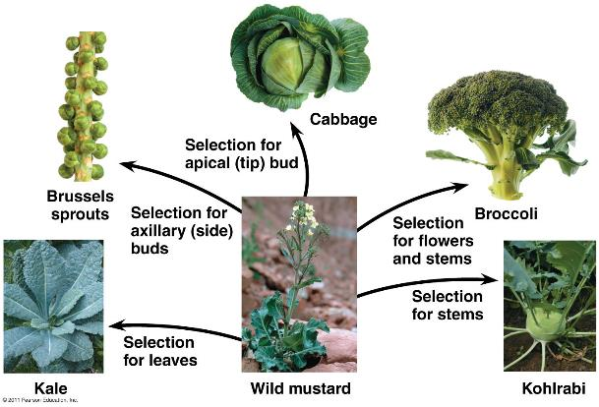
- The dog is a result of artificial selection. Someone just kept on choosing the dog that has the longest hair and continued to breed them.
- All those vegetables came from the mustard plant.
- Darwin knew artificial selection, and this allowed him to know that there are traits that are carried from generation to generation

Peppered moth: when England was covered in soot, this caused certain moths to be more visible or not. White moths more visible to predators so that they were eaten more often, and dark moths became more prominent. Go out to the country side and the peppered moths survive more because they blend into the white trees. When the city got cleaned up the dark moths became very rare because they were more visible to predators. Natural selection is a very simple process as demonstrated in this example.
Climate and the Medium Ground Finch
- Drought in 1977 (also in 1980,1982)
- Population went from 1200 to 80
- Selection favouring individuals that had bigger stronger beaks to break available seeds during the drought
- In the experiment they would catch birds and band them and eventually built a pedigree of the specimens and if you know the morphology of the parents and the nesting, you can measure the inheritability of a trait.
- Natural selection can be observed during one season
Mountain life: Adaptation to altitude
- The guide has an adaptation and genetic basis that allowed him to run at such high altitudes
- Over 2 000m, the partial pressure of O₂ is insufficient for the normal saturation of hemoglobin for a traveller in high altitudes
- Shortness of breath, altitude sickness
- Physiological response (acclimatization): After a few days at high altitude, the body compensates the low partial pressure of O₂ by increasing the concentration of red blood cells in our blood. Serious heath risks: thrombosis, pulmonary edema, etc.
- You get loaded with high blood cells and when you get back to your normal altitude they last for 3 months
- Danger is your circulatory system is not able to handle that rush of red blood cells
**MUTATIONS ARE RANDOM**
If someone has the genetic traits that allows for survival and reproduction in high altitudes and they migrate to the top, eventually due to natural selection, the desired trait will become more prominent
ADAPTATIONS
Andes:
- Increase in hemoglobin concentration (red blood cells)
Qinghai-Tibet Plateau
- Deeper breath, larger pulmonary capacity and increased blood flow
Natural selection keeps the individuals with the genetic traits that allow adaptation to high altitude. This means that individuals that have the mutation are at an advantage for survival and reproduction (production of offspring)
EVOLUTION AND NATURAL SELECTION:
- In the three cases (moths, finches, and humans), the hereditary traits that give a reproductive advantage (i.e. adaptation) to individuals in a population will be favoured. Thus, from generation to generation, there will be a higher percentage of individuals carrying the adaptation. This is natural selection. Its Darwin’s descent with modification. It’s evolution
- These adaptations can sometimes redefine a species and, in certain circumstances, define a new species
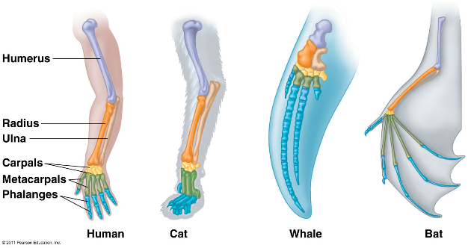
Proof of Evolution: Homology
- Descent with modification theory (theory of evolution) explains the resemblance between certain traits even if the functions are different (Homologous structures)
- Structures may only occur in larvae, pharyngeal pouches are characteristics of humans and chick embryos but will regress very differently during embryology, will form gills and have different fate, where one will be an organ, morphology structure. Post-anal tail will eventually be a homologous structure.
- Think of life as a tree, not a straight line (regarding evolution)
Evolution of the horse:
- Horses are 50 million years old, ancestor of horses used to be the size of a dog
- Foot gets simpler and simpler, only one digit left at the end
- They liked to live in the plains at the end instead of tree areas at the beginning of their time and this caused their teeth to become more adapted so that they can eat grass with sand on it.
- The hooves made moving around more efficient. Allows them to move faster and a horse’s larger size makes them less likely to be hurt by predators
- This is simple linear example of evolution
- **linear graph is not valid because it doesn’t match the graph that includes all the species
False Images from Humanity
- The image of chimps walking is a false representation of how humans evolved, its linear evolution. Would mean that only one humans species lives at the same time, be we know this was not the case.
- We share a common ancestor with chimpanzees, we are not transformed into chimpanzees
- Species of humans went extinct and they weren’t very tall, human species have all kinds of sizes during the whole of history
- Many similar species lived at the same time
- All species of humans disappeared except for one
- Humans now developed a morphology that allows us to move quickly
- Found out brain size does not reflect intellect
Whales and hippos
- Whales are mammals and they show structures that are also in the hippo, this discovery was made through analyzing fossils
- To look if there is a common ancestor, look at the bone structure
Vestigial structure: anatomic structure that has lost almost all its initial function
- Whales have this, back two bones just sit there, don’t move and don’t have a function
- The presence of this bone suggests that at one point, an ancestor of the whale had four limbs
- Human remanence of nictitating membrane, it’s a third eye lid and is translucent and provides protection for the eye. It can still fly and see through it, in humans this nob of flesh has no function, it’s a vestigial structure
- If you look at rabbits and horses their caecum is huge and it’s a place where there is a lot of microorganisms that help digest plant material. At one point (or ancestors of humans) had a large caecum or appendix to help with vegetation digestion.
- Just a remnant of common ancestor
- Goose bumps: each strand of hair has a muscle attached to it and when we are cold or scared, the muscles will contract, and the hair stands up, doesn’t prevent us from being cold. If you had a large density of hair, the tips of the hair can create layer that helps keep animals warm
- Still have the morphology to have goosebumps but its not helpful for us. Hair on the human body is a vestigial structure, indicator we had a common ancestor who has fur
- Hiccups: a heritage from fishes and amphibians. The phrenic nerve goes down through to touch the diaphragm and when we have the hiccups this nerve gets pinched.
- Epiglottis probably evolved in tadpoles because for part of its life it has lungs and gills at the same time
- Shutting of the glottis allowed water to go to the gills
Proof of Evolution
Discovery of a fossil in the wrong place in the geological archives would be sufficient to refute our concept of evolution, this hasn’t happened yet


