Antibiotics
- “Anti-life”
  - Selective poisons for microbes
    - Bacteria
    - Viruses
    - Fungi
    - Protozoa
    - Reserved for bacteria despite being able to be used for all above
- Have had largest impact on human life of all medications except vaccines
- Antibiotics à Most likely for bacteria (Antibacterial)

HISTORY
Infectious disease – the leading cause of death throughout history
- Middle ages – 25 % of Europe killed by plague
- Antibiotics à Biggest impact on the human life (other than vaccines)
- illness is now not a big deal
- Before vaccines and antibiotics, infectious disease = leading cause of death

Paul Erlich and the magic bullet 1907

- Relatively new drug (70 years)
- Magic bullet à Created medication that you can shoot in any
direction and it will kill whatever you need to kill
- Can kill microorganisms without killing human host

Trypan red effective against trypanosomes

- Blood cells did not take up the dye aà̀ did not change color
- Chemical difference that causes one to interact with a dye and the
other does not.
- Discovered in 1903 when Erlich invented a dye, trypan red, which was the first drug to show activity against trypanosomes (had affinity to trypanosomes rather than cells
- Thought that he could turn the dye into poison to kill bugs

Simple SAR to increase toxicity
- Salvarsan 606
- Really crappy drug àBut first successful antibiotics
- One of the first to do SAR
- By replacing the Nitrogen (N) with Arsenic (As), it created a successful antibiotic against Syphilis (Syphilis used to be a big problem)
- Erlich used simple SAR to increase toxicity
  - Played around with substitution of nitrogen group
  - Salvarsan 606 comes from arsenic
  - 606 = 6th compound in 6th row was arsenic

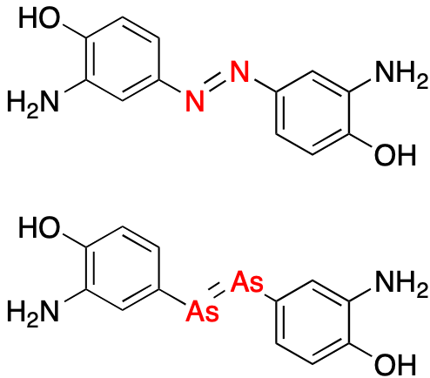

Salvarsan 606 was a poor product
- Syphilis
  - Did not work for trypanosomes but did work for syphilis
- Weekly injections
  - Drug very insoluble
  - 600 mL each injection
  - Required 1 hour
  - Syringe was used (slow i.v. drip invented 1935)
  - Intramuscular injection produced necrosis

- Failed as a drug cause it was inconvenient to take
- Poor product as it was not drug likeàFailed as a drug
  - Inconvenient
  - Insoluble
  - Could only inject 600 mL via syringe that you had to push for
full hour
  - If pushed into muscle instead of vein, tissue was damaged à
necrosis. Some needed imputation
- More for proof of principle à If you can find a product that can have
potential. In principle, it is possible to create compound that can cure a bacterial disease

Gerhard Domagk at IG Farben 1932

- Effective in vivo
- Ineffective in vitro
- Came up with something that might work better
- Chemical compound named prontosil àUsed to dye clothing, found
that it has antibacterial properties
- Discovered that red dye, prontosil, had activity against certain type of bacteria
- Domagk gave it to his sick daughter and she was cured
- Effective in living animal, but not in petri dish

Prontosil was effective because of metabolism

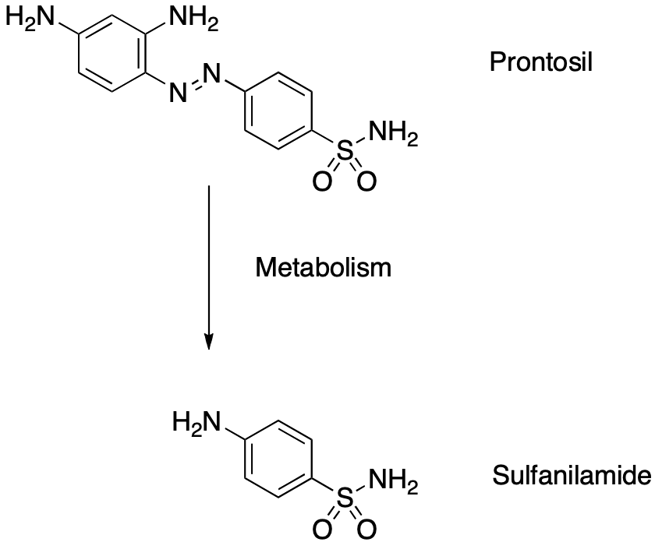

- Only effective in a living animal ààProntosil (Inactive form) gets converted into Sulfanilamide (Active form) in the liver
- Petri dish when in the presence of Prontosil would become red
- Prontosil (inactive form) is colored red but Sulfanilamide (Active
ingredient) is colorless
- Drug was a pro drug (gets converted into something else in the body)
- Sulfanilamide was a more desirable drug as it was colorless

Mechanism of Action
- Bacteriostatic, interferes with growth
  - Does NOT kill bacteria
  - Only effective if patient has competent immune system
- Interferes with tetrahydrofolate biosynthesis (coenzyme F)
- Prevents bacteria from making coenzyme F
  - Bacterial growth stops
- Works with immune system to help clear a disease
- Coenzyme F needed for bacteria to grow

Sulfa drugs inhibit coenzyme F synthesis

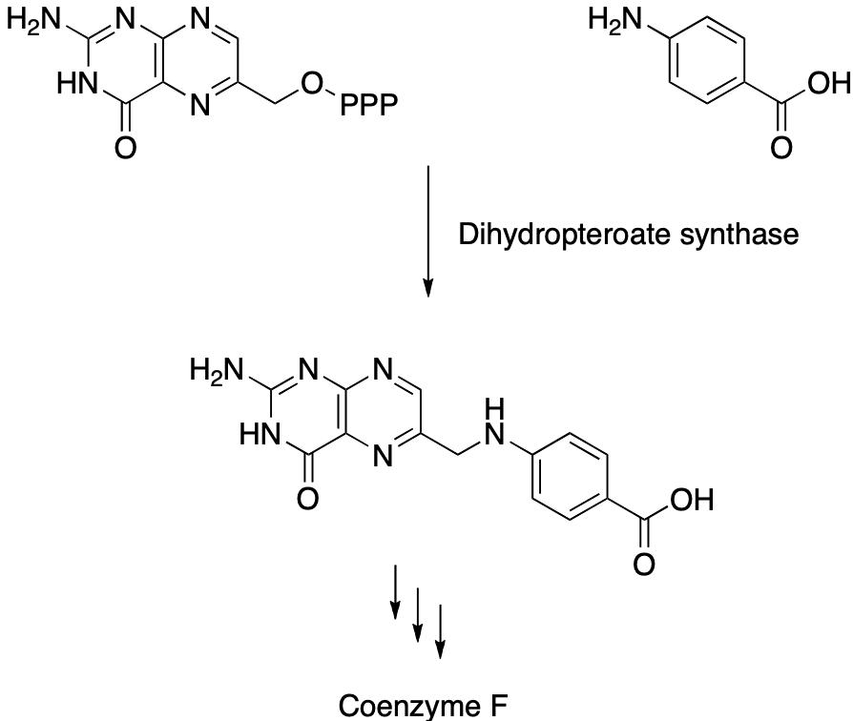

- Cascade of chemical events that produces Coenzyme F
- Drug blocks the enzyme that uses PABA to produce Coenzyme F
- Drug inhibits enzyme that combines PABA with other compounds

Sulfonamides are competitive inhibitors of PABA
- Sulfonamide competes with p-aminobenzoic acid for active site
- Binding is in the active site
  - Substrate cannot bind

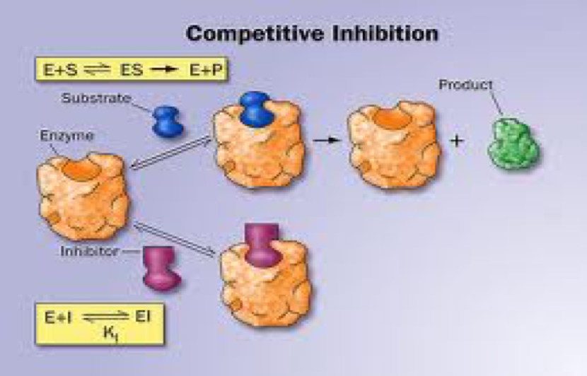
Sulfonamide competes with PABA for active site
Model of sulfonamide competition

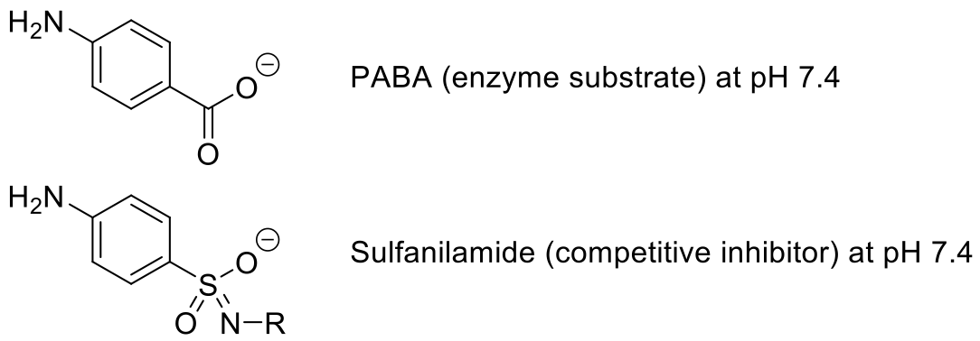

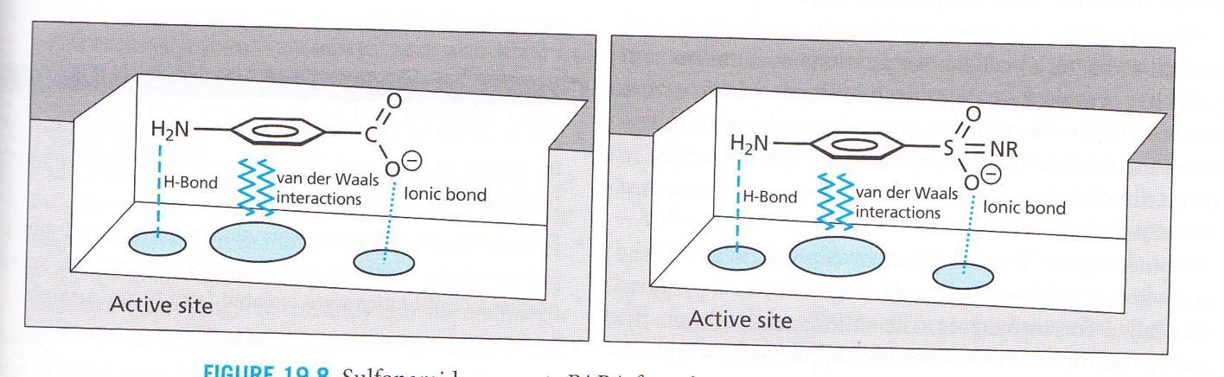

- Chemical structure that inhibits PABA
- Acidic that adopts a negative charge
- Pharmacophores fits perfectlyàReacts like the original molecule
- Both drug and natural substrate have overall, same general structure
- Right hand side = negative charge
- Same pattern of interactions
- When sulfide is there, acid cannot be there, enzyme cannot function,
bacteria cannot continue function
- Use principles of rational drug design to create a drug to block enzyme
function, isosteres, etc.

Blocking enzyme function
- Strategy for competitive inhibition

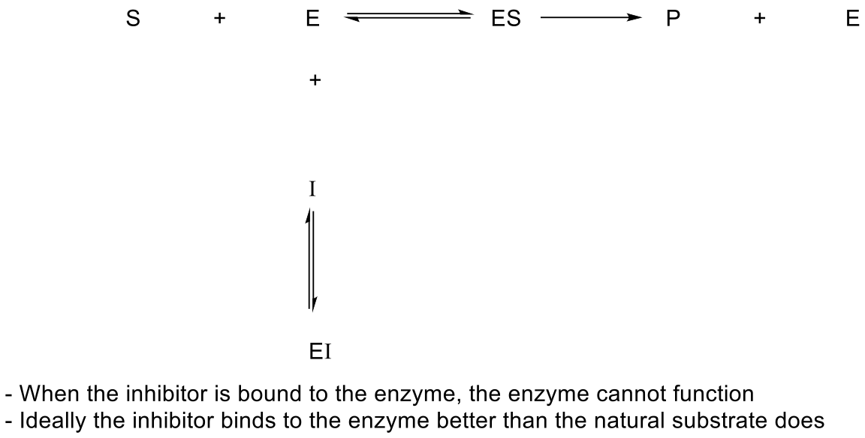

- Competitive inhibitor of this enzyme
- The new equilibrium in bleu is favored over equilibrium in red (inhibits reaction)

Competitive Inhibitor
- Binds better than the natural substrate
  - Nature does not make optimal systems, just good enough
  - If nature were optimal, drugs would not be possible
- Basis for selectivity in humans
  - Humans lack the enzyme
  - Get tetrahydrofolate from folic acid in our diet
  - Nature does not necessarily optimize anything à Gives a decent one
  - Compound needs to outcompete the natural substrate

Common structural modifications

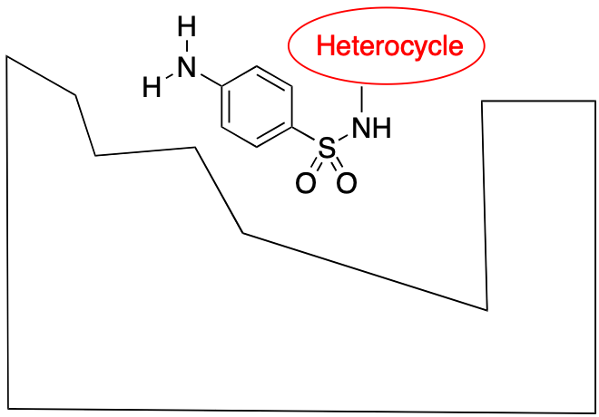

- Most common structural modification is to stick a heterocycle
  - Make changes to its property in order to get it into the bloodstream
    - Increases solubility àAdding nitrogen which is basic
      - Changes will improve the amount that gets into the body
- Getting it from the pill and into the body
- Small molecules are tough to come up with drug analogs for
- Due to binding conformation, easy to add heterocycle onto drug =
variability because it does not usually fit into the active sit but rather stays out in the solvent

Penicillin
- 80 % of all antibiotics
- More than 30,000 synthesized
- More than 100 sold as drugs
  - Most are semi-synthetic à made from penicillin (but not natural penicillin, artificial that we make on our own)

Alexander Fleming contaminates culture in 1938

- Discovered the mold and that it is able to kill bacteria
- Accidently affected a bacteria culture with mold
- Came back from vacation to find bacteria not growing in a certain part
of the plate

Mold prevented bacterial growth

- Fleming found penicillin by accident
- The penicillin mold did not have any bacteria around it
- Mold secreted penicillin which prevented bacterial growth

Howard Florey & Ernst Chain isolate penicillin in 1941

- They discovered what Fleming had forgotten about
- They were looking for antibiotics à Interested in finding natural products used to kill bacteria
- Took them 2 years to figure out how to isolate the bacteria
- Fleming thought he found something interesting but trivial
- Florey and Chain wanted to find next antibiotic àread Fleming's paper
- Howard Florey & Ernst Chain
  - Used sample of Fleming’s mold
  - Isolated penicillin from mold
  - Conducted an experiment on affected animals
  - First researchers to give penicillin to a person

Florey & Chain publish their discovery

- Used to treat disease
- Miracle drug
- First human experiment with penicillin àThe guy died but the experiment showed that it did kill the bacteria (Proof of Principle)
- Partial recovery with penicillin

Penicillin time line
- 1929 - Discovered mold by accident
  - Flemming
- 1940 – Active substance isolated, identified, tested
  - Chain & Ernst
- 1940 – First demonstration in animals
  - Chain & Ernst
- 1941 - First human use
  - Chain & Ernst
- 1942 – Production made war priority
  - Development of corn fermentation
  - Simplified extraction process
- 1943 – First widespread use by US Army
  - More people were being killed in army by infection than combat
  - Priority for soldiers
- 1944 – available to general public
- Substance was not isolated until 1940
- Very different Timeline today
- Penicillin was isolated in 1940 and made it to market by 1942
  - The entire process took 2 years.
- This is very different to the process today
  - The entire process takes about 10-12 years

Mechanism of Action

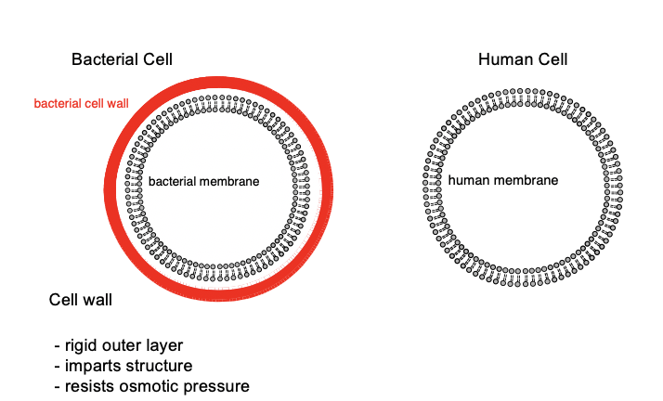

- Osmotic pressure à Balance of concentration by moving water inside or outside the cell to make the solute concentration equal
  - Human cells are really big compared to bacterial cell because human cells are affected with the osmotic pressure.
  - Bacterial cells have the cell wall surrounding the cell which prevents the interference of osmotic pressure
- Penicillin interferes with the bacterial cell wall à Preventing the production of the cell wall
- Human cells do not have a cell wall surrounding the cellàPenicillin will not affect the human cells
- Penicillin is very safe à Will not cause any adverse effects following consumption
- Penicillin prevents bacteria from making cell wall
- If cell wall cannot be created in time, osmotic pressure causes bacterial cell to
explode

Origin of osmotic pressure

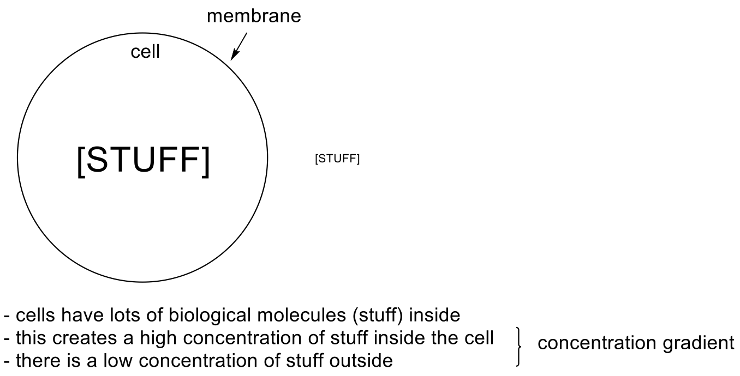

Origin of osmotic pressure

Cell Wall Structure

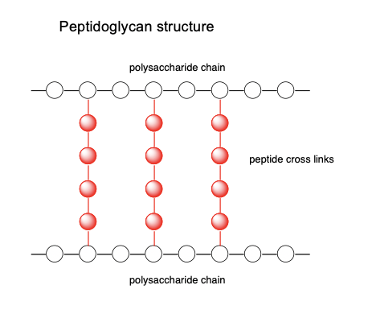

- Gigantic rigid molecule à Resembles plastic
- Polysaccharide chains = long chains of sugars
- Peptide cross links = little proteins that connect sugar chains o Web like structure = very strong

Cell Wall Formation

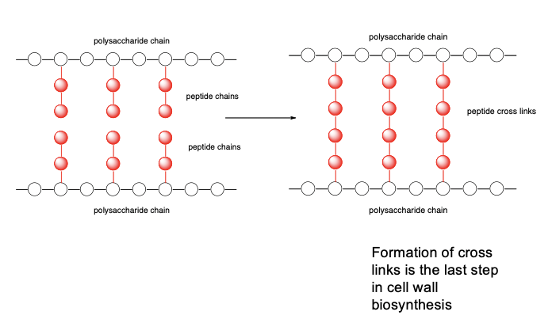

- Reform the cell wall around it when the bacteria is dividing
- Polysaccharides alone are in a liquid state
- When a chain of polysaccharides is linked together by the enzyme
- transpeptidase (Forming a peptide cross link) àIt becomes a solid
- Bacteria make chains and at every second sugar, there is a peptide chain o Transpeptidase (enzyme) links protein chains together to generate cross
- linked chain
- Go from flexible to solid molecule
- Solid = pressure bottle called cell wall (resists osmotic pressure)
- Penicillin blocks transpeptidase, which causes rupture in cell wall
- Formation of cross links is the last step in cell wall biosynthesis

Polymer structures
- Small molecules (monomers) linked to make giant molecules called polymers
- Polymers are used to make plastic
- Generally, monomers are going to be liquids
- Polymer are normally solids à Because the molecule becomes gigantic and it’s difficult to push them around
  - Change of state from liquid to solid
- Can go from propylene monomers in gaseous form to polypropylene, a solid

- Spaghetti-like mixtures

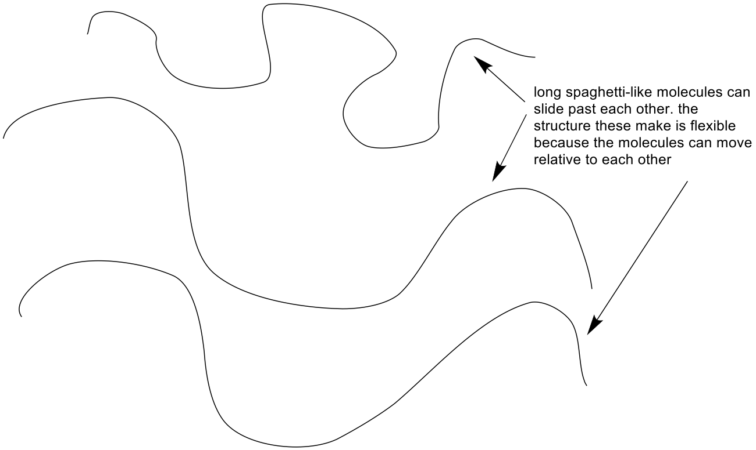

- Chains of molecules that form one after the other, they are linked in odd ways
- Thick viscous liquid
- Spaghetti like mixtures with cross linking

Cross linking
- Method of strengthening structures
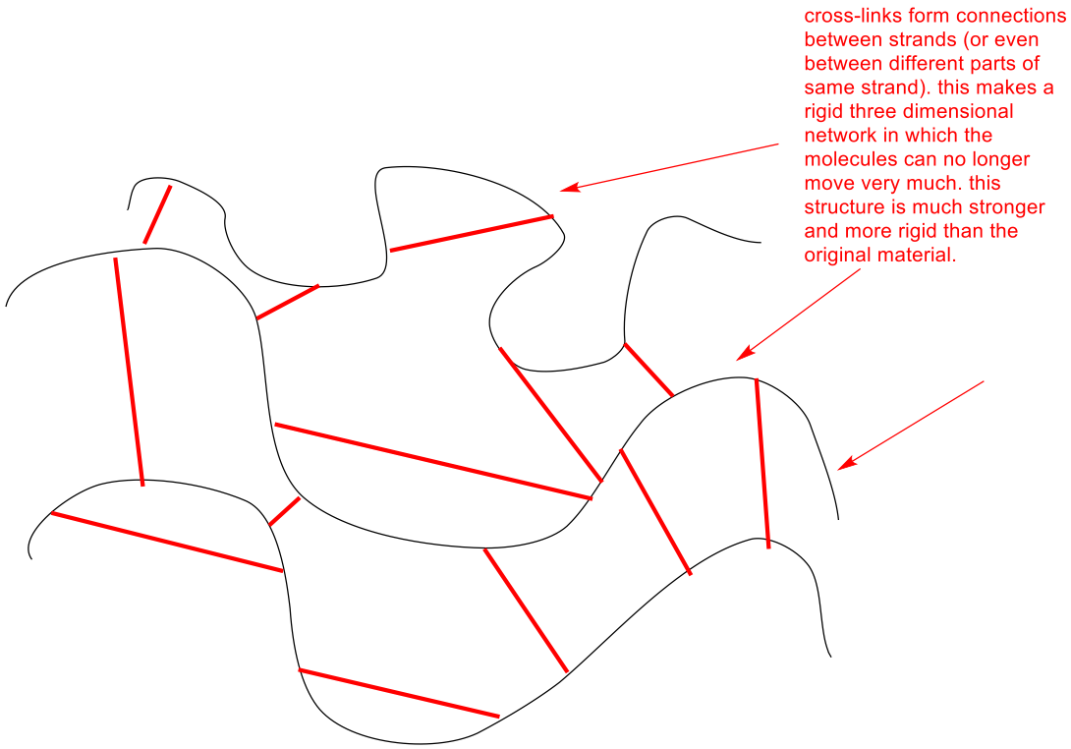

- Spaghetti like structures will be linked with cross links which creates a network of interactions àForms a really strong and ridged structure
- Use cross links to connect spaghetti structures together
- Solid, large structure created that holds shape

Cross Link Formation

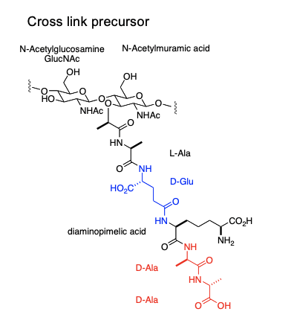

- D-amino acids are rareàFound in bacteria
- Involves special structures
D and L amino acids

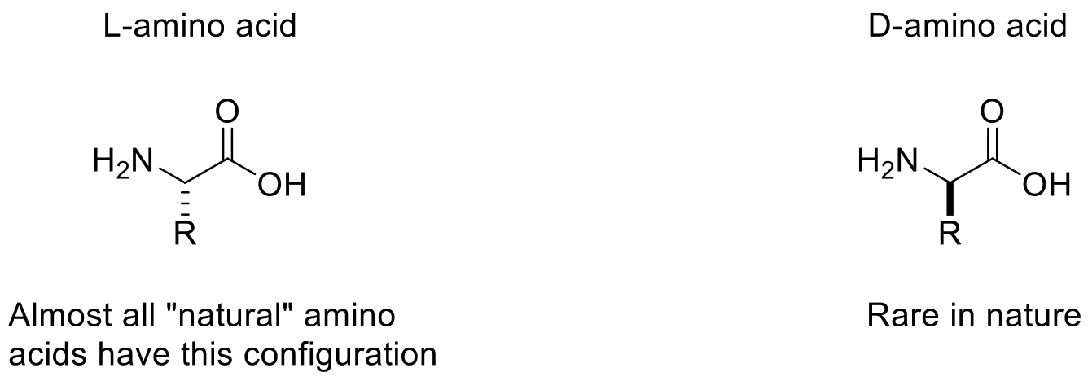

- Alpha carbon makes bond with other amino acid
- All amino acid has an “S” configuration at alpha carbon (except one)
- The L-amino acid is the natural form
- Penicillin has a shape which is a mirror image of what the body expects to see
  - Penicillin has a D-amino acid
- Gamma link and D amino acids = early origins as now only L amino acids are used

Transpeptidase

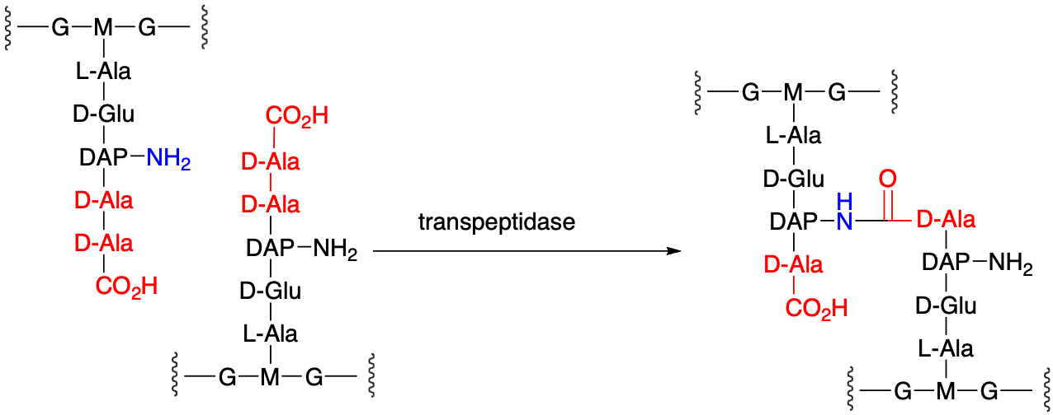

- Penicillin targets transpeptidase enzyme, so that no cross link is formed
- Bond that is cut occurs between D-ala-D-ala (Only in bacteria)

Transpeptidase reactions

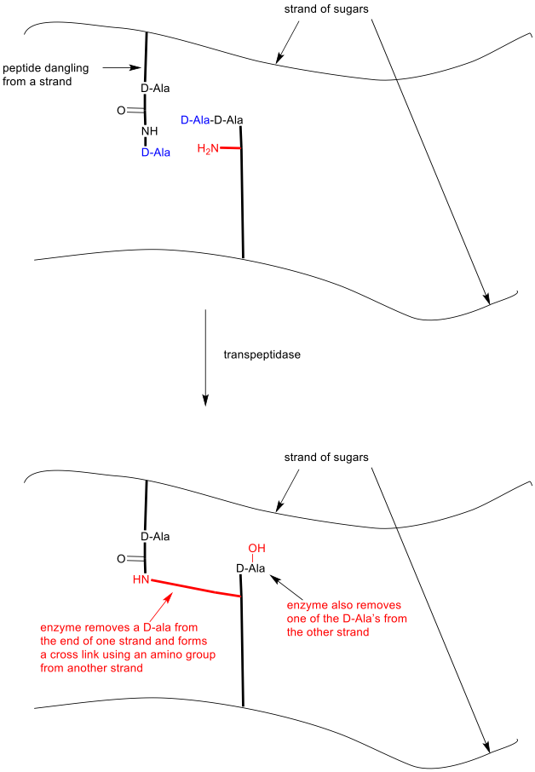

Serine protease active site

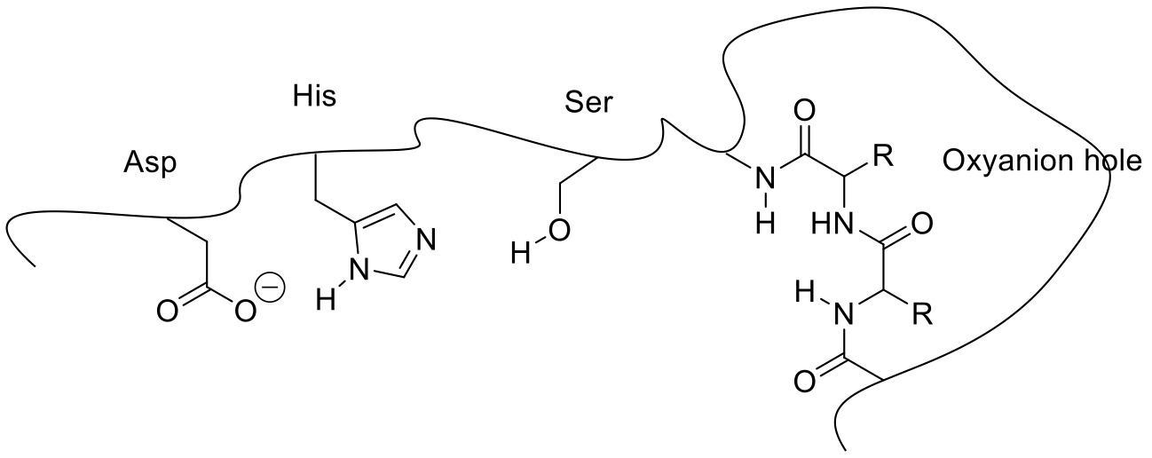

- Penicillin affects the active site of the enzyme
- Protease cuts the amide bonds
- Amino acid serine
- The three residues are called the catalytic triad à Atom for atom they line up perfectly
- Oxyanion hole is the same of every single one of these enzymes à Creates a region for the substrate to go into (Substrate binding grove)

Amide hydrolysis in solution
- Very slow reaction
  - At pH 7.4 half life is hundreds of years

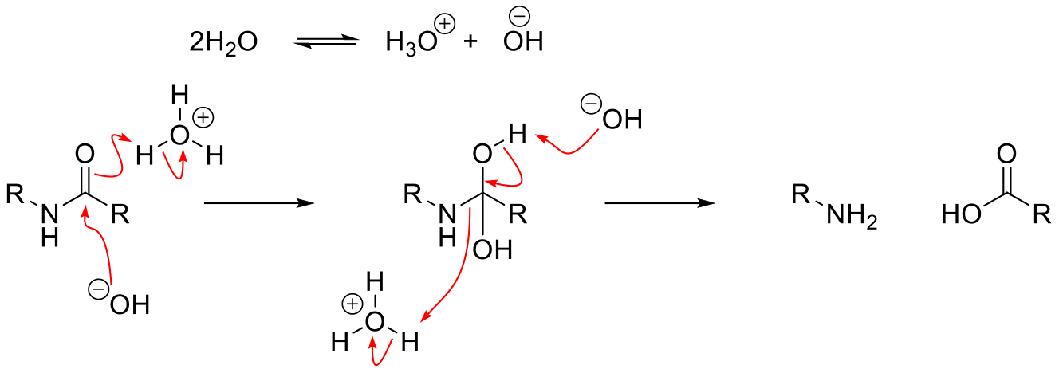

- Generates an intermediate
- Gives a reaction in which there’s a cut in the
nitrogen and acid
- Reaction which serine protease does

Amide hydrolysis in enzyme

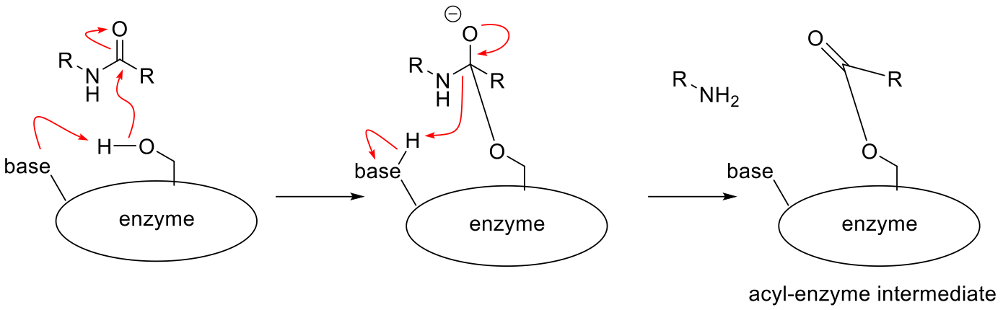

- Enzyme has the serine which has a specialized kind of baseàBase will move the hydrogen from the OH group. OH group will be a nucleophile
- Forms an intermediate

Formation of new amide bond
- Formation of cross link between D-Ala and 6-aminopimelic acid

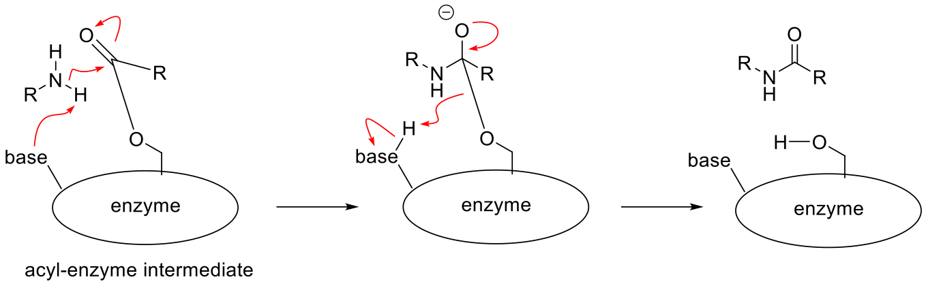

Role of water in the reaction
- Hydrolysis of one D-Ala-D-Ala peptide bond

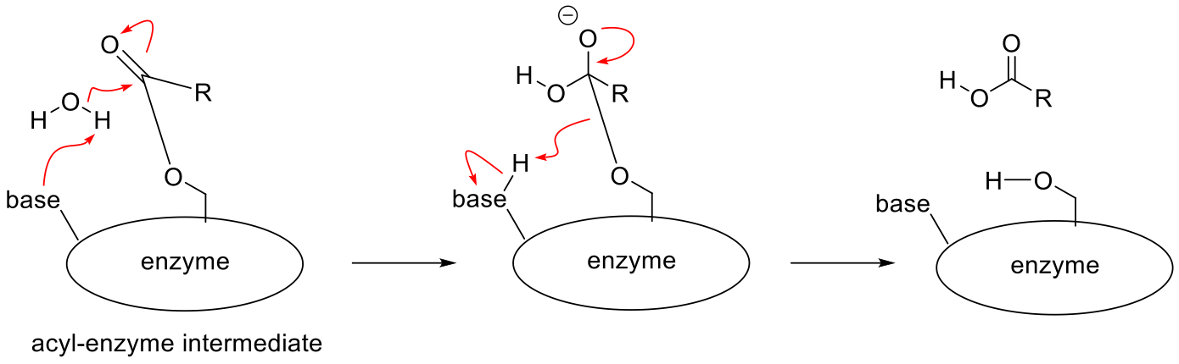

- Same movement of electrons as amide hydrolysis in enzyme BUT different product
Role of the catalytic triad

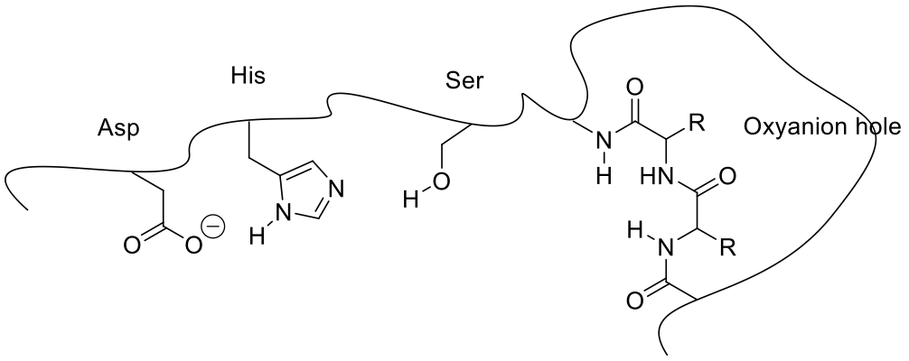
- Side chain acts like a base
Role of the Oxyanion hole

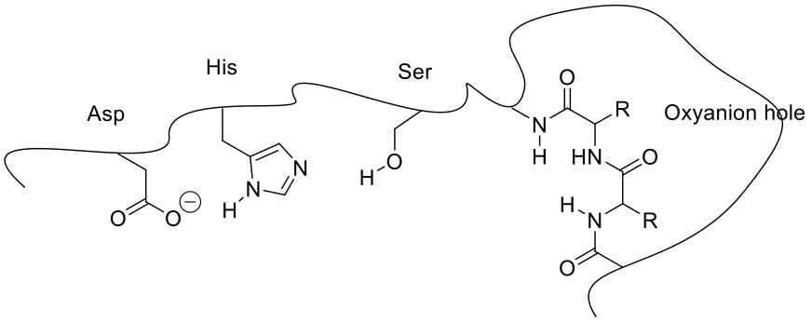
- Role is to stabilize the tetrahedral intermediate
- Negatively charged is high energy species. The oxygen is in a perfect location to form a hydrogen bond à H-bonds stabilize the negative charge
- Side chains line up atom for atom

Reactions catalyzed by transpeptidase
- Cross link formation
- “trim” one D-Ala from each strand

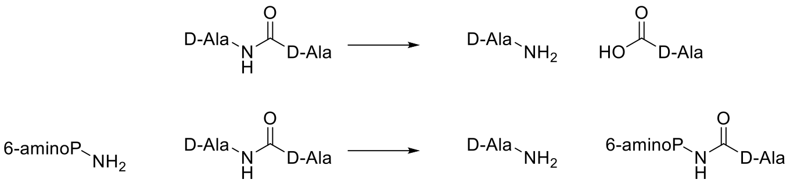

- Catalyzes two different types of reactions
b-lactam opening by enzyme

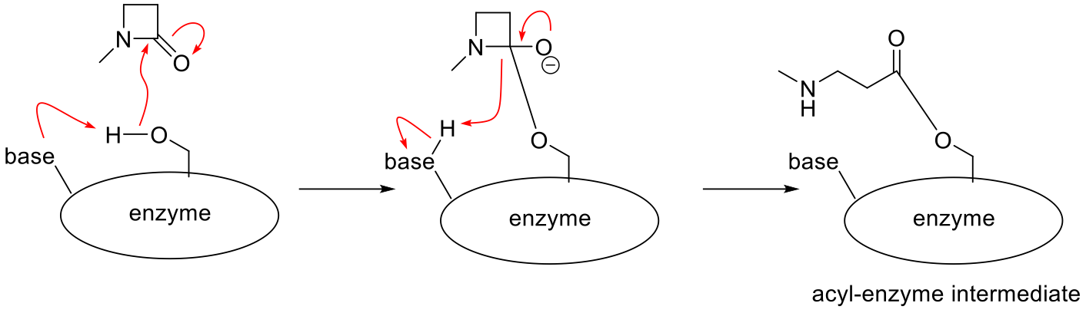
- Penicillin is jammed in the active site of the enzyme and the overall shape of the enzyme is different than normal
- In the wrong shape to carry out the second part of the reaction
- The enzyme is now trapped by the penicillin à Covalent inhibition

Covalent inhibition

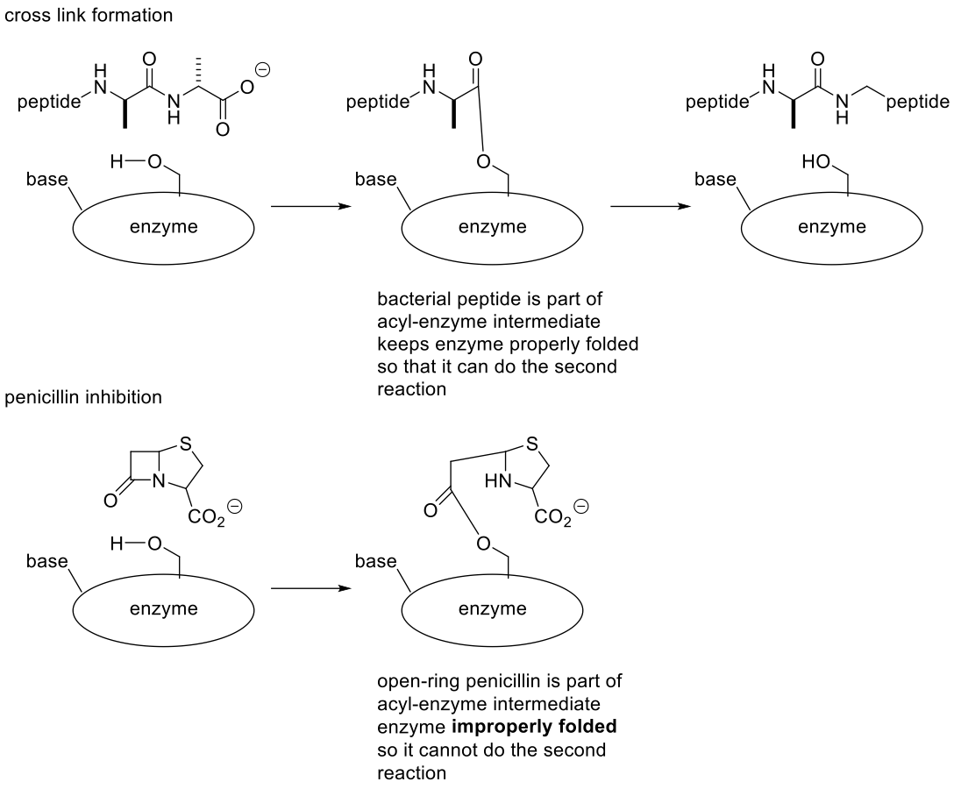

- Enzyme is folded in a different shape à Not in the proper fold thus cannot proceed to the second part of the reactions
- Enzyme is permanently disabled
  - No free OH group to preform reactions

Irreversible inhibition
- Inhibition is permanent
  - Enzyme unable to hydrolyze the ester formed
- Cell wall formation is prevented
  - Cells burst from turgor (internal pressure) when dividing

- Bacteria unable to grow the cell wall and they will explode à Pressure can't be held back
  - Bacteria cell will die

Selectivity
- Human cells do not have cell walls
  - No equivalent enzyme
  - D-Ala-D-Ala linkage is unique in nature
    - Bacteria only
    - Virtually all other amino acids have L configuration
- Very clean drug
  - Non-toxic
  - Very safe
  - Few side effects
  - Major side effect is allergy (~ 0.1 % incidence)
  - Only concern is allergy to the drug àRare
- Structures of penicillin resembles the D-ala-D-ala linkage
  - D-ala-D-ala linkage is unique to bacteria
- Penicillin targets only the bacteria
- Penicillin has molecular shape that looks like D-Ala-D-Ala

Source of Allergy
- Penicillin is a good electrophile
- Can acylate host serine proteases or other proteins

Source of Allergy
- Acylate host (human) serine proteases
  - “tagged” protein recognized by immune system
- Strongest reactions happen second time taking drug
- A lot of serine proteases in the body à The penicillin can change or react
with the serine protease and the body now recognizes it as a foreign protein
- Generates an allergy
  - The allergy gets stronger as the consumption of penicillin increases
- Encounter penicillin if you have allergy, recognized as foreign by immune
System
- Worst effects on second exposure as the first time, do not have time to
generate antibodies

Mechanism and Structure à Penicillin

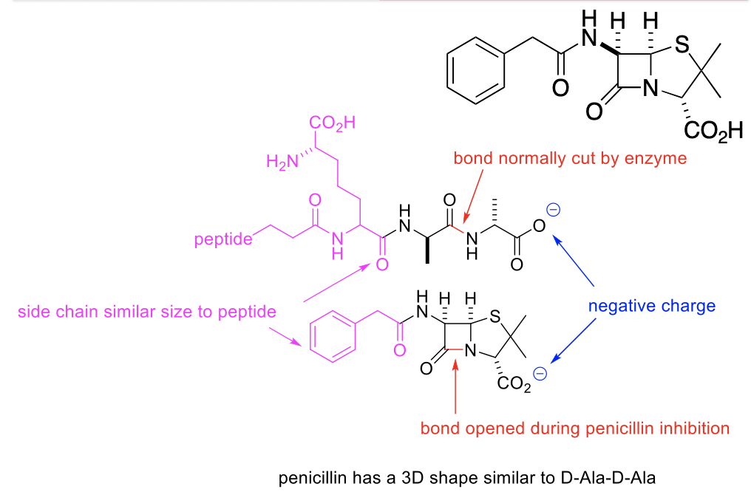

- Penicillin has a similar structure of D-ala-D-ala
- Carboxylic acid sits in the similar side to D-ala-D-ala
- Ring = beta lactam (cyclic amide group) = functional part of molecule, acylates enzyme
- Carboxylate group (CO2H) = @ pH 7.4, in its negative form = similar to D- Ala-D-Ala
- 3D shape of core is similar to D-Ala-D-Ala
- Side chain = benzene = looks like normal cross link piece

b-lactam carbonyl

o Difficult reaction to do
o Small ring is strained
o Easily opened
o Suicide enzyme inhibitors
o Drug terminates the enzyme

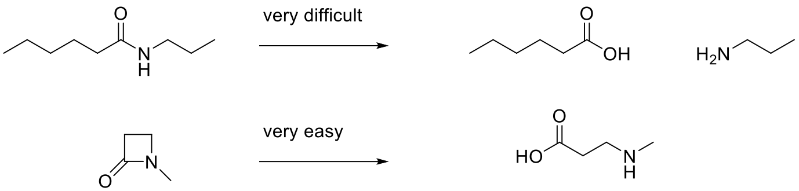

Penicillin G
- Isolated from mold
- Natural form
- It's a natural form of penicillin
  - Drug worked great in 1941 but rarely used IV because it is acid
sensitive
  - Only works with Gram positive bacteria
  - Doesn’t work in clinic because lots of bacteria have developed
resistance to the drug
- Natural version is no longer used as a drugàArtificial drugs are
largely used
  - Sensitive to acids (stomach is acidic) which will destroy the
drug (penicillin)
  - Gram positive bacteria is sensitive to the natural form of
penicillin

- Has 4 significant limitations as a drug
  - Acid sensitivity
  - Resistance
  - Spectrum of action
  - Bioavailability

1) Acid sensitivity
- Stomach environment is very acid
- Drug must be given by i.v. injection

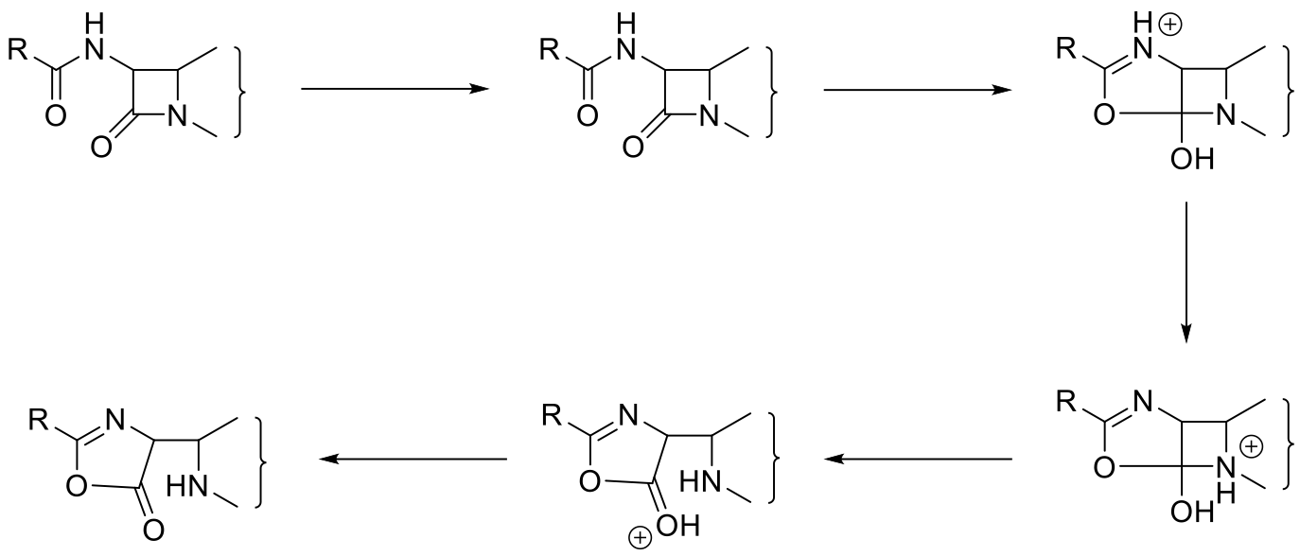

o The natural version of penicillin has to be given by IV because it will not last in the stomach (acid)
o Opens the ring (the ring is a functional part of the drug thus opening the ring renders the drug useless)
o Cannot take orally

Engineering for Acid Resistance

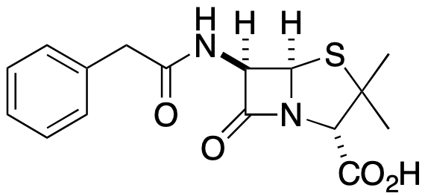
- Reengineer to bypass problems
- Protonated in stomach, if occurred on beta lactam, starts
- process of destruction (open ring)
- Therefore, original Penicillin G only available through IV

Engineering for Acid Resistance - heteroatoms

- Attach a hetero-atom
Engineering for Acid Resistance - charge

- Add a charge on the side chain by adding nitrogen à At pH < 11, the group will be protonated, and this will be positively charged.
  - Very strong EWG à Electron Withdrawing Group

Penicillin Semi-synthesis
- Penicillin “core” is very complex and difficult to synthesize
- Strategy
  - obtain the core from biological sources
  - use synthetic transformation to prepare new drug
  - Use synthetic transformation to prepare new drug
  - This part of the molecule is extremely complex à Too hard to make it
    - Grow large quantity and extract the penicillin G
  - Extract natural penicillin G and use synthetic transformation to make the artificial drug
  - How to engineer structure = penicillin semi synthesis
  - Many stereo genic centers
  - Obtain core from mold that makes penicillin G and then modify

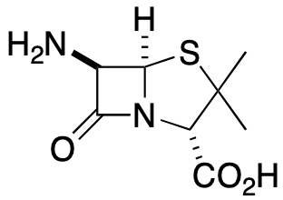

Biochemical preparation of 6-apa
- Grow penicillin mold
- Extract Penicillin G from mold
- Use amidase enzyme from E. coli to remove side chain
  - Modern versions have been optimized by genetic modification
- World-wide production over 20, 000 tons per year

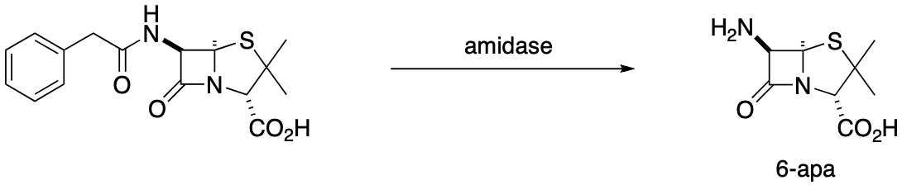

- Manufactured from natural penicillin G
- Most subject to degradation à Cut the side chain of the
- penicillin
- Very little is used clinically, amides can cut the side
- chain of the penicillin
- Semi-synthesis à Take something from the nature and
- synthesis it ( fix it / play with it) to obtain the desirable
- properties
- Most efficient way
- Natural Pen G = starting material that is processed

Creation of artificia
l drug
- Convert penicillin G into 6-APA
- Attach acyl group to NH₂ of 6-APA

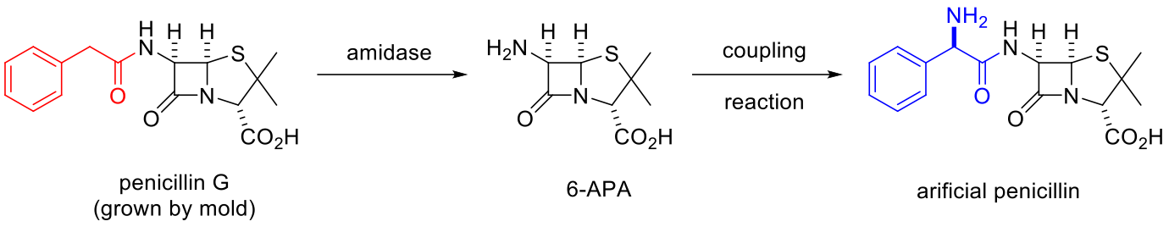

Peptide coupling reagents
- DCC

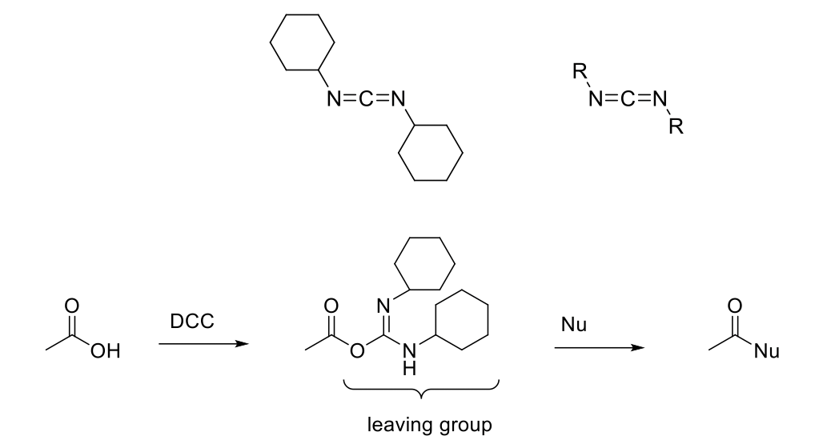

- End up coupling two components together (amine and acid component) à Formation of an amide bond
- Used to manufacture different penicillin o Acts as a dehydrating reagent
  - Removes H2O
- Used specifically for penicillin

2) Resistance
- Many bacteria develop resistance to penicillin
  - Mutations in transpeptidase
- Bacteria evolve ways to get rid of the drug
  - Actively transport out of cell
  - Destroy the drug
  - Bacteria protects themselves from penicillin by destroying it before it destroys them
  - Situation in which bacteria evolves to become immune to certain drugs àMechanisms to actively transport out of the cell or by destroying the drug
  - Bacteria developed resistance so are not affected
  - Cannot control basicity here due to not want to affect beta-lactam
  - Can reduce nucleophilic ability (electron pair donor)
  - Modify benzene ring into electron withdrawing group (charge, heteroatom)
  - Many bacteria develop resistance to penicillin
  - Bacteria develop strategies that allow them to survive
    - Mutate transpeptidase
    - Major way = get rid of drug
      - Pump drug out of cell (Actively transport out of cell)
      - Evolve enzymes that destroy drug before it reaches target (beta lactamase)

b-lactamase aka: Penicillinase
- Penicillinase

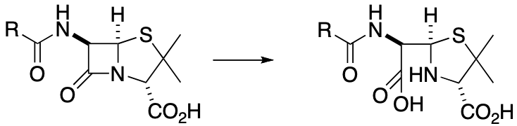
- Enzyme evolved to open b-lactam ring of penicillin
- Bacteria use transpeptidase to make cell walls and penicillinase to protect against penicillin
- First appeared in Staph. aureus in 1960’s
- First molecule works properly
- Second molecule does not work à The ring / cycle is opened
- Bacteria evolved an enzyme that destroys penicillin by opening the ring
- Bacteria produces both enzymes

Antibiotic resistance by b-lactamase

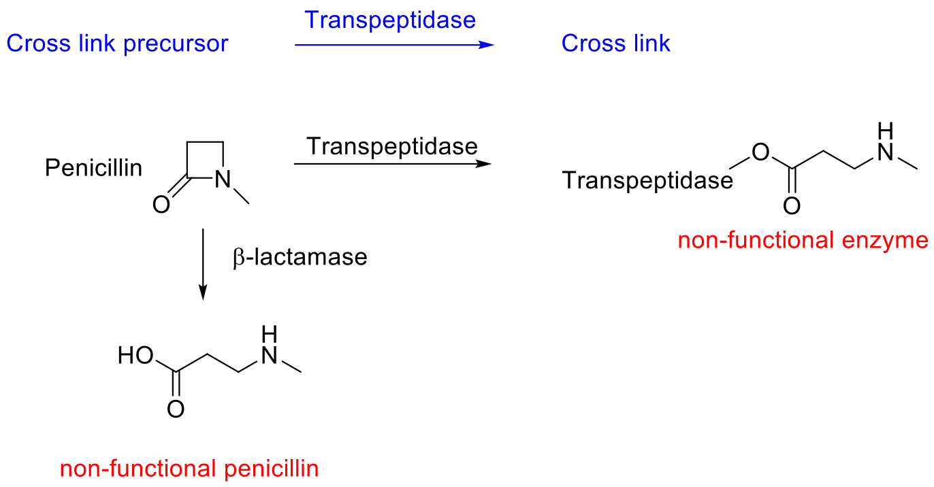

Regain activity using a “shield”
- Large substituted heterocycle

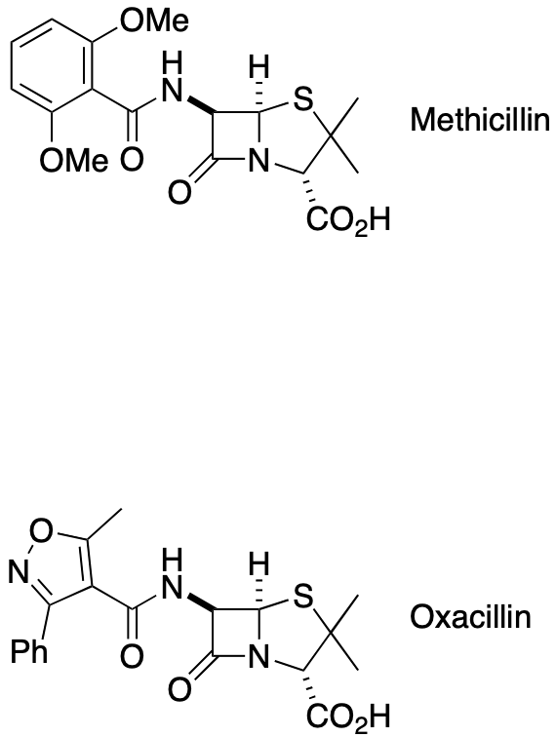

- Double bonds like to line themselves up with other double bonds à Aromatic ring becomes flat
- Changes when we put ortho groups on the aromatic ring which forces the group to change (90°)àThis changes the functions of the molecule
  - Taking something that is thin and making it large
  - It will no longer firs in the transpeptidase
- Aromatic ring at ortho position
- 3D structure hard to enter beta lactamase active site so it can enter active site of transpeptidase

“Shield” provides selectivity

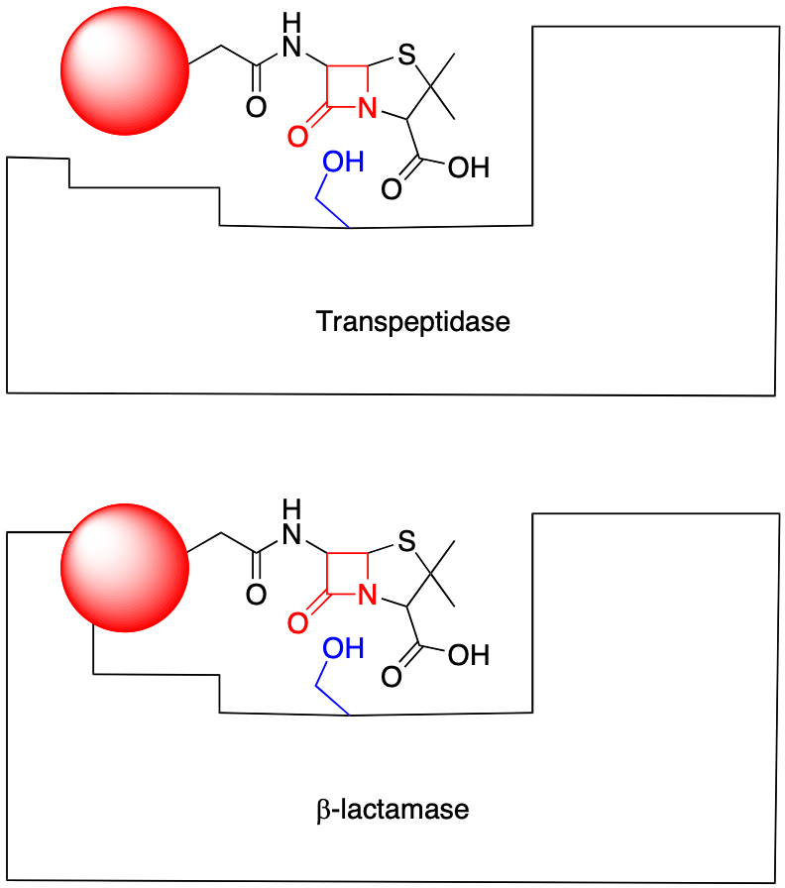

o Transpeptidase has a larger room to accommodate large groups
o Inhibits the production of the cell wall
o By adding groups, you can selectively choose what
enzyme it will bind with
o Transpeptidase has larger active site so drug can enter and prevent formation of cell wall
o Shield allows it to not fit into beta lactamase

3) Spectrum of Activity
- Two general types of bacteria
  - Gram positive
  - Gram negative
- Original penicillins were only active against gram positive strains
  - Narrow spectrum of activity
- Desirable to have activity against gram negative strains
- Increasing the spectrum thus making it possible to use for a wide range of bacteria
- Original penicillin only kills gram + bacteria

Gram positive vs. Gram negative

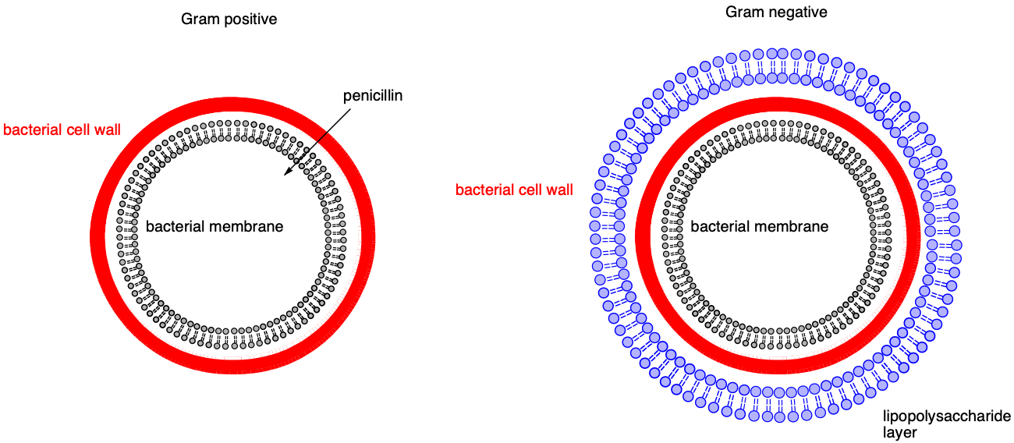

- Penicillin gets easy accessà Bacteria cells make a layer of lipopolysaccharide around the cell wall for protection against the drug
- Gram positive have a cell wall that’s more exposed than gram negative
- Gram negative has a LPS layer that adds more protection against penicillin
- Gram negative bacteria resist penicillin (can engineer structure to make it go through this kind of bacteria)
- Gram negative has another layer that surrounds cell wall (thick slime layer)
- Lipophilic environment that makes it difficult for drugs to penetrate (penicillin cannot go all the way through to access cell wall)

Branched groups on LHS

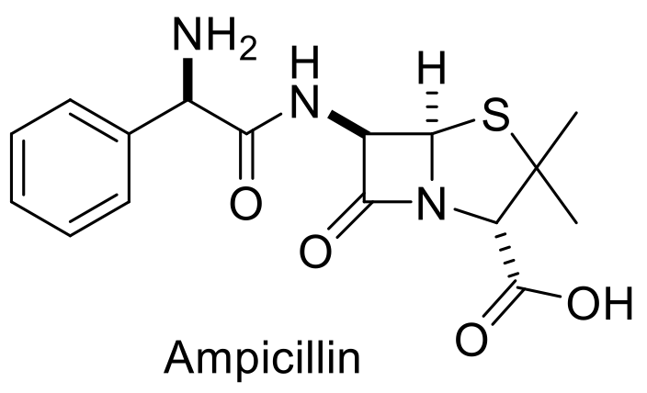

- Hydrophilic groups are shown on the left
- Hydrophilicity allows compounds to penetrate in the
- layer
- Adding hydrophilic groups on side chain, will allow it to go through better than adding lipophilic side chains

4) Bioavailability
- Some forms not very water soluble
  - Results in poor bioavailability (poor absorption from intestine)
  - Need to improve water solubility

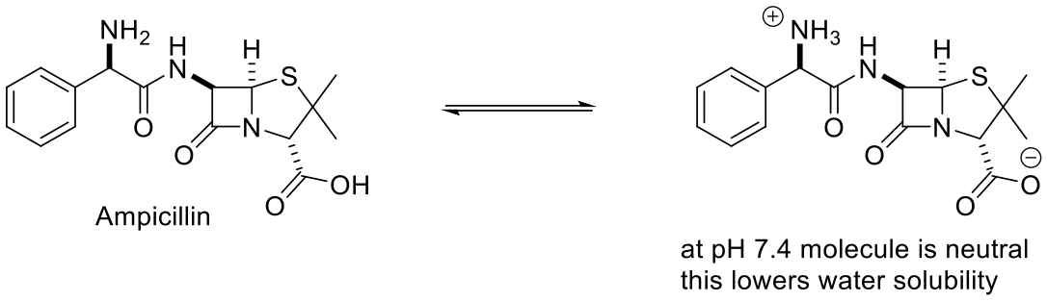

- Drug needs to be charged positive or negative in order to get into the body
- At pH 7.4, positive and negative charges cancel out à Lowering its solubility
- Some drugs don’t get into the body very well
- Ampicillin is water soluble but it’s neutral and almost insoluble at physiological pH
- Engineer drugs that will penetrate much better (only small % makes it to actual site)
- Ampicillin = charge = 0 = neutral, therefore reduced water solubility
- Impairs ability to travel and get absorbed into body

Charge and solubility

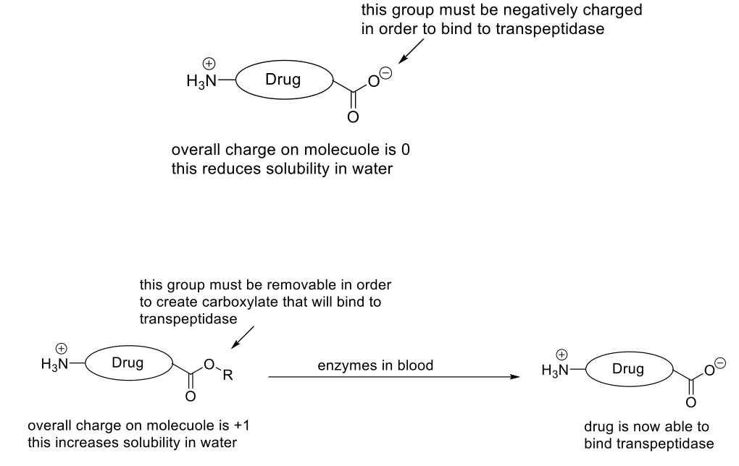

Prodrugs
- Add removable group to a drug to improve absorption into the body
- Once in the blood, this group is removed to deliver the drug in active form

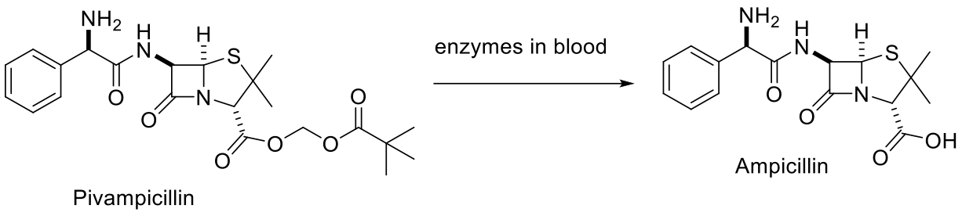
- Add a removable group so that the overall charge is +1 which has a high solubility
- The group must be removable to bind to the enzyme
- Leave one side of molecule alone
- Add removable group onto negatively charged oxygen
- Removable because need CO2- group to inhibit
- transpeptidase (recognition element)

Prodrugs

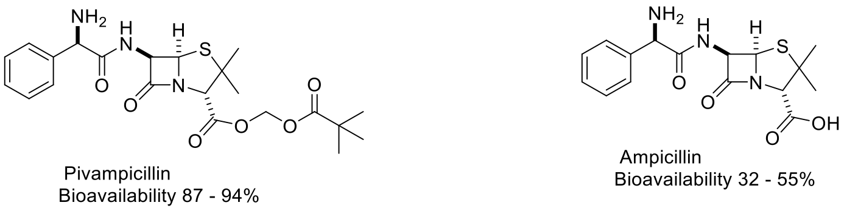

- Inactive to active form
- Enzyme in the blood will remove the added group
- therefore taking the inactive drug and activating it à Administer something that you know the body will convert to something else
- Add removable group to a drug to improve absorption into the body = prodrug
- Once in the blood, this group is removed to deliver the drug in active form
- Prodrugs = once drug is in the body, rely on chemical reaction in body to remove removable group so active drug can act
- Enzyme has nucleophilic group that attacks carboxylic group
- Improves bioavailability

Cephalosporins
- Cephalosporin
  - Discovered 1948
  - Fungus growing in an Italian sewer

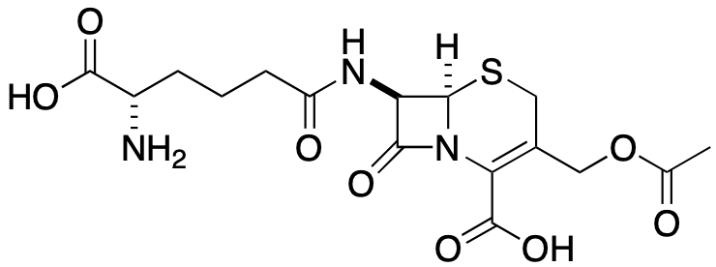

- Cephalosporins are antibiotics discovered shortly after penicillin
- Engineering these compounds creates artificial compounds

Advantages
- Lipophilic – broad spectrum
- [4,6] ring system less reactive than [4,5]
  - Activity against resistant strains
  - Less risk of allergy

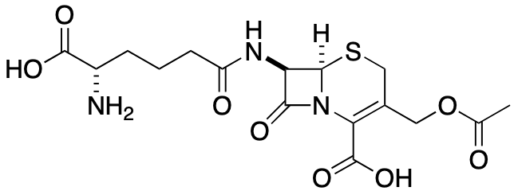
- Broad spectrum of action à Works on gram positive and gram negative
- Has a different ring structure than penicillin à Less risk of allergy but
- less reactive than penicillin
- Weaker but also contains beta lactam ring

Disadvantages
- Not orally active
- Low potency (larger doses)

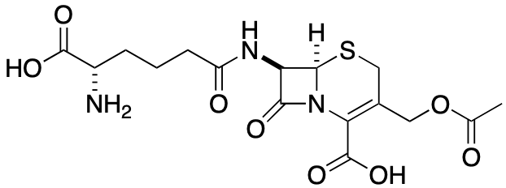
- Use Semi-synthesis to improve properties

Semi synthesis

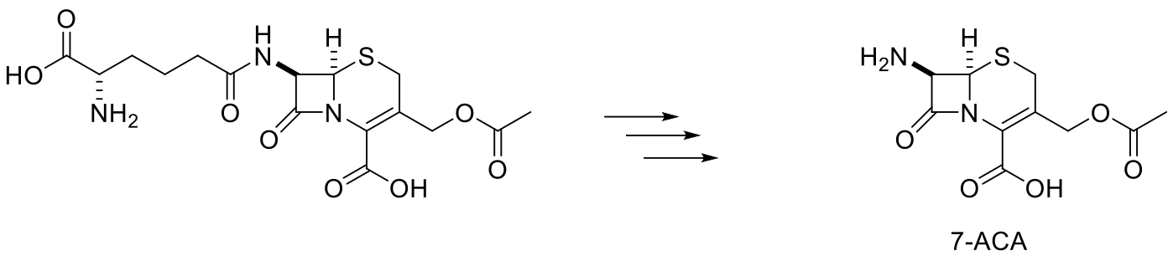
- Transfer it to 7-ACA
- Use the same mechanism you would to "tune" penicillin
- ACA = raw material to create whatever type of cephalosporin you want

Modify properties

- 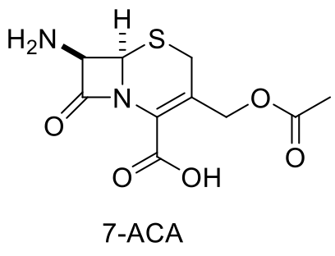

- Attach a side chain that does the same thingàAcidity, resistance, bioavailability
  - Add “decorations” to make it work the way you want it to
- Same types of changes made to penicillin

Clavulanic Acid
- Discovered in 1976
  - Streptomyces clavuligerus
- Not an antibiotic
  - Does not inhibit transpeptidase
  - Does not kill bacteria

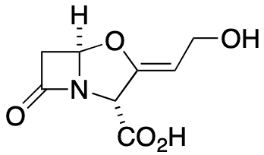

- Useful chemical compounds to use for beta lactamase
- Produced by species of yeast
- Used with types of penicillin to make it work better
- Given in combination with antibiotic that does not work anymore

Bacteria uses b-lactamase to destroy antibiotics

- Secrete another enzyme for the B-lactamase
- B-lactamase has the ability to interact with drug and destroy the ring à Destroys the ability of drug
- Substrate for beta lactamase
- Beta lactam ring opens and we no longer have functional antibiotic
- Clavulanic acid is inhibitor of beta lactamase
- Use this as a way of regaining function of older penicillin

Clavulanic Acid destroys b-lactamase

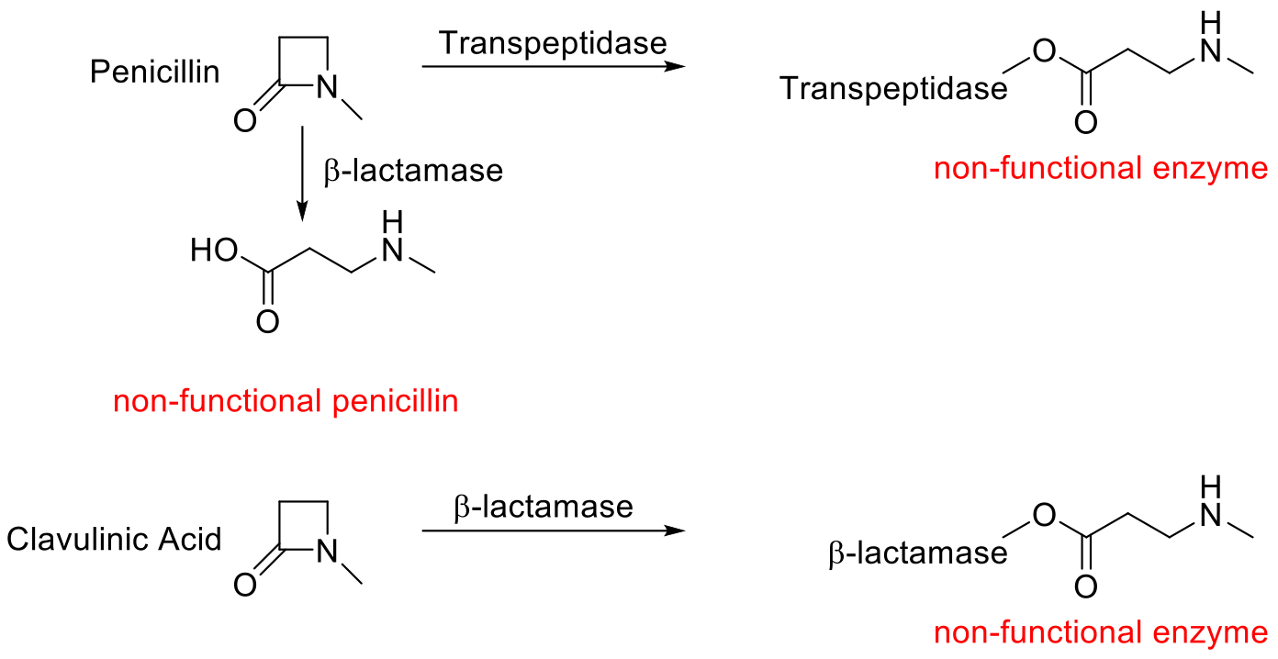

- Has a different chemical structure that destroys B-lactamase in the same way that penicillin destroys transpeptidase
- Restore activity of the drug with clavulanic acid à The old antibiotic kills the bacteria but clavulanic acid helps the old antibiotic to work (reverse the resistance)
- Beta lactamase is a serine protease (catalytic triad)
- Active site is covered
- Permanent inhibition

Clinical use
- Use in combination with b-lactam that is sensitive to b-lactamase
- Clavulinic acid
  - Inhibits b-lactamase
  - “protects” the antibiotic from the resistance enzyme
- b-lactam antibiotic à Penicillin
  - Inhibits transpeptidase
  - Kills bacteria

Clinical use

Selectivity for b-Lactamase

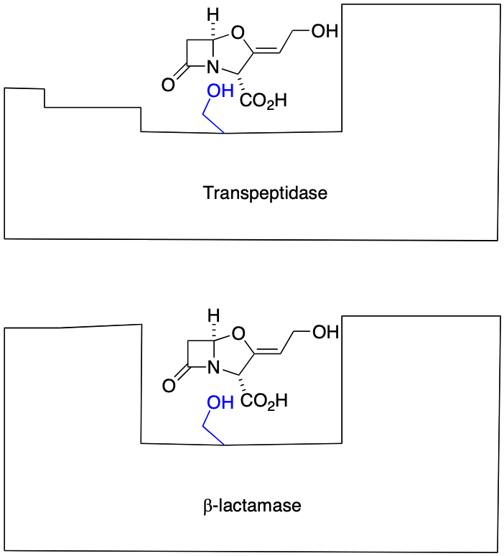
- Transpeptidase cannot revive the drug that no longer works àBy blocking the production of the enzyme making it a poor fit
- B-lactamase will be able to revive the drug
- Give in combination with the antibiotic
- Inhibition by clavulanic acid
- Because there is no side chain

Drug-drug interactions
- One drug changes the bioavailability of another
  - Most common type of drug-drug interaction
- Clavulanic acid restores the activity
- We do not want a drug to interact with another drugàCan change the bioavailability of the drug
- Clavulanic acid increases bioavailability of penicillin by shutting down mechanism of resistance

Grapefruit inhibits liver function

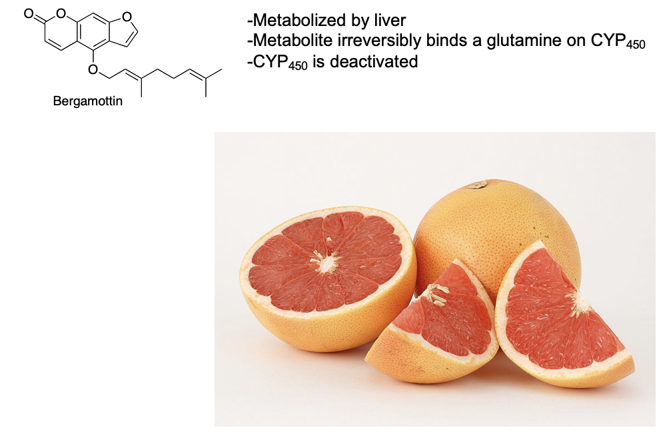

- Bergamottin (found in grapefruit) causes drug-drug interactions
  - Stop serving grapefruit in hospitals because bergamottin will cause them to overdose on the medications being processed in the liver à By deactivating CYP450, which causes the liver to absorb more of the other drug you are taking (overdose)
- Drug-food interaction à Can cause overdoses

Vancomycin discovered 1956
- Streptomyces orientalis
- Glycopeptide drug
  - Sugars (glycol)
  - Short protein (peptide) containing 7 amino acids
- Aromatic rings on peptide are linked forming a bowl-shaped structure
- Penicillin was more effective than vancomycin (back in the day), now
vancomycin is the drug of last resort à To cure infections that other
drugs no longer can cure
- "Last ditch" drug
- Fewest resistant bacteria against it

Complex three dimensional structure

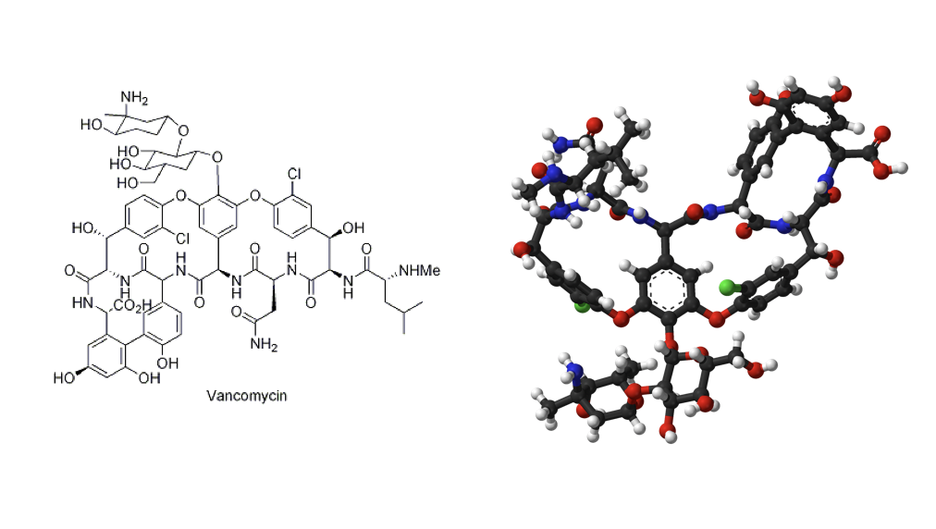

- Complex molecular structure
Forms a bowl shape structure (3D) because of the ortho groups
- 3D structure allows it to react with D-Ala-D-Ala
- Groove allows it to capture tail of D-Ala-D-Ala in cross link
Prevents cell wall cross linking by novel mechanism
- Binds very strongly to D-Ala-D-Ala tail of peptide chains
- Prevents transpeptidase from binding

- Enzyme inhibitor àActs by INHIBITING THE SUBSTRATE
- Same process as penicillin but in a different way à Doesn't bind to
enzyme, it binds to the tail-end of the cross-link precursor

Enzyme inhibition by substrate binding

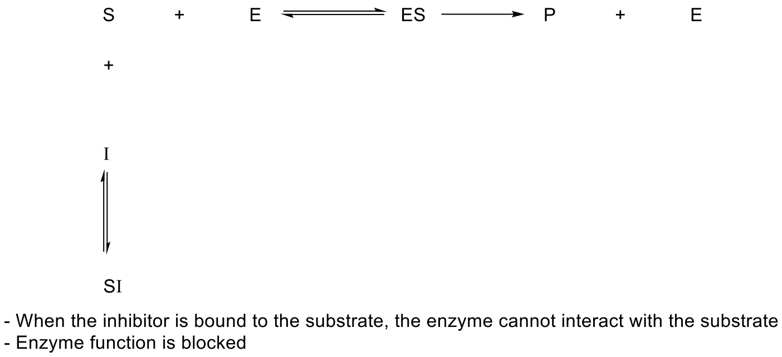

Vancomycin not widely used
- Considered a drug of last resort
- Used for infections with bacteria that are resistant to other antibiotics
- Works only on gram positive bacteria
  - Large molecule
  - Not lipophilic enough to cross lipopolysaccharide
- Binds to the substrate not the enzyme
  - It gives the same result as if it was to bind to the enzyme
- Hold it in reserve when other antibiotics don't work

Timeline of Discovery for antibiotic classes

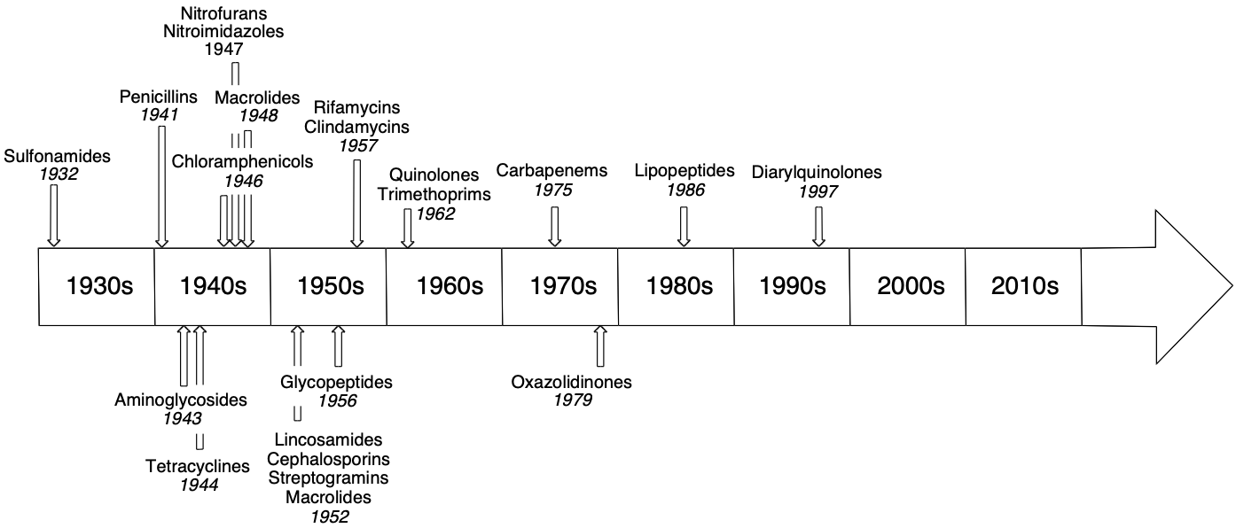

- No new class of antibiotics has been discovered since 1997
- 1990: Shut off all the businesses devoted to discovering new antibiotics
- No antibiotic research because there is no money to be made
- Can not justify expenditure on antibiotic that will not be used

Modern antibiotic research
- Very limited
  - Academic and small company only
- Antibiotics too cheap and readily available
  - New drugs will not make money
  - New drugs not likely to be used by doctors

- Can’t make money in the industry to make antibiotics because old antibiotics still work and are cheaper à No one will buy the newer and more expensive antibiotics when the cheaper and older ones still work efficiently
- At some point, there will be resistance crisis

