CHM2123 – Organic Chemistry II Lab – Final Exam Review

EXPERIMENT 1 – SEPARATION AND PURIFICATION OF NATURAL PRODUCTS
TLC
- TLC plate is a polar silica gel, usually placed into a development jar filled with a relatively non-polar solvent (ex, 60:40 hexanes:ethyl acetate)
- Compound is spotted onto the TLC plate with a capillary tube onto the TLC plate. Lanes that the compounds are spotted to depend on what you want to observe (extent of reaction, purity of sample, determination of unknown product).
- UV light must be used before placed into the development jar to check if compounds have been spotted correctly.
- The purpose of the non-polar solvent, is to un-adhere the compound from the silica gel and transport it a certain length up the silica gel.
- The ability of the solvent to do so depends on the compound spotted. If the compound is mainly non-polar, and can’t form hydrogen bonds to the silica gel the non-polar solvent will be a preferred medium for the compound to interact with, and it will move it further up the plate. IF the compound is mainly polar, and forms one or more hydrogen bonds to the silica gel, the non-polar solvent won’t be able to un-adhere the compound as easily and the compound will remain mostly stationary near the bottom of the plate.
- A pure substance must show as ONE individual spot on a TLC plate.
Retention Factor: Rf
- A calculation (ratio) that shows the relative = distance spot has travelled/distance the solvent line has travelled.
- This is an area of source of error as many mistakes include: improper measurements and improper indication of solvent front.
- Lower Rf values have more polar functional groups
- Higher Rf values have more non-polar functional groups.
- Must be careful about observing Rf values since every compound has a different Rf value.
- If there is one hydrogen bond to the silica gel, but the compound contains a long hydrocarbon chain, the Rf may be shown as higher than if the hydrocarbon chain was smaller.
- The number of hydrogen bonds also makes a difference. A hydroxyl group can form two hydrogen bonds; oxygen is dipole negative and hydrogen is dipole positive hydrogen bond to corresponding hydrogens and oxygens on silica gel. An aldehyde group can form only one; only the oxygen is dipole negative, the hydrogen is not. An aldehyde will show up higher on the TLC plate than alcohol.
- 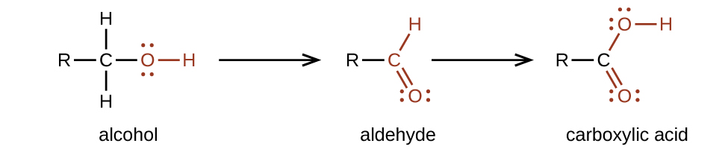
- When creating the solvent system for a TLC plate analysis, the desired Rf value for the target compound is ~ 0.3.
- Increasing solvent polarity will increase the Rf values of all compounds moderately polar compounds have a greater attraction to the mobile phase now.
- A co-spot may be useful if the event that the starting material and final compound have very close Rf values. The co-spot is a lane where both compounds are spotted. The dots displayed will show stretched due to the slightest Rf value difference, helping visualize if the final product is indeed the final product.
Creating the Solvent System
- Start with a NON-POLAR solvent such as hexanes
- Slowly increase ratio of POLAR solvent such as ethyl acetate
- Make sure target compound’s Rf value is approximately 0.3
Distinguishing Polarity
- The more heteroatoms with acidic protons, the more polar the compound is.
Practical Stuff
- The TLC plate needs to stand as vertically as possible.
- Solvent must start at the base line (solvent front), and plate must be removed when solvent reaches top
- Ratio of solvents is best added up to 10.
- Additional Note
- The higher the non-polar solvent in the system, the slower the spots would migrate. Therefore, increasing the ratio of polar solvent to non-polar solvent will allow the spots to move up higher.

EXTRACTION
- When drawing an extraction, include ALL and EVERY compound in the reaction mixture. This include solvents, starting materials and product.
- Don’t draw the structure of solvents, instead indicate them along the arrow(s)
- ‘Trace H₂O” in organic layer after first extraction
- See pages at the end of the notes for detailed scenarios of extractions and the steps to complete the extraction
- Usually, extractions start with a protonation or deprotonation.
- This will result in a charged species will reside in the aqueous phase.
- Useful in order to dissolve undesired compounds into a different layer than desired compound
- The main concept is that compounds are separated into two immiscible solvents based on their relative polarities and solubilities of the solvents.
- Organic Phase non-polar compounds
- Aqueous Phase (H2O) polar compounds
- When mixed together, the organic phase is usually on top of water, since the density of most organic solvents is less than water. Exceptions: chloroform and dichloromethane halogenated solvents (halogens molar mass is high, which increases their density)
Extraction vs. Washing
Extraction: Transferring desired compound from one phase to another based on polarity
Washing: removes impurities from the phase containing desired compound
- Emulsion
- The dispersion/suspension of tiny droplets of a liquid in another liquid, where the 2 liquids are immiscible
- Forms a brown turbid phase – unwanted emulsion; so add 10mL of DCM.
- Instead of using a weak base or acid to do a certain deprotonation or protonation, consider using a lower concentration of a strong acid or base to achieve the same goal.
- When an acid or base has a percent density that is very small, we know it is dissolved in water approximate its density.
- Method to test which layer is which?
- Add a drop of water it will move to aqueous solvent.
- Brine: a concentrated aqueous solution of sodium chloride
- Washes the organic layer to remove large amounts of water that may still be dissolved. It draws out the water from the organic phase and transfers them into the aqueous phase.
- Salting Out Effect
- Used to induce precipitation of a compound by saturating the solution with salt ions and reducing the solubility of the ionic or polar compound
- Water is tightly occupied by dissolved ions in solution less capable of dissolving other ionic or polar compounds.
- Dielectric constant of salts makes them hard to dissolve in organic solvents.
- Drying Agents
- Na₂SO₄ removes trace amounts of water from organic solutions by forming hydrates. Addition of the drying agent forms clumps of hydrates, so we add until no more clumps form.

SUBLIMATION
- Purification method that uses sublimation and recrystallization
- Solid volatizes to gas form and condenses on the cold finger apparatus to form crystals isolate by scraping the cold finger
- Liquid and impurities remain at the bottom; useful when compound sublimes and impurities do not
- Good for small scale purification. So, if you have a small amount of crude product.
- Compound needs to have a higher vapour pressure, higher volatility and needs to sublime near room T°.
- Sublimation in the laboratory can be accomplished using an apparatus called a ‘cold finger’. A cold finger, or test tube typically filled with dry ice, sits in a side-arm flask containing a loose, crude solid. As the flask is heated, molecules vapourize and condense as fine crystals on the surface of the cold finger, optimally positioned about 1 cm above the base of the flask. Applying reduced pressure can speed up the process.

SPECIFIC TO THIS LAB
- Addition of Na₂CO₃ during extraction Na₂CO₃ is slightly basic; added to deprotonate the OH groups on the catechins/tannins/polyphenols to move them into the aqueous phase.
- Caffeine is resistant to deprotonation because it is very basic.
- Pigments in leaves
- Caffeine is soluble in DCM
- HCl: Strong acid which displaces the porphyrin ring resulting in the conversion of chlorophyll to pheophytin
- Addition of Na2CO3 to extraction caused tannins to become surfactants
- Surfactants decrease surface tension between two liquids, and cause water insoluble compounds to mix, forming the emulsion
- Possible impurities
- Tannins, polyphenols etc..

EXPERIMENT 2 – THE KINETIC STUDY OF NUCLEOPHILIC SUBSTITUTION
KINETICS
- Possible way to optimize yield observe kinetics of reaction postulate a mechanism fine tune to optimize yield.
- Observed by rate of disappearance of reactants or rate of formation of product.
- For a simple reaction: A + B C + D
- The rate of the reaction is given by:

$$r=k{\left[A\right]}^{x}{\left[B\right]}^{y}$$

- [A] and [B] represents the concentrations of the reactants. X and y are constants that represent the order of the reaction with respect to each reactant. These are determined experimentally and the sum of these powers determine overall order of the reaction. K is the rate constant of the reaction, depending on experimental conditions.
Zero Order Reactions
- These reactions are very uncommon. Usually a reaction is zero order w.r.t. one reactant but a higher order w.r.t. another.
- Meaning that the formation of products can be NOT AT ALL dependant on the concentration of one of the starting materials and be ONLY dependant on the concentration of the other starting material.
- The function of [reactants]/ time, is linear and with a slope of – k (rate constant)
- Units of k: Ms⁻¹
First Order Reactions
- The following function is linear:

$${\ln\left[A\right]}_{t}=-kt+{\ln\left[A\right]}_{0}$$

- Where [A]₀ represents the initial concentration of the reactant and [A]_{t} represents the concentration of A at a particular time t. This is the equation that gives a linear function with slope = - k.
- Units of k: s⁻¹
- Second Order Reactions
- Two cases: the formation of products depends on the concentration of both reactants first order with respect to each of the two reactants…. OR … second order with respect to one reactant and zero order with respect to another.
- The following function is linear:

$$\frac{1}{{\left[A\right]}_{t}}= kt+\frac{1}{{\left[A\right]}_{0}}$$
- Units of k: M⁻¹s⁻¹

Summary Table
 | Zero Order | First Order | Second Order
Rate Law | -k | -k[A] | -k[A]²
Rate Equation | [A]=[A]₀ – kt | [A] = [A]₀e ^{-kt}  ln[A]_{t} = ln[A]₀ – kt | $$\frac{1}{{\left[A\right]}_{t}}= kt+\frac{1}{{\left[A\right]}_{0}}$$
Units of k | Ms⁻¹ | s⁻¹ | M⁻¹s⁻¹
Linear Plot to Determine k | [A] vs. t | ln[A] vs. t | $\frac{1}{[A]}$ vs. t
Units of Rate Law | Ms⁻¹ | Ms⁻¹ | Ms⁻¹

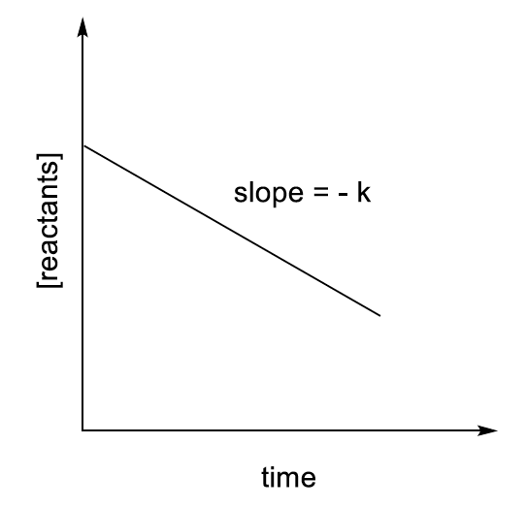 | 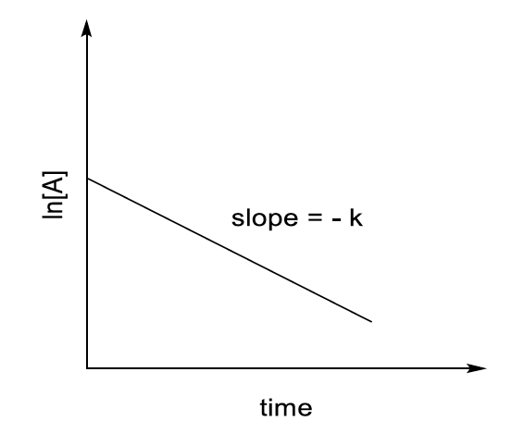 | 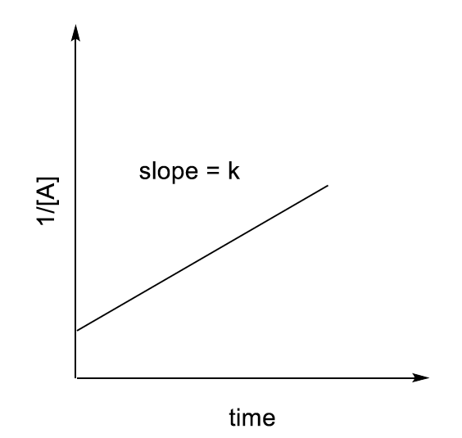
Zero Order Reaction | First Order Reaction | Second Order Reaction

SUBSTITUTION REACTIONS
SN2 REACTION
- Bimolecular substitution reaction nucleophile attacks electrophile BEFORE departure of leaving group.
- This means the order of the reaction is SECOND ORDER.
- Concerted reaction attack of the nucleophile and the departure of the leaving group OCCUR AT THE SAME TIME.
- General Reaction:

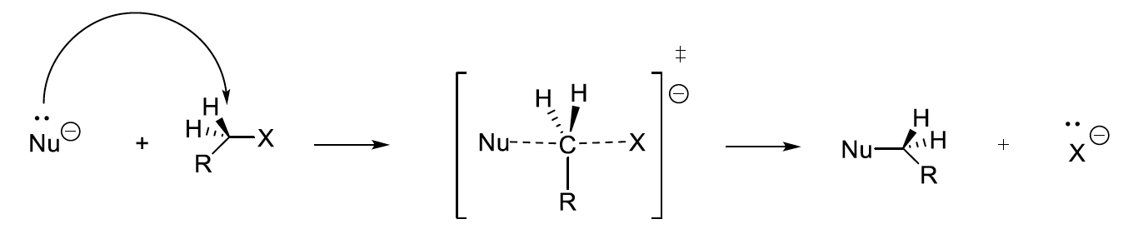
- Don’t forget to write the transition state with the appropriate superscript, charge and brackets.

SN1 REACTION
- Unimolecular substitution reaction nucleophile attacks electrophile AFTER departure of leaving group.
- This means the order of the reaction is FIRST ORDER.
- Zero order with respect to the NUCLEOPHILE.
- Reaction proceeds through a carbocation intermediate and is NOT concerted.
- General Mechanism:

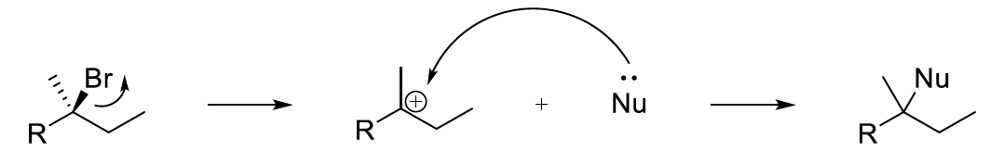

- This reaction gives a racemic mixture, depending on which face the nucleophile attacks (different stereochemistry).
- Consider the possibility that the solvent (e.g. EtOH) can undergo a substitution reaction with the starting material.

SN1 vs. SN2
- Best way to examine the mechanism for a substitution reaction is to examine the α-carbon.
- Primary α carbons Always prefer SN2 REACTIONS. Carbocation formed in SN1 would be too unstable.
- Tertiary α carbons Always prefer SN1 REACTIONS. Transition state formed in SN2 would be too crowded and access to α carbon is less. Also, a tertiary carbocation is VERY stable.
- Secondary α carbons Can go either way based on the solvent, nucleophile etc.
- Nucleophile
- In SN2 Reactions: stronger nucleophiles are formed when the nucleophilic atom has less of a hold on its electrons (meaning it prefers forming a bond with another atom).
- Increased atomic radius, decreased electronegativity.
- SN1 rate does not depend on the nucleophile so increasing its strength would have no effect.
Leaving Group
- Increase the polarization of the carbon leaving group bond, decrease E_{a} and thus increase the overall rate of reaction.
- Larger LG’s, resonance stabilized, possessing strong electron-withdrawing groups are faster to depart. They are weak bases on their own (conjugate acid is SUPER STRONG). They can easily stabilize their own negative charge when they leave.
- Bigger atomic size= more polarizable (delocalize charge therefore increasing stability= faster reaction)
- Order of stability of LG (most to least): I, Br, Cl, F

K – RATE CONSTANT
- Greater than 1= favours products
- Less than 1= favours reactants
- K value is temperature dependent (higher temp = higher K value and faster rate of reaction)

NUCLEOPHILES
- Good nucleophiles are stronger than their conjugate acids. (Tend to be strong bases SOMETIMES)
- Nucleophilicity increases DOWN the periodic table The atom increases in size and radius makes the valence electrons less tightly attracted to the nucleus “want to form a new bond”
- Special Case: I⁻ is only more nucleophilic in POLAR solvents. Br⁻ even though lower up in the periodic table (smaller size), is more nucleophilic in NONPOLAR solvents.

RESULTS
Effect of Solvent on Rate of Reaction and type of substitution reaction
- 70:30 has less protic solvent molecules present
- 85:15 water: acetone has more water (more protic solvent molecules present)
- Reaction occurs faster in this solvent because the polar water molecules help stabilize the transition state of this SN1 reaction (tertiary C+) and also stabilizes the leaving group (Cl-)
- Increases rate of reaction
- Note: SN1 reaction rates theoretically only depend on the concentration of the electrophile, but this case is special and this reaction is also dependent on solvent
Effect of leaving group
- A larger atom is a more stable leaving group as it can better stabilize its negative charge
- Br is a better leaving group than Cl
- When Br is a leaving group, the reaction occurs faster and the rate constant is higher

SN1 | SN2
Weak nucleophile (H2O) | Strong Nucleophile
Protic solvent | Aprotic* solvent
2,3 | 1,2
Racemic products | Good LG
First order | Second order
*acetone is the aprotic solvent used in this experiment*

SPECIFICS IN THE LAB

Phenolphthalein
- Added to monitor the reaction; more reflux= less HCL needed
- Pink= basic condition
- Clear= acidic

Bromothymol blue
- Turns blue when basic
- Green when neutral
- Yellow when acidic
KOH role in this experiment – nucleophile.
  - Allows a colour change to signify the end of the reaction HCl is a byproduct of the reaction and neutralizes the remaining -OH (Part B) in the reaction mixture
    - Used calculate how much tBuCl was used in the reaction
  - Indicator is basic initially (base) and turns green when the reaction is complete (neutral).

Water: a protic solvent
- Speeds up the reaction; more water present= faster reaction
- Forms H bonds with the leaving group, shifts electron density, and weakens Cl bond
- Helps push off the leaving group and HCl is generated thus creating an acidic environment (yellow)
- Acts as a weak nucleophile (SN1)
NaOH
- Neutralize HCl
- Base

EXPERIMENT 3: COMPETITION STUDIES OF SUBSTITUTION AND ELIMINATION REACTIONS

CONVERSION AND SELECTIVITY
- When proceeding a reaction, there is a possibility that two reaction pathways compete for the formation of the final product.
- E.g. SN2 versus E2 Reaction

A + B C
A + B D

- Conversion – represents the ratio of all products produced to the total that COULD have been produced. Kind of like a yield but for both the E2 and SN2 products overall

$$Conversion=\frac{n_{C}+n_{D}}{n_{limiting reagent}}×100\%$$

- Selectivity – represents the ratio of the desired product (E2 or SN2) among the products formed

$Selectivity\left(C\right)=\frac{n_{C}}{n_{C}+n_{D}}×100\%$ $Selectivity\left(D\right)=\frac{n_{D}}{n_{C}+n_{D}}×100\%$

ELIMINATION REACTIONS
- Strong base deprotonates a hydrogen (beta hydrogen) adjacent to the alpha-carbon, allowing the electrons from the C-H bond to attack the alpha-carbon. Leaving group leaves and a new alkene bond is formed.

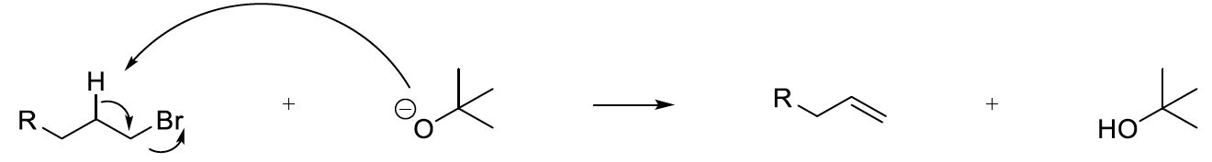

- E1 Reaction
- RDS formation of carbocation since LG leaves before nucleophilic attack, followed by the β-hydride elimination to create the alkene.
- E2 Reaction
- Bimolecular and concerted reaction occurs in a single step.
- H must be anti-periplanar to the leaving group
- For all elimination reactions, consider the E/Z isomers of the elimination product and as well the minor product (where the less stable alkene forms) All 3 are possible to show up on a TLC plate (the E/Z isomers are likely to have VERY similar Rf values)
- Elimination reactions are preferred when heat is present.

COMPETITION
- Elimination reactions require strong bases, and substitution reactions require strong nucleophiles.
- PROBLEM bases can also be nucleophiles reason for competition
- Choosing the base/nucleophile in right strengths for each role can allow for one pathway to be favoured, and yield more product.
- Can vary the electrophile as well.
- Methyl SN2 > E2
- Anti-periplanar β-hydrogen to LG E2 > SN2
- Secondary α – carbons, and anionic nucleophile E2 > SN2
- Tertiary α – carbons ONLY E2
Summary Table
R – X | Nucleophile;Base Strength
R – X | Strong;Strong | Strong;Weak | Weak;Strong | Weak;Weak
Methyl | SN2 | SN2 |  | -
Primary | SN2 | SN2 | E2 | -
Secondary | E2 | SN2 | E2 | SN1/E1
Tertiary | E2 | - | E2 | SN1/E1

Nucleophiles;Bases
- Strong;Strong OH-, OR- (non-bulky), NR₂- (non-bulky)
- Strong;Weak RCOO-, I-, N₃-, CN-, RS-, RNH₂-, RSH
- Weak;Strong bulky OR-, bulky NR₂-, H-
- Weak;Weak H₂O, ROH, RCOOH

- To favour E2, use a bulky base less likely to act as a nucleophile.

- Solvent
- Usually has more of an effect when the electrophile is a secondary α-carbon and the nucleophile has been determined i.e. if there is still a chance that there is high competition.
- Polar aprotic solvent: SN > E
- Temperature Increase: E > SN
- Activation energy of elimination reactions are higher than substitution reactions thus require ways to lower it like heat, to favour it.
- Optimal temperature is 60°C for the possibility and 70°C for favoured.

THE EXPERIMENT
- Pressure of the gas inside the eudiometer (alkene product)

$$P=P{}_{atm}-P_{water}-P*$$

- P_{atm} is the pressure of the atmosphere. P_{water} is the vapour pressure of water, which changes with the temperature of the room. P* is the pressure exerted by the height of the water column above the level of the water in the beaker
- This pressure can be determined with an easy conversion.

$$13.6 mm H_{2}O =1 mm Hg$$

- mm H2O represents the height of the water column above the level of water in the beaker
- Number of moles of gas can be determined
- Moles of KBr = moles butene (E2) + moles butanol (SN2)
- Purpose of letting KOH reflux – to make the reaction mixture at the right temperature (for the ones that required a specific temperature)
- Electrophile quickly added to reflux condenser, and thermometer adapter capped immediately to prevent gas product from escaping
- Must remove thermometer adapter immediately after turning off the heat source, to prevent backflow of water into the reaction mixture (due to a drop-in pressure in the reflex condenser)

RESULTS
- Reaction of 1-bromo with reflux favours SN2
- KOH is small strong base, and a strong nucleophile
- Electrophile has a primary alpha carbon = little steric hindrance
- Reaction of 1-bromo at 50 C favours SN2, and less E2 formed than in reflux setting
- Lower temperature than reflux setting in previous reaction favours SN2 more
- Reaction of 2-bromo with reflux favours E2 greatly
- 2-bromo has a secondary alpha carbon, which provides some steric hindrance, making SN2 less preferable
- E2 is thus favoured instead
- To favour SN2 in this reaction instead, you would have to reduce heat, and use a polar aprotic solvent (increases nucleophilicity)
- To favour E2 in this reaction, you would have to increase heat, and use a strong base

EXPERIMENT 4: BENZYLIDENE ACETALS AS A PROTECTING GROUP
CARBOHYDRATES
- Carbohydrates vital source of energy
- Glucose = animals
- Starch = plants
- Oligosaccharides and glycoconjugates shape of cells and organs. Structure and function via DNA, RNA, ATP and glycoproteins. Present on cell surfaces for cell recognition and signaling (by glycans)
- Glycans targets for carb-biding proteins and changes to it signal disease progression (inflammation and onset of cancer).
- Tumors produce unique carb sequences on their surfaces relative to healthy cells good way for diagnosis, vaccination and therapeutic remedies.
- Multichiral and multifunctional.
- Dissolving in aqueous base gives rise to ketoenol tautomerization leading to isomerization.
- Protecting groups prevent this reaction. Ex. acetals.

ACETALS
- Acetals protect alcohols, aldehydes, and ketones from being reduced, undergoing nucleophilic additions, or reacting with bases
- Acetals are stable to nucleophiles because they do not have a good leaving group for an SN2. They are stable to bases as well because they do not have a proton that a base can remove.
- Aldehydes and ketones WILL REACT (reversibly) with alcohols + acid cat. to give ACETALS.
- Carbon bound to to alkoxy groups (OR).
- Hemiacetal – one alkoxy, one hydroxyl.
- Intermediate between aldehyde/ketone, and an acetal
- e.g. glucose (cyclic and acyclic) coexist in equilibrium. Two cyclic forms: α (axial position of OH group) and β (equatorial position of OH group).
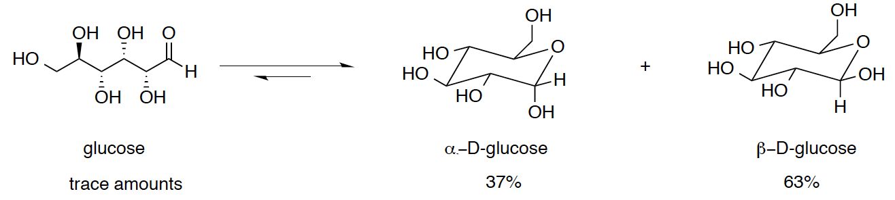
- Aldehyde or ketone can be regenerated by addition of excess water and acid.
- Preparation of a cyclic acetal
- Goal of THIS particular experiment. Add a benzylidene acetal to glucose form a protecting group at the c4 and c6 alcohol
- Solvent THF Why? easily removable solvent
- Acid catalyst 10-camphorsulfonic acid Why? ANHYDROUS. We need anhydrous conditions since we don’t want the protecting group formed to be converted back to its original functional group by water

MECHANISM OF FORMATION OF AN ACETAL – THIS SPECIFIC CASE
- Dimethyl acetal protonated by acid, forming oxonium ion which reacts with a hydroxyl on glucose to create a mixed acetal
- Proton transfers occur
- Methanol is eliminated and the newly formed oxonium ion reacts with another hydroxyl on glucose
- The major product has the phenyl group in an equatorial position which minimizes steric hindrance (thermodynamically favoured)
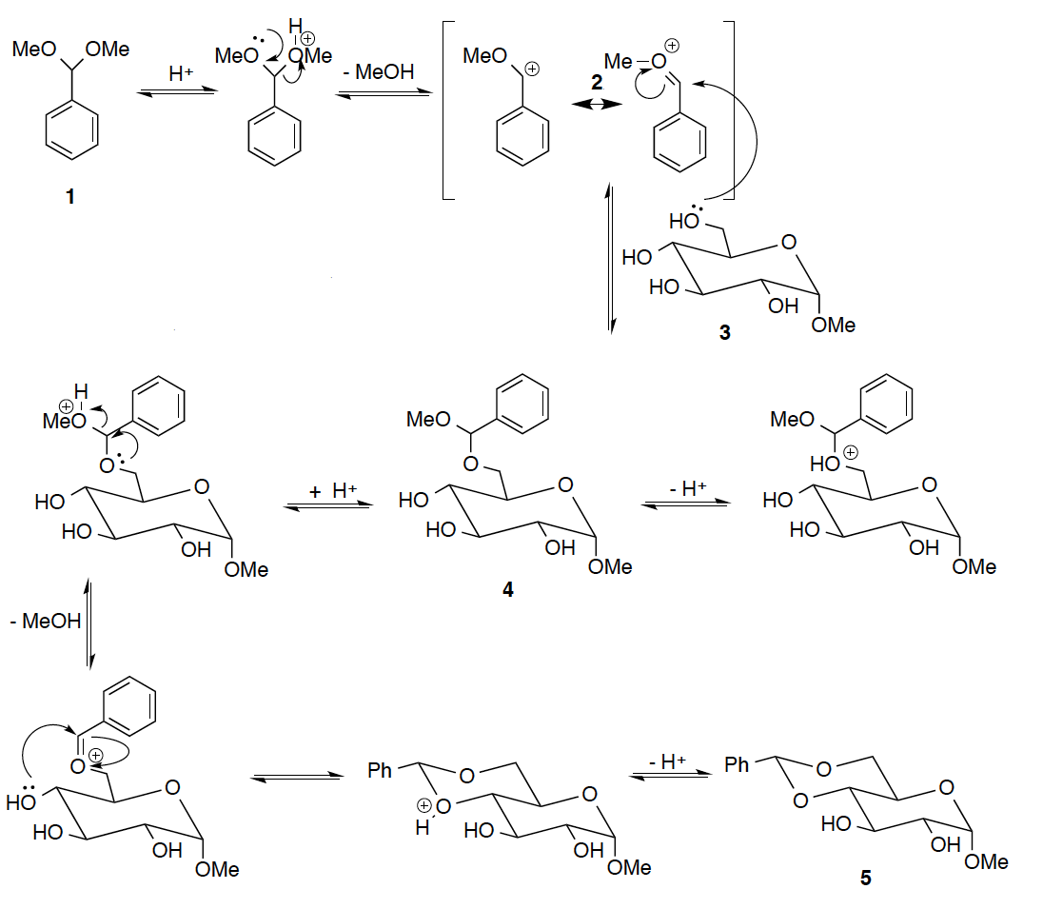

1 – Dimethyl acetal
2 – Oxonium ion
3 – Sugar – methyl-α-D-glucopyranoside
4 – Mixed acetal
5 – Final product - 4,6-O-benzylidene-α-D-glucopyranoside

Corrected mechanism for hydrolysis of benzilidene acetal – Refer to end of document.

REDUCING SUGARS
- Reducing sugars – contain FREE aldehyde or alpha-hydroxy-ketones. any sugar that contains a hemi-acetal as well.
- ALL monosaccharides, some disaccharides, oligosaccharides and polysaccharides.
- NOT sucrose
- Benedict’s Reagent – alkaline cupric citrate solution determine amount of reducing sugar in a sample.
- Contains Cu(II) which looks blue and oxidizes reducing sugars to enediols in presence of heat and base; the enediols reduce the Cu(II) to Cu2O, which looks red
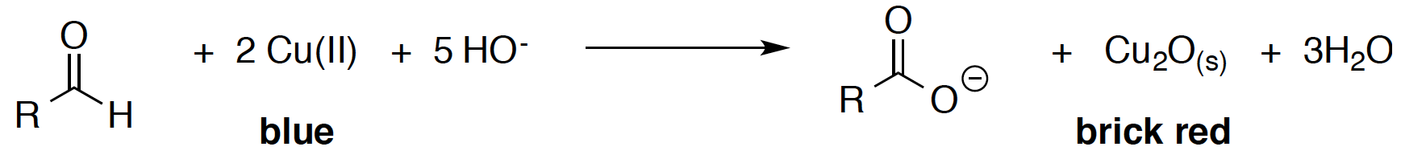
- Under heat: reducing sugars enediols (in presence of base); tautomerize to contain 2 OH groups
- Enediols reduce Cu(II) to Cu₂O.
- Brick red = high concentration of reducing sugar.
- Usually performed in a steam bath overall dispersion of heat

RESULTS OF PART B

Blue= no reducing sugars
- Sucrose (fructose and glucose)
Red= very high concentration of reducing sugars
- Glucose
- Coca cola
- Sucrose after the addition of HCl; HCl deprotonated sucrose, causing glycosidic bond between 2 monomers to break and glucose has reactive aldehydes
Green= minimal reducing sugars
- milk; lactose (glucose and galactose)
- when heated, the linear form of glucose and galactose reveals reactive aldehydes which reduce the Cu(II)
Orange= relatively high concentration of reducing sugars

MECHANISMS
- Make sure to draw all charges and lone pairs
- Make sure to include equilibrium arrows during acid/base reactions
- Make sure to specify the acid or base instead of basic H-A or A-

PRACTICAL STUFF

Methanolic Stain
- TLC plate analysis. Methanol dissolved in acid = acidic solution
- This solution protonates the oxygens on the carbohydrate
- Heat allows for the combustion of these oxygens to occur basically burning your sugar stains the TLC plate
- The reason it’s used is because glucose DOES NOT VISUALIZE under UV light and neither does the final product.
- Reaction that is happening

$$C_{6}H_{12}O_{6}+H_{2}S{O4}^{+}→6C+6H_{2}O+acid$$

- H₂SO4⁺ - any reaction with an acid is exothermic, this is very exothermic produces black char. Adding additional heat enhances this effect.
Et₃N (trimethylamine) is a base.
- Used to complete finals step of formation of benzylidene acetal on glucose molecule (deprotonates the acetal and forms final product). Also ensures product does not have a charge and can dissolve in organic phase of extraction.
- Also: Used to deprotonate the acid catalyst so that it can be removed by extraction. Used to terminate the reaction because the reaction MUST occur in acidic conditions. i.e. Basic conditions will stop the reaction.
10-Camphorsulfonic acid: an organic acid under anhydrous conditions. Note: even concentrated HCl is still an acid in aqueous solutions.
- anhydrous conditions are needed since water can ADD to an acetal to yield an aldehyde through acid-catalyzed acetal hydrolysis
- Basically, converts an acetal back to its original functional group, in this case OH
THF solvent
- Polar and aprotic, preventing undesired a/b reactions
Ethyl acetate organic solvent for extraction
- Has a lower boiling point than other products, making it easy to boil off the solvent
Methyl-a-D glucopyranoside
- High Rf value of zero; very polar
- There will always be 5% of glucose starting material present in the reaction mixture, due to its equilibrium shift, even when the reaction is considered complete
- Limiting reagent
Benzaldehyde dimethyl acetal
- low polarity 2 EDG alkoxy groups and stability of benzene ring
Hexanes
- Added to crude product dissolved in DCM; hexanes increase the hydrophobicity of the solvent, forcing the precipitation of the glucose product because the product has a low solubility in the overall solvent.
- Add hexanes slowly
Na2SO4 drying agent
- Not a good choice for this lab because it requires a longer time to remove all the water from the organic phase
- MgSO4 is better (faster)
Acetone
- Can form a side product (new acetal) with glucose.

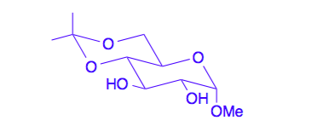

INFRARED SPECTROSCOPY
- See notes from CHM2120 Module 3 for notes on Infrared Spectroscopy.

EXPERIMENT 5 – REACTIONS OF CARBONYLS UNDER BASIC CONDITIONS

CARBONYLS AND ENOLATES
- α hydrogens of ketones and aldehydes are ACIDIC!
- Due to the delocalization of the negative charge UPON deprotonation of the α carbon, via resonance.
- Stability depends on the alpha carbon acidity and resonance.
- More resonance = more stable.
- Alpha carbon more acidic = more stable.
- Enolate is formed upon deprotonation of the α hydrogen of a ketone or aldehyde.

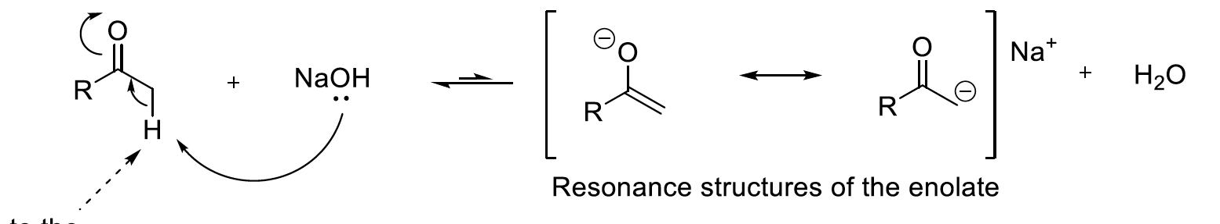

- Competing reactions
- The most favourable reaction is the addition of the hydroxyl group to the α carbon. However, the product is not stable and the TI reverts back to the starting material.
- The slow reaction of formation of the enolate anion is more favourable. The enolate can participate in further reactions.

ALDOL CONDENSATION
- Aldehydes and ketones tend to dimerize (form new molecule with a common molecule) in basic medium forming a new C-C bond.
- This forms an ALDOL (aldehyde and alcohol functional groups present in the product).
- The aldol product can then eliminate the hydroxyl group in protic solvents to form an unsaturated ketone or aldehyde.
- Also, it is easily obtained when there are aromatic groups adjacent to the carbonyl. (R and R’ are aromatic)
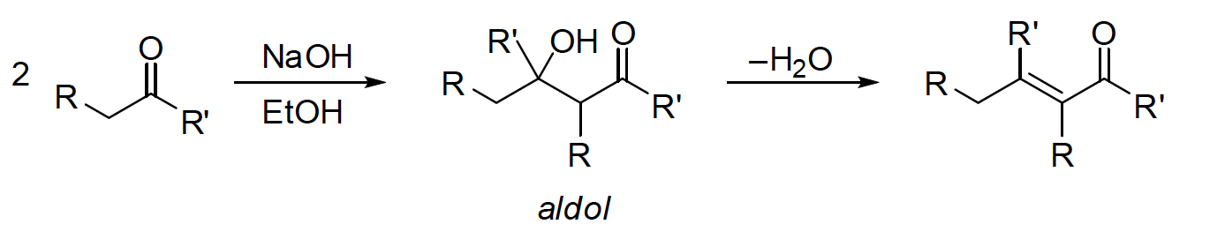
- Two α protons need to be present in order for the 1) aldol reaction to occur 2) elimination to occur.
- First α H is removed by the base enolate. Carbonyl of second molecule = electrophile, attacked by the enolate.
- Second α H abstraction leads to elimination of the hydroxyl group and forming an unsaturated product
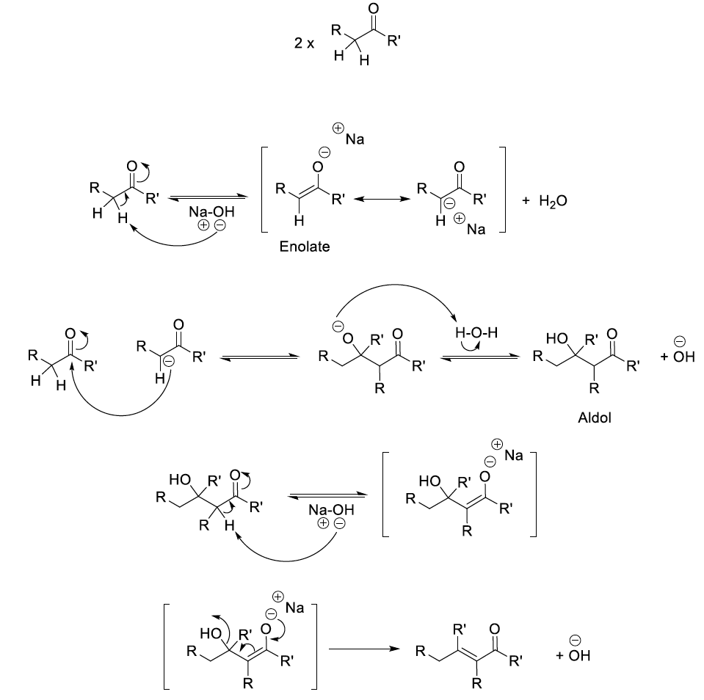
- Crossed condensation where you get two unsaturated products because carbonyl #1 was the electrophile in one reaction but the enolate in the second (and v.v. for carbonyl #2). Other possibility: two of the same carbonyl condense to form 2 other possible products.
- Prevent: make only ONE capable of forming the enolate (choose the second carbonyl with NO α HYDROGENS won’t self-condense).
- Ketones self-condense much more slowly than aldehydes.
- In this specific experiment: Acetophenone has three alpha protons but since it’s a ketone, self-condenses really slowly. Benzaldehyde is the second carbonyl compound with NO α protons thus CANNOT self-condense.
- See lab report for SPECIFIC mechanism for this reaction!

HALOFORM REACTION
- The traditional haloform reaction involves reacting a methyl ketone with a halogen X₂. But since it’s super toxic, we use sodium hypoboromite or sodium hypochlorite (commercial bleach).
- Excellent source of electrophilic halogens because the oxygen is MORE electronegative than both chlorine and bromine.
- Since a base is needed, NaOCl eliminates the need for NaOH, as it is a base as well.
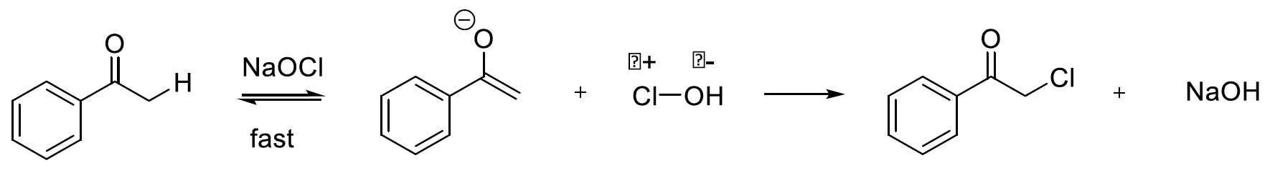
- The first enolate formed on the α carbon reacts with hypochloride (Cl-OH) to give a α-haloketone.
- The remaining α protons are INCREASINGLY acidic, due to inductive effects by chlorine. The reaction repeats until you get a α-α-α-trihaloketone.
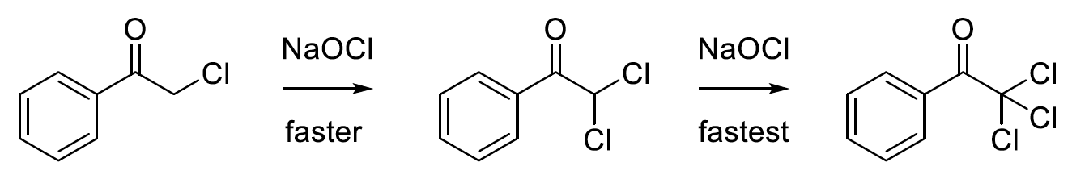
- The subsequent NaOH formed wont react with the methyl ketone in the same way, but acts as a strong nucleophile for the very strong electrophile that is the trihaloketone. Due to the inductive effects by the three chlorine atoms, the α carbon is HIGHLY electrophilic.
- The hydroxide ion adds on to the α carbon via addition. The tetrahedral intermediate will collapse, expelling the CCl₃ as an anion, forming a carboxylic acid as well.
- The CCl₃ gets protonated rapidly and a carboxylate anion is subsequently formed.
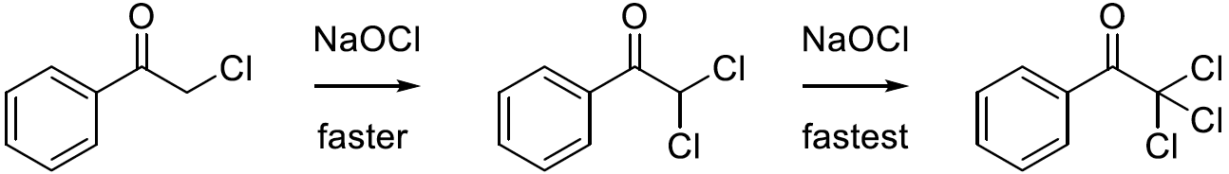
- The expulsion of the CH3 is impossible in the methyl ketone because it is such a poor leaving group.

NaOHCl (bleach solution): acts as a base and source of electrophilic protons
- Increase in acidity due to the strong inductive effects of the oxygen causing a weak bond between the trihaloketone
- Followed addition elimination by a nucleophilic attack and collapse of the trihaloketone
- ChCl3 is protonated to form (trichloromethane)
- HCl: protonates to isolate the desired product

PRACTICAL
- Product is yellow because it is fully conjugated you can create resonance anywhere.
Recrystallization (miscible solvents) vs. Crystallization
- Use a solvent in which your desired product is relatively insoluble.
- Slowly: to ensure the impurities don't contaminate the formation of the crystal lattice
- For most compounds (organic), ideal solvent is EtOH
- Use MINIMUM amount of solvent achieved by reacting EtOH + solvent not too much to avoid decomposing product. (solution needs to be saturated to precipitate out the product)
- Use hot solvent solubilize the crude product’s impurities.
- Use slow cooling to allow molecules to interact in a more organized fashion to form a better lattice t.f. purer product.
- Don’t disturb crystals don’t move flask
- Wash in solvent that your compound is soluble in (especially cold).
- Use miscible solvents
3 ways to induce crystallization
- Scratch the flask with a glass rod/spatula
- Add a co-solvent
- Evaporate solvent
3 ways for selecting a solvent system
- Dissolves compound when hot
- Doesn’t dissolve compound when cold
- Dissolves impurities or doesn’t dissolve them at all
Green Chemistry
- Bleach is safer than chlorine gas, it is a source of Cl (good source) also a good Nu
- One pot chemistry
- Acetone, is once again used, this time to react with any left-over hypochlorite in the reaction.
- HCl, was added at the end to protonate the carboxylate product to form the benzoic acid.

PROTON NMR
- Don’t forget to calculate DU (degrees of unsaturation)
- Integration is GIVEN on the spectrum
- Always look for possibility of aromatic rings ( δ of 7-8.5)
- Keto-enol tautomerization
RESULTS
EXPERIMENT 6 – REDUCTIVE AMINATION OF VANILLIN AND p-TOLUIDINE

AMINES
- Class of organic compounds, containing an N, with a lone pair of electrons. Found in drugs, synthetic dyes, fertilizers, pesticides and cosmetics.
- Alkaloids – natural compounds containing basic nitrogen atoms used for medicinal, eutrophic and/or toxic effects.
- N can form three covalent bonds and still be neutral making amines basic react easily with acids to form ammonium ions after accepting a proton.
- Secondary and primary amines are good nucleophiles. Tertiary are good as well (even more so) due to electron-donating ability of the alkyl groups BUT, there is increased steric hindrance which decreases nucleophilicity.
- When adding amines to alkyl compounds a problem arises
- The first substituted product becomes a STRONGER nucleophile then the lone amine leading to an undesired double substitution product.
- Use reductive amination instead. Use a carbonyl group, with an amine form an imine reduce to an amine.
- The imine is NON-NUCLEOPHILIC.
- Storing the monoamine in the end is done in different ways, since it’s such a good nucleophile.
- Use acid to generate ammonium salt
- Add a protecting group.

PRACTICAL STUFF – scheme of reaction
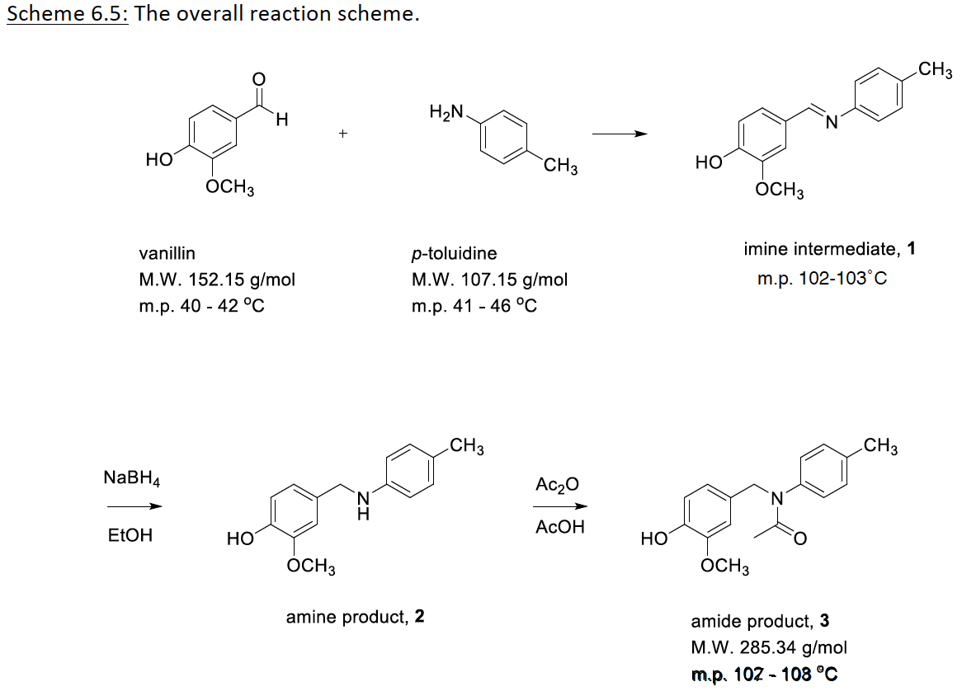

- View Mechanism for this Lab – Reductive Amination – attached separately.
- In this reaction, there is no solvent to protonate and deprotonate during the given steps. In this specific scheme, vanillin has an acidic hydrogen allows it to behave like an acid.
- Amines are MORE nucleophilic than alcohols

EXPERIMENT 8 – HYDROLYSIS OF AN UNKNOWN ESTER + STUDY OF FATS AND DETERGENTS
ESTER HYDROLYSIS
- Two forms of ester hydrolysis: acid or base catalyzed.
- Acid Catalyzed
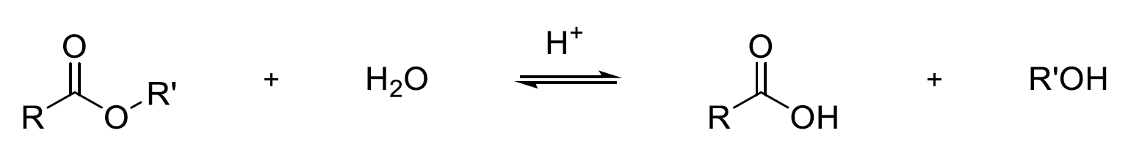
- The reaction is in equilibrium. Ester is usually in high amounts (more favoured). Adding water could push forward but esters are insoluble in water (mostly).
- Base Catalyzed Saponification
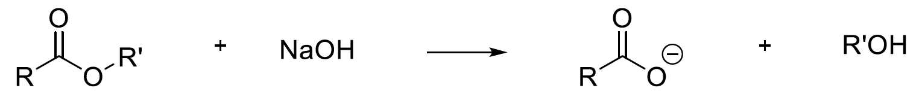
- Reaction is essentially irreversible. Carboxylic acid IMMEDIATELY reacts with base to give a carboxylate and alcohol.
- The neutralization equivalent is the quantity of ester (in grams) that reacts with an equivalent of base (in moles) in a saponification reaction.
- Mono-esters, when hydrolyzed, the neutralization equivalent corresponds to their molar mass.

$$Neutralization equiv. \left(\frac{g}{mol}\right)=\frac{mass of ester (g)}{moles of base required for neutralization (mol)}$$
- In this lab:
- Known mass of ester react with excess base (known molarity)
- Certain moles of base present. initially.
- After reaction, some base is left.
- Find moles of base that is left.
- Subtract from mols of base initially.
- Find moles of base that reacted.
- This is = to the moles of ester (1:1 ratio)
- Use mass and moles of ester to find molar mass.
- Molar mass = neut equiv. = our goal of the experiment.
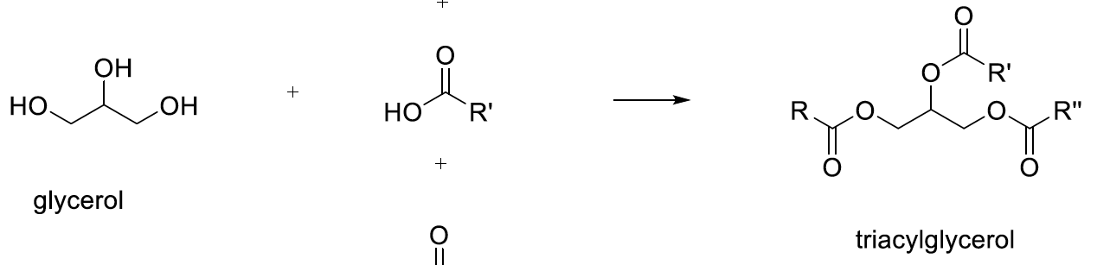
FATS AND DETERGENTS
- Biological carboxylic acids are derived from esters of glycerol.
3*
- Glycerol + fats = triacylglycerols.

- Common fats consist of large hydrocarbon chains (sometimes saturated sometimes not) that will attach to glycerol to form its eseters.
- Unsaturation are commonly soft/liquid which hinders stacking (weaker IMFs)
- Saponification of triacylglycerols – base hydrolysis of glycerides by heating to form glycerol and salts. The salts formed are known as soaps.
- Sodium salts are generally solids or flakes.
- Potassium salts are soluble in water syrupy liquids called soft soaps.
- Adding sodium ions to the solution salts out the soap to form a hard soap from a soft soap solution.
- Magnesium and calcium salts have low solubility in water. This is observed when soap is used in hard water reduces effectiveness of soap under these conditions.
- Soaps must be PARTLY soluble in water to be effective in real life.
- In real life conditions we use “hard water” rather than “distilled water” which as we described, reduces detergency of soaps.
- Solution: addition of phosphates or carbonates which bind more strongly to these metal ions than carboxylates prevent from detergency from being lost.
- Soaps also suck in acidic conditions. Acid/base rxn occurs to produce long chain carboxylic acids which are insoluble in water.
- Mixture of acids formed are usually semi-solid or oily masses with NO DETERGENCY.
- Salts of alkylbenzenesulfonic acids are known as synthetic detergents.
- Effective in both hard and soft water.
- Mg and Ca salts are soluble in water.

DETERGENCY
- Ability to decrease surface tension between water and water insoluble materials.
- Contain hydrophilic (carboxylate ion) and hydrophobic (hydrocarbon chain) parts.
- Hydrophobic traps the grease
- Hydrophilic makes it soluble in water.
- = emulsion that lifts dirt off a surface to be washed away.
- Best soap has a polar head (ionic) and carbon chain of 10-12 carbons.
- Soap scum: precipitate formed when metal ions in the water react with soap; upon acidification, the protonated form precipitates out of solution, forcing the insoluble fatty acids to clump together. Sulphuric acids allows for the magnesium (metal ions in water) to not react with soap- found in detergents
- The retrieval of fatty acids and triglycerides can be done by heating the acidified (sulfuric acid) solution to 80°C.

Cross linking: linking a linear polymer chains through covalent, ionic bonds to form a 2D or 3D network
Ex:DNA

Calculating Equivalents: Only depends on the lowest # of moles of the REAGENTS= limiting reagent

Percent Yield
1. Find total mass: add up reagents
2. Divide mass obtained by total mass
3. Divide number by moles of the limiting reagent

Hard water
- To test for presence of hard water, hard soap SHOULD not produce a precipitate (suds)

