University of Ottawa

“DO I DARE DISTURB THE UNIVERSE?”
Verification of Charles’ and Boyle’s Law

Adam Cook
Tuesday September 17, 2019

Work Sheet – Experiment 1

Experiment Title:
Verification of Charles’ and Boyle’s Law
Author(s) Name(s):
Submitting Author’s Partner:

TA (Demonstrator)’s Name:
Adam Cook
Date Experiment Performed:
Tuesday September 10, 2019
Date Experiment Submitted:
Tuesday September 17, 2019
(The report for Experiment 1 does not require an Introduction)

Attach here (if required, indicate the appropriate document(s)):

Medical or other Acceptable Document: N/A
Change of Lab Day Form: N/A
Change of Lab Section Form: N/A
Late Pass: N/A
Procedure – Charles’ Law:
- Obtain a 125mL Erlenmeyer Flask and ensure it is dry
- Place a rubber stopper in the flask and mark the bottom of the stopper on the flask
- Obtain a large beaker (600mL or 1L) and fill it 2/3 full
- Place the beaker on a hot plate
- Clamp the Erlenmeyer Flask with an extension clamp and place it in the beaker of water. Submerge the flask as much as possible and ensure no water enters the flask
- Turn on the hot plate and allow the water to boil. After the water has reached boiling point, let the flask remain in the boiling water for 6-7 minutes
- Prepare an ice bath (temperature should be below 6°C)
- Disconnect the clamp and place your finger over the hole on the stopper and dunk the Erlenmeyer flask into the ice bath. Do not touch it directly.
- Keep the flask submerged in the water with the stopper facing down and move your finger. If air bubbles escape, then restart the experiment
- Keep the flask submerged for 5-6 minutes to allow the temperature of the air to equilibrate to the temperature of the water
- Record the temperature of the water
- Keep the stopper underwater, raise or lower the flask so that the water level in the flask matches the water level in the bath
- When the 2 levels are matched, place your finger on the hole again and remove the flask from the ice bath
- Transfer the water in the Erlenmeyer flask in a graduated cylinder and call it Vcw. This corresponds to T2 (Measured in step 11). V2 is the volume occupied by the gas at T2 is the difference between V1 and Vcw
- Fill the Erlenmeyer flask to the mark you had drawn. Transfer that volume to a graduated cylinder and call that volume V1. V1 Corresponds to T1 (the temperature of the boiling water, which is 100°C)
- Repeat the experiment

Procedure – Boyle’s Law:
- Identify independent and dependent variable
- Come up with the numbers of intervals, determine starting and ending values, and determine the number of measurements and at what intervals
- Bring the syringe to the starting position
- Turn on LabQuest and connect the gas senor to the LabQuest machine
- Connect the syringe into the gas sensor
- Continue the experiment with the intervals and measurements that you’ve came up with until your ending value
- Record the volume and pressure at each interval until the end of the experiment
- After each interval when the pressure stabilizes, add 0.8mL to the volume
- Repeat the experiment

Discussion:
Charles’ Law
Observations
- During the ice bath, when allowing the water to come in, I noticed the water slowly entered the flask, then stopped. This indicated the amount of water that came in, was the amount of empty space in the flask as the rest was taken up by the gas, which is V2 to help us confirm Charles’ Law.
TRIAL #1
V1 | 158 mL
T1 | 100°C
Vcw | 42 mL
T2 | 3.5°C
V2 | 116 mL

Data Analysis
- V1 = 158mL and T1 = 100°C
- The volume of V2 that I’ve calculated by subtracting Vcw from V1 is 116mL
- Using Charles’ law equation, I plugged in the numbers to solve for V2. The values I used were 158mL for V1, 100°C for T1, and 3.5°C for T2. The final volume I calculated was 117.14. The value 117.14 mL and 116mL are very close to each other indicating that this verifies Charles’ Law being true.
- The percent error of our experiment was 0.972%.
The values are not the same because of a possibility of human error that occurred when performing the lab. An error that might have occurred during the experiment was during the ice bath. My partner and I did not see any air bubbles implying that we let gas out. Some water may have entering without us knowing.
Boyle’s Law
Observations
- As we pushed the syringe every interval, it became slightly harder. This indicates that the pressure was getting higher in smaller volumes
Interval | Volume | Pressure
1 | 20mL +0.8ml | 101.23 kPa
2 | 19mL + 0.8mL | 107.06 kPa
3 | 18mL + 0.8mL | 112.71 kPa
4 | 17mL+ 0.8mL | 118.80 kPa
5 | 16mL + 0.8mL | 125.79 kPa
6 | 15mL + 0.8mL | 134.83 kPa
7 | 14mL + 0.8mL | 142.53 kPa
8 | 13mL + 0.8mL | 152.66 kPa
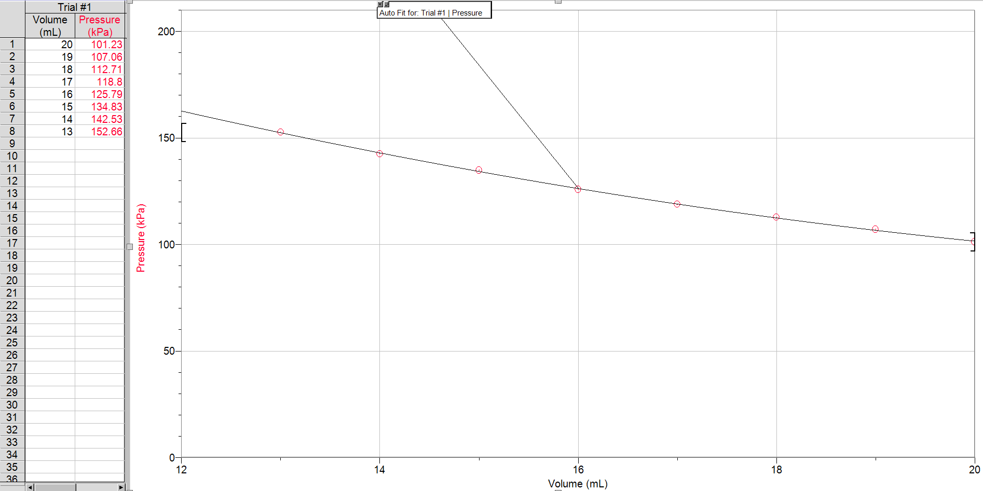
(Figure 1)
Data Analysis
- 2114.84 is the constant that I ‘ve calculated based the results of the tests
Since we kn0w that pressure and volume are inversely proportional to each other (as volume increase, pressure decreases and vice versa), if we multiply the volume and the pressure together, we will get a number that will be our constant. What I did was I multiplied each volume with its corresponding pressure, then found the average of the constants.
- As mentioned above that volume and pressure are inversely proportional so if volume increase then pressure decreases or if pressure increases then volume decreases. So having PV = k, k being the constant, we can easily use this equation to find any unknown value if needed. P = k/V or V = k/P
- It is important to take multiple readings of the dependent variable for the same value of the independent variable because it increases the preciseness of our results because in some cases, errors could occur and having more than one trial, we could see the trend or the pattern to have more accurate results.
- Some of the variables that must have certain conditions met in order for Boyle’s Law to work are the mols of the gas and the temperature. These 2 conditions MUST remain constant during the experiment. In order to ensure that these conditions were met, the experiment took place in a room that is at room temperature(21°C – 24°C), also we ensured that the syringe was secure and properly connected to the gas sensor in order to prevent gas from escaping or entering. If the temperature of the air changed or the mols of the gas, it could affect the overall results of our test because the change in temperature can cause gas particles to increase or decrease in the number of collisions, depending on if the temperature became hot or cold, which then causes an increase or decrease in pressure. Also, if gas escaped the pressure wouldn’t be the same because there is a lower amount of gas.

Conclusion:
Lastly, both the tests done to verify the laws of Charles and Boyle concluded with results we anticipated. In the test of Charles’s Law, we were able to see that when the temperature dropped, the volume did as well, showing us that they are directly proportional to each other. In Boyle’s test, we were able to see the trend between pressure and volume satisfying Boyle’s law by proving they are inversely proportional to each other.
Reference(s):
“What in the World ISN’T Chemistry”, General Chemistry Laboratory Manual, Dr. Rashmi Venkateswaran, 2019.
Appendix:
Raw Data:
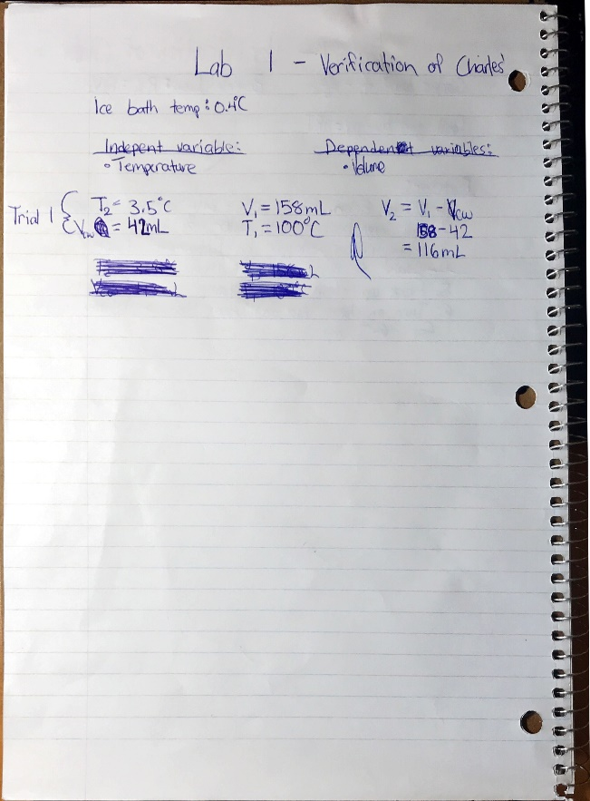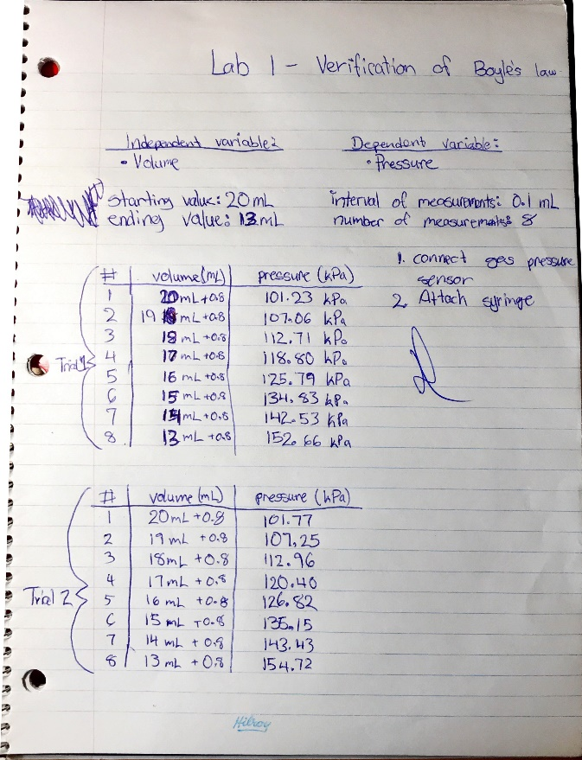
Additional Data, Charles’ Law
N/A
Additional Graphs, Charles’ Law
N/A
Sample Calculations, Charles’ Law
Kelvin temperature conversion
- T1 = 100°C 373.15 K
- T2 = 3.5°C 276.65 K
V2 Calculation
- V2 = V1 – Vcw
V2 = 158 – 42
V2 = 116mL
- V1/T1 = V2/T2
V2 = (V1T1)/T2
V2 = (158)(276.65)/(373.15)
V2 = 117.14 mL

Percent Error
- (V1/T1-V2/T2)/(V1/T1) x 100
= (158/373.15-116/276.65)/(158/373.15) x 100
= 0.972%
Additional Data, Boyle’s Law
Trial #2
Interval | Volume | Pressure
1 | 20mL +0.8ml | 101.77 kPa
2 | 19mL + 0.8mL | 107.25 kPa
3 | 18mL + 0.8mL | 112.96 kPa
4 | 17mL+ 0.8mL | 120.40 kPa
5 | 16mL + 0.8mL | 126.82 kPa
6 | 15mL + 0.8mL | 135.15 kPa
7 | 14mL + 0.8mL | 143.43 kPa
8 | 13mL + 0.8mL | 154.72 kPa

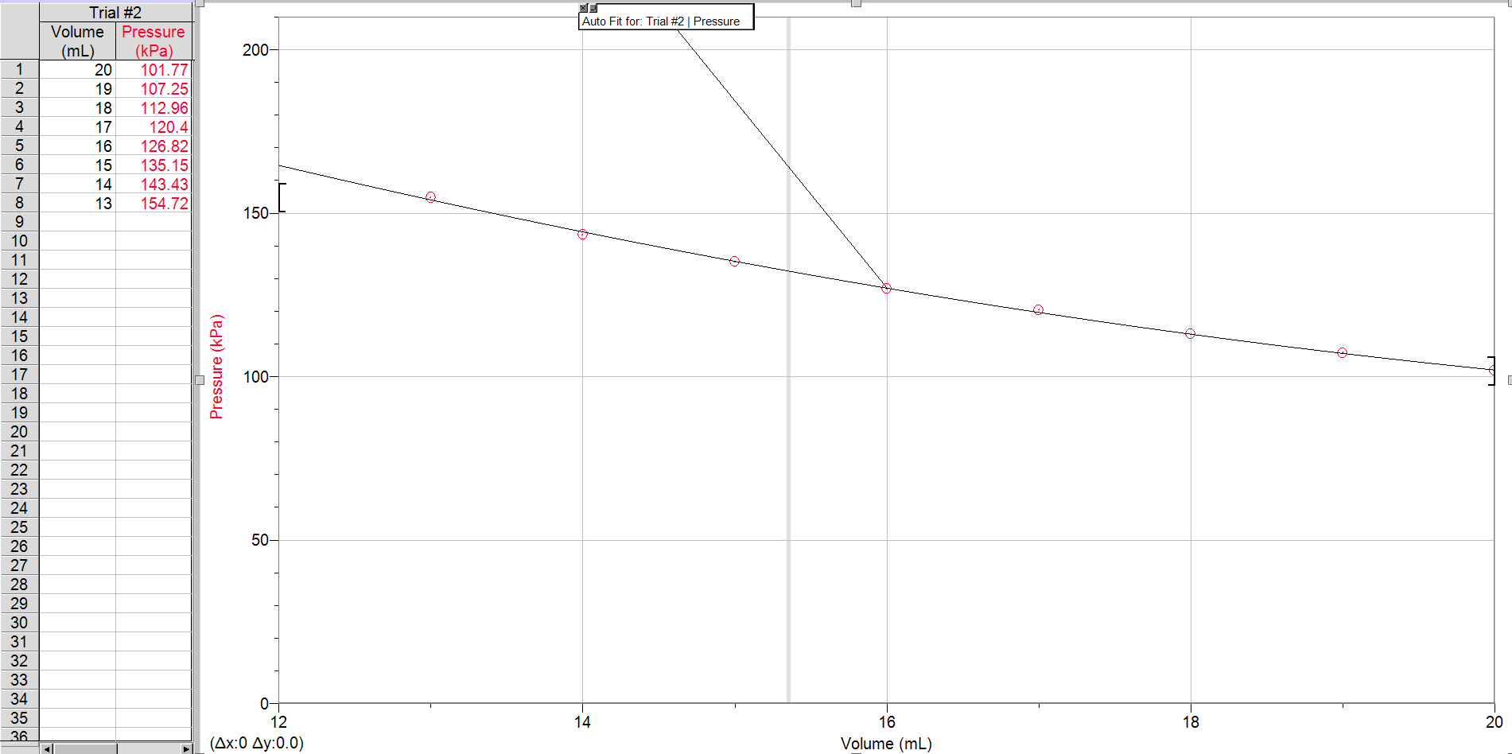
Additional Graphs, Boyle’s Law

Sample Calculations, Boyle’s Law
Constant Calculation
(20.8)(101.23) = 2105.58
(19.8)(107.06) = 2119.79
(18.8)(112.71) = 2118.95
(17.8)(118.80) = 2114.64
(16.8)(125.79) = 2113.27
(15.8)(134.83) = 2130.31
(14.8)(142.53) = 2109.44
(13.8)(152.66) = 2106.71
16918.72/8 = 2114.84

