- What is the definition of social media?
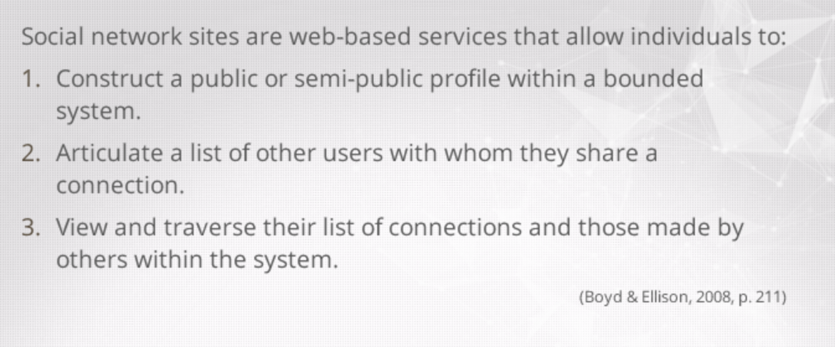
first social media : sixdegrees
- How is Web 1.0 different than Web 2.0?
Web 1.0 : push technology, info presented to users
Web 2.0 : interaction
- What is Facebook? What is a wiki? What is a blog? What are some ways we could use these social media in the classroom?
Facebook : social network site – can be used to get students comfortable to discuss manners outside the classroom
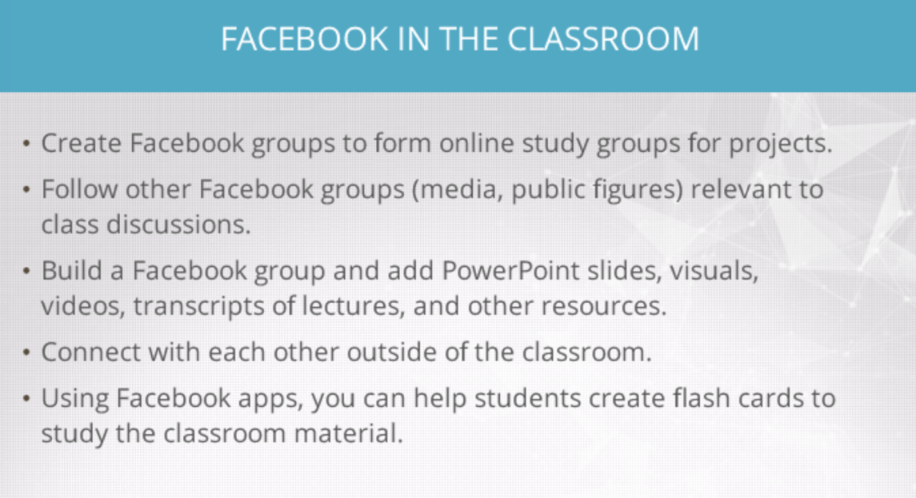

Blogs : create blogs and comment others blogs
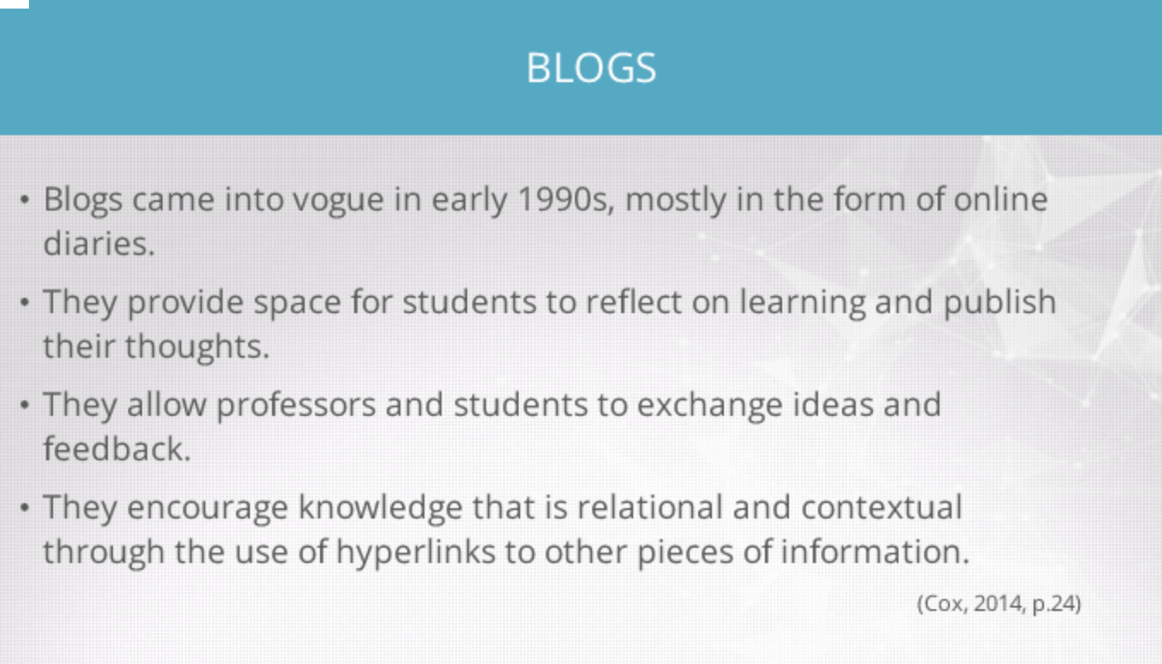
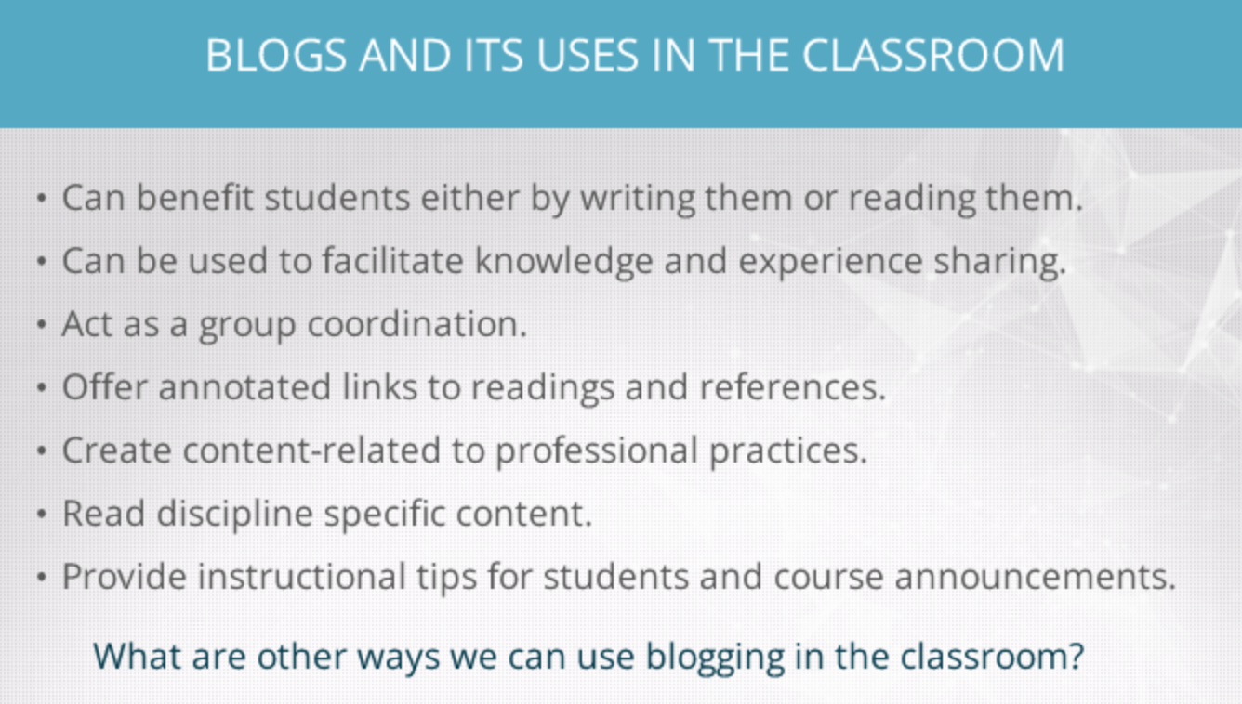
Wiki : open access technology

- History of technology/social media and their corresponding dates.
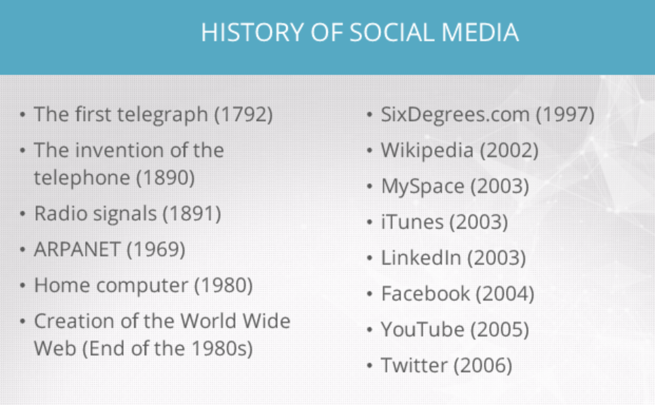
- What should teachers take into consideration when incorporating new technologies including social media in the classroom?
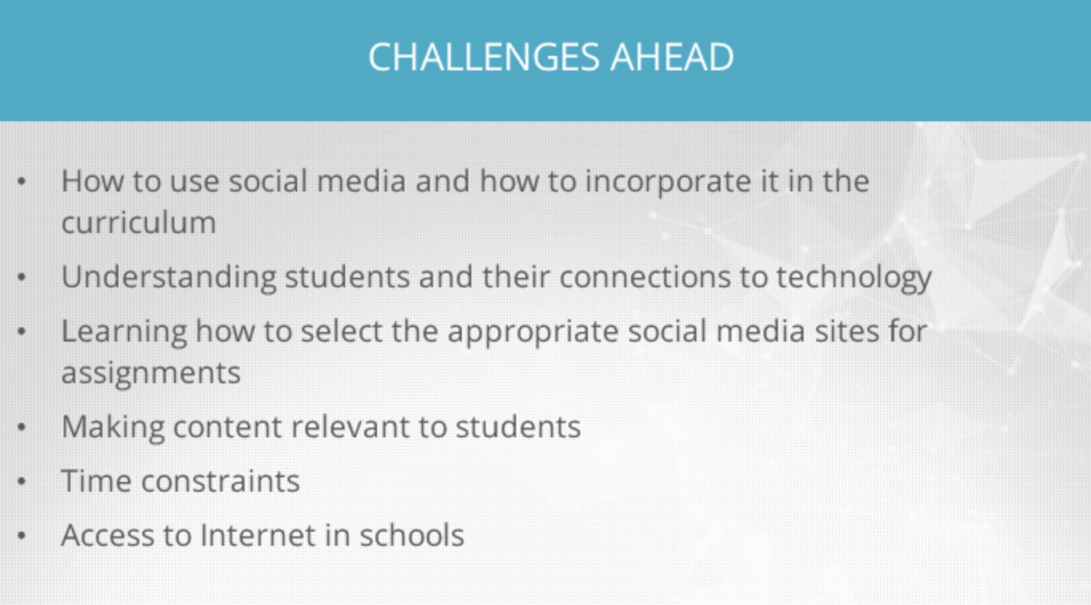
- What were main arguments in the Great Technology Debate?

- What is the take-away message from Howard Rheingold's TedTalk?
You prove to me that you are trustworthy and I will cooperate
What forms of pain can be eleviated if we all cooperate
- Identify the learning theories embedded in the game Little Big Planet.
Come up with concepts (be the creator) – community assessment (community of practice online) – student centered learning
- What is a constructivist approach to learning?

Problem based learning – project based learning – authentic tasks – discovery learning – case based learning – collaborative learning – active learning
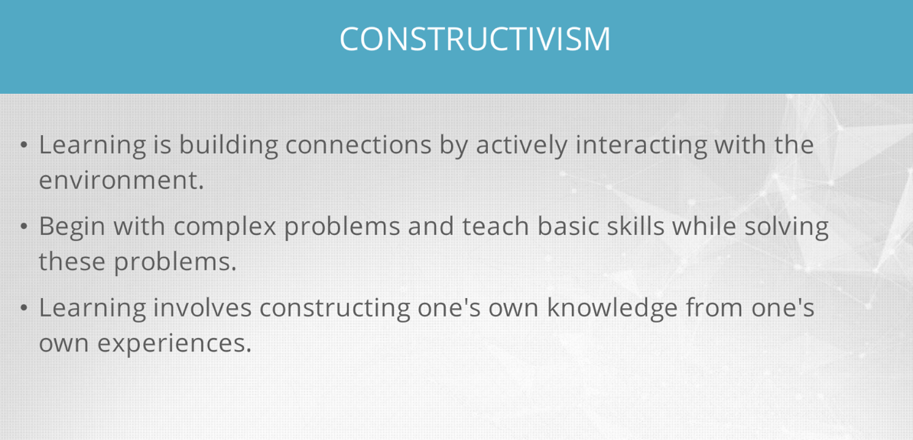
10. What is a behaviourist approach to learning?
Direct instruction – stimulus response – operant conditioning – punishment – shaping – drill and practice
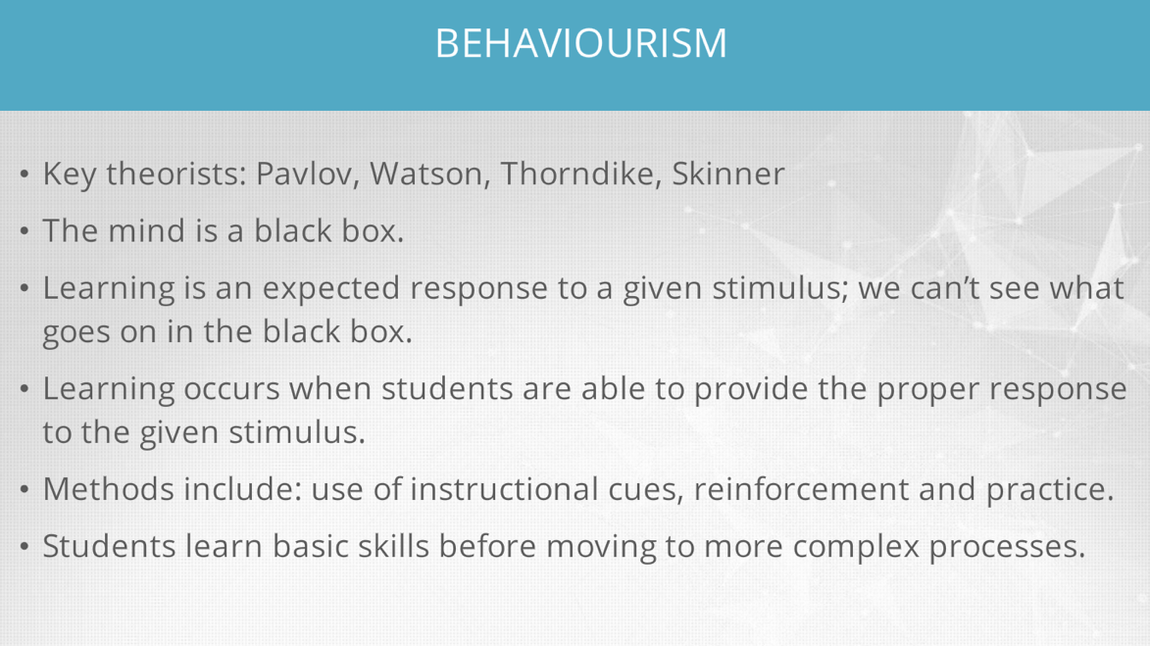
- What is the difference between the constructivist and behaviourist approach?

- What are the steps in Bloom's taxonomy?
- Give an example of each step of Bloom's taxonomy.
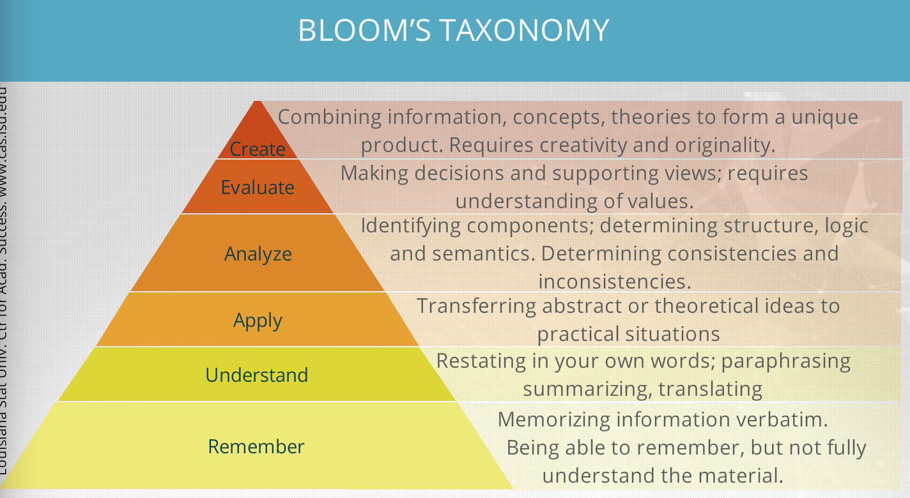
14. Define the zone of proximal development.
The distance between a student’s ability to perform a task under adult guidance and/or with peer collaboration and the students ability solving problems independetly
15. What is the take-away message from Sherry Turkle's TedTalk?

16. What are the tensions related to social media uses?
Hate speech – abuse online
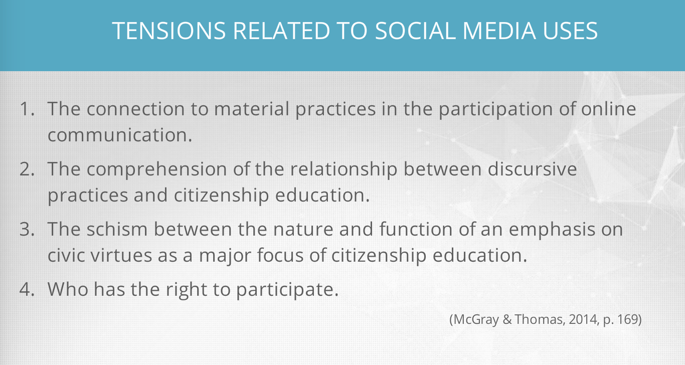
17. What is the goal of digital citizenship?
To learn the appropriate use of technology
18. Define the 9 elements of digital citizenship programs.
Access – commerce – communication – literacy – etiquette – law – rights and responsibilities – health and wellness - security
19. Give an example of each element in the 9 elements of digital citizenship programs.
Access : full electronic participation in society
Literacy : teaching and learning about technology and the use of technology
Communication :
20. Define Edward Said's concept of orientalism.
21. What is Adorno's Culture Industry theory?
22. What do we mean by us-ness vs them-ness in social media?
23. How can we use Bloom's taxonomy to implement critical thinking in pedagogy? Give an example.
24. What is structuralism?
25. What is post-structuralism?
26. What is deconstruction?
27. Define: digital dissonance- chaining- lurking
28. What is the holistic approach to integration of technology in education? What are its benefits?
29. What are the components of research reports? Define each.
30. What is the definition of privacy according to Steeve 2014?
31. What is the link between privacy, technology and Foucault's Panopticon?
32. How can we increase awareness of privacy using stakeholder's agency?

Midterm
- according to the nine elements of digital citizenship programming in the classroom, download illegally obtained material from the web. this relates to
Digital law

2. Web 2.0
A new way to utilize the world wide web using interactive capabilities

3. In quantitative research, what is the typical function of a research question?

To state the relationship between variables

4. Which of the following is a no data collection

Lit review

5. Research paper

Intro, lit review, hypo or research question, research methods, results, discussion, references

6. Texting in an educational environment

Exchanging ideas about class discussion

7. Steeves, which is not a main concern?ff
Profitability

8. What is facebook?
A social networking site

9. What are wikis NOT used for?

To learn the opinion of experts

10. In a research report, why review the literature?

All of the abovefdte

11. Due to a severe snow storm , only a few students were able to attend the statistics 101 class. One of the students who managed to make it to class decided to tweet the lecture notes and answer questions and was able to interact and share her knowledge with her peers. According to langmias et al’s taxonomy of practical application she is : INTERACTING

12. Social networks are considered: WEB 2.0 Sites

13. Kenneth is a grade 5 teacher who wants to foster critical thinking and active learning in his classroom. Which one of the following stages in Bloom's taxonomy is NOT an instance of such learning: REMEMBERING

14. ACCORDING TO THE NINE ELEMENTS OF DIGItal citizenship programming in the classroom, having up-to-date virus protection and/or firewalls, is an example of: DIGITAL SECURITY

15. According to Langmia et al., what was the first true social networking site and when was it launched?: SixDegrees.com in 1997

16. What can people do on social networking sites that was NOT possible in the web 1.0 era? THEY CAN INTERACT WITH OTHER PEOPLE

17. Ratna would like to use a social media platform for her CEGEP students so that they can benefit from access to powerpoint slides, visuals, videos, and transcripts for her lectures even after the course is over. She scans publicly available social media sites for possible ways to do this. To which of the following does this correspond, according to Langmia et al.’s taxonomy of practical applications?: SEARCHING

18. Why didn't many people create online niche communities in the beginning: THEY DIDN'T HAVE THE TECHNOLOGY TO DO SO

19. _____ aids in identify distortion in the cyber world and illustrates the multiple signifier and multiple signified dimensions of social media communication: CHAINING

20. What is meant byf the term poststructuralism: ALL OF THE ABOVE

21. What is meant by the word structuralism?
- The idea that a that phenomena of human life are not intelligible without discovering their deep structures and interrelations.

22. Which of the following statements is conducive of a healthy online community?
a. Moderation on forums allows everyone to feel welcome and participate.

23. According to Langmia, what is the most popular social networking site on the internet?
b. Facebook

24. According to the nine elements of digital citizenship, an ideal email message communicated in work settings :
C. is concise, clear and informative.

25. Who founded Facebook?
Mark Zuckerberg

26. According to the nine elements of digital citizenship programming in classroom, protecting the identity of others and yourself online is an example of:
- Digital rights and responsibilities

27. Orientalism is a term popularized by Edward that seeks to explain :
d. the ways that western cultures view eastern cultures as opposite, arabic or exotic.

28.According to the nine elements of digital citizenship programming in the classroom, understanding how to research and network to get the approriate deals online relates to:
d. digital commerce
29. What is the correct sequence of stages in Bloom’s taxonomy?
- Remembering, understanding, applying, analyzing, evaluating, creating

30. According Langmia et al.’s taxonomy of practical applications, when students follow the teacher on Twitter and they tweet about their individual learning process, they are:
b. interacting and community building

Q. 30 : according to langmia et al’s taxonomy of practical applications, when students follow the teacher on twitter and when they tweet about their individual learning process, they are : b) interacting and community building

Q. 31 : Steeves (2014) defines privacy as : a) social right, personal right, democratic component and human right.

Q. 32 : an individual’s right to a private life and the ability of technology to invade that privacy is an issue that started with the invention of : c) the telephone

Q. 33 : According to langmia et al. social media development is linked to the following historical milestones : d) all of the above

Q. 34 : The Holistic framework for technology integration in education is NOT a useful lens to : b) develop new understandings of the debates surrounding ICT integration in education

Q.35 : technology has the power to seduce and numb the working classes and/or the general public to extent that they stop thinking about important issues. Which theory subscribes to this view? c) orientalism theory

Q.36 : educators believe learning with social media is important because : e) all of the above

Q. 37 : according to the nine elements of digital citizenship programming in the classroom, using ergonomic chairs, desks, and other furniture and equipment to minimize physical harm is an example of: d) digital health and wellness

Q. 38 : the panopticon effect of technology refers to: a) the feeling that someone is watching you

Q. 39 : what was the original web 1.0 mainly used for : b) browsing content, reading and watching videos online.

40. According to the nine elementts of digital citizenship programming in the classroom, creating a wiki to share classroom notes is an example of
Digital access ******

41. Vygotsky’s notion of the zone of proximal development refers to
The zone between a learners actual development and his her potential

42. According to the nine elements of digital citizenship programming in the classroom, makins sure everyone in class has access to the internet in order to complete the assignment requires
Digital access

43. Linda wants to use social media to enhance learning in the classroom. She asks her students to explore and browse the internet in order to find out which social media sites they might benefit from. According to lagmia et als taxonomy of practical applications, this corresponds to:
Connecting

44. Proponents of online surveillance argue that the __ of privacy is justified because surveillance increases __
Loss, security **

45. According to the nine elemets of digital citizenship programming in the classroom, using a blog to share information with others is an example of:
Digital communication

46. What do web 2.0 sites rely on
Users creating content

47. Which of the following best desbribes Ferdinand de saussures approach to text meaning
Structuralism

48. Dana is teaching a communication course using social media. In order to direct her students to be critical of the information they find on the web, she shows them an example of a racist discussion on FB, then she provides them with a series of questions in the form of a handout that will help them analyze the content of what happened in this communicatin. In this model of critical analysis, which of the following is the teacher adopting?
Blooms taxonomy

49. What defenition of social media do langmia et al subscribe to?
Digital forms of communication through which individuals create online communities to share information, ideas, personal messages, and related content*

50. Blogs or weblogs
Online diares and or postings that are organized chronologically

