ADM 1300C Chapter 1:

Are managers important to an organization?
- Think about your boss. Can you say she or he:
  - Inspires me
  - Energizes me
  - He/she has changed my life
Are managers important to an organization? (Cont)
- An organization needs a manager:
- To use her/his skills and abilities (managerial skills, critical issues, bottlenecks)
- To get things done
- He or She matters
- Gallop Organization:
  - Employee productivity and loyalty depends on quality of relationship b/n employee and supervisor (not pay or benefits)
- Tower Watson:
  - The way a co. treats its people significantly affects its financial performance

Definition of manager:
- Manager is someone who works with and through other people by coordinating their work activities so that organizational goals can be accomplished
  - It is not about personal achievement
  - Managerial/non-managerial work
  - Changing nature of work has blurred the distinction
  - Eg. In morning star company: no employee is called manager

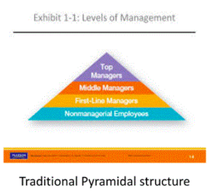
Types of managers:
- First line: Who manage the work of non-managerial employees
- Middle: who manage the work of the first-line managers
- Top: at the upper levels of the organization
  - Make organization-wide decisions
  - Establish goals and plans that affect the entire organization

Types of managers (cont):
- Not all organizations use the traditional pyramid form.
  - Can be more flexible with work being done by ever-changing teams who move from one project to another as demanded
  - However, there is a coordinator

Where do managers work?
- Organization: a deliberate arrangement of people who act together to accomplish some specific purpose
  - 1. Composed of people
  - 2. Has distinct purpose
  - 3. Has a deliberate structure (open/flexible/rigid/hierarchical) within which members do their work
- E.g., college, grocery store, church

The Functions, Roles, and the Skills of managers:
- Management: coordinating work activities with and through other people so that the activities are completed effectively and efficiently.
  - Efficiently: getting the most output from the least amount of inputs
    - Can be referred to as “doing things right”
  - Effectiveness: completing activities so that the organization goals are achieved
    - -Can be referred to as “doing things right”

Management Functions (Functions Approach):
- In the early part of the twentieth century a French industrialist, Henri Fayol proposed that all managers perform five functions: planning, organizing, commanding, coordinating and controlling
- Today we use four management functions: Planning, organizing, leading and coordinating
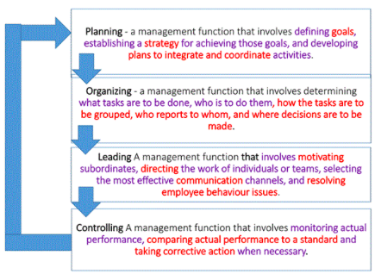

4 functions of management:
Planning:
- Defining goals, establishing a strategy for achieving those goals, and developing plans to integrade and coordinating activities.
Organizing:
- What tasks are to be done, who is to do them, how the tasks are to be grouped, who reports to whom, and where decisions are to be made
Leading:
- Motivating subordinates, directing the work of individuals or teams, selecting the most effective communication channels, and resolving employee behaviour issues
Controlling:
- Monitoring actual performance, comparing actual performance to a standard and taking corrective action when necessary

Mintzberg’s Managerial Roles and Contemporary Model of Managing:
- Management can be described by looking at the roles managers play at work
- Mangers perform 10 different highly interrelated roles
- Role: specific action or behaviour exhibited by a manager
  - Interpersonal Roles: performing duties that are ceremonial and symbolic in nature
  - Informational Roles: receiving, collecting and disseminating information
  - Decisional Roles: making significant choices that affect the organization

Validity of Minzberg’s model:
- Found to be valid regardless the type of organization or level of manager
- However, emphasis given to various roles seems to change with organizational levels
  - Higher levels – disseminator, figurehead, negotiator, liaison and spokesperson
  - Lower levels – Leading more important

Function vs Roles:
- Each have merit
- The classical approach
  - Represents the most useful way of conceptualizing a manager’s job
  - Provides a distinct method of classifying thousands of managerial activities
- Mintzberg’s role approach (and other models) offer us other insights to a manager’s work.

Management Skills:
Research by Robert L. Katz found that managers need three essential skills:
- Technical skills – knowledge of and expertise in a specialized field (at which level is more important?)
- Human skills – the ability to work well with other people. Important at all levels (communicate, motivate, lead, inspire enthusiasm, and trust: at which level is it more important?)
- Conceptual skills – Mental ability to analyze and generate ideas about abstract and complex situations (visualize the organization as a whole and how it fits into its broader environment – at which level is it more important?)

How is the manager’s job changing?
- In today’s word managers are dealing with:
  - Global economic and political uncertainties
  - Changing workplaces
  - Ethical issues
  - Security threats
  - Changing technology
-E.g., Headwater MB – Denver based investment bank – David Manley laid off all employees except 7 key employees and invited the laid off to form independent member firms
- How are these changes affecting the way manager’s plan, organize, lead and control?
- There is increasing important on four of these changes:
-Customers
-Social media
-Innovation

Importance of customers:
- Delivering consistent, high-quality customer service is essential for survival and success in today’s competitive environment and employees are an important part of it
  - Customers are not the responsibility of the marketing types
  - Employees attitudes and behaviours play a big role in customer satisfaction
  - In today’s economy, the majority of employees work

Importance of Social Media:
- Social media: forms of electronic communication through which users create online communities to share ideas, information, personal messages and other content
- More and more businesses are turning to social media to
  - Connect with customers
  - Manage their human resource to tap into their innovation and talent

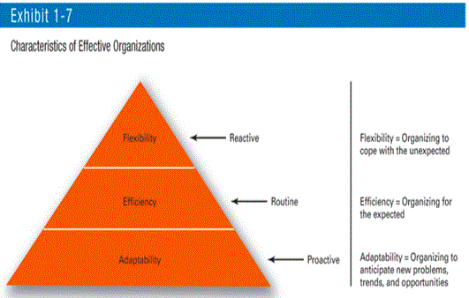
Importance of Innovation to the Manager’s Job:
- Innovation means exploring new territory, takin risks, and doing things differently
- Adaptability Enables an organization to create a set of skills, processes and a culture that enables it to continuously look for a new problem and offer solutions
- The best companies outshine their competitors in:
  - Flexibility – Reacting to events
  - Efficiency – Organizing for the expected
  - Adaptability – Being proactive

Importance of Managing Responsibly:
- Responsible management and sustainability have become mainstream issues for managers
- Sustainability: a company’s ability to achieve its business goals and increase long-term shareholder value by integrating:
  - Economic
  - Environmental
  - Social opportunities into its business strategies

Why study management?
- The University of Management
- The reality that management is needed in:
  - All types and sizes of organizations
  - At all organizations levels
  - In all organizational work areas
  - In organizations, no matter where they are located
- All managers plan, organize, lead and control
- Organizations that are well managed develop a loyal customer base, grow and prosper
- You will be able to recognize poor management and work to get it corrected
- The reality of work:
  - Understanding of management is the foundation to build your management skills
  - You will gain a great deal of insight into the way your boss behaves and how organizations function
- Rewards and challenges of Being a Manager
Rewards:
  - Opportunity to think creatively, use imagination
  - Help others find meaning and fulfilment in work
  - Support, coach and nurture others
  - Work with a variety of people
  - Recognition and status in organization and community
  - Role in influencing organizational outcomes
  - List more from note
Challenges:
  - Can be thankless and spend your time doing clerical work than managerial
  - Deal with interruptions and spend time in meetings that can be unproductive and time consuming
  - Deal with a variety of personalities
  - Challenging to motivate employees in the face of uncertainty and chaos
  - Difficult to blend the knowledge, skills, ambitions and experience of a diverse group of people
  - More from note

More control and power hierarchy

