Chapter 2-The Tools of Economic Analysis
Time-Series Data: Measures variables at multiple point in time (Ex: price 1kg of steak from 2002 until 2008)
Cross-Section Data: Measures variables for different groups at one point in time (Ex: Monthly rent of an apartment in multiple cities during 2008)
Longitudinal Data: Tracks variables for different groups at multiple point in time (Ex: GPA score for Bob, Kev and Laura in 2006, 2007 and 2008)
Index number: Number that is relative to a given base year number
$${Index value}_{x}= \frac{{Price}_{x year}}{{Price}_{base year}}*100$$
$$CPI=$$
Chapter 3-Demand, Supply and the Market

The Demand Curve
Demand: amount of good or service that buyers want and are able to buy at any possible price. (It is the entire curve) Example: computer at 100$ -> demand is 100 million. Computer at 1000S -> demand is 30 million.
Quantity demanded: amount purchased at a specific price. Example: When the price of a laptop is 3000$, 1 million laptops are purchased.
Normal good: demand increases in response of higher income (ex: Steak, can afford more premium steak)
Inferior good: demand decreases in response of higher income (ex: public transportation, people can afford cars)
- A change in price would change the Quantity demanded, not the Demand.
- Demand changes from these factors (shift in demand curve):
- Income: Income ↑, demand ↑ = normal good
Income ↑, demand ↓ = inferior good
Demand curve shifts to the right
- Price of related goods:
- Complementary goods: Price of product 1 goes down and demand for product 2 goes up. (Ex: Price of cars go down, more people will buy cars and therefore demand for gas goes up) Demand curve shifts to the left.
- Substitute goods: Price of product 1 goes down and demand for product 2 goes down. (Ex: Price for Starbucks coffee goes down, Starbucks is cheaper now, and therefore demand for Tim Horton’s coffee goes down.) Demand curve shifts to the right.
- Tastes and preferences: Baseball caps are no longer in fashion; demand for caps goes down. Demand curve shifts to the left.
- Expectations: Price is expected to go up in two weeks, people will buy more today at a cheaper price. Present demand goes up, demand curve shifts to the right.
- Number of buyers: When the number of buyers increases, the demand increases with it, vice versa. (Ex: After WWII, baby boom had the baby population growing which made the demand for baby diapers go up, no matter what the price.) Demand curve shifts to the right.
- Information: If doctor says red wine is good, demand for red win will increase. Demand curve shifts to the right.

The Supply Curve
Supply: Amount of a good or service that sellers want and are able to sell at every price. (Supply is the entire curve) Example: Market is willing to buy computer at 100$ -> supplier is willing to supply 10 million computers. 1000$ -> supply 30 million. 3000$ -> supply 100 million.
Quantity supplied: amount supplied at a specific price. Example: When the price of a laptop is 3000$, 100 million laptops are supplied.
- A change in price will would change the Quantity supplied, not the Supply.
- Supply changes from these factors (shift in supply curve):
- Input costs: A decrease in input costs allows for more output at the same price, vice versa. (Ex: A large reserve of copper was discovered, which decreases the cost of copper. Cable companies can now make their product cheaper. If the market price stays the same, the cable company will want to increase the supply of their good in the market as they make more money now.) Supply curve shift to the right.
Input cost: set of costs incurred to create a product or service. Ex: direct materials, direct labor, factory overhead.
Output: amount of something produced by a person, machine, or industry

- Technology: Allows more output to be produced with the same or fewer inputs. Technology improves. Supply curve shift to the right.
- Expectations: If companies expected the price of their product to go up in 2 weeks, they will decrease their supply today so they can sell the product after the price goes up. Supply goes down, supply curve shifts to the left.
- Tax: If the tax goes up, then the supply goes down. Supply curve shift to the left.
- Subsidy: Negative tax, government giving money (ex. Scholarships). If subsidy goes up, supply curve shifts to the right.
- Number of producers: If the number of companies selling the same product goes up, supply of that product will go up. Supply curve shifts to the right.

Equilibrium
Equilibrium price: Price where the quantity demanded equals the quantity supplied.
- Excess supply: quantity supplied > quantity demanded at a specific price.
- Excess demand: quantity supplied < quantity demanded at a specific price.
The market always tries to reach equilibrium.
- When there is excess supply, suppliers accept lower prices. (Ex: Airplane tickets at 800$ -> only 100 people will buy them. This leaves 200 seats empty. Airline will reduce price until they fill up all the seats.)
- When there is excess demand, consumers accept higher prices. (Ex: 10 000 seats to a hockey game, price is 100$. There are 20 000 people who want to buy tickets. Excess demand. Buyers will be willing to pay more for a ticket. Ticket prices will go up.)
Demand curve has negative slope because more is purchased at lower price. Supply curve has positive slope because more is supplied at higher price.

Free Markets and Managed Markets
The government can limit the ability of people to influence price by setting up:
- Quotas: physical restrictions on output. (Ex: only 1 million apples can be produced in Canada)
- Price controls: restrictions on what price the seller can sell his product.
- Price floors: A minimum price allowed for a good or service. (Ex: can’t pay an employee less than 8$ per hour)
- Price ceilings: A maximum price allowed for a good or service. (Ex: Can’t sell milk for more than 2$)
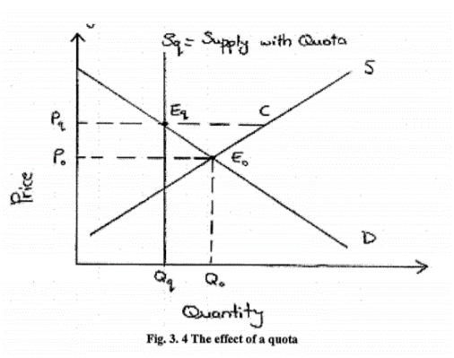
- Production subsidy: The government asks the producers to increase production in return for financial assistance from the government.
The effect of a Quota:
- The government thinks that the equilibrium price Po is low and not enough for agricultural suppliers.
- Decides to increase the price by placing a production quota (Qo->Qq).
- Supply is fixed at Sq, Price goes up ↑ (Po->Pq).
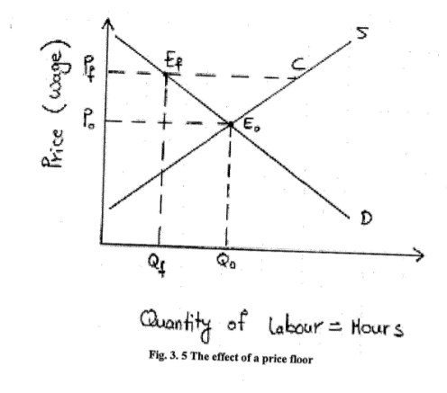
The effect of a Price Floor:
- The equilibrium wage and number of hours worked are on point Eo.
- A minimum wage equal to Pf is set by the gouv. Which is higher than Po.
- The hours of work demanded goes down (Qo->Qf).
- EfC represents the excess supply (unemployed)

The effect of Price Ceiling:
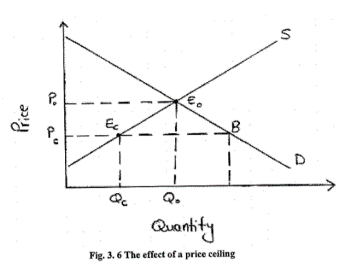
- The equilibrium rent and number of apartments rented are on point Eo.
- The gouv. thinks that rent is too high for the average Canadian resident.
- Decides to put a price ceiling at Pc.
- The numbers of apartments offered goes down (Qo->Qc).
- EcB represents the excess demand (more buyers than sellers).
The effect of Production Subsidy:
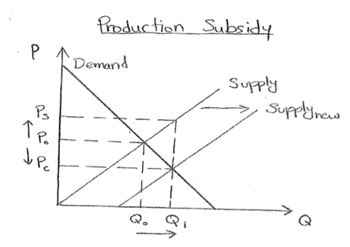
- The gouv. thinks that the equilibrium quantity Qo is too low and that consumers should get more of that good.
- It decides to have producers increase their production (Qo->Q1)
- Consumers pay a lower price (Po->Pc)
- Producers pay a higher price (Po->Ps)

Chapter 4-Elasticities of demand and supply
Elasticity: if the price of the product changes by 1%, then by how much (in %) does the quantity demanded changes? Answer: Price elasticity of Demand -> Epsilon (ɛ)
2 types of Price elasticities:
- Demand = negative numbers
- Supply = positive numbers
Point Elasticity
$$ε=\frac{1}{∆Q}* \frac{P}{Q}$$
$$∆Q=Slope$$
Arc elasticity
$$ε=\frac{\frac{Q_{2}-Q_{1}}{Q_{2}+Q_{1}}}{\frac{P_{2}-P_{1}}{P_{2}+P_{1}}}$$

The Price Responsiveness of Demand
Two types of price elasticity of Demand:
- Point Elasticity: consumer responsiveness at one specific point of the demand curve.
- Arc Elasticity: consumer responsiveness over a segment or arc of the demand curve.
General Demand Elasticity Rule:
Demand is:
- Perfectly inelastic when $ε$ = 0 -> no response (Ex: Insulin)
- Inelastic when 1 > $ε$ > 0
- Unit elastic when $ε$ = 1 -> if price changes 1%, quantity changes 1% -> spend fix amount of money (20$)
- Elastic when ∞ > $ε$ >1
- Perfectly elastic when $ε$ = ∞
Inelastic is not a need, it’s a want. (Ex: hair tie)
Four factors that change elasticity:
- The more substitutes, the more elastic the good is.
- More substitutes -> elastic demand (Ex: Soft drinks: Pepsi, Cola, Sprite, etc.)
- Less substitutes -> inelastic demand (Ex: eggs)
- The more of your income, the more elastic the good is.
- Small percentage of income -> inelastic demand (Ex: if the price of the newspaper goes up by 10%, it won’t affect me since its 0.10$ more)
- Large percentage of income -> elastic demand (Ex. If the price of cars goes up by 10%, it will affect me since it’s 3000$ more)
- The more time to adjust, the more elastic the good is.
- Short-run -> inelastic demand. (People are not able to switch products in a short period of time. If the price of gas goes up tomorrow, there’s nothing I can do.)
- Long-run -> elastic demand. (People are able to switch products over a long period of time. If the price of gas stays up, I’m going to start taking the bus instead.)
- The more luxury, the more elastic the good is.
- Luxury goods -> Elastic (Rolex watch. If the price goes up, I won’t buy. Not a necessity)
- Necessity goods -> Inelastic (Bread. If the price of bread doubles, I will still buy some)
Scenario
If P↑ and… | Then TR…
$ε$ = 0 | TR↑ (P↑, Q)
1 > $ε$ > 0 | TR↑ (P↑, Q↓)
$ε$ = 1 | Doesn’t change
∞ > $ε$ >1 | TR↓ (P↑, Q↓)
$ε$ = ∞ | TR ↑(P↑, Q↓)
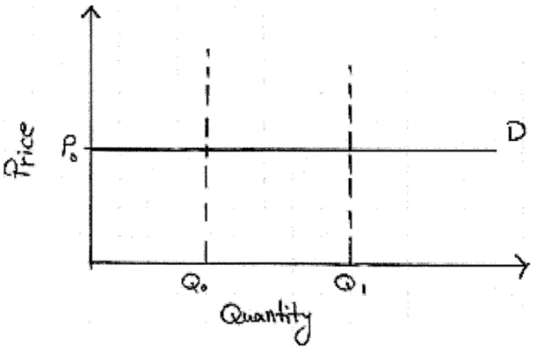

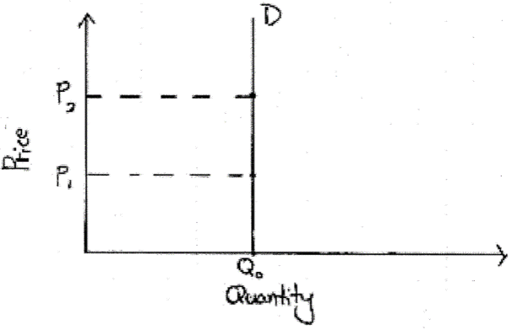
Perfectly elastic. It is price sensitive for the consumers. (Ex: I will not buy soda if it goes from 1$ to 2$)

Perfectly inelastic. It is a need. No matter the price, I will buy it (Ex: insulin)

Complementary (the more expensive milk is, the less cereal you buy)
Cross elasticity: measures the quantity of one good compared to the price of another good.
$ε_{x}$ = negative -> Inferior (more income I have, less demanding I am)
$ε_{x}$ = positive -> Normal
$ε_{x}$ = 0 -> Necessity (Ex: Toothpaste)

$$ε_{I}=\frac{\frac{Q_{2}-Q_{1}}{Q_{2}+Q_{1}}}{\frac{I_{2}-I_{1}}{I_{2}+I_{1}}}$$

Price of Coke
Cross price elasticity = $ε_{x}$ Income elasticity = $ε_{I}$
Quantity of Pepsi
$$ε_{x}=\frac{\frac{{Q_{2}}^{A}-{Q_{1}}^{A}}{{Q_{2}}^{A}+{Q_{1}}^{A}}}{\frac{{P_{2}}^{B}-{P_{1}}^{B}}{{P_{2}}^{B}+{P_{1}}^{B}}}$$
$ε_{x}$ = negative -> Complementary
$ε_{x}$ = positive -> Substitute
$ε_{x}$ = 0 -> Unrelated
Inferior goods: Income ↑, Quantity demanded ↓ (Ex: Public transport)
Normal goods: Income ↑, Quantity demanded ↑ (Nike, Adidas)

The Price Responsiveness of Supply
Elasticity of Supply: How much will supply change with a specific change in price.
Two types of Elasticity of Supply:
- Point elasticity: consumer responsiveness at one point of the supply curve
- Arc elasticity: consumer responsiveness over a segment or arc of the supply curve
General Supply Elasticity Rule:
Supply is:
- Elastic when ∞ > ε >1
- Inelastic when 1 > $ε$ > 0
- Unit elastic when $ε$ = 1

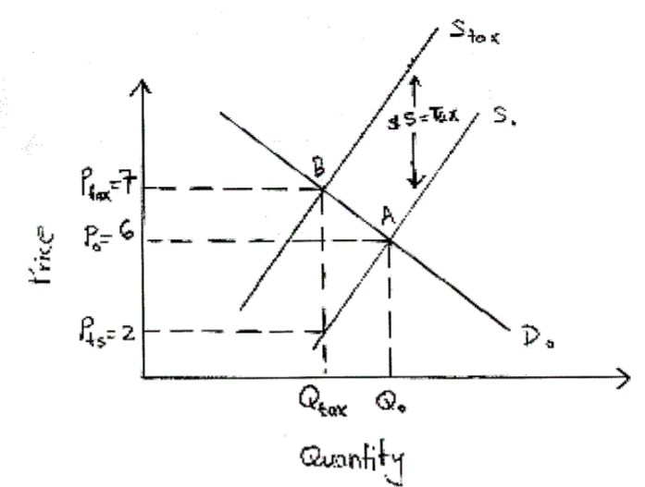
Elasticities and Taxes
Taxes are a burden on both the consumers and the sellers, but who has to pay more taxes? Depends on how elastic the demand and supply curves are.
- Demand curve more elastic than supply curve -> sellers pay more of the tax. (If P↑ it will cause demand to fall. Suppliers will have to pay more of the tax to prevent demand from falling)

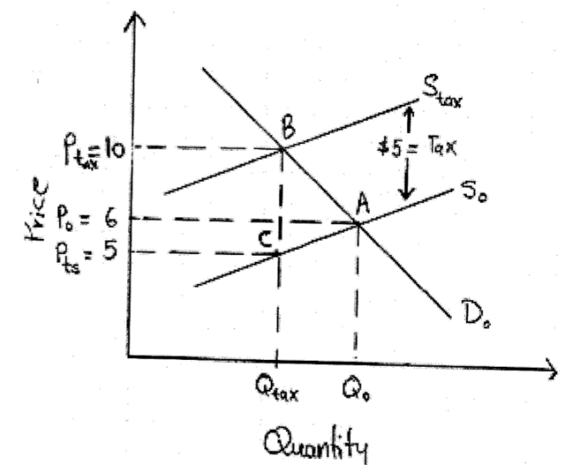

- Supply curve more elastic than demand curve -> consumers pay more of the tax. (If P↑ it will NOT cause demand to fall. Suppliers will NOT HAVE to prevent the demand from falling and will pass most of the taxes to the consumer.

Chapter 5: Welfare Economics
Welfare Economics: looks at how well the economy is using its resources and how they are used to increase Efficiency and Equity
Private markets and government choose:
- What goods and services to produce (milk or oranges)
- How to produce those goods and services (manual labor, machines, both)
- Who to produce those goods and services for (6 years old girl or 70 years old grandpa)

Consumer and Supplier surplus
Consumer surplus (CS): difference between what the consumer is willing to pay and what he’s actually paying (market price)
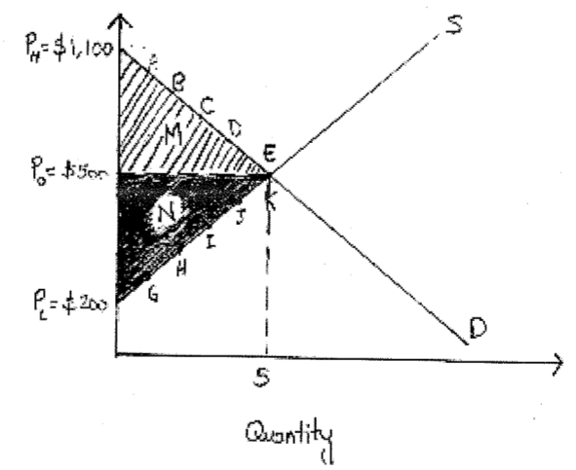
Producer surplus (PS): difference between what the producer is receiving and what they’re willing to receive
M = $\frac{Q_{o}(P_{H}-P_{o})}{2}$ (Triangle formula)
M= $\frac{5(1100-500)}{2}$ = 1500$

N = $\frac{Q_{o}(P_{0}-P_{c})}{2}$ (Triangle formula)
N = $\frac{5(500-200)}{2}$ = 750$
$$Q_{o}$$

What increases PS:
- Shift supply right
- Increase $P_{o}$
- More elastic
Perfectly inelastic = 0
What increases CS:
- Lower $P_{o}$
- Increase demand
- More elastic
Perfectly elastic = 0 (Buy at the price I want)

Externality
Externality: third party (not consumer or producer) involved in the transaction.
Negative externality affects negatively the third party, usually society. (Ex: Nuclear power plant (seller) produces electricity for City A. All the waste goes in river between City A and City B. City B is not a buyer or seller and its water is spoilt)
- Cost on people other than those involved in the activity. Social cost is higher than private cost.
- Marginal Cost: cost paid by those involved in the activity (Ex: City A and power plant)
- Marginal External Cost: cost paid by third party (Ex: City B)
- Marginal Social Cost: cost that everyone in the society pays, even those not involved in the activity (Ex: City A, City B and power plant)
- Marginal Cost + Marginal Eternal Cost = Marginal Social Cost
- Gouv. usually interferes to make sure that Social Cost = Private Cost.
- Solution: tax producers
Positive externality benefits society. Enables people to get a “free ride” on the efforts of others. (Ex: Company A discovered a cure for HIV. Patients (buyers) are willing to pay for the cure, but society places more value on the cure. If a patient is cured less people will contract the virus. Positive because it benefits society as a whole)
- Society gets a “free-ride” because the patient will pay for the cure. Social benefit is higher than private benefit.
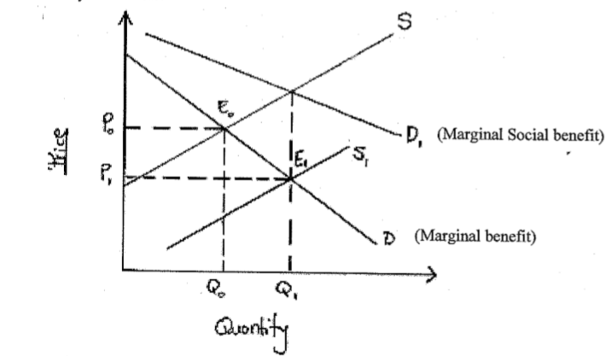
- The gouv. can give a subsidy (financial support) to Company A. They can be compensated for the full benefit they are offering by finding this cure, motivating them to produce more.
- Supply curve shifts to the right $(S_{o}→S_{1})$
- Price goes down $(P_{o}→P_{1})$
- Output goes up $(Q_{o}→Q_{1})$
- The gouv. will protect Company A with patent laws.
- Gouv. allows Company A to produce and sell this cure for a limited time.
- If this protection was no there, firms would not make any effort and the economy’s resources would not be used efficiently.

Chapter 6- Consumer choice and demand decision
People are interested in maximizing their utility (happiness). Need to measure happiness. Utility does that.
- Marginal utility: Benefit gained from consuming one additional unit of good or service
- Utility: The satisfaction you gain from a good or service. NOT a cardinal number.
- Cardinal Utility: Measurable satisfaction. We use Utils to measure satisfaction. Higher utils means higher satisfaction.

Consumer Choice with Measurable Utility
Buying more of a good or service will increase your utility.
Non-Station: Marginal utility seen when adding each good is positive. (Ex: eating more pizza will increase your utility because more of something good is better. Every additional slice of pizza will give you positive utility)

Diminishing marginal utility: each unit of a good you consume provides happiness, but not as much as the previous unit. (Ex: you’re on a desert island, first glass of water=amazing. Second= okay. Third= have to pee)
Consumer equilibrium: The buyer reaches maximum utility with his budget and gets the same utility per dollar for the last unit of each product consumed.
Maximize utility: spend all you income.
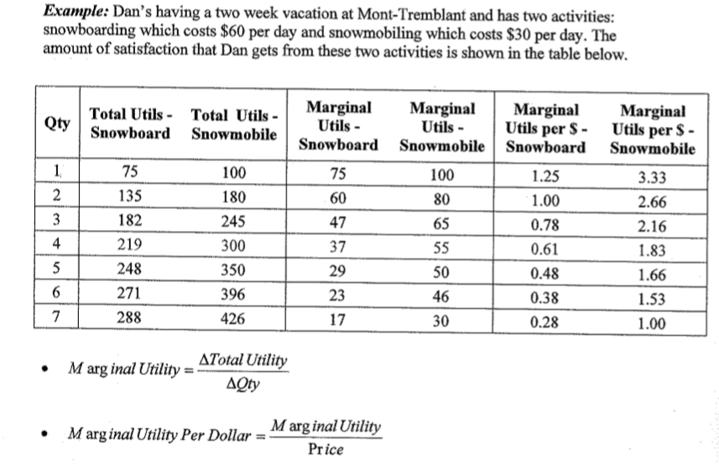

Indifference Analysis
Indifference analysis: trying to find different combinations of two goods that give people the same amount of total satisfaction. (Ex: If I buy 3 watches and 2 socks or 1 watch and 4 socks, I will get the same satisfaction. I am indifferent)
Ordinal Utility: Can’t measure utility (like cardinal utility), can only say if one collection of good or service gives them more satisfaction than another collection. (Ex: I prefer BMW than Mazda, but can’t say by how much)
Indifference curve (IC): Curve where every bundle gives the same level of utility.

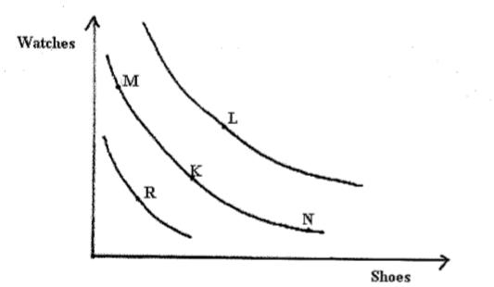
- M, K and N gives the same amount of satisfaction
- L gives more satisfaction
- R gives less satisfaction
- M,K and N = indifference curve
- L has higher indifference curve
- R has lower indifference curve
Characteristics of Indifferent Curves
- Higher IC is better

- I like B because I get the same amount of beer, but more pizza
${IC}_{1}$-> higher level of happiness
B
A
$${IC}_{0}$$

- CAN’T curve down
- I would have the same amount of happiness everywhere, no tradeoff. I don’t give up anything.

- IC can’t touch

- I like A and B the same, C and B the same. Therefore I like C and A the same. Not possible
A
C
B

- IC have to bow in. Avoids extremism
Marginal rate of substitution (MRS): if you want one more unit of “x”, how much “y” will you be willing to give up to maintain your current level of happiness. Slope of indifference curve.
Relative price ratio: what you have to give up

Budget Constraint
Budget constraint: shows all bundles of goods that consumer can afford with a given budget.

Chapter 7 – Firms, Investors and Capital Markets

Business Organizations
- Sole proprietorship : business is owned by one person
- The person keeps all the profits, is personally responsible for losses and debt.
- Example: I borrowed 100 000$ three years ago for my company. My business is failing, the bank is asking me to pay back the loan. The company doesn’t have enough money to pay back the loan, so the bank took my personal items to repay the loan (car, house)
- Partnership: like a proprietorship, but is owned by two or more people.
- They share the profit and are jointly responsible for losses and debt.
- Example: Two equal partners in the business: you will get 50% of the profit and will be responsible for 50% of losses or debt.
- Corporation: separate legal entity from its owners (shareholders) and it is this entity that makes the profit and is responsible for losses/debt
- Example: If the company does not have enough money to pay its debt, the bank cannot go to shareholders and take their personal belongings to repay what’s outstanding. The corporation would go bankrupt.
Shareholders: owners of the corporation.
- They own shares of the corporation
- They receive dividends from the corporation
- They don’t have to manage the corporation
- They are not personally responsible for losses and debt (limited liability)
Limited liability: if the corporation owes people money, the shareholders don’t have to give their personal belongings to the people that the company owes.
Dividends: payments made from after-tax profits to company shareholders.
- It is made on a per share basis
- Example: Corporation decided to give 1$ of dividends to each share outstanding this year. If you own 100 shares, you will be given 100$ (1$x100) as dividends.
Capital gain: difference between how much a shareholders sold his shares and how much he paid to buy them.
- Example: Bought 5 shares at 10$. One year later you sold those shares at 20$. Capital gains= (20$x5) – (10$x5) = 50$
Retained earnings: profits that the company keeps to itself instead of giving them to shareholders in the form of dividends.
- Example: Company made 10 000 000$ in after tax earnings in 2008. It paid 7 000 000$ out in dividends and 3 000 000$ kept in the company. That 3 000 000$ is considered retained earnings.

Profit, Ownership and Corporate Goals
Profit (π) = Total revenue (TR) – Total cost (TC).
- Total cost: explicit (can get a receipt) and implicit cost (same as opportunity cost)
- $π_{accounting}$ > $π_{econ}$
Profit maximization: it’s every company’s objective.
If companies are not as productive or profitable as possible, other companies might try to take them over to do so. Managers always try to maximize profits.
- Shareholders don’t usually manage the company they own stock in -> they hire professionals to manage their company for them.
Example: Just because I own stock in Microsoft, doesn’t mean I work there.
Principal-Agent Relationship: shareholder-manager relationship
Principal: OWNER, person that hires someone (agent) to make decisions on his behalf. Example: Shareholders, defendant, investor, etc…
- Goal: Maximize profit $$$
Agent: person who is hired by the principal to make decisions. Example: CEO, President, lawyers, etc…
- Goal: Not get fired
Principal-Agent Problem: Principal and agent don’t have the same goal. Creates a clash.
- Example: The CEO (agent) decides to re-decorate his office with 5million$ worth of furniture. This expense will not affect the CEO’s pay so he does not care but it will decrease the profits of the company, shareholders (principal) will receive less money.
- SOLUTION: provide incentives –> not necessarily money (Example: 3 days off)

Risk and the Investor
When the owner of the company doesn’t have enough money to keep growing the company, he will need to raise money from someone else (shareholders or bank). In most cases, firms need investors.
Two things that makes an investment risky:
- The possible outcomes. Example: Make 100$, lose 5000$.
- How far the possible outcomes are from each other. Example:
- Scenario 1: lose 100$ or make 100$ vs. Scenario 2: lose 5000$ or make 5000$.
Example 1: If you had a 50% chance of making 20$ and a 50% chance of losing 20$, on average you break even:
- Average Outcome = (0.5 x 20$) + (0.5 x -20$) = 0
- This is a fair gamble because the average outcome is zero.
Example 2: If you had a 70% chance of making 20$ and a 30% chance of losing 20$, on average you win:
- Average Outcome = (0.7 x 20$) + (0.3 x -20$) = +8
- This is not a fair gamble because the average outcome is not zero. The odds are favorable for you.
Example 3: If, instead of 20$, you had a 50% chance of making 200 000$ and a 50% chance of losing 200 000$, on average, you still break even, and this is still a fair game; however it is riskier than 20$ because the possible outcomes are much further from each other. The 50% chance you lose 200 000$ makes it more dangerous than 20$.
Dispersion/Spread: This is the difference between two possible outcomes.
- Example: You can make 200 000$ or lose 200 000$, therefore the dispersion or spread is 400 000$ (-200 000$ -> 200 000$).
There are 3 types of people when it comes to risk tolerance:
- Risk-Averse: prefers to avoid risk
- He will refuse a fair gamble, even if the dispersion in outcomes is small, but may choose to gamble if the odds are sufficiently in his favor.
- Example: I will not lie.
- AGENT (people hired) IS RISK-AVERSE
- Risk-Neutral: indifferent to risk.
- He will accept a fair gamble
- PRINCIPAL (owner) IS RISK NEUTRAL
- Risk Lover: prefers to take risk
- He will accept a gamble even if the dispersion in outcomes is large.
- NERVER THE ANSWER

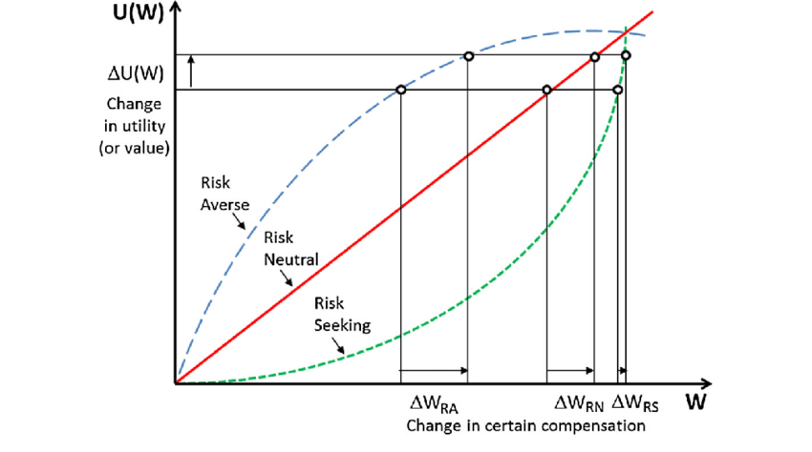

Diminishing Marginal Utility and Risk
Diminishing Marginal Utility: the additional utility from winning 20 000$ is less than the decrease in utility from losing 20 000$. You care more about not losing 20 000$ than you do about winning 20 000$.
- Example: You have 21 000$ and you are offered an equal chance (50/50) of winning or losing 20 000$. By definition, this is a faire gamble but it may not be fair in terms of utility.
- The more money we have, the less we will value additional money (less marginal utility).
- The less money we have, the more we will value additional money (more marginal utility).
Risk-averse people spend a lot of money on reducing risk. Losing 100$ will make their happiness go down much more than winning 100$ will make their happiness go up. Therefore they will try to reduce risk. Examples: Car insurance, home insurance, health insurance, etc.
Example: I’m a car salesperson, my friend is a consultant. We both have risky incomes. On a good month each of us makes 6000$, on a bad month each of us makes 0$.
- If we decide to help each other and split the income when one of us has a good month, then either:
- Both of us have a good month and make 6000$ each (1/4 of the time)
- One will have a good month and the other a bad one so we split the income into 3000$ each (2/4 of the time)
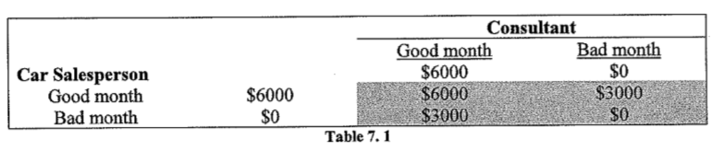
- Both of us have a bad month and get 0$ each (1/4 of the time)

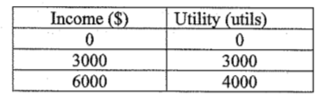
Utility table:

Alone, we get either 0$ or 6000$ with equal probability. We get a utility of 0 (0$) or 4000 (6000$) with equal probability. The probability of making money alone is ½ or 50% of the time.
- Alone, we will each make:
- Av. Income = (0.5 x 6000$) + (0.5 x 0$) = 3000$
- Av. Utility = (0.5 x 4000) + (0.5 x 0) = 2000 utils
- Together, we will each make:
- Av. Income = (0.25 x 6000$) + (0.25 x 3000$) + (0.25 x 0$) = 3000$
- Av. Utility = (0.25 x 4000) + (0.25 x 3000) + (0.25 x 0) = 2500 utils
We will make the same money on average, but when we’re together the probability of making money is 75% as opposed to 50%. Shared outcome -> more utility on average.
- Not sharing outcome would make us both worst off because the gain in utility in going from 3000$ to 6000$ (gaining 1000 utils) is less than the loss in utility in going from 3000$ to 0$ (losing 3000 utils).
Two ways to reduce risk:
- Risk pooling: Act of combining independent risks to make the combined outcome less uncertain, increases average utility. Bringing all together in one location.
- Example: Everyone pays 100$. If my house burns down, I receive 200 000$. Guaranteed loss of income but if something happens, the risk of incurring a larger loss is avoided.
- Risk spreading: Spreads risk over many people, reduces the stake of risk that each person is liable for.
- Example: A project requires and investment of $10 million. I can invest the entire $10 million and take 100% of the risk, or I can invest only $1 million and tell my friends to invest $1 million each. The risk is spread out to 10% each.

Uncertainty and Asset Returns
When an investor thinks of investing in a firm, he will check out the returns normally obtained from other similar investments products to compare if it is a good investment or not (Example: Government treasury bills, bonds, gold, companies in same industry, etc.)
Treasury bills: short-term government bonds (you are lending the government your money). Usually sold for a period of 3, 6 or 9 months, usually the safest investments.
- Example: I purchased a treasury bill from the Gouv. of Canada for 99$, I am promised to get 100$ back after 3 months. I earned around 1% in this three-month period:

$$Capital Gain Return= \frac{P_{sold- }P_{purchased}}{P_{purchased}}= \frac{100-99}{99}=1.01\% return$$
Investors invest in company shares because shares tend to give a higher return on average over a long time period.
- The higher return compensates the investor for investing in a risky company rather than in low-risk government treasury bill.
Nominal Return: rate of return achieved before inflation is taken into consideration.
Inflation: rate of increase in prices.
Real Return: Equal to nominal return MINUS the rate of inflation.

Financing the Risky Firm: Diversification
Risky firms succeed in attracting investors through the capital market.
Capital Market: All the financial institutions that help people invest their money in companies and at the same time help companies to get money from investors. Link between investors and firms. (Examples: Stock brokers, investment banks, etc.)
Portfolio: Mix of assets including the shares that the investor owns. Designed to achieve a specified return and reduce risk through diversification.
- Example: I invest 10% of my money in ‘Google Inc.’, 20% in ‘Walmart’, 20% in ‘Gold’ and 50% in government treasury bills.
Diversification: When an investor invests in many different assets whose returns are independent. (Example: A weapon manufacturer, Tim Hortons, and an oil company).
- This reduces total risk of a portfolio by pooling risks while still achieving similar return.
Chapter 8 – Production and Costs

Efficient Production
Efficient production: The company produces goods and services with minimal waste of resources (labour, machines, money, time, space, etc.)
$$Q=f(k,L)$$
Q= quantity
K= capital
L= labor
Production function: How much output can be produced with specific amounts of inputs in production. Example: how many IPods can we produce with 500 machines and 1000 assembly workers.
Production efficiency can take 2 forms:
- Technological Efficiency: Maximum output is produced given any set of inputs.
- Example: Mega uses 300 workers and 5 machines to produce cellphones. Given the amount of input, they are producing the maximum possible amount of cellphones. They don’t have waste (they are technologically efficient).
- Economic Efficiency: Production method produces the exact output required at the least cost. Doesn’t matter what kind of inputs are used as long as it’s the cheapest method.
- Example: Mega can use 2 different methods to produce 1 million cellphones per month:
Option 1: 300 workers and 5 machines: Total cost per month = 800 000$
Option 2: 60 workers and 12 machines: Total cost per month = 1 200 000$
Both methods produce the same output, but should choose Option 1 because it is economically efficient.
Companies can work within 2 different time frames:
$Q=f(\overline{k},L)$ $\overline{k}$ = fixed
- Short-Run: At least one factor of production is fixed.
- Example: Mega can hire new employees in a short period of time. Installing new equipment takes more than 4 months. -> 4 months or less is the “short-run” for Mega as equipment is fixed within that period (can’t add or remove equipment within that period).
- Long-Run: All factors of production are variable.
- Example: It takes Mega more than 4 months to install new equipment -> 4 months and above is considered the “long-run” because equipment, employees and all other factors become variable after that period (can add and remove anything easily within that period).

Production in the Short-Run
K (capital) will always be fixed. Companies cannot install additional machines and equipment in the short-run, so production is fixed L (labour) changes.
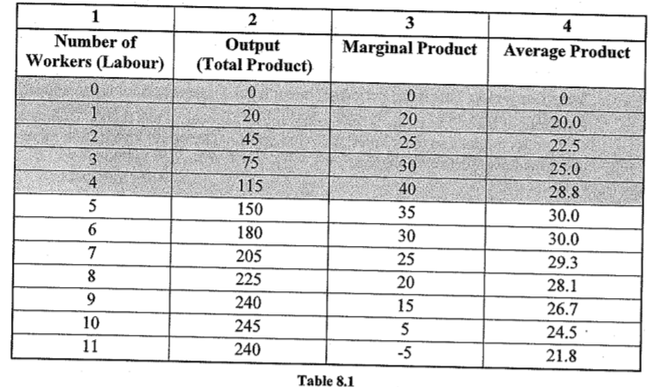
Total Product (TP): Total output produced with a given number of workers (labour) in a facility of fixed size.
$$AP=\frac{TP}{L}=\frac{20}{1}=20$$
$$MP=\frac{∆TP}{∆L}=\frac{45-20}{2-1}=25$$

$$AP=\frac{Q}{L}or \frac{TP}{L}$$
Average production (AP): Amount of output produced, on average, by workers at different employment levels.
Marginal product (MP): Additional output produced by each additional worker.
- Example: In table 8.1, when we hired a 2nd worker, total production went from 20 to 45. This 2nd worker processed 25 additional applications (marginal product), his MP is +25.
$$MP=\frac{∆Q}{∆L} or \frac{∆TP}{∆L}$$
0 to 4 workers: MP of each worker is increasing. Why? Many reasons:
- With each additional worker, all workers can spend more time in their office
- Can specialize with one task -> less time moving between tasks.
- Fewer errors to deal with in product.
At worker 4: MP reaches a maximum and begins to fall.
- Additional workers produce more total output (115, 180, 205) but at a diminishing rate (35, 30, 25)
Law of Diminishing Returns: As more workers are hired, each additional worker won’t be as productive as the previous one.
- MP will start to decrease.
- Why? Many reasons:
- Office becomes crowded, workers are getting in each other’s way.
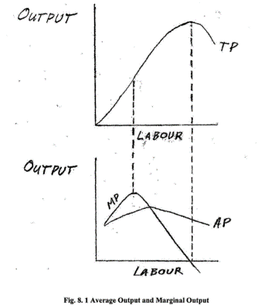
- Social environment is too large, less efficient (workers waste time).
- Workers can no longer keep tabs on who is doing what tasks.
As soon as MP went below AP, AP started falling.
GENERAL RULE:
- If MP > AP, then AP ↑
- If MP < AP, then AP ↓
- MP is the leader indicator
Example: if I keep scoring lower on my next courses than my present GPA, my GPA will go down (vice-versa)

Costs in the Short-Run
Fixed Costs (FC): Costs that don’t change as the level of output changes.
- Example: A person who sells me a machine does not care is I use the machine to produce 100 units or 100 000 units (level of output) -> I will pay a fixed cost of 10 000$ to buy it.
Variable Costs (VC): Costs that change as the level of output changes.
- Example: Producing 1000 units per week -> pay electricity bill of 150$. I increase production to 5000 units per week -> consume more electricity -> electricity bill is now 750$. Electricity cost is a variable cost.
Total Cost (TC): Sum of fixed cost and variable cost.
$TC=FC+VC$
Average Fixed Cost (AFC): Total fixed cost per unit of output.
$$AFC=\frac{FC}{Q}$$
Average Variable Cost (AVC): Total variable cost per unit of output.
$$AVC=\frac{VC}{Q}$$
Average Total Cost (ATC): Sum of all costs per unit of output.
$$ATC=\frac{TC}{Q}$$
Marginal Cost (MC): Cost of every additional unit produced.
$$MC=\frac{∆TC}{∆Q}$$
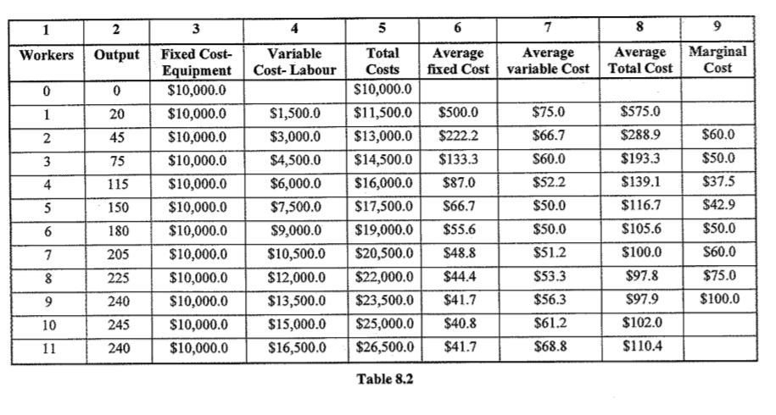
$$MC=\frac{∆TC}{∆Q}= \frac{13 000\$-11 500\$}{45-20}$$
$$MC=60\$$$

When Marginal Product (MP) of an additional worker is increasing -> MC of the additional output produced is decreasing.
- When workers are more efficient, it costs us less for each additional output produced.
0 to 6 workers: Workers become more productive, but the cost of employing each additional worker is constant (same salary) -> labour costs per application decreases (AVC↓)
6 workers and more: As productivity declines, the labour cost per application increases (AVC↑)
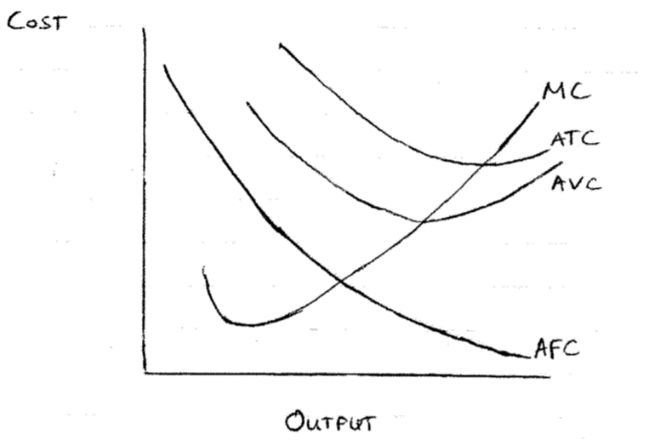
GENERAL RULE:
- AVC goes ↓ when AP ↑
- AVC goes ↑ when AP ↓
- AVC is minimum when AP is maximum

GENERAL RULE:
- MC goes ↓ when MP ↑
- MC goes ↑ when MP ↓
- MC is minimum when MP is maximum

GENERAL RULE:
- If MC < AVC, then AVC↓
- If MC > AVC. Then AVC↑
- Marginal cost is the leader indicator
MC curve intersects ATC and AVC curve at their minimum.
- If company cannot make profit, will NOT necessarily shut down. If it can cover variable costs, should stay in production. All other costs are not to be taken into consideration, they will exist whether you stay in business or shut down. If Price < AVC, in short-run business should SHUT DOWN.

Long-Run Production and Costs
Both factors are changing (K and L)
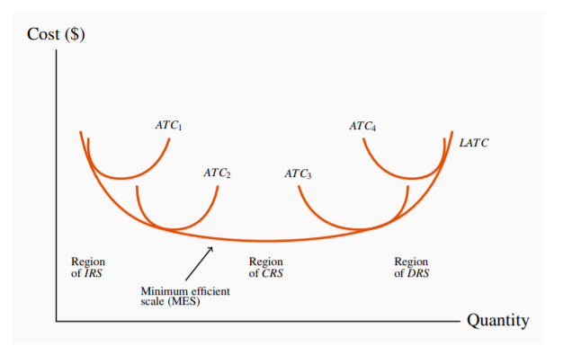
Economies of Scale: Cost advantages that a business gets when they expand. ATC↑ as they increase their output.
- Production costs almost always go down when the size of production initially increases.
Diseconomies of Scale: Forces that cause a firm to produce at higher average costs because it becomes too large. Example: Monitoring costs are high due to the large size of the company.
The ATC curves shift to the right (${ATC}_{1}$→${ATC}_{2}$) as the business initially expands and ATC decreases.
- Point in expansion (${ATC}_{4}$): Company becomes too large, cannot benefit from any more economies of scale.
Constant Returns to Scale (CRS): When all inputs are increased by a given proportion, output increases equally proportionately.
- Example: Own 2 machines (input), produce 1000 units (output) per day. Decide to double the amount of machines (4 machines). Output increases to 2000 units per day. -> Output doubled when input doubled.
- ATC remains constant
Increasing Returns to Scale (IRS): When all inputs are increased by a given proportion, output increases more than proportionately.
- Example: Own 2 machines, produce 1000 units per day. Decide to double the amount of machines (4 machines). Output increases to 3000 units per day. -> Output more than doubled when input doubled.
- ATC↓
- Not sustainable, will burn out
Decreasing Returns to Scale (DRS): When all inputs are increased by a given proportion, output increases less than proportionately.
- Example: Own 2 machines, produce 1000 units per day. Decide to double the amount of machines (4 machines). Output increases to 1500 units per day. -> Output less than doubled when input doubled.
- ATC↑
Long-Run Average Total Cost (LATC): Average cost of production in the long-run (where all economies of scale are achievable)
- Combination of all short term ATC curves at their lowest ATC
Minimum Efficient Scale: The firm has expanded enough to take advantage of all available economies of scale.
Chapter 9 – Perfect Competition
Perfect Competition (PC) is the most market friendly structure. Maximizes the total surplus.

The Perfectly Competitive Marketplace
5 characteristics of PC:
- There are many buyers and many sellers.
- There are no barriers to entry or exit.
Key to determine my demand curve.
- People can open and close a business in the industry easily.
- All firms, all consumers are price takers.
- Not one firm or consumer is big enough to influence the price.
- The product is homogeneous.
- Perfect information.
- Buyers have full information about the product features and its price.

A Firm’s Supply Decision
Number of firms in the industry and their size are considered:
- Fixed in the short-run.
- Variable in the long-run.
Marginal Revenue (MR): Additional revenue received from selling one additional unit.
- Since each firm is a price-taker, price is constant. Each additional unit sold brings in the same additional revenue. MR = Price.
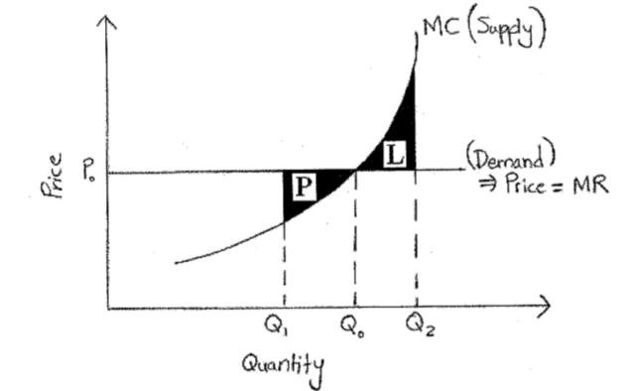
Marginal Cost (MC): Additional cost incurred from producing one additional unit.
MR = MC → Max Profit (TR-TC)
- At $P_{0}$, optimal quantity is $Q_{0}$ where MR=MC
- $Q_{1}$ → MR > MC → giving up profit (Area P)
- $Q_{2}$ → MR < MC → having a loss (Area L)
- MC curve = additional cost from producing an additional unit. Firm require additional revenue (price) to cover additional cost.

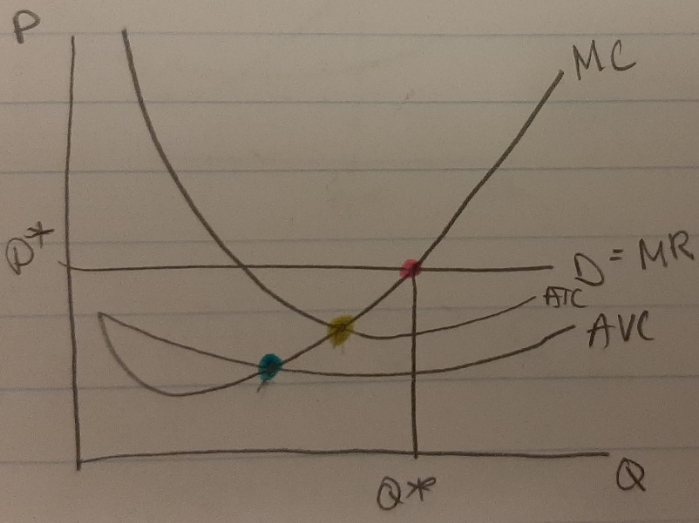
Optimal Point (MR=MC): Where the firm wants to be.
Breakeven point (MC=ATC): No profit, firm is selling product at price less than ATC (Price < ATC)
Shut down point (MC=AVC): Firm is not covering AVC. Constantly losing money, should shut down.
MC intersects ATC and AVC at their min.
Q*: quantity produced and brought. Always achieve this point in PC.

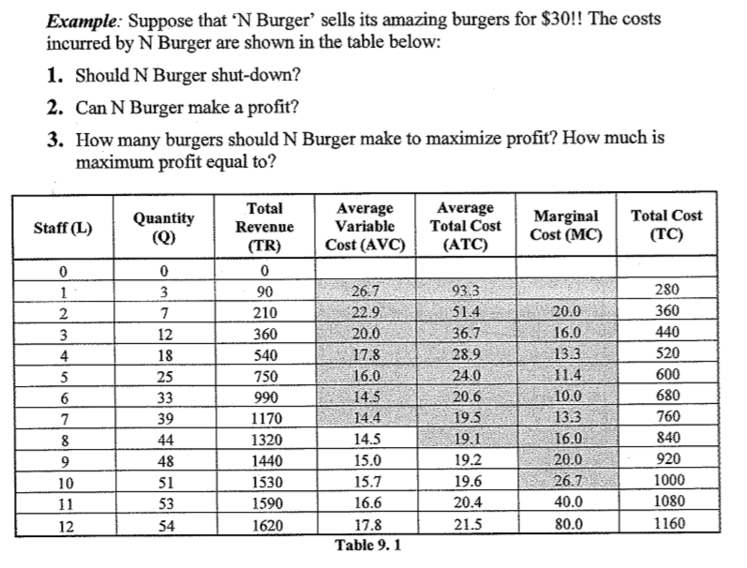
- Minimum AVC = 14.4$
- Price (30$) > AVC, should not shut-down.
- Minimum ATC = 19.1$
- Price (30$) > ATC, can make a profit
- Profit maximization: MR=MC (or Price=MC).
- MR (30$) ≈ MC (26.7$) → should make 51 burgers.
- Anything above 51 will make MR < MC, will lose money.
- Maximum profit:
M.p = (Price x Quantity) – (ATC x Quantity)
M.p = (30$ x 51) – (19.6$ x 51) = 530.4$

Industry Dynamics: Entry and Exit of Firms
Normal Profits: Profits that producers require to stay in business. Cover opportunity cost → if can make more money working somewhere else, will not stay in business. IMPLICIT COST.
- Demand curve for the entire industry is not fixed at one price like demand curve for each firm. Industry as whole is not a price taker → each firm in the industry is a price taker.
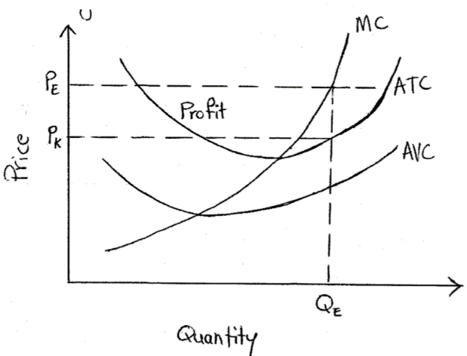
Supernormal Profits: All profits above normal profits.
At $Q_{E}$:
- Market price = $P_{E}$
- ATC = $P_{K}$
- Profit per unit = $P_{E}- P_{K}$
- Total profit (supernormal) = Area ‘Profit’ = $Q_{0}*(P_{E}-P_{K})$

Free entry and exit = firms will enter the industry when supernormal profits exist.
- When more firms enter the industry, supply curve shifts to the right, equilibrium price falls.
- New firms will keep entering, pushing the price ↓ until supernormal profits don’t exist anymore. (Price = minimum ATC)
- Long-run industry equilibrium price = minimum point of a firm’s ATC curve → only normal profits exist, no incentive for firms to enter or exit
- When firms can’t cover ATC in the long-run, they will shut down.
- When firms exit the industry, supply curve shift to the left, price goes up.

Long-Run Industry Supply
Some firms won’t survive in the long run because
- Firms are making supernatural profits → new firms enter industry → price ↓ to minimum ATC of firms operating with lowest cost
- Firms who DO NOT operate at lowest cost are forced to exit industry (or adjust cost size)
In long-run, firms will not make economic profit: MC, ATC and D (MR) will intersect →breakeven point.
- If economic profit = 0 → accounting profit = positive.
Summary of Rules
- Demand ↑ → Price ↑ → supernormal profits exist → new firms enter industry → short-run supply curve shifts to right → Price ↓
- Demand ↓ → Price ↓ → losses exist → firms exit industry → short-run supply curve shifts to left → Price ↑
- Free entry/exit will lead to a long-run industry equilibrium price equal to the minimum point of a firm’s ATC curve.

4 steps to maximization
- Find Q* → optimal quantity (MR=MC)
- Find P* → optimal price (use MR)
- Find AC*
- Find total profit (π) → π = (P* – ATC)Q

Advantage of PC
- Perfectly efficient: Price = AC / π = 0 / no one wants to enter or leave.
- Allocatively efficient: price the consumer is willing to pay is almost equal to the marginal utility.

Disadvantage of PC
- Prone to market failure
Chapter 10 - Monopoly

The Monopolistic Marketplace
Monopolistic is the least market friendly structure.
Monopolist: A company that has a monopoly over an industry.
5 characteristics of a Monopoly:
- The company is a Price Setter.
- The monopolist can set the price they want to sell their product at.
- The products are heterogeneous.
- Example: Hydro Quebec provides electricity AND water to the people.
- There is one seller, many buyers.
- Can have both perfect and imperfect information.
- Imperfect information: consumers can keep secrets → single price monopoly (SPM)
- Perfect information: everything is shared → price discrimination monopoly
- There are barriers to entry or exit.
- High cost of entry
- Government says no
- Economies of scale (able to produce larger quantities)
- Government driven
- Predatory pricing
- No substitutes (can’t stop buying electricity from Hydro-Quebec)

3 reasons why monopolies exist:
- Economies of Scale (Natural Monopolies)
- One firm in the market is large compared to other competitors. Larger scale → can produce at lower ATC.
- Can usually supply the entire market at lower prices, smaller firms can’t compete at these prices to survive.
- National Policy
- Some governments have a “national firm” control an industry.
Example: Hydro-Quebec is the provincial electricity producer.
- Successful Entry Barriers
- Patents: legal rights a firm gets to be the only producer of a product in the industry. Usually happens when the firm invents the product.
Example: Gatorade, Viagra, Xerox photocopy machines.
- Predatory Pricing: Existing firm sells at a price lower than a new firm can afford to. Monopolist can afford to, new entrants cannot survive and must exit the industry.
- Lobbying: Firms hire people to influence political groups to pass laws that make it hard for new firms to enter.
Example: I hire a lobbyist to convince a political group to pass a law that says ‘new weapons manufacturers have to pass five stages of licensing and pay 15M$.
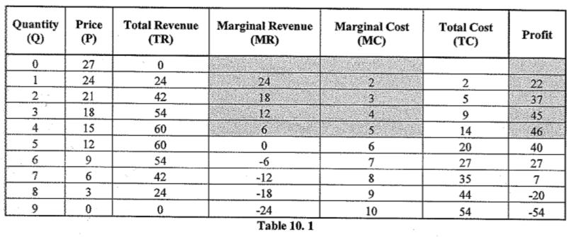
Profit Maximization Rule:
- If MR > MC, increase output
- If MR < MC, reduce output
- If MR = MC, optimal output
Optimal output in Table 10.1 is 4 units
Demand and supply line functions:
- Demand: P = 27 – 3Q
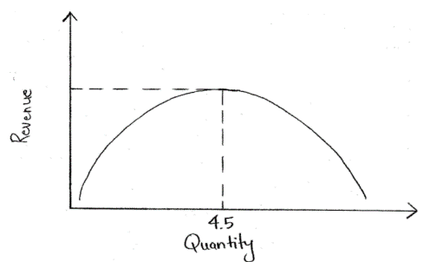
- Marginal Cost: MC = 1 + 1Q

Total Revenue is maximized at midpoint of the demand curve (unit elastic). Midpoint is output where MR goes from positive to negative.
Important Note: Maximum total Revenue is NOT the same as Maximum Profit.
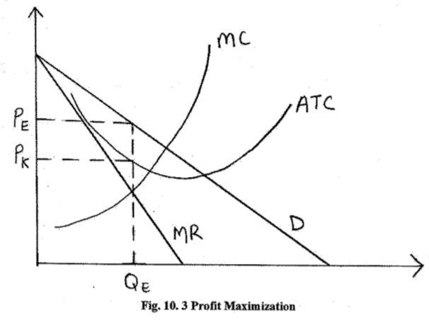
Profit maximization price for a monopolist lies on the elastic segment of the demand curve.

- Profit Maximizing Output (optimal output) is at $Q_{E}$, where MR=MC
- Profit Maximizing Price is at $P_{E}$
- Profit per unit is $P_{E}$ - $P_{K}$ → Total Profit = $(P_{E}$ - $P_{K}$) x $Q_{E}$

Monopoly in the Long Run
- Monopolist can choose to expand as much as he likes.
- If demand ↑ and demand curve shift to the right, monopolist is able to expand at a constant return to scale.
- Monopolist’s ATC and MC curve is horizontal
- By ↑ output, earns a profit on each additional unit as long as MR curve is above the long-run MC curve.

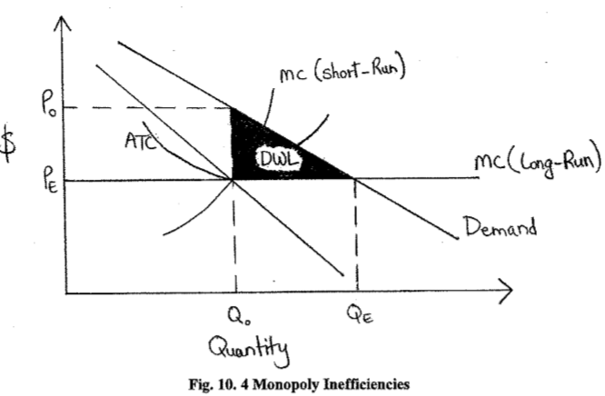
Monopoly and Inefficiencies
Marginal benefit (MB) = demand curve (willingness of buyers to pay increasing amounts).
MR
=MB
MR is lower than demand curve (MB), monopoly equilibrium NOT equal to free market equilibrium.
- It output is increased beyond$Q_{o}$, the MB > MC or producing it.
- Creates a DWL: industry output is so low that society as a whole is sacrificing the possibility of creating additional surplus (inefficient).

Monopoly and Price Discrimination
PERFECT INFORMATION
- Segment market at reasonable cost.
- Different elasticities.
- Prevent resale from one market to another.
Price Discrimination: firm charges different prices to different consumers to increase profit. (Example: Regular pay 11$, students pay 6$)
- Two conditions:
- The seller must be able to divide the market. (Example: Students, seniors).
- Resale must be impossible or impractical. (Example: Students should not be able to buy movie tickets at a lower price and re-sell it to regulars at a higher price).
- Can reduce DWL because monopolist can sell at a free market equilibrium quantity as long as he charges a different price to different consumers.
Perfect Price Discrimination: firm charges different price to every single buyer (or for every unit sold).
- Perfect because each unit is sold at the different prices that people are willing to pay for them.

Cartels
Cartel: agreement among competing firms. They co-operatively reduce output to increase profits. (Example: OPEC → ‘Oil Cartel’. Represents biggest oil producing countries, control the supply of oil to achieve maximum profits.)
- Cartels act like a monopoly → result in DWL
- When each firm in cartel produces at quantity $Q_{o}$ and price${ P}_{o}$, each firm will make a profit per unit of $P_{o}$ - $P_{E}$. All member of cartel must agree to restrict their output to $Q_{o}$ or it will not work.
- Since DWL loss exists (lost value), each firm faces incentive to increase output at discriminatory prices to increase revenue. Firms stop increasing output once they reach market equilibrium (Quantity Demanded = Quantity Supplied).

Monopoly and Rent-Seeking Behaviour
Rent Seeking: Resources are being used to redistribute benefits (NOT creating new benefits). Takes form of lobbying. (In this case, pass laws that increase difficulty for new firms to enter the industry).
- Example: Canadian media owners try to reduce competition from U.S based competition by requesting the Radio Commission to restrict the inflow of signals from U.S stations.
- Industries with supernormal profits (monopolies, cartels) exercise rent seeking (lobbying) to protect profits.
- Lobbying costs money, ATC increases and shifts upwards.

Advantages of Monopolies
- Innovative: Create better products, services or processes.
- Market doesn’t fail.

Disadvantages of Monopolies
- Market inefficiency: not being productively efficient, not using resources at their fullest.
- Allocatively inefficient: Sell a lower quantity in the market, at a higher price.
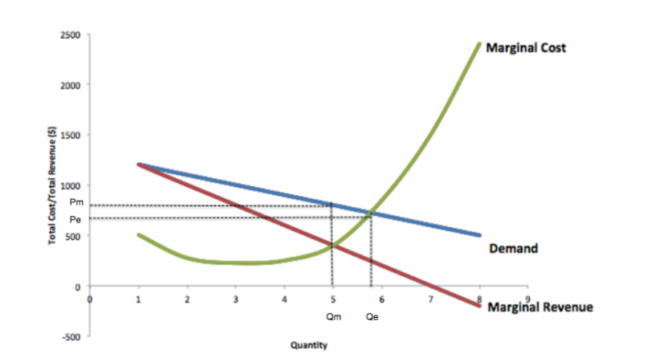
Reminder
Allocative Efficiency: Production at $Q_{e}$ where${ P}_{e}=MC$.
Monopoly produces less output, sell at higher price to maximize profit. $Q_{m}$ and${ P}_{m}$.
Monopolies don’t produce enough output to be allocative efficient.
Reminder output: quantity of goods or services produced by a firm, industry or country.

Chapter 11 – Imperfect Competition
PC and pure monopoly: opposite extreme market structures. Most markets are in between. Are Imperfectly Competitive.

Imperfect Competition
Two specific forms of imperfect competition:
- Monopolistic Competition
Product Differentiation → choice
- 5 characteristics:
- Price makers. → Firms can to some extent influence the price and quantity of products sold.
- Many buyers, many sellers. → not as many sellers as in PC
- Heterogeneous product. → differentiated products (Example: Restaurants, clothing stores, hair dressers).
- No barriers to entry or exit.
- Imperfect information.
Example: Fast food industry in Canada = monopolistic competition. Many chains and restaurants, but differentiate themselves from each other (how they present food, type of food). If I want spicy food, I go to Thai express. Thai can increase its price a little without affecting my consumption.
DIFFERENCE BETWEEN MONOPOLISTIC COMPETITION AND PC: In Mono. Comp. each firm has SOME ability to affect its output price because of its Product Differentiation.
- Oligopoly
Strategic inter-dependence. Decisions of my firm affects other firms (vice-versa). Game theory.
- 5 characteristics:
- Price makers.
- Many buyers, fewer sellers. → Industry is dominated by 6 or less firms.
- Heterogeneous products.
- Barriers to entry or exit.
- Imperfect information.
Example: Cell phone industry in Canada is an oligopoly. If ‘Fido’ lowers its monthly plan, ‘Bell’ and ‘Telus’ will react by lowering their monthly plan. Each firm is able to influence the market.
An Imperfectly Competitive firm faces a downward-sloping demand curve (unlike PC → horizontal) because products are differentiated, consumers have some brand loyalty.
Most efficient

Less efficient
Structure | # of firms | Ability to affect $ | Entry barriers | Example
Perfect Competition | Very many | None | None | Veggie Store
Monopolistic Competition | Many | Little | Little | Thai Express
Oligopoly | Few | Medium | Medium | Fido
Monopoly | One | Large | Large | Hydro-Quebec

Why Do Market Structures Differ
Main reason for different market structures in different industries: they have different costs.
- The higher the costs in an industry, the fewer the number of companies.
Example: How easy is it to start a business that competes with ‘Boeing’ as opposed to a business that competes with a ‘Depanneur’? → Business like Boeing need very high investment in equipment, expertise, ability to produce high quantity airplanes in order to take advantage of working at minimum average total cost (ATC) to be able to compete with Boeing. → Depanneur requires less investment, little knowledge to begin.
Sometimes, enough companies in market are operating at minimum ATC. → No more room or demand for new company to enter industry because all the current market demand is already satisfied.

Monopolistic Competition
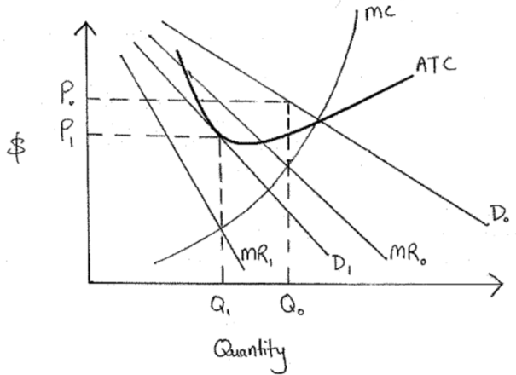
Short-run:
- $D_{o}$ → Demand for each firm.
- ${MR}_{o}$→ MR for each firm.
- Profit maximized at MR = MC, at price $P_{o}$ and quantity $Q_{o}$
- $P_{o}$ > ATC → supernormal profits exist.
- Supernormal profits exist → new firms enter industry
- New firms enter → demand curve for each firm in the industry shifts to left.
- Goes on until supernormal profits disappear in long-run.
Long-run:
- $D_{1}$ → Demand for each firm.
- ${MR}_{1}$ → MR for each firm.
- Profit maximized at MR = MC, at price $P_{1}$ and quantity $Q_{1}$
- $P_{1}$ = ATC → supernormal profits are Zero.
- ATC is tangent to demand curve → Price = ATC → supernormal profits Zero.

Advantages of Monopolistic Competition
- Product differentiation: allows for choice → excess capacity (Example: more clothes on racks than customers, more hotels room than clients).
- Productively efficient

Disadvantages of Monopolistic Competition
- Allocatively inefficient
- Marketing and advertising (informative vs. non-informative).

Oligopoly and Game Theory
Each firm must think about its actions and how competitors will react.
- Example: If ‘Fido’ wants to offer customers a deal, how will ‘Telus’ react? Will it also make the same offer to customers? Will this end up negatively affecting Fido?
Conjecture: When ‘Firm A’ thinks ‘Firm B’ will have a certain strategic reaction to Firm A’s action. (Example: Fido thinks Telus will make the offer as them → conjecture).
Firms in an oligopoly can:
- Collude: Make an agreement to avoid competition and work together to increase profits → Decreasing quantity supplied to increase price and profits of firms. (Illegal but always happens).
- Compete: Don’t agree with anything, compete with each other.
Oligopolists are interdependent: always try to guess their competitor’s next move (like chess).
Nash Equilibrium: No player in the game would take a different action as long as other player remains the same. No incentive (motivation) to do so. Can have multiple Nash equilibrium.
Dominant Strategy: Player’s best strategy no matter what the other players do.

Game Theory
Payoff matrix |  | Telus
 |  | Offer deal 2 | No Offer
Fido | Offer deal 1 | $10M, $10M | $25M, $5M
Fido | No Offer | $5M, $25M | $20M, $20M

Fido (first number):
- When Telus offers deal 2 ($10M) → Fido makes more profit it offers deal 1 ($10M).
- When Telus no offer ($5M) → Fido make more profit it offers deal 1 ($25M).
- Fido makes more profit when offers deal 1 no matter Telus’s strategy → Offer deal 1 is a Dominant Strategy.
Telus (second number):
- When Fido offers deal 1 ($10M) → Telus makes more profit if offers deal 2 ($10M)
- When Fido no offer ($5M) → Telus makes more profit if offer deal 2 ($25M)
- Telus makes more profit when offers deal 2 no matter Fido’s strategy → Offer deal 2 is a Dominant Strategy.
Natural outcome is (Offer deal 1, Offer deal 2) → Nash Equilibrium.
- BUT: They can make more profit if they both offer nothing ($20M instead of $10M).
- Why not do it? Not an equilibrium outcome → each firm will have an incentive (motivation) to make an offer.
The (No offer, No offer) outcome is a two-player cartel → both firms have to collude. How?
- Commitment: Agreement that restricts future actions. (Example: Fido and Telus agree to restrict making an offer in the future).
- Credible Threat: Threat that will always be effective.

Duopoly and Cournot Games
Duopoly: Market with just 2 dominant firms. (Example: VISA and MasterCard, FedEx and UPS).
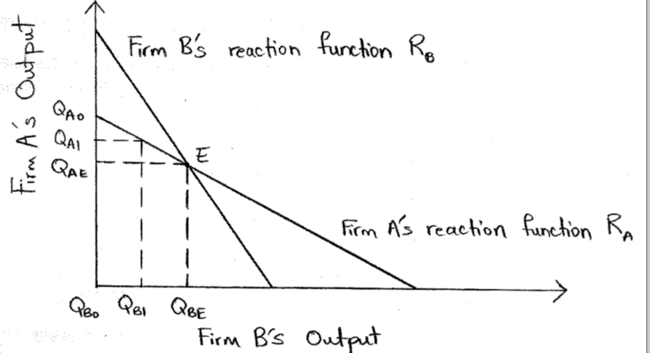
Cournot Duopoly Model: each firm tries to maximize its profits based on the output produced by the other firm. Cournot game is competitive, not co-operative.
Reaction function: Shows how Firm A will react to a change in the output of Firm B (vice-versa).
- $R_{A}$ → reaction function of Firm A
- $R_{B}$ → reaction function of Firm B
- $R_{A}=R_{B}$ → intersect at point E (Nash equilibrium)
- If both firms have same MC curves → will produce same output $Q_{AE}=Q_{BE}$ at equilibrium
- If both firms have different MC curves → will produce different output. Firm with lower cost = greater market share.
Chapter 15 – International Trade
International Trade: goods or services are exported or imported from one country to another.
- Trade is good → makes us better-off.
- Will never engage in free market if I’m going to lose.
- When we trade, I gain something but I also lose something.

Comparative Advantage
Law of Comparative Advantage: Countries can specialize in producing goods they have low relative costs in and export them to countries that have high relative costs.
Comparative advantage: Opportunity cost of producing product to ‘Country A’ is lower than opportunity cost of producing same product to ‘Country B’.

Law of Absolute Advantage: If Country A uses fewer inputs (resources) than Country B to produce a good, Country A has absolute advantage in its production.
Opportunity cost: Relative cost of producing different goods. (Example: Canada gives up 15 computers to produce 1 car. China gives up 10 computers to produce 1 car. → cost to produce 1 car in China (10 computers) is relatively less than cost to produce one car in Canada (15 computers).
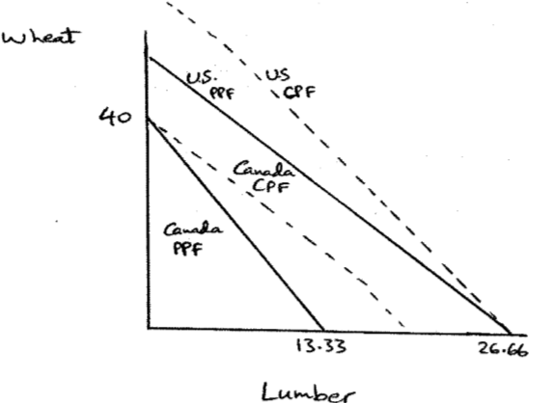
Consumption Possibility Frontier (CPF): Different combinations of 2 goods/services that a certain economy can consume

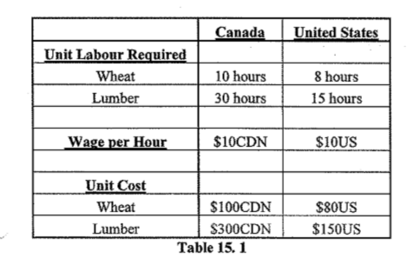
- Canada and U.S have 400 hours of labour each.
- U.S uses less labour hours in producing both products → U.S has absolute advantage in producing both products.
Who has comparative advantage in producing W and L?
- Canada:
- Can produce 40 units of wheat OR 13.33 units or lumber in 400 hours.
- 40 units of W = 13.33 units of L
40W=13.33L40W13.33=1L3W=1L40W=13.33L40W13.33=1L3W=1L
$40W=13.33L$
$$1W=\frac{13.33L}{40}$$
$$1W=0.33L$$
- Canada’s opportunity cost of producing:
- 1 unit of W = 0.33 units L
- 1 unit of L = 3 units of W
- U.S:
- Can produce 50 units of wheat OR 26.66 units of lumber in 400 hours.
- 50 units of W = 26.66 units of L
$$50W=26.66L$$
$$\frac{50W}{26.66}=1L$$
$$1.86W=1L$$

$50W=26.66L$
$$1W=\frac{26.66L}{50}$$
$$1W=0.53L$$

- U.S.’s opportunity cost of producing:
- 1 unit of W = 0.53 units of L
- 1 unit of L = 1.86 units of W

- Canada’s opportunity cost of producing W (0.33) is less than U.S. (0.53). → Canada has comparative advantage to producing W.
- Canada’s opportunity cost of producing L (3) is more than U.S. (1.86) → U.S. has comparative advantage to producing L.
- U.S. should specialize completely in producing L; Canada should specialize in producing W AND trade L for W (vice-versa).
- U.S. will produce 26.66 units of L, Canada will produce 40 units of W.

Does Everyone Gain from Trade?
Consumers generally gain from international trade:
- Can buy goods at lower price (because increased competition).
- Get a wider variety of good available.
BUT, some people lose from trade. Example: When CAD-USD exchange rate goes down, products in U.S. become more expensive;
- Canadian consumers lose → have to pay high local price.
- U.S. producers lose → Canadian consumers buy less U.S. products.
- Canadian producers gain → Canadians buy more Canadian products.

Protectionism
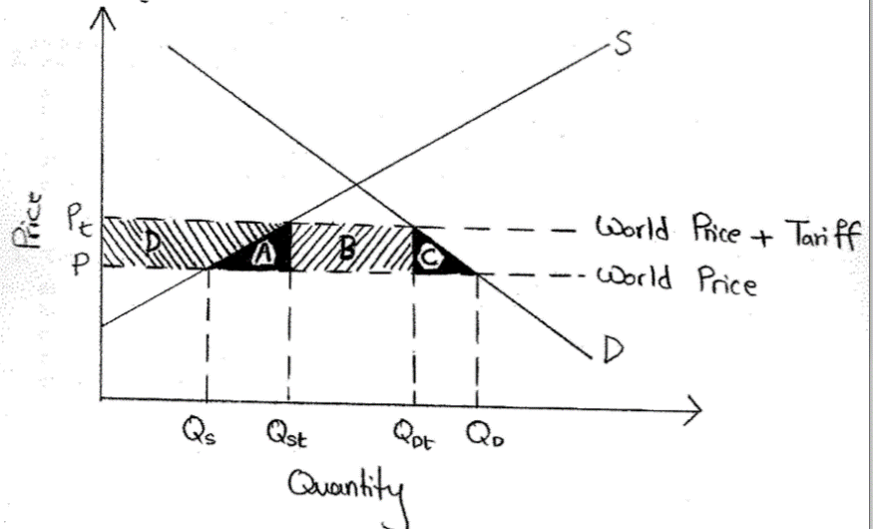
Tariff: Tax imposed on imports. (Example: Country A puts a 30% tariff on imported shoes to reduce external competition).
Before tariff:
- D → domestic demand curve
- S → domestic supply curve
- P → world price of the product
- At P → domestic quantity supply $Q_{s}$ domestic quantity demanded$Q_{D}$.
- Gap between $Q_{s}$ and $Q_{D}$ → filled by imports.
- Free trade equilibrium.
After tariff:
- $P_{t}$ → new price that consumers pay.
- As P →${ P}_{t}$, domestic quantity supplied increases $Q_{s}$ →$Q_{st}$, domestic quantity demanded decreases $Q_{D}$ →${ Q}_{Dt}$.
- Consumer surplus LOSES area A, B, C and D.
- Producer surplus (domestic) GAIN area D
- Government tax revenue is B (no tax revenue when no tariff).
- Net loss to the domestic economy → area A and C.

Quota: Restriction on quantity imported. (Example: Country A places a 1000 unit limit on vehicles imported from other countries → wants to protect its auto producers from global competitors).
- Accomplish same thing as tariff
- Need to have a license to import → government gives license
- Advantage of license: can buy good at price without tariff and sell it in Canada at price with tariff → guaranteed profit.
- More corruption.

