COMM 210- Final Exam
The Theorists:
Alfred Chandler: The Enduring Logic of Industrial Success
The Concepts:

- Logic of Managerial Enterprise: The dynamic growth and competition that drives modern industrial capitalism

- Economies of scale: Large plants can produce products at a much lower cost than small ones because the cost per unit drops as the volume of output rises

- Economies of scope: Large plants can use many of the same raw and semi-finished materials and intermediate production processes to make a variety of different products

- Management hierarchy:
- lower and middle managers: coordinate products though production and distribution
- top managers: coordinate and monitor current operations and to plan and
Allocate resources for future activities

- First movers & challengers: companies that quickly dominated their industries by making large investments and gaining competitive advantage. (high market share)
- created national and international marketing distribution organizations
- recruited teams of managers
- They engaged in systematic R&D to improve their products and processes, they differentiated as well. They captured markets and others may not want to compete.

- Research & development: to improve products and processes. Innovation and strategy is more important than price.

- Related & unrelated diversification:
- Unrelated diversification: when managers acquire businesses in which they
have few if any organizational capabilities to give them a competitive edge
(ignore logic of managerial enterprise)
- Related Diversification: Expanding in your field of knowledge

This leads to…

- Separation of top vs middle managers:
- Top managers have little knowledge of or experience with the technological processes and markets of the new acquisitions
- Overload in decision making at the corporate office
- Stock market pressures: loose profits and market share if:
- Entrepreneurial enterprises fail to become managerial enterprises
- Managerial enterprises fail to maintain their competitive capabilities
- Short‐term thinking: making a quick buck and trying to gain competitive edge through unrelated diversification

CHANDLER’S MAIN CLAIMS:

• Logic of Managerial Enterprise: Successful firms capitalize on economies of scale & scope, create management structures and invest in research & development
• Once a firm loses the opportunity to be a first mover, it is difficult to regain
Competitive advantage
For firms to benefit from economies of scale or scope:
- Flow of materials must be kept constant
- National (and international) marketing and distribution functions must be created
- Teams of lower and middle managers need to be recruited

CHANDLER’S SECONDARY CLAIMS:

- Growth through unrelated diversification is a poor corporate strategy
- Business ownership patterns have diminished the likelihood of many firms’ long-term success
- In competitive battles Research/innovation and strategy are more powerful weapons than price.

Side Notes:

-Continuing growth: Companies grew horizontally (combining with competitors) and vertically (moving backward to control materials and forward to control outlets).

Larry Greiner: Evolution and Revolution as Organizations Grow

A theory of organizational life cycles, with a focus on growth

Greiner’s claims:
• Organizational growth is characterized as a series of developmental phases
• Management practices that work well in one phase bring on a crisis in the next

Concept list:

• Evolution & Revolution: Phases begin with a period of evolution (steady growth and stability) and ends with a revolutionary period (turmoil and change)
- If the revolutionary period is resolved, the company can move to next stage of evolution

• How organizations develop:
- Age of the organization: The same organizational practices are not maintained throughout a long life span. Management problems and principles are routed in time.
- Size of the organization: Problems and solutions tend to change with increased employees and sales revenue.
- Stages of evolution: As organizations grow, different evolutionary period emerge.
- Stages of revolution: Practices become outdated; companies that do not change will fold of cease to grow. Solution for one crisis becomes a major problem in the next.
- Growth rate of the industry: Speed of stages are related to the speed of the growth of the industry
- Management

• Evolutionary and Revolutionary phases:
1. Creativity: Birth stage of organization. Frequent, informal communication, long work hours and modest salaries as well as promise of ownership benefits, decisions and motivations are highly sensitive to market feedback.
- “Crisis of Leadership”: Informal communication becomes infeasible, additional functions must be implemented. Need a strong business manager.
2. Direction: Functional organizational structure. Different departments, formal communication, more employees, increased efficiency, need of systems (accounting, inventory...)
- “Crisis of Autonomy”: Impersonal environment. Lower level employees have more knowledge about markets and machinery than management; want to take initiatives on their own. Need a decentralized hierarchy of management.
3. Delegation: Decentralized organizational structure. More responsibility given to lower management, bonuses are used to motivate employees, diversification of products.
- “Crisis of Control”: Lower level management begins to run their own show without coordinating with the rest of the organization. Management must focus on control.
4. Coordination: Strategic business units are formed. Top level management takes responsibility for the initiation and administration of the new system.
- “Red Tape Crisis”: Procedures take precedence over problem solving. Company has become too large and too complex to me managed though formal programs and rigid systems. Conflict between like and staff; line managers resent direction from those who are not familiar with local conditions. Management must promote interpersonal collaboration.
5. Collaboration: Strong interpersonal collaboration. Social control and self-discipline replace formal control, rewards are geared for team performance.
- “? Crisis”: Psychological saturation of employees who grow exhausted from the intensity of teamwork and innovation. May perhaps be solved though new structures and programs that allow employees to periodically rest, reflect and revitalize themselves.

• Management style:
- Managers need to know where they stand in the phases of development.
- Must know when it’s time to change and be able to activate it.
- Cannot skip phases, must go with the flow.
- Must be able to persuade ideas to other managers.

•Advantages of large, bureaucratic organizations:
Hierarchical Authority: Promises, control and responsibility
Specialization of sub-units: Promises accountability, control and expertise
Management by Rules: Promises control and consistency
Being IMPERSONAL promises objectivity, consistency and equality

Greiner’s secondary claims

• Organizations should not try to skip phases of growth
• Top managers whose style is no longer appropriate should remove themselves (As growing and developing managers should give up position to someone more suitable)
• Growth is not inevitable

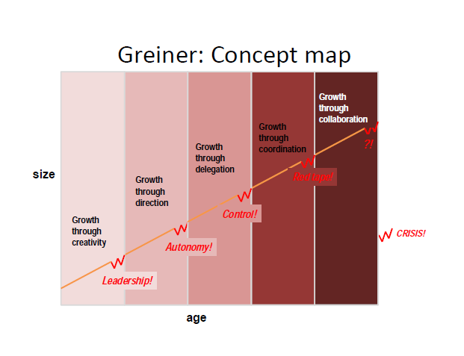
**Chandler says you must grow and Greiner says you don’t have to BUT Chandler has evidence and Greiner does not.
James C. Collins and Jerry I. Porras: Building your Company’s Vision
“Companies that enjoy enduring success have core values and a core purpose that remain fixed while their business strategies and practices endlessly adapt to a changing world”

• Core ideology: Enduring character; glue that holds the organization together as it grows, decentralizes and expands globally. Captures what you stand for and why you exist. (Consists of core values & core purpose). Core ideology is a consistent identity that transcends product or market life cycles, technological breakthroughs, management fads and individual leaders.

– Core values: Beliefs about what is important in the long-term. Timeless guiding principles, rarely if ever change. Intrinsic values inside the organization, excludes anything external. A company should never change its core values; they must always remain true to them.
– Core purpose: Inspiration for people who work there. It is not just about making profits, it’s about finding a reason why you come in to work every day and produce. It is the reason why people enjoy innovating and not just working for a paycheck. Reflects people’s idealistic motivation for doing the company’s work. Why are we here? A group of people get together so they are capable to accomplish something collectively that they could not accomplish separately.

• Discovering your Core Ideology:
– Must be authentic.
– Must be meaningful and inspirational only to the people inside.
– Once established, everything else that is not part of the core ideology should change and adapt to market changes.
– Core ideology should not change in response to market changes.
– Getting people to share the core ideology.
- Sony’s ideology: We shall welcome technical difficulties and focus on highly sophisticated technical products that have great usefulness for society regardless of the quantity involves: we shall place our main emphasis on ability, performance, and personal character so that each individual can show the best ability and skill.

** Don’t confuse core ideology with the concept of core competence. Core competence is a strategic concept that defines your organization’s capabilities- what you are particularly good at- whereas core ideology captures what you stand for and why you exist.

• Envisioned future: BHAGs (big hairy audacious goal)
– Audacious, vivid goals stimulate progress
– 10 to 30 year audacious goal plus vivid descriptions of what it would be like to achieve the goal.
– Spur passion & team spirit
– Inventing such a goal forces and executive team to be visionary rather than strategic or tactical.
– Difficult but not impossible to achieve
– Companies need to build a strong organization with people capable of achieving the goals
– Avoid the “We have arrived” syndrome which is an organization who achieved their BHAG but failed to replace it with another.

•Vision Level
- Companies often use a bold mission called BHAG
- There’s a difference with having a goal and setting yourself a huge challenge like climbing Mount Everest
- It means thinking beyond the current capability
- Successful companies preserve the core ideology and stimulate progress through a vivid and audacious envisioned future.

•Vivid Description
- A vibrant, engaging and specific description of what it will be like to achieve that BHAG
- Creating an image that people could carry on in their head.
- Passion, emotion and conviction are essential parts.

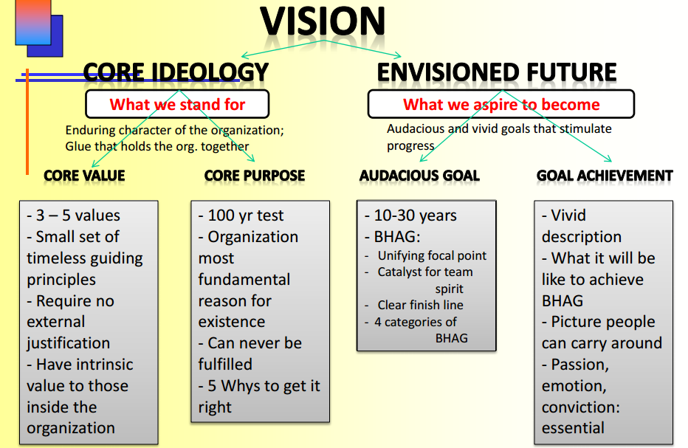

Jay Barney: Looking Inside for a Competitive Advantage
A theory of sustained competitive advantage

BARNEY’S KEY CONCPETS:
Sustained competitive advantage:
•Valuable resources and capabilities
•Rare resources and capabilities
•Hard to imitate resources and capabilities
•Resources and capabilities organized to be exploited

-Barney says there are a lot of tools to focus on a company like SWOT.
-Socially complex resources are organizational phenomena like reputation, trust, friendship, teamwork and culture.
-Sustained competitive advantage cannot be created simply by evaluating environmental opportunities and threats, and then conducting business only in high-opportunity, low-threat environments. Rather, creating sustained competitive advantage depends on the unique resources and capabilities that a firm brings to competition in its environment.

BARNEY’S MAJOR CLAIMS:
- The most careful and complete analysis of firms’ competitive environments cannot, by itself, explain their success
- Strategists also need to analyze the competitive implications of firms’ internal strengths and weaknesses.
- Financial, physical, human, organizational assets used by the firm to develop, manufacture and deliver products and services to its customers.

A Firm’s Resources and Capabilities
- Financial: debt, equity, retained earnings, etc…
- Physical: machines, manufacturing facilities, buildings.
- Human: experience, knowledge, judgment, wisdom, etc…
- Organizational: history, relationships, trust, culture, formal reporting structure.

FOUR IMPORTANT QUESTIONS ABOUT RESOURCES AND CAPABILITIES (VRIO):

QUESITON OF VALUE: Does firms resources and capabilities enable it to exploit opportunities and/or neutralize threats?
-Sony’s and 3M’s resources-including their specific technological skills and their creative organization cultures- made it possible for these firms to respond to, and even create, new environmental opportunities.
-Changes in a firm’s environment may reduce the value of a firm’s resources in their current use, while leaving the value of those resources in other uses unchanged.
-Rolex and Timex exploit very different valuable resources. Rolex emphasises on quality and a high-status reputation while Timex emphasises on high-volume and low-costs.

QUESTION OF RARITY: How many competing firms already possess these valuables resources and capabilities?
-If a firm’s resources are valuable and rare, those resources may enable a firm to gain at least a temporary competitive advantage.
-Wal-Mart gained a competitive advantage over K-Mart because of their Just-on-Time principle to control inventory. This point-of-purchase inventory control system was rare.
QUESTION OF IMITABILITY: Do firms without resources or capability face a cost disadvantage in obtaining it compared to firms that already possess it?
-Imitation can occur either through substitution or duplication
-If these substitution resources have the same strategic implications and are no more costly to develop, then imitation through substitution will lead to competitive parity in the long-run.
-History
- Small decisions
- Socially complex resources (reputation, trust, friendship, teamwork, culture)

QUESTION OF ORGANIZATION: Is a firm organized to exploit the full competitive potential of its resources and capabilities? (Rolex v. Timex)
- Wal-Mart’s continuing competitive advantage in the discount retailing industry can be attributed to its early entry into rural markets in the US.

Not valuable Competitive Disadvantage
Valuable, but not rare Comparative equality
Valuable and Rare Competitive advantage
Valuable, Rare, but not costly to imitate Temporary competitive advantage
Valuable, rare, and costly to imitate Sustained competitive advantage

Frederick Herzberg: One More Time: How do you Motivate Employees?

Herzberg’s concepts:

Motivating with KITA:
- Negative KITA: fear of what will happen if something is not done. Will never lead to motivation.
-Negative physical KITA-> It is a physical attack; it directly stimulates the autonomic nervous system and usually leads to negative feedback from employees.
-Negative psychological KITA-> This has more advantages over physical KITA because the cruelty is not visible (the hurting is internal). Those who use this type of KITA like managers receive ego satisfaction. If the employee complains, he or she can be accused of being paranoid because there is no tangible evidence of an attack.

2. Positive KITA: rewards, incentives, seduction to get and employee to “move” or “jump”.
“Do this for me or the company, and in return I will give you a reward, an incentive, more status, a promotion, all the quid pro quos that exist in the industrial organization”

**KITA is NOT motivation because we are kicking our employees each time to do something. For motivation, one needs no outside stimulation because one WANTS to do it. KITA results only in short-term movement

3. Hygiene factors: These factors are extrinsic and do NOT provide job satisfaction. Hygiene factors are what employers do to get their employees to move. Hygiene factors are tied in with the KITA concepts. Hygiene factors include company policy, supervision, salary, status, working conditions, etc.

4. Motivator or Growth factors: This is the primary cause to job satisfaction. The growth or motivator factors that are intrinsic to the job are achievement, recognition for achievement, the work itself, responsibility, and growth or advancement.

5. Dissatisfiers (mentioned above)
6. Satisfiers (mentioned above)

7. Horizontal job loading: reducing personal contribution of employees rather than giving them opportunities for growth in their accustomed jobs in order to enrich certain job. Job loading enlarges the meaningless of a job. Examples of job loading include:
- Increasing the quota of hamburgers that need to be produced without extra time given
-Asking a dishwasher to mop the floors as well in his shift (adding another meaningless task)
-Removing the most difficult parts of the job to free the worker to accomplish more less challenging tasks.

8. Vertical job loading: Has internal motivators involved. Examples include:
-Introducing new difficult tasks not previously handled (growth and learning)
-Removing some controls while retaining accountability (responsibility and achievement)

9. Job enlargement: No change in challenges.

10. Job enrichment: a systematic attempt to motivate employees by manipulating the motivational factors.

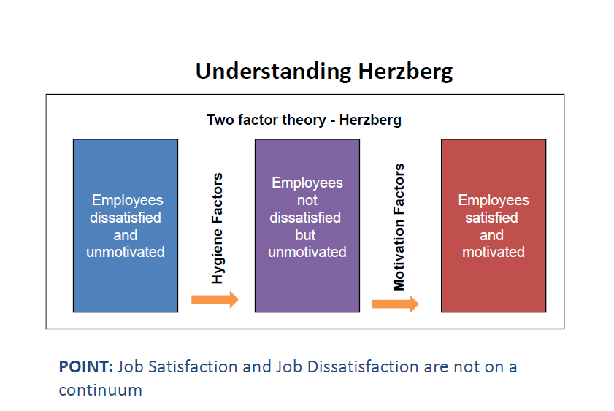
Vertical job loading (providing motivator factors)

What might you do to ‘improve’ a job?
• Remove some controls while retaining accountability
• Increase accountability of individuals for own work
• Give person a complete natural unit of work
• Grant additional authority; job freedom
• Make periodic reports directly available to workers themselves rather than supervisors
• Introduce new, more difficult tasks
• Assign workers to specialized tasks, enabling them to become experts

Steps for JOB ENRICHMENT (instilling motivators)

How might you go about improving a job?
• Select jobs, approaching them with the conviction that they can be changed
• Brainstorm possible changes
• Remove hygiene & horizontal loading issues
• Avoid direct participation by the employees whose jobs are to be enriched
• Be prepared for an initial drop in performance
• Expect first‐line supervisors to experience some anxiety

Not all jobs can or need to be enriched.
Ultimate reward in motivation is personal growth

French and Raven: The Bases of Social Power
*The most common description of power is French and Raven (1960). This divides power into five different forms.
*P is the person who holds power of O

1) Coercive power
This is the power to force someone to do something against their will. It is often physical although other threats may be used. It is the power of dictators, despots and bullies. Coercion can result in physical harm, although its principal goal is compliance. Demonstrations of harm are often used to illustrate what will happen if compliance is not gained.
Coercion is also the ultimate power of all governments. Although it is often seen as negative, it is also used to keep the peace. Parents coerce young children who know no better. A person holds back their friend who is about to step out in front of a car.
Other forms of power can also be used in coercive ways, such as when a reward or expertise is withheld or referent power is used to threaten social exclusion.
***Negative reward based on P’s perception that O has the ability to mediate punishments on him***

2) Reward power
One of the main reasons we work is for the money as we need to conduct our lives. There are many more forms of reward -- in fact anything we find desirable can be a reward, from a million dollar yacht to a pat on the back.
Reward power is thus the ability to give other people what they want, and hence ask them to do things for you in exchange.
Rewards can also be used to punish, such as when they are withheld. The promise is essentially the same: do this and you will get that.
***Power to provide something like bonuses, and incentives based on P’s perception that O has the ability to mediate rewards for him***

3) Legitimate power
Legitimate power is that which is invested in a role. Kings, policemen and managers all have legitimate power. The legitimacy may come from a higher power, often one with coercive power. Legitimate power can often thus be the acceptable face of raw power.
A common trap that people in such roles can fall into is to forget that people are obeying the position, not them. When they either fall from power or move onto other things, it can be a puzzling surprise that people who used to fawn at your feet no long do so. This power comes from values.
*** based on P’s perception that O has a legitimate right to prescribe behaviour for him ***

4) Referent power
This is the power from another person liking you or wanting to be like you. It is the power of charisma and fame and is wielded by all celebrities (by definition) as well as more local social leaders. In wanting to be like these people, we stand near them, hoping some of the charisma will rub off onto us.
Those with referent power can also use it for coercion. One of the things we fear most is social exclusion, and all it takes is a word from a social leader for us to be shunned by others in the group. A group/person you look up to and you want to associate with. Anyone one in this group holds power.
***Based on P’s identification with O***

5) Expert power
When I have knowledge and skill that someone else requires, then I have Expert power. This is a very common form of power and is the basis for a very large proportion of human collaboration, including most companies where the principle of specialization allows large and complex enterprises to be undertaken.
Expert power is that which is used by Trades Unions when they encourage their members to strike for better pay or working conditions. It is also the power of the specialist R&D Engineer when they threaten to leave unless they get an exorbitant pay rise or a seat by the window. Completely based on knowledge and skill.
***based on P’s perception that O has some knowledge or expertise***

Examples:
1. Share my experience & special skills: Expert
2. Tell them that they have commitments to meet: Legitimate
3. Give them tough, undesirable jobs to do: Coercive
4. Make them feel like I approve of them: Referent
5. Make them feel important: Referent
6. Provide good technical suggestions: Expert
8. Make them recognize they have tasks to accomplish: Legitimate
9. Provide them with special benefits: Reward
10. Make things unpleasant for them: Coercive
11. Make them feel they have commitments to meet: Legitimate
13. Make the work difficult for them: Coercive

Handy: The Sigmoid Curve
The Sigmoid Curve:
Concept map:

-It is the story of a product’s life cycle and of many a corporation’s rise and fall
-There is life beyond the curve. The secret to constant growth is to start a new sigmoid curve before the first one peters out.
-The real energy for change comes only when you are looking disaster in the face, at point B on the first curve. At this point it is going to require mighty effort to drag oneself up to where, by now, one should be on the second curve. At point B, resources are depleted and energies are low. For an individual, an event like being laid off typically takes place at point B,
-If a company is left at point B, only new people will have the credibility and the vision to lift the place back onto the second curve.
-It is wise for a company to start their second curve at point A and to ensure renewal and the continued growth of their organization.
-Maintaining traditional business strategies and never adapting to new markets (think of Blockbuster) will never be able to reach the second curve and will eventually die.
The Discipline of the Second Curve:
-You will only know for sure where you are on the curve when you look back.
-The discipline of the second curve follows the traditional four-stage cycle of discovery (questioning, ideas, possibilities, and hypotheses). The first two stages cost nothing except for the time for imagination.
-The second curve is always different, although it builds on and grows out of the first.
-Climbing the first curve is when a company is expanding or growing, but to reach the second curve the company must to something really different like launch a new product. (Megabus was still on their first curve, all they did was add wi-fi, new routes, and more busses)
Curvilinear Logic:
-Logic that everything has its ups and downs and nothing lasts forever.
-Curvilinear Logic means starting life over again, something that gets harder as one gets older.
-Coca-Cola is an exception to this general rule**
-Kaizen means continuous improvement
Fertilizing the Second Curve:
-Second-curve thinking will come most naturally from the second generation, those who will inherit the future.
-Include some thoughts and recommendations on how the organization should adapt to the changes they might foresee for their industry and their world around them
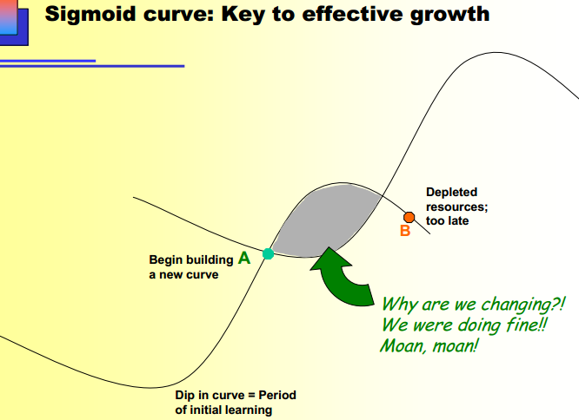
**We can also relate this curve to Collin’s Company Vision

improves quality of the shoes so it last longer
show impact that they have
familiarize yourself with the industry
create more jobs (allowing poor ppl to be autonomist)
First curve: the making of the shoes
Second: making of the eyewear
Dip in curve: intro in argentina then intro to china they needed a supervisor
Started box then bags then back to box again
Point B in article: the bags are the point B
Shaded area: No shaded area
Culture: culture of sharing, educating (teaching ppl and giving them the jobs), unorthodox
If the quality is as important as the quantity
Focusing too much on economies of scope (chandler)

Kaplan and Norton: The Balanced Scorecard
• The “bottom line”(profitability) is not enough
• The traditional financial performance measures worked well for the industrial era but not anymore
- Why?
- Theres no competition
- Consumers had no say because there was no variety
• A stakeholder is anyone who has invested interest in a company and stockholders are company owners, employees, etc.
• Four perspectives for a balanced scorecard

– Customer perspective
• What matters most to customers? How do customers see us? (Specific measures, includes numbers, that reflect the factors that really matter to customers) To achieve our vision, how should we appear to customers?

– Internal business perspective
• How can we produce to meet customer expectations? What must we excel at? (Internal operations that enable them to satisfy customer needs) To satisfy our shareholders and customers, what business processes must we excel at?

– Innovation & learning perspective
• How can we make continual improvements? Can we continue to improve and create value? (Improve existing products, launch new ones, and create more value for customers.....)To achieve our vision, how will we sustain our ability to change and improve?

– Financial perspective
• How can we ensure profitability for shareholders? How do we look to them? To succeed financially, how should we appear to our shareholders?
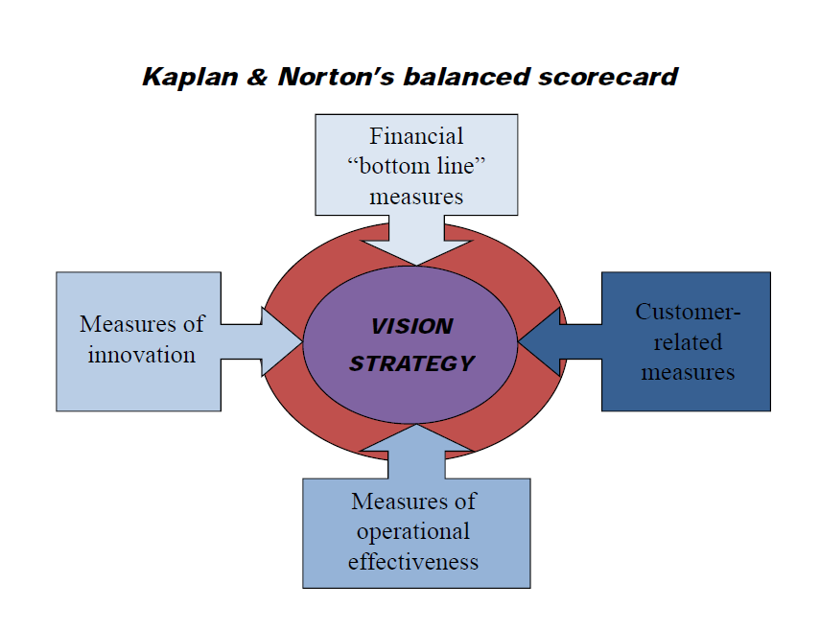

Example:
ECI 's Balanced Scorecard
Perspectives | Questions | Goals | Measurements
Customer | How do customers see us? | New products. | Percent of sales from new products.
Customer | How do customers see us? | Responsive supply. | On-time delivery as defined by the customer.
Customer | How do customers see us? | Preferred supplier. | Share of key account's purchases.
Customer | How do customers see us? | Customer partnership. | Number of cooperative engineering efforts.
Internal business | What must we excel at? | Technology capability. | Manufacturing geometry versus the competition.
Internal business | What must we excel at? | Manufacturing excellence. | Cycle time, Unit cost and Yield.
Internal business | What must we excel at? | Design productivity. | Silicon efficiency and Engineering efficiency.
Internal business | What must we excel at? | New product introduction. | Actual introduction schedule versus planned introduction.
Innovation & learning | Can we continue to improve & create value? | Technology leadership. | Time to develop the next generation.
Innovation & learning | Can we continue to improve & create value? | Manufacturing learning. | Process time to maturity.
Innovation & learning | Can we continue to improve & create value? | Product focus. | Percent of products that equal 80% of sales.
Innovation & learning | Can we continue to improve & create value? | Time to market. | New product introduction versus the competition.
Financial | How do we look to shareholders? | Survive. | Cash flow.
Financial | How do we look to shareholders? | Succeed. | Quarterly sales growth and operating income by division.
Financial | How do we look to shareholders? | Prosper. | Increased market share and Return on Equity.
Example:What you want to measure-> percent of sales from new products
The measurements-> 100%, 95%, $5000…
American Apparel Measures:
- Financial Perspective- 14% interest rate on financing must be reduced to 7% by next month. Charney must find a solution to decrease his interest rate from money borrowed.
- Customer Perspective: Launch Quarterly sales campaigns to attract customers. By attracting new customer using discount tactics, this can help satisfy new and old customers.
- Innovation Perspective: Enter new market segments such as business wear. Add two new collections by next year. Greater diversification can appeal more customers and generate greater revenue.
- Internal Perspective: Employees must be trained faster. Increasing efficiency in training will help his economic situation. If employees are trained faster (let’s say in three days), efficiency will be increased.

Henry Mintzberg: The Manager’s Job (Folklore and Fact)

Myth: Managers plan, organize, coordinate and control

Managerial Roles: categories of role

Informational Roles:

- Monitor Role: Scanning the environment for information through networking.
- Disseminator Role: Manager passes some privileged information directly to subordinates who have no access to the information.
- Spokesperson: Sending information to people outside the unit. Satisfying the influential people.
Interpersonal Roles:
- Figurehead Role: Every manager must perform ceremonial duties (the sales manager takes an important customer to lunch)
- Leader Role: Motivate, encourage employees, recognize their goals
- Liaison: Tying two people together. Vertical and horizontal communications.
Decisional Roles:
- Entrepreneur: Seeks to improve the unit. Adapt it to changing conditions in the environment.
- Disturbance Handler: Responding to pressure. Manager must act, not ignore.
- Resource Allocator: Deciding who will get what. Most important resource; managers allocating his or her time.
- Negotiator: Integral part of the manager’s job because of authority
**Managerial Skills: developing peer relationships, carrying out negotiations, motivating subordinates, resolving conflicts, establishing information networks and disseminating information, making decisions in conditions of high ambiguity and allocating resources

Liker and Choi: Building Deep Supplier Relationships

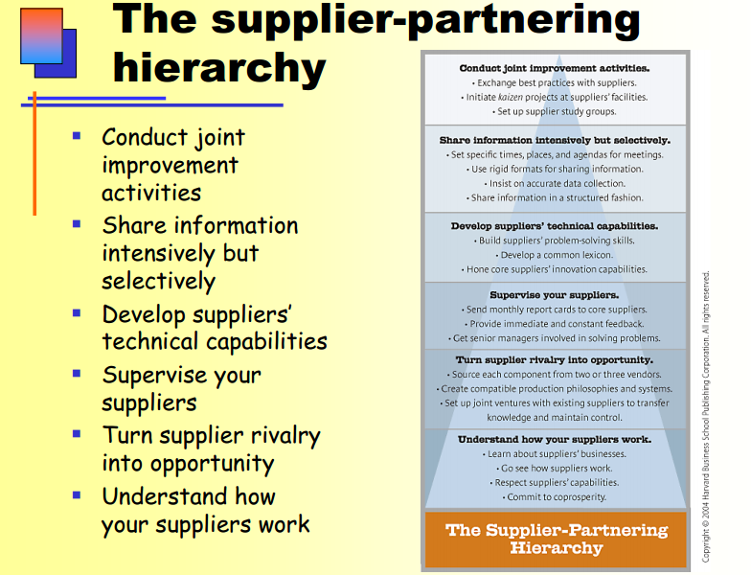
Side Notes…
-The 100 biggest U.S. manufacturers spent 48 cents out of every dollar in 2002 to buy materials, compared to 43 cents in 1996.
-Businesses are increasingly relying on their suppliers to reduce costs, improve quality, and develop new processes and products faster than their rivals can.
-Supplier Keirestsu: Close-knit networks of vendors that continuously learn improve and prosper along with their parent companies. (Japanese supplier-partnering model)
-Toyota and Honda believe they can create the foundations for partnerships only if they know as much about their vender as the vendors know about themselves
-Neither Toyota nor Honda depends on a single source for anything: both develop two to three suppliers for every component or raw material they buy. If Toyota doesn’t approve of the performance of their suppliers, they simply give the contract to this supplier’s competition.
-Toyota and Honda don’t source from low-wage countries much; their suppliers’ innovation capabilities are more important than their wage costs.
Understand how your suppliers work
- Learn about suppliers’ business
- Go see how suppliers work
- Respect suppliers’ capabilities
- Commit to coprosperity
Turn supplier rivalry into opportunity
- Source each component from two or three vendors
- Create compatible production philosophies and systems
- Set up joint ventures with existing suppliers to transfer knowledge and maintain control
Supervise your suppliers
- Send monthly report cards to core suppliers
- Provide immediate and constant feedback
- Get senior managers involved in solving problems
Develop suppliers’ technical capabilities
- Build suppliers’ problem-solving skills
- Develop a common lexicon
- Hone core suppliers’ innovation capabilities
Share information intensively but selectively
- Set specific times, places, and agendas for meetings
- Use rigid formats for sharing information
- Insist on accurate data collection
- Share information in a structured fashion
Conduct joint improvement activities
- Exchange best practices with suppliers
- Initiate kaizen projects as suppliers’ facilities
- Set up supplier study groups

Critical Thinking by Linda Dyer
Critical Thinking: Analyzing the validity of arguments in a text.
- Identify the author’s major conclusions
- Describe and evaluate supporting evidence
- Uncover assumptions and values
- Determine soundness of causal logic and deconstruct use of persuasive language

What is a claim?
– Main thesis or conclusion of a text that the author is trying to persuade you to accept.
- Easiest claims to find are towards the beginning or end of a text.
- Cue words are indicators that the claim is about to come (eg. Data shows that, in summary, in fact, therefore, etc.)

Unproblematic Claims: Consistent with our own experiences and observations, facts independent of interpretation, agreement among experts or strongly supported general claims that are common sense, technical or mathematical claims. (Quebec is larger than Nova Scotia)

Contestable Claims: Not commonly accepted knowledge, often introduce new ideas that awaken curiosity, sometimes presented as if it were a fact, cannot stand on its own. Needs good evidence to support it.

• How can one identify it?
– Explicit or implicit?
– Often found in the very beginning or end of a text
- Explicit: very obvious and clear
- Implicit: idea that summarizes what the author is trying to say

• What is an example of an unproblematic claim (uncontestable)?
– I do not juggle fire on Sundays.
– You are bigger now than when you were born.

• How about a contestable claim?
– Art students make poor entrepreneurs.

•Presenting Your Claim: We make a concept map or concept list. It has to be a fair summary of your main ideas.

EVIDENCE

•Evidence is any statement that is a response to the question: Why is it true. It may consist of statistics, details of past events, anecdotes, etc.
Evaluate the supporting evidence
Why is this true?
• Finding the evidence:
– Indicator words. (Because, as a result...)
– Logical sequence of reasons

•A claim (persuasion to accept) and evidence (details to support claim) = Argument

• Good evidence:
- Accuracy: Evidence has to be true (do your own research). Look for errors. Take a proxie for accuracy
- Precision: Evidence can`t be vague, it has to be as specific as possible. Overuse of ambiguous words such as many, often, usually, high probability, etc, are indicators of low precision.
- Sufficiency: You need enough evidence to support the claim.
- Representativeness: The evidence they provide must be representative to all Canadians (let`s say). Should represent everyone from the group you wish to target.
- Authority: Expert, valid source
- Clarity of expression: Clear, paragraphs, etc.

Example from Moonbot:

EVIDENCE - SUFFICIENT – WHY/EXAMPLES
ACCRURATE – WHY/EXAMPLES
PRECISION – WHY/EXAMPLES/ WHAT LEVEL OF PRECISION
REPRENSENTATIVE – HOW/EXAMPLES/DIFFERENT VIEWPOINTS- AUTHORITY – HOW/EXAMPLES

SUFFICIENT – its development of Lessmore and the story book app., Adam Volker who claims that “this is not a place for specialists.. if I worked for a studio in California, my whole job would be animating a background characters shoes” proves that the employees work on projects they build and are passionate about. (there could be more evidence regarding other companies whom tried such things, or other companies with small staff and their successes)
Hiring young, multitalented creative who veer from the typical studio machine

PRECISION – (ambiguous words)
Considering this article is more about the environment of a workplace and how it succeeds because of its lack of control over creativity, precision is not a main focus of evidence. Ambiguity is seen in the last paragraph when looking upon the future of Moonbot and in comparison to Pixar and whether or not they will “be the next Pixar”. When talking about numbers in the articles, the ambiguous terms “more than” comes up.

ACCURACY – information is researchable

REPRENSENTATIVE – (variety of sources of evidence)
The representativeness of the article is rather weak considering the standpoint of the article is based around solely the opinion and experience from the Moonbot staff and employees themselves. The article is representative of the life and experiences of the Moonbot staff considering that the article speaks with no more than 3 people who work there and their staff but I do not think it is representative of the industry or other players within the industry. A small staff and personal work environment may work for moonbot but may not for other companies

AUTHORITY – (credentials)
The magazine fast company’s founders are two former Harvard business review editors and calls itself the world’s leading progressive business media brand.

UNDERLYING ASSUMPTIONS –
the underlying assumption of the article is that work should be something an individual is passionate about and if so, the work will be that much better since you’ve put your all into it
core business strategies are for large companies, personalized work is better and makes the employees happier, animated movies and apps are the future, future business will be revolved around new technologies, compatible with new technologies

CONVINCING? SUPPORT CONCLUSION
The article was convincing on the part that employees seem to really love what they do so they strive to do their best, and that creates great products. As far as the evidence is concerned, the representativeness could’ve been better.

UNDERLYING ASSUMPTIONS

• Underlying assumptions = Implicit or explicit principles that form the bases of our beliefs & reasoning. Logical link that fills the gap between the evidence and the claim. Different people have different assumptions reflecting different values.

• They tell us whether evidence provided for a claim is relevant
– Reality assumptions: our beliefs about what events have taken place, what exists or how things work in the world.
– Value assumptions: our ideals, our standards of right and wrong, the way things out to be. Can be recognized though the use of words like ought, should, desirable....

• Challenging underlying assumptions:
– To challenge reality assumptions we must present information showing that the author`s notions of reality and how the world works are debatable or just plain wrong.
– Challenging value assumptions are difficult as values develop early in life and are quite resistant to change.

Causal claims

• Causal explanation = Author’s interpretation of cause & effect relationships. May be multiple causes
• Rival causes: The same evidence can be consistent with different interpretations. Can we think of plausible rival causal explanations that would account for exactly the same events?
• Three types of rival causes:
– Differences between groups: When an author says that an outcome is caused by a specific difference between groups, we must pause and think: Are there any other differences between these groups that may be relevant? If we can think of some other relevant factors that differ between the groups, we have a plausible rival cause.
– Association of characteristics: A correlation between two factors might be explained by one of three causal links. There may be a direct causal relationship, a reverse causal relationship or no relationship save though the effect of a third factors.
– Post hoc, ergo propter hoc (After this therefore because of this): Just because an event was followed by another even, it does not necessarily means that the first event caused the second.

Techniques of persuasion

– Anticipate objections based on
• negative evidence (show that it is misleading) evidence that goes against the claim
• alternative/rival causes (same evidence can be consistent with different interpretations)
• conflicting assumptions (If you know that there are reality assumptions that your audience might feel are debatable or wrong, you must provide explicit data to back up your assumptions)
– Counter‐argue objections
– Limit claims you cannot rebut
• Acknowledging limitations makes your writing MORE persuasive
– Rhetoric – Use of language & form:
-Detail, be complete (evidence and assumptions)
-Tone (scholarly vs. narrative)
-Vividness (being concrete draws attention); bring evidence to life, attracting attention to your points and making them memorable for your readers.

Quality evidence

HOW TO EVALUATE EVIDENCE: FROM MIDTERM

 | Unraveling Solar Star | Once and Future Pixar
Claim | Applied took risks that made them vulnerable | Moonbots method of focusing on passion instead of making it big is what made them successful.
Sufficiency | -Detailed evidence of the failure of the factories.  -Took risks with making bigger panels but it failed. | - Success of Lessmore  - What companies based in Hollywood had to go through before making it big  -Hiring young, multitalented creatives who veer from the typical studio machine.
Precision | - Uses direct quotations from executives at Applied as well as their customers  -Uses statistics and numbers in reference to revenue  -Appropriate and detailed facts | - Direct quotations from the founders of Moonbot  - Numbers to describe success of the studio  - Uses some abstract words (Moonbot will be doing something different)
Accuracy | - Information is researchable  - Uses quotations  - Remains on target and never strays from the claim | - Information is researchable  - No trivial errors (grammar)
Representativeness | - Relative to the claim  - Variation in sources matches the variation in the population  - Represents both sides | - Only shows Moonbot’s POV  - Not enough variety in sources for the concerned population  - Relative to the claim
Authority | - Author is the Digital Strategy Editor and Green Biz.  - Credible and believable  - Doesn’t commit fallacy of argumentation ad populum | - Author is a writer and filmmaker in NYC  - Experience in the field  - All quotes come from members of the field
Underlying Assumptions | - Solar energy is the future  - Value assumption  - Companies should use clean energy | - Big companies don’t foster talent  - Younger people are more creative  - Value assumption
Scale | - Making bigger panels to slice costs  - Making more factories | - N/A  - Company is relatively small
Slope | - Basing solar panels based on equipment and machines they already have  - “Combining its amorphous-silicon machines with the best tools it could find” | - Using their first creating (Lessmore), an interactive storybook, to create more like it.
Limitations | - Resources being strained  - Economic crisis froze bank financing for solar energy at the end of 2008  - Many competitors | - Don’t have the advantage of being in Hollywood
Diversification | - Poor, what do they know about solar energy? | - Related
Barney (VRIO) | - Solar energy is something new (values)  - Using similar technology (not very rare)  - Is imitatible  - Collaborating with solar manufacturers | - Value talent and continue to do so  - Rare that a company this successful started without a business structure  - Their products are imitatible  - Single organization
Stage of Evolution | - Collaboration (experimenting with new practices) | - Creativity and delegation
BHAGs | - Goals were big and risky because they knew little about solar energy.  - Customers were compelled to see what they could do  - Not so daring | - Innovative business  - Risky because they chose a base far from Hollywood, and did not have a proper structure  - Daring
First Mover? | - Not in solar energy | - Yes because they are the first business of the kind
Core Value | - Their business failed because of poor choices | - Passion and talent are what’s important
Core Purpose | - Applied was a industry leader and so their motivation was to continue to dominate markets | - Because they love doing what they do

