Lab Practical Study Notes

- 10am group (arrive 9:45)
- Stairwell C
- Lab coat, goggles, student ID, pen*, pencil, ruler, calculator

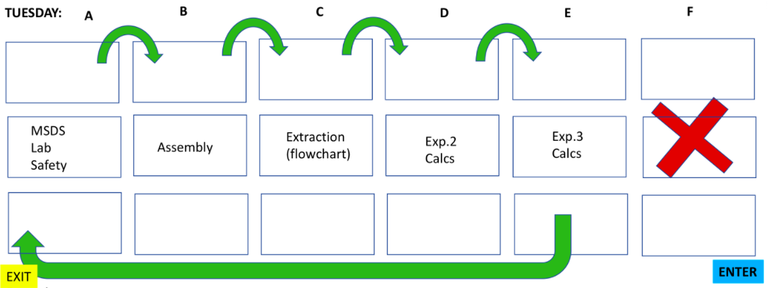

1. TLC
- Perform a TLC
- Calculate the Rf values
- Determine / justify which lane holds a given compound
- Actual Thing You Need to Do in the Lab:
  - You are given two vials. You do not know which vial is which. You are given 4 compounds and told that two of the compounds are in vial A and two of the compounds are in vial B. You need to perform a TLC with 2 LANES, and by using polarity and Rf values, find out which spot corresponds to which compound.
  - You need to copy the TLC to SCALE in your exam booklet, dots and calculate Rf values. Identify the spots to compounds and explain why.
- Some Notes
  - Stationary phase and mobile phase
  - First compound adheres to stationary phase, when added to NON POLAR mobile phase THAT MOVES IN ONE DIRECTION, the mobile phase may unadhere the compound and take it along with it.
  - Use UV light to see colourless compounds on the polar silica gel.
  - One use: Purity of the sample
    - If a substance claims to be pure, it must show as one spot on the TLC plate. Any other spots in the same lane indicate an impurity.
  - Use of a co-spot may be useful if your starting material and final product have similar Rf values that are too hard to discern if side by side. The co spot will be elongated showing the tiniest difference in their heights significantly.
  - Can be used to monitor a reaction: spot at different time intervals to see the disappearance of the starting material in the product lane.
  - Retention Factor: Rf
    - The Rf value is a ratio that shows the relative distance that the spot traveled compared to the distance that the solvent travelled alone.
    - Error occurs in recording measurements or identifying the solvent front ( top of the solvent line)
    - Lower Rf have more polar functional groups
    - Higher Rf have less polar functional group.
    - Structure can affect Rf value as well. If it has a polar functional group but a non polar R group or chain that’s very long, that will give a higher Rf value then the compound without all those hydrocarbon chains/group.
      - Also, it is about the number of hydrogen bonds it can have with the silica gel. A hydroxyl group can form two because the O is dipole negative (can H bond with dipole positive H in silica gel) and the dipole positive H (can H bond with dipole negative O in the silica gel. Consider an aldehyde. The H is not dipole induced because it’s attached to carbon (non polar bond) so only the O is dipole negative to H bond with the dipole positive H in silica gel. SO 2 H bonds vs. 1 makes hydroxyl > polar than > aldehyde.
  - Increasing the solvent polarity will increase the Rf values; moderately polar compounds have a greater attraction to the mobile phase and it is likely that the mobile phase will adhere to the stationary phase and leave less space for less polar compounds to bind to the silica gel.

2. Lab 3 Calculations
- Given raw data identical to what you obtained in the lab, calculate moles of gas (given the necessary conversions and equations to find P), the conversion and selectivity of the reaction
- Interpret the results based on the reagents used
- Actual Thing You Need to Do in the Lab:
  - Do the calculations from Experiment 3.
  - Conversion, specificity, and moles of gas (using that equation with P*)

3. Lab Safety / MSDS
- Circulate in the section to note any safety hazards
- Identify safe/unsafe laboratory practices
- Answer questions based on the MSDS sheet provided.
  - Explain an MSDS sheet
  - Identify the meaning of various WHMIS symbols
- Identify notable properties of chemicals used in the first 3 labs
- Actual Thing You Need to Do in the Lab:
  - You will walk to the station and various hazards will be placed around the room. You need to identify them (lab guy has no goggles, rolled up sleeves, skin showing, fumehood is up, reflux water tube is connected to gas instead, cold finger is attached to the hot plate directly)
  - You will be given a compound’s MSDS partially, and you have to explain (I think in your booklet) how to handle the reagent safely.
    - Note, if the MSDS show 4 for almost all of the categories, the waste is NOT THE ORGANIC DISPOSAL. It is HIGHLY reactive and you need to get someones assistance to dispose of the chemical.

4. Apparatus Assembly
- Identify glassware
- Build 1 of 3 possible apparatus set ups (sublimation, suction filtration or reflux)
- Some Notes
  - If you don’t have metal lattice to attach to, make sure the apparatus is assembled on top of the heavy base side of the ring stand.
  - U clamps should be used only for round bottom flasks, not 3 fingers!
  - Cleaning: acetone soap and water upside down to evaporate
    - If needed immediately, acetone only is fine as acetone will evaporate
  - Small thin glass pipettes are called Pasteur pipettes
    - Graduated glass pipette – like a graduated cylinder
    - Volumetric glass pipette – only hold one certain volume (the one with the big bulge in the middle)
  - Gravity filtration used for getting the solvent and removing the precipitate.
  - Suction filtration is faster than gravity filtration make sure that the seal is good. Desired isolation is the precipitate at the top. Rinse with solvent first to make the paper stick (so no solid goes throught he wholes). Clamp the sidearm flask underneath the protrusion of the head.
    - Turn on the water before attaching tube side arm (check for suction).
    - Turn of water before removing tube (break the vacuum first).
- Actual Thing You Need to Do in the Lab:
  - Pick from a draw. Either reflux, cold finger apparatus and suction filtration.
  - Need to explain some things about what youre setting up, and for the case of reflux, you need to fill the water in the condenser etc…

5. Extractions (flowchart)
- Given two molecules in an organic solvent, describe a method for isolating each compound to its crude form by constructing a flowchart
- Some Notes:
  - MOST of the time, the organic solvents that DON’T have any halogens, are the top layer (organic) and the bottom layer is thus aqueous. EXCEPTION: Halogenated solvents like DICHLOROMETHANE, is more dense than water and thus will be in the bottom layer (organic) and the top layer is thus aqueous.
  - If a sample of 10% NaOH is used, basically 90% of the solution is water, so we can assume that the density is very close to water (NaOH’s true density doesn’t matter anymore)
  - If unsure of which layer is which: Add a drop of water to the separatory funnel. If it stays in the top layer, the top layer is aqueous, if it’s the bottom layer, it will travel to the bottom layer, thus bottom is aqueous.
  - Distribution coefficient?
  - REMOVE stopper before extraction.
  - DON’T SHAKE VIGOROUSLY!
  - Use of brine: washes the organic layer to remove large amounts of water that may be dissolved in the organic slayer.
    - Can also do the Salting Out effect
    - If water is being tightly occupied by dissolving ions in a solution, they are less capable of dissolving organic compounds. And the dielectric constants of salts make theme extra insoluble with organic compounds.
  - Drying agents
    - Like MgSO4, remove trace amounts of water from organic solutions by forming hydrates. MgSO4 is clumpy, so we add to the organic solvent until we’re sure it’s completely dried out.
- Actual Thing You Need to Do in the Lab:
  - You will be given two compounds, and ask for a technique to separate them.
  - You can first protonate one with acid, making it aqueous and perform liquid liquid extraction of the compound, then purify using drying agent etc.. etc..
  - Then with the protonated second organic compound in the aqueous phase, you can react with a base to deprototonate it, isolate it, purify it etc…
6. Lab 2 Calculations
- Calculations, protocol design, and graphical analysis of data obtained following experiments similar to what you performed in the lab
- Interpret the data given the reagents used
- Actual Thing You Need to Do in the Lab:
  - Lab 2 Calculations
  - Two graphs will be shown with the equation of line of best fit and R2 value, and you need to determine the order of the reaction. (check whether ln or 1/A and the highest R2 values shows the order)
  - Determine the rate constant of the reaction: the slope of the line of best fit.
  - Find the moles of KOH neutralized when given the volume of HCl titrated!

