The Heart and Circulatory System
The pulmonary and systemic circuits
- The heart is a systemic pump consisting of two side by side pumps
- Pulmonary circuit
  - The right side receives blood from tissue
  - The portion of the circulatory system which carries deoxygenated blood away from the right ventricle
  - Oxygenated blood is returned to the left side of the heart
- Systemic circuit
  - The left side receives oxygenated blood from the lungs
  - Pumps blood to body tissue via the aorta
  - Deoxygenated blood is returned to the right side of the heart

Size location and orientation of the heart
- A transport system pump, hollow blood vessels provide delivery routes
- Enclosed within mediastinum of the thorax, extends obliquely for 12-14cm from the 2nd rib to the 5th intercostal space
- ⅔ of the mass of the heart is on the left side
- The right side of the heart lies on the superior side of the diaphragm
- Broad and flat base directed towards the right shoulder, apex point of the heart is towards the left hip

Coverings of the heart
- Pericardium: double-walled, fibro serous sac
  - Fibrous pericardium
    - Loosely fitting superficial part of the sac
    - Anchors it to surrounding structures
    - Protects the heart
    - Prevents overfilling of the heart
  - Serous pericardium
    - Thin slippery, 2 layered serous membranes that form a closed sac around the heart
    - 2 layers are separated by a fluid-filled pericardial cavity
    - Parietal and visceral (epicardium layers)
      - Parietal layer
        - Top layer
        - lines the internal surface of the fibrous pericardium
        - attaches to the large arteries exciting the heart
      - Visceral layer
        - Bottom layer
        - Also called the epicardium
        - The internal part of the heart wall
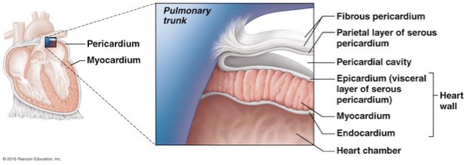

Layers of the heart walls
- 1.Epicardium:
  - a visceral layer of serous pericardium
  - Often infiltrated with fat
- 2.Myocardium:
  - cardiac muscle, the middle layer of the heart, the bulk of heart wall
  - Layers of the heart which contracts
  - Circular or spiral bundles of contractile cardiac muscle cells
  - Cardiac skeleton:
    - Crisscrossing interlacing layer of connective tissue
    - Anchors cardiac muscle fibres/ supports great vessels and valves
    - Branching cardiac muscle cells are tethered to one another by crisscrossing connective tissue fibres
      - Interlacing bundles link all parts of the heart together
    - The network of collagen and elastic fibres is thicker in some areas than others
    - limits spread of action potential to specific paths
      - Connective tissue is not electrically excitable
      - The cardiac skeleton allows action potential to spread via specific pathways
- 3.Endocardium
  - Glistening white sheet of endothelium
  - Endothelium(squamous epithelium) and connective tissue
  - Innermost layer
  - Is continuous with endothelial lining of blood vessels
  - Lines heart chambers and cover cardiac skeleton of valves

Heart chambers, internal muscles and great vessels
Surface features of the heart:
- Interarterial septum: separates the atria
- Interventricular septum: separates the ventricles
- Coronary sulcus: encircles the junction of the atria and ventricles like a crown
- Anterior interventricular sulcus: the anterior position of the septum
- Posterior interventricular sulcus:
Great vessels of the heart:
- Superior vena cava
- Inferior vena cava
- Coronary sinus
- Pulmonary trunk
- Left pulmonary artery
- Right pulmonary artery
- Pulmonary veins

- The heart has four chambers
  - Two atria: the left atrium, right atrium
    - The receiving chambers for blood
    - Relatively small thin-walled chambers
    - Atria are the chambers found on the upper half of the heart
    - The right atrium has two basic parts
        - smooth-walled posterior part
        - Anterior part in which bundle of muscle tissue for ridges in the wall
          - Muscle bundles are called pectinate, they look similar to the teeth of a comb
          - Posterior and anterior regions of the right atrium are separated by a C shapd ridge called the crista terminals
    - The left atrium
      - Mostly smooth and pectinate muscle
  - Two ventricles: The left ventricle, right ventricle
    - The discharging chambers
    - The left ventricle, right ventricle
    - Right ventricle forms most of the anterior surface
    - Ventricles are the chambers found on the lower half of the heart
    - Ventricles, together, make up most of the heart’s volume
    - Right ventricles form most of the hearts anterior surface
    - Left ventricle forms most of the heart’s posterior surface

Name the heart valves; describe their location, function and mechanism of operation
- Heart valves
  - Blood flow through the heart is upwards
  - It is enforced by 4 heart valves that open and close in response to pressure changes
- Two major types of valves
  - Atrioventricular valves
    - Tricuspid valve
    - Mitral (bicuspid) valve
  - Semilunar valves
    - Paired from ventricles to either pulmonary or systemic circuits
    - The aortic and pulmonary valves guard the bases of the large arteries issuing from the ventricles and prevent backflow into the associated ventricles.
    - Pulmonary valve: right ventricle to the pulmonary trunk
    - Aortic valve left ventricle to the aorta

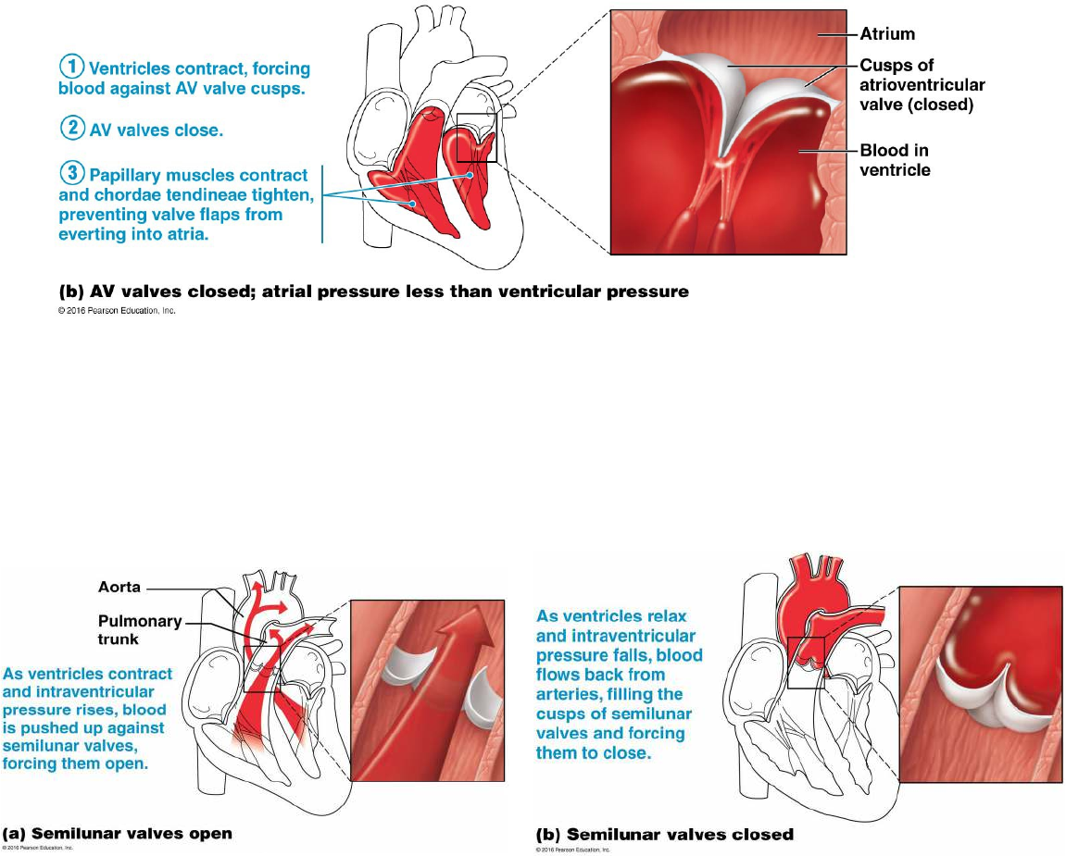

The function of the atrioventricular (AV) valves
- Two atrioventricular valves
- Papilary muscles anchor the right and left atrioventricular valves
  - Tricuspid valve (right side of the heart)
    - Has three flexible cusps
    - Cusps are flaps of endocardium reinforced by connective tissue cores
  - Bicuspid/Mitral valve (left side of the heart)
    - Has two flexible cusps
- One atrioventricular valve located at each atrium-ventricle junction
- Atrioventricular valves prevent backflow into the atria when the ventricles contract
- Open and close in response to differences in blood pressure
The function of the semilunar (SL) valves
- Prevent backflow into the associated ventricles
- Semilunar= half moon
- Each SL valve is made from 3 cusps each shaped roughly like a crescent moon
- Like the AV valves the SL valves open and close in response to pressure, when the ventricles contract and intraventricular pressure rises above the pressure in the aorta and pulmonary trunk the SL valves are forced open
- Aortic semilunar valve
  - Guard the bases of the large arteries (aorta)
- Pulmonary semilunar valve
  - Guard the bases of the large arteries (pulmonary trunk)

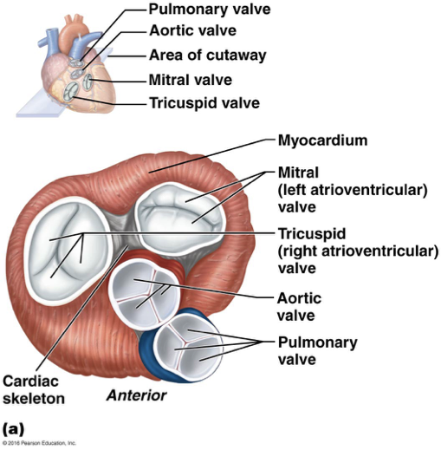
Differentiate between the pathways of the pulmonary and systemic circuits: oxygenation of the blood, workload, structure of the ventricular wall

Describe the organization of coronary circulation
- The blood which fills the heart provides little nourishment to its tissues
- The myocardium is too thick for diffusion so, heart gets nourishment through coronary circulation
- They provide arterial supply of the coronary circulation
- Coronary arteries
  - Coronary arteries deliver blood to the heart muscle
  - Left and right coronary arteries both come from the base of the aorta and encircle the heart in the coronary sulcus
  - The left coronary artery
    - runs toward the left side of the heart and then divides
    - The anterior interventricular artery and the circumflex artery supply the interventricular septum, anterior ventricular walls, left atrium and posterior wall of the left ventricle
  - The right coronary artery
    - runs toward the right side of the heart and then divides
    - The right marginal artery and the posterior interventricular artery supply then right atrium and most of the right ventricle
  - Left coronary artery
  - Interventricular artery
  - Circumflex artery
  - Right coronary artery
  - Right marginal artery
  - Posterior interventricular artery
- Coronary veins

Microscopic Anatomy of the Heart muscle
- Cardiac muscle is striated
- Contracts by sliding filaments mechanism
- Cardiac muscle cells are short, fat, branched and interconnected
- Each cardiomyocyte contains one or maybe two nuclei
- The plasma membrane of adjacent cardiac cells interlock(intercalated discs)
- Intercalated discs are made up of gap junctions and desmosomes
  - Desmosomes
    - for strong cell-cell adhesion
    - prevent adjacent cells from separating during contraction
  - Gap junctions
    - allows ions to pass from cell to cell electrically coupling adjacent cells
    - Gap junctions allow ions to pass from cell to cell which then allows a current to be transmitted across the entire heart
    - Functional syncytium:
      - When the myocardium behaves as a single coordinated unit
- Cardiac muscle cells contain a large number of mitochondria
  - Makes cardiac cells highly resistant to fatigue
- The myofibrils of cardiac muscles cells vary greatly in size and diameter which accommodated to the large number of mitochondria
  - Produces a less dramatic banding pattern than seen in skeletal muscle
- System for delivering calcium ions
  - Cardiac sarcoplasmic reticulum is simpler and lacks terminal cisterns
  - Cardiac muscle fibres do not have triads

Compare the physiological properties with those of skeletal muscle cells
- Similarities with muscle cells
  - Muscle contraction is preceded by depolarizing action potential
  - Depolarization wave travels down T tubules; causes sarcoplasmic reticulum (SR) to release Ca²⁺
  - Excitation-contraction coupling occurs
  - Ca²⁺ binds troponin causing filaments to slide
- Differences between cardiac and skeletal muscle
  - Some cardiac muscle cells are self-excitable
    - Two kinds of myocytes
    - Contractile cells: responsible for contraction
    - Pacemaker cells: non-contractile cells that spontaneously depolarize
      - Initiate depolarization of the entire heart
      - Do not need nervous system stimulation, in contrast to skeletal muscle fibres

Explain how the intrinsic conduction system of the heart allows it to function as a pump
- The coordinated activity of the heart is due to:
  - Presence of gap junctions (calcium ion flow), (desmosomes cell adhesion)
  - The activity of the heart’s in the house conduction system
- Intrinsic cardiac conduction system consists of non-contractile cardiac cells that are specialized in distributing impulses throughout the heart
Action potential initiation by pacemaker cells:
- Action potential initiation is done by
  - Cardiac pacemaker cells
  - They have an unstable resting membrane potentials called pacemaker potentials or prepotentials which allows them to continuously depolarize
  - Have the ability to depolarize randomly
- Three parts of action potential in typical pacemaker cells
  - 1. Pacemaker potential:
    - K⁺ channels are closed, but slow Na⁺ channels are open, causing interior to become more positive
    - Special properties of ion channels cause pacemaker potential
    - Hyperpolarization of at the end of action potential close potassium ion channels and cause sodium ion channels to open
    - The membrane interior becomes more positive
  - 2. Depolarization:
    - Ca²⁺ channels open (around -40 mV), allowing a huge influx of Ca²⁺, leading to the rising phase of action potential
    - At threshold (-40mV) calcium ion channels open, allowing a lot of sodium ions to enter from the extracellular space
    - Produces a rising phase of action potential
  - 3. Repolarization:
    - K⁺ channels open, allowing efflux of K⁺, and the cell becomes more negative
    - Calcium ion channels inactivate and close
    - Potassium channels then open and potassium ions leave the cell

- Heart depolarizes and contracts without NS stimulation
- Rhythm can be altered by ANS
  - Coordinated heartbeat is a function of:
    - Presence of gap junctions
    - Intrinsic Cardiac Conduction System
      - A network of noncontractile (autorhythmic) cells
      - Initiate and distribute impulses to coordinate depolarization and contraction of the heart

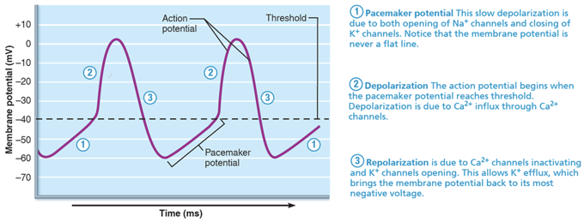

The intrinsic conduction system: Sequence of Excitation
- Typical cardiac pacemaker cells are found in the
  - sinoatrial nodes
  - ventricular nodes
- Cells from these parts sometimes act as pacemakers:
  - Atrioventricular bundle (bundle of his)
  - Right and left bundle branches
  - Subendocardial conducting network (Purkinje fibres)
- Impulses pass through the heart in order from 1-5
- 1. Sinoatrial (SA) node
  - Located in right atrial wall, inferior to the entrance of superior vena cava
  - Pacemaker of heart in the right atrial wall
    - Sets the pace for the whole heart because no other region has a faster depolarization rate
  - Inherent rate of 100´/minute tempered by extrinsic factors
  - Generates impulses about 75´/minute (sinus rhythm)
  - The impulses spread across atria & to AV node
- 2. Atrioventricular (AV) node
  - Depolarization spreads via gap junctions from SA node to AV node
  - Located in the inferior portion of the interatrial septum
  - Delays impulses approximately 0.1 seconds
    - Allows atrial contraction prior to ventricular contraction
    - Allow atria to respond and complete their contractions before the ventricles contract
    - Delay reflects the fact that fibres have a smaller diameter and fewer gap junctions for current flow
  - Inherent rate of 50´/minute in absence of SA node input

- 3. Atrioventricular bundle(bundle of his)
  - In superior interventricular septum
  - Atria and ventricles are adjacent to each other but, are not connected by gap junctions
    - AV bundle is the only electrical connection between the atria and ventricles
- 4. Right and left bundle branches
  - The short AV bundle(bundle of his) splits into two sections
    - Right and left bundle branches
  - Found along the interventricular septum of the heart
  - Carry impulses toward apex of heart
- 5. Subendocardial conducting network (Purkinje fibres)
  - Long strands of barrel-shaped cells with few myofibrils
  - Complete pathway through the interventricular septum into apex and ventricular walls; more elaborate on left side of heart
  - AV bundle Purkinje fibres depolarize 30´/minute; ventricular contraction immediately follows from apex toward atria
  - Process from initiation at SA node to complete contraction takes ~0.22 seconds

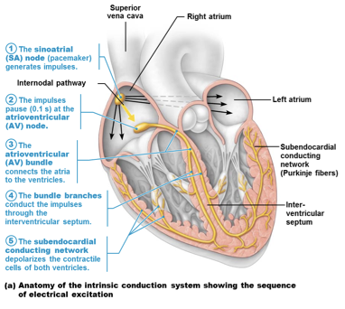

Extrinsic Innervation of the Heart
- Intrinsic conduction system sets basic heart rate
- ANS can modify the beats, sympathetic nervous system increases both the rate and force of the heartbeat
- Heartbeat modified by ANS via cardiac centers in medulla oblongata
  - Cardioacceleratory Center:
    - sends SNS signals to increase rate and force
    - Stimulates SA and AV nodes, heart muscle, and coronary arteries
  - Cardioinhibitory Center:
    - PNS via vagus nerve to decrease rate
    - Inhibits SA and AV nodes via vagus nerves

Action potential of Contractile Cardiac muscle cells
- Contractile muscle fibres make up the bulk of heart and are responsible for pumping action
- Cardiac muscle action potentials have plateau
- Steps involved in AP:
  - 1. Depolarization
    - opens fast voltage-gated Na⁺ channels
    - Positive feedback influx of Na⁺ causes rising phase of AP (from -90 mV to +30 mV)
  - 2.Depolarization by Na⁺ also opens slow Ca²⁺ channels
    - At +30 mV, Na⁺ channels close, but slow Ca²⁺ channels remain open, prolonging depolarization; seen as a plateau
  - 3. Action potential falls
    - After about 200ms, slow Ca² channels are closed and voltage gated potassium ion channels are open
    - Rapid efflux of potassium ion causes cell membrane to return to resting membrane potential
    - Calcium ions are pumped both back into the sarcoplasmic reticulum and out of the cell into the extracellular space
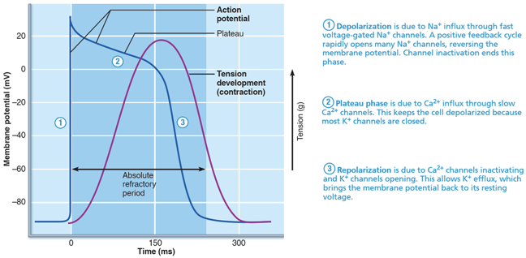

Explain what is an ECG tracing and the nature of the information it is providing
- Electrocardiograph can detect electrical currents generated by heart
- Electrocardiogram (ECG or EKG) is a graphic recording of electrical activity
  - Composite of all action potentials at given time; not a tracing of a single AP
  - Electrodes are placed at various points on body to measure voltage differences
    - 12 lead ECG is most typical
- Main features:
  - P wave
    - depolarization of SA node and atria
    - Atrial depolarization initiated by the SA node
    - Impulse is then delayed by the AV node when atrial depolarization is complete
  - QRS complex
    - Ventricular depolarization and atrial repolarization causes QRS complex
    - Between the S and T ventricular depolarization becomes complete
      - Plateau phase between the S and T
  - T wave:
    - ventricular repolarization (Ventricular relaxation)
    - Repolarization is slower than depolarization
    - Which is the reason the T wave is more spread out and has a lower amplitude
  - P-R interval:
    - beginning of atrial excitation to beginning of ventricular excitation
    - Q wave is often not visible but marks the beginning of ventricular excitation
    - PR interval includes the atrial depolarization and contraction
  - S-T segment:
    - entire ventricular myocardium depolarized
  - Q-T interval:
    - the beginning of ventricular depolarization through ventricular repolarization
- Changes in patterns or timing of ECG may reveal the diseased or damaged heart or problems with the heart’s conduction system
- Problems that can be detected:
  - Enlarged R waves may indicate enlarged ventricles
  - Elevated or depressed S-T segment indicates cardiac ischemia/ infarction
  - Prolonged Q-T interval reveals a repolarization abnormality that increases risk of ventricular arrhythmias
  - Junctional blocks, flutters, and fibrillations are also detected on ECG

The sequence of depolarization and repolarization of the heart related to the deflection waves of an ECG tracing
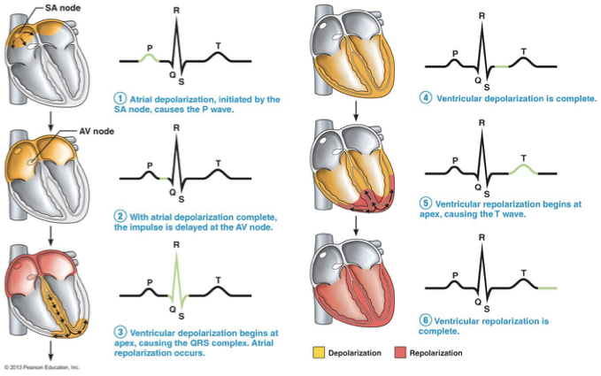

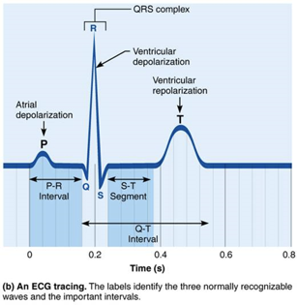

Abnormal Activation of the Heart
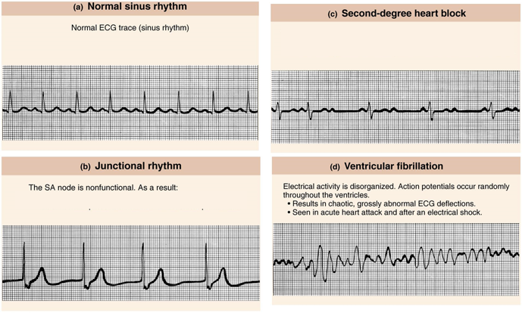

Explain the events of each phase of the cardiac cycle and describe the pressure changes responsible for valve opening & closing & link these with resultant volume changes
Mechanical Events of Heart
- Systole: periods of contraction
- Diastole: period of relaxation
Cardiac cycle
- Blood flow through the heart during one complete heartbeat
  - Atrial systole and diastole are followed by ventricular systole and diastole
  - Cycle represents a series of pressure and blood volume changes
  - Mechanical events follow electrical events seen on ECG
- Three phases of the cardiac cycle (following left side, starting with total relaxation)
  - 1. Period of ventricular filling:
    - mid-to-late diastole
    - Pressure in the heart is low, blood returning from the circulation is flowing from the atria through the AV valves into the ventricles, the aortic and pulmonary valves are closed (SL valves are closed)
    - More than 80%of ventricular filling occurs during this period
    - Remaining 20%of blood is delivered to the ventricles when the atria contract at the end of this phase
    - Atrial systole(depolarization) occurs (P wave)
    - After atrial systole, there is a rise in atrial pressure
    - Rise in pressure causes extra blood found in the atria to enter the ventricles
    - The ventricles are in the last part of diastole
      - The ventricles contain the maximum amount of blood they will contain during the cycle (End diastolic volume)
  - 2. Ventricular systole (comprises QRS complex & T waves)
    - Isovolumetric contraction and ventricular ejection
    - The atria will then enter diastole and relax
    - The ventricles will begin systole and depolarize (QRS complex)
      - The ventricle walls close in on the blood in their chambers and ventricular pressure rises rapidly
      - The AV valves then close
      - Isovolumetric contraction phase is the split second when the ventricles are completely closed chambers and the blood volume remains constant as the ventricles contract
      - Pressure in the large arteries is exceeded and causes the SL valves to open
    - Ventricular ejection
      - Blood rushes from the ventricles into the aorta and pulmonary trunk
    - Following the peak of the T wave the ventricles repolarize

  - 3. Isovolumetric relaxation: Early diastole
    - Early diastole
    - Blood remaining in ventricle chambers is referred to as the end systolic volume
    - Ventricular pressure drops rapidly
      - blood in the aorta and pulmonary truck flow back towards the heart causing the SL valves to close
    - The ventricles become completely closed chambers once again since the SL valves are closed
    - Ventricles are relaxed
    - Atria are relaxed and begin filling
    - Closure of aortic valve raises aortic pressure and backflow rebounds off the closed cusps
      - Dicrotic notch

Indicate the physiological significance of the first and second heart sounds
- Two sounds (lub-dup) associated with closing of heart valves
- The sound is usually “lub-dub pause lub-dub pause…”
- First sound(lub) is closing of AV valves at beginning of ventricular systole
  - The first sound tends to be louder and longer than the second sound
  - The point when ventricular pressure rises above arterial pressure
- Second sound(dub) is closing of SL valves at the beginning of ventricular diastole
  - Occurs when the SL valves snap shut at the beginning of ventricular relaxation (diastole)
  - This sound is short and sharp
- Pause between lub-dups indicates heart relaxation
- Heart murmurs: abnormal heart sounds heard when blood hits obstructions dues to
  - Incompetent valve
  - Stenotic valve

The Cardiac Cycle(wiggers diagram)
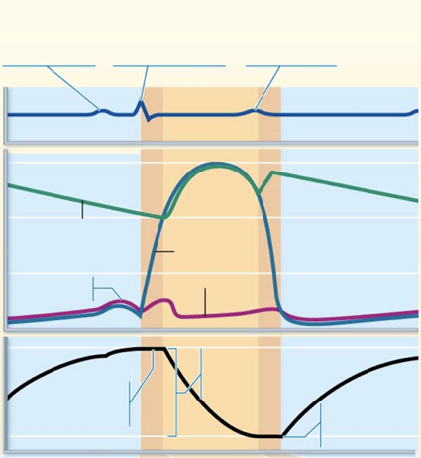
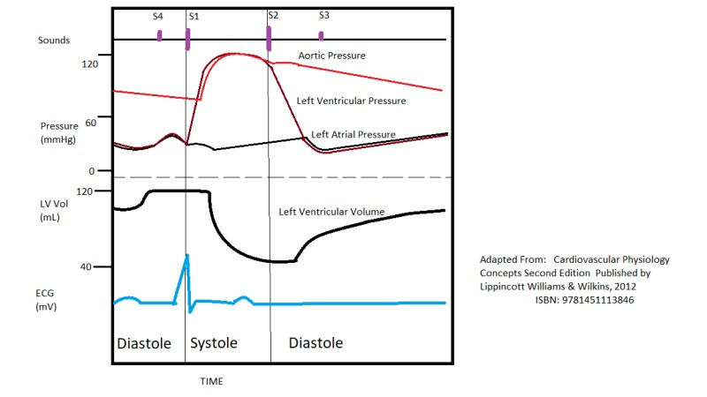

Define cardiac output (CO) in terms of heart rate and stroke volume
- Cardiac output:
  - Amount of blood pumped by each ventricle in a minute
  - units =ml/min
  - It is the product of stroke volume and heart rate CO = HR X SV
  - Maximal CO is 4–5 times resting CO in nonathletic people (20–25 L/min)
  - Maximal CO may reach 35 L/min in trained athletes
  - Cardiac reserve
    - difference between resting and maximal cardiac output (CO)
- Stroke volume:
  - Volume of blood pumped out by one ventricle with each beat SV = EDV-ESV
  - The stroke volume represents the difference between end diastolic volume(EDV) and end systolic volume (ESV)
    - End diastolic volume(EDV)
      - The amount of blood that collects in a ventricle during diastole
      - EDV is determined by how long ventricular diastole lasts and by venous pressure
      - Is usually around 120ml
    - En systolic volume (ESV)
      - Volume of blood remaining in a ventricle after it has contracted
      - Determined by arterial blood pressure and force of ventricular contraction

Describe in detail the mechanisms for the regulation of HR & SV
- CO = HR X SV
- CO changes (increases/decreases) if either or both SV( stroke volume) or HR(heart rate) is changed
- CO is affected by factors leading to:
  - Regulation of stroke volume
  - Regulation of heart rates

Regulation of stroke volume
- SV = EDV - ESV
- EDV is affected by length of ventricular diastole, venous pressure
- ESV is affected by force of ventricular systole, arterial blood pressure
- Three main factors that affect SV: Preload,Contractility, Afterload
  - Preload
  - The degree to which cardiac muscle cells are stretched just before they contract
  - Changes in preload cause changes in stroke volume
  - Affects end diastolic volume
  - Frank starling law of heart
    - Described the relationship between the preload and stroke volume
    - The higher the preload, the higher the stroke volume
    - Larger end diastolic volume causes larger stroke volume
  - Most important factor in preload stretching is venous return
    - Slow heartbeat and exercise increase the venous return
    - Increased venous return distends ventricles and increases contraction force
  - Contractility
  - Contractile strength achieved at a given muscle length
  - Independent of muscle stretch and end diastolic volume
  - Increased contractility can cause a decrease in end systolic volume which is caused by
  - Sympathetic nervous system
    - Epinephrine release stimulates an increased calcium influx which leads to more cross bridge formations
  - Inotropic agents
    - Positive inotropics agents
      - Positive inotropics increase the contractility
      - Thyroxine, glucagon, epinephrine, digitalis, high extracellular Ca²⁺
    - Negative inotropics agents
      - Negative inotropics decrease the contractility
      - Acidosis (excess H⁺), increased extracellular K⁺, Ca²⁺ channel blockers
  - Afterload
  - Back pressure exerted by arterial blood
  - Pressure that the ventricles must overcome in order to eject blood
    - Back pressure from arterial blood pushing on SL valves is major pressure
    - Aortic pressure is around 80 mm Hg
    - Pulmonary trunk pressure is around 10 mm Hg
  - Hypertension increases the afterload resulting in reduced ESV and reduced stroke volume
  - A large afterload reduces the ventricles ability to eject blood
  - Therefore more blood remains in the heart after systole

Regulation of heart rates
- If stroke volume decreases as a result of decreased blood volume or weakened heart cardiac output can usually be maintained by an increased heart rate
  - Positive chronotropic factors increase the heart rate
  - And negative chronotropic factors decrease the heart rate
- Heart rate can be regulated by :
- Autonomic Nervous System regulation of HR
  - Sympathetic nervous system
    - Can be activated by emotional or physical stressor
    - Norepinephrine is released causing
      - pacemaker cells to fire more rapidly
        - A decrease in end diastolic volume bc the heart is contracting more rapidly
      - Increased contractility
        - Decrease in end systolic volume because of increased volume of ejected blood
    - If both EDV and ESV decrease, stroke volume can remain unchanged
  - Parasympathetic nervous system
    - Opposes sympathetic effects
    - Acetylcholine hyperpolarizes pacemaker cells by opening potassium ion channels which slow heart rate (HR)
    - Has little to no effect on contractility
  - Under resting conditions both autonomic divisions continuously send impulses to the SA node
    - Heart at rest exhibits vagal tones
    - Parasympathetic has a dominant effect on the heart
    - Decreases the heart rate by about 25 beats per minute
    - Cutting the vagal nerves leads to a heart rate of less than 100beats/min
  - When SNS is activated PNS is inhibited and vise versa
- Chemical regulation of heart rate
  - Hormones
    - Epinephrine released by the adrenal medulla
    - Epinephrine increases heart rate and contractility
    - Thyroxine increases the heart rate
      - It also enhances the effects of epinephrine and norepinephrine
  - Ions
    - Intra and extracellular ion concentration
    - Ex. calcium ions and potassium ions must be maintained in order for a normal heart rate
      - Imbalances in ions are very dangerous
      - Hypocalcemia: depresses heart
      - Hypercalcemia: increases heart rate and contractility
      - Hyperkalemia:alters electrical activity which can lead to heart block and cardiac arrest
      - Hypokalemia: results in weak heartbeat, arrhythmias
- Other factors that influence heart rate
  - Age
    - Fetus has a faster heart rate
    - The heart rate declines with age
  - Gender
    - Women typically have a faster heart rate than men
  - Exercise
    - Exercise increases the heart rate
    - Trained athletes can have a slower heart rate
  - Body temperature
    - Heart rate increases with increased body tempurture

