Antibiotic Resistance Case Study

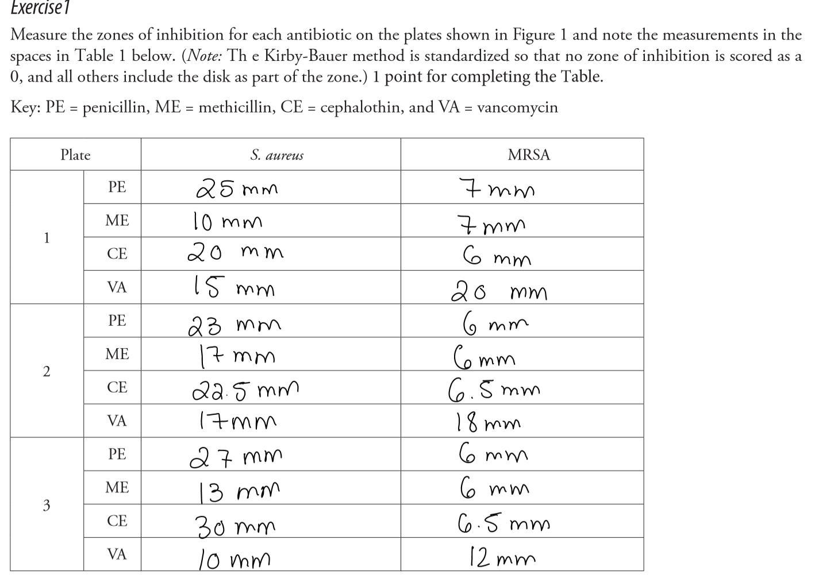
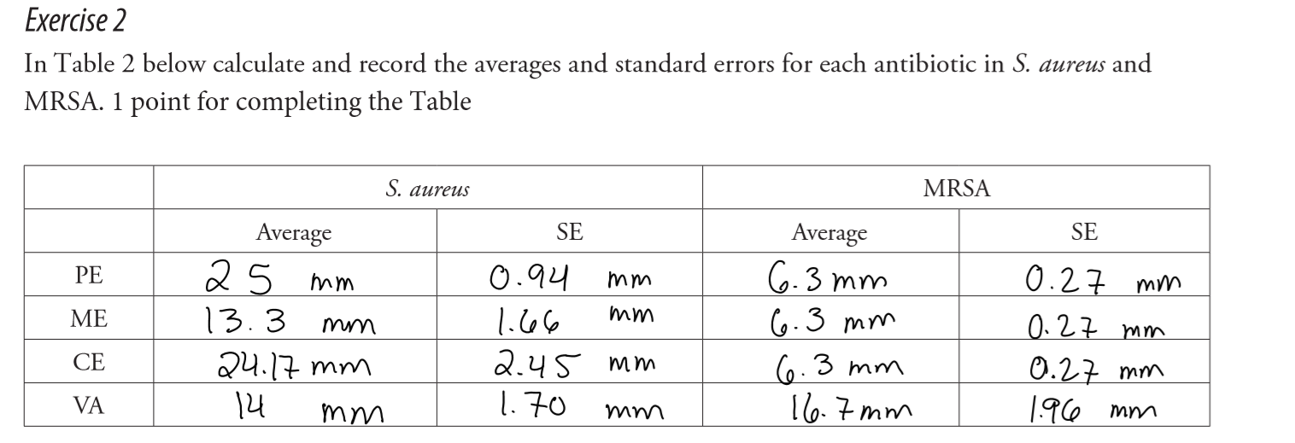
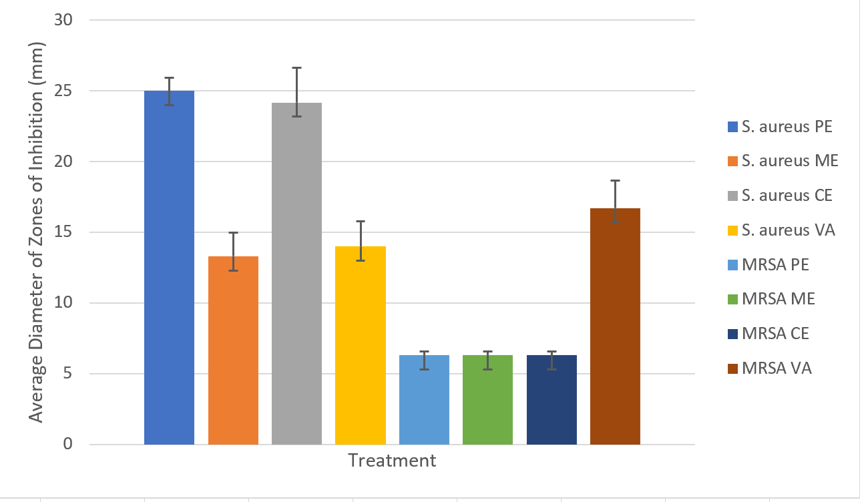
Figure 1. The average diameter of the zones of inhibition of penicillin (PE), methicillin (ME), cephalin (CE) and vancomycin (VA) on S. aureus and MRSA.

Part I Questions

1. What do you think the experimental question is? 1 point for an answer reflecting that the team thought about it seriously

Do Staphylococcus aureus and MRSA exhibit resistance to vancomycin?

2. What hypotheses can you come up with to answer the experimental question? 1 point if answer is correct within the experimental question established in question 1.

Staphylococcus aureus and MRSA will not exhibit resistance to vancomycin. MRSA will exhibit resistance to penicillin and its derivatives (methicillin and cephalothin). Staphylococcus aureus will not exhibit resistance to penicillin and its derivatives.

3. If your hypothesis is correct, what would the plates look like (i.e., what predictions would you make for each hypothesis)? 1 point
If the hypothesis is correct, there will be zones of inhibition on the MRSA and S. aureus plates treated with vancomycin, as well as one the S. aureus plates treated with penicillin and its derivatives.

4. Is the experiment you just collected data for an appropriate test of the experimental question you came up with in your answer to Question 1? 1 point
Yes, it is an appropriate test for the experimental question as the hypothesis may be answered by evaluating the zones of inhibition on the plates; the resistance exhibited by a microorganism is inversely proportional to the diameter of the zone of inhibition.

5. Which antibiotics were most effective against S. aureus? Against MRSA? 1 point
Penicillin and cephalothin (a derivative of penicillin) were the antibiotics most effective against S. aureus. Vancomycin was the only antibiotic effective against MRSA.

6. When comparing the antibiotics effective against both, were there differences in effectiveness? 1 point
Vancomycin was the only antibiotic effective against both S. aureus and MRSA. Vancomycin was more effective on MRSA, as the diameters of its zones of inhibition were larger than those of S. aureus.

7. What other questions do the data shown in Figure 1 make you think of? 1 point
The data prompted is why vancomycin is not as effective on S. Aureus as it is on MRSA?

Part II Questions:
1. Describe what is happening in Figures 7 and 8 in a complete sentence of your own words. 1 point
Figure 7 shows the inhibition of penicillin-binding protein (PBP) by beta-lactam which prevents the cell wall of the bacterium cells from forming properly, causing it to undergo osmotic stress.

Figure 8 shows a similar process by vancomycin in which it inhibits cell wall synthesis by binding PBP’s substrates thus preventing cross-bridging. This also causes bacterium cell walls to undergo osmotic stress.

2. What are the differences in how beta-lactam antibiotics and vancomycin work? 1 point
Beta-lactam inhibits PBP by binding to the active site of PBP and in turn blocking the site from the amino acids which prevents cross-linking. Vancomycin inhibits the second stage of cell wall synthesis by binding PBP’s substrates and preventing cross-bridging.
3. What other mechanisms might arise to allow resistance to the beta-lactam antibiotics? 1 point for well thought out answer
A mechanism that might arise to allow resistance to beta-lactam antibiotics is a change in the active site on PBP. If the active site changes to a conformation to which beta-lactam antibiotics cannot bind to, PBP will not be inhibited and will be able to form cross-bridges that stabilize the cell wall.

4. Could resistance arise to vancomycin? Why or why not? 1 point for well thought out answer.
Resistance may arise to vancomycin if the amino acid composition of the cell wall changes, such that vancomycin would no longer be able to bind them. Changing the properties of amino acids such as polarity and charge may affect the ability of vancomycin to bind them.

Part III Questions:

1. What do you think the experimental question is? 1 point for well thought out answer

What are the growth patterns of MRSA in mice treated with FtsZ inhibitor and imipenem over time?

2. What hypotheses can you come up with to answer the experimental question? 1 point if answer is correct within the experimental question established in question 1.

The number of MRSA colonies will decrease exponentially in mice treated with FtsZ inhibitor and imipenem within a 24 hour period.

3. What predictions would you make for each hypothesis? 1 point for well thought out
If mice are treated with FtsZ inhibitor and imipenem, the number of MRSA colonies will decrease exponentially within a 24 hour period.

4. Looking at the data in Table 1, what do these numbers mean? (Keep in mind a log value means each integer increase is actually a ten-fold increase in the number of cells.) 1 point
The data in Table 1 reflects the exponential growth or decay of the MRSA colonies in mice infected

5. What do you think FtsZ inhibitor and imipenem are? 1 point
FtsZ inhibitor and imipenem are antibiotics. They are used to counter bacterial resistance. FtsZ inhibitor will inhibit the cell division protein FtsZ, while imipenem has a wide spectrum inhibiting Gram positive and Gram negative activity by interfering with the cell wall.

Next, Katelyn further analyzed the data she collected by calculating the average and standard error:
6. Does Table 2 change your interpretation of the experimental data from Question 4? Why or why not? 1 point
No, since overall the results are the same as in table 1; the log CFU/g of MRSA found in mice varies slightly from the control when FtsZ inhibitor, from 9.008 log CFU/g to 8.094 log CFU/g , and imipenem, from 9.008 log CFU/g to 7.993 log CFU/g, are given separately. When FtsZ inhibitor and imipenem are combined, the same results can be observed as in Table 1; the combination causes a drastic decrease of MRSA (log CFU/g) observed, from 9.008 log CFU/g to 4.53 log CFU/g.
7. How effective was the FtsZ inhibitor alone? Imipenem alone? 1 point
Both the FtsZ inhibitors and the Imipenem were not that effective alone as both only decreased the number of bacteria colonies by less than 10%.

8. How effective was the combination of the inhibitor and the -lactam antibiotic? 1 point
When combined the combination was much more effective.

9. How would you explain these results? 1 point
An explanation for this result is that when used alone the antibiotics do not work as well due to resistance exhibited by MRSA. However, when the inhibitors are added, they slow the resistance mechanisms making the antibiotics more effective. This may be observed by the decreased logCFU/g values of the FtsZ inhibitor + imipenem samples compared to the control samples.

10. What questions would you pursue next? 1 point for well thought out answer
- What would be the most effective and safest dosage of FtsZ inhibitor and imipenem that can be administered to treat an MRSA infection?
- What is the optimal duration of treatment to treat an MRSA infection by using a FtsZ inhibitor and imipenem treatment?

