University of Ottawa

Benzylidene Acetals as Protecting Groups

CHM 2123

October 9, 2019

Introduction
Background theory
Carbohydrates are very common macromolecules that mainly consist of sugars and starches and constitute one of the three principal nutrient and energy sources used by the human body. Carbohydrate molecules can contain multiple poly-hydroxy aldehydes and ketones. A single unit (monomer) of carbohydrate is referred to as a monosaccharide, which can be present in either a cyclic pyranose form or a linear chain-type form. Within the linear form of the monosaccharide, there is a free aldehyde present on the anomeric carbon (C₁). After the process of cyclization is complete, the free aldehyde is lost and there is a stereocenter produced at the anomeric carbon. This stereocenter can exist as two different forms, either the α-anomer (less stable because the anomeric group is situated on the axial position which leads to more steric hindrance) or the β-anomer (more stable due to anomeric group being situated in the equatorial position). Since the ring is more stable than the linear form, only trace amounts of sugars are found in the linear form as opposed to the ring. There is a ratio of 1:2 (approximately) α to β-anomers. Monosaccharide strands are linked together via glycosidic linkages formed through dehydration reactions. The different α and β glycosidic linkages can alter the reactivity of the sugar molecules and can prevent them from decyclization.
Part A
There are several hydroxyl groups present within carbohydrates which, along with the aldehydes and ketones present, can allow carbohydrates to undergo multiple reactions at multiple locations.In order to control regioselectivity of reactions on carbohydrate molecules, protecting groups are used to cover reactive groups to prevent unwanted reactions. Acetals are commonly used as protecting groups. They are characterized by single carbon atoms bound to two alyoxy groups, and are primarily used to protect alcohols, aldehydes and ketones. Acetals can be formed when ketones or aldehydes are reacted with activated (through acid catalysis) alcohols. Protecting the more reactive functional groups (ketones and aldehydes) allows the less reactive groups within the molecule such as esters to be reduced instead. The protecting groups can later be removed from the carbohydrate molecule using an acid.
For this experiment specifically, a cyclic acetal is formed to protect the C₄ and C₆ hydroxyl groups of the methyl-α-D-glucopyranoside (MDG). For this to occur, the MDG is reacted with benzaldehyde dimethyl acetal (BMA), which contains an acetal. The reaction occurs via the following mechanism:

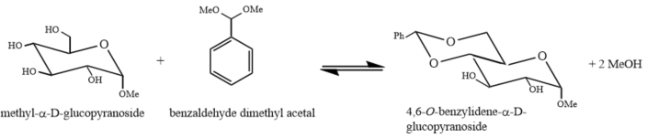
Figure 1. Acid-catalyzed acetal formation from methyl-α-D-glucopyranoside and benzaldehyde dimethyl acetal

Part B
Benedict’s solution is often used to detect for the presence of reducing sugars (sugars that are oxidized and help to reduce other molecules) in various compounds and solutions. Cu²⁺ ions within the Benedict’s solution are present in copper sulphate and are reduced in the presence of reducing sugar. This reaction incites a colour change when the copper sulphate (blueish green) is reduced to insoluble Cu₂O which is red in colour.

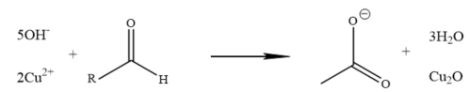

Figure 2. Redox reaction occurring with free aldehydes and Cu²⁺

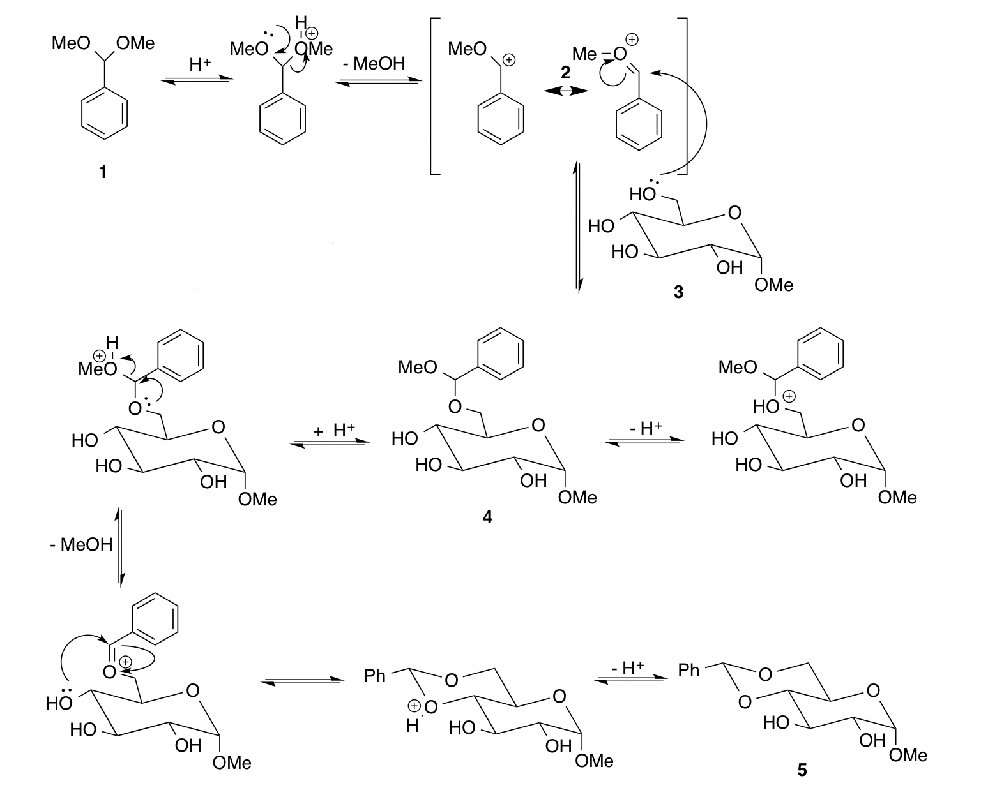
Figure 3. Full mechanism of the reaction in Part A

Table 1. Table of Reagents
Compound | Mol. Weight (g/mol) | Amount | Density (g/mL) | mol
Tetrahydrofuran (solvent) |  | 10 mL
α-D-glucopyranoside | 194.18 | 0.5 g |  | 0.002575
Benzaldehyde dimethyl acetal | 152.19 | 0.7 mL | 1.014 | 0.004664
Camphorsulfonic acid (catalyst) | 232.26 | 0.1 g | 1.84 | 0.00043

Experimental Procedure:
The procedure followed for this experiment can be found in the CHM 2123 lab manual, Experiment 4 found on the TopHat website, provided by the Department of Chemistry of the University of Ottawa.

Observations and Results:

Part A:

Table 2. Qualitative observations from Part A
Key step | Observations
1) | α-D-methylglucopyranoside is a fine white powder
2) | The solution of α-D-methylglucopyranoside and tetrahydrofuran was colourless  Adding the camphorsulfonic acid and benzaldehyde dimethyl acetal did not change the colour of the previous solution.  Tetrahydrofuran: colourless, clear, liquid with slight ether-like odour.  Camphorsulfonic acid: fine white powder  Benzaldehyde dimethyl acetal: clear, colourless liquid
4) | At this point solution became slightly cloudy.
5) | Exposure to the methanolic sulfuric acid solution and heat produced new dark spots to accompany the normal TLC spots.  The TLC results indicated that the reaction was complete, so the solution was removed from the reflux apparatus.
6) | Trimethylamine caused the solution to become cloudier.  Trimethylamine: clear, colourless liquid.
7) | Solution split into organic and aqueous phases after adding distilled water.  The upper phase was the organic phase composed of ethyl acetate and tetrahydrofuran. The bottom phase was the aqueous phase that contained only the water.  The organic phase became clearer as it was washed with the distilled water.
8) | The addition of the reducing agent Na₂SO₄ made the organic phase clearer.
9) | After heating, the solution was thick and was the consistency of maple syrup.  Light yellowish colour.
11) | Suction filtration produced white crystalline solid, however we ran out of time before successfully completing a second TLC analysis.

Table 3. TLC plates for Part A
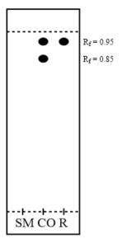
After 30 minutes of reflux

Solvent system:
3:7 hexanes:ethyl acetate

SM: Starting material (α-D-methylglucopyranoside)

CO: Co-spot

R: Reaction mixture

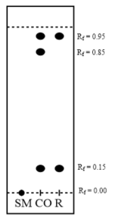
After sulfuric acid and heating

Solvent system:
3:7 hexanes:ethyl acetate
10% H₂SO₄ in methanol

SM: Starting material (α-D-methylglucopyranoside)

CO: Co-spot

R: Reaction mixture

Part B:
Table 4. Observations from Part B
Test tube | Initial | During | After 5 mins | Adding HCl
S | Clear blue | Clear blue | Clear blue | Bubbled violently when added  Became clear yellow
G | Clear blue | Red colour starting at base of test tube  Top is clear with red tint | Cloudy red + lumps at base  Top is clear with red tint | N/A
M | Clear blue | Purple-ish with white clumps | Blueish green base + the rest is yellow/green  After a few more minutes it became cloudy yellow with no clumps and orange on top | N/A
R | Cloudy blue | Crimson red | Cloudy with lumps  Dark red at base | N/A
D | Greenish blue and clear | Greenish blue and clear | Greenish blue and clear | N/A

Calculations:
Theoretical mass of protected sugar
Theoretical mass (m_{theoretical}) = $n_{product }× M_{product}$
$n_{product }=0.95× n_{limiting reagent}$
The 0.95 is derived from the fact that during acetal formation, there is 5% of the starting material left over, therefore indication the expected yield should be 95%
The limiting reagent is α-D-Methyl glucopyranoside which is stated to have a 1:1 ratio with the final product 4.6-O-benzylidene-α-D-Methyl glucopyranoside, and since approximately 0.002575 mol of the starting material were added, we are expected to have the same amount of the final product. Therefore:
$m_{theoretical}=\left(0.95× n_{limiting reagent}\right)×\left(282.26\frac{g}{mol}\right)$
$m_{theoretical}=\left(0.95×0.002575 mol\right)×\left(282.26\frac{g}{mol}\right)$
$m_{theoretical}=0.69g$

Percent yield of protected sugar
$m_{theoretical}=0.69 g$
$m_{actual }=0.48 g$

% yield = $\frac{m_{actual }}{m_{theoretical}}×100\%$
= $\frac{0.48 g}{0.69 g}×100\%$
= 69.56%

Discussion:
Part A:
The goal of Part A was to create an acetal to use as a a protecting group to protect a sugar molecule. In this experiment, a 2,6-O-benzylidene-α-D-glucopyranoside was formed by reacting methyl-α-D-glucopyranoside (MDG) with benzaldehyde dimethyl acetal (BDA). Tetrahydrofuran (a polar aprotic solvent) is used instead of a polar protic solvent, because that would lead to unwanted side reactions within the mechanism. In order for this reaction to occur properly, there must be no water or acetone present on the glassware or anywhere within the apparatus or the purification of the crude product would be longer involving another work up step. A catalyst was also used in this experiment that was in the form of camphorsulphonic acid, which is also non-aqueous.
The reflux reaction was heated via heating mantle to maximize the rate of reaction and overcome the E_{a} barrier since the reaction is unable to take place spontaneously as are most chemical reactions To ensure the reaction occurs and reaches the necessary activation energy, a catalyst is used. This also helps to make sure that maximization of product formed occurs.
To assess/analyze whether the reaction was complete or not, a TLC analysis was performed. This analysis was also performed at the end of the reaction to see if the desired product had been formed or not. However for the first test, the sugars would not show up on the plate under UV light, so the plate was dipped in 10% H₂SO₄ in methanol and heated via heat gun to ‘burn’ the sugars and allow them to be visualized as dark/black spots near the bottom of the plate. Both TLC plates confirmed that the reaction was complete, as the spots appeared in the co-spot and reaction lane, however there was a light and not very discernible spot in the lane with the starting materials (after heating) that had an R_{f} of zero, unlike the other compounds that had R_{f} values of 0.85 and 0.95. This means that although there will always be a bit of starting products in the reaction mixture, they had mostly disappeared and thus the reaction was complete. A final TLC analysis was conducted after the product has been recrystallized a second time. Unfortunately, my group could not finish the experiment, therefore we do not have a plate to analyze, however there was a final weight from another group (Ramu El-Khawaldeh (300057095) and Hossein Arshadi (300101905)) provided.
Trimethylamine is added dropwise to the reaction to deprotonate any excess acid left. Doing so charges the triethylamine and the camphorsulphonic acid to increase the solubility in aqueous solvent in order to allow for the removal of the camphorsulphonic acid and trimethylamine from the organic phase during separation. The separation is carried out in a separatory funnel using distilled water to separate the solution into two phases: organic (upper) and aqueous (lower). The organic layer consisted of the BDA and the final product, and the aqueous layer contained the distilled water, camphorsulphonic acid and triethylamine. The separation process was done three times to ensure the most product possible was present in the organic phase. Once thoroughly separated, the organic phase is treated with Na₂SO₄ which is a drying agent in order to remove any traces of water. This salt is removed via gravity filtration and suction filtration, and the resulting crystalline product is heated in a steam bath to avoid burning and ruining the crude product. After thorough evaporation, the product was around 1 mL of thick syrupy crude product which was then cooled to reform the final crystalline solid (hopefully more pure) product.
The final mass of product purified was 0.48 g (again, no by my lab group), therefore the percent yield achieved was 69.56% which is a fair amount of product that was able to be purified, however there was still a moderate portion that was lost during the experiment. The experimental melting point was measured at 158-164°C, which is slightly lower than the literature value at 169-171 °C. This shows that there are still impurities present within the purified product.
Many of the possible sources of error for this portion of the experiment can be sourced from the recrystallization process, seeing as the final product was largely dependent on this part going well. For example, taking the reaction off the heat source too early or too late could have lessened the volume of crystals formed, if water were to enter the reaction solution, losing sample when transferring from the suction filtration apparatus back to the flask, not boiling off all of the dichloromethane, boiling or burning the crude product, etc.

Part B:
Part B involved Benedict’s solution being used to determine the concentration of reducing sugars in samples of sucrose, glucose, milk and coke. In the presence of reducing sugars, Benedict’s solution changes colour from blue to red, also exhibiting colours of green, yellow and orange as it undergoes this colour change. When the solution is heated in basic conditions, reducing sugars are converted into enediols which are capable of reducing the Cu²⁺ ions present in Benedict’s solution allowing the Cu to precipitate out as Cu₂O, a red coloured salt.
Reducing sugars are sugars that contain free aldehyde groups, alpha-hydroxy-ketones and hemiacetals. These groups will be oxidized by Benedict’s solution allowing the characteristic colour change to occur, otherwise leaving it blue.

Sucrose
When Benedict’s solution is added to the sucrose solution and heated, the colour remains unchanged. This indicates that there are no reducing sugars present in this sample, which is to be expected as sucrose is not a reducing sugar. Sucrose is a disaccharide made of glucose and fructose linked by an α-glycosidic linkage. This glycosidic linkage is between the anomeric carbons of both the glucose and fructose and as such prevents their acyclic conversion, ultimately impeding its ability to form free aldehyde or ketones. Due to the lack of free aldehyde groups and/or hemiacetals, sucrose itself cannot reduce the Cu²⁺ ions present in Benedict’s solution. Therefore, the Benedict’s test comes out as negative.
After HCl was added, a colour change was observed. This is caused by the breaking of the glycosidic bond by acid hydrolysis, hence freeing the anomeric carbons on both the glucose and fructose, enabling them to undergo acyclic conversions to form free aldehyde groups which are in turn able to reduce the Cu²⁺ ions and produce a positive Benedict’s test result. Being an equilibrium reaction, this doesn’t occur with all the sucrose molecules present, which is why the entire solution doesn’t change colour but rather we see a yellow coloured layer above the sucrose solution.

Glucose
The glucose turned a dark red-brown colour following heating and addition of Benedict’s reagent. Glucose is a reducing sugar since it’s a monosaccharide and has a free anomeric carbon. This free anomeric carbon allows it to undergo acyclic conversion whereby it produces a free aldehyde group. This free aldehyde is then able to react with the Benedict’s solution, allowing for the oxidation of the aldehyde and the reduction of the Cu⁺ ions.

Milk
The milk solution turned orange following heating with the Benedict’s solution indicating the presence of reducing sugars. Unlike the sugar however, the colour wasn’t as deep of a red, indicating a lower concentration of reducing sugars. The milk, having less sugars than a pure solution of sugar, is expected that the red colour that is produced is not as deep as that seen with pure glucose. The primary reducing sugar seen in milk is lactose, which is a disaccharide composed of glucose and galactose. This disaccharide however, unlike sucrose as seen earlier, has a β-glycosidic linkage, allowing the anomeric carbon on the glucose molecule to be free. This allows the glucose to become acyclic and become linearized, forming a free aldehyde once again allowing oxidation and a positive Benedict’s test.

Coke
Lastly, the regular coke resulted in a positive Benedict’s test result as the solution turned a dark red once again indicating that it is positive for reducing sugars. However, the diet coke was changed to a greenish blue colour and thus was not as successful. The major carbohydrate present in coke is fructose. Fructose is able to undergo acyclic conversion, producing a free aldehyde which is able to be oxidized by the Benedict’s reagent allow the colour change. Since there is a high concentration of fructose in coke, a stark colour change is seen. Despite this, one reason for the colour being so deep might be due to the already dark colouration of the coke.
In the presence of other compounds with free aldehydes or ketones such as ascorbic acid (Vitamin C) which is also found in coke can also cause the colour change in the Benedict’s solution with coke. Despite this, due to the high concentration of fructose in the coke, the colour chance can be attributed to the fructose rather than the other compounds.

Infrared Analysis
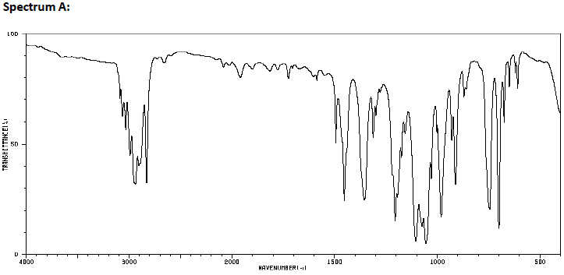
The peaks below ~1500 can be ignored as they correspond to the fingerprint region. As such we must look at peaks above this. Looking at the spectrum, there are peaks around ~3000. These peaks can only correspond to C-H bonds that are either sp³ or sp² hybridized. From the structures shown on the CHM2123 page for Experiment 4, it is evident that these sp³ and sp² hybridized C-H bonds are only both present in the benzaldehyde dimethyl acetal. The produced acetal protected sugar doesn’t have any sp² hybridized C-H bonds and also has several O-H groups which would also be evident on the IR spectrum. Since the O-H signals are not observed here, the formed protected sugar product can be ruled out and hence this IR spectrum can be associated with that of benzaldehyde dimethyl acetal.

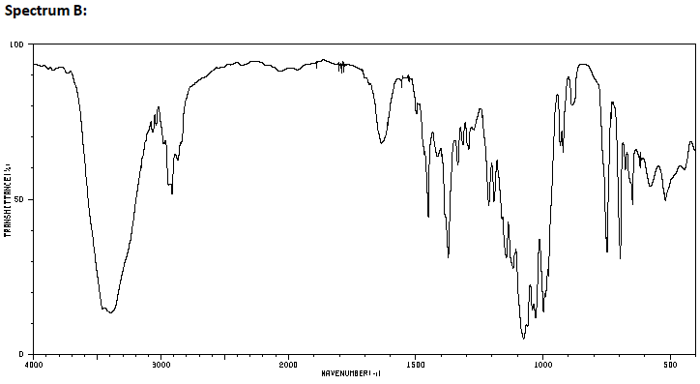
There is a very weak peak seen at ~1650 which is attributed to carbonyls. Since the peak is very small it can be ignored. The only strong peaks which are observed here are the sharp peak at ~2900 and the broad peak at ~3450. As mentioned before, peaks near ~3000 can be attributed to C-H bonds. In this case, this peak corresponds to sp³ hybridized C-H bonds as the peaks are not above ~3000 (generally, sp² hybridized C-H bonds are shifted above ~3000). The broad peak observed at ~3450 is either an N-H bond or an O-H bond. Since none of the compounds used have N-H bonds, this can be eliminated and hence it must correspond to an O-H group. There is only one molecule which contains O-H groups which is the final protected sugar. As such, it can be concluded Spectrum B corresponds to the final protected sugar.

Raw data:


